**Assignment3**

June 21,2015

Liu Hongkun

1. Grab Cut

1.1 Input image and Use image signature

**Input** The input color image (*m*n*3* matrix)

**Output** The saliency map (*m*n* matrix)

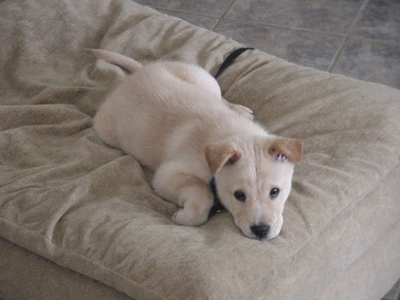

（a）Input image （b）Saliency map

1.2、**Draw the rectangle**

**Input** The input saliency map image (*m _ n* matrix).

**Output** A rectangle that is used to initialize the grab cut.

**1.3.Implement grab cut**

**Input** The input image (*m _ n _* 3 matrix) from step 1, and the rectangle that you computed from step 3.

**Output** The image after segmentation (*m _ n _* 3 matrix).

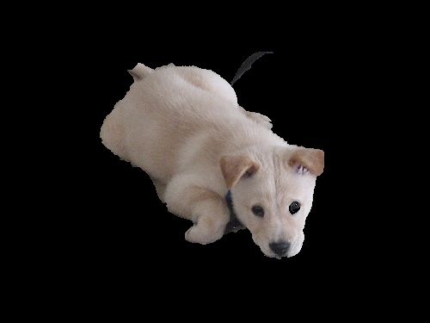

Segmentation result

**1.4.Evaluate segmentation result**

**Input** Segmentation result (*m _ n _* 3 matrix) and groundtruth (*m _ n* matrix) from dataset.

**Output** A figure that indicates evaluation results

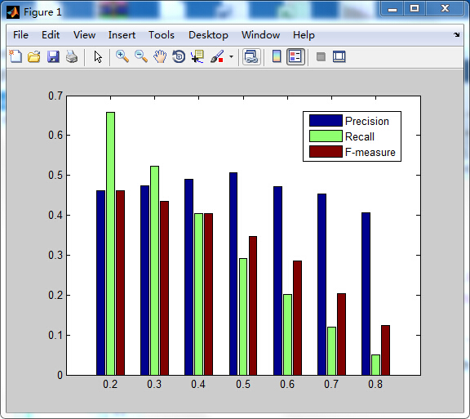

PRF bar graph(times of iteration=3)

1.5 Discussion

The parameters I choose to adjust are threshold and times of iteration.

The range of threshold is from 0.2 to 0.8, the times of iteration are 3,4,5,6.



Times of iteration=3

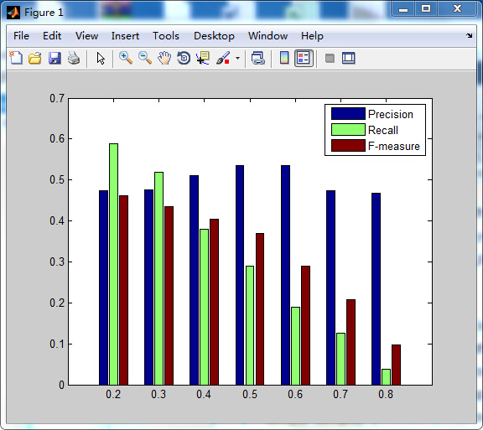

Times of iteration=4

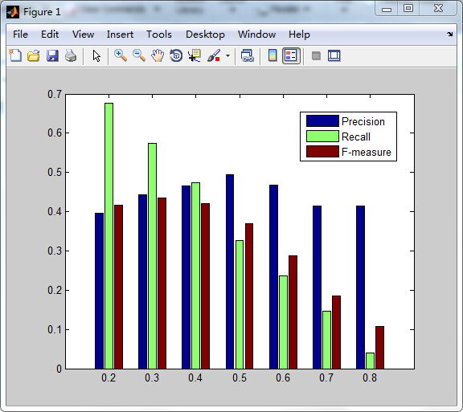

Times of iteration=5

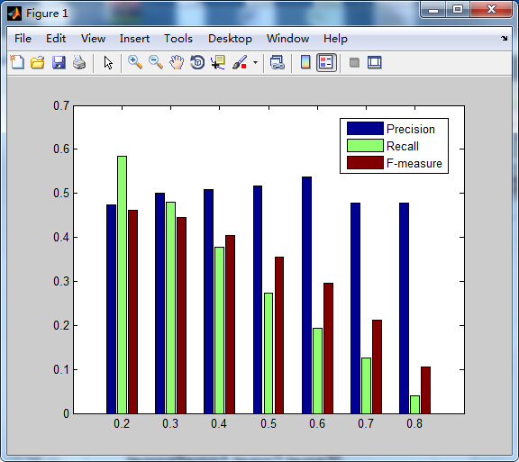

Times of iteration=6

When the times of iteration remain, the precision rises to its peak, then it drops down, the recall always drops down. only when times of iteration equals 5,the F-measure fluctuates, the F-measure drops down in other situations.

1. Mean shift

2.1 **Input image**

**2.2 Segment via mean shift**

**Input** The color image (*m _ n _* 3 *matrix*).

**Output** The segmentation results (*m _ n _* 3 *matrix*) and label matrixes (*m _ n matrix*) of different parameters.

I choose the spatial radius and color radius to get different segmentation results.

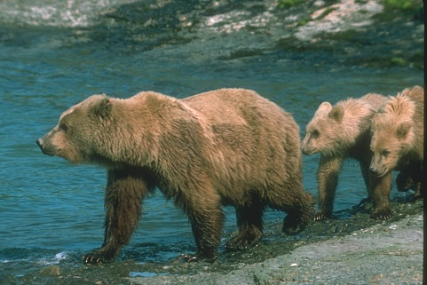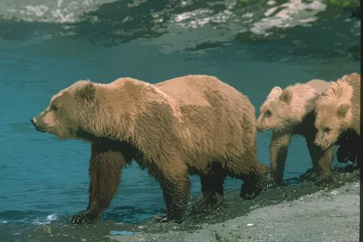

2.3 **Evaluate segmentation result with groundtruth**

**Input** The label matrixes (*m_n matrix*) from step 2, the groundtruth matrixes (*m_n matrix*) from dataset.

**Output** Line chart of the evaluation results. (The horizontal axis represents parameters. The vertical axis represents the evaluation results.)

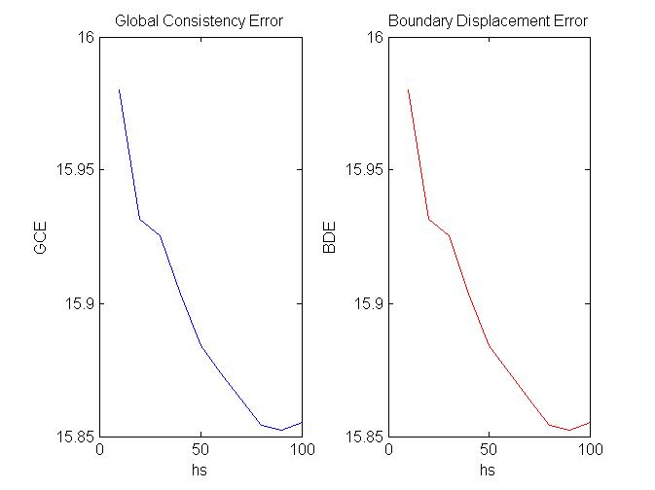

Evaluation with same hr and different hs

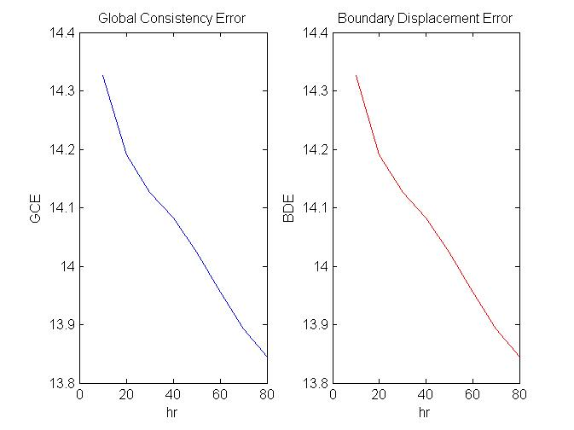

Evaluation with same hs and different hr