Assignment3

HAO LI

For this assignment, I will implement segmentation through grab cut and mean shift. Then, evaluate each method by adjusting parameters in segmentation.

1. Grab Cut

The whole framework of the implementation for evaluation of grab cut is shown in the following. In this part, I need to:

(1) Implement image signature, grab cut and evaluation.

(2) Adjust one parameter to obtain different segmentation results, then evaluate.

(3) Adjust another parameter to obtain different segmentation results and evaluate points.

. 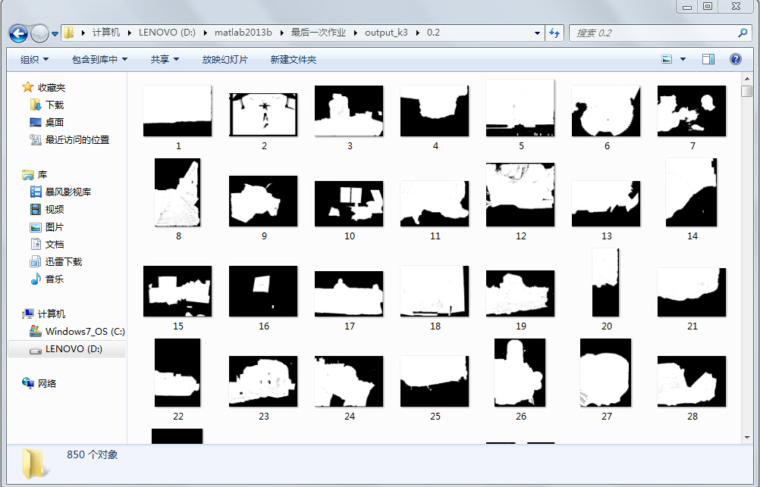

2: Use image signature  
Input the input color image (m × n × 3 matrix).  
Output the saliency map (m × n matrix).

Step 3: Draw the rectangle  
Input the saliency map image (m × n matrix).  
Output a rectangle which is used to initialize the grab cut.  
Step 4: Implement grab cut

Input the image (m × n × 3 matrix) from step 1, and the rectangle that I computed from step 3.

Output the image after segmentation (m × n × 3 matrix).

Implementation: Use grab cut with the rectangle to initialize and iterate k times for segmentation.

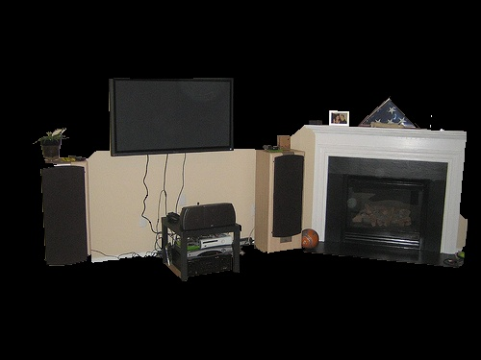

Step 5: Evaluate segmentation result  
Input segmentation result (m × n × 3 matrix) and ground truth (m × n matrix) from dataset.  
Output a figure that indicates evaluation results (The horizontal axis represents the parameter, the vertical axis represents the evaluation results.

Implement: Adjust threshold to obtain different segmentation results and draw a bar graph to evaluate grab cut.

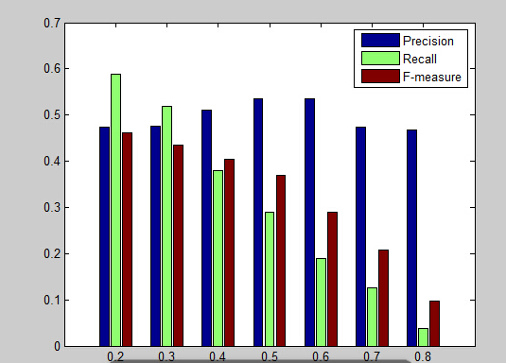

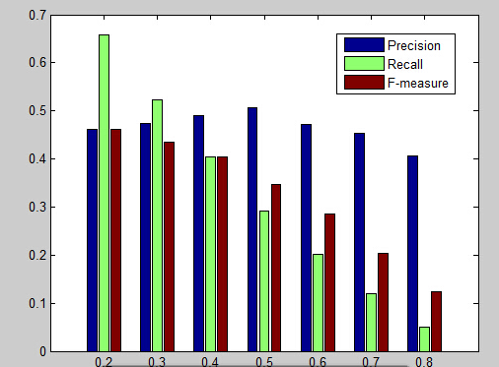

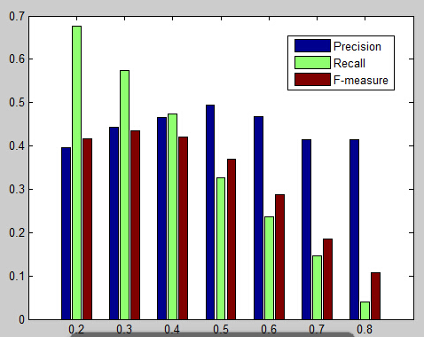

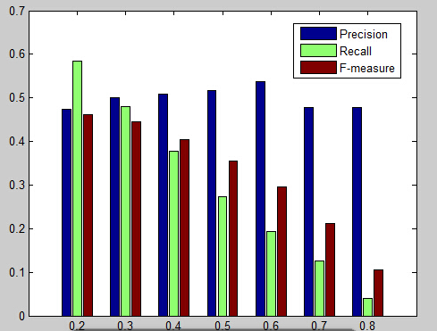

MAIN SHIFT

The whole framework of the implementation for evaluation of mean shift is shown in the following. In this part, I need to do:  
1. Input all images by batch processing.

2. Adjust two parameters of mean shift to get different segmentation results.  
3. Evaluate these segmentation results via two evaluation methods.

Step 1: Input image  
A simple dataset (BSDS500) can be downloaded from the website. The dataset contains input images and ground truth. Use all images from the dataset for segmentation.  
Step 2: Segment via mean shift  
In this step, I need to adjust the parameters of mean shift to get different segmentation results.  
Input the color image (m × n × 3 matrix).  
Output the segmentation results (m × n × 3 matrix) and label matrixes (m × n matrix) of different parameters.  
Implementation: The parameters of mean shift, which can be adjusted, include:  
• Spatial radius  
• Color radius  
• The number of iterations

Step 3: Evaluate segmentation result with ground truth  
In this step, I need to evaluate the different segmentation results from step 2.  
Input the label matrixes (m × n matrix) from step 2, the ground truth matrixes (m × n matrix) from dataset.  
Output line chart of the evaluation results. (The horizontal axis represents parameters. The vertical axis represents the evaluation results.)  
Implementation: The evaluation methods include:  
• Probabilistic Rand Index (PRI)  
• Variation of Information (VOI)  
• Global Consistency Error (GCE)  
• Boundary Displacement Error (BDE)  
I choose two evaluation methods from them.

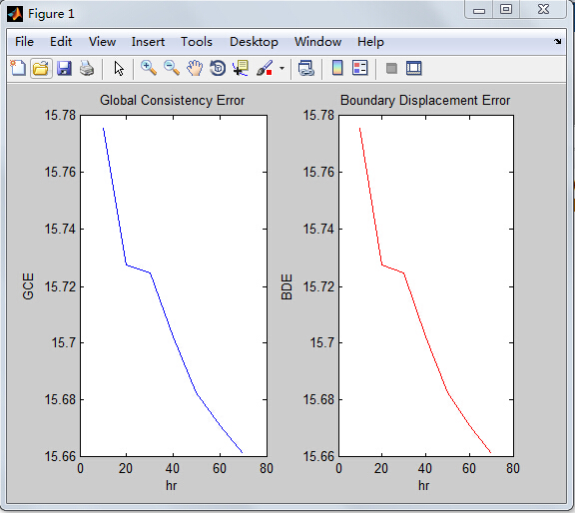

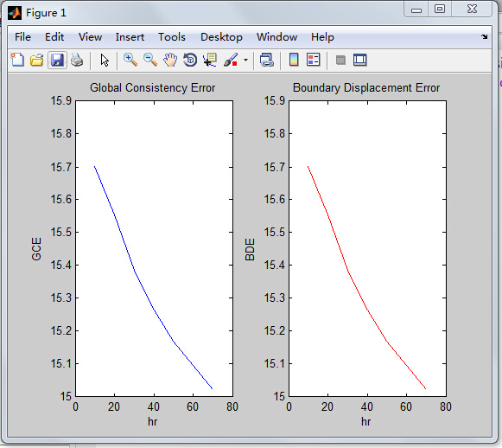

Lable2