Report on the object detection

PengyuWang
My assignment is programmed by C++ based OpenCV 2.4.8 and the IDE is vs2010.

Step 1&2 Input image and convert colorspace

Program
//step1 input image
if(argc>3)
{
cout<<"Usage: ./SURF_descriptor <img1> <img2>"<<endl;
return -1;
}
if(argc<3)
{
argv[1]="E:/object.jpg";
argv[2]="E:/scene.jpg";
}

//step2 colorspace conversion
Mat object,scene;
object=imread(argv[1],0);
scene=imread(argv[2],0);

if(!object.data||!scene.data)
{
cout<<"Error reading images."<<endl;
return -1;
}

Explanation
In this step, I choose two pairs of images which is given as test images and convert them to gray scale.
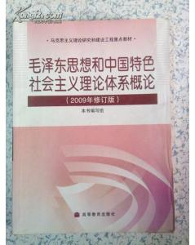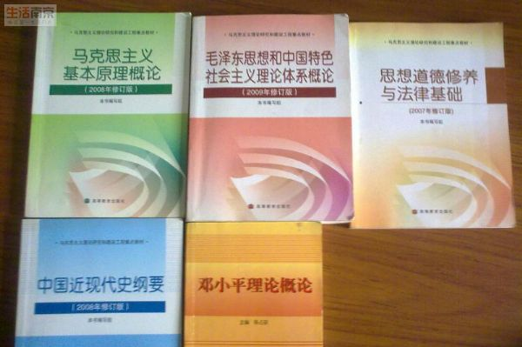
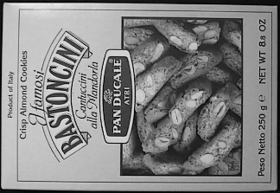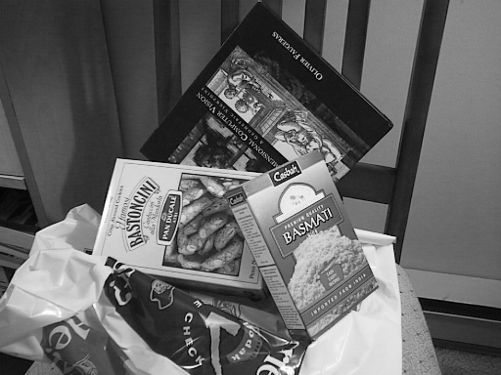

Step 3&4 Features2d detection,calculate descriptors

Program
int minHessian=380; //设置参数
SurfFeatureDetector detector(minHessian); //使用surf算法提取特征点，并将结果分别存
//入keyp_object,keyp_scene中
vector<KeyPoint>keyp_object,keyp_scene;
detector.detect(object,keyp_object);
detector.detect(scene,keyp_scene);

Explanation
In this step, I choose surf, sift, and orb algorithm as feature detector algorithm. After testing I find that the outcome is the best when we use surf algorithm as the feature detection coordinated by surf algorithm as the descriptors algorithm. The runtime is the minimum and the matching performance is the best. And the best parameter of Hessian is 380.If we choose other number, it will take more time and get worse outcome. And I store the keypoints detected from the object image and scene image in keyp_object and keyp_scene.

Step 5 Match descriptors

Program
//step5 match descriptors
//step5.1
BFMatcher matcher; //利用上一步生成的特征描述子，利用暴力匹配方法进行特征点匹配,并算出各特征点之间的距离
vector<DMatch>matches;
matcher.match(des_object,des_scene,matches);
//step5.2
double mindis=1000,maxdis=0; //找到特征点间的最大距离和最小距离并显示
for(int i=0;i<des_object.rows;i++)
{
double dist=matches[i].distance;
if(dist<mindis)
mindis=dist;
else if(dist>maxdis)
maxdis=dist;
}
printf("-- Max dist : %f \n", maxdis );
printf("-- Min dist : %f \n", mindis );
//step5.3
vector<DMatch>goodmatches; //找到距离小于3倍最小距离的特征点对，并将该匹配存入goodmatches中
for(int i=0;i<des_object.rows;i++)
{
if(matches[i].distance<3*mindis)
{
goodmatches.push_back(matches[i]);
}
}

Mat matchimage;
drawMatches(object,keyp_object,scene,keyp_scene,goodmatches,matchimage,Scalar::all(-1),
Scalar::all(-1),vector<char>(),DrawMatchesFlags::NOT_DRAW_SINGLE_POINTS);

Explanation
In this step, I use Flann algorithm and brute force matcher to match keypoints gotten in the last step.After testing, it turns out that brute force have the better performance while taking almost same time. And I use matches to store the outcome of matching. Then I use a circulation and two if-else to find the largest distance between keypoints from two image and the smallest one and show it in the command window. After that, I use a circulation and one if-else to find good matches( whose distance is less than tree times the minimum distance) with the minimum distance calculated in the last step. Finally, I use function drawMatches to draw the image which shows good matches and store the image in matchimage.

Output
Maxdistance:0.556398
Mindistance:0.058969
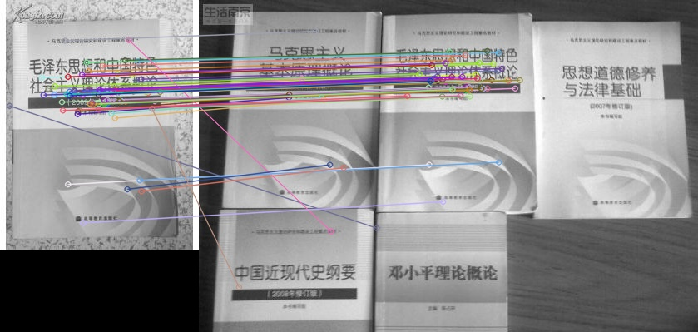
Maxdistance:0.685440
Mindistance:0.070356
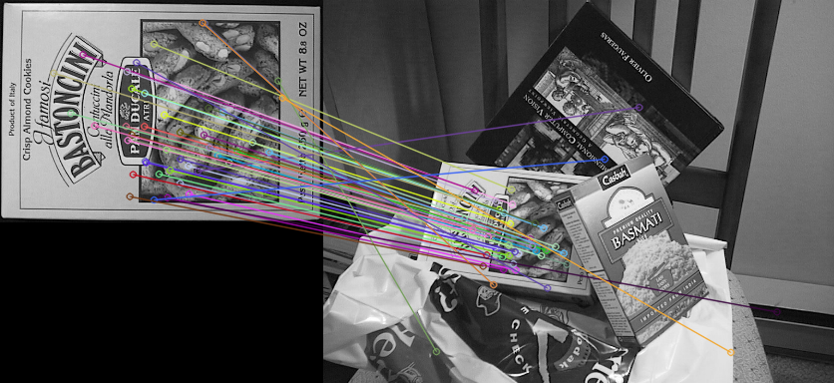

Step 6 Find homography transformation

Program
vector<Point2f>pointf_object,pointf_scene;
for(int i=0;i<goodmatches.size();i++) //从goodmatches中取出小于3倍最小距离的特征点对，并分别存入pointf_object和pointf_scene中
{
pointf_object.push_back(keyp_object[goodmatches[i].queryIdx].pt);
pointf_scene.push_back(keyp_scene[goodmatches[i].trainIdx].pt);
}

Mat H=findHomography(pointf_object,pointf_scene,CV_RANSAC); //使用基于随机采样一致性算法，找到单应行变换矩阵，并存入H中
vector<Point2f>corner_object(4),corner_scene(4);
corner_object[0]=cvPoint(0,0); //取出物体图像的四个角点，并存入corner_object中
corner_object[1]=cvPoint(object.cols,0);
corner_object[2]=cvPoint(object.cols,object.rows);
corner_object[3]=cvPoint(0,object.rows);

Explanation
In this step, I take good matches out from goodmatches, and store them in pointf_object and pointf_scene respectively. Then I use function findHomography to find the homography matrix with the help of vector pointf_object and pointf_scene. After that I take out four corners of object image and store them in vector corner_object.

Step 7 Perspective transform

Program
perspectiveTransform(corner_object,corner_scene,H); //使用上步得到的单应行变换矩阵和物体图像的四个角点，找到场景图像中的对应角点，并存入corner_scene中

Explanation
In this step, I use function perspectiveTransform to find the coordinate corner of object corner in scene image and store them in vector corner_scene.

Step 8 Localize the object

Program
line(matchimage,corner_scene[0]+Point2f(object.cols,0),corner_scene[1]+Point2f(object.cols,0),Scalar(0,0,255),4); //根据上步得到的四个角点在匹配图中的
line(matchimage,corner_scene[1]+Point2f(object.cols,0),corner_scene[2]+Point2f(object.cols,0),Scalar(0,0,255),4); //场景图中连线，框出要匹配的物体
line(matchimage,corner_scene[2]+Point2f(object.cols,0),corner_scene[3]+Point2f(object.cols,0),Scalar(0,0,255),4);
line(matchimage,corner_scene[3]+Point2f(object.cols,0),corner_scene[0]+Point2f(object.cols,0),Scalar(0,0,255),4);

Explanation
In this step, I draw four red lines to connect four corners gotten in last step to localize the object in scene image showed in matchimage.

Step 9 Show the final matching image and store it

Program
imshow( "Good Matches & Object detection", matchimage );
imwrite("finalmatchimage.png",matchimage);

Output
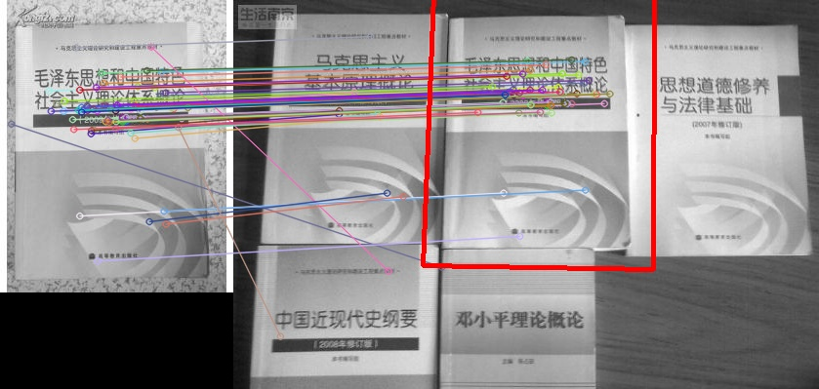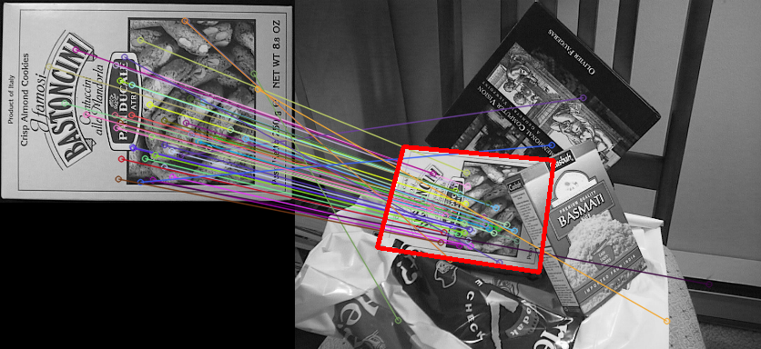

Result
This is my first C++ program,and this program have a good performance in matching object in scene image.But there are still some mistakes in matching key points. And there are a lot work we can do to minish the runtime in order to realize real-time processing.

