刘畅 21140211043
Part I: Extract image information and segment the input image to superpixel
The image contains three channels(R,G,B). In the color image, each pixel is has the information from the three channels,which ranges from 0 to 255. In order to simplify the problem, we compress each channel to 0~16.
We store the RGB information in a m*n matrix. R channel goes to hundreds, G channel goes to the tens, and B channel goes to the ones. So the m*n matrix ranges from 0 to 4096. The size of the matrix is same with the image.
In my assignment, the result can be shown as below.
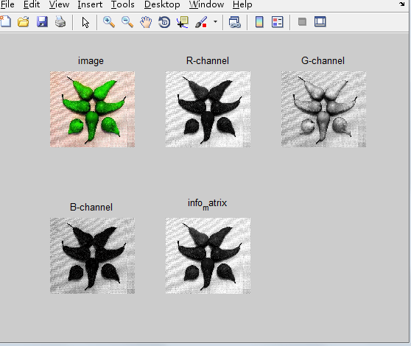

Then, we chose SLIC algorithm to segment the image to superpixels. The result is stored in M_segments matrix.

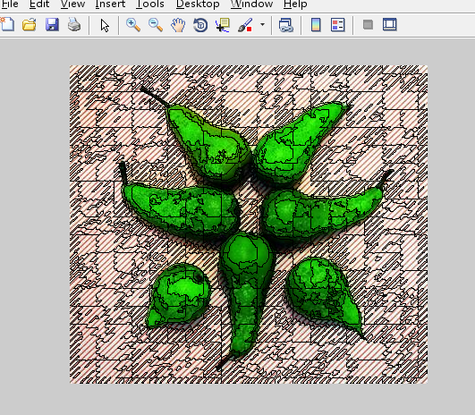
Part II: Create the histogram for each channel and compute superpixel feature contrast
The parameter of each superpixel is stored in a one-dimensional vector to do the following analysis.
After we got the vector, we compute the contrast of every superpixel. Then, transform the superpixel global contrast to pixel contrast.
Part III: Enhance the result
Multiply the initial saliency map with center prior.
My work is not efficient enough. But we can see the shadowy outline of the original image.
