Experiment of assignment3
Liu Xuefei
- Grab cut
Step1 step2.
In this step, I use image signature to get the saliency maps of the input images. The saliency map is obtained by image signature and the matlab code of SIG single, signatureSal and default signature param are used. Firstly, I create a file to save saliency maps using function mkdir. Then I process all of the images which is given in the assignment. When I process each image, I read in one image and use function default_signature_param() to generate default parameters.Then I use function signatureSal() to get the initial saliency map. After that, I use imresize() to ensure that the map have the same size as the input image.When I get the saliency map, I use two for loops and one if...else to get the binary images of seven thresholds as the input of the next step and save this image.
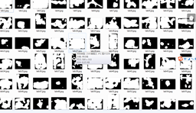
Step3step4
In this step, I use opencv to process images. Firstly,I use thresholding to transform saliency map to binary image and draw a rectangle according to the binary image. The size of rectangle is also adjustable. I use a for loop to process images of seven thresholds and use two strings to store the path of origin images and saliency maps. Then I use the function GetListFiles of class Directory to get all of the images stored in these paths and store their information in two string vectors. Thirdly, I use one for loop to process images of each threshold with the iterations of 3,4,5 and 6 in Grab Cut. I read in the origin image and saliency map and their length and height. Then I improve the program of drawing rectangle through find the edges from four directions in order to void traversing all the pixels and reducing the processing time. After that, I use the program which is given to proceed Grab Cut ,save the final map and show which step is proceeding in the screen.
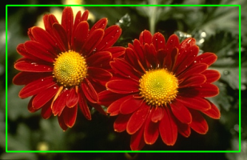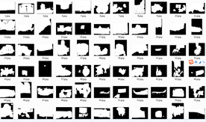

Step5
Input: Segmentation result(m* n* 3 matrix)and groundtruth (m* n matrix) from dataset.
Output :A figure that indicates evaluation results (The horizontal axis represents the parameter,the vertical axis represents the evaluation results.)
I can draw PRF(Precision Recall F-measure)bar graph to evaluate.The evaluation is shown following.
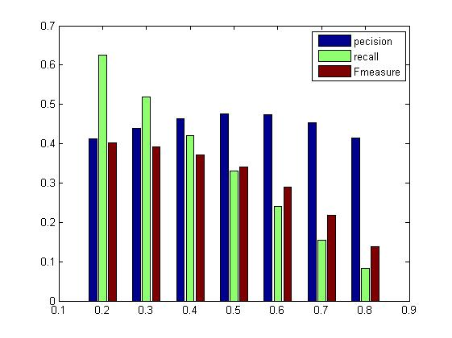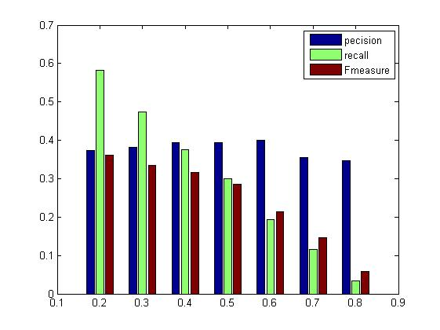
Evaluation chart when iteration=3\4

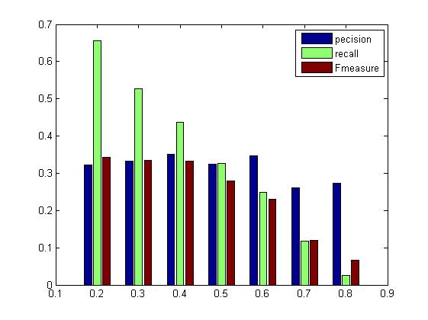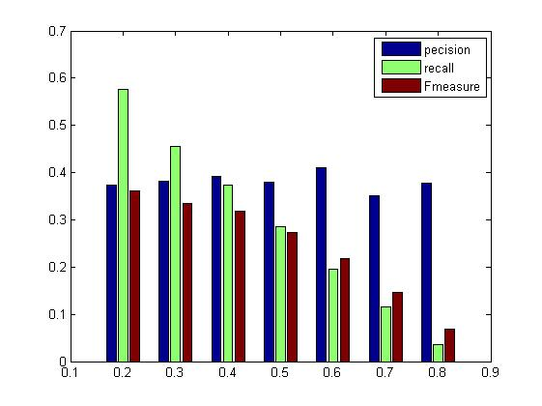
Evaluation chart when iteration=5\6

Mean Shift

Step1step2
Firstly, I use two matrix to store the parameters of means shift and use one for loop to get the outcome with different parameters. And in the first loop, I fix hr as 10 and changes hs from 10 to 100; in the second loop, I fix hs as 40 and changes hr from 10 to 100. Without that I use function dir get all the images and mat files under two paths and store their information in Files1 and Files2. And I use one for loop to get the outcome of each images with every parameters. Then I use function processSuperpixelImage() to get the label maps and save them.

Step3
Firstly, I choose three string to store the paths of two segmentation output with different parameters and the path of groundTruth. Then I use one for loop to get the influence of hs and hr to the outcome of segmentation and use function EvaluationBatch to get the evaluation.
