Report on the assignment3

Pengyu Wang

Grab Cut

Step1&2 Input image and use image signature
Program

Imgnum=850;
mkdir(strcat('E:/class/computer vision/assignment3/signmap',num2str(threshold)));
for num=1:Imgnum
image=imread(sprintf('E:/class/computer vision/assignment3/PASCAL/%d.jpg',num));
param=default_signature_param();
signmaplab=signatureSal(image,param);
signmaplab=imresize(signmaplab,[size(image,1) size(image,2)]);
for i=1:size(signmaplab,1)
for j=1:size(signmaplab,2)
if signmaplab(i,j)>=threshold
signmaplab(i,j)=255;
else
signmaplab(i,j)=0;
end
end
end
imwrite(signmaplab,strcat('E:/class/computer vision/assignment3/signmap',num2str(threshold),'/lab',[num2str(num),'.jpg']));
end

Explanation
In this step, I use matlab to get the saliency maps of the input images. Firstly, I create a file to save saliency maps using function mkdir. Then I use a for loop to batch process all of the images which is given in the assignment. When I process each image, I read in one image and use function default_signature_param() to generate default parameters.Then I use function signatureSal() to get the initial saliency map. After that, I use imresize() to ensure that the map have the same size as the input image.When I get the saliency map, I use two for loops and one if...else to get the binary images of seven thresholds as the input of the next step and save this image.
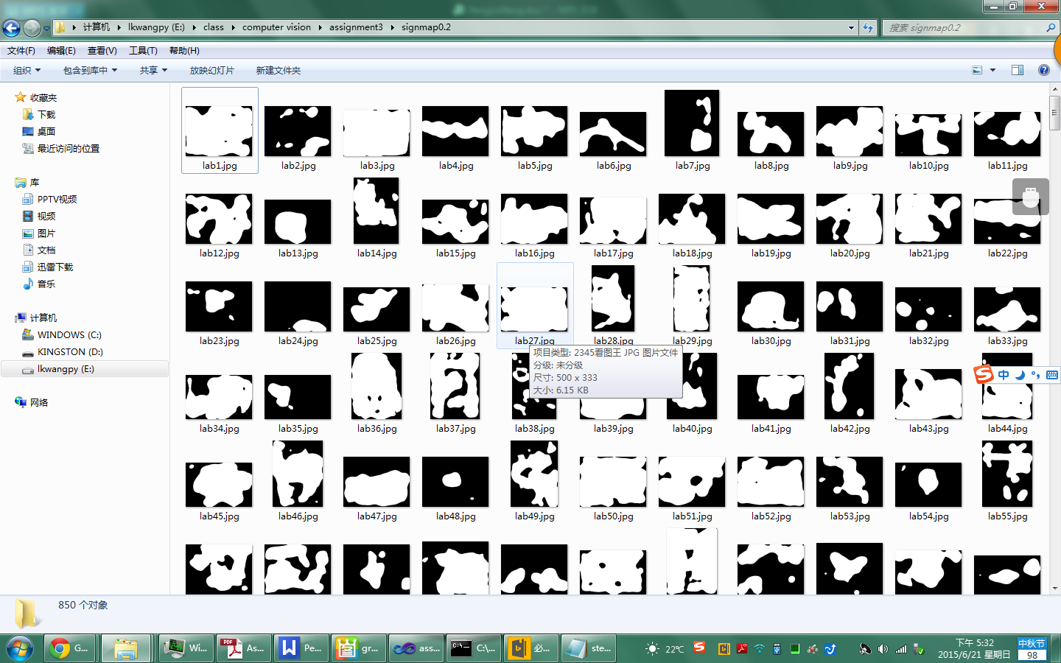

Step3&4 Draw the Rectangle&Implement Grab Cut
Program
#include <iostream>
#include <cv.hpp>
#include <opencv2/highgui/highgui.hpp>
#include <opencv2/core/core.hpp>
#include<string>
#include<contrib/contrib.hpp>

using namespace std;
using namespace cv;

int main()
{
for(int threshold=2;threshold<9;threshold++)
{

Directory dir1,dir2;
char threch[1];
itoa(threshold,threch,10);
string threst=threch;
string path1="E:/class/computer vision/assignment3/PASCAL";
string path2="E:/class/computer vision/assignment3/signmap0."+threst;
string exten="*.jpg";
string extenout=".jpg";
string filenames3;
bool addPath1 = true;
string output="E:/output5/0."+threst+"/";
char numch[1];

vector<string> filenames1 = dir1.GetListFiles(path1, exten, addPath1);
vector<string> filenames2 = dir2.GetListFiles(path2, exten, addPath1);

for(int n=0;n<filenames1.size();n++)
{
itoa(n+1,numch,10);
filenames3=output+numch+extenout;

Mat mOriginImg=imread(filenames1[n],1); //输入原始图像
Mat mSaMap=imread(filenames2[n],0); //输入saliency map的二值图像

const int nRow=mOriginImg.rows;
const int nCol=mOriginImg.cols;

//~~~~~~~~~~~~~~~~Draw Rectangle~~~~~~~~~~~~~~~~~~~~//
int i=0,j=0,c=0;
int nRowMin=0, nRowMax=0, nColMin=0, nColMax=0;

for(i=0;i<nRow;i++)
{
for(j=0;j<nCol;j++)
{
if(mSaMap.at<uchar>(i,j)==255)
{
nColMin=j;
nColMax=j;
nRowMin=i;
nRowMax=i;
c=1;
break;
}
}
if(c==1)
break;
}
for(c=0,j=0;j<nColMin;j++)
{
for(i=nRowMin;i<nRow;i++)
{
if(mSaMap.at<uchar>(i,j)==255)
{
nRowMax=i;
nColMin=j;
c=1;
break;
}
}
if(c==1)
break;
}
for(c=0,i=nRow-1;i>nRowMax;i--)
{
for(j=nColMin;j<nCol;j++)
{
if(mSaMap.at<uchar>(i,j)==255)
{
nRowMax=i;
if(j>nColMax)
nColMax=j;
c=1;
break;
}
}
if(c==1)
break;
}
for(c=0,j=nCol-1;j>nColMax;j--)
{
for(i=nRowMin;i<nRowMax;i++)
{
if(mSaMap.at<uchar>(i,j)==255)
{
nColMax=j;
c=1;
break;
}
}
if(c==1)
break;
}

Mat mDrawRec=mOriginImg.clone();
Point2f pRecLeftUp,pRecRightDown;
pRecLeftUp=cvPoint(nColMin,nRowMin);
pRecRightDown=cvPoint(nColMax,nRowMax);
rectangle( mDrawRec, pRecLeftUp,pRecRightDown, Scalar(0, 255, 0), 2);

//~~~~~~~~~~~~~~~~Implement grab cut~~~~~~~~~~~~~~~~~~~~//
Rect rect(pRecLeftUp,pRecRightDown);
Mat OutMask(mOriginImg.size(), CV_8UC1);
Mat BgdModel, FgdModel;

int nIteration=5;
Mat mask;
Mat obj;
bool isInitialized=false;

for(i=0; i<nIteration; i++)
{
if(!isInitialized)
{
grabCut(mOriginImg, OutMask, rect, BgdModel, FgdModel, 1, GC_INIT_WITH_RECT);
isInitialized=true;
}
else
{
grabCut(mOriginImg, OutMask, rect, BgdModel, FgdModel, 1);
}
}
compare(OutMask, GC_PR_FGD, mask, CMP_EQ);
mOriginImg.copyTo(obj, mask);

//~~~~~~~~~~~~~~~~Show segmentation result~~~~~~~~~~~~~~~~~~~~//
Mat mSegBinary=obj.clone();
cvtColor(mSegBinary,mSegBinary,CV_RGB2GRAY);
for(i=0;i<nRow;i++)
for(j=0;j<nCol;j++)
{
if(mSegBinary.at<uchar>(i,j)>0)
mSegBinary.at<uchar>(i,j)=255;
}

imwrite(filenames3,mSegBinary);
cout<<n+1<<endl;
}

}
return 0;
}
Explanation
In this step, I use opencv to process images. Firstly, I use a for loop to process images of seven thresholds and use two strings to store the path of origin images and saliency maps. Then I use the function GetListFiles of class Directory to get all of the images stored in these paths and store their information in two string vectors. Thirdly, I use one for loop to process images of each threshold with the iterations of 3,4,5 and 6 in Grab Cut. I read in the origin image and saliency map and their length and height. Then I improve the program of drawing rectangle through find the edges from four directions in order to void traversing all the pixels and reducing the processing time. After that, I use the program which is given to proceed Grab Cut ,save the final map and show which step is proceeding in the screen.
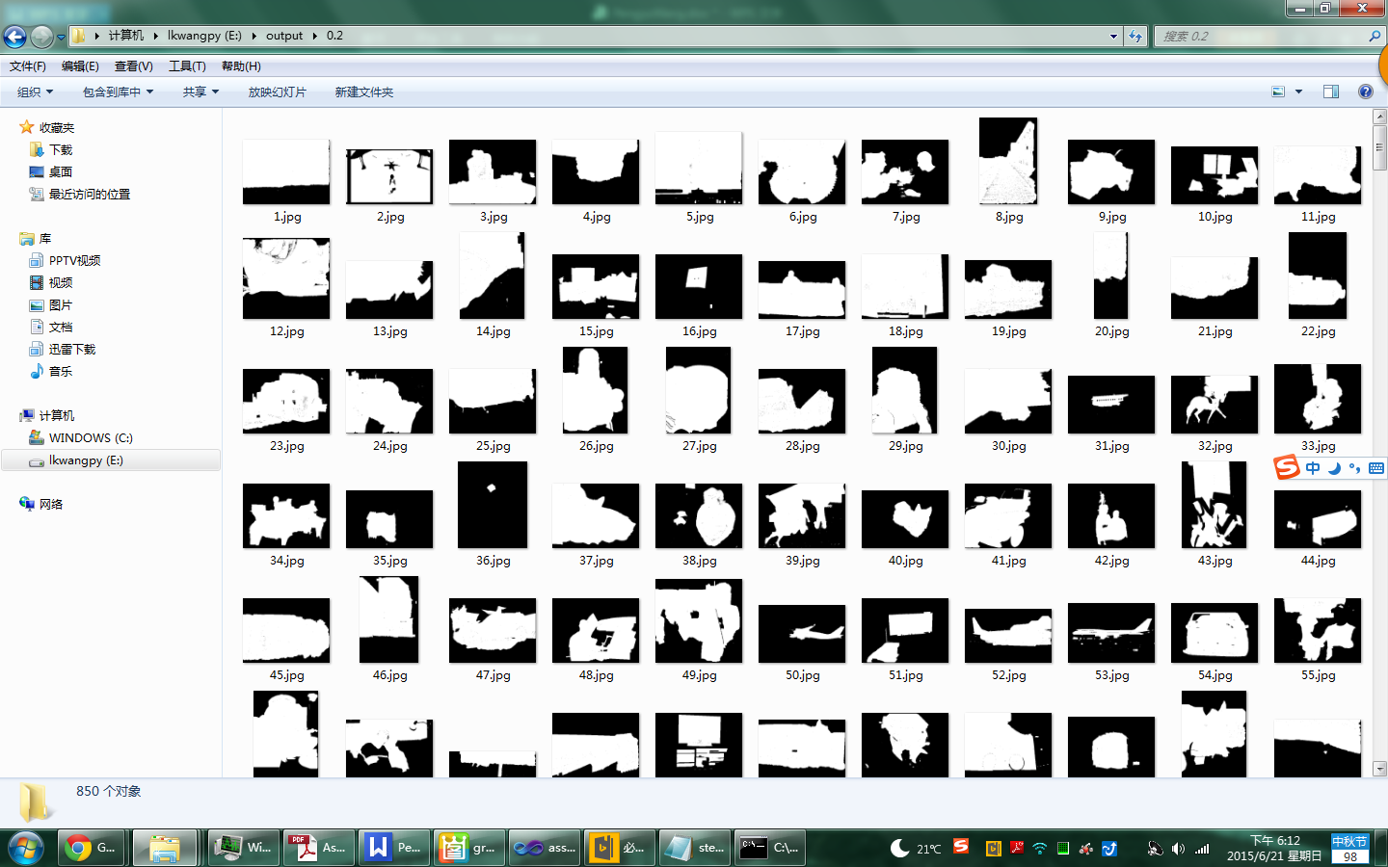

Step5 Evaluate segmentation result
Program
clc;
clear all;
evalu=zeros(7,3);
i=1;
for threshold=0.2:0.1:0.8
for num=1:850
image1=imread(sprintf('E:/class/computer vision/assignment3/PASCAL_GT/%d.png',num));
image1=im2double(image1);
image2=im2double(imread(sprintf('E:/output/%2.1f/%d.jpg',threshold,num)));
[precision recall Fmeasure]=prfCount(image1,image2);
evalu(i,:)=evalu(i,:)+[precision recall Fmeasure];
end
i=i+1;
end

avrevalu=evalu/850;
x=[0.2,0.3,0.4,0.5,0.6,0.7,0.8];
bar(x,avrevalu,'group');legend('pecision','recall','Fmeasure');
Explanation
In this step, I use matlab to evaluate the outcome of Grab Cut. Firstly, I generate a matrix to store the evaluation index of each threshold. Then I use two for loops to compute these indexes. I read in each final map and the groundtruth and change their types to double. After that, I use prfCount() to computer three indexes of each image and add them into the matrix. Then I computer the average indexes of each threshold and iteration and draw the bar charts.
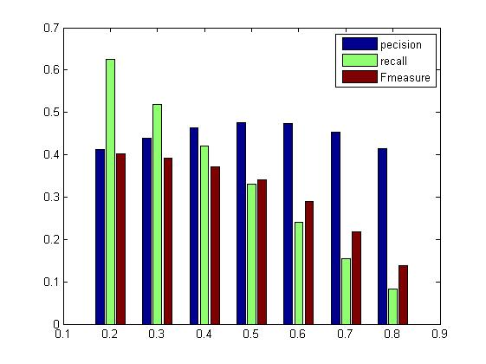

Evaluation chart when iteration=3

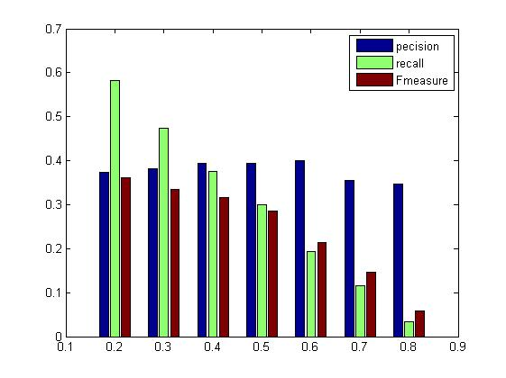
Evaluation chart when iteration=4

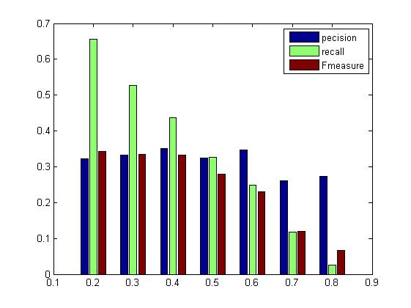
Evaluation chart when iteration=5
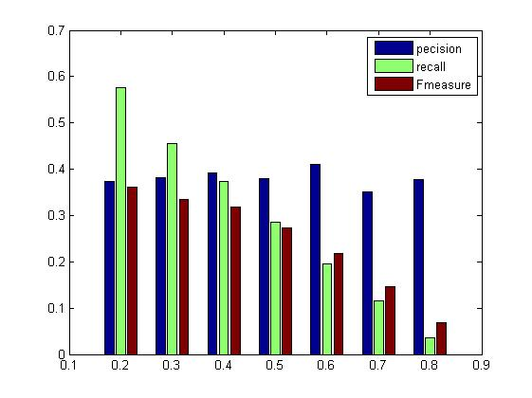
Evaluation chart when iteration=6

Evaluation
The indexes of evaluation are precision, recall and Fmeasure. The larger indexes means that the outcomes are better. From the charts we can get the conclusion that if we proceed more iterations, we will get better segmentation. And when we set the threshold as 0.2 or 0.3, we will get the best segmentation, and the outcomes will become worse if we increase the threshold. Because of the limitation of time, I just choose fifty images as input when the iteration is 4,5 and 6, and from the charts we can see that if we take fewer images as input, the outcome is worse.

Mean Shift

Step1&2 Input image&Segment via mean shift
Program
param1=[10 10;10 20;10 30;10 40;10 50;10 60;10 70;10 80;10 90;10 100];
param2=[10 40;20 40;30 40;40 40;50 40;60 40;70 40;80 40;90 40;100 40];
Files1=dir('E:/class/computer vision/assignment3meanshift/input/*.jpg');
LengthFiles1=length(Files1);
Files2=dir('E:/class/computer vision/assignment3meanshift/groundTruth/*.mat');
for n=1:2
if n==1
param=param1;
else
param=param2;
end
for numpa=1:10
for i=1:LengthFiles1
Img1=imread(strcat('E:/class/computer vision/assignment3meanshift/input/',Files1(i).name));
Output=zeros(size(Img1));
[Output,m]=meanShiftPixCluster(Img1,param(numpa,1),param(numpa,2));
Lable=processSuperpixelImage(Output);
save(sprintf('E:/class/computer vision/assignment3meanshift/output/%d/%d/%i.mat',n,numpa,Files(i)),'Lable');
end
end
end

Explanation
Firstly, I use two matrix to store the parameters of means shift and use one for loop to get the outcome with different parameters. And in the first loop, I fix hr as 10 and changes hs from 10 to 100; in the second loop, I fix hs as 40 and changes hr from 10 to 100. Without that I use function dir get all the images and mat files under two paths and store their information in Files1 and Files2. And I use one for loop to get the outcome of each images with every parameters. Then I use function processSuperpixelImage() to get the label maps and save them.

Step3 Evaluate segmentation result with groundtruth
Program
Path1='E:/class/computer vision/assignment3meanshift/output/1';
Path2='E:/class/computer vision/assignment3meanshift/output/2';
benchPath = 'E:/class/computer vision/assignment3meanshift/groundTruth';
for n=1:2
if(n==1)
testpath=Path1;
else
testpath=Path2;
end
EvaluationBatch(benchpath,testpath);
End
Explanation
Firstly, I choose three string to store the paths of two segmentation output with different parameters and the path of groundTruth. Then I use one for loop to get the influence of hs and hr to the outcome of segmentation and use function EvaluationBatch to get the evaluation.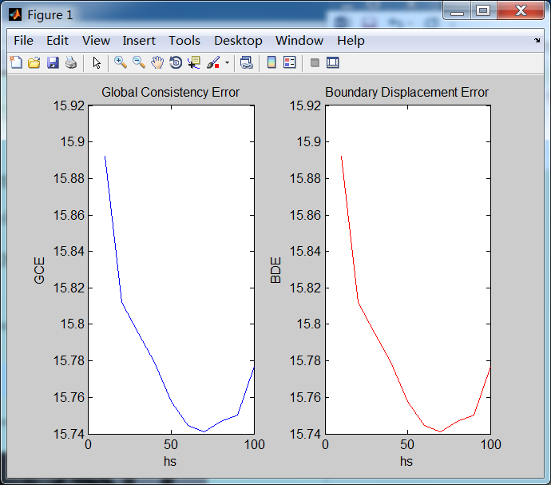
Evaluation with same hr and different hs
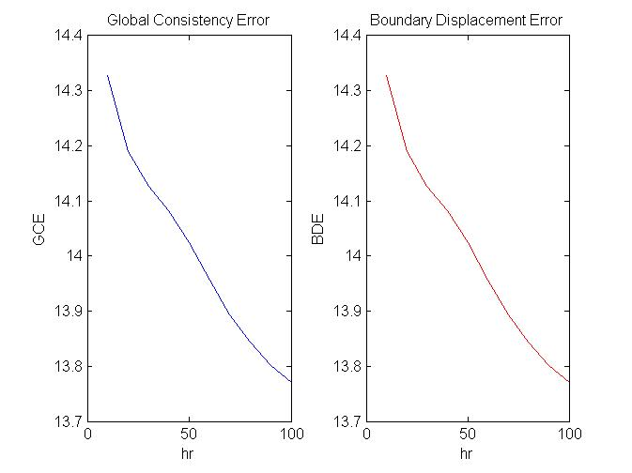
Evaluation with same hs and different hr

Evaluation
We choose GOE and BDE to evaluate the outcome of mean shift. And the smaller indexes mean the better outcome. From the charts we can get that: we will get the best outcome when the hs is about 70,and when hs is under 70,we will have the better outcome if hs is larger, and if hs is larger than 70, the outcome will become worse. As for the the bandwidth of feature kernel, we will get the better outcome if hr is larger when hr is under 100.

