探伤实训装置JSON结构说明

概述
为了方便技术交流沟通，并将不同型号和版本的超声波探伤仪生成的B显数据转换成统一的数据结构，遵循以下原则设计此数据交换格式：
- 不对现场仪器进行升级改造，只对现有已经在铁路应用的数据进行转换；
- 可读性强，采用标准专业词语命名和十进制数值表达各种参数；
- 具有扩展性，为未来可能出现的新信息预留位置；
- 尽量减小输出数据量的大小。

数据交换格式
数据交换的代码格式采用JSON格式。JSON的全称为JavaScript Object Notation，是基于ECMAScript（欧洲计算机协会制定的js规范）的一个子集，采用完全独立于语言的文本格式，但是也使用了类似于C语言家族的习惯（包括C, C++, C#,Java,JavaScript,Perl,Python等），在各种开发工具软件中都有类库可以调用。这些特性使JSON易于人阅读和编写，同时也易于机器解析和生成，成为理想的数据交换语言。
本系统JSON结构为一个list型数组，数组中每一个JSON对象代表每一个编码脉冲的数据。
说明：
- 每个编码中一定含有E即编码脉冲序号。
- 每个编码中最多含9个通道数据，编号从0开始，依次对应ABCDEFGHI。
- 每个编码中含有B1（第一B显点）。当第二B显点有数据时含B2
- 作业参数和控制参数，有变化时才会记录
- 关于x、y坐标的说明：x、y坐标是相对于本次脉冲反射点位置的水平和垂直偏移量。
每种数据类型具体的JSON表示方法详见事例部分。

间隔编码
B显数据是探伤仪移动等距离间隔生成的。此间隔对应《双轨式钢轨超声波探伤仪暂行技术条件》中，6.4.6要求的“应保证在最高持续检测速度下，每个探头（晶片）超声脉冲反射距离间隔不大于3mm”，和7.3.5要求的“在15km/h最高检测速度下，每个探头（晶片）超声脉冲反射距离间隔不大于3mm，即在双轨探伤仪沿钢轨纵向移动3mm的时间内，超声仪器所有通道均至少工作一次。”

对每次间隔进行编码，再将其他事件与一系列间隔编码根据先后顺序记录，是整个交换文件的总体结构，示意图如下：
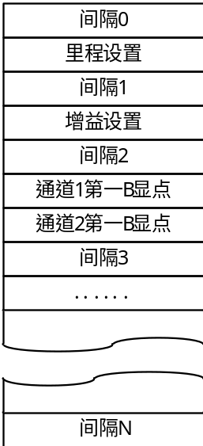
图2-1 文件结构示意图
一次间隔编码事件包括键名E和编码。一个文件起始编码为1，之后B显生成都计数累积。
例如第100个间隔编码，用JSON格式表示为：
{"E":100}

第一B显点
（解释：因为B显图像是由A显信号转换而来，并且探伤采用反射式报警，所以A显信号分析多针对超过报警阈值的第一根最高波，只有在孔裂等端角反射的时候才分析双波信号，所以对于一条A显信号最多只分析两根超过报警阈值的信号，与之对应的B显点最多记录两个。）
B显图像是由A显波形转换而来，A显波形在大闸门内超过大闸门阈值（反射报警阈值）的信号视为反射报警信号。在A显中，从左至右第一个反射报警信号的最高点或者其上升沿与阈值线交点对应的B显点定义为第一B显点，如下图所示。由于报警信号上升沿的陡峭特性，可将最高点深度等同于上升沿与阈值线交点深度。如果报警信号是饱和状态，则其最高点深度为达到饱和状态的第一个点的深度。
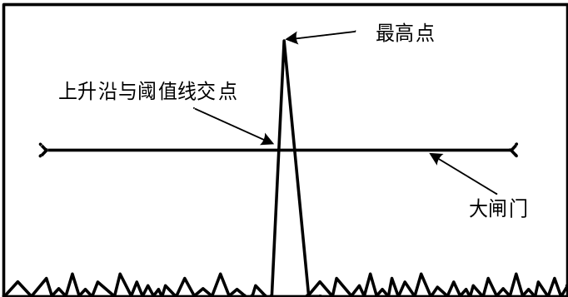
图2-2 B显点对应A显波形位置
以报警信号最高点为例，一次第一B显点事件对应一个B显点，具体包括键名B1、通道号、深度值、幅度值。
由于每个厂家对通道的编号方法不同，在此交换格式中，将通道编号与角度、射向、股别（车别）配置挂钩，通道编号规则为如下表：
表2-1通道号基本配置
通道编号 | 默认角度 | 对应通道
0 | 70° | A
1 | 70° | B
2 | 70° | C
3 | 70° | D
4 | 70° | E
5 | 70° | F
6 | 37° | G
7 | 37° | H
8 | 0° | I
深度值、幅度值如下图所示。深度值数值范围为0~500，单位为mm。幅度值范围为0~100，单位%。
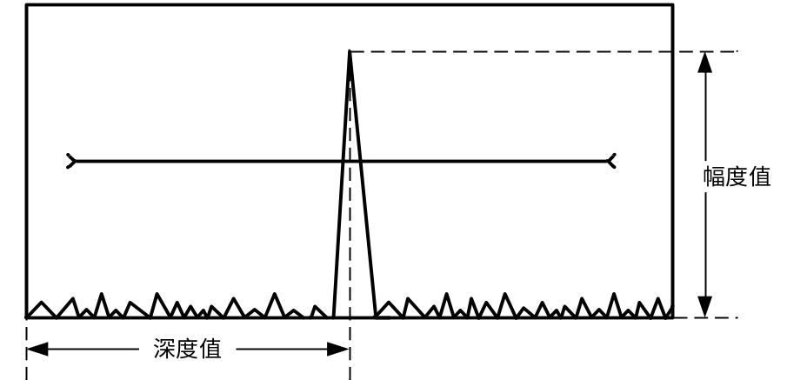
图2-3 A显波形最高点示意图
例如前外70°通道存在一个深度为62mm幅度为100%的报警信号，用JSON格式表示为：
{"B1":[1.0,62.0,100.0,16.61,14.57]}

第二B显点
有些特殊伤损会在A显中产生双波报警信号，例如螺孔孔裂，此时如果将第二根回波也转换成B显，会增强伤损显示效果，因此有必要记录下来同一个间隔编码下的第二个报警信号。不同报警信号区分标准是之间波形低于穿透报警阈值，如下图所示。
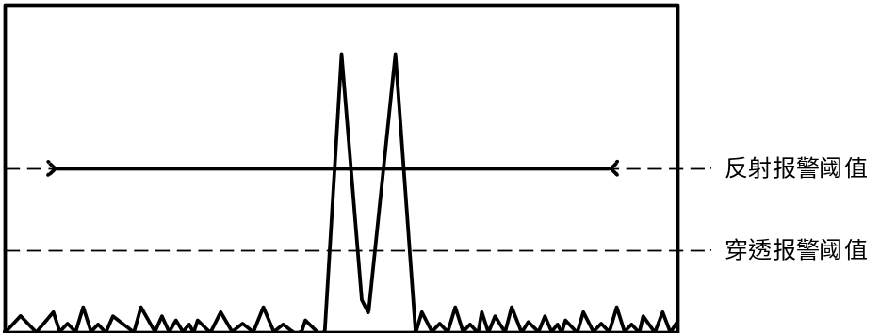
图2-4 双波报警信号示意图
第二报警信号对应的B显点定义为第二B显点，其深度值与幅度值分析方法同第一B显点。深度值数值范围为0~1000，单位为mm。幅度值范围为0~100，单位为%，如果原始记录中无幅度值，则视信号幅度为100%。
例如前直37°通道存在深度为83mm幅度为100%的第一报警信号，同时存在深度为150mm幅度100%的第二报警信号，用JSON格式表示为：
{"B1":[6.0,83.0,100.0,133.73,80.95]，"B2":[6.0,150.0,100.0,148.85,146.3]}
如无第二报警信号，则不转换此事件。

JSON格式说明
表2-2 JSON格式说明
键值 | 类型 | 实例 | 说明
E | int | 1 | --间隔编码事件。相当于第几个编码脉冲，和JSON在数组中的索引对应
RailType | String | 60 | 轨型
RailHgt | int | 176 | 轨高（单位mm）
RailBoltHgt | int | 79 | 螺孔高（单位mm）
RailHeadHgt | int | 46 | 轨头高（单位mm）
Operator | String | 001 | 执机人
DeviceNum | String | 10000 | 机号
DeviceType | String | 8C | 设备类型
Date | String | 2024-04-01 | 日期（YYYY-MM-dd）
Time | String | 10:20:10 | 时间（HH:mm:ss）
Location | String | 1km2m | 实际里程值
Count | String | 增 | 里程方向（增或减）
Line | String | 001 | 线号
LineType | String | 正线 | 线别
UpDown | String | 上行 | 上行下行
LeftRight | String | 左股 | 股别（左股或右股）
SiteNum | String | 00 | 场号
TrackNum | String | 000 | 股号
RailNum | String | 000 | 铁号
Speed | float | 0.7 | 速度（单位km/h）
Suppress | String | 开 | 抑制（开或关）
BackAlarm | String | 开 | 反射报警（开或关）
PassAlarm | String | 关 | 穿透报警（开或关）
Battery | short | 23.0 | 电池电压（单位V）
GPS | string | A,4717.11437,N,00833.91522,E | gps坐标.采用NMGA协议RMC语句中的字段2、3、4、5、6
TrolleyType | string | 右手单轨仪 | 车别（左或右）
Mark | String | 岔号，岔号7，无 | 标注
Back | short | 1093 | 倒车距离单位mm
AutoMark | String | 关机 | 自动标注
Sensitivity | float[] | [0,43] | 灵敏度，2个一组依次是通道号、值
GateStart | int[] | [0,10，1,10] | 反射报警闸门前沿，2个一组依次是通道号、值
GateEnd | int[] | [0,191,1,191] | 反射报警闸门后沿，2个一组依次是通道号、值
GateLevel | int[] | [1,50] | 反射报警阈值，2个一组依次是通道号、值
RailBaseStart | int[] | [8,128] | 轨底闸门前沿，2个一组依次是通道号、值
RailBaseEnd | int[] | [8,155] | 轨底闸门后沿，2个一组依次是通道号、值
SignalLossLevel | int[] | [1,10] | 穿透报警阈值，2个一组依次是通道号、值
BoltHoleStart | int[] | [6,64] | 螺孔闸门前沿，2个一组依次是通道号、值
BoltHoleEnd | int[] | [6,91] | 螺孔闸门后沿，2个一组依次是通道号、值
TestRange | int[] | [0,251,2,251] | 探测范围，2个一组依次是通道号、值
ZeroDelay | int[] | [0,78,1,78] | 零点延迟，2个一组依次是通道号、值
BeamAngle | int[] | [0,68] | 角度，2个一组依次是通道号、值
BeamWay | int[] | [0,-1,1,1,1,1,2,-1,-1,3,1,-1,4,-1,0,5,1,0,6,-1,0,7,1,0,8,0,0] | 射向，3个一组依次是通道号（-1后、0直、1前）、（-1左、0正、1右）
BeamOffset | int[] | [0,-4] | 拼孔，2个一组依次是通道号、值
B1 | float[] | [6.0,83.0,100.0,133.73,80.95] | 第一B显点，5个为一组，依次是通道号、深度、幅度、x坐标、y坐标（注意x坐标是当前编码的x轴偏移量。不是实际要显示的x轴坐标）
B2 | float[] | [6.0,150.0,100.0,148.85,146.3] | 第二B显点，5个为一组，依次是通道号、深度、幅度、x坐标、y坐标（注意x坐标是当前编码的x轴偏移量。不是实际要显示的x轴坐标）

JSON样例

样例一
{
"E":1,--间隔编码事件。相当于第几个编码脉冲，和JSON在数组中的索引对应
"RailType":“60”（轨型60）
"RailHgt":176,（轨高176mm）
"RailBoltHgt":79,（螺孔高79mm）
"RailHeadHgt":40,（轨头高40mm）
"Operator":“001”,（执机人001）
"DeviceNum":“10000”,（机号10000）
"DeviceType":“8C”,（设备类型8C）
"Date":“2024-01-01”,（日期2024-01-01）
"Time":“10:20:10”,（时间10:20:10）
"Location":“1km2m”,（里程1km2m）
"Count":“增”,（里程方向是增）
"Line":“001”,（线号001）
"LineType":“正线”,（线别是正线）
"UpDown":“下行”,（行别是下行）
"LeftRight":“左股”,（股别是左股）
"SiteNum":“02”,（场号是02）
"TrackNum":“050”,（股号是050）
"RailNum":“02”,（铁号是02）
"Speed":0.7,（速度是0.7km/h）
"Suppress":“开”,（抑制状态是开）
"BackAlarm":“开”,（报警声音开）
"Battery":23,（表示电池电量23V）
"GPS":“A,4717.11437,N,00833.91522,E”,（gps坐标4717.11437,N,00833.91522,E）
"TrolleyType":“右手单轨仪”,（单轨右手机）
"Mark":“岔号,岔号7,无”,（标记岔号7）
"Back":1093,（倒车1093mm）
"AutoMark":“关机”,（关机）
"Sensitivity":[0.0,43.0],（A通道增益43dB）
"GateStart":[0,10,1,10],（反射报警闸门A通道、B通道前沿分别是10、10）
"GateEnd":[0,191,1,191],（反射报警闸门A通道、B通道后沿分别是191、191）
"GateLevel":[1,50],（B通道反射报警阈值50%）
"RailBaseStart":[8,128],（I通道轨底闸门前沿是128）
"RailBaseEnd":[8,155],（I通道轨底闸门后沿是155）
"SignalLossLevel":[1,10],（B通道穿透报警阈值10%）
"BoltHoleStart":[6,64],（G通道螺孔闸门前沿是64）
"BoltHoleEnd":[6,91],（G通道螺孔闸门后沿是91）
"TestRange":[0,251,2,251],（A、C通道探测范围分别是251、251）
"ZeroDelay":[0,78,1,78],（A、B通道零点延迟分别是78、78）
"BeamAngle":[0,68],（A通道角度是68°）
"BeamWay":[0,-1,1,1,1,1,2,-1,-1,3,1,-1,4,-1,0,5,1,0,6,-1,0,7,1,0,8,0,0],（各通道射向分别是A后右，B前右，C后左，D前左，E后直，F前直，G后直，H前直，I直直）
"BeamOffset":[0,-4],（A通道拼孔值-4）
"B1":[0.0,62.0,100.0,16.61,14.57],（A通道第一B显点:深度62mm、幅度100%、X轴16.61、Y轴14.57）
"B2":[6.0,150.0,100.0,148.85,146.3],（G通道：深度150mm、幅度100、X轴148.85、Y轴146.3）
}

样例二
[{"E":2707,
"RailType":"60",
"RailHgt":176,
"RailBoltHgt":79,
"RailHeadHgt":46,
"Operator":"120",
"DeviceNum":"18082",
"DeviceType":"8C",
"Date":"2024-1-15",
"Time":"10:38:28",
"Location":"0km5m",
"Count":"增",
"Line":"001",
"LineType":"正线",
"UpDown":"上行",
"LeftRight":"左股",
"SiteNum":"00",
"TrackNum":"000",
"RailNum":"000",
"Speed":0.0,
"Suppress":"关",
"BackAlarm":"开",
"PassAlarm":"开",
"Battery":"23",
"GPS":"V,00.0,N,00.0,W",
"TrolleyType":"左手单轨仪",
"Sensitivity":{"0":41.0,"1":40.0,"2":41.0,"3":40.0,"4":44.0,"5":44.0,"6":44.0,"7":44.0,"8":49.0},
"GateStart":{"0":10,"1":10,"2":10,"3":10,"4":10,"5":10,"6":10,"7":10,"8":10},
"GateEnd":{"0":191,"1":191,"2":191,"3":191,"4":134,"5":134,"6":191,"7":192,"8":155},
"GateLevel":{"8":50},
"RailBaseStart":{"8":128},
"RailBaseEnd":{"8":155},
"SignalLossLevel":{"8":10},
"BoltHoleStart":{"6":64,"7":64,"8":55},
"BoltHoleEnd":{"6":91,"7":91,"8":58},
"TestRange":{"0":251,"1":251,"2":251,"3":251,"4":251,"5":251,"6":251,"7":251,"8":248},
"ZeroDelay":{"0":78,"1":78,"2":78,"3":78,"4":78,"5":78,"6":46,"7":46,"8":100},
"BeamAngle":{"0":68,"1":68,"2":68,"3":68,"4":68,"5":68,"6":39,"7":39,"8":0},
"BeamWay":{"0":[-1,1],"1":[1,1],"2":[-1,-1],"3":[1,-1],"4":[-1,0],"5":[1,0],"6":[-1,0],"7":[1,0],"8":[0,0]},
"BeamOffset":{"0":-4,"1":98,"2":137,"3":246,"4":5,"5":-18,"6":115,"7":273,"8":257},
"AutoMark":"开机",
"B1":[3.0,64.0,100.0,224.72,15.04,4.0,127.0,100.0,47.22,59.71,8.0,176.0,100.0,257.0,176.0]},
{"E":2708,"B1":[4.0,125.0,100.0,46.56,58.77,8.0,176.0,100.0,257.0,176.0]},
{"E":2709,"B1":[4.0,122.0,100.0,45.56,57.36,8.0,176.0,100.0,257.0,176.0]},
{"E":2710,"B1":[4.0,120.0,100.0,44.9,56.42,8.0,176.0,100.0,257.0,176.0]},
{"E":2711,"B1":[4.0,117.0,100.0,43.9,55.01,8.0,176.0,100.0,257.0,176.0]},
{"E":2712,"B1":[4.0,114.0,100.0,42.9,53.59,8.0,176.0,100.0,257.0,176.0]},
{"E":2713,"B1":[4.0,111.0,100.0,41.9,52.18,8.0,176.0,100.0,257.0,176.0]},
{"E":2714,"B1":[4.0,108.0,100.0,40.91,50.77,8.0,176.0,100.0,257.0,176.0]},
{"E":2715,"B1":[4.0,106.0,100.0,40.24,49.83,8.0,176.0,100.0,257.0,176.0]},
{"E":2716,"B1":[4.0,103.0,100.0,39.24,48.42,8.0,176.0,100.0,257.0,176.0]},
{"E":2717,"B1":[4.0,101.0,100.0,38.58,47.48,8.0,176.0,100.0,257.0,176.0]},
{"E":2718,"B1":[4.0,98.0,100.0,37.58,46.07,8.0,176.0,100.0,257.0,176.0]},
{"E":2719,"B1":[4.0,95.0,100.0,36.58,44.66,8.0,176.0,100.0,257.0,176.0]},
{"E":2720,"B1":[4.0,92.0,100.0,35.59,43.25,8.0,176.0,100.0,257.0,176.0]},
{"E":2721,"B1":[4.0,90.0,100.0,34.92,42.31,8.0,176.0,100.0,257.0,176.0]},
{"E":2722,"B1":[4.0,87.0,100.0,33.92,40.9,8.0,176.0,100.0,257.0,176.0]},
{"E":2723,"B1":[4.0,117.0,100.0,43.9,55.01,8.0,176.0,100.0,257.0,176.0]},
{"E":2724,"B1":[4.0,115.0,100.0,43.23,54.07,8.0,176.0,100.0,257.0,176.0]},
{"E":2725,"B1":[4.0,112.0,100.0,42.24,52.65,8.0,176.0,100.0,257.0,176.0]},
{"E":2726,"B1":[4.0,110.0,100.0,41.57,51.71,8.0,176.0,100.0,257.0,176.0]},
{"E":2727,"B1":[4.0,107.0,100.0,40.57,50.3,8.0,176.0,100.0,257.0,176.0]},
{"E":2728,"B1":[4.0,104.0,100.0,39.58,48.89,8.0,176.0,100.0,257.0,176.0]},
{"E":2729,"B1":[4.0,101.0,100.0,38.58,47.48,8.0,176.0,100.0,257.0,176.0]},
{"E":2730,"B1":[4.0,99.0,100.0,37.91,46.54,8.0,176.0,100.0,257.0,176.0]},
{"E":2731,"B1":[4.0,96.0,100.0,36.92,45.13,8.0,176.0,100.0,257.0,176.0]},
{"E":2732,"B1":[4.0,94.0,100.0,36.25,44.19,7.0,180.0,100.0,232.38,175.56,8.0,176.0,100.0,257.0,176.0]},
{"E":2733,"B1":[4.0,91.0,100.0,35.25,42.78,7.0,177.0,100.0,233.06,172.63,8.0,176.0,100.0,257.0,176.0]},
{"E":2734,"B1":[4.0,88.0,100.0,34.2600021,41.37,7.0,176.0,100.0,233.28,171.66,8.0,176.0,100.0,257.0,176.0]},
{"E":2735,"B1":[4.0,85.0,100.0,33.2600021,39.96,7.0,174.0,100.0,233.74,169.71,8.0,176.0,100.0,257.0,176.0]},
{"E":2736,"B1":[4.0,83.0,100.0,32.59,39.02,7.0,173.0,100.0,233.959991,168.73,8.0,176.0,100.0,257.0,176.0]},
{"E":2737,"B1":[4.0,80.0,100.0,31.6,37.61,8.0,176.0,100.0,257.0,176.0]},
{"E":2738,"B1":[4.0,78.0,100.0,30.93,36.67,8.0,176.0,100.0,257.0,176.0]},
{"E":2739,"B1":[4.0,75.0,100.0,29.93,35.26,8.0,176.0,100.0,257.0,176.0]},
{"E":2740,"B1":[4.0,73.0,100.0,29.27,34.32,8.0,176.0,100.0,257.0,176.0]},
{"E":2741,"B1":[4.0,70.0,100.0,28.27,32.91,8.0,176.0,100.0,257.0,176.0]},
{"E":2742,"B1":[4.0,68.0,100.0,27.61,31.97,8.0,176.0,100.0,257.0,176.0]},
{"E":2743,"B1":[4.0,65.0,100.0,26.61,30.56,8.0,176.0,100.0,257.0,176.0]},
{"E":2744,"B1":[4.0,63.0,100.0,25.95,29.62,8.0,176.0,100.0,257.0,176.0]},
{"E":2745,"B1":[4.0,60.0,100.0,24.95,28.21,8.0,176.0,100.0,257.0,176.0]},
{"E":2746,"B1":[4.0,57.0,100.0,23.95,26.8,8.0,176.0,100.0,257.0,176.0]},
{"E":2747,"B1":[4.0,55.0,100.0,23.29,25.86,8.0,176.0,100.0,257.0,176.0]},
{"E":2748,"B1":[4.0,52.0,100.0,22.29,24.45,8.0,176.0,100.0,257.0,176.0]},
{"E":2749,"B1":[4.0,50.0,100.0,21.62,23.51,8.0,176.0,100.0,257.0,176.0]},
{"E":2750,"B1":[8.0,176.0,100.0,257.0,176.0]},
{"E":2751,"B1":[8.0,176.0,100.0,257.0,176.0]},
{"E":2752,"RailType":"60",
"RailHgt":176,
"RailBoltHgt":79,
"RailHeadHgt":46,"
Operator":"120",
"DeviceNum":"18082",
"DeviceType":"8C",
"Date":"2024-1-15",
"Time":"10:38:32",
"Location":"0km6m",
"Count":"增",
"Line":"001",
"LineType":"正线",
"UpDown":"上行",
"LeftRight":"左股",
"SiteNum":"00",
"TrackNum":"000",
"RailNum":"000",
"Speed":0.7,
"Suppress":"关",
"BackAlarm":"开",
"PassAlarm":"开",
"Battery":"23",
"GPS":"V,00.0,N,00.0,W",
"TrolleyType":"左手单轨仪"
"Sensitivity":{"0":41.0,"1":40.0,"2":41.0,"3":40.0,"4":44.0,"5":44.0,"6":44.0,"7":44.0,"8":49.0},
"GateStart":{"0":10,"1":10,"2":10,"3":10,"4":10,"5":10,"6":10,"7":10,"8":10},
"GateEnd":{"0":191,"1":191,"2":191,"3":191,"4":134,"5":134,"6":191,"7":192,"8":155},
"GateLevel":{"8":50},
"RailBaseStart":{"8":128},
"RailBaseEnd":{"8":155},
"SignalLossLevel":{"8":10},
"BoltHoleStart":{"6":64,"7":64,"8":55},
"BoltHoleEnd":{"6":91,"7":91,"8":58},
"TestRange":{"0":251,"1":251,"2":251,"3":251,"4":251,"5":251,"6":251,"7":251,"8":248},
"ZeroDelay":{"0":78,"1":78,"2":78,"3":78,"4":78,"5":78,"6":46,"7":46,"8":100},
"BeamAngle":{"0":68,"1":68,"2":68,"3":68,"4":68,"5":68,"6":39,"7":39,"8":0},
"BeamWay":{"0":[-1,1],"1":[1,1],"2":[-1,-1],"3":[1,-1],"4":[-1,0],"5":[1,0],"6":[-1,0],"7":[1,0],"8":[0,0]},
"BeamOffset":{"0":-4,"1":98,"2":137,"3":246,"4":5,"5":-18,"6":115,"7":273,"8":257},
"AutoMark":"开机","B1":[5.0,57.0,100.0,-36.95,26.8,8.0,176.0,100.0,257.0,176.0]},
{"E":2753,"B1":[5.0,59.0,100.0,-37.6200027,27.74,8.0,176.0,100.0,257.0,176.0]},
{"E":2754,"B1":[5.0,61.0,100.0,-38.28,28.68,8.0,176.0,100.0,257.0,176.0]},
{"E":2755,"B1":[3.0,152.0,100.0,195.47,35.73,5.0,64.0,100.0,-39.28,30.09,8.0,176.0,100.0,257.0,176.0]},
{"E":2756,"B1":[3.0,150.0,100.0,196.13,35.26,5.0,66.0,100.0,-39.9400024,31.03,8.0,176.0,100.0,257.0,176.0]},
{"E":2757,"B1":[3.0,147.0,100.0,197.13,34.55,5.0,69.0,100.0,-40.9400024,32.44,8.0,176.0,100.0,257.0,176.0]},
{"E":2758,"B1":[1.0,182.0,100.0,37.49,42.78,3.0,144.0,100.0,198.13,33.85,5.0,72.0,100.0,-41.9400024,33.85,8.0,176.0,100.0,257.0,176.0]},
{"E":2759,"B1":[3.0,142.0,100.0,198.790009,33.38,5.0,74.0,100.0,-42.6,34.79,8.0,176.0,100.0,257.0,176.0]},
{"E":2760,"B1":[3.0,139.0,100.0,199.790009,32.67,5.0,77.0,100.0,-43.6,36.2,8.0,176.0,100.0,257.0,176.0]},
{"E":2761,"B1":[3.0,136.0,100.0,200.790009,31.97,5.0,80.0,100.0,-44.6,37.61,8.0,176.0,100.0,257.0,176.0]},
{"E":2762,"B1":[3.0,134.0,100.0,201.45,31.5,5.0,82.0,100.0,-45.2600021,38.55,8.0,176.0,100.0,257.0,176.0]},
{"E":2763,"B1":[3.0,131.0,100.0,202.45,30.79,5.0,85.0,100.0,-46.2600021,39.96,8.0,176.0,100.0,257.0,176.0]},
{"E":2764,"B1":[3.0,129.0,100.0,203.11,30.32,5.0,87.0,100.0,-46.92,40.9,8.0,176.0,100.0,257.0,176.0]},
{"E":2765,"B1":[3.0,126.0,100.0,204.11,29.62,5.0,90.0,100.0,-47.92,42.31,8.0,176.0,100.0,257.0,176.0]},
{"E":2766,"B1":[3.0,124.0,100.0,204.77,29.15,5.0,93.0,100.0,-48.92,43.72,8.0,176.0,100.0,257.0,176.0]},
{"E":2767,"B1":[3.0,121.0,100.0,205.77,28.44,5.0,95.0,100.0,-49.58,44.66,8.0,176.0,100.0,257.0,176.0]},
{"E":2768,"B1":[3.0,119.0,100.0,206.44,27.97,5.0,98.0,100.0,-50.58,46.07,8.0,176.0,100.0,257.0,176.0]},
{"E":2769,"B1":[3.0,117.0,100.0,207.1,27.5,5.0,100.0,100.0,-51.25,47.01,8.0,176.0,100.0,257.0,176.0]},
{"E":2770,"B1":[3.0,115.0,100.0,207.77,27.03,4.0,131.0,100.0,48.55,61.59,5.0,103.0,100.0,-52.24,48.42,8.0,176.0,100.0,257.0,176.0]},
{"E":2771,"B1":[3.0,112.0,100.0,208.76,26.33,4.0,129.0,100.0,47.89,60.65,5.0,105.0,100.0,-52.91,49.36,8.0,176.0,100.0,257.0,176.0]},
{"E":2772,"B1":[3.0,110.0,100.0,209.43,25.86,4.0,127.0,100.0,47.22,59.71,5.0,108.0,100.0,-53.91,50.77,8.0,176.0,100.0,257.0,176.0]},
{"E":2773,"B1":[3.0,108.0,100.0,210.09,25.39,5.0,110.0,100.0,-54.57,51.71,8.0,176.0,100.0,257.0,176.0]},
{"E":2774,"B1":[3.0,106.0,100.0,210.76,24.92,5.0,113.0,100.0,-55.57,53.12,8.0,176.0,100.0,257.0,176.0]},

