* 算法
  + 记号
    - 
    - 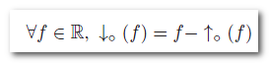
  + 表示方式
    - 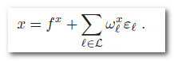
  + 加法
    - 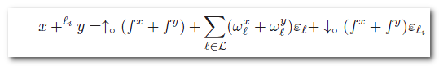
  + 减法
    - Same as above
  + 乘法
    - 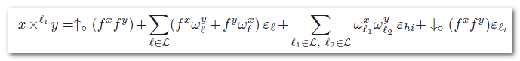
  + 例子
    - 
    - 
    - 
* 精度估计
  + 10 to 2

|  |  |  |  |  |  |  |
| --- | --- | --- | --- | --- | --- | --- |
| Valid bit | 1 | 2 | 3 | 4 | 5 | 6 |
| Eps (bin) | 0.25 | 0.125 | 0.0625 | 0.03125 | 0.015625 | 0.0078125 |
| Eps (dec) | 0.05 | 0.005 | 0.0005 | 0.0005 |  |  |

* + - 0->0
    - 1->3
    - 2->6
    - …
  + 2 to abs
    - 1.00110102*212, binary valid bits: 5. Then eps is 1*212-5-1.
  + abs to 2
    - value is 1.1001*212, eps is 1.11001*28. Then binary valid bits is 12-8-1 = 3.
  + 2 to 10

|  |  |  |  |  |  |  |
| --- | --- | --- | --- | --- | --- | --- |
| Valid bit | 1 | 2 | 3 | 4 | 5 | 6 |
| Eps (bin) | 0.25 | 0.125 | 0.0625 | 0.03125 | 0.015625 | 0.0078125 |
| Eps (dec) | 0.05 | 0.005 | 0.0005 | 0.0005 |  |  |

* + - 0->0
    - ..
    - 3->0
    - 4->1
    - ..
    - 6->1
    - 7->2
    - …