1. Insure Font (source-code-pro) is installed (to use the TextPattern.m funciton). You can find the Font files in the folder: /*others*/*source-code-pro-2.030R-ro-1.050R-it/*
2. If the GUI is password required or can't run, please contact me with e-mail.(zhengshuiqin@163.com)
3. Make the Release folder as the current working directory, and type D2NN in command window.

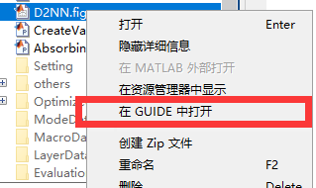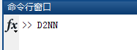 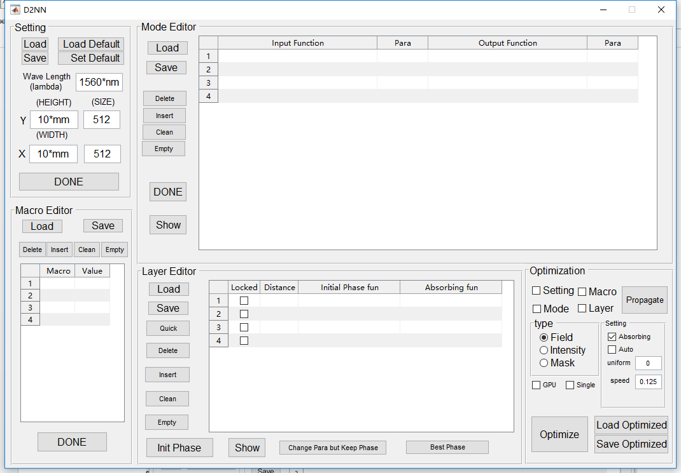

1. If the GUI is not well displayed in your computer, you can open the D2NN.fig in guide. And make some adjustment!
2. You can load our Opitmized files for a quick start of this tool!

The GUI is formed by 5 part： 1. Setting, 2. Macro Editor, 3. Mode Editor, 4. Layer Editor and 5. Optimization.

The GUI is in metric system. And the some units is preliminary defined, such as *m, mm, cm, nm*. (You can all “units.m” to watch all defined units)

They are **Load** button and **Save** button for loading the saved contents and saving the contents.

1. 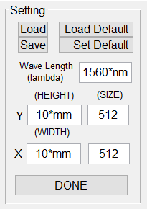Setting

The Setting is for setting the working wavelength, the simulation window and the sampling number.

We can see there 3 word in capital letter. They are **the name of global variables**.

* **HEIGHT** is the height of simulation window.
* **WIDTH** is the width of simulation window.
* **SIZE** is a row vector representing the sampling number.

The following setting set HEIGHT=10*mm， WIDTH = 10*mm, SIZE = [512 512].

1. Macro Editor

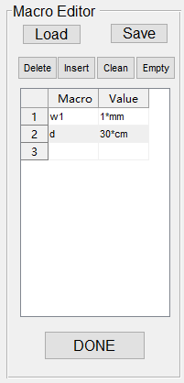The Macro Editor is for setting some **global variables** (called **Macro**)we can used in Mode Editor and Layer Editor.

The following sets two global variables, w1=1*mm， d = 30*mm.

And there is 4 button:

* **Delete** is to delete the selected Macro.
* **Insert** is to insert an empty before the selected.
* **Clean** is to delete some unpaired input (no value or no macro name).
* **Empty** is to delete all.

**They are the same function to similar buttons of the following Editors.**

1. Mode Editor

The Mode Editor is for input modes and output modes.

The Function is require to write as a function handle as @(X) function_name(X)

And the corresponding Para is the X to call the function handle.

And there is another global variables called **var**. This is **a very import variables** and generated by the Setting window. It include the simulation spatial- and spectrum- variable. Then we can customer defined an m-function file to define arbitrary function to call.

When the Inputs and Outputs are defined, use the “**DONE**” button to create the inputs and outputs.

After a message-box show they are loaded, you can use the “**SHOW**” button to check them.

* If you still have problems for the customer defined function, do not hesitate to contact me. (zhengshuiqin@163.com)

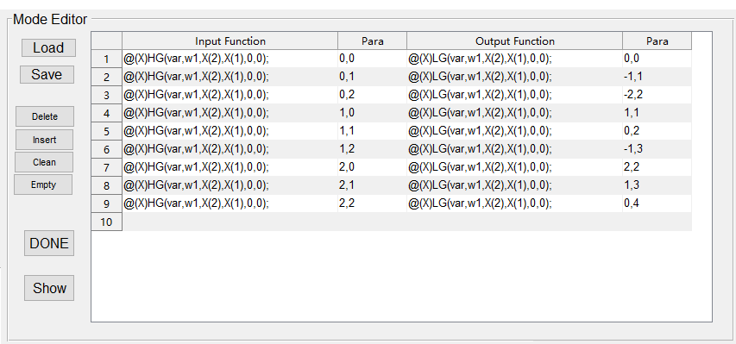 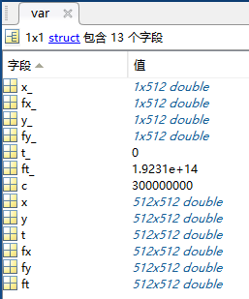 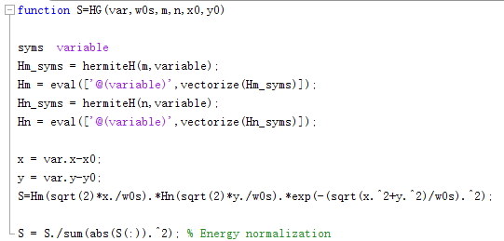

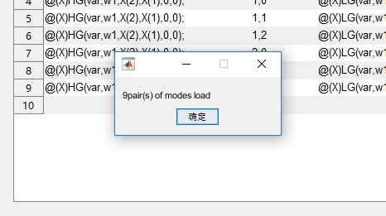 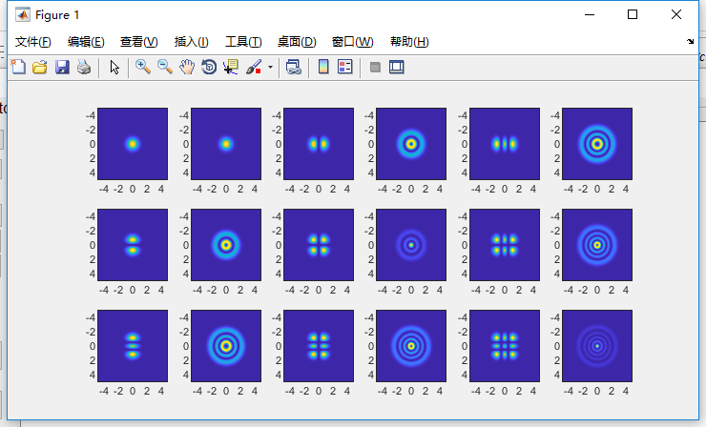

1. Layer Editor

The Layer Editor is used to define the layers number and the Distance between layers.

There are 4 parameters of each layers. :

* **Locked**: If the Locked is selected, the Phase won’t be changed by Optimization.
* **Distance**: The distance between this layers and prior one. And the Distance of first layers is Distance between the input field and the first layers.
* **Initial Phase fun**: The initial distribution of phase in ‘radian’ units.
* **Absorbing fun**: The intensity limit function, in order to limit the intensity not to escape from border.

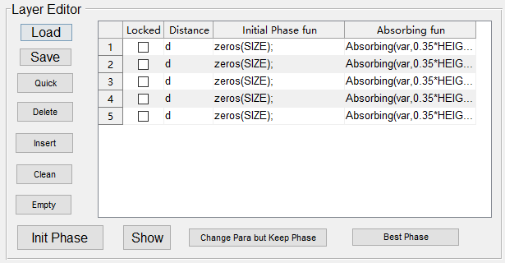 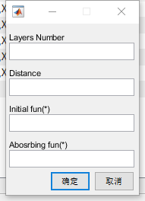

**Quick** button: To defined the layers quickly, and each layers with same parameters. The Layers Number and Distance is required, and the Initial and Absorbing fun is default if they are empty. The initial phase default is rand(SIZE), and Absorbing default is Absorbing(var,0.35*HEIGHT,0.45*HEIGHT,1), you can check the Absorbing function by open the ‘Absorbing.m’ or customer defined an m-function file.

When the layers are defined, use the “**Init Phase**” button to create the layers.

After a message-box show they are loaded, you can use the “SHOW” button to check them.

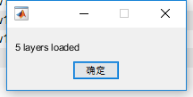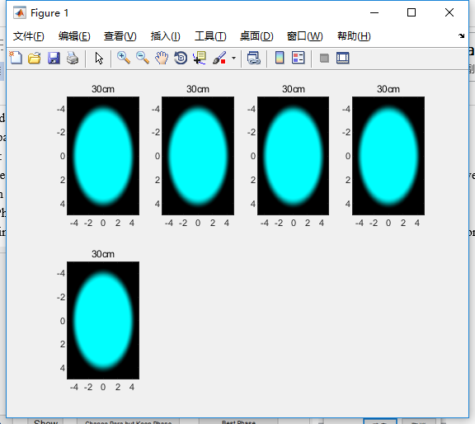

**Change Para but Keep Phase**: As its name, you can change the distance and Absorbing and Lock after Optimization, but keep the Optimized Phase.

**Best Phase**: Some Time, the Optimization will crash, and you can used the **Best Phase** to set the phase to the Best phase distribution while the last Optimization.

1. Optimization

The Optimization is used to Optimize the Phase of each layer.

There three type of Optimization

**Field**: the outputs are optimized to the same as defined.

**Intensity**: the Intensity of outputs are optimized to the same Intensity as of defined.

**Mask**: the Intensity of outputs is limit in the region of defined: The defined should be flat-topped distributions.

**GPU**: If the GPU is selected, the GPU is used for speed up.

**Single**: If the Single is selected, the simulation precision is used single precision. Otherwise, it is used double.

(You can used both (GPU and Single) to find a rough quickly)

The parameters in small setting box can be set during optimization.

**Absorbing**: Consider the Absorbing border to limit the intensity not to escape from border.

**Auto**: Auto set the speed of optimization. (Beta version…use it carefully)

**uniform**: If the optimization for different modes is not uniformed, you can set the uniform as 0~1 value. According to my experience, 0.4~0.6 is befitting, and **0.4** is my favorite.

**speed**: If speed of optimization: According to my experience, 0.125 ~ 0.25 is befitting, and **0.125** is always worked. But the value is not limited.

**Optimize**: Start Optimize. and Optimize state window is shown. The left is for each optimization status of each modes (from 0 to 1, 1 is the best!), and the title of left is the mean optimization status. And the right is the mean optimization status via iterations. the title of right is the used time of last optimization. **Close the Optimize state window, the Optimize will stop.** And Show in layer Editor can used to show the **Optimized Phase.**

**Propagate:** Show the Propagate of each modes.

You can save the Optimized D2NN by Save Opitmized, and Load the prior Opitmized by Load Opitmized.

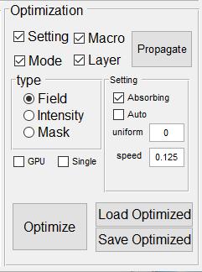 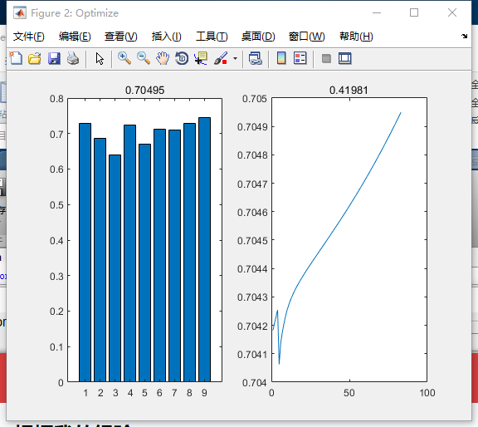 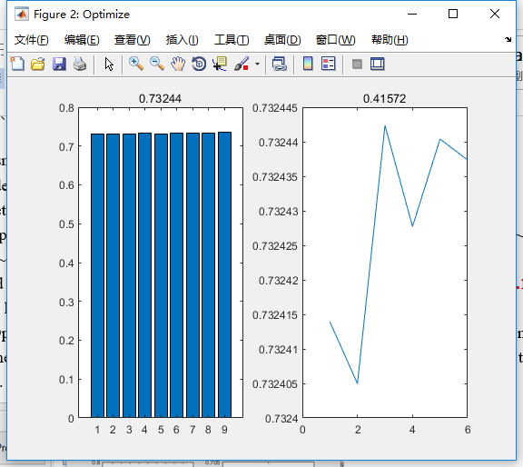

There is another script called FieldTransformEvaluation.m is a demo for using Opitmized files.

If you have any problem with this toolm please contact me with e-mail.(zhengshuiqin@163.com)