**Preparation of engineering prototypes**

1. **What is engineering prototype**

Compared to a regular working prototype, the engineering prototype undergoes some special modifications to meet specific radio frequency testing requirements. The engineering prototype can achieve some functionalities that the regular prototype cannot, such as continuous transmission at designated signal and power levels.

1. **Why engineering prototype is needed**

Generally speaking, a regular prototype exhibits several characteristics when operating, including intermittency, instability (power may vary with environmental changes), and variability (for products supporting multiple operating modes, their working modes might change frequently). Under these conditions, it is difficult for laboratories to measure the accurate radio frequency parameters of the product. Therefore, it is necessary to provide a special engineering prototype that can operate continuously and stably in terms of radio frequency functions.

Furthermore, different products may adhere to different test standards, and the corresponding test requirements might vary. Consequently, different requirements for the operational state of the prototype are needed. The creation of an engineering prototype involves preparing special samples that comply with specific test conditions outlined in the standards, ensuring that laboratories can measure the accurate radio frequency parameters of the product under stable and reliable conditions.

1. **How many types of the engineering prototype**
2. Conducted fixed frequency prototype

For the conducted fixed-frequency prototype to maintain a fixed frequency, the RF antennas (such as Bluetooth antennas, Wi-Fi antennas) need to be disconnected, and an SMA connector with a radio frequency cable should be installed for connection to instruments such as spectrum analyzers and power meters. If the antenna of the prototype is detachable, there is no need to cut the antenna welding wire.

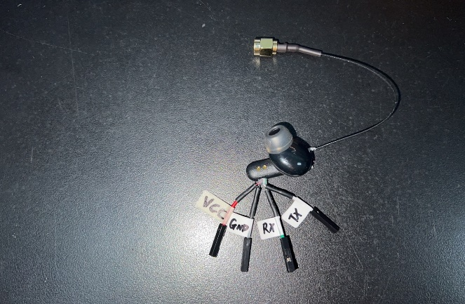 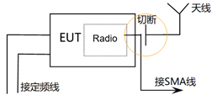

1. Radiated fixed frequency prototype

To maintain a fixed frequency with the radiated fixed-frequency prototype, RF antennas (such as Bluetooth antennas, Wi-Fi antennas) need to be retained for conducting radiated testing inside an anechoic chamber.

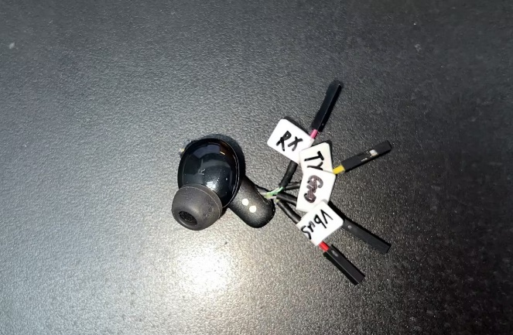 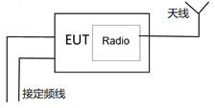

1. Adaptive Test Prototype / DFS Test Prototype / 2G3G4G5G Test Prototype / GNSS Test Prototype

Adaptive Prototype (as per CE standard EN 300 328 for Bluetooth or custom transmission power greater than 10dBm products, as well as 2.4GHz Wi-Fi products and EN 301 893 5GHz Wi-Fi products) requires using a regular prototype, where the antenna is either severed and soldered, or detachably connected to an SMA connector RF cable.

DFS Prototype (for Wi-Fi products supporting the 5G frequency band 5250-5725MHz) requires using a regular prototype, where the antenna is either severed and soldered, or detachably connected to an SMA connector RF cable.

For 2G/3G/4G/5G prototypes with antennas concealed within the casing, it is necessary to create a hole in the prototype shell for connecting or soldering an SMA connector RF cable.

GNSS Prototype (comprising BDS, Galileo, GLONASS, GPS, SBAS) requires the soldering or detachable connection of an SMA connector RF cable.

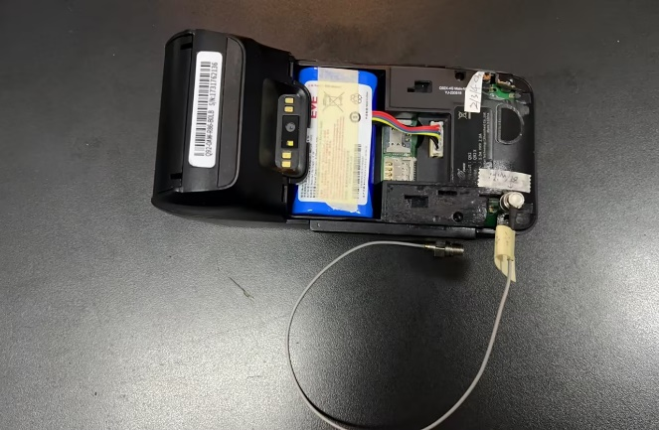 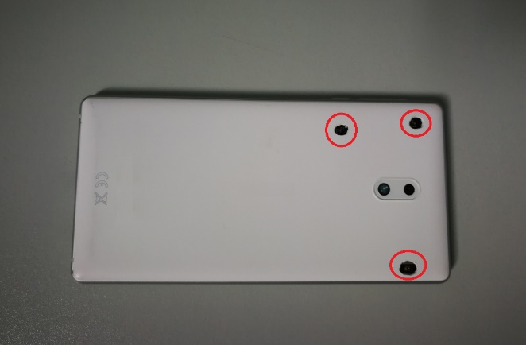

1. **What are the requirements for engineering prototypes?**
2. Products with a single channel such as 27MHz, 40MHz, and 49MHz remote control toys, as well as wireless charging and NFC technology, do not require fixed-frequency prototypes. The radio frequency tests can be directly conducted using regular prototypes."

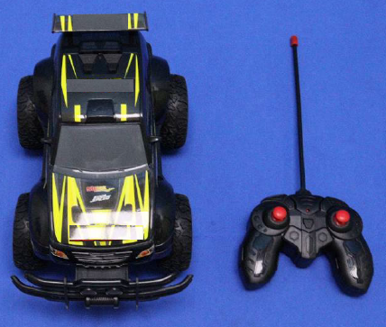 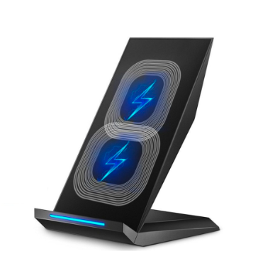

1. For single-channel fixed-frequency prototypes such as 315MHz, 433MHz, 868MHz, and 915MHz, etc., it is necessary to have both modulated signal long-transmission prototypes and carrier signal long-transmission prototypes, which usually require the manufacturer to flash specific firmware for implementation. However, if it involves multi-channel fixed-frequency prototypes, the fixed frequency can be implemented according to the methods mentioned in points c and d below.

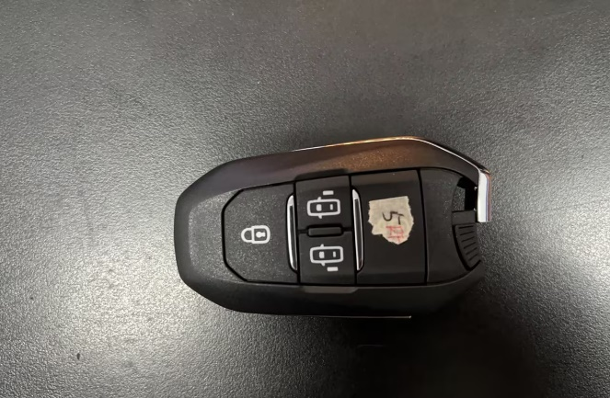 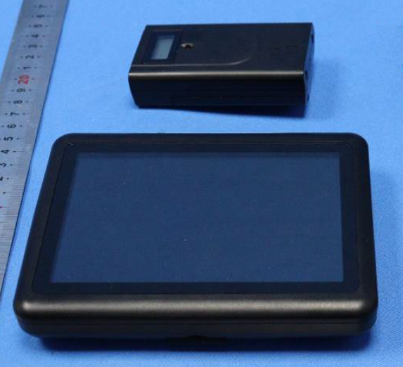

1. For the 2.4GHz/5.8GHz custom fixed-frequency prototypes, the prototypes need to continuously transmit modulated and carrier signals at the lowest, middle, and highest channels. This can be achieved through the manual operation of a combination of buttons as described below, or the fixed frequency can be implemented according to the method mentioned in point d below.

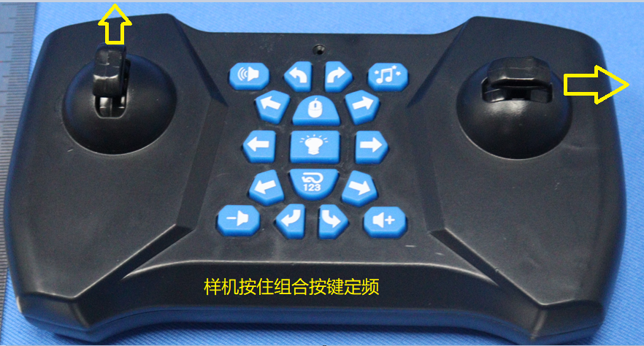 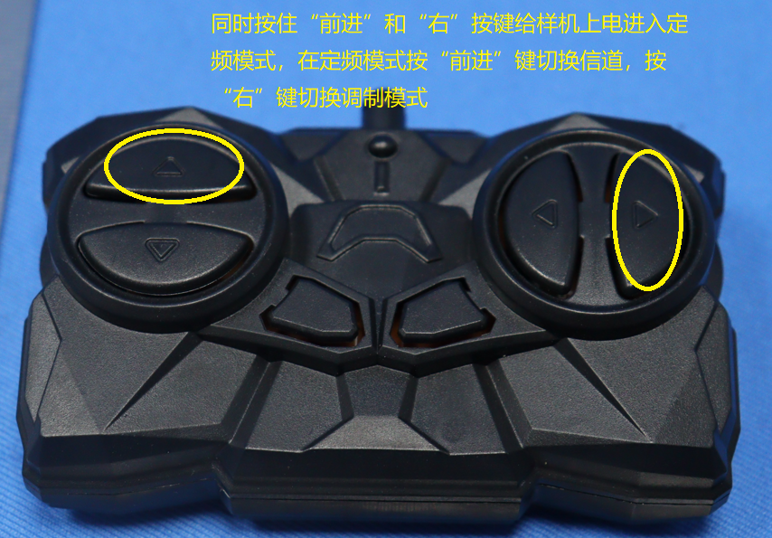

1. For Bluetooth/Wi-Fi fixed-frequency prototypes, it is usually necessary to connect to a computer to achieve fixed frequency through fixed-frequency software or commands. The prototype needs to be connected to the computer via UART/USB/network ports, and the fixed-frequency transmission and reception of signals are controlled by software or commands on the computer side. Fixed frequencies on devices with screens such as tablets or smartphones are typically implemented through built-in apps or menu options.

UART connect to PC JieLi solution software interface

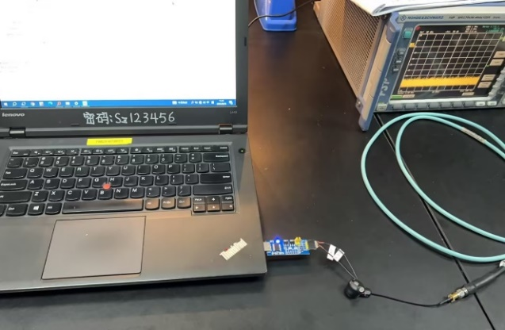 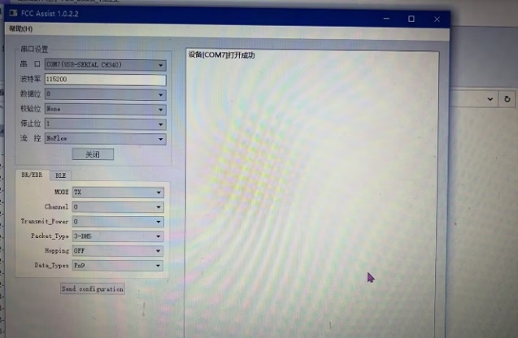

USB connect to PC input ADB command

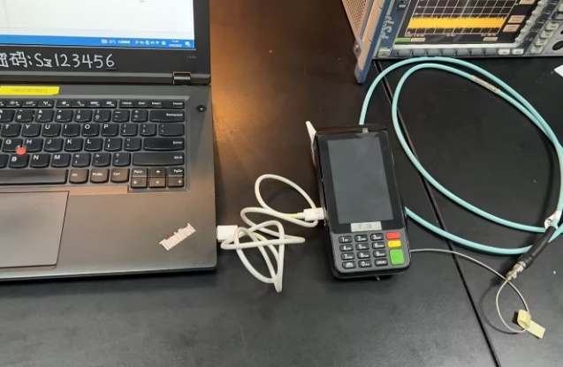 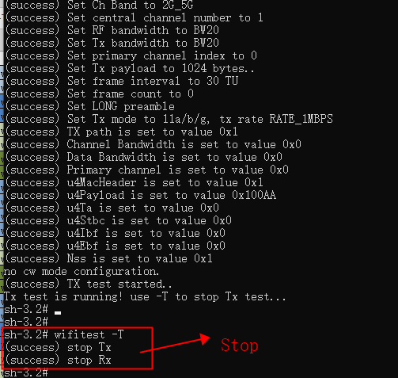

Tablet installed software Bult-in fixed frequency menu

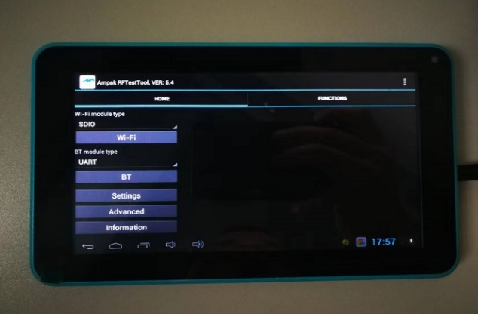 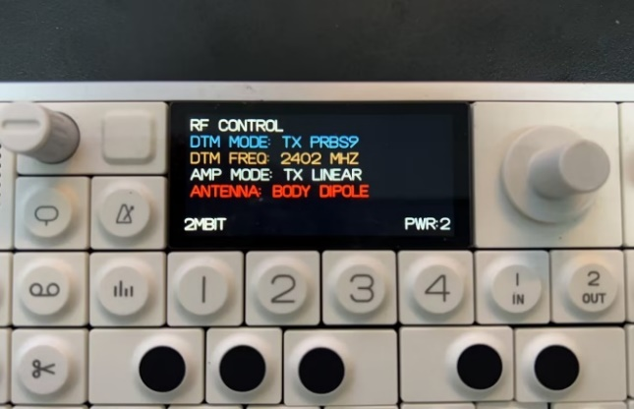

1. For adaptive prototypes and DFS prototypes, it is necessary to provide methods for running streams connected to routers or smartphones. The connection schematics are usually of the following two types: as shown in figure one, for hotspot devices like router AP products, if two smartphones can connect at the same time, they can use iperf software; as shown in figure two, smartphones, tablets, and televisions (such as Android products with screens) can directly install iperf software within these prototypes. Moreover, prototypes with Linux or Unix systems need to install corresponding stream running software; remote control types and other prototypes that cannot install stream running software can be tested based on actual usage connections.

Figure 1 Figure 2

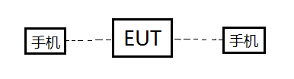 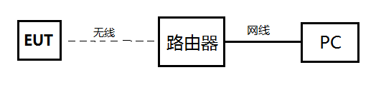

1. For GNSS test prototypes, it is necessary to provide methods for monitoring signal reception and the C/N0 carrier-to-noise ratio. This usually requires installing GPS monitoring software or commands on the computer, or installing GPS APP software in the prototype, among other methods.

