## 用数据库的方式来实现水果案例

第一步、导入sql文件

|  |
| --- |
| */\**  *Navicat MySQL Data Transfer*  *Source Server : 练习数据库*  *Source Server Version : 50553*  *Source Host : localhost:3306*  *Source Database : fruit*  *Target Server Type : MYSQL*  *Target Server Version : 50553*  *File Encoding : 65001*  *Date: 2018-11-13 21:39:05*  *\*/*  SET FOREIGN_KEY_CHECKS=0;  *-- ----------------------------*  *-- Table structure for mytable*  *-- ----------------------------*  DROP TABLE IF EXISTS `mytable`;  CREATE TABLE `mytable` (  `id` int(11) NOT NULL AUTO_INCREMENT,  `title` varchar(255) DEFAULT NULL,  `src` varchar(255) DEFAULT NULL,  PRIMARY KEY (`id`)  ) ENGINE=MyISAM AUTO_INCREMENT=14 DEFAULT CHARSET=utf8;  *-- ----------------------------*  *-- Records of mytable*  *-- ----------------------------*  INSERT INTO `mytable` VALUES ('1', '香蕉', 'img/banana1.jpg');  INSERT INTO `mytable` VALUES ('2', '苹果', 'img/apple1.jpg');  INSERT INTO `mytable` VALUES ('3', '橘子', 'img/orange1.jpg');  INSERT INTO `mytable` VALUES ('4', '菠萝', 'img/pineapple1.jpg');  INSERT INTO `mytable` VALUES ('5', '芒果', 'img/mango1.jpg');  INSERT INTO `mytable` VALUES ('6', '葡萄', 'img/grape1.jpg');  INSERT INTO `mytable` VALUES ('7', '柚子', 'img/pomelo1.jpg');  INSERT INTO `mytable` VALUES ('8', '木瓜', 'img/pawpaw1.jpg');  INSERT INTO `mytable` VALUES ('9', '猕猴桃', 'img/kivi1.jpg');  INSERT INTO `mytable` VALUES ('10', '柿子', 'img/pomegranate1.jpg');  INSERT INTO `mytable` VALUES ('11', '柠檬', 'img/lemon1.jpg');  INSERT INTO `mytable` VALUES ('12', '石榴', 'img/pomegranate1.jpg');  INSERT INTO `mytable` VALUES ('13', '梨', 'img/pear1.jpg'); |

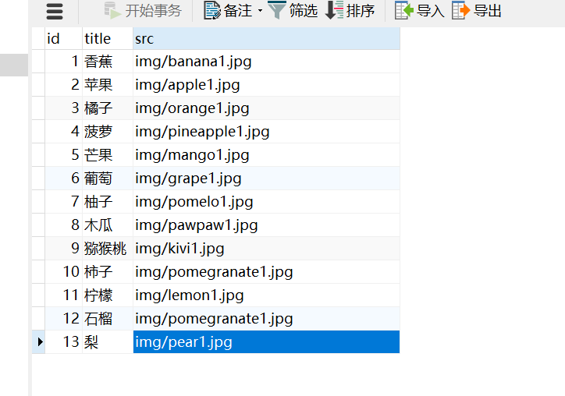

第二步、修改fruit.html为fruit.php,读取数据库中的数据

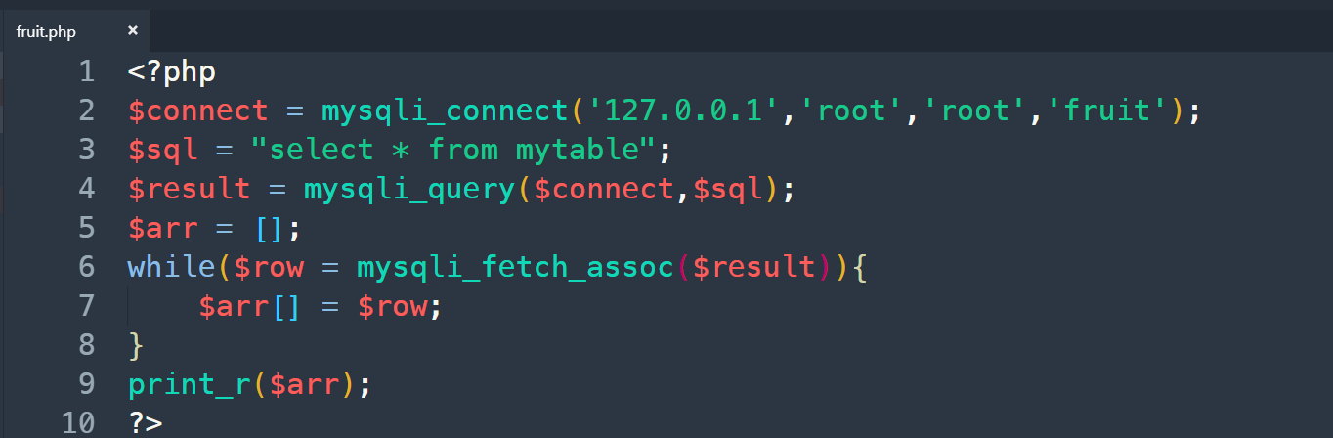

第三步、html,php混写

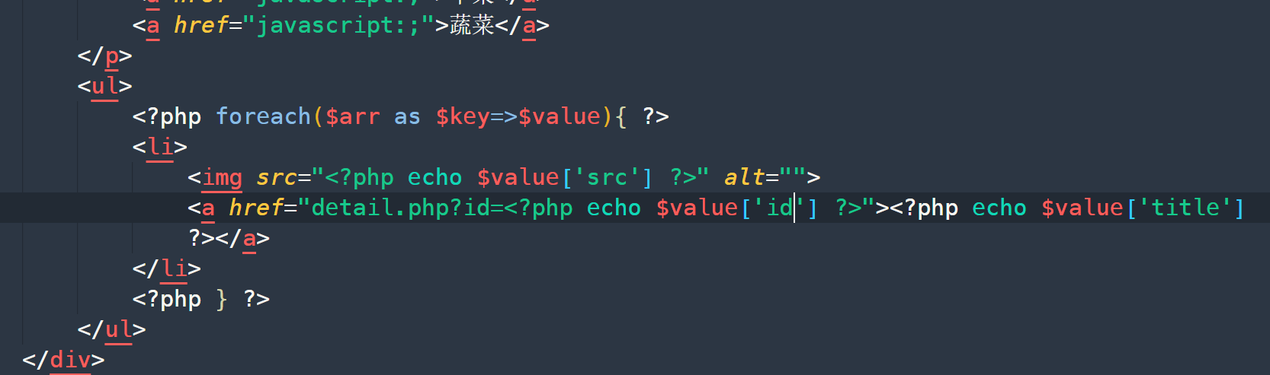

第四步、修改detail.html为detail.php

