咱们在学习canvas的最开始的时候说过，咱们其中的一个目的是为了让大家对面向对象有一定的认识，如果大家对面向对象有更进一步的兴趣，咱们可以再来看一下如下的贪吃蛇和坦克大战的案例：

假设整个画布的宽高是400*400
我们首先来画一个蛇：
本质上，蛇就是三个宽度都是20px的正方形
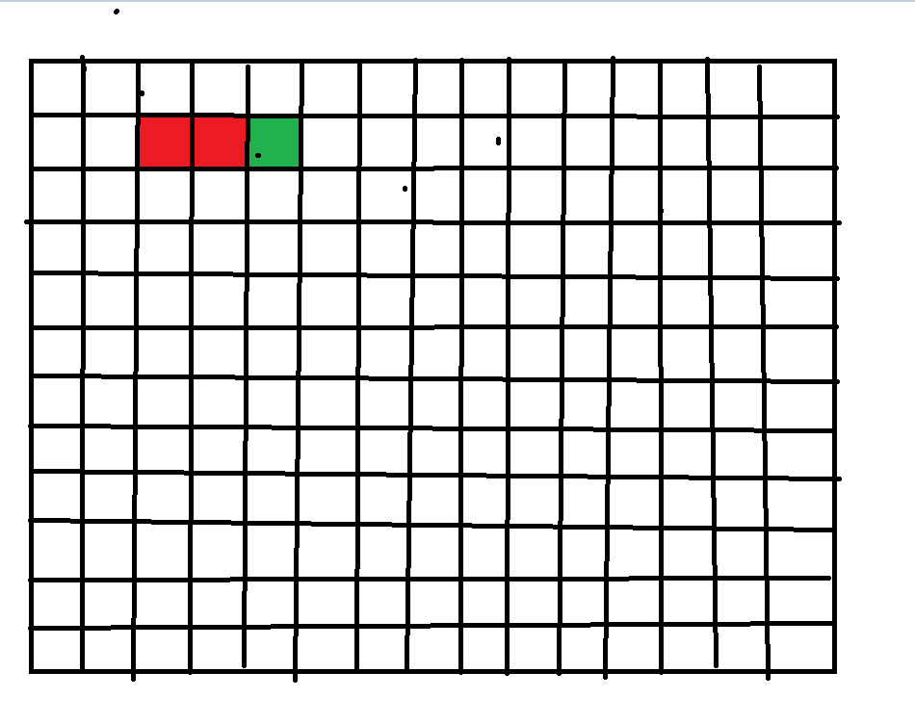

我们简化一下：如何画一个矩形呢？
<!DOCTYPE html>
<html lang="en">
<head>
<meta charset="UTF-8">
<meta name="viewport" content="width=device-width, initial-scale=1.0">
<meta http-equiv="X-UA-Compatible" content="ie=edge">
<title>Document</title>
<style>
#canvas{
background:black;
border:2px solid pink;
}
</style>
</head>
<body>
<canvas id="canvas" width="400" height="400"></canvas>
<script>
var canvas = document.getElementById('canvas')
var ctx = canvas.getContext('2d')
ctx.fillStyle = '#fff'
ctx.fillRect(0,0,20,20)
</script>
</body>
</html>

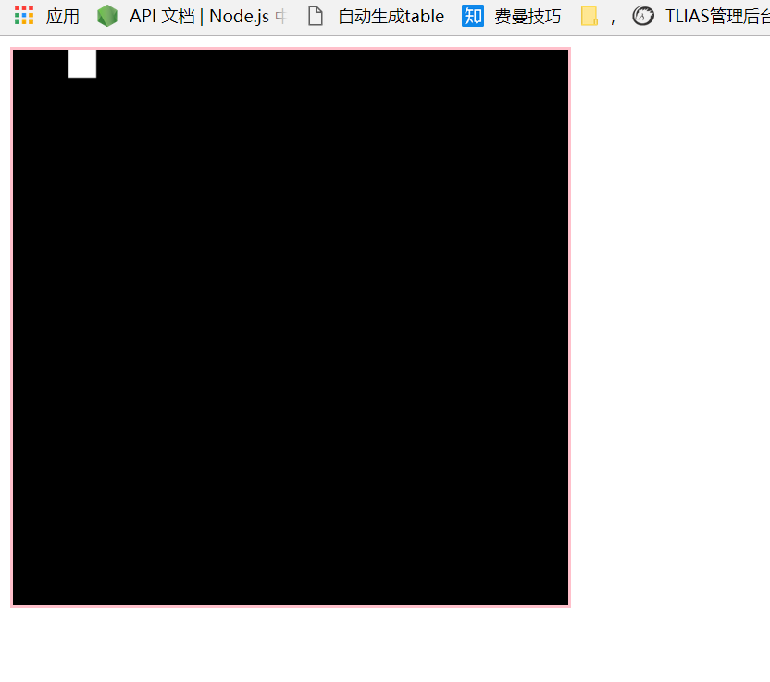

那我们如何才能画出如下的这个蛇呢？其实我们只要画三个正方形即可，这里我们要明确一下我们这个蛇的位置要画在哪里呢？这里我们可以确定一下每个格子的宽高是20px,这样，横竖都是20个格子：
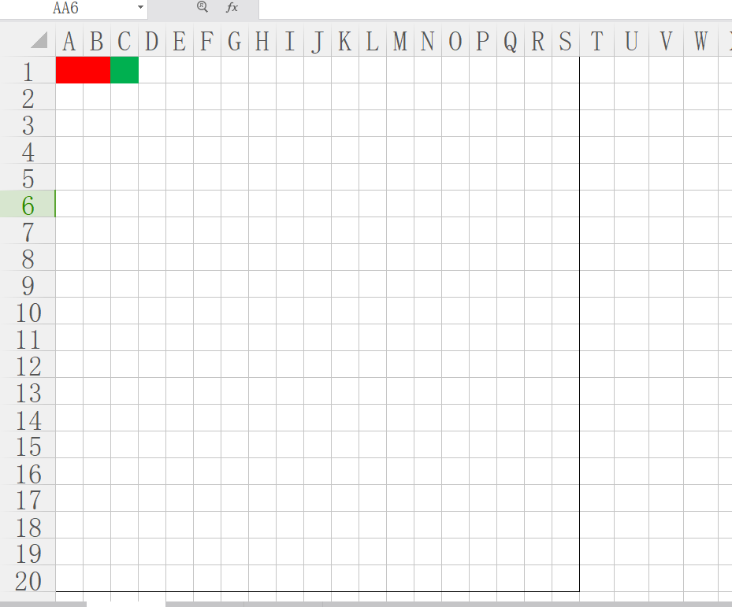

我们只要确定一下A1、B1、C1这三个的左上角坐标即可：

<!DOCTYPE html>
<html lang="en">
<head>
<meta charset="UTF-8">
<meta name="viewport" content="width=device-width, initial-scale=1.0">
<meta http-equiv="X-UA-Compatible" content="ie=edge">
<title>Document</title>
<style>
#canvas{
background:black;
border:2px solid pink;
}
</style>
</head>
<body>
<canvas id="canvas" width="400" height="400"></canvas>
<script>
var canvas = document.getElementById('canvas')
var ctx = canvas.getContext('2d')
ctx.fillStyle = '#fff'
var data = {//记录蛇的左上角的坐标数据
head:{
x:40,y:0
},
body:[{x:0,y:0},{x:20,y:0}]
}
//先画蛇头
ctx.beginPath()
ctx.save()
ctx.fillStyle = 'red'
ctx.fillRect(data.head.x,data.head.y,20,20)
ctx.restore()
//再画蛇身子
ctx.beginPath()
ctx.save()
ctx.fillStyle = 'green'
for(var i=0;i<data.body.length;i++){
ctx.fillRect(data.body[i].x,data.body[i].y,20,20)
}
ctx.restore()
</script>
</body>
</html>

接下来咱们可以考虑监听键盘事件：
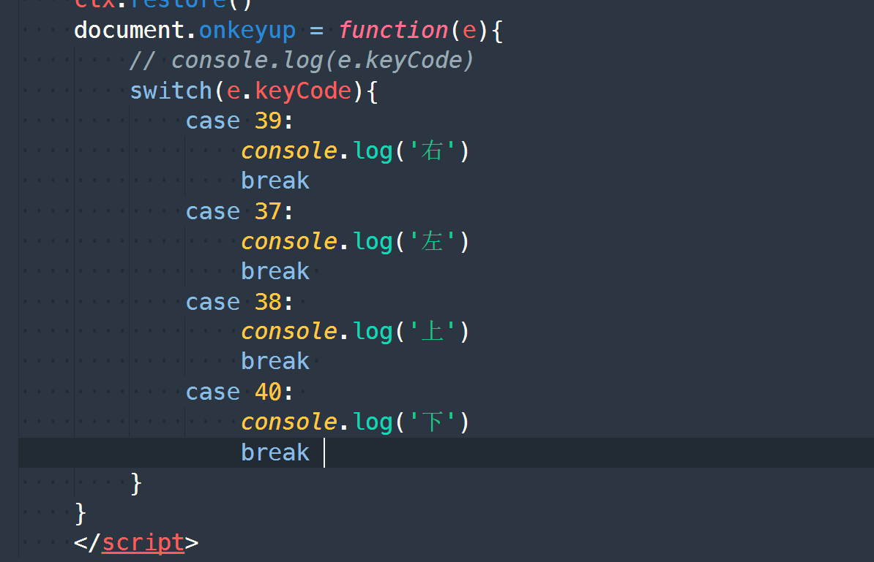

接下来，咱们要考虑的是：我们按上下左右的时候，蛇开始移动，这里，咱们先为了简化，只考虑一种情况：蛇向右移动的情况：

为了简化代码，我们把画蛇封装成一个函数：
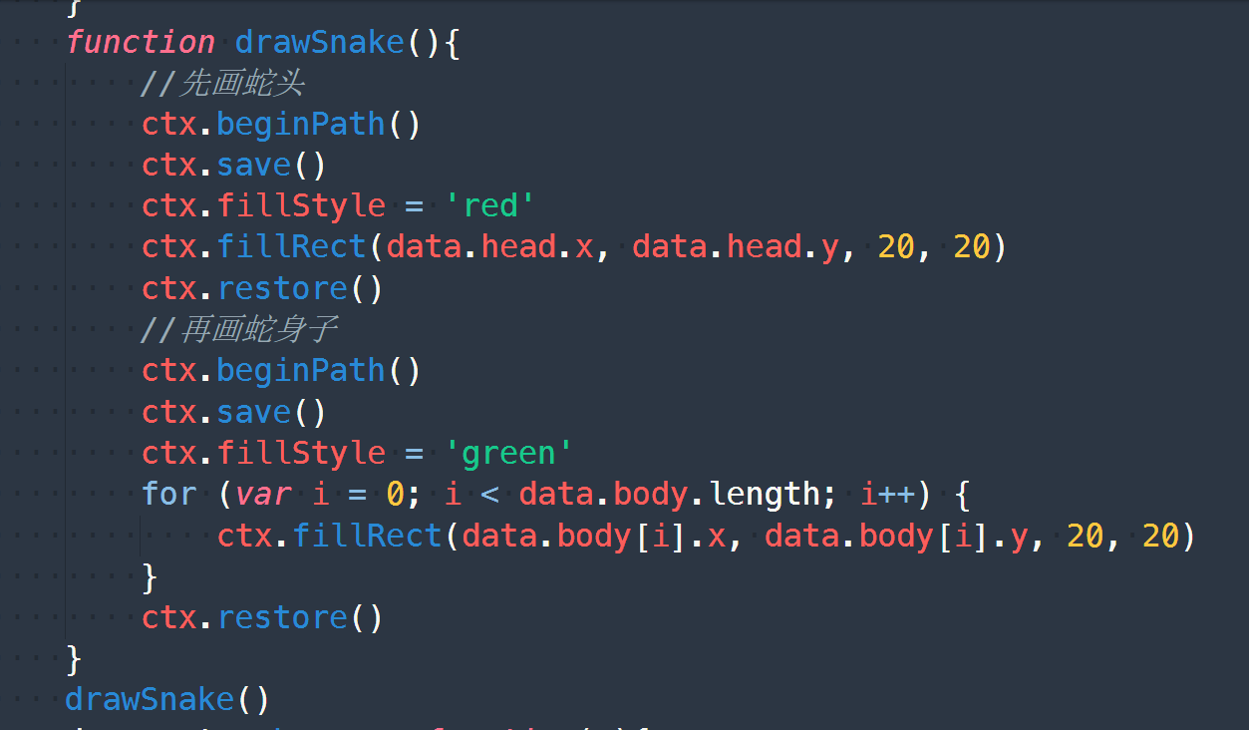

接下来，大家思考，咱们向右移动20px，data数据发生了变化，那到底是怎么变化的？
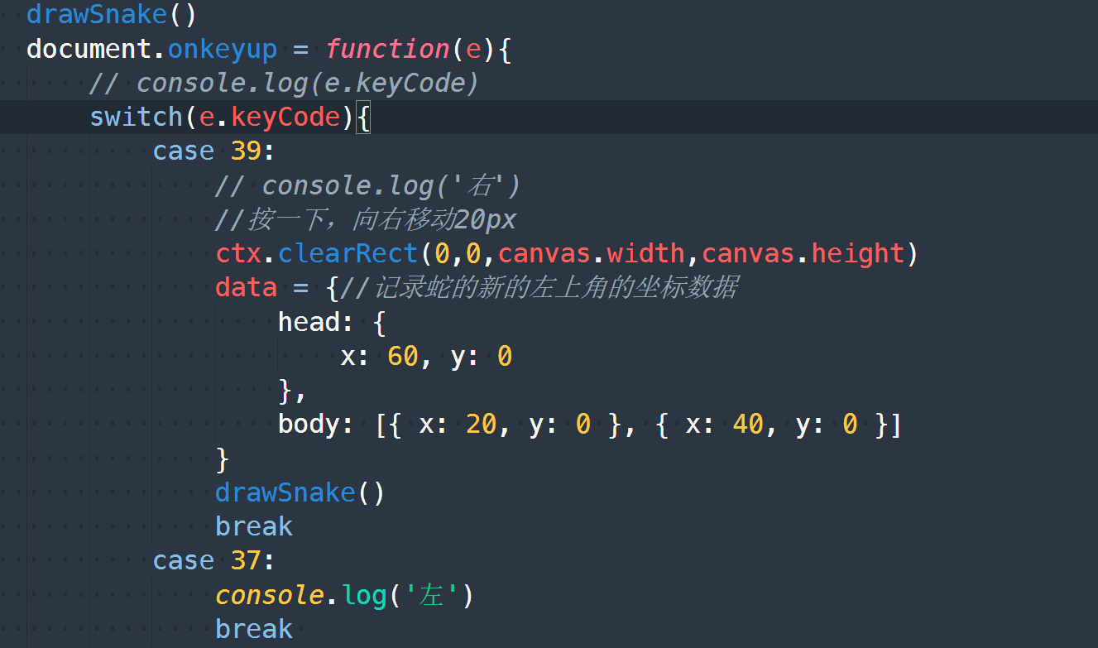

我们会发现，蛇头向右移动了20px
蛇身变化：

大家可以思考：
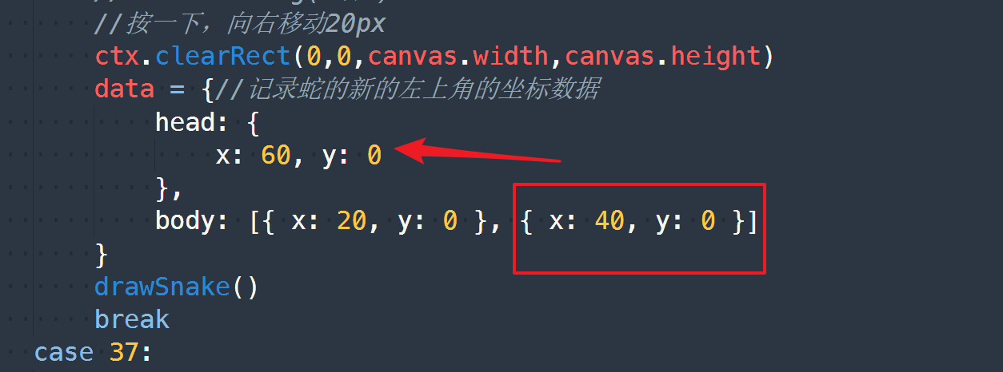

身体的最后一个数据和之前的数据的关系是 ----> 填充了之前的蛇头的位置

<!DOCTYPE html>
<html lang="en">
<head>
<meta charset="UTF-8">
<meta name="viewport" content="width=device-width, initial-scale=1.0">
<meta http-equiv="X-UA-Compatible" content="ie=edge">
<title>Document</title>
<style>
#canvas{
background:black;
border:2px solid pink;
}
</style>
</head>
<body>
<canvas id="canvas" width="400" height="400"></canvas>
<script>
var canvas = document.getElementById('canvas')
var ctx = canvas.getContext('2d')
ctx.fillStyle = '#fff'
var data = {//记录蛇的左上角的坐标数据
head:{
x:40,y:0
},
body:[{x:0,y:0},{x:20,y:0}]
}
function drawSnake(){
//先画蛇头
ctx.beginPath()
ctx.save()
ctx.fillStyle = 'red'
ctx.fillRect(data.head.x, data.head.y, 20, 20)
ctx.restore()
//再画蛇身子
ctx.beginPath()
ctx.save()
ctx.fillStyle = 'green'
for (var i = 0; i < data.body.length; i++) {
ctx.fillRect(data.body[i].x, data.body[i].y, 20, 20)
}
ctx.restore()
}
drawSnake()
document.onkeyup = function(e){
// console.log(e.keyCode)
switch(e.keyCode){
case 39:
// console.log('右')
//按一下，向右移动20px
ctx.clearRect(0,0,canvas.width,canvas.height)
// data = {//记录蛇的新的左上角的坐标数据
// head: {
// x: 60, y: 0
// },
// body: [{ x: 20, y: 0 }, { x: 40, y: 0 }]
// }
data.body.shift()
data.body.push(Object.assign({},data.head))
data.head.x = data.head.x + 20
drawSnake()
break
case 37:
console.log('左')
break
case 38:
console.log('上')
break
case 40:
console.log('下')
break
}
}
</script>
</body>
</html>

接下来，咱们考虑用面向对象的方式来改造一下代码：
我们先看一下，关于蛇的代码有哪些？
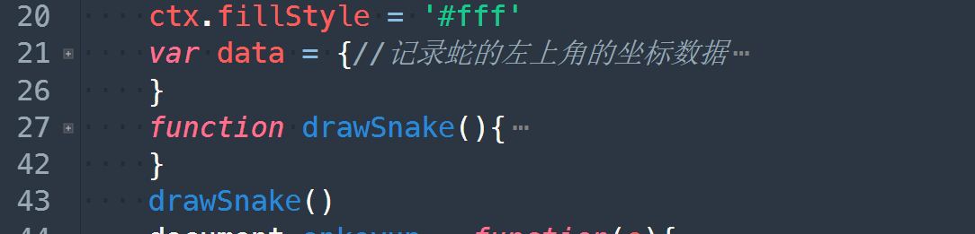

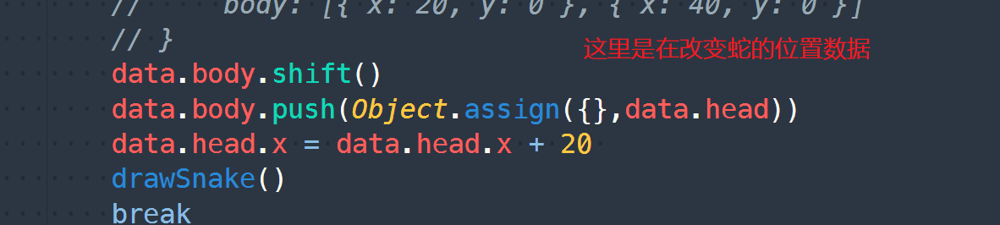

<!DOCTYPE html>
<html lang="en">
<head>
<meta charset="UTF-8">
<meta name="viewport" content="width=device-width, initial-scale=1.0">
<meta http-equiv="X-UA-Compatible" content="ie=edge">
<title>Document</title>
<style>
#canvas{
background:black;
border:2px solid pink;
}
</style>
</head>
<body>
<canvas id="canvas" width="400" height="400"></canvas>
<script>
var canvas = document.getElementById('canvas')
var ctx = canvas.getContext('2d')
function Snake(data){
this.data = data;
}
Snake.prototype.draw = function(){
ctx.clearRect(0,0,canvas.width,canvas.height)
//先画蛇头
ctx.beginPath()
ctx.save()
ctx.fillStyle = 'red'
ctx.fillRect(this.data.head.x, this.data.head.y, 20, 20)
ctx.restore()
//再画蛇身子
ctx.beginPath()
ctx.save()
ctx.fillStyle = 'green'
for (var i = 0; i < this.data.body.length; i++) {
ctx.fillRect(this.data.body[i].x, this.data.body[i].y, 20, 20)
}
ctx.restore()
}

Snake.prototype.setDirection = function(direction){
switch(direction){
case 'Left':
this.data.body.shift()
this.data.body.push(Object.assign({}, this.data.head))
this.data.head.x = this.data.head.x - 20
break
case 'Right':
this.data.body.shift()
this.data.body.push(Object.assign({}, this.data.head))
this.data.head.x = this.data.head.x + 20
break
case 'Top':
this.data.body.shift()
this.data.body.push(Object.assign({}, this.data.head))
this.data.head.y = this.data.head.y - 20
break
case 'Bottom':
this.data.body.shift()
this.data.body.push(Object.assign({}, this.data.head))
this.data.head.y = this.data.head.y + 20
break
}

}

var snake = new Snake({
head: {
x: 40, y: 0
},
body: [{ x: 0, y: 0 }, { x: 20, y: 0 }]
})

snake.draw()

document.onkeyup = function(e){
// console.log(e.keyCode)
switch(e.keyCode){
case 39:
snake.setDirection('Right')
break
case 37:
// console.log('左')
snake.setDirection('Left')
break
case 38:
// console.log('上')
snake.setDirection('Top')
break
case 40:
// console.log('下')
snake.setDirection('Bottom')
break
}
snake.draw()
}
</script>
</body>
</html>

接下来，咱们再来画豆子：
豆子的位置是随机的，但是它必须得保证还是在网格上面的 ---> 果子的左上角的坐标必须是0---> 20这几个数
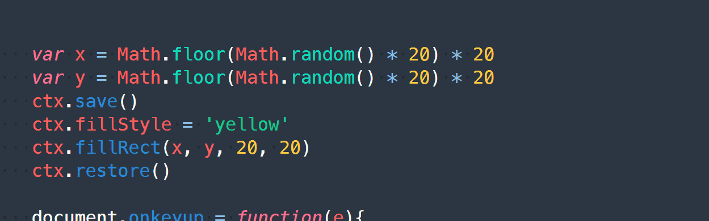

我们把豆子封装成一个对象：

<!DOCTYPE html>
<html lang="en">
<head>
<meta charset="UTF-8">
<meta name="viewport" content="width=device-width, initial-scale=1.0">
<meta http-equiv="X-UA-Compatible" content="ie=edge">
<title>Document</title>
<style>
#canvas{
background:black;
border:2px solid pink;
}
</style>
</head>
<body>
<canvas id="canvas" width="400" height="400"></canvas>
<script>
var canvas = document.getElementById('canvas')
var ctx = canvas.getContext('2d')
function Snake(data){
this.data = data;
}
Snake.prototype.draw = function(){
ctx.clearRect(0,0,canvas.width,canvas.height)
//先画蛇头
ctx.beginPath()
ctx.save()
ctx.fillStyle = 'red'
ctx.fillRect(this.data.head.x, this.data.head.y, 20, 20)
ctx.restore()
//再画蛇身子
ctx.beginPath()
ctx.save()
ctx.fillStyle = 'green'
for (var i = 0; i < this.data.body.length; i++) {
ctx.fillRect(this.data.body[i].x, this.data.body[i].y, 20, 20)
}
ctx.restore()
}

Snake.prototype.setDirection = function(direction){
switch(direction){
case 'Left':
this.data.body.shift()
this.data.body.push(Object.assign({}, this.data.head))
this.data.head.x = this.data.head.x - 20
break
case 'Right':
this.data.body.shift()
this.data.body.push(Object.assign({}, this.data.head))
this.data.head.x = this.data.head.x + 20
break
case 'Top':
this.data.body.shift()
this.data.body.push(Object.assign({}, this.data.head))
this.data.head.y = this.data.head.y - 20
break
case 'Bottom':
this.data.body.shift()
this.data.body.push(Object.assign({}, this.data.head))
this.data.head.y = this.data.head.y + 20
break
}

}

var snake = new Snake({
head: {
x: 40, y: 0
},
body: [{ x: 0, y: 0 }, { x: 20, y: 0 }]
})

snake.draw()

function Fruit(){
this.x = Math.floor(Math.random() * 20) * 20
this.y = Math.floor(Math.random() * 20) * 20
}

Fruit.prototype.draw = function(){
ctx.save()
ctx.fillStyle = 'yellow'
ctx.fillRect(this.x, this.y, 20, 20)
ctx.restore()
}

var fruit = new Fruit()//由于豆子的位置是随机的，我们没必要传参
fruit.draw()

document.onkeyup = function(e){
// console.log(e.keyCode)
switch(e.keyCode){
case 39:
snake.setDirection('Right')
break
case 37:
// console.log('左')
snake.setDirection('Left')
break
case 38:
// console.log('上')
snake.setDirection('Top')
break
case 40:
// console.log('下')
snake.setDirection('Bottom')
break
}
snake.draw()
fruit.draw()
}
</script>
</body>
</html>

接下来，咱们考虑蛇吃豆子

只要蛇头的最新位置刚好和豆子重复，意味着吃掉了豆子了

<!DOCTYPE html>
<html lang="en">
<head>
<meta charset="UTF-8">
<meta name="viewport" content="width=device-width, initial-scale=1.0">
<meta http-equiv="X-UA-Compatible" content="ie=edge">
<title>Document</title>
<style>
#canvas{
background:black;
border:2px solid pink;
}
</style>
</head>
<body>
<canvas id="canvas" width="400" height="400"></canvas>
<script>
var canvas = document.getElementById('canvas')
var ctx = canvas.getContext('2d')
function Snake(data){
this.data = data;
}
Snake.prototype.draw = function(){
ctx.clearRect(0,0,canvas.width,canvas.height)
//先画蛇头
ctx.beginPath()
ctx.save()
ctx.fillStyle = 'red'
ctx.fillRect(this.data.head.x, this.data.head.y, 20, 20)
ctx.restore()
//再画蛇身子
ctx.beginPath()
ctx.save()
ctx.fillStyle = 'green'
for (var i = 0; i < this.data.body.length; i++) {
ctx.fillRect(this.data.body[i].x, this.data.body[i].y, 20, 20)
}
ctx.restore()
}

Snake.prototype.setDirection = function(direction){
switch(direction){
case 'Left':
this.data.body.shift()
this.data.body.push(Object.assign({}, this.data.head))
this.data.head.x = this.data.head.x - 20
break
case 'Right':
this.data.body.shift()
this.data.body.push(Object.assign({}, this.data.head))
this.data.head.x = this.data.head.x + 20
break
case 'Top':
this.data.body.shift()
this.data.body.push(Object.assign({}, this.data.head))
this.data.head.y = this.data.head.y - 20
break
case 'Bottom':
this.data.body.shift()
this.data.body.push(Object.assign({}, this.data.head))
this.data.head.y = this.data.head.y + 20
break
}

}

var snake = new Snake({
head: {
x: 40, y: 0
},
body: [{ x: 0, y: 0 }, { x: 20, y: 0 }]
})

snake.draw()

function Fruit(){
this.x = Math.floor(Math.random() * 20) * 20
this.y = Math.floor(Math.random() * 20) * 20
}

Fruit.prototype.draw = function(){
ctx.save()
ctx.fillStyle = 'yellow'
ctx.fillRect(this.x, this.y, 20, 20)
ctx.restore()
}

var fruit = new Fruit()//由于豆子的位置是随机的，我们没必要传参
fruit.draw()

document.onkeyup = function(e){
// console.log(e.keyCode)
switch(e.keyCode){
case 39:
snake.setDirection('Right')
break
case 37:
// console.log('左')
snake.setDirection('Left')
break
case 38:
// console.log('上')
snake.setDirection('Top')
break
case 40:
// console.log('下')
snake.setDirection('Bottom')
break
}
if(snake.data.head.x === fruit.x && snake.data.head.y === fruit.y){
alert('吃掉了')
}
snake.draw()
fruit.draw()
}
</script>
</body>
</html>

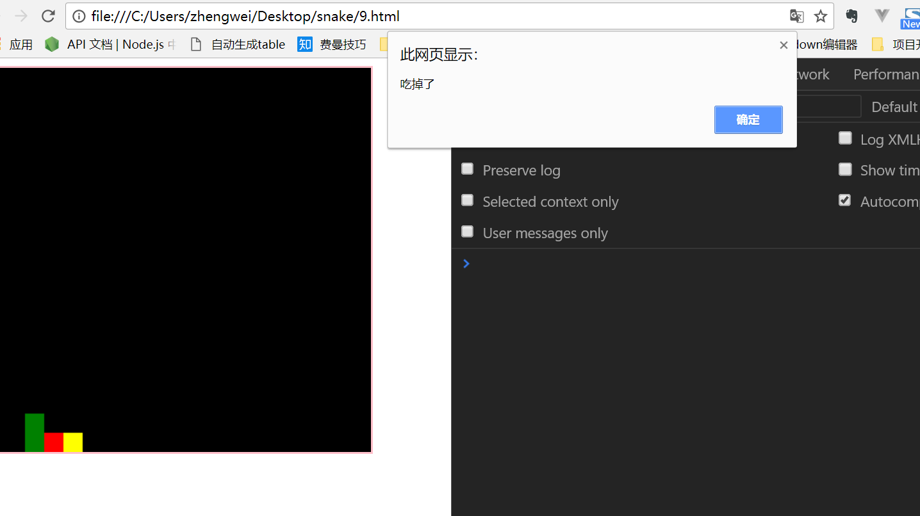

吃掉豆子之后，要做的事情是：
- 蛇身变长
- 重新生成豆子

我们先考虑第一件事情：
蛇身变长

所谓的蛇身变长，是指蛇之前所有的位置都是没有变，但在豆子这个地方变成了最新的蛇头 ----> 最后一段蛇身还是需要追加进去 ---> 我们还是得记录之前的最后个蛇身的位置

