## 使用vue ui搭建项目

要安装的东西：

1. vue router
2. vuex

安装的插件：

1. axios

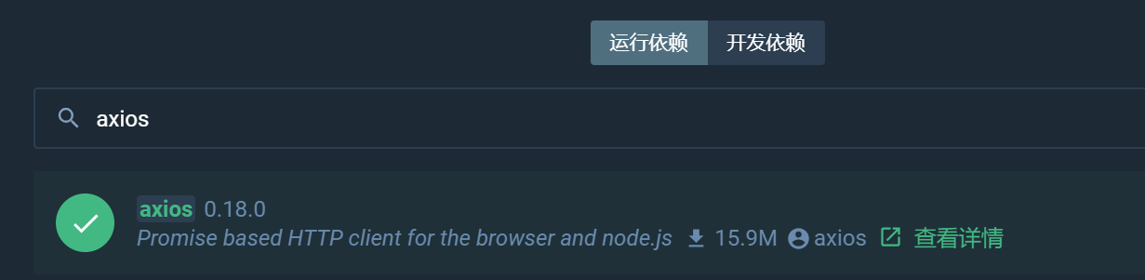

## 导入jquery,bootstrap

第一步、拷贝jquery,bootstrap文件到public中

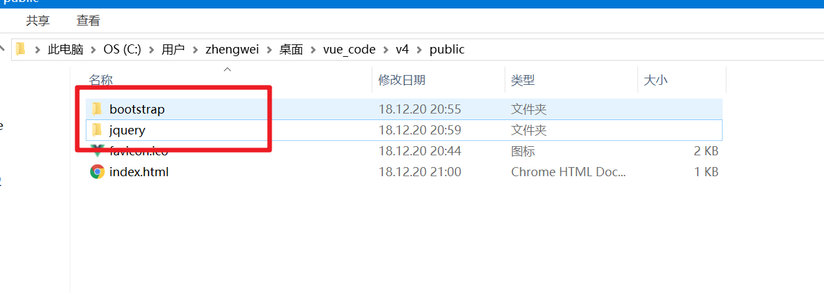

第二步、修改index.html文件

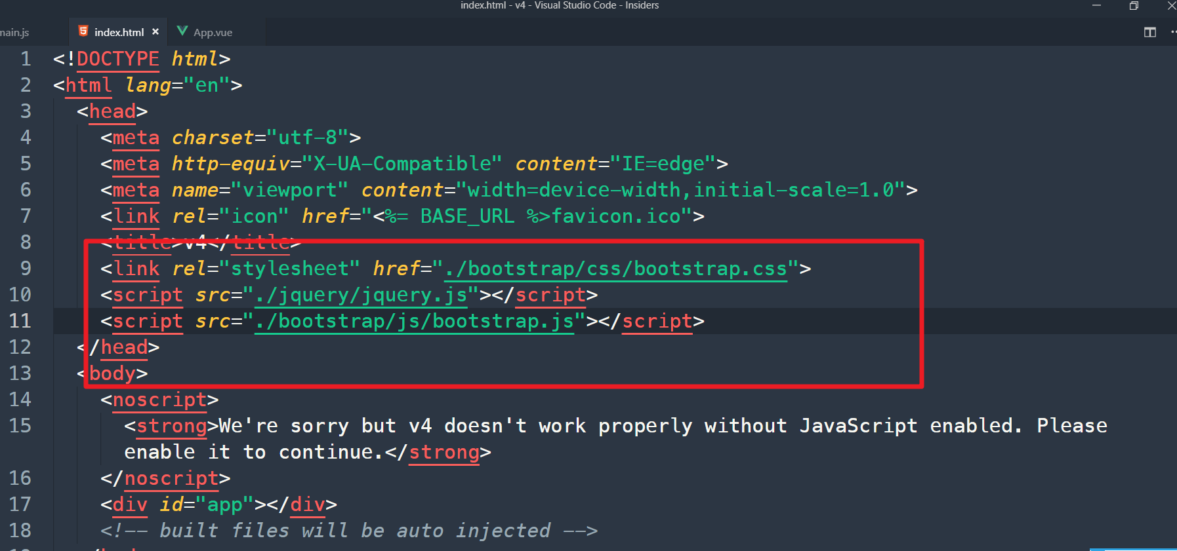

## 导航修改

修改App.vue代码为：

|  |
| --- |
| <template>  <div id="app">  <!-- Static navbar -->  <nav class="navbar navbar-default">  <div class="container">  <div class="navbar-header">  <button type="button" class="navbar-toggle collapsed" data-toggle="collapse" data-target="#navbar" aria-expanded="false" aria-controls="navbar">  <span class="sr-only">Toggle navigation</span>  <span class="icon-bar"></span>  <span class="icon-bar"></span>  <span class="icon-bar"></span>  </button>  <a class="navbar-brand" href="#">用户管理系统</a>  </div>  <div id="navbar" class="navbar-collapse collapse">  <ul class="nav navbar-nav">  <li>  <router-link to="/">主页</router-link>  </li>  <li>  <router-link to="/about">关于我们</router-link>  </li>  </ul>  </div><!--/.nav-collapse -->  </div><!--/.container-fluid -->  </nav>  <router-view/>  </div>  </template>  <style>  .router-link-exact-active{  background:#e7e7e7 !important;  }  </style> |

修改about.vue,home.vue代码如下：

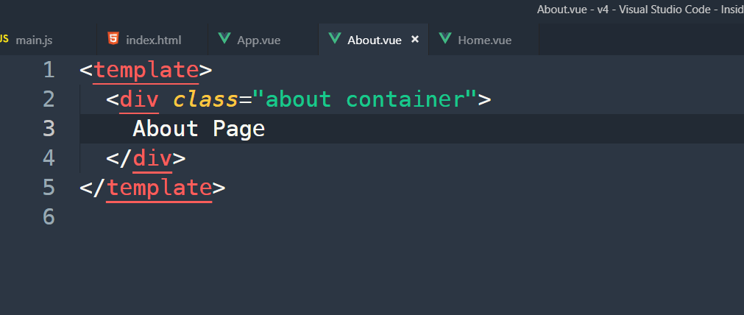

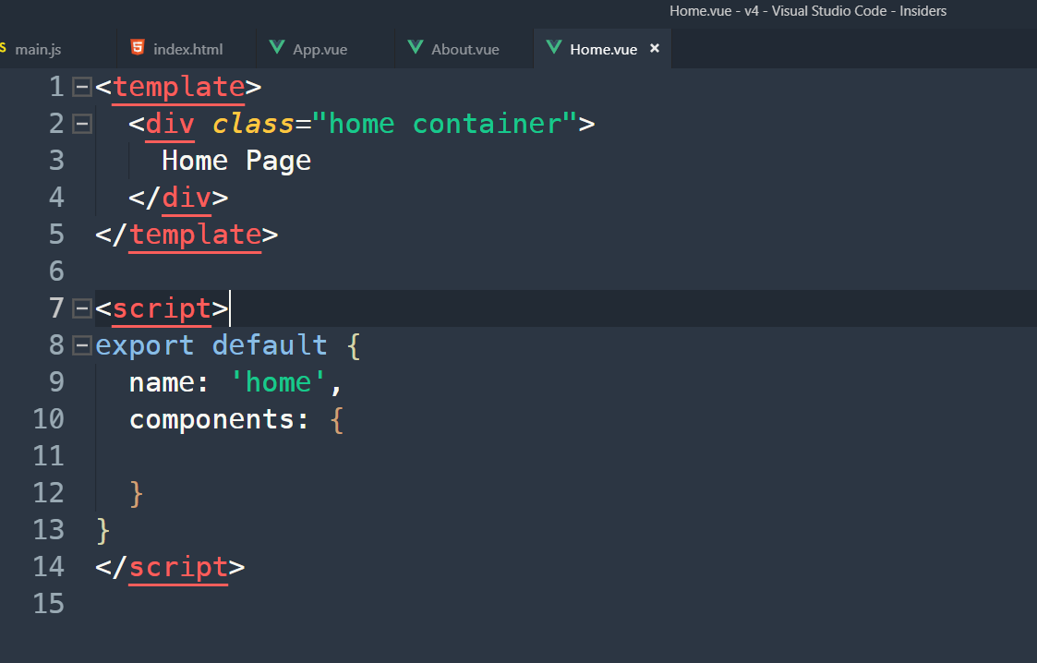

## 列表静态页面

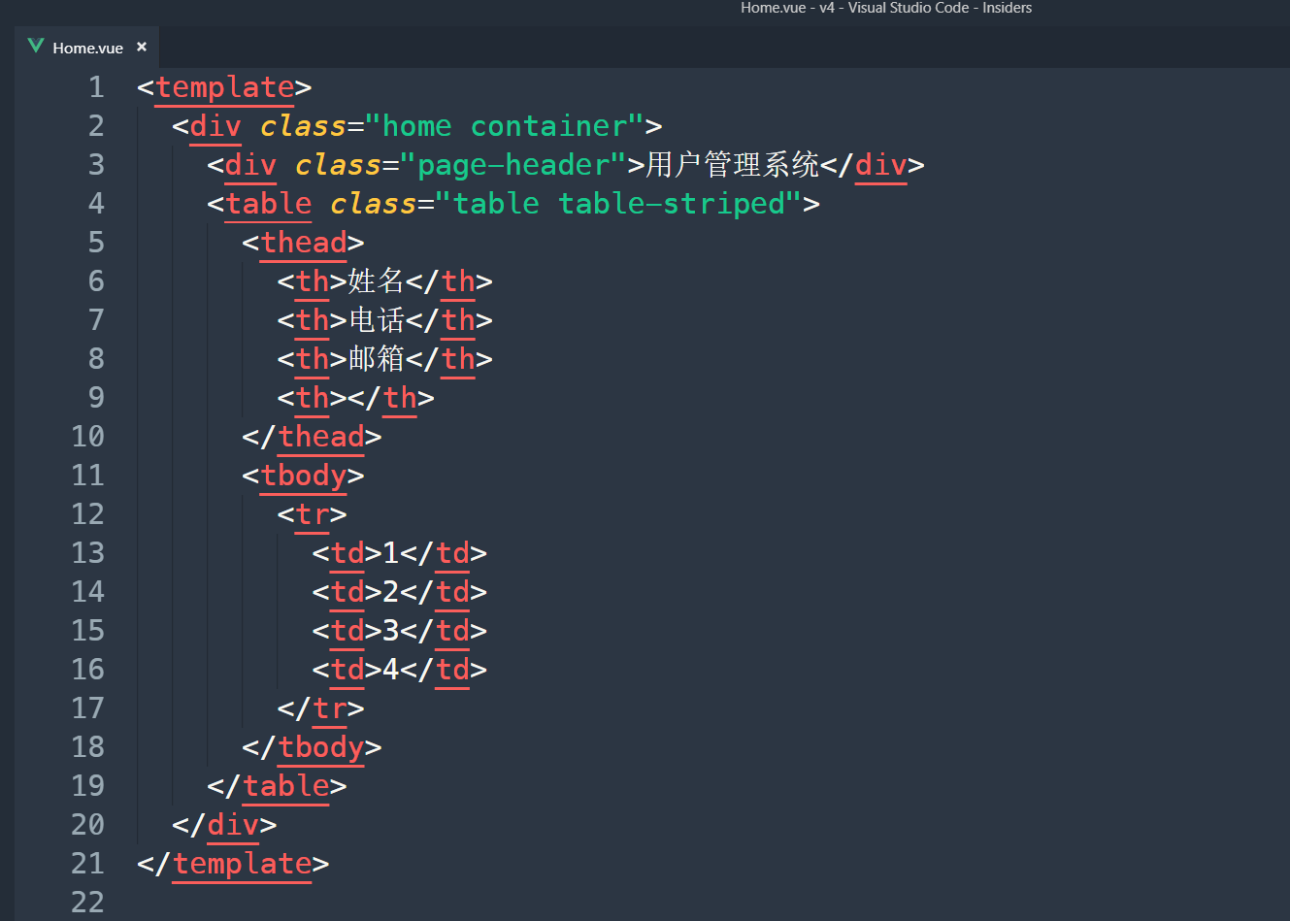

## 开启json-server接口服务

第一步、创建.env.development文件

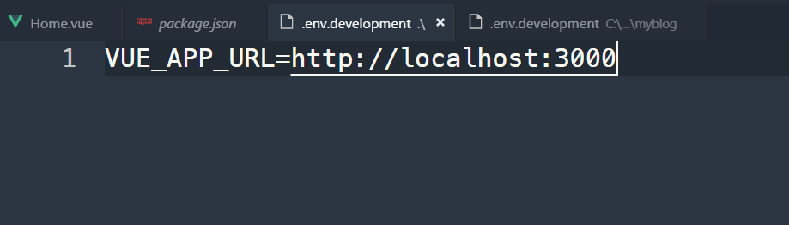

第二步、

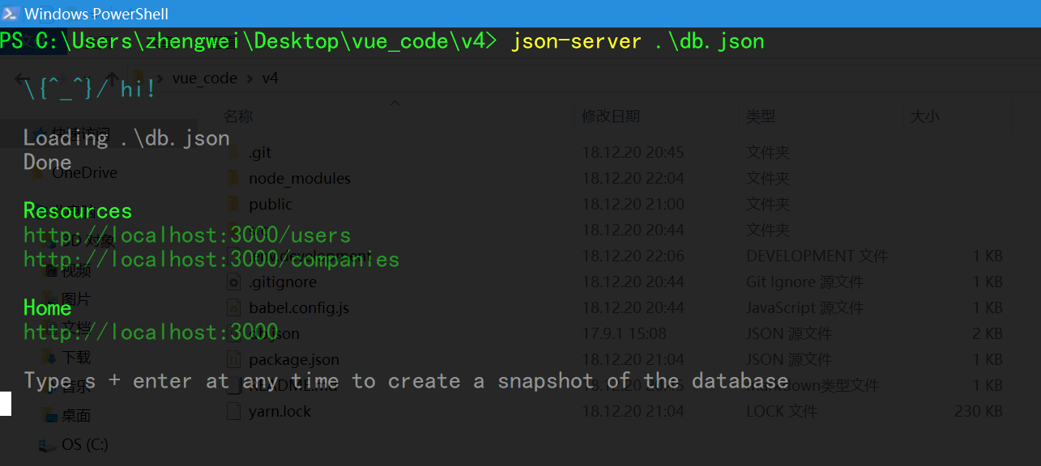

第三步、修改main.js代码

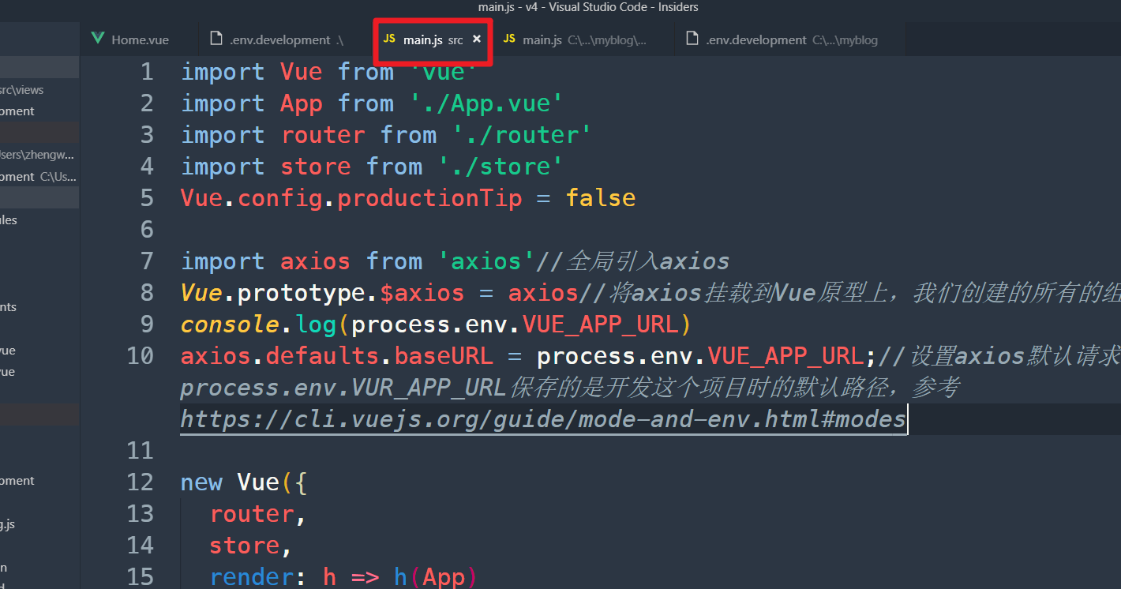

## 请求数据

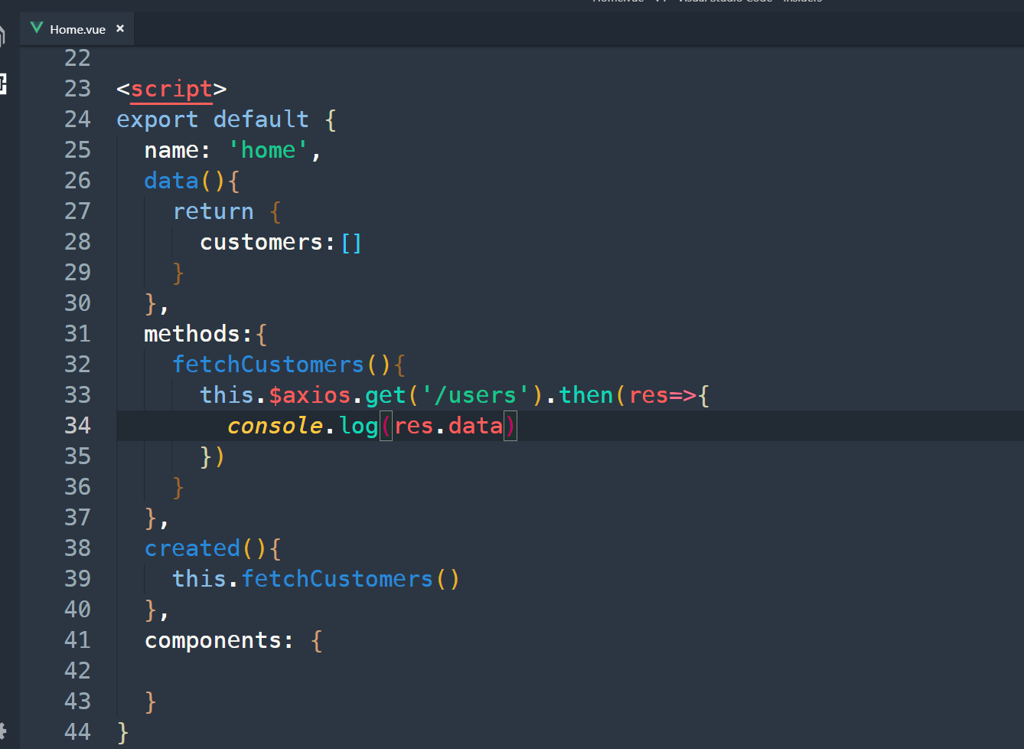

## 把数据渲染到页面上

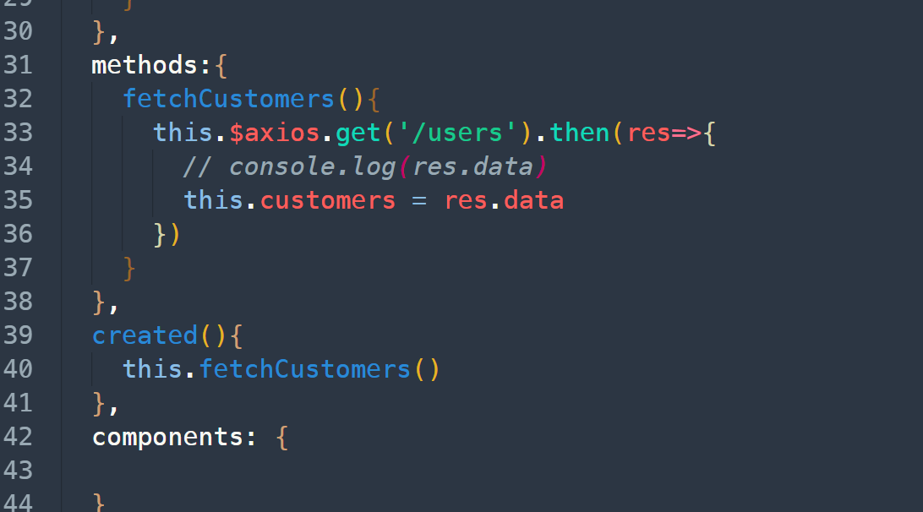

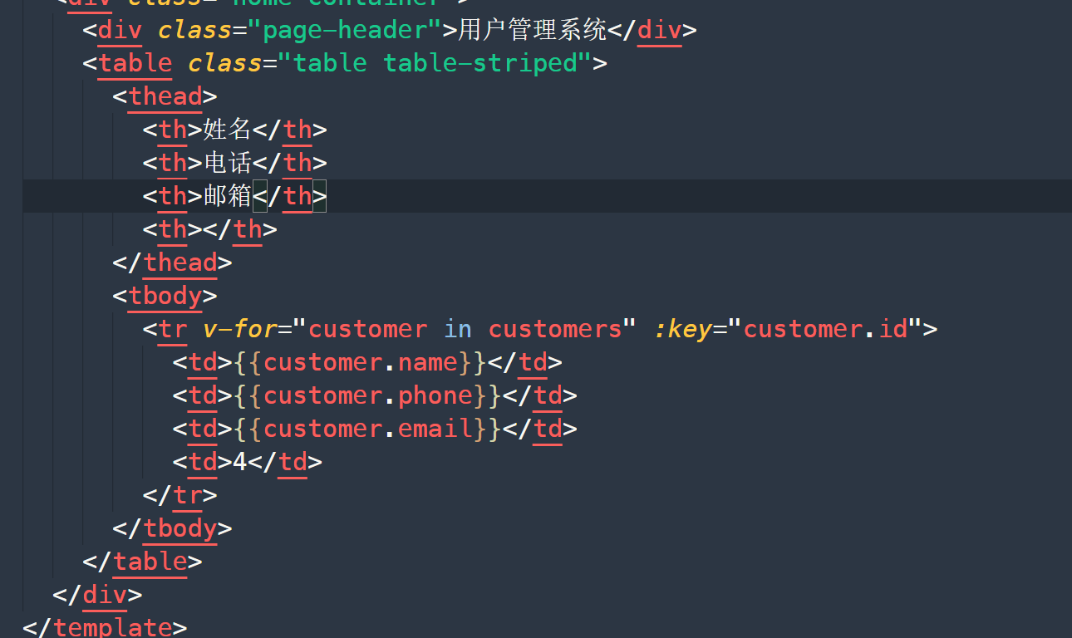

## 添加Add.vue

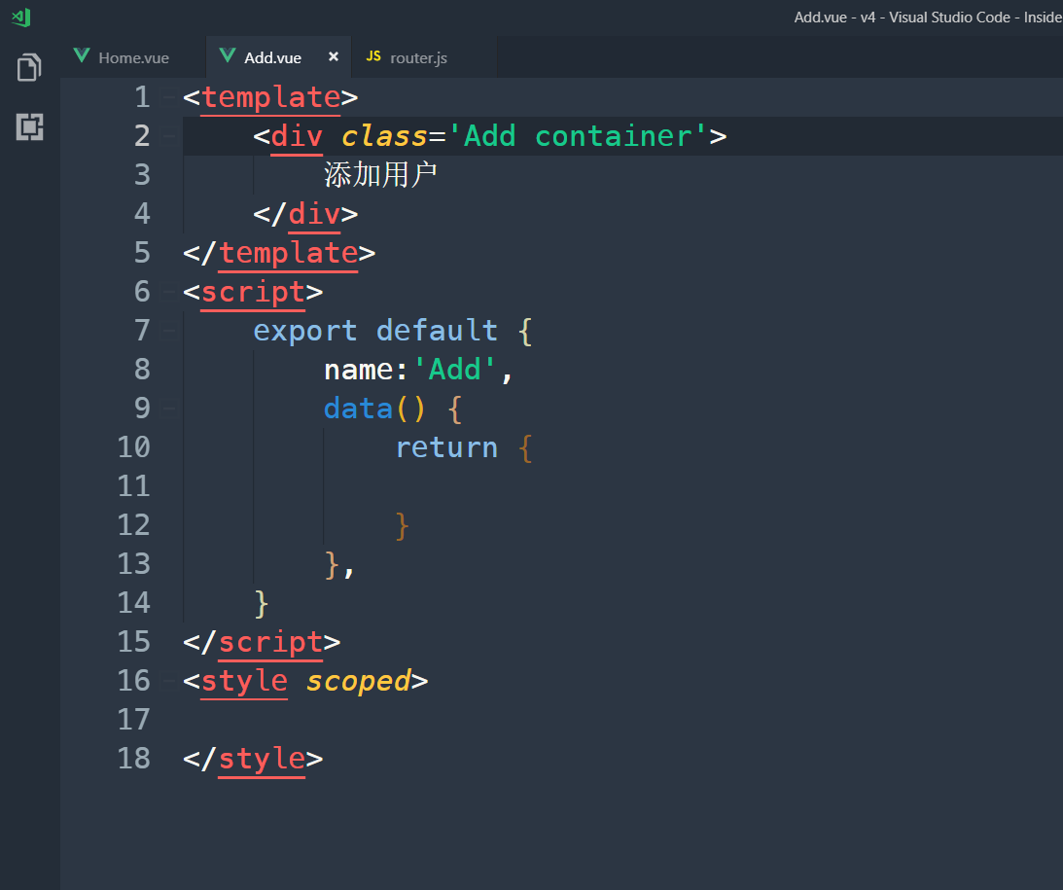

## 规划添加路由

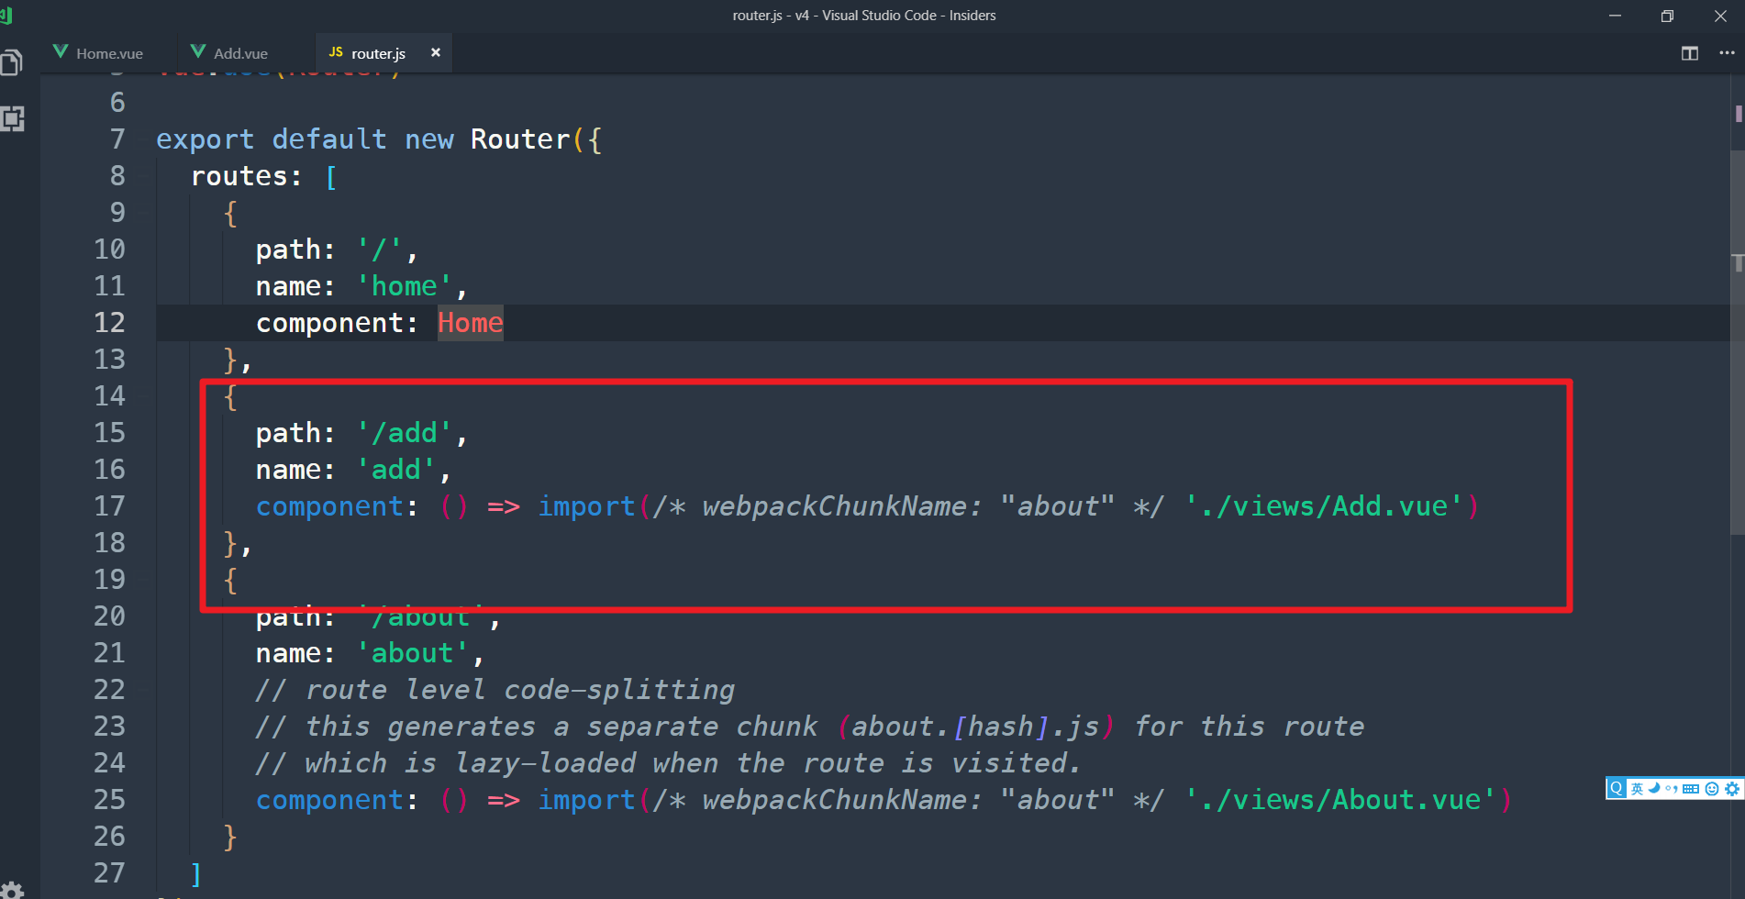

## 修改App.vue

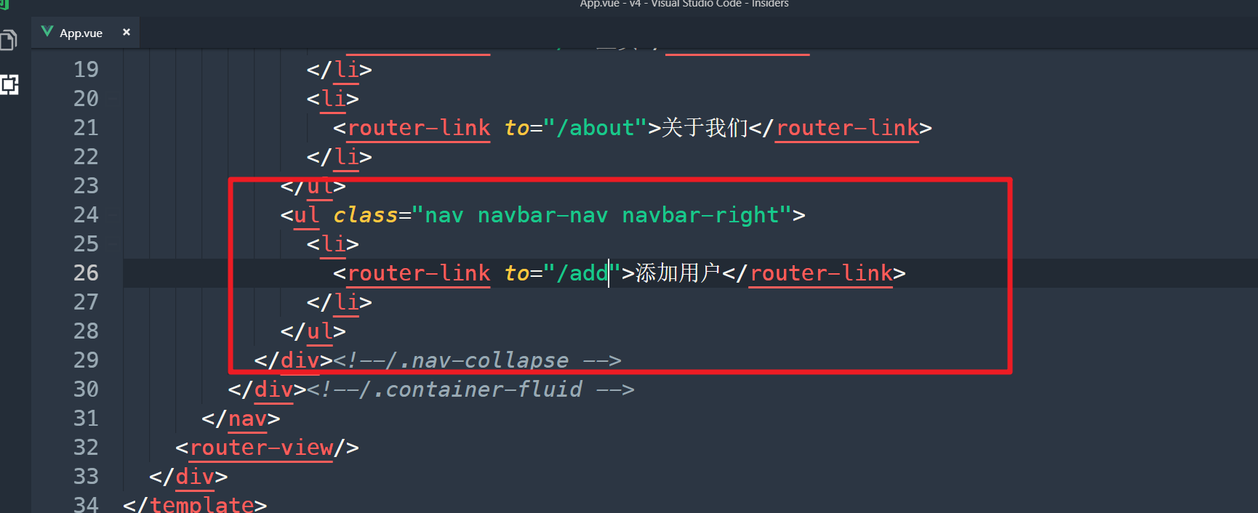

## 修改Add.vue

|  |
| --- |
| <template>  <div class='Add container' @submit="addCustomer">  <h1 class="page-header">添加用户</h1>  <form>  <div class="well">  <h4>用户信息</h4>  <div class="form-group">  <label for="">姓名</label>  <input type="text" class="form-control" v-model="customer.name">  </div>  <div class="form-group">  <label for="">电话</label>  <input type="text" class="form-control" v-model="customer.phone">  </div>  <div class="form-group">  <label for="">邮箱</label>  <input type="text" class="form-control" v-model="customer.email">  </div>  <div class="form-group">  <label for="">学历</label>  <input type="text" class="form-control" v-model="customer.education">  </div>  <div class="form-group">  <label for="">毕业学校</label>  <input type="text" class="form-control" v-model="customer.graduationschool">  </div>  <div class="form-group">  <label for="">职业</label>  <input type="text" class="form-control" v-model="customer.profession">  </div>  <div class="form-group">  <label for="">个人简介</label>  <textarea class="form-control" v-model="customer.profile" name="" id="" cols="30" rows="10"></textarea>  </div>  <div class="form-group">  <button type="submit" class="btn btn-primary">添加</button>  </div>  </div>  </form>  </div>  </template>  <script>  export default {  name:'Add',  data() {  return {  customer:{}  }  },  methods:{  addCustomer(e){  e.preventDefault()  alert(1)  }  }  }  </script>  <style scoped>  </style> |

## 实现添加功能

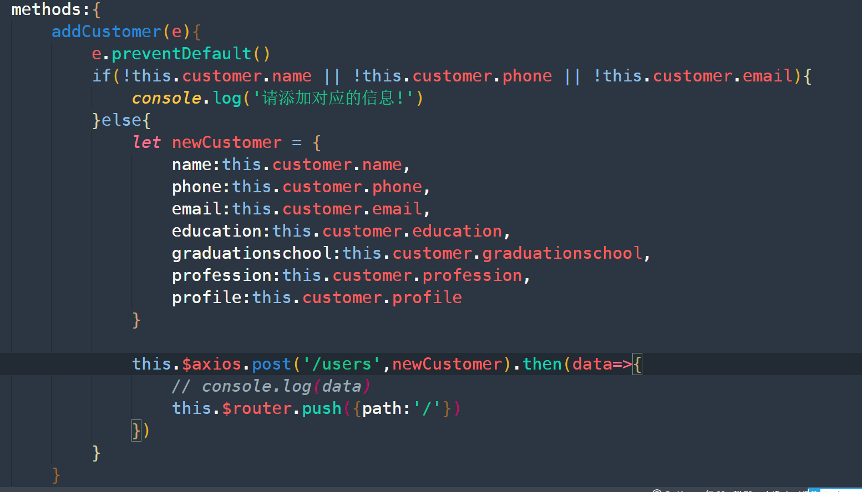

## 创建Alert.vue

在components当中创建

|  |
| --- |
| <template>  <div class='Alert'>  <div class="alert alert-warning alert-dismissible" role="alert">  <button type="button" class="close" data-dismiss="alert" aria-label="Close"><span aria-hidden="true">&times;</span></button>  <strong>Warning!</strong>{{message}}  </div>  </div>  </template>  <script>  export default {  name:'Alert',  props:['message'],  data() {  return {  }  },  }  </script>  <style scoped>  </style> |

## 修改Home.vue

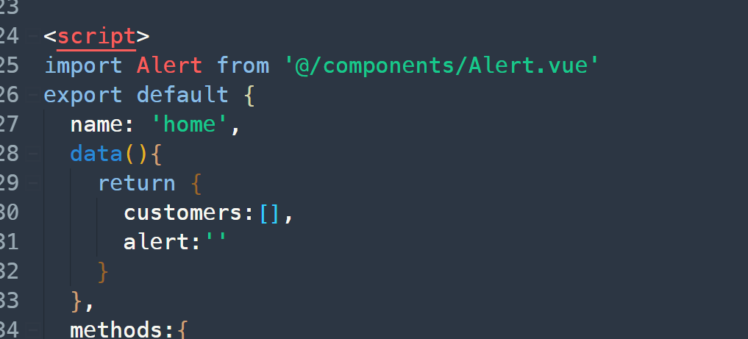

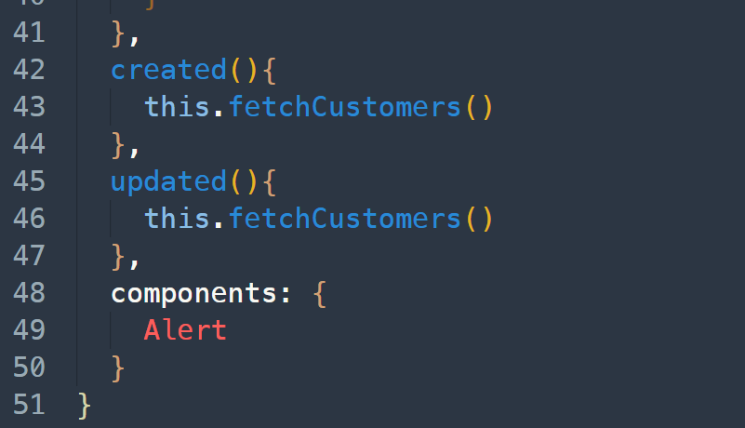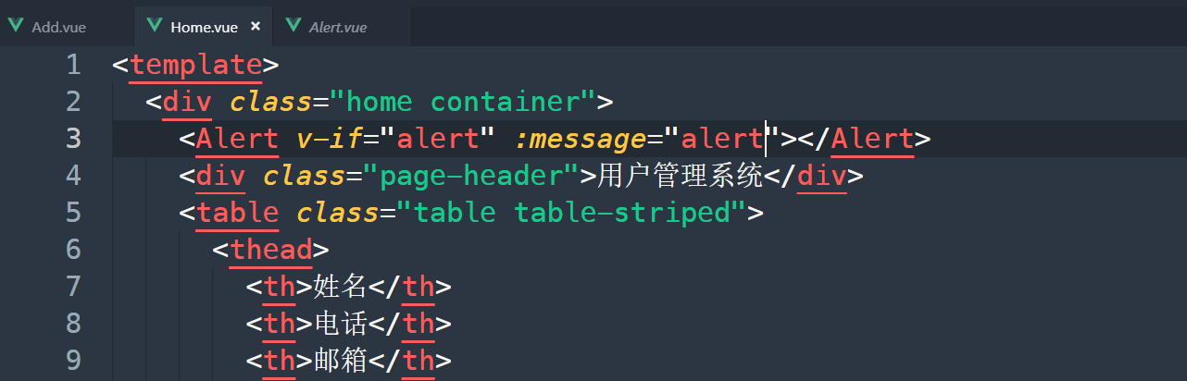

## 修改Add.vue

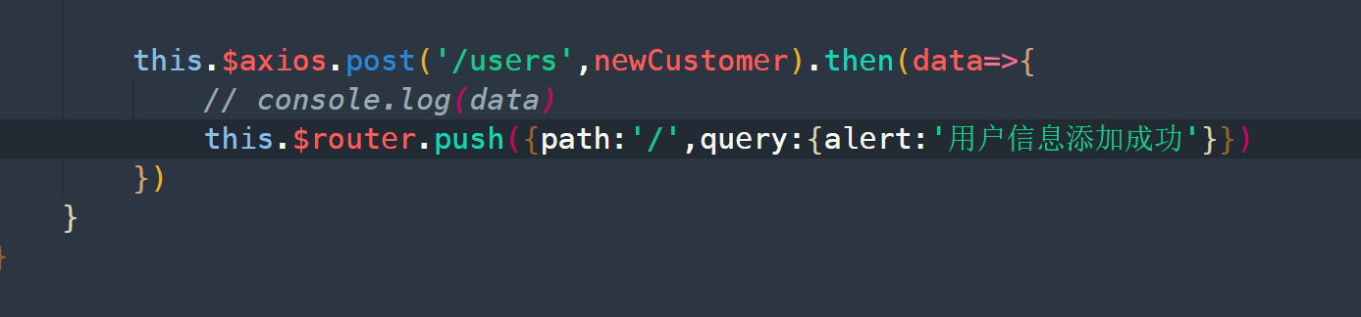

## 修改Home.vue

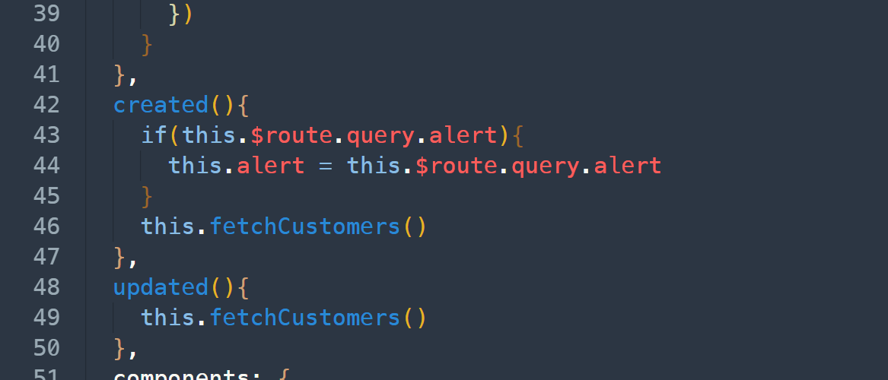

## 添加详情页组件和路由

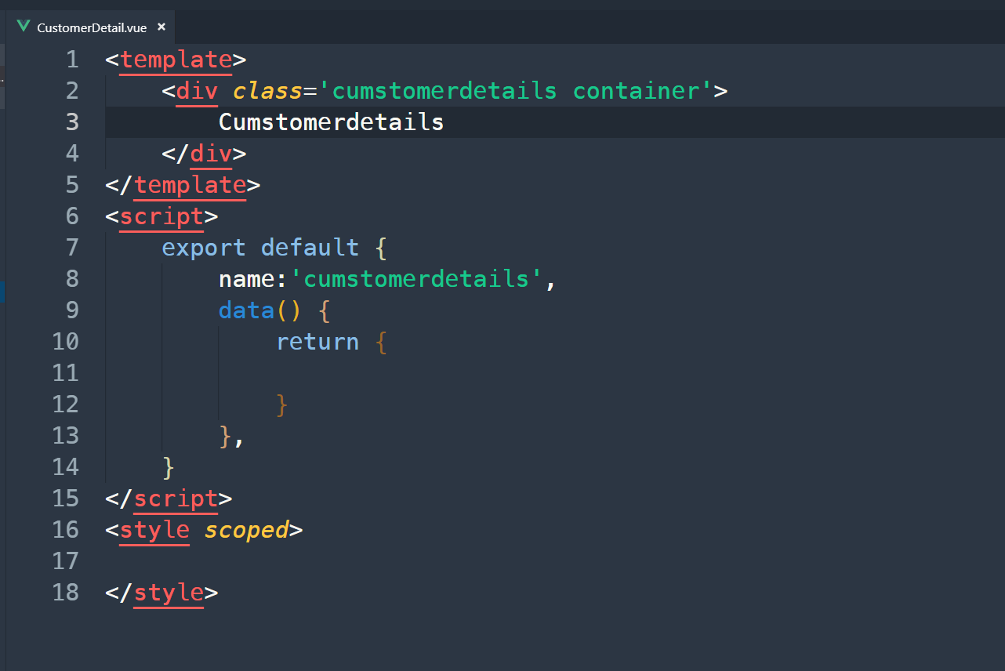

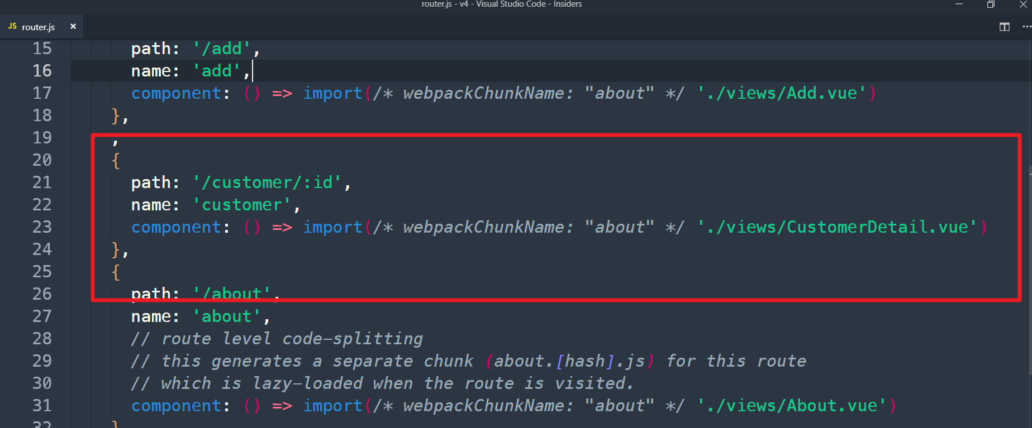

## 修改Home.vue

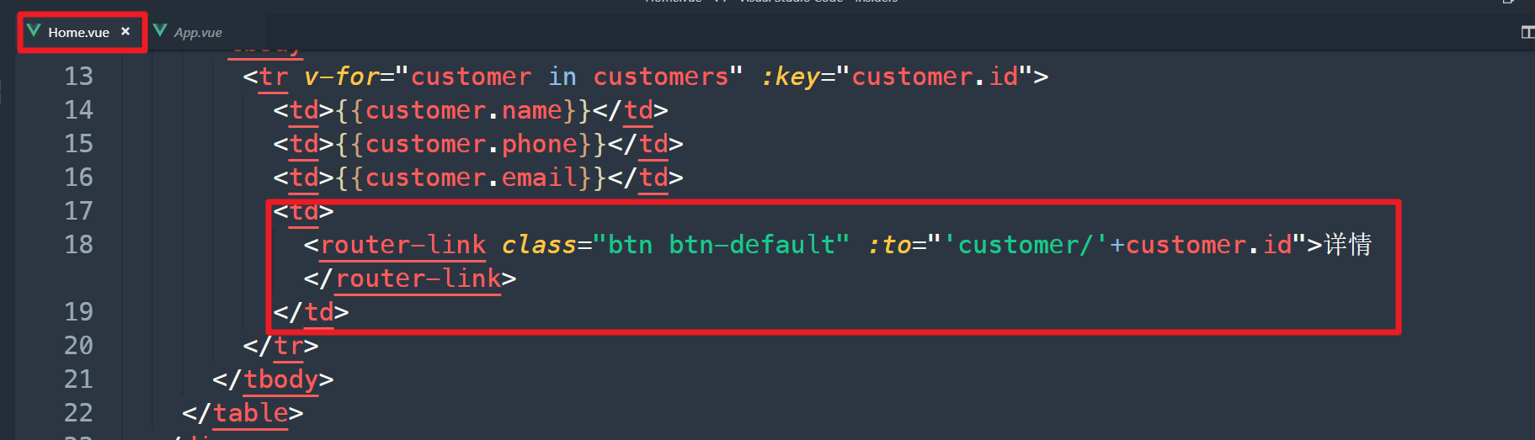

## 修改customerDetail.vue

|  |
| --- |
| <template>  <div class='cumstomerdetails container'>  <h1 class="page-header">{{customer.name}}</h1>    </div>  </template>  <script>  export default {  name:'cumstomerdetails',  data() {  return {  customer:''  }  },  methods:{  fetchCustomers(id){  this.$axios.get('/users/'+id).then(res=>{  console.log(res.data)  this.customer = res.data  })  }  },  created(){  this.fetchCustomers(this.$route.params.id)  }  }  </script>  <style scoped>  </style> |

## 添加编辑、删除按钮

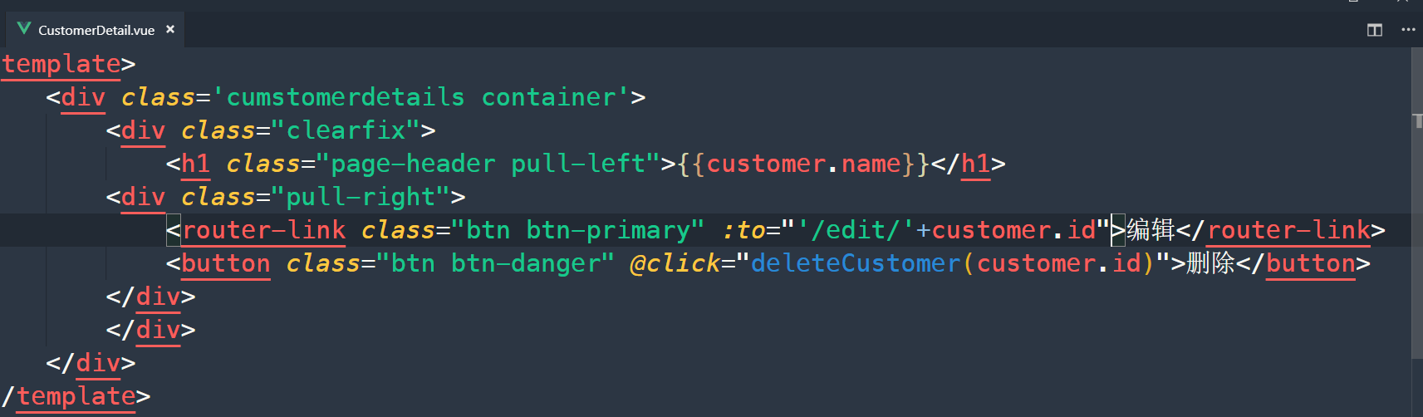

## 删除功能

CustomerDetail.vue

