GEOL1370: Environmental Geochemistry
Analysis of Organic Contaminants
Goals:
- To introduce and demonstrate the materials and equipment used for analysis of organic compounds
- To analyze temporal changes in organic contaminants in Narragansett Bay
- To determine sources of organic contaminants based on temporal variability in the contaminants

Introduction:
Polychlorinated biphenyls (PCBs) and polycyclic aromatic hydrocarbons (PAHs) are common organic contaminants in environmental samples. PCBs are manmade compounds used as coolants in electrical systems. PCBs are persistent organic pollutants (meaning they degrade very slowly) and are toxic, acting as teratogens, mutagens, and carcinogens in humans and other animals. Domestic production of PCBs was banned in 1979, but they persist in many environments.
PAHs are a byproduct of biomass burning, and therefore occur in natural environments, but are also a product of anthropogenic activities. Some PAHs have been identified as carcinogenic, mutagenic, and teratogenic. These are the compounds that supposedly make grilled food carcinogenic.
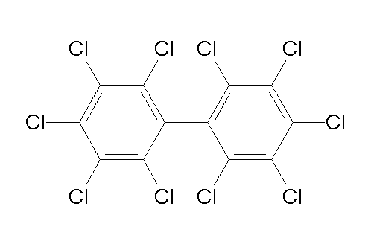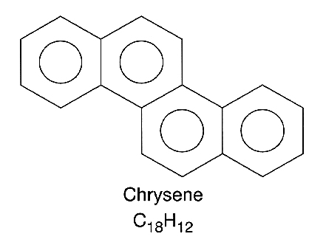
An example of a PCB (left) and a PAH (right)

Overview:
Today we will take a tour of the organic geochemistry lab where we prepare samples for PCB and PAH analyses. We will then have a brief introduction to the gas chromatograph-mass spectrometer, a machine that we use to analyze PCBs and PAHs.

Today we will be introduced to the following analytical steps:
1. extract organic compounds from a sediment sample
2. separate organic compounds by polarity (to clean the sample)
3. use a gas chromatograph to analyze the amount of compounds in a sample

Once we have toured the lab where we prepare samples and analyze organic contaminants, we will analyze existing organic contaminant data for Narragansett Bay.
Organic compound extraction from sediments
We place our samples in little pressure capsules that then are pumped full of organic solvents at high pressure and temperature on the Accelerated Solvent Extractor (ASE). This helps to extract the target compounds out of the sediment samples. The sediments are rinsed three times with solvent, which is collected in a large vial. This solvent, with all of the organic compounds, is called the total lipid extract (TLE). We use the TLE for the rest of our work.
Purification of PAHs
We use flash column chromatography to purify PAHs. Using a combination of alumina and silica gel solid phases allows us to separate compounds by polarity (a measure of the distribution of electrons in a molecule). We separate the TLE into acid compounds fraction and neutral fraction by using the aminopropylsilyl (LC-NH2)column. We further separate the neutral fraction using different solvents with a silica gel column. PAHs have a medium polarity and so will elute from a silica gel column with a solvent of medium polarity. In this case, we use hexane (a non-polar solvent) to first flush out the straight-chain hydrocarbons, and then we use dichloromethane (DCM) to flush out the PAHs. All very polar compounds will remain stuck to the silica gel.
Gas chromatograph-mass spectrometer
A gas chromatograph separates and analyzes compounds by vaporizing them at increasing temperatures and directing them through a long, thin tube called a column. The column is lined with a solid phase, much like the flash columns that we learned about in the prep lab, that interacts with the compounds being analyzed. More volatile and less polar compounds interact with the column lining less, and therefore elute out of the end of the column faster than less volatile and more polar compounds. When a compound elutes, it is detected by the mass spectrometer, resulting in a peak on the chromatogram.
The mass spectrometer uses an electron beam to break the eluted compounds into smaller ions, which then are detected by mass. This allows us identify the compounds, since each compound breaks in a characteristic way.
Lab #4 Report
Remember to show your work, units, and explain your reasoning!
- [30 pts] A soil has a bulk density of 1.29 g/cm³ and an organic carbon content of 1%. The porosity of the soil is 30%, of which 50% is occupied by water and 50% by air.
- Using values given below, find the percentages of benzene and 2-butanone contained within the solid, liquid, and gas phases.
- Comment on the how water solubility, Henry’s constant and K_{ow} (octanol-water partitioning coefficient) affect the distribution of these compounds in the three phases.
 | BP  ºC | Density  25ºC | Water solubility  (mg/l)  25ºC | Vapor pressure  mm Hg  10ºC | Henry’s constant  (dimensionless)  25ºC | K_{ow}
Benzene | 80.1 | 0.88 | 1770 | 47.8 | 0.22 | 134.9
2-Butanone | 79.6 | 0.7994 | 26,800 | 314.3 | 0.001 | 1.82
c. Briefly explain the reasons for different partitions in the three phases for benzene and 2-butanone. If you flush the soil three times with water at 25°C (i.e., to replace the soil water three times by withdrawing and addition), what are the percentages of benzene and 2-butanone removed from the system, respectively?
- [20 pts] An aquifer is contaminated with benzene (C₆H₆). The contaminated zone in the aquifer contains 1000 moles of O₂, 600 moles of NO₃⁻ and 3600 moles of available Fe(OH)₃. Assuming microbial respiration of benzene will proceed to completion (i.e., all the electron acceptors will be used up to oxidize the benzene to carbon dioxide), what is the maximum amount of benzene that can be removed by the biodegradation (or also called “intrinsic bioremediation”)? Your lecture slides have balanced chemical reactions between benzene and above TEAs. The number you just arrived at is called “assimilative capacity”.
- [40 pts] Plot the downcore Narragansett Bay PAH and PCB data by depth (Raw data can be found on our lab website: http://zhengyinsui.github.io/organics.html). Write a few sentences describing how the concentrations change through time, whether they change at the same time, and why the concentrations change. Include a copy of your plot with your lab report. Be sure to label axes clearly and correctly. (You can download the related paper on lab website if you want to read more about PAH pollution in Narragansett Bay).
- [10 pts] If you have a set of sediment samples and you want to know the PAH concentration of your samples. Explain briefly on how you will analyze them (extraction; purification, which solvent fraction will contain PAH; What equipment are you going to use for analyzing your PAH concentration).

