SEMI P43-0304 （中英文对照稿20141025）
PHOTOMASK QUALIFICATION TERMINOLOGY
光掩模版质量评定术语
This terminology was technically approved by the Global Micropatterning Committee and is the direct responsibility of the European Micropatterning Committee. Current edition approved by the European Regional Standards Committee on January 9, 2004. Initially available at www.semi.org February 2004; to be published March 2004. This document replaces SEMI PR7-0302 in its entirety.

该术语由欧洲微图形化委员会负责制定并由全球微图形化委员会技术审定。本版由欧洲地区标准委员会于2004年1月9日批准。2004年2月第一次在www.semi.org上发布, 2004年3月出版。该文档整体取代SEMI PR7-0302。

1 Purpose 目的
  - This standard defines a unique language in the field of specification for, and qualification of, photomasks for use in optical lithography within the semiconductor industry.
该标准定义一种专用于半导体工业光学光刻中描述光掩模版的参数和质量评定的术语。

2 Scope 使用范围
2.1 At present only the International Technology Roadmap for Semiconductors (ITRS) serves as a universally accepted working document on how to specify photomasks, however the definitions used are subject to interpretation. Different tool makers, mask makers and mask users are hindered in the communication with each other, as they first need to know and understand each others terminology. The lack of a common terminology complicates comparison of tools. A uniformly used, and universally accepted terminology, with a minimum of ambiguity, is required.
目前只有半导体国际技术路线图(ITRS)可以作为业界通用的描述如何定义光掩模版的有效文件，而相关的词汇含义在使用过程中还会有不同的诠释。而不同的设备制造商、掩模版生产者和掩模版使用者之间对这些词汇及其含义理解的差异阻碍了相互之间的交流。设备间的比较由于缺乏统一的术语而变得复杂。因此需要一套被业界完全接受并尽量减少词语的歧义性的统一的技术术语。
2.2 The definitions listed are for mask qualification, incorporating 3 possible types of value for a given
qualification parameter:
下面所列定义用于描述掩模版质量评定，包含了给定的质量评定参数数值的三中可能类型：
• <(true) qualification parameter>, which would be the result of an ideal measurement of the total population of features of interest1.
<(合格)质量评定参数>指全部被测结构中的理想测量结果。1 参见4.2节中的参考文献。
• <measured qualification parameter>, the result of a given population of measurements. It is hereby mentioned that a measured value (for example the mean, the standard deviation, the range) is always subject to the sample size of the measured population and the measurement method. Therefore both the sample size and the measurement method are mandatory information.
<实测质量评定参数>给定的测量总体的测量结果。由此所说的一个测量值（比如平均值、标准偏差、测量范围）都是与测量总体的样品尺寸和测量方法相关。因此样品尺寸和测量方法都是必要的测量信息。
• <qualification parameter spec(ification)>, the maximum or minimum value that may not be exceeded for the selected population of measurements which must be defined as mandatory information.
<质量评定参数规范>，所选被测总体的测量结果所不能超过的最大或最小值是必须提供的必要测量信息。
2.2.1 The first two types of value for a given parameter, the true and measured qualification parameters, will be defined in the present document.
本文件将对给定参数的合格和测量所得的质量评定参数这两种数值给予定义。
2.2.2 The third parameter type, the parameter specification, will not be discussed here, since it is subject to the agreement between the individual parties of the mask qualification process.
本文件将不涉及参数规范的定义，因为该参数的定义基于掩模版质量评定工艺中当事双方的协议。
2.3 In order to assist users, the major differences in recommended default values between this standard and the ITRS mask table definitions are noted where applicable.
为方便用户使用，如果本标准的推荐值与ITRS掩模版参数定义表存在重要差别，本文件将予以说明。
NOTICE: This standard does not purport to address safety issues, if any, associated with its use. It is the responsibility of the users of this standard to establish appropriate safety and health practices and determine the applicability of regulatory or other limitations prior to use.
说明：本标准不涉及在使用该标准时可能存在的任何安全事项。该标准的使用者有责任设立适当的安全和卫生准则并确定规则的适用性或其它使用限制。

3 Limitations 使用限制（约束）
3.1 This document is restricted to dimensional metrology aspects. Other conventional mask qualification aspects, including those related to materials, overlay and defectivity, are not considered within the scope of this version.
本文件只涵盖尺寸计量方面。关于常规掩模质量评定要素，包含材料，套刻和缺陷等其它方面没有包括在本版本中。
3.2 The definitions listed are specific to state-of-the-art photomasks, with a focus on reduction reticles. They may therefore overrule any related terminology in other standards, with a more general scope. Application to other types of masks, e.g., for next generation lithography, may be feasible, but is not within the scope of the present document.
本文所列定义针对于现行工艺水平的光掩模版，即缩小用掩模版。因此可以从更普遍的范围来取代其它标准中相关的条目。本标准也许可以用于其它类型的掩模，比如下一代光刻技术，但并不是本标准所针对的范围。

4 Referenced Standards 参考标准
4.1 SEMI Standards SEMI标准
SEMI P10 — Specification of Data Structures for Photomask Orders
光掩模版订单的数据结构标准
SEMI P19 — Specification for Metrology Pattern Cells for Integrated Circuit Manufacture
集成电路生产中计量用单元图形标准
SEMI P21 — Guidelines for Precision and Accuracy Expression For Mask Writing Equipment
掩模版描绘设备的精确度和准确性的表述方法
SEMI P22 — Guideline for Photomask Defect Classification and Size Definition
光掩模版的缺陷分类和尺寸定义方法
SEMI P24 — CD Metrology Procedures
关键尺寸计量规范
SEMI P35 — Terminology for Microlithography Metrology
微光刻计量术语
SEMI Compilation of Terms SEMI词汇表
4.2 ISO Standards 2 ISO标准 2 International Organization for Standardization 1, rue de Varembé Case Postale 56 CH-1211 Genève 20 Switzerland 国际标准化组织
International Vocabulary of Basic and General Terms in Metrology 国际基础和通用计量术语词汇
4.3 Other Standards 其它标准
International Technology Roadmap for Semiconductors (ITRS) 3 国际半导体技术路线图(ITRS) 3 International Technology Roadmap for Semiconductors, organized by International SEMATECH, 2706 Montopolis Drive, Austin, Texas 78741, see itrs.org 国际半导体技术路线图，由位于2706 Montopolis Drive, Austin, Texas 78741， USA的国际 SEMATECH组织编写
NOTICE: Unless otherwise indicated, all documents cited shall be the latest published versions.
注意： 除非特别标明，所有引用文献都应是本标准编制时最新的版本。

5 Interpretation of Related General Terminology 相关通用术语解释
NOTE 1: This paragraph includes general terms, as a basis for the specific mask related terminology, which is the main subject of this document.
备注1：本章包含的通用词条作为特指的掩模版相关术语的基础，而掩模版相关术语是本文件的主要主题。
5.1 feature — as defined in SEMI P35.
图素—参见SEMI P35中的定义。
5.2 proximity range — distance over which a feature influences another significantly (criterion to be stated). This term applies to mask fabrication, mask metrology and/or printed wafer image, defining 3 types of proximity range (for example mask fabrication proximity range). It is mandatory to state which of the 3 types is referred to.
邻近范围 — 一个图素会对另一个图素造成显著影响（标准另述）的距离 。该术语用于掩模版制造，掩模版计量和/或成图于硅片时三种情形下的邻近范围 （如掩模版制造邻近范围）。使用时必须表明所适用的类型。
NOTE 2: Within this document proximity range will refer by DEFAULT to the first type mentioned.
备注2：本文中的邻近范围默认为上文所提到的第一种类型。
5.3 line — （in?）a clear field, dark feature of quasi-infinite length (>> proximity range) determined by its width. A line is an example of a 1D feature (see Figure 1).
线条 —在透明区域中由其宽度决定的，较之于邻近范围其长度可视为无限的不透明图素，线条是一维图素 （见图1）。
5.4 space — in analogy to line, but a clear feature in a dark field (see Figure 1).
间距 — 与线条类似，所不同的是它是不透明区域中的透明图素（见图1）。
5.5 contact — a clear feature in a dark field with length: width ratio ranging from 0.5 (1 is default) to 2 maximum (see Figure 1). The width of such feature may be measured as if it were a 1D feature, but for enhanced relevance it requires 2D assessment such as an area measurement. A large contact can be called a window.
通孔—不透明区域中具有一定长度的透明图素：宽度比例从0.5（默认值为1）到2（最大值）。测量该图素的宽度时它可以被看做一维图素，而为强调图素长度与宽度的相关性需对其进行二维评价，如面积测量。大的通孔也可称为窗口。
5.6 dot — in analogy to contact, but a dark feature in a clear field (see Figure 1). A large dot can be called a pad.
点—与通孔类似，所不同的是它是透明区域中的不透明图素（见图1）。大点也可称为（引线）盘。
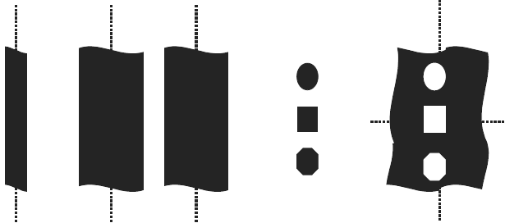
line
线条

space
间距

dots
点

contacts
通孔

Figure 1 图一
Nomenclature for Feature Types (as Designed) 图素类型的命名（如同设计）
Default contact (dot) is square. 通孔（点）的默认形状为正方形。

5.7 isolated feature — feature that has no neighbors that are within a distance smaller than the proximity range to any edge of the feature.
孤立图素—在距该图素小于邻近范围的距离内没有其它任何图素。
5.8 dense features — features that influence each other (i.e., features that are not isolated). Clarification is required to describe the proximity, either by detailing the feature pitch and number of lines, for regular arrays (pitch = design values of line width and space width added), or by describing the surrounding area (see Section 7). In absence of such clarification dense is regarded by default as equal lines and spaces in a semiinfinite array size, insofar that the feature width does not exceed the proximity range.
密集图素（形）—互相影响的图素（即非孤立图素）。对于规则的阵列（步距（周期？）=线条设计宽度加上空间宽度）需要通过详细描述图素步距（周期？）和线条数量对邻近范围给予说明，或对测量区域加以描述（见第7节）。如果没有这类说明且在图素的宽度没有超过邻近范围的情况下，则将在半无限的阵列尺寸中等宽度的线条和间距默认为密集图素。
5.9 nominal feature — feature as it is intended. This usually corresponds to the data used for mask making, including any pre-compensation to overcome process biases of the wafer process (e.g., subresolution features such as hammerheads and serifs), but excluding any pre-compensation that is purely done to deal with mask process limitations (e.g., chrome etch bias). In the simplest case it corresponds to the original design itself.
名义图素—目标图素。通常对应于掩模版生产所使用的数据，这些数据为克服集成电路生产工艺中的偏差而附加了预补偿（如锤头和辅助线类的亚分辨率图素），但不包含仅为处理掩模版生产工艺限制所做的任何预补偿（如铬刻蚀偏差）。简单来说就是对应于其本身的初始设计。
5.10 actual feature — feature as it is on the mask. In practical cases this will include deviations in feature widths, lengths, shape and position from the nominal feature.
实际图素—掩模版上的图素。这些图素包含了名义图素以及在宽度、长度、形状和位置上的误差。
NOTE 3: A feature, whether actual or nominal, may contain holes, as shown in Figure 2.
备注3：不管是实际还是名义图素，都包含孔，见图2。
5.11 pattern — subset of a layout containing one or more features.
图形—包含一个或多个图素的版图子集。
NOTE 4: It is possible that some features are only included in part, see clipped feature.
备注4：也有可能只包含部分图素，见被剪切的图素。


Figure 2 图2
Example of Features Containing Holes 包含孔的图素示例
(left: nominal; right: actual) （左边：名义图素；右边：实际图素）

5.12 region of interest (ROI) — circumscribed section of a pattern that contains (parts of) the features
considered for measurement.
关注区(ROI) —确定范围的包含（部分）欲测量图素的图形。
NOTE 5: It is recommended to make the ROI as small as possible without affecting the obtained result.
备注5：在不影响测量结果的情况下关注区要尽可能的小。
5.13 clipped (nominal/actual) feature — the part of the (nominal/actual) feature lying within the region of interest (Figure 7). 被剪切的（名义/实际）图素—位于关注区内的（名义/实际）图素部分（图7）。
5.14 feature (or Pattern) alignment — positioning of nominal and actual feature (or pattern) relative to eachother (see Section 8.4).
图素（或图形）对准—名义和实际图素（或图形）之间的相互定位（见图8）。
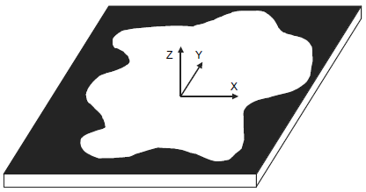
Figure 3 图3
Mask Coordinate System 掩模版坐标系

6 Coordinate System 坐标系
6.1 The coordinate system XYZ for this document is defined in Figure 3. It is defined with patterned mask side upwards and mask orientation as it was patterned. XY determines the mask plane. Z is the direction perpendicular to it. z = 0 at the absorber–substrate interface and z < 0 to the substrate side. Absorber is for example chrome or embedded material. (x,y) = (0,0) is tool or application specific.
图3定义了本文件所使用的XYZ坐标系。坐标系的定义采用掩模版的图形面向上，图形方向与绘图时相同。XY确定了掩模版平面，Z方向垂直于掩模版平面。z = 0定义为滤光层与衬底的界面且z < 0朝向衬底方向。滤光层可以为铬或嵌入材料。(x,y) = (0,0)由设备或特定的用途确定。
6.2 Features are called vertical when their length is along Y. Feature width is then measured in X. This
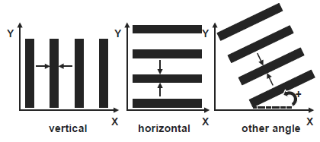
corresponds to Figure 2 of SEMI P35. Horizontal features have their length along X. Feature width is then measured in Y. See Figure 4.
Figure 4 图4
Orientation of Mask Features 掩模版图素的方向
垂直
水平
其它角度
垂直图素的长度方向与Y坐标轴平行。垂直图素的宽度沿X轴测量。对应于SEMI P35中的图2。水平图素的长度方向与X坐标轴平行。水平图素的宽度沿Y轴测量。见图4。Figure 4 Orientation of Mask Features

7 1D Mask Qualification Terminology 一维掩模版质量评定术语
7.1 feature width — width of a cross section of a mask feature at a certain height defined by an appropriate bounding box model as described in SEMI P35 (see Figure 5). The bounding box model must be stated as mandatory information, as well as the z height of the measurement. DEFAULT is at z = 0.
图素宽度—用在SEMI P35中所描述的适当的界定框模型（见图5）定义的在掩模版图素一定高度上的横截面的宽度。界定框模型和测量值所在的z轴的高度是必须提供的信息。默认值是在z = 0处测得的宽度。
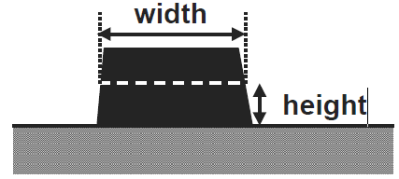
Figure 5 图5
Cross Section of a Mask Feature掩模版图素的横截面
宽度
高度

7.2 measured feature width — width determined from the measured signal obtained on the mask feature. For example, the width may be determined at a certain level of the measured signal. To be stated as mandatory information:
测得的图素宽度—由掩模版图素上获得的一定的信号水平所确定的宽度。所必须提供的信息包括：
• region of interest. For 1D features this corresponds to the specified line segment (SEMI P35).
关注区。对于一维图素就是指定的线段(SEMI P35)，
• measurement method used (SEM, optical reflection, optical transmission, AFM, etc.),
所采用的测量方法（扫描电镜，反射光，透射光，原子力显微镜，等），
• calibration and/or correlation used,
所采用的校准和/或关联方法，
• precision (SEMI P24),
精确度，
and as optional information: 和下面选项：
• measurement tool (vendor, model or any tool specific options), and
测量工具（生产商，型号或特定选配项），及
• measurement algorithm used.
采用的测量算法。
NOTE 6: The bounding box could be infinitely short as in the special situation of a measurement of a feature using a crosssection.
备注6：在使用横截面测量图素的特定情况下界定框可以无限短。
7.3 feature width deviation (from target) — difference between actual and nominal feature width.
图素宽度偏差（与目标值比较）—图素的实际宽度与名义宽度的差别。
7.4 measured feature width deviation (from target) — difference between measured and nominal feature width.
测得的图素宽度偏差（与目标值比较）—图素测得的宽度与名义宽度的差别。
7.5 feature edge — position of the material boundary of a mask feature at a certain height of the physical cross section (see Figure 2 of SEMI P35), to be stated as mandatory information. DEFAULT is feature/substrate interface.
图素边缘—在物理横截面（见SEMI P35中的图2）的一定高度上掩模版图素的材料边界位置是必须提供的信息。默认值是图素与衬底的界面。
7.6 measured feature edge — position determined from the measured signal obtained on the mask feature edge. For example position determined at a certain level of the signal, as defined by the bounding box model of SEMI P35. The same mandatory/optional information must be stated as for measured feature width.
测得的图素边缘—在掩模版图素边缘上获得的测量信号所确定的位置。例如采用SEMI P35所定义的界定框模型并由一定的信号水平确定的位置。所必须/选择提供的信息与在测得的图素宽度条目中所要求的一样。
7.7 critical dimension (abbreviated to CD) — a user defined feature width of interest, mainly used for further qualification. The critical dimension can be plural. DEFAULT CD is one width and one pitch. Mandatory information is the nominal feature width and pitch.
关键尺寸（缩写为CD）—关注的图素宽度，由用户来定义，主要用于下一步质量评定。关键尺寸可以是多个。默认的CD是一个宽度值和一个步距值。必须提供的信息是名义图素宽度和步距。
NOTE 7: The ITRS mask table assumes multiple pitches.
备注7：ITRS提供的掩模版数据表中设想了多项步距值。
7.8 feature width uniformity — the spread of the distribution of the width of all mask features of a given design size, selected as detailed hereafter. To be stated as mandatory information:
图素宽度均匀性—所有给定设计尺寸的掩模版图素宽度值的分布范围，后面有详细描述。
所必须提供的信息：
• its targeted feature width,
目标图素宽度，
• the criterion used (range, 3-sigma, maximum deviation, etc.), where sigma stands for standard deviation. Recommendation: before 3-sigma is relevant, the distribution needs to be “normal” or “near normal”, and the number of measurements should be > 30,
所采用的的标准（范围，3倍标准差，最大偏差等），此处的sigma为标准差。建议：提取3倍方差前，测量值应为正态或近正态分布，并且测量个数应大于30。
• type and tone of features considered (line, contact, space, etc. as defined in SEMI P19),
所测图素（在SEMI P19中定义的线条，通孔，间距等）的类型和色调
NOTE 8: Several types and/or tones of features could be combined, but the recommendation is one tone and one type, DEFAULT is lines for clearfield, spaces for darkfield).
备注8：图素的几种类型和/或色调可以组合，但推荐使用一个色调和一个类型，默认是线条是透明的，间隔是不透明的。
• all orientations considered (adopting a predetermined mask orientation, based on the coordinate system in Section 6), for example horizontal and vertical together, horizontal only, vertical only, including other angles, horizontal-and-vertical separately, etc. DEFAULT is horizontal and vertical together,
所有测量的方向（采用基于第6节中所述坐标系统预设的掩模版方向），例如分别给出水平和垂直方向一起，仅水平方向，仅垂直方向，包含其它角度，水平与垂直方向一体等。默认是水平与垂直一起，
• the pitch of the feature (or in general: a description of the surrounding area, see further), e.g., equal lines and spaces, isolated line, etc., or (if wished, but not recommended) an interval of pitches, and
图素的步距（或更一般的表述为测量区域，见下文），例如等宽度线条和间距，孤立线条，等，或（如有要求，但不推荐）步距的间隔，以及
NOTE 9: In case of multiple pitches the defined feature width uniformity would not be proximity free. DEFAULT is one fixed pitch, to be mentioned. (The ITRS mask table assumes multiple pitches.)
备注9：在多项步距的情况下所定义的图素宽度均匀性是与邻近范围相关的。默认值是给出的一个固定步距。（ITRS提供的掩模版数据表中设想了多项步距值。）
• The considered area of interest on the mask. 掩模版上所要测量的关注区域。

7.9 measured feature width uniformity — measured value of feature width uniformity, stating as mandatory information in addition to that of measured feature width and feature width uniformity:
实测的图素宽度均匀性—实测得到的图素宽度均匀性数值，所必须提供的信息是除在实测的图素宽度和图素宽度均匀性条目中的信息之外还要提供：
• the number of measurement points used, 所使用的的测量点个数，
• the measured area on the mask, 掩模版上的测量区域，
and as optional information: 和可选择提供的信息：
• the spatial distribution of measurement locations, e.g., by their coordinates. DEFAULT is spread evenly over the measurement area. 测量位置的空间分布，比如它们的坐标系。默认为在测量区域内均匀分布。
7.10 (measured) CD uniformity — the special case of feature width uniformity where the selected feature is the critical dimension.
（实测的）CD均匀性—所选的图素为关键尺寸时图素宽度均匀性的特例。
7.11 feature mean-to-target — the difference between the mean width of features, selected as detailed, and the targeted feature width, stating the same information as for feature width uniformity. (DEFAULT: selecting the same information and values as for feature width uniformity.)
图素的平均值与目标值之差—图素的平均宽度（见详细定义）与目标图素宽度的差值，所需提供的信息与图素宽度均匀性相同。（默认：选择与图素宽度均匀性相同的信息和数值。）
7.12 measured feature mean-to-target — the difference between the mean of measured feature widths and the targeted feature width, stating the same information as for measured feature width uniformity. (DEFAULT: selecting the same values as selected for measured feature width uniformity.)
测得的图素平均值与目标值之差—测得的图素宽度的平均值与目标图素宽度之差，所需提供的信息与测得的图素宽度均匀性相同。（默认：选择与测得的图素宽度均匀性相同的数值。）
7.13 (measured) CD mean-to-target — the special case of (measured) feature mean-to-target where the selected feature is the critical dimension.
（测得的）CD平均值与目标值之差—当选择的图素是关键尺寸时（测得的）图素的平均值与目标值之差的特例。
7.14 maximum feature width deviation from target — maximum deviation of the width of a feature from its target width in the total population of features considered, stating the same information as in feature width uniformity. (DEFAULT: selecting the same information and values as used for feature width uniformity.)
图素宽度与目标值的最大偏差—所要测量的全部图素的宽度值与目标宽度值的最大偏差。所需提供的信息与图素宽度均匀性相同。（默认：选择与用于图素宽度均匀性相同的信息和数值。）
7.15 measured maximum feature width deviation from target — maximum deviation of the measured width of a feature from its target width in the population of measurements, stating the same information as in measured feature width uniformity. (DEFAULT: selecting the same values as used for measured feature width uniformity.)
测得的图素宽度与目标值的最大偏差—所测量的全部图素宽度值中与目标宽度值的最大偏差。所需提供的信息与测得的图素宽度均匀性相同。（默认：选择与用于测得的图素宽度均匀性相同的数值。）
NOTE 10: (Measured) maximum feature width deviation from target combines (measured) feature width uniformity and (measured) mean-to-target.
备注10：（测得的）图素宽度与目标值的最大偏差与（测得的）图素宽度均匀性和（测得的）平均值与目标值之差相结合。
7.16 mean X-Y deviation — the difference between the mean of considered feature widths in X and Y directions (horizontal and vertical direction), stating the same information as feature width uniformity. (DEFAULT: selecting the same values as used for feature width uniformity.)
X-Y平均偏差—X方向（水平方向）上所要测的图素宽度的平均值与Y方向（垂直方向）上所要测的图素宽度的平均值的差别，所需提供的信息与图素宽度均匀性相同。（默认：选择与用于图素宽度均匀性相同的数值。）
7.17 measured mean X-Y deviation — the difference between the mean values of measured feature widths in X and Y directions, stating the same information as for measured feature width uniformity (DEFAULT: selecting the same values as used for measured feature width uniformity.)
测得的X-Y平均偏差—X方向上测得的图素宽度的平均值与Y方向上测得的图素宽度的平均值的差别，所需提供的信息与测得的图素宽度均匀性相同。（默认：选择与用于测得的图素宽度均匀性相同的数值。）
7.18 X-Y deviation uniformity — the spread of the distribution of the difference between the width(s?) of all considered feature widths in X and Y directions (horizontal and vertical direction), stating the same information as feature width uniformity. (DEFAULT: selecting the same values as used for feature width uniformity.)
X-Y偏差均匀性—所有要测量的的图素宽度在X和Y方向（水平与垂直方向）上宽度差别的分布范围，所需提供的信息与图素宽度均匀性相同。（默认：选择与用于图素宽度均匀性相同的数值。）
NOTE 11: For such purpose X and Y feature width measurement locations should be as close as practically possible.
备注11：用于此参数的测量时所选择的X和Y图素宽度测量位置应该在实际操作允许的情况下尽可能的近。
7.19 measured X-Y deviation uniformity — the spread of the distribution of the difference between the width of the measured feature widths in X and Y directions (horizontal and vertical direction), including/stating the same information as measured feature width uniformity. (DEFAULT: selecting the same values as used for measured feature width uniformity.)
测得的X-Y偏差均匀性—所有测得的的图素宽度在X和Y方向（水平与垂直方向）上宽度差别的分布范围，所需包含/提供的信息与测得的图素宽度均匀性相同。（默认：选择与用于测得的图素宽度均匀性相同的数值。）
7.20 feature linearity error — total range of the deviations between the mask feature width and the
respective target width on a range of feature widths (see Figure 6a), stating as mandatory information:
图素线性度误差—掩模版上一个图素宽度系列（见图6a）上的图素宽度与对应的目标宽度总的偏差范围，所需提供的必要信息：
• the range of feature widths used (at mask level). (DEFAULT is the interval from the critical dimension to 5 times this value.)
采用的图素宽度系列（在掩模版平面）。（默认的间距为从关键尺寸到该值的5倍）
NOTE 12: The ITRS uses a wider interval.
备注12：ITRS采用了较宽的间距。
• all types and tones of features considered, e.g., line, contact, space, etc. (see in Section 5 for definitions of these terms). It is a strong recommendation to fix on 1 tone and 1 type to reach a useful number. DEFAULT is on lines (“line linearity error”). Contacts may be more challenging (“contact linearity error”).
要测图素的所有类型和色调，如线条、通孔、间距等（见第5节中的术语定义）。特别建议固定在一种色调和一种类型上来达到一个有效的测量值个数。默认是在线条上（“线条线性度误差”）。通孔的测量难度更大（“通孔线性度误差”）。
• all orientations considered, e.g., horizontal and vertical together, horizontal only, vertical only, including other angles, horizontal-and-vertical separately, etc.
所有测量的方向，例如分别给出水平和垂直方向一起，仅水平方向，仅垂直方向，包含其它角度，水平与垂直方向一体等。
• the pitch of the feature (or in general: a description of the surrounding mask area, see further), e.g., equal lines and spaces, isolated line, etc., or (if wished, but not recommended) an interval of pitches. DEFAULT is isolated features only, which is defined as feature intra-proximity error.
图素的步距（概况来说就是掩模版测量区域的描述，见下文），如相等的线条和间距，孤立线条等，或（如要求，但不推荐）步距的间隔。默认仅为孤立图素，定义为内邻近误差图素。
NOTE 13: If a range of pitches is included, the resulting definition will include (inter)proximity effects. (The ITRS mask table assumes multiple pitches.)
备注13：如果包含一个步距系列，则得出包含（内）邻近效应的定义。（ITRS提供的掩模版数据表中设想了多项步距值。）
7.21 measured feature linearity error — measured value of feature linearity error, stating as mandatory information in addition to that of measured feature width and feature linearity error:
测得的图素线性度误差—测得的图素线性度误差数值，除了提供与测得的图素宽度和图素线性度误差相同的测量信息（条件）外，还必须提供如下信息：
• the number of measurement points per feature width (which is recommended to be more than one measurement per feature width). If more than one measurement per feature is taken, then the mean value for each feature width is used.
每个图素宽度（推荐每个图素宽度上的测量点要多于一个）上的测量点个数。当每个图素的测量多于一个时，要采用多点图素宽度的平均值。
and as optional information: 和可选择提供的测量信息：
• the measured area. 测量的区域。
• the spatial distribution of measurement locations. 测量位置的空间分布。
7.22 feature inter-proximity error — range of the deviations between the mask feature width of a given size and the respective target width, on a variation of local pattern density and configuration (i.e., of the surround) (see Figure 6b), stating as mandatory info:
图素内邻近误差—由于局部图形密度和构成（指周围的图形）（见图6b）造成的给定尺寸的掩模版图素宽度与各自的目标宽度间的偏差范围，必须提供的测量信息：
• the nominal feature width at mask level.
掩模版上的标称图素宽度。

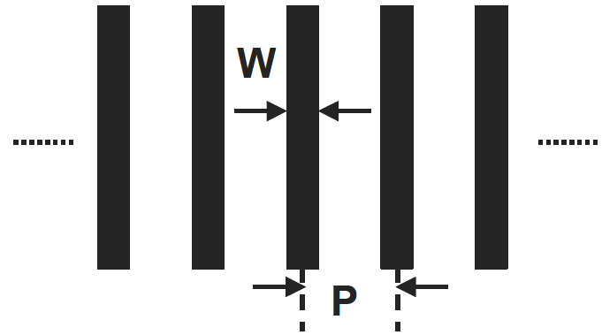
Figure 6 图6
Choice of width (W) and pitch (P) in an array of features (here shown for lines) for the determination of a) feature linearity: varying W and P fixed; 在一个图素（此处以线条为例）阵列中宽度(W)和步距(P)的选择来决定a)图素的线性度：W变化而P固定；
b) feature interproximity: fixed W and varying P; 图素内邻近：W固定而P变化
c) feature proximity: W and P BOTH varying. 图素邻近：W和P都变化

• all types and tones of features considered, e.g., line, contact, space, etc. (see in Section 5 for definitions of these terms). It is a strong recommendation to fix on 1 tone/ 1 type to reach a useful number. DEFAULT is on lines (line inter-proximity error).
要测量图素的所有类型和色调，如，线条，通孔，间距等（见第5节中的术语定义）。特别建议固定在一种色调和一种类型上获得一个有效的测量值个数。默认测量对象是线条（线条内邻近误差）。
• all orientations considered, e.g., horizontal and vertical together, horizontal only, vertical only, including other angles, horizontal-and-vertical separately, etc.
所有测量的方向，例如分别给出水平和垂直方向一起，仅水平方向，仅垂直方向，包含其它角度，水平与垂直方向一体等。
• range of feature pitches. DEFAULT is equal lines-and-spaces to isolated features. If only equal lines-and-spaces and isolated features themselves (and nothing in-between) are used, the term iso-dense deviation can also be used. In more general cases an alternative detailed description of the surrounding (mask area), preferably clarified with a drawing, will replace the pitch information.
图素步距的范围。默认为等宽度线条与间距的图素与孤立图素间的步距范围。如果所考察的图形中仅含等宽度线条与间距的图素与孤立图素（两者之间没有其它图素），则可使用等密度误差这个名称。通常情况下采用测量区域图素分布的详细描述来取代步距信息，最好用绘图的方式阐明。
7.23 measured feature inter-proximity error — measured value of feature inter-proximity error, stating as mandatory information in addition to that of measured feature width and feature inter-proximity error:
测定的图素内邻近误差—测定的图素内邻近误差值，必须与测定的图素宽度和图素内邻近误差一起提供的必要信息为：
• the number of measurement points used per pitch or surrounding mask area (to be more than one measurement per pitch). If more than one measurement per pitch is taken, then the mean value for each pitch is used.
每个步距或掩模版测量区域上采用的测量点个数（每个步距上有多个测量点）。当每个步距上有多个测量点时，要使用每个步距上的多个测量值得平均值。
and as optional information: 可选择提供的信息：
• the measured area on the mask. 掩模版上的测量区域。
• the spatial distribution of measurement locations. 测量位置的空间分布。
7.24 feature proximity error — total range of the deviations between the mask feature width and the respective target width on a range of feature widths and on a variation of local pattern density and configuration (i.e., of the surround) (see Figure 6c), stating as mandatory info:
图素邻近误差—针对某一图素宽度范围和局部图形密度和构成（即图素周围，见图6c）的变化，掩模版图素宽度与其对应的目标宽度的偏差的总范围，必须提供的测量信息：
• the range of feature widths used (at mask level). (DEFAULT is the interval from the critical dimension to 5 times this value.) 所采用的图素宽度（在掩模版上）的范围。（默认值介于1到5倍的关键尺寸之间）
NOTE 14: The ITRS uses a wider interval. 备注14：ITRS采用了更宽的区间
• all types and tones of features considered, e.g., line, contact, space, etc. (see in Section 5 for definitions of these terms). It is a strong recommendation to fix on 1 tone and 1 type to reach a useful number. DEFAULT is on lines (“line proximity error”). 所关注的图素的全部类型和色调，比如，线条，通孔，间距，等（见第5节中这些术语的定义）。特别建议固定在一种色调和一种类型上获得有效的测量值个数。默认测量对象为线条（“线条邻近误差”）。
• all orientations considered, e.g., horizontal and vertical together, horizontal only, vertical only, including other angles, horizontal-and-vertical separately, etc. 测量时关注的所有方向，比如，分别给出水平与垂直方向一起，只有水平方向，只有垂直方向，包括其它角度，水平与垂直一体等。
• range of feature pitches. In more general cases an alternative detailed description of the surround(ing mask area), preferably clarified with a drawing, will replace the pitch information.
图素步距的范围。通常情况下采用图素分布的详细描述来取代步距信息，最好用绘图的方式阐明。
7.25 measured feature proximity error — measured value of feature proximity error, stating as mandatory information in addition to that of measured feature width and feature proximity error:
测定的图素邻近误差—测定的图素邻近误差值，需要与测定的图素宽度和图素邻近误差一起提供的必要信息为：
• the number of measurement points used per pitch or surrounding mask area (recommendation is > 1. Then the mean value is used). 在每个步距或掩模版上测量区域上采用的测量点个数（推荐测量点个数>1, 此时要采用平均值）。
and as optional information: 可选择提供的信息：
• the measured area on the mask. 掩模版上的测量区域。
• the spatial distribution of measurement locations. 测量位置的空间分布。

8 2D Mask Qualification Terminology 掩模版二维图素质量评定术语
8.1 Introductory Remarks 引言注释
8.1.1 The 2D terminology adds onto the 1D terminology (Section 7). The 1D errors are an inherent part of, and affect, the 2D qualification. Section 8.2 treats 2D-qualification without considering the impact of 1D control (Section 7). Section 8.3 will suggest how to include consequences of feature width deviation.
二维图素术语以一维图素术语为基础（第7节）。一维图素误差是二维技术图素指标的一部分并对其产生影响。8.2节所处理的二维图素技术指标没有考虑一维图素参数控制的影响（第7节）。8.3节会将就如何评估图素宽度偏差对测量结果造成的影响提出建议。
8.1.2 Most 2D definitions are based on a comparison of a nominal and an actual feature/pattern. Where relevant, appropriate alignment of nominal and actual feature/pattern is assumed. This will be treated in detail in Section 8.4.
多数二维图素术语定义基于设计图素/图形与实际图素/图形的比较。这种比较需要使设计图素/图形与实际图素/图形相对应并以恰当的方式对准。详见8.4节的描述。
8.2 True Values 真值
NOTE 15: Reminder: The meaning of true is described in Section 2.2. An ideal measurement then includes the idea of perfect alignment of nominal and actual feature (see Section 8.4).
备注15： 提醒：真的意思在2.2节中做了表述。理想的测量需要以设计图素与实际图素完美对准为前提。
8.2.1 feature contour — shape formed by all edges of a feature, including external and internal edges (see Note 3 in Section 5.10). If the feature considered is clipped, then the edge(s) clipped by the region of interest serve as the edge(s) of the clipped feature (Figure 7).
图素轮廓—图素所有外部和内部的边（见5.10节中的备注3）构成了其形状。当所关注的图素被关注区域截取时，关注区域在被截取图素上的边界就成为被截取图素的边。
8.2.2 General Approach, Based on Area 常用基于面积的质量评估方法用术语
8.2.2.1 (clipped) feature area — enclosed area defined by the edges of the (clipped) feature, i.e., area in the (clipped) feature contour, mentioning as mandatory information: （截取的）图素面积—由（截取的）图素的边所构成的面积，即（截取的）图素轮廓内的面积，必须提供的信息：
• description of the nominal feature including type, dimensional information, tone, surrounding area, and orientation relative to the coordinate system (described in Section 6). 对图素设计的类型，尺寸，色调，测量区域及其与坐标系（见第6节中的描述）的相对位置的描述。
• additionally if clipped: region of interest, clipping details. 如果图素被截取则要标明关注区域，截取的细节。
8.2.2.2 (clipped) feature area gain — area in the actual (clipped) feature contour outside of the nominal (clipped) feature (see Figure 8). Additional mandatory information: （被截取的）图素面积增大—设计（被截取的）图素（见图8）之外的实际（被截取的）图素轮廓中的面积。必须提供的额外信息：
• relative position of actual and nominal feature (see Section 8.4). 实际和设计图素的相对位置（见第8.4节）
8.2.2.2.1 Note that the value of the (clipped) feature area gain is always positive. 注意：（被截取的）图素面积增大值总是正的。

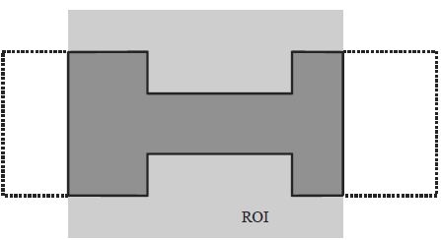
Figure 7 图7
Contour (for definition see Section 8.2.1, shown as a full line,) of a clipped feature (region of interest in light grey; the dotted line shows the feature contour outside ROI) 被截取图素（关注区为浅灰色；点画线为关注区外的图素轮廓）的轮廓（见8.2.1节中的对完整线条轮廓的定义，）

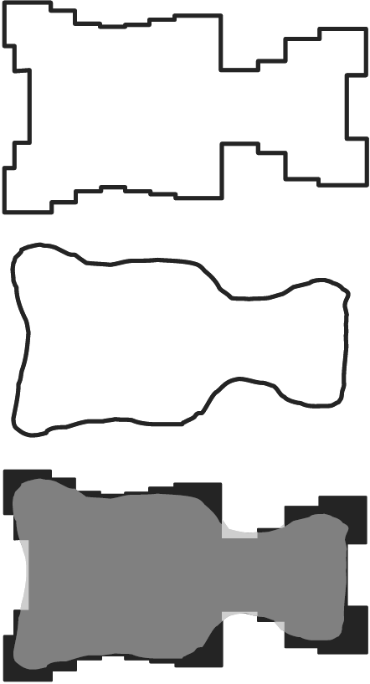
Figure 8 图8
Illustration of feature area (top: nominal feature, center: actual feature) and bottom: feature area gain (light gray), feature area loss (black) and overlapping area (medium gray) 图素面积图解（上：设计图素，中：实际图素，下：图素面积增大（浅灰），图素面积减（缩）小（黑）和重叠区域（中度灰）

8.2.2.3 (clipped) feature area loss — (clipped) area outside of the actual feature, still inside of the nominal feature (see Figure 8).
（被截取的）图素面积损失—实际图素之外的（被截取的）面积，仍属设计图素面积（见图8）。
8.2.2.3.1 Same mandatory information as in (clipped) feature area gain.
所必须提供的测量信息与（被截取的）图素面积增大条目中所要求的相同。
8.2.2.3.2 Note that the value of the (clipped) feature area loss is always positive.
注意：（被截取的）图素面积减损失值总是正的。

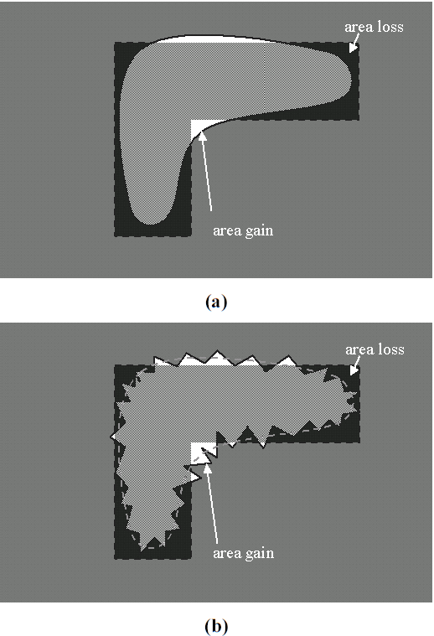
区域增大
区域损失
区域增大
区域损失

Figure 9图9
Illustration that edge roughness can influence feature area deviation, unlike feature area difference. 图解边缘的粗糙可以影响图素面积偏差而不是图素面积差别。
(a) without edge roughness (or with severe smoothing)边缘无粗糙（或极度光滑）
(b) with edge roughness: area gain and area loss are larger than in case (a), but can compensate each-other when using feature area difference边缘粗糙：面积增大和面积损失都比(a)中的大，但当使用图素面积差别时可以相互抵消

8.2.2.4 (clipped) feature area difference — (clipped) feature area gain minus (clipped) feature area loss. This is also equal to the (clipped) feature area of the actual feature minus the (clipped) feature area of the nominal feature. The value of the (clipped) feature area difference may be positive or negative accordingly. Same mandatory information as in (clipped) feature area gain.
（被截取的）图素面积差别—（被截取的）图素面积增大值减去（被截取的）图素面积损失值。也就是等于实际的（被截取的）图素面积减去设计的（被截取的）图素面积。相应的（被截取的）图素面积差别可以是正的或负的。必须提供的测量信息与（被截取的）图素面积增大相同。
NOTE 16: This qualification parameter is recommended for contacts or dots, because in these cases it is of relatively minor importance where the gain and loss are situated.
备注16：该项质量参数推荐用于通孔或点状图素，这种情况下图素面积在何处增大或减（缩）小相对来说不太重要。
8.2.2.5 absolute (clipped) feature area deviation — the sum of the values of (clipped) feature area gain and (clipped) feature area loss. Note that the value of the absolute (clipped) feature area deviation is always positive. Same mandatory information as in (clipped) feature area gain.
绝对（被截取的）图素面积偏差—（被截取的）图素面积增大与（被截取的）图素面积损失值之和。注意绝对（被截取的）图素面积偏差总是正的。必须提供的测量信息与（被截取的）图素面积增大条目中所要求的相同。
NOTE 17: This qualification parameter is recommended for features for which it does matter where the gain and loss are situated.
备注17：该项质量参数推荐用于当图素的面积增大和损失对产品性能的有影响的情况。
NOTE 18: This reasoning could be extended to Pattern area gain /loss /difference /deviation if several features are present in the region of interest.
备注18：如果在关注的区域内有几个图素则上述推荐理由可以扩展用于图形面积增大/损失/差别/偏差质量评定条目。
NOTE 19: Edge roughness may influence feature area deviation, unlike feature area difference, in which the effect of edge roughness is filtered out by allowing the resulting area gain and area loss to cancel out (see Figure 9).
备注19：边缘粗糙性可以影响图素面积偏差，而不是图素面积差别，在计算图素面积差别时边缘粗糙性的影响造成的图素面积增大与损失可以相互抵消而使其影响没有体现（见图9）。
NOTE 20: Normalized feature area, normalized feature area gain, normalized feature area loss, normalized feature area difference and normalized feature area deviation are defined as the ratio between the actual value of the considered parameter and the nominal feature area.
备注20：规范的图素面积，规范的图素面积增大，规范的图素面积损失，规范的图素面积差别和规范的图素面积偏差定义为该参数的测量值与对应的设计图素面积之值的比。
8.2.3 Specific Case of Corner Rounding (CR)
角部圆化(CR)的特定情况
8.2.3.1 corner rounding — deviation of an actual feature corner from the nominal one.
角部圆化—实际图素的角与设计图素的角的偏差。
8.2.3.1.1 The definition above is qualitative, and can be quantified in all practical cases by treating it as a special case of feature area difference (see further in Sections 8.2.3.2–7). Quantitative determination requires as mandatory information:
上述定义是定性的，可以通过在所有实际情况中作为图素面积差别（见8.2.3.2-7中的进一步描述）来处理的特例达到定量化。定量化必须提供的测量信息：
• the designed angle (see Figure 10), DEFAULT angle is 90 degrees. 设计的角度值（见图10），默认角度值是90度。
• feature tone: dark vs. clear. 图素的色调：不透光还是透光。
• corner type: outer vs. inner. Corner type is ambiguous without feature tone specified (see Figure 11). 角部类型：外角还是内角。图素的色调未指定时角部类型也是不确定的（见图11）。
• other features or feature corners within the proximity range from the corner of interest, DEFAULT is an isolated corner. 在关注的角部邻近范围内的其它图素或图素角部，默认为孤立角部。
• orientation of the corner (determined by the 2 linear sections, e.g., 90^180, 160^210,…, (see Figure 10). DEFAULT is all 4 orientations with linear sections along X- and Y-axes (Figure 12) for both dark and clear feature tone. 角部的方向（由2个线性截面定义，例如90^180, 160^210,…,（见图10）。 默认为在不透明和透明两种图素色调下沿X- 和 Y-轴（见图12）线性截面的全部4个方向。
NOTE 21: The purpose of the default corners is to help the user of this document to select representative features to qualify, for example, the corner rounding fingerprint of a mask making process.
备注21：默认角部的目的是帮助使用该文件的用户选择有代表性的图素来评定，比如掩模版生产工艺过程中角部圆化的特点。
8.2.3.2 corner area gain — special case of clipped feature area gain, in which the region of interest contains one corner of a feature. 角部面积增大—被截取的图素面积增大的特例，此时的关注区域包括图素的一个角部。
8.2.3.3 corner area loss — special case of clipped feature area loss, in which the region of interest contains one corner of a feature. 角部面积损失—被截取的图素面积损失的特例，此时的关注区域包括图素的一个角部。
NOTE 22: In non-corrected isolated cases normally there is only a loss for outer corners and a gain for inner corners. In other cases (i.e., corrected corners) there may be a loss and a gain, which makes it necessary to also define the difference and deviation, as done below.
备注22：在无校正的孤立图素中通常外角部只有损失而内角部增大。其它情况下（如经校正的角部）可以既有损失又有增大，这也就需要定义差别和偏差，如下。
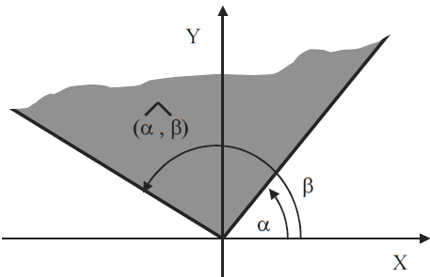

Figure 10 图10
Nomenclature of Feature Corners by the Angles of Their Linear Sections 用线性截面定义图素角部的方向

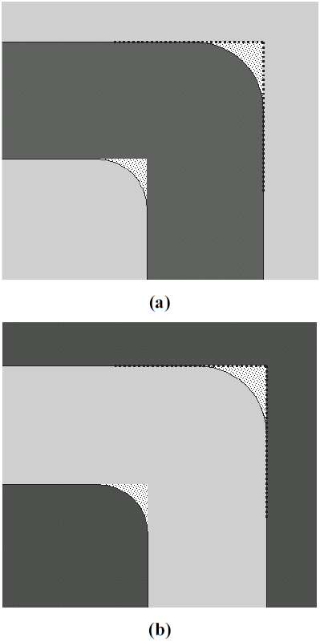

Figure 11 图11
Illustration of nomenclature used for feature corners (elbow as example) 图素角部（以肘状角为例）定义图解
(a) dark feature; (b) clear feature; (a) 不透明图素；(b)透明图素
bottom left in each sub-figure: inner corner; 两种图素的左下角部：内角部
top right in each sub-figure: outer corner. 两种图素的右上角部：外角部

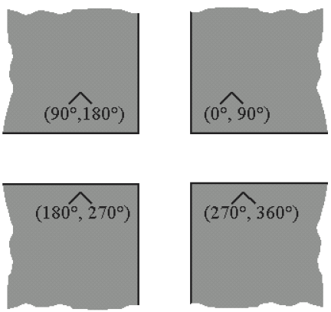

Figure 12 图12
The 4 Default Orientations of a 90º Corner 90º角部的4种默认方向

8.2.3.4 corner area difference — corner area gain minus corner area loss. As such it is a special case of clipped feature area difference, in which the region of interest contains one corner of a feature.
角部面积差别—角部面积增大减去角部面积缩小。就是当关注区域包含图素的一个角部时被截取的图素面积的差别的一个特例。
8.2.3.5 corner area deviation — the sum of corner area gain and corner area loss. As such it is a special case of clipped feature area deviation, in which the region of interest contains one corner of a feature.
角部面积偏差—角部面积增大与角部面积缩小之和。就是当关注区域包含图素的一个角部时被截取的图素面积的偏差的一个特例。
NOTE 23: As the corner shape is expected not to be decisive for its printability (at least for an isolated corner), but rather the balance between area gain and loss, it is recommended to use area difference for corner qualification rather than area deviation.
备注23：鉴于角部形状对于成像性能不是决定性的（至少对孤立角部来说），反之面积增大和缩小之间的平衡则更重要，因此建议使用面积差别而不是面积偏差作为角部质量评定参数。
NOTE 24: Certain features with non-isolated corners, such as line-ends and contacts, have specific definitions listed in Sections 8.2.4 and beyond.
备注24：在第8.2.4或其他章节中对于像线条端部和通孔具备非孤立角部的图素，有专门的定义。
8.2.3.6 In present practice, corner rounding quantification is done without comparison to the nominal corner. However, this is only valid if the corner is isolated, non-corrected, and its area gain is negligible. Typically it is done based on the determination of a reference corner which is obtained by the extrapolation of the linear sections of the corner, if present (Figure 13).
就当前的实际使用中，角部圆化质量评定没有与设计的角部做比较。然而，这只在角部为孤立的，没有经过校正的，并且它的面积增大是可忽略的情况下有效。代表性的角部圆化质量评定是基于由角部的外线性截面所确定的参考角部，前提是这种参考角部是存在的（图13）。
8.2.3.7 equivalent corner rounding radius (ECRR) — an equivalent, effective corner rounding radius calculated from the area difference. It assumes that the corner is a circular arc. The ECRR is calculated as ECRR = sqrt( 4 * corner area difference / (π - 4) ), for a 90 degree corner.
等价角部圆化半径(ECRR) —将角部看做圆弧并由面积差别计算得到的等价有效的角部圆化半径。90度角部ECRR的计算公式：ECRR =( 4 * 角部面积差别 / (π - 4) )的平方根。
8.2.3.7.1 The ECRR is defined only for negative corner area differences, i.e., where the corner area loss is larger than the corner area gain.
ECRR仅适用于角部面积差别为负的情况，就是角部面积损失大于角部面积增大。

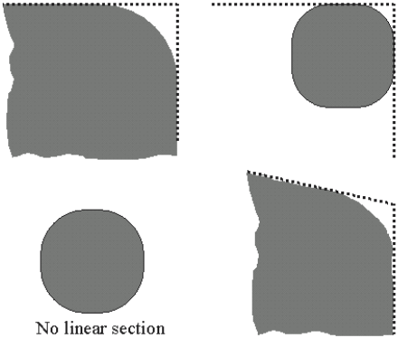

Figure 13 图13
Corner Rounding Determination by Extrapolation of the Linear Sections of the Actual Feature Contour 由实际图素轮廓外的线性截面定义的角部圆化

无线性截面

NOTE 25: This definition actually gives a 1D representation for a 2D quality assessement, but it is found useful when comparing mask quality to wafer printing results, which are typically characterized by 1D measurements, such that a dimensionless MEEF (mask error enhancement factor) can be used. As with area based assessment, also this term disregards the shape at the feature corner.
备注25：该定义实际上给出了二维质量评估的一维表述，但是ECRR可被用于掩模版质量与在硅片上成像结果的比较，成像结果通常由一维测量来表征，如采用无量纲的MEEF（掩模版误差增强因素）。作为基于面积的评估，该定义也没有考虑图素角部的形状。
NOTE 26: Current methods to determine a corner rounding radius based on fitting a circle to an actual corner have been experimentally shown to deliver unreliable results and are therefore strongly discouraged.
备注26：经试验验证当前所使用的将实际角部与圆形拟合以确定角部圆化半径的方法所得结果不可靠，因此不推荐使用。
8.2.3.8 corner pull-back (CPB) — the distance between the reference corner and the actual feature contour. This may be based on the minimum distance (minimum CPB) or that determined along the bisectric （bisectrix?）(bisectric CPB) (see Figure 14). The choice of CPB technique is mandatory information.
角部后缩(CPB) —参考角部与实际图素轮廓之间的距离。该参数可以用最小距离（最小CPB）或沿等分线确定（等分线CPB）（见图14）。确定CPB所使用的方法是必须随该数值一起提供的测量信息。
NOTE 27: Edge roughness may have an important influence on the corner pull-back, such that contour averaging may be necessary to produce a meaningful result. The method of contour averaging is mandatory information for corner pullback, if used.
备注27：边缘粗糙性可对角部后缩产生重要影响，因此可以采用平均轮廓来获得合理的结果。如果采用了平均轮廓，则获得平均轮廓的方法是在角部后退测量时必须提供的信息。
8.2.4 Specific Case of Line-End Shortening
线条端部缩短的特定情况
8.2.4.1 line-end shortening — deviation of the actual feature from the nominal feature at the nominal line-end. This is still qualitative, and can be quantified in general cases by overlaying the actual line contour to the nominal line (see Section 8.4). Alternatively, a test pattern such as Figure 17 may overcome the need to overlay to the nominal case.
线条端部缩短—实际图素与设计图素在线条端部的偏差。该参数为定性的，一般可以通过将实际线条轮廓与设计线条重叠比对的方法实现定量化（见第8.4节）。另一种方法是采用图17的测试图形以避免与设计线条重叠比对的情况。
NOTE 28: “line-end” is also used for the darkfield case (for spaces).
备注28：“线条端部”也用于图形不透明的情况（例如间隔）。
NOTE 29: In non-corrected isolated cases normally there is only a loss (or shortening). In other cases (i.e., corrected lineends) there may be a loss and a gain (or extension), which makes it necessary to also define the difference and deviation, as done below.
备注29：无校正孤立线条一般只有损失（或缩短）.其它情况（即校正的线条端部）可以是损失和增大（或延长），需要定义其差别和偏差，如下。
NOTE 30: The minimum (= DEFAULT) region of interest must include all feature area divergence until the feature can be treated as one-dimensional (see Sections 5.3 and 5.4).
备注30：最小（=默认）关注区域必须包括所有图素面积的分叉（？）直到图素可以被看做是一维的（见第5.3和5.4节）。

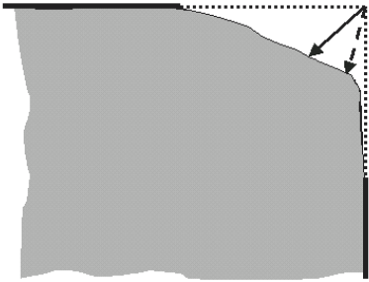

Figure 14 图14
Corner Pull-Back: Bisectric (Full Line Arrow) vs. Minimum (Dotted Arrow) 角部后缩：等分线（实线箭头）与最小距离（点画线箭头）

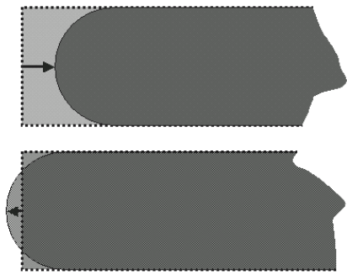

Figure 15图15
Quantification of line-end shortening by pull-back(arrow) or area comparison. Top: shortening case, below: extended case (e.g., caused by overcompensation) 用拉回或面积比较法对线条端部缩短的量化。上图：缩短的情况，下图：延长的情况（如，过补偿而造成的）

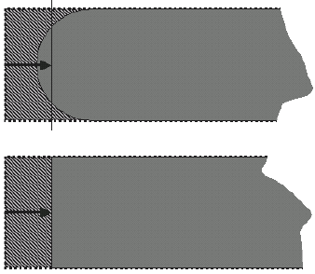
Figure 16图16
Quantification of line-end shortening by equivalent line-end shortening (shaded area is equal in the two figure halves)用等效线条端部缩短法对线条端部缩短进行量化（上下两图中的阴影面积相等）

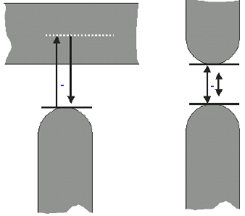
Figure 17 图17
Proposed test patterns to overcome the need to overlay to the nominal case for the determination of line-end shortening 不采用与设计图形重叠比对时建议用于确定线条端部缩短的测试图形

8.2.4.2 line-end area gain — special case of clipped feature area gain, in which the region of interest
contains a line-end.
线条端部面积增大—截取的的图素面积增大的特例，此时的关注区域内含有线条端部。
8.2.4.3 line-end area loss — special case of clipped feature area loss, in which the region of interest
contains a line-end.
线条端部面积缩小—截取的的图素面积缩小的特例，此时的关注区域内含有线条端部。
8.2.4.4 line-end area difference — line-end area gain minus line-end area loss. As such it becomes a special case of clipped feature area difference, in which the region of interest contains a line-end.
线条端部面积差别—线条端部面积增大与线条端部面积缩小之差。它是关注区域内含有线条端部时截取的的图素面积差别的特例。
8.2.4.5 line-end area deviation — the sum of line-end area gain and line-end area loss. As such it becomes a special case of clipped feature area deviation, in which the region of interest contains a line-end. Mandatory information for each of the 4 above:
线条端部面积偏差—线条端部面积增大与线条端部面积缩小之和。它是关注区域内含有线条端部时截取的的图素面积偏差的特例。上述4项质量评定参数中的每一条所必须提供的测量信息为：
• actual and nominal width, 实际和设计宽度，
• tone, pitch (or surrounding area), and 色调，步距（或周围区域），和
• orientation. 方向
DEFAULT: isolated feature (line or space). 默认：孤立图素（线条或间距）
NOTE 31: As the line-end shape is expected not to be decisive for its printability, but rather the balance between
area gain and loss, it is recommended to use area difference for line-end qualification rather than area deviation.
备注31：鉴于线条端部形状对于成像性能不是决定性的，反之面积增大和损失之间的平衡则更重要，因此建议使用面积差别而不是面积偏差作为线条端部质量评定参数。
8.2.4.6 line-end pull-back (LEPB) — the distance, parallel to the line center, between the line-ends of the nominal and the actual features (see Figure 15). This distance may be determined along the line center (center LEPB), or alternatively it may be determined by the distance between the extreme point of the actual line and the nominal line-end (minimum LEPB), in analogy to corner pull-back. Mandatory information is:
线条端部后缩(LEPB) —设计图素线条端部与实际图素线条端部在平行于线条中心线方向上之间的距离（见图15），该距离可以沿线段中心（中心LEPB）来确定，或者用实际线段的最顶端与设计线段的端部的距离来确定（最小LEPB），类似于角部后缩条目:
• actual and nominal width, 实际和设计宽度，
• tone, pitch (or surrounding area), 色调，步距（或测量区域）
• orientation, and 方向， 和
• choice of LEPB technique (center or minimum). 测量LEPB的方法（中心法或最小法）
DEFAULT: isolated feature. 默认：孤立图素。
NOTE 32: Edge roughness may have an important influence on the line-end pull-back, such that contour averaging may be necessary to produce a meaningful result. The contour averaging method is mandatory info for LEPB, if done.
备注32：鉴于边缘粗糙性可对线条端部后缩有重要影响，有必要采用轮廓平均来得到符合实际情况的结果。如果采用了轮廓平均法，则轮廓平均的方法是必须要随LEPB数值一起提供的信息。
8.2.4.7 equivalent line-end pull-back (ELEPB) — defined as the negative line-end area difference divided by the nominal line width (see Figure 16), assuming accurate 1D control (see Section 8.1).
等效线条端部后缩—定义为在精确的一维控制下（见第8.1节）负的线条端部面积差别除以设计线条宽度（见图16）。
NOTE 33: This definition actually gives a 1D representation for a 2D quality assessement, but it is found useful when comparing mask quality to wafer printing results, which are typically characterized by 1D measurements, such that a dimensionless MEEF (mask error enhancement factor) can be used. As with area based assessment, also this term disregards the shape at the line-end.
备注33：为便于采用无量纲的MEEF（掩模版误差增强因素），该定义实际上给出了二维质量评估的一维表述，而这对于比较掩模版质量与在硅片上的成像结果（大多采用一维测量来表征）具有意义。正如基于面积的评估方法，该定义忽略了线条端部的形状因素。
NOTE 34: LEPB and ELES are positive when the actual line is shorter than the nominal line. A negative sign is added in case of over-correction, when the actual line becomes longer than the nominal line.
备注34：当实际线条比设计线条短时LEPB 和 ELES为正，当由于过校正造成实际线条比设计线条长时则为负。
8.2.5 Specific Case of Contacts and Dots
通孔和点的特例
NOTE 35: This sub-section explains terminology for contacts in full detail. This terminology can analogously be extended to dots.
备注35：该小节详细解释了通孔的术语。该术语可类推用于点的定义。
8.2.5.1 contact area — special case of feature area, in which the feature is a contact (see Figure 18a).
通孔面积—图素为通孔（见图18a）时的图素面积特例。
8.2.5.2 contact area gain — special case of feature area gain, in which the region of interest contains a
contact (see Figure 18b).
通孔面积增大—关注区包含通孔（见图18b）时图素面积增大的特例。
8.2.5.3 contact area loss — special case of feature area loss, in which the region of interest contains a contact (see Figure 18b).
通孔面积损失—关注区包含通孔（见图18b）时图素面积损失的特例。
8.2.5.4 contact area difference — contact area gain minus contact area loss. As such it becomes a special case of feature area difference, in which region of interest contains a contact.
通孔面积差别—通孔面积增大与通孔面积损失之差，是当关注区包含通孔时图素面积差别的特例。
8.2.5.5 contact area deviation — the sum of contact area gain and contact area loss. As such it becomes a special case of feature area deviation, in which the region of interest contains a contact. Mandatory information for each of the 4 above:
通孔面积偏差—通孔面积增大与通孔面积损失之和，是当关注区包含通孔时图素面积偏差的特例。上述4项定义的必须提供的测量信息：
• nominal width in X and Y (Y not required for square contacts),
X 和 Y方向（通孔为正方形时不要求Y方向）上的设计宽度，
• nominal area (not required for square or rectangular contacts), and
设计面积（通孔为正方形或矩形时不要求），和
• pitch (or the surroundings). 步距（或测量区域）。
NOTE 36: The absolute value of the above qualification parameters can be normalized to the nominal contact area,
i.e., normalized contact area deviation and normalized contact area difference.
备注36：上述质量评定参数的绝对值可以规范为名义的通孔面积，即，规范的通孔面积偏差和规范的通孔面积差别。
NOTE 37: As the contact shape is expected not to be decisive for its printability, but rather the balance between area gain and loss, it is recommended to use area difference for contact qualification rather than area deviation.
备注37：鉴于通孔形状对于成像性能不起决定性作用，而面积增大和缩小之间的平衡则影响更大，因此建议使用面积差别而不是面积偏差作为通孔质量评定参数。
8.2.5.6 contact X-width (or contact Y-width) — width in X (or Y) of the smallest rectangle along X (or Y) encompassing the contact (see Figure18c).
通孔X-宽度（或通孔Y-宽度）—沿X（或Y）方向包围通孔的最小矩形X（或Y）方向宽度。
8.2.5.7 contact diagonal widths — widths determined using the smallest rectangle encompassing the contact confined along the directions ± arctan(WY,nominal/WX,nominal) (see Figure 18d), which is ± 45degrees for square contacts.
通孔对角线宽度—由包围通孔的最小矩形沿± arctan(WY,名义/WX,名义)方向确定的宽度（见图18d），当通孔为正方形时就是沿± 45度方向。
NOTE 38: Edge roughness may have an important influence on the 1D determination of contact width (X-, Y-, diagonal-), such that contour averaging may be necessary to produce a meaningful result. The contour averaging method used is mandatory information for contact width and contact diagonal width, as its influence is increasingly important for smaller contacts (see Note 43 in Section 8.5).
备注38：鉴于边缘粗糙性可对通孔宽度（X-, Y-,对角线-），的一维度量有重要影响，有必要采用轮廓平均来得到符合实际情况的结果。所采用的轮廓平均方法必须与通孔宽度和通孔对角线宽度的数值一起提供，通孔越小不同轮廓平均方法对测量结果的影响越显著（见第8.5节中的备注43）。
8.2.6 Specific Case of Optical Proximity Correction (OPC)
光学邻近校正(OPC)的特例
8.2.6.1 This document recommends to treat OPC’d features or patterns as a special case of Section 8.2.1 (based on area). OPC fidelity is based on normalized pattern area deviation and normalized pattern area difference.
本文建议将OPC’d（s？）图素或图形看做第8.2.1节（基于面积）所述定义的特例。OPC保真性基于规范的图形面积偏差和规范的图形面积差别。
8.2.6.2 1D metrology techniques for measuring OPC are not considered within this document’s scope. As a good reference the reader is referred to for example Yonekura et al., (Toppan, PMJ2001, SPIE Proceeding Vol. 4409 p. 204) .
测量OPC的一维计量方法不在本文所涉范围。(Toppan, PMJ2001, SPIE Proceeding Vol. 4409 p. 204) 可作为这方面的参考范例。
NOTE 39: Edge roughness may have an important influence on the 1D determination of OPC’d features, such that contour averaging may be necessary to produce a meaningful result.
备注39：鉴于边缘粗糙性可对OPC’d图素的一维度量有重要影响，有必要采用轮廓平均来得到符合实际情况的结果。

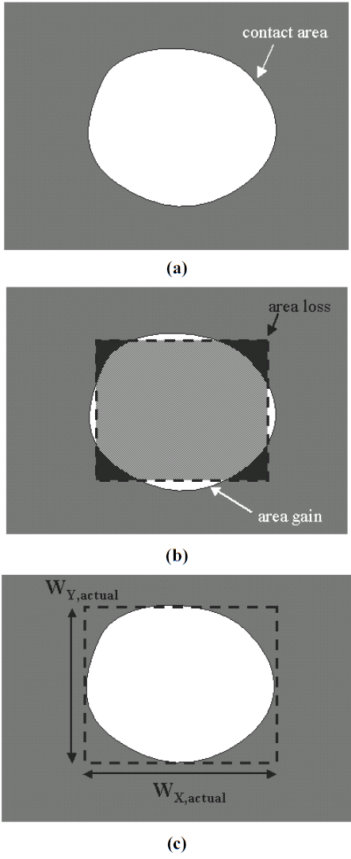
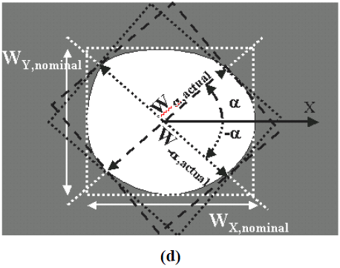
Figure 18 图18
2D Quantification of a contact hole by contact area, by area gain and area loss (dotted line is nominal contact), by X and Y width (dashed line is smallest rectangle encompassing the actual contact), by diagonal width (white dotted lines are the nominal contact and its diagonals confined by ± α, where α = arctan(WY,nominal/WX,nominal) ) 通孔的二维量化质量评定。采用通孔面积，面积增大和面积损失（点画线是名义通孔），X 和 Y方向宽度（虚线是包围实际通孔的最小矩形），对角线宽度（白色点画线是名义通孔，其对角线由± α确定，α = arctan(WY,nominal/WX,nominal)）。

8.2.7 Uniformity of 2D Qualification Parameters
二维均匀性质量评定参数
8.2.7.1 In principle all 2D qualification parameters, as defined above, may vary across the mask. By analogy to the transition from feature width to feature width uniformity, any 2D qualification parameter may be additionally characterized by uniformity. Below, as an example, corner area difference uniformity is elaborated.
原则上在掩模版的不同位置上前面所定义的所有二维质量评定参数都是变化的。采用类似于从图素宽度到图素宽度均匀性的转换的方法，任何二维质量评定参数都可以用其均匀性来进一步表征。以下将以角部面积差别均匀性为例进行详细阐述。
8.2.7.2 corner area difference uniformity — the spread of the distribution of the corner area difference of all mask features selected as described below. To be stated as mandatory information in addition to that of corner rounding (Section 8.2.3.1) and also adopting the same DEFAULTS:
角部面积差别均匀性—按下面所述的方法选择的掩模版上所有图素的角部面积差别的分布范围。所必须提供的测量信息除了包含与角部圆化（第8.2.3.1节）中所要求的测量信息并采用相同的默认值外，还有如下两项：
• the criterion used (range, 3-sigma, maximum area difference, etc.), where sigma stands for standard deviation.
所采用的标准（范围，3倍sigma标准偏差，最大面积差别等），sigma代表标准偏差
(Recommendation: before 3-sigma is relevant, the distribution needs to be “normal” or “near normal”, and the number of measurements should be > 30.)
（建议：在3倍sigma标准偏差提取之前，数据分布应是“正态”或“近似正态”，而且测量点数目应> 30.）
• The considered area of interest on the mask. 掩模版上的关注区。
8.3 Corrected True Values
校正后的真值
8.3.1 Some 2D measurements and definitions require that the mask is on target from a 1D-viewpoint, i.e., nominal and actual size coincide for semi-infinitely long features present in the region of interest. It is recommended to limit 2D characterization to features with approximately the same width, such that 1D-linearity does not significantly affect the 2D value.
有些二维测量和定义要求掩模版在一维上达到了目标值，即出现在关注区内的图素的设计和实际尺寸在半无限长度上相一致。为了使一维的线性度对二维数值没有显著影响，建议将二维表征限制在具有大约相同宽度的图素上。
8.3.1.1 As an example, Figure 19 illustrates how a feature width deviation could affect the line-end.
图19举例说明了图素宽度偏差如何影响线条端部。
8.3.1.2 Correction is required for benchmarking purposes, as described below.
标准检验要求如下所述的校正。
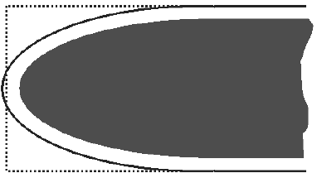
Figure 19 图19
Example where correction of 2D-measurement (here shown for line-end shortening) for 1D-errors (full line) provides a different result 由一维误差（全线条）的二维测量（此处以线条端部缩短为例）的校正而得到的不同结果

8.3.2 2D qualification may be refined by customer/vendor agreement (or by the user of this document) by compensating for
二维质量评定可以由客户/供应商（或该文件的使用者）通过如下条款的补充协议细化：
• the feature misplacement by alignment (see Section 8.4), 由对准（见第8.4节）造成的图素错位，
NOTE 40: Pattern alignment is often required and affects the obtained values. Recommendations on pattern alignment for 2D qualification will be addressed in Section 8.4.
备注40：在测量中经常要求图形对准并且会影响到测量数值。二维质量评定参数测量中建议使用的图形对准方法将在第8.4节中说明。
• the linewidth deviation (see Figure 20) b1) by a sizing correction based on the CD mean-to-target. This correction should be done before 2D-parameter determination,
基于CD的平均值与目标值之差的尺寸校正的线宽偏差（见图20) b1)。校正应当在二维参数确定之前进行。
or 或者
b2) by a sizing correction based on the feature mean-to-target of the feature considered. This correction should be done before 2D-parameter determination, and
对所关注图素进行的基于图素平均值与目标值之差的尺寸校正，此校正应该在确定二维参数之前进行，以及
• feature linearity errors (feature proximity errors), using the same sizing corrections as in 8.3.2b, but based on specific feature width deviation.
图素线性误差（图素邻近误差），采用8.3.2b中相同的尺寸校正，所不同的是基于特定的图素宽度偏差。
8.3.2.1 What was modified and how it was done, is mandatory information.
所必须提供的测量信息是修改了什么和这些修改是如何做的。
NOTE 41: Scaling is not permitted.
备注41：不允许对图形进行缩放。
NOTE 42: Sizing algorithm to be mentioned: orthogonally, by circular brush, perpendicularly, etc. (see Figure 21).
备注42：尺寸算法：正交，圆形刷，垂直，等（见图21）
DEFAULT is compensation a and b1. 默认是补充a和b1。

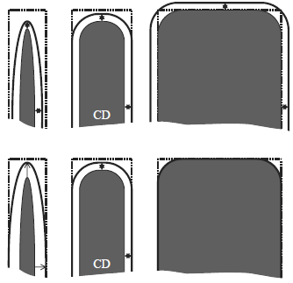
Figure 20 图20
Illustration of correction for 2D features for 1D-error, according to techniques described under Section 8.3.2: b1 (upper) and b2 (lower) 根据第8.3.2节: b1（上图）和b2（下图）所述方法对二维图素的一维误差进行校正的图解

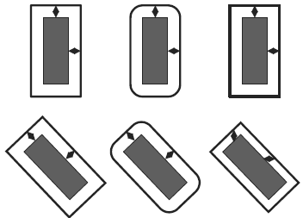
Figure 21 图21
Examples of sizing rules for correction: from left to right: perpendicularly, by circular brush, orthogonally 校正的尺寸规则示例：从左至右：垂直，圆形刷，正交

8.4 Alignment 对准
8.4.1 Alignment of nominal and actual feature (or pattern) is only practical when the ROI includes features where the actual case is a fairly good approximation to the nominal one.
设计和实际图素（或图形）的对准只有在包含图素的关注区中的实际尺寸与设计尺寸相当接近时才可进行。
8.4.2 Alignment can be done by one or more of the methods shown below. The result obtained by the different methods may differ. The method is mandatory information (see Figure 22).
对准可以用下列方法中的一个或多个来完成。所得结果可能会由于采用的不同对准方法而不同。对准方法是必须提供的测量信息（见图22）。
8.4.2.1 In the center-of-gravity (COG) method the COG of actual and nominal features are superimposed.
重心(COG)法中实际和设计图素的COG重叠放置。
8.4.2.2 In the area based method the absolute feature area deviation between the actual and nominal features is minimized.
基于面积的对准方法中实际和设计图素之间的绝对图素面积偏差被最小化。
8.4.2.3 In the line-edge based method, alignment is performed by minimizing the distance between multiple actual and nominal edges.
基于线条边缘的对准方法是将多个实际和设计的线条边缘之间的距离最小化。

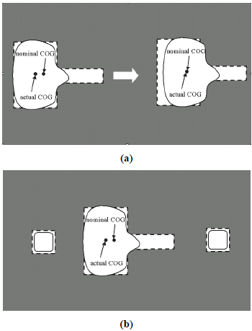
Figure 22 图22
Alignment of nominal and actual feature (a) by center of gravity (COG) only, left is the intended overlay, right is actual overlay from the COG method, leading to an incorrect result. (b) by the use of alignment markers. 设计和实际图素的对准(a)仅重心(COG)对准，左边是希望的重叠，右边是采用COG方法的实际重叠，导致了错误的结果。(b) 采用对准标记的对准结果

8.4.3 Alignment is preferably done on dedicated alignment features (markers), which are symmetric and not clipped, and their position does not suffer from the resolution of the imaging process. Crosses are typically used, as they have X and Y components, which can be used to correct for rotational error if only one marker were present.
对准可以用专门的对准图素（标记）来精确完成，这些标记是几何对称且不会被截取，其位置不会受到成像工艺分辨率的影响。由于十字形标记具备X和Y两个方向，如果在只有一个标记时还可以用来校正旋转误差，因而常被用到。
8.4.4 Additional markers allow for more accurate rotational compensation and decouple magnification errors of the feature to be measured from sizing errors.
多个标记可以实现更准确的旋转补偿并将被测图素的放大误差与尺寸误差区分开。
8.4.5 If no markers are present, one of the methods above can be attempted on the feature to be measured or on other features in the ROI, but in such situation alignment may be less accurate, especially if these features are clipped (see Figure 22). 如果没有对准标记，可以使用被测图素或关注区内的其他图素按上述方法进行对准，但此时对准的准确性就会降低，尤其是当这些图素是被截取的。
8.5 Measured Values 测量获得的数值
8.5.1 By analogy to Section 7 (1D Mask Qualification Terminology) a measured qualification parameter can be defined for every 2D (true) qualification parameter defined in Section 8.2. In Section 7 this was done immediately after the definition of the true parameter, whereas here the measured parameter is treated in a generic way. Thereby, one 2D qualification parameter is used for the explanation, i.e., measured corner area difference and its uniformity, as examples for all other 2D qualification parameters and their uniformity.
由第7节（掩模版一维质量评定术语）类推可以定义第8.2节中的所列所有二维（真值）质量评定参数的测量值。在第7节中随参数真值之后即给出了参数测量值的定义，而本节中则以通用的方式来定义测量参数。因此对一个二维质量评定参数进行解释，即测量的角部面积差别及其均匀性的定义也可用于所有其它二维质量评定参数和均匀性的描述。
NOTE 43: The most critical feature in terms of impact of the measurement details to the measured values is the size of a contact near the resolution limit of the metrology tool and of the mask patterning process.
备注43：从测量细节对测量值影响的角度来说最关键的图素是接近测量设备和光刻成像工艺设备分辨率的通孔的尺寸。
8.5.2 measured corner area difference — measured value of corner area difference, stating as mandatory information, in addition to that of corner rounding (Section 8.2.3.1):
测量的角部面积差别—角部面积差别的测量值，所必须提供的测量信息除了角部圆化条目中所列出的，还有：
• calibration method used4, 采用的校准方法4
• measurement method used (SEM, optical reflection, optical transmission, AFM, etc.) and its resolution limit, 采用的测量方法（扫描电镜，光反射，光透射，原子力显微镜等）及其极限分辨率，
• edge detection algorithm and parameters, 边缘探测算法和参数，
• precision (SEMI P24), 精确度(SEMI P24),
and as optional information : 及可选项：
• measurement tool (vendor, model or any tool specific options). 测量设备（设备生产商，型号或设备选配配置）。
8.5.3 measured corner area difference uniformity — measured value of corner area difference uniformity, thereby stating as mandatory information in addition to that of corner area difference uniformity and of measured corner area difference:
测量的角部面积差别均匀性—角部面积差别均匀性的测量值，由此所必须提供的测量信息除了在角部面积差别均匀性和测量的角部面积差别中所列的条目外，还有：
• the number of measurement points used, and as optional information: 采用的测量点个数， 及可选项：
• the spatial distribution of measurement locations, e.g., by coordinates of measurement locations. DEFAULT is spread evenly over the measurement area. 测量位置的空间分布，如测量位置的坐标值。默认是在测量区域中均匀分布。
NOTE 44: Edge roughness, either originating from the process (Note 19 in Section 8.2.2) or from the measurement technique used, may influence the measurement result. This is not the case for the two examples treated above, as the difference parameter filters out the effect of roughness by allowing compensation of area gain and area loss. In case of, e.g., corner area devation uniformity, line-edge roughness will influence the measurement result.
备注44：边缘粗糙性，不管是来自于工艺（第8.2.2节中的备注19）或采用的测量方法，都会影响测量结果。而对于上述两个例子中的情况却不适用，原因是差别的定义使面积增大和缩小相互补偿而消除了粗糙性的影响。有些情况下，比如对于角部面积偏差均匀性，线条边缘粗糙性就会影响测量结果。
-----------------------------------------------------------------------------------------
4 See reference document in Section 4.2. 参见第4.2节中的参考文献。
NOTICE: SEMI makes no warranties or representations as to the suitability of the standards set forth herein for any particular application. The determination of the suitability of the standard is solely the responsibility of the user. Users are cautioned to refer to manufacturer’s instructions, product labels, product data sheets, and other relevant literature, respecting any materials or equipment mentioned herein. These standards are subject to change without notice.
注释：SEMI对于将本文所述的标准使用于具体的场合时的适用性不做任何保证或表示。该标准的适用性完全由用户决定。特别告知用户对于本标准所涉及的材料或设备都需要参照设备厂商的说明，产品标签，产品数据表，和其它相关文献。本标准如有更改，恕不另行通知。
By publications of this standard, Semiconductor Equipment and Materials International (SEMI) takes no position respecting the validity of any patent rights or copyrights asserted in connection with any items mentioned in this standard. Users of this standard are expressly advised that determination of any such patent rights or copyrights, and the risk of infringement of such rights are entirely their own responsibility.
半导体设备和材料国际组织(SEMI)无意因本标准的发布而对本标准涉及的条款相联系的、受保护的专利权和版权的有效性产生任何影响。本标准的使用者应明了所涉及的任何专利权和版权的确认和违反这些权利的风险完全是使用者自己的责任。
_____________________________________________

