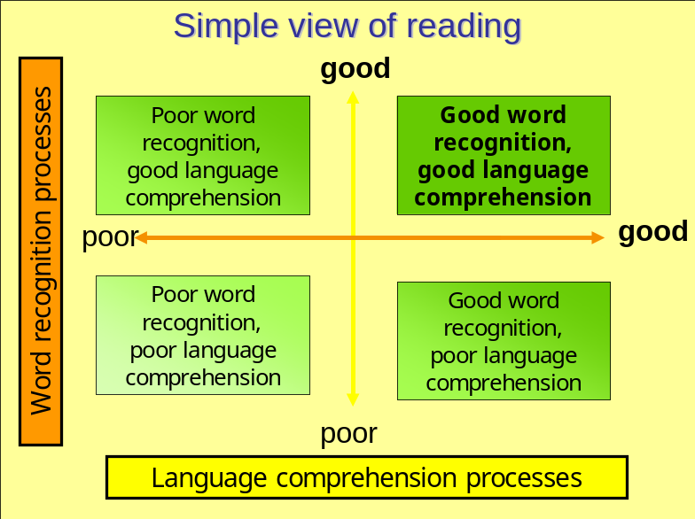

Reading comprehension is the product of two inter-related, but very distinct, dimensions; word recognition and language comprehension. This is known as the simple view of reading.
The four elements of the searchlights model have been subsumed into the 2 dimensions this simple view of reading:

- Word recognition – encompasses phonic knowledge, word recognition and graphic knowledge. Recognising the words!
Learning includes:
Phonic knowledge (sound and spelling)
Fast and automatic phonic decoding
Recognition of whole words and morphemes (smallest unit of meaning – ed, ing, un)

- Language comprehension – is language awareness, vocabulary, knowledge of grammar - whether the words are heard or seen. Understanding the meaning!
Reading comprehension involves:
Grammatical knowledge
Predictions from knowledge of syntax to make sense of strings of words, identifying sense-making syntactic boundaries in sentences, and reading with fluency and expression appropriate to the text
Using knowledge of context
Making predictions from context to aid comprehension

The word recognition element is time-limited. Language comprehension is a life-long process.

This becomes clearer when we think of learners in each of these four areas:
- Good language comprehension, poor word recognition – possible dyslexic tendencies(?)
- Poor language comprehension, poor word recognition – L
- Poor language comprehension, good word recognition – EAL? (Proficient decoding skills but insufficient experience of the English language, ie ‘keep your eye on the ball’, raining cats and dogs’, etc.)
- Good word recognition, good language comprehension – J where we want all children to be!

