**NEURAL NETWORK**

**Define Model Classes**

We first define the network model classes. Each model inherits the initialization function from corresponding models in PyTorch NN Module. In the initialization, we construct hidden layers, RNN layer and output layer for FNN, RNN, GRU and LSTM model respectively with input layer size. And we define forward propagation function for them to generate output. We use ReLU as activation function in FNN and use unsqueeze method to add dimensions to the input data.

Python Code

class FNN_net(torch.nn.Module):

def __init__(self, feature_size, hidden_size1, hidden_size2, output_size):

super(FNN_net, self).__init__()

self.hidden1 = torch.nn.Linear(feature_size, hidden_size1) # Hidden layer 1

self.hidden2 = torch.nn.Linear(hidden_size1, hidden_size2) # Hidden layer 2

self.output = torch.nn.Linear(hidden_size2, output_size) # Output layer

self.feature_size = feature_size

def forward(self, x):

x = torch.relu_(self.hidden1(x))

x = torch.relu_(self.hidden2(x))

x = self.output(x)

return x

class RNN_net(torch.nn.Module):

def __init__(self, feature_size, hidden_size, output_size):

super(RNN_net, self).__init__()

self.rnn = torch.nn.RNN(input_size = feature_size, hidden_size = hidden_size, num_layers = 1, batch_first = True) # RNN layer

self.output = torch.nn.Linear(hidden_size, output_size) # Output layer

def forward(self, x):

x, _ = self.rnn(x.unsqueeze(2))

x = self.output(x[:, -1, :])

return x

class GRU_net(torch.nn.Module):

def __init__(self, feature_size, hidden_size, output_size):

super(GRU_net, self).__init__()

self.rnn = torch.nn.GRU(input_size = feature_size, hidden_size = hidden _size, num_layers = 1, batch_first = True) # RNN layer

self.output = torch.nn.Linear(hidden _size, output_size) # Output layer

def forward(self, x):

x, _ = self.rnn(x.unsqueeze(2))

x = self.output(x[:, -1, :])

return x

class LSTM_net(torch.nn.Module):

def __init__(self, feature_size, hidden_size, output_size):

super(LSTM_net, self).__init__()

self.rnn = torch.nn.LSTM(input_size = feature_size, hidden_size = hidden_size, num_layers = 1, batch_first = True) # RNN layer

self.output = torch.nn.Linear(hidden_size, output_size) # Output layer

def forward(self, x):

x, _ = self.rnn(x.unsqueeze(2))

x = self.output(x[:, -1, :])

return x

**Define Functions**

Here we define two function for training and testing. Firstly, we choose a loss function, which is MSELoss in this case. In train function, the **optimizer** chooses a way to update the weight in order to converge to find the best weights in this neural network. The learning rate will be tuned later at the tuning section. We loop over the data serval times and log the losses for training and validation set. Similar to training the neural network, we also need to load batches of test data and collect the outputs.

Python Code

criterion = torch.nn.MSELoss()

def train(model, num_epoch, dataloader):

optimizer = optim.Adam(model.parameters(), lr = 0.01)

loss_train_list = [] # record training loss

loss_vali_list = [] # record validation loss

for epoch in range(num_epoch): # loop over the dataset multiple times

running_loss = 0.0

batch_num = 0

for _, data in enumerate(dataloader, 0):

inputs, labels = data

optimizer.zero_grad()

outputs = model(inputs)

loss = criterion(outputs, labels) # get loss

loss.backward() # back propagation, get gradients of loss

optimizer.step() # optimize one step

running_loss += inputs.shape[0] * loss.item()

batch_num += inputs.shape[0]

loss_train = running_loss / batch_num

loss_vali = test(model, dl_validation_data)

loss_train_list.append(loss_train)

loss_vali_list.append(loss_vali)

print('Finished Training')

return loss_train_list, loss_vali_list

def test(model, dataloader):

with torch.no_grad():

running_loss = 0.0

batch_num = 0

for i, data in enumerate(dataloader):

inputs, labels = data

outputs = model(inputs) # forward propagation, get outputs

loss = criterion(outputs, labels) # get loss

running_loss += inputs.shape[0] * loss.item()

batch_num += inputs.shape[0]

return (running_loss / batch_num)

**Prepare Data**

After loading the data, we firstly plot the price path. Then we normalize the stock price, and again, plot the normalized price path. Then we slice the data into training, validation and testing data set with following data size. And we set lag to 10 days.

|  |  |
| --- | --- |
| Training | 60% |
| Validation | 15% |
| Testing | 25% |

We also create tensor datasets from these three datasets, and then create data loader out of them.

Python Code

# Load data

df_stock_data = pd.read_csv('Zhu-Zhengyu-data.csv')[["Date", "Adj Close"]]

df_stock_data["Date"] = pd.to_datetime(df_stock_data["Date"])

df_stock_data.set_index("Date", inplace = True)

ax = plt.axes()

plt.plot(df_stock_data, color = "#3F5161")

plt.savefig("Stock_Price.png", dpi = 150)

plt.show()

# Normalization

df_stock_data_norm = (df_stock_data - np.mean(df_stock_data)) / np.std(df_stock_data)

ax = plt.axes()

plt.plot(df_stock_data_norm, color = "#3F5161")

plt.savefig("Stock_Price_Normalized.png", dpi = 150)

plt.show()

# Prepare training and testing set

# Training: 2016-2018, Testing: 2019

narray_training_data_raw = df_stock_data_norm.loc[ : dtm.date(2019, 1, 1)]

narray_testing_data = df_stock_data_norm.loc[dtm.date(2019, 1, 1) : ]

# Training: 55%, Validation 20%, Testing 25%

slice_line = round(narray_training_data_raw.shape[0] * 3 / 4)

narray_training_data = narray_training_data_raw.iloc[ : slice_line]

narray_validation_data = narray_training_data_raw.iloc[slice_line : ]

narray_training_data = narray_training_data.to_numpy()

narray_validation_data = narray_validation_data.to_numpy()

narray_testing_data = narray_testing_data.to_numpy()

lag = 10

narray_training_data = np.concatenate([narray_training_data[i: i + lag + 1].reshape(1, -1) for i in range(len(narray_training_data) - lag)], 0)

narray_validation_data = np.concatenate([narray_validation_data[i: i + lag + 1].reshape(1, -1) for i in range(len(narray_validation_data) - lag)], 0)

narray_testing_data = np.concatenate([narray_testing_data[i: i + lag + 1].reshape(1, -1) for i in range(len(narray_testing_data) - lag)], 0)

tensor_training_data = torch.from_numpy(narray_training_data).float()

tensor_validation_data = torch.from_numpy(narray_validation_data).float()

tensor_testing_data = torch.from_numpy(narray_testing_data).float()

# Create Tensor Dataset

td_training_data = Data.TensorDataset(tensor_training_data[:, 0:-1], tensor_training_data[:, -1:])

td_validation_data = Data.TensorDataset(tensor_validation_data[:, 0:-1], tensor_validation_data[:, -1:])

td_testing_data = Data.TensorDataset(tensor_testing_data[:, 0:-1], tensor_testing_data[:, -1:])

# Create Dataloaders

dl_training_data = Data.DataLoader(td_training_data, batch_size = 256, shuffle = True, num_workers = 0)

dl_validation_data = Data.DataLoader(td_validation_data, batch_size = 32, shuffle = True, num_workers = 0)

dl_testing_data = Data.DataLoader(td_testing_data, batch_size = 32, shuffle = True, num_workers = 0)

**Training & Testing**

We first set the hidden layer size to 8 for all models. Then we train each model and get the loss plots for training and validation.

Python Code

# Training

fnn = FNN_net(10, 8, 8, 1)

rnn = RNN_net(1, 8, 1)

gru = GRU_net(1, 8, 1)

lstm = LSTM_net(1, 8, 1)

net_names = ["FNN", "RNN", "GRU", "LSTM"]

fig, (ax1, ax2) = plt.subplots(1, 2, figsize=(15, 7))

ax1.set_title("Training Loss")

ax2.set_title("Validation Loss")

for i, net in enumerate([fnn, rnn, gru, lstm]):

print("Training", net_names[i])

loss_train, loss_vali = train(net, 500, dl_training_data)

ax1.plot(range(1, 1 + len(loss_train)), loss_train, label = net_names[i])

ax2.plot(range(1, 1 + len(loss_vali)), loss_vali, label = net_names[i])

ax1.set_ylim([0, 0.5])

ax2.set_ylim([0, 0.5])

ax1.legend()

ax2.legend()

plt.show()

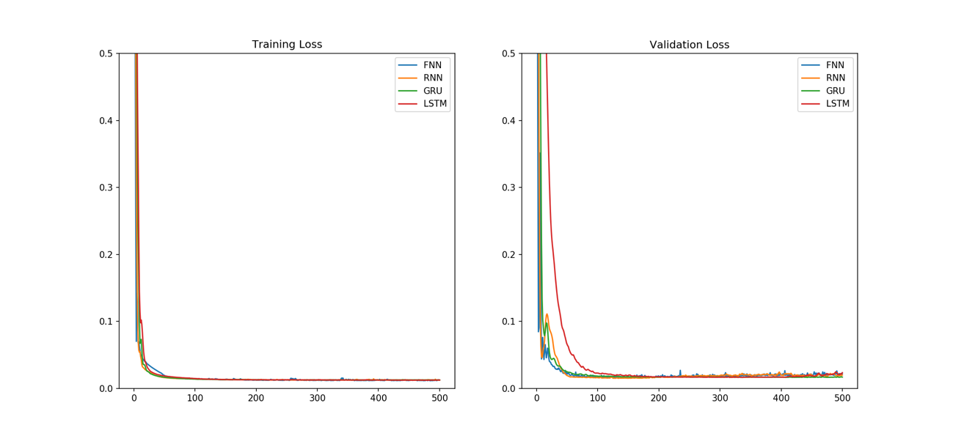

We print the loss table to show the loss in training, validation and testing set. The loss values are quite similar among the models. And it shows a lag from the real price to predicted price.

# Testing

fig, (ax1, ax2, ax3) = plt.subplots(1, 3, figsize=(22, 7))

ax1.set_title("Prediction on Training set")

ax2.set_title("Prediction on Validation set")

ax3.set_title("Prediction on Test set")

ax1.plot(tensor_training_data[500 : 550, -1], label = "Origin", color = "#3F5161")

ax2.plot(tensor_validation_data[:, -1], label = "Origin", color = "#3F5161")

ax3.plot(tensor_testing_data[:, -1], label = "Origin", color = "#3F5161")

df_loss_testing = pd.DataFrame(columns = ["Net", "Training", "Validation", "Testing"], index = [0, 1, 2, 3])

count = 0

for i, net in enumerate([rnn, gru, lstm, fnn]):

ax1.plot(net(tensor_training_data[500 : 550, : -1])[ : , ].squeeze().data.numpy(), label = net_names[i])

ax2.plot(net(tensor_validation_data[ : , : -1])[ : , 0].squeeze().data.numpy(), label = net_names[i])

ax3.plot(net(tensor_testing_data[ : , : -1])[ : , 0].squeeze().data.numpy(), label = net_names[i])

df_loss_testing.iloc[count]["Net"] = net_names[i]

df_loss_testing.iloc[count]["Training"] = test(net, dl_training_data)

df_loss_testing.iloc[count]["Validation"] = test(net, dl_validation_data)

df_loss_testing.iloc[count]["Testing"] = test(net, dl_testing_data)

count += 1

print(df_loss_testing)

df_loss_testing.to_csv("Loss_Testing.csv")

ax1.legend()

ax2.legend()

ax3.legend()

plt.savefig("Prediction.png", dpi = 150)

plt.show()

|  |  |  |  |
| --- | --- | --- | --- |
| **Net** | **Training** | **Validation** | **Testing** |
| **FNN** | 0.01243 | 0.01996 | 0.01107 |
| **RNN** | 0.01261 | 0.01688 | 0.01074 |
| **GRU** | 0.01263 | 0.02347 | 0.01082 |
| **LSTM** | 0.01249 | 0.02184 | 0.01244 |

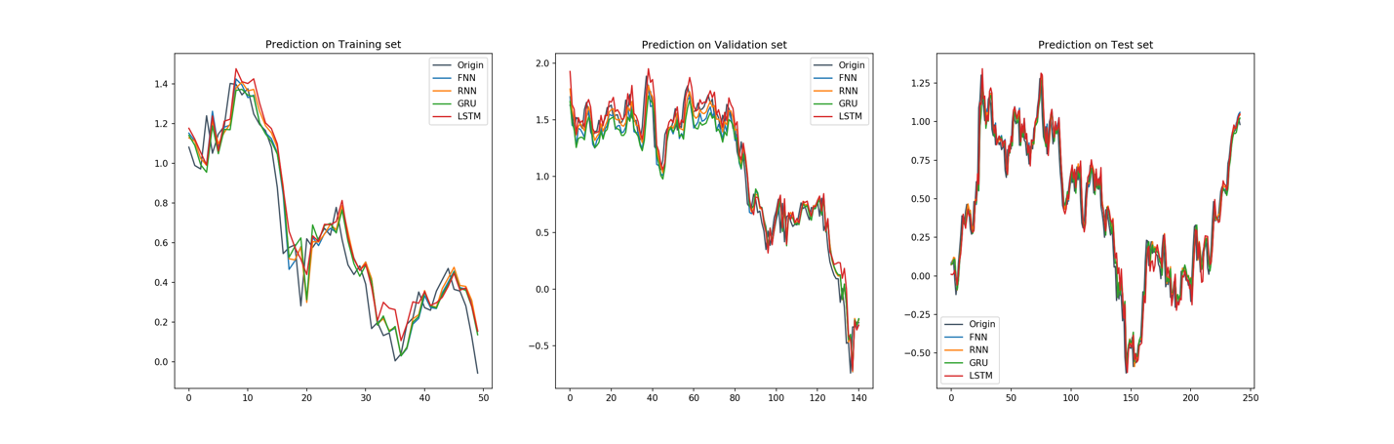

**Tuning**

We first change the learning rate to 0.001, 0.01 and 0.1. And get the following results. From the loss table we find that all the performances are quite good and there’s no underfitting and overfitting. And the testing performance of lr = 0.01 is better than others. we find that the loss graph of 0.001 and 0.01 is decreasing more smoothly than 0.1.

|  |  |  |  |  |  |  |  |  |  |
| --- | --- | --- | --- | --- | --- | --- | --- | --- | --- |
|  | **Training** | | | **Validation** | | | **Testing** | | |
| **LR** | **0.001** | **0.01** | **0.1** | **0.001** | **0.01** | **0.1** | **0.001** | **0.01** | **0.1** |
| **FNN** | 0.01372 | 0.01243 | 0.01070 | 0.01766 | 0.01996 | 0.02592 | 0.01087 | 0.01107 | 0.01194 |
| **RNN** | 0.01390 | 0.01261 | 0.01084 | 0.02059 | 0.01688 | 0.02925 | 0.01104 | 0.01074 | 0.01274 |
| **GRU** | 0.01542 | 0.01263 | 0.00974 | 0.03016 | 0.02347 | 0.01992 | 0.01301 | 0.01082 | 0.01237 |
| **LSTM** | 0.01344 | 0.01249 | 0.01224 | 0.01786 | 0.02184 | 0.02426 | 0.01239 | 0.01244 | 0.01351 |

Loss graph (lr = 0.001, 0.01, 0.1).

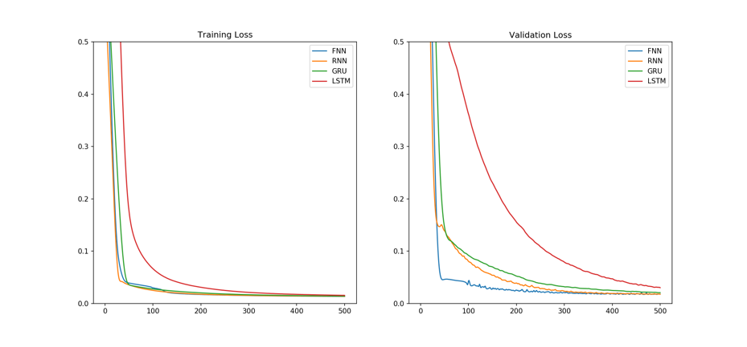

Prediction graph (lr = 0.001, 0.01, 0.1).

Then we tune the hyperparameter, we change the dataset size from 60%, 15%, 25% to 80%, 10%, 10%. And we have the following result that the losses from validation and testing set after tuning are lower than the previous ones.

|  |  |  |  |  |  |  |
| --- | --- | --- | --- | --- | --- | --- |
| **Net** | **Training** | **Training (Tuned)** | **Validation** | **Validation (Tuned)** | **Testing** | **Testing (Tuned)** |
| **FNN** | 0.01243 | 0.01370 | 0.01996 | 0.00986 | 0.01107 | 0.00868 |
| **RNN** | 0.01261 | 0.01299 | 0.01688 | 0.00977 | 0.01074 | 0.00948 |
| **GRU** | 0.01263 | 0.01316 | 0.02347 | 0.0100 | 0.01082 | 0.00865 |
| **LSTM** | 0.01249 | 0.01341 | 0.02184 | 0.01146 | 0.01244 | 0.00993 |

Loss graph (set size = [60%, 15%, 25%] and [80%, 10%, 10%])

Prediction graph (set size = [60%, 15%, 25%] and [80%, 10%, 10%])

Since the loss in training set and testing set are quite close, and in a good range. There’s no need to tune the network size.