1.• Write a single SQL statement to project two columns for a list: the title of a book in the first column named Title, and the total stock of that book in the second column named Stock. All books from the database must be included in the list

• Hint: You are told that transactionTypeID 1 means sold and 2 means received

Sample output

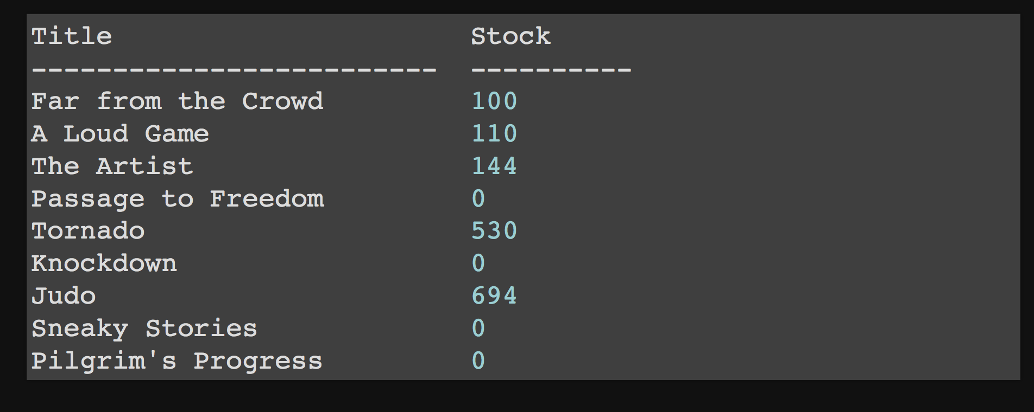

* 2. Write a single SQL statement to generate two rows of information: one row showing the combined salary of all managers, and the other row showing the combined salary of all other employees. There should be three columns in the output. First column is named Type which has the value Manager or non-Manager. Second column is named Salary which shows the total salary as an integer with a dollar sign. Third column is named Percentage which shows the percentage of the total salary in 2 decimal places with a percentage sign

Sample output

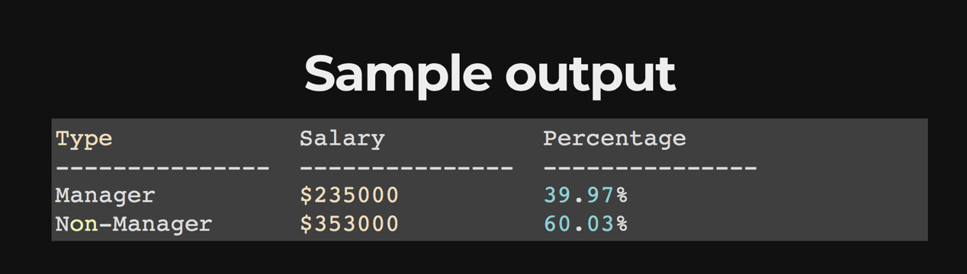

* 3. Write a single SQL statement to project two columns for a list: the book grade in the first column named Grade, and the second column named Books showing the full name of all books belonging to that grade based on the latest price. The full name of a book composes of the book title followed by the published year in a bracket. Each book is separated by a comma with a space among each other

Sample output

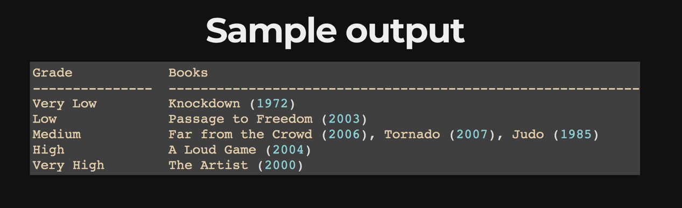

4. • Write a single SQL statement to create a view named StaffStatus with three columns: first column named Staff which shows the first name of staff; second column named Status which shows the value Active or Inactive reflecting the employment status of staff; and third column named Duration which shows the number of years and the number of months each staff has worked for. The output of the view should be ordered first by Status accendingly and then by Duration decendingly

• Hint: You are told that on average there are 365.25 days in a year and 30.44 days in a month

Sample output

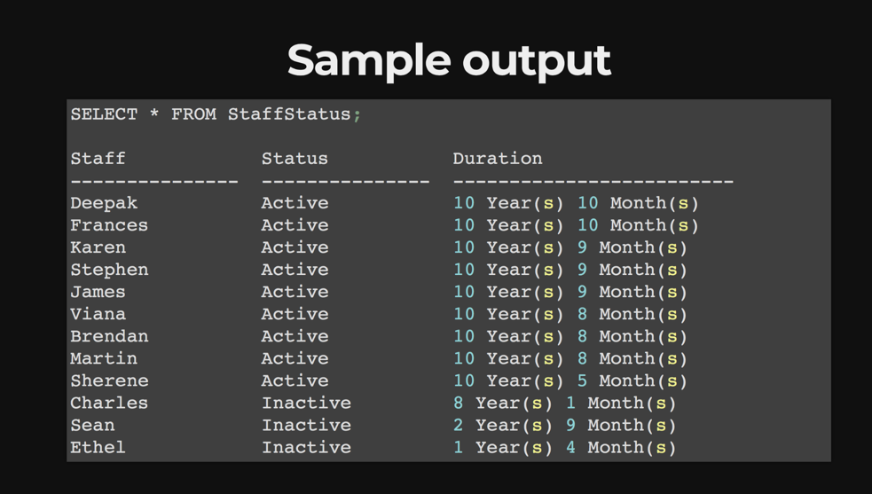

* 5. Write two SQL statements to create two triggers. First trigger is named UndeleteStaff and its purpose is to reverse the deletion of a staff after it happens. It assigns the value of current timestamp to the end date of that staff's assignment. Second trigger is named AssignStaff and its purpose is to add a new assignment and assign the value of current timestamp to the start date after any insertion of new staff happens. In other words, it will not be activated if no new staff is being inserted