**Final Project Report of Image Compression**

By

Zhengyu Li

**Abstract**

This is a report about JPEG image compression. There are two modules designed which are encoder and decoder. The function of the encoder is to read a 512*512 grayscale image first; then 8*8 DCT, quantization, Zig-zag scan and Huffman coding of system are applied. DC coefficients is predicted in encoder either. Huffman decoding, inverse scan, inverse quantization, inverse DCT and calculating PSNR are applied in decoder.

**Part 1: Encoder**

In this part, an 512*512 pixels grayscale image is read by the encoder. To achieve DCT, a dct matrix is created, then 8*8 DCT is applied using blockproc statement divided the whole image into 64 8*8 blocks. 



The quantization is calculated by using the quantization table and processing by 8*8 blocks. Step size is defined as 1 and it can be changed from 1 to 255.

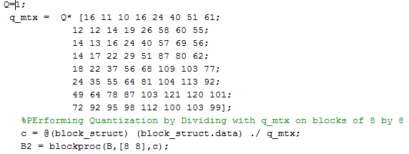

DC coefficients predicted by a loop which is DCi – DCi-1

To do Zig-zag scan, an order matrix is produced which provide the sequence to scan the image matrices.

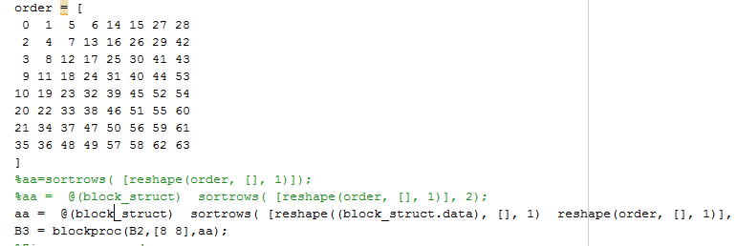

After finishing these parts above, a 4096*64 matrix created. Combining with the given table, run-length, size, and amplitude are extracted and stored in a new matrix which name is run. First column is run length, second column is size and the third column is amplitude. 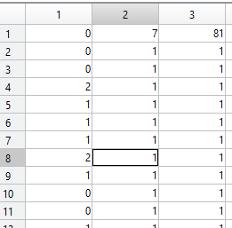

Then the Huffman code is applied by reshape the 4096*64 matrix to 1 row matrix. System Huffman function called to do the Huffman coding.

At the end, output the bit stream file for decoder to decoding the image.

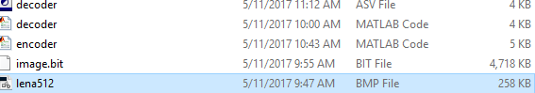

**Part 2: Decoder**

In this part, the output bit stream produced in the encoder is taken as the input bit stream. First of all, the Huffman decoding is applied. Then the inverse zig-zag scan is applied and DC coefficient are reduced.

The inverse quantization and inverse DCT are applied to reconstruct the image. Finally, MSE and PSNR are computed. At the same time, R-D curve shown on the screen.

**Result:**

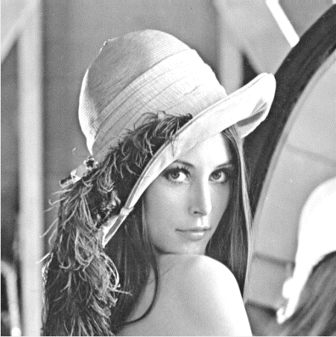 MSE 2.4469 PSNR 44.2447

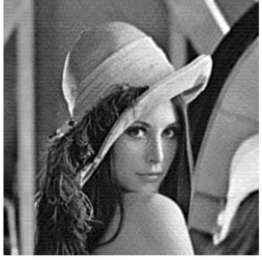MSE 6.7968 PSNR 39.8078

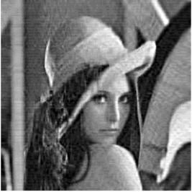MSE 27.1872 PSNR 33.7872