CS 5615 Distributed Operating System

Project 1 Report

1. Group members: Zhengyu Li, UFID: 29453969

Yue Yu, UFID: 96141901

1. The number of worker actors is 8.
2. Size of work unit of each worker actor should be the same in order to get the best performance. Because in this way, all processes will have the same working loading so that they will start and finish the work in a very close time, so the whole project will be finished in this time. If some processes have more work load, then they will finish later, and the whole project will be finished late.

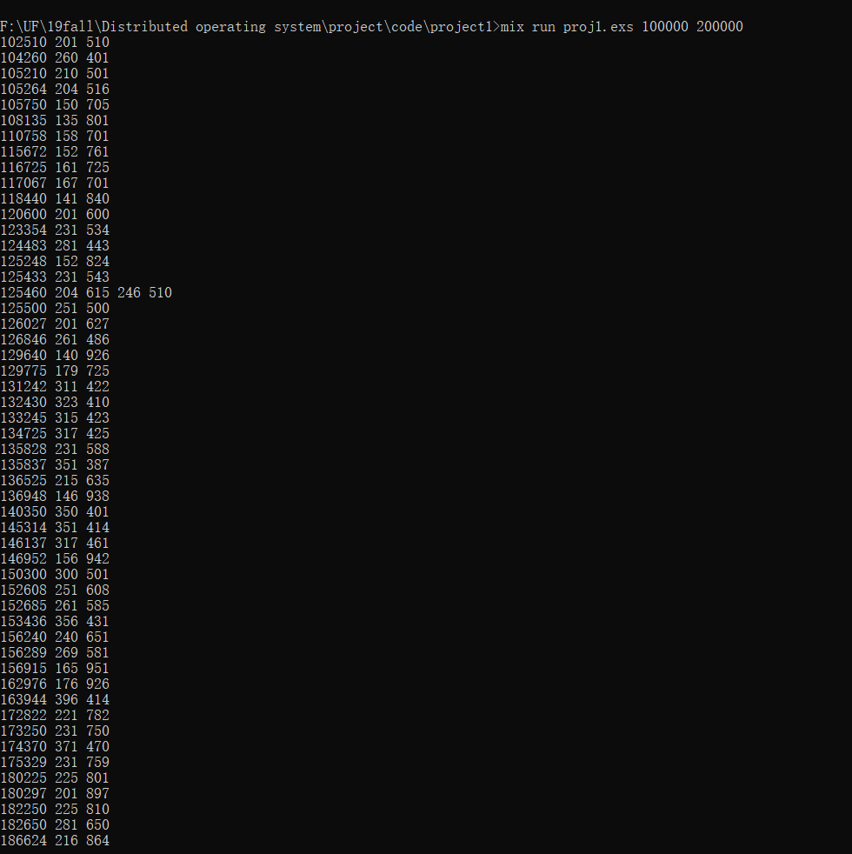

Fig. 1 Screenshot of Finding Vampire Number between 100000 and 200000 (1)

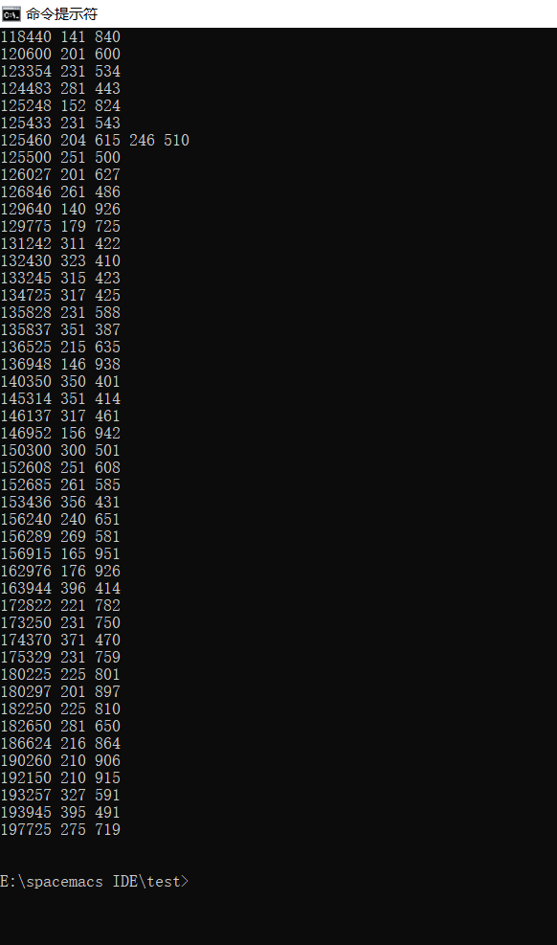

Fig. 2 Screenshot of Finding Vampire Number between 100000 and 200000 (2)

1. The running time for the program above is:

CPU time: 0.743s

Real time: 1.694s

Sys time: 0.051s

The time ratio of CPU time to real time = 0.743/1.694 = 0.438

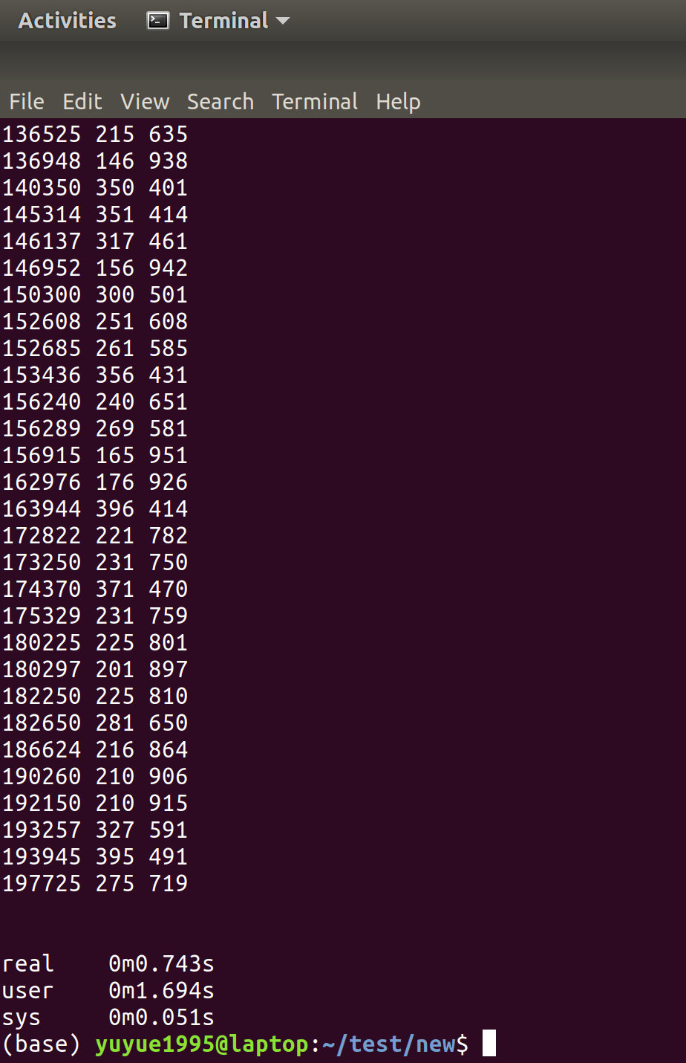

Fig. 3 Execution Time

1. The largest number we tried to solve is 600,000

The screenshots are below:

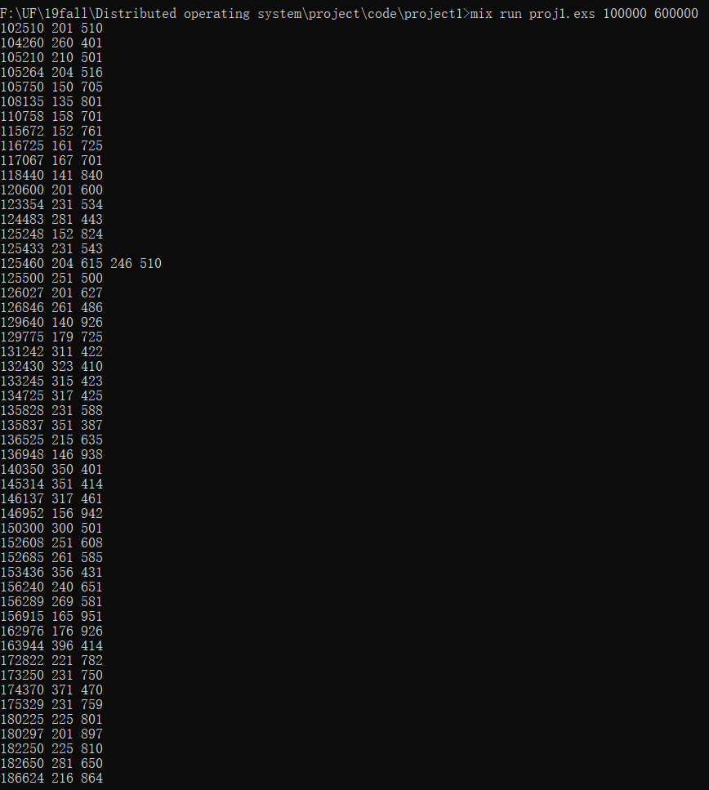

Fig 4. Screenshot of 100000-600000 (1)

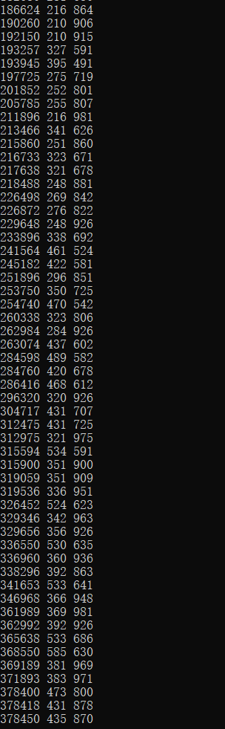

Fig 5. Screenshot of 100000-600000 (2)

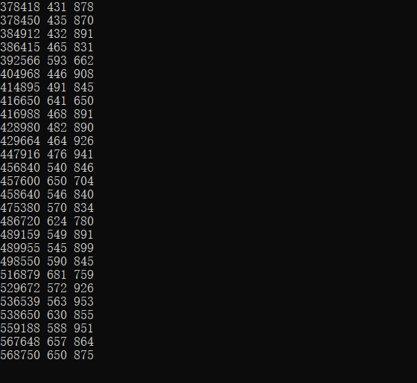

Fig 6. Screenshot of 100000-600000 (3)