Project 2 Report

Team members:

Yue Yu, UFID: 96141901

Zhengyu Li, UFID: 29453969

Figures:

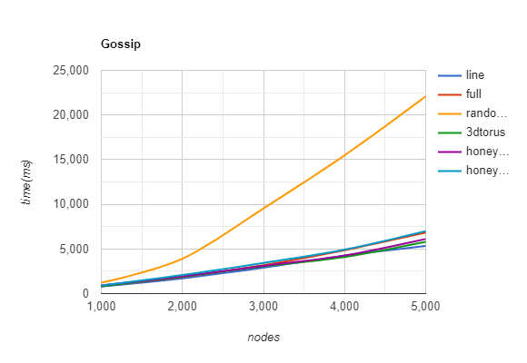

Figure1 Gossip

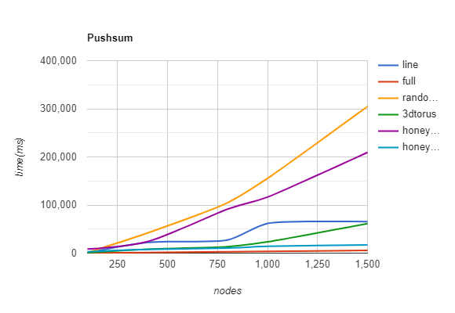

Figure2 Push-sum

Gossip (millisecond)

|  |  |  |  |  |  |
| --- | --- | --- | --- | --- | --- |
| Topo\Nodes | 1000 | 2000 | 3000 | 4000 | 5000 |
| Line | 781 | 1703 | 2906 | 4235 | 5344 |
| Full | 875 | 1859 | 3187 | 4860 | 6844 |
| Random2d | 1219 | 3906 | 9531 | 15484 | 22078 |
| 3D Torus | 813 | 1890 | 3047 | 4094 | 5797 |
| Honeycomb | 907 | 1938 | 3110 | 4266 | 6110 |
| Honey_extra | 906 | 2078 | 3438 | 4921 | 7000 |

Pushsum (millisecond)

|  |  |  |  |  |  |
| --- | --- | --- | --- | --- | --- |
| Topo\Nodes | 100 | 400 | 800 | 1000 | 1500 |
| Line | 421 | 22244 | 27220 | 61674 | 65455 |
| Full | 375 | 1422 | 2985 | 3688 | 5672 |
| Random2d | 1468 | 41875 | 104750 | 155375 | 304891 |
| 3D Torus | 703 | 8078 | 13545 | 23406 | 61391 |
| Honeycomb | 8360 | 23990 | 91419 | 116500 | 209400 |
| Honey_extra | 2906 | 7829 | 10375 | 14422 | 16969 |

Finding:

Push sum algorithm is much slower than gossip and the maximum node number we tested are smaller compared with gossip algorithm. We think the reason is mainly because of communication times between nodes. In gossip algorithm, the maximum receiving message time is 10 which means the node will be removed from the alive node list once it receives 10 messages from other nodes. However, in the push sum algorithm, the node will be removed from the alive node list when the ratio of s/w did not change more than 10 to -10 in 3 consecutive rounds. To achieve this, all nodes send much more messages and communication frequency is much more than 10 times. Therefore, the push sum is slower and cannot support as many as nodes as gossip algorithm. Some algorithms such as line is faster in push-sum but slower in gossip. Random 2D is slow at the beginning because of generating map and will be fast after map generated.