WORK-CASE №2

1,2, Виконав Корольов Євгеній  
Install the hypervisor of the second type Virtual Box.

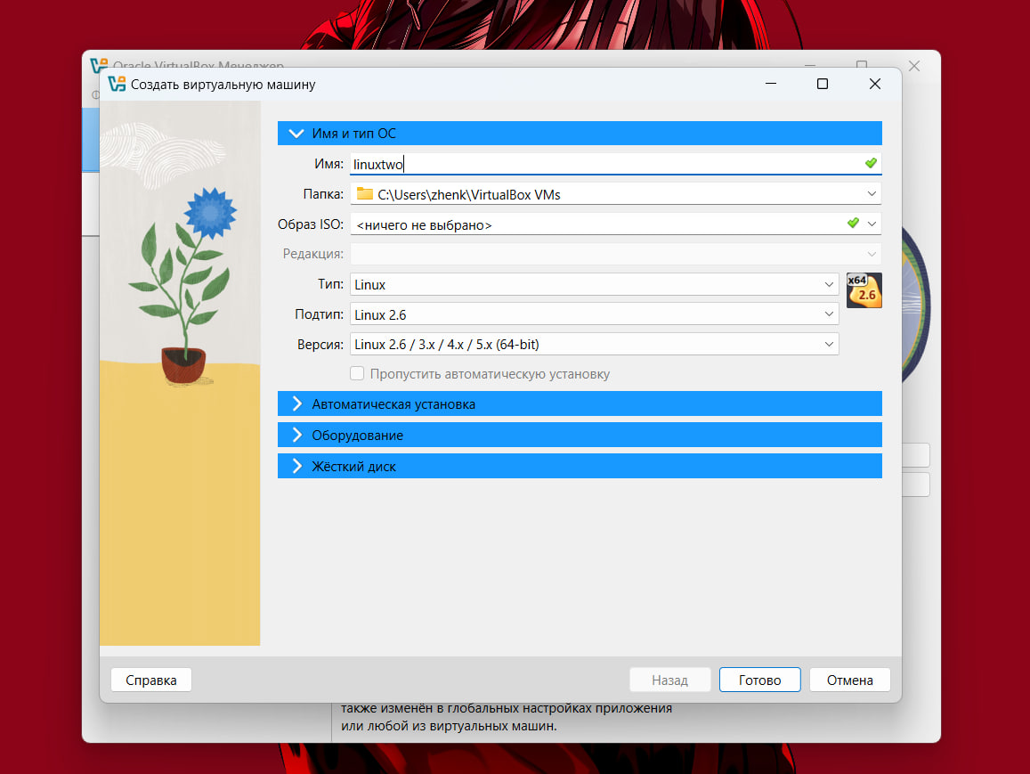

You can modify the hardware by changing the amount of RAM and the virtual number of CPUs, then click “Next”

Choose the size of the Virtual Hard disk (at least 45 GB) and click "Next"

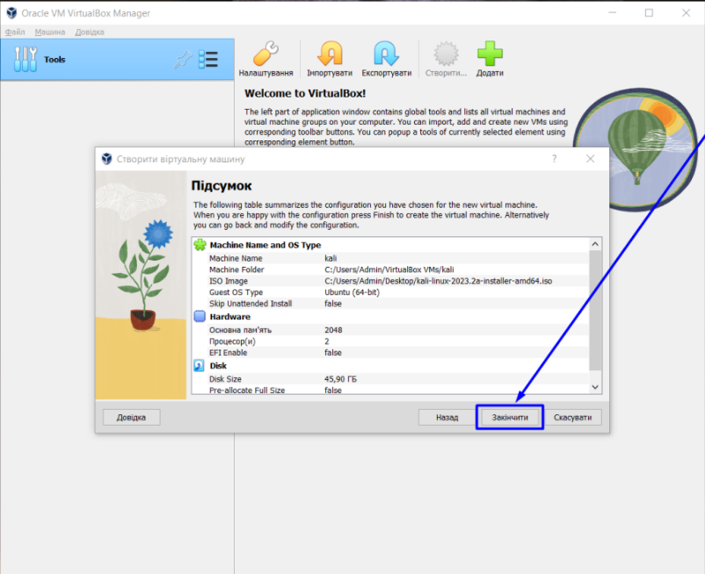

Click "Finish"

Congratulations, you have created a virtual machine

3,4. Виконав Горохов Данило

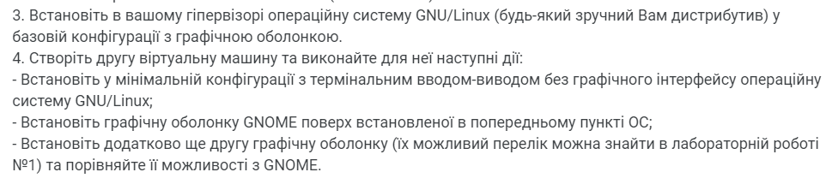

1. I used the downloaded Linux Mint graphical shell to install it. And commands in the terminal.
2. Terminal Linux Mint:
3. 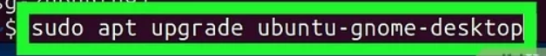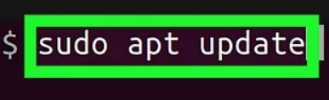Installing GNOME(To download, I used the commands in the terminal):
4. Further in the work, on top of the installed graphical system, you need to install another graphical shell, I chose **sddm.**
5. To install sddm, we need to write several commands:



1. 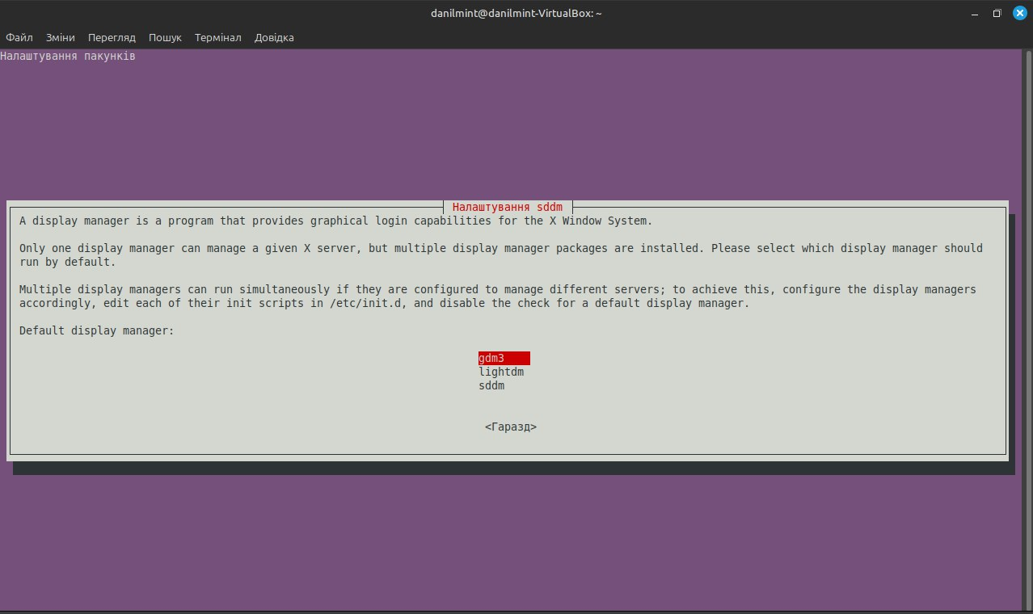As a result(we can choose which graphical shell we can use):
2. I chose gdm3, and wrote a command sudo systemctl disable lightdm(to disable Mint), and sudo systemctl start gdm3(to start the GNOME)
3. 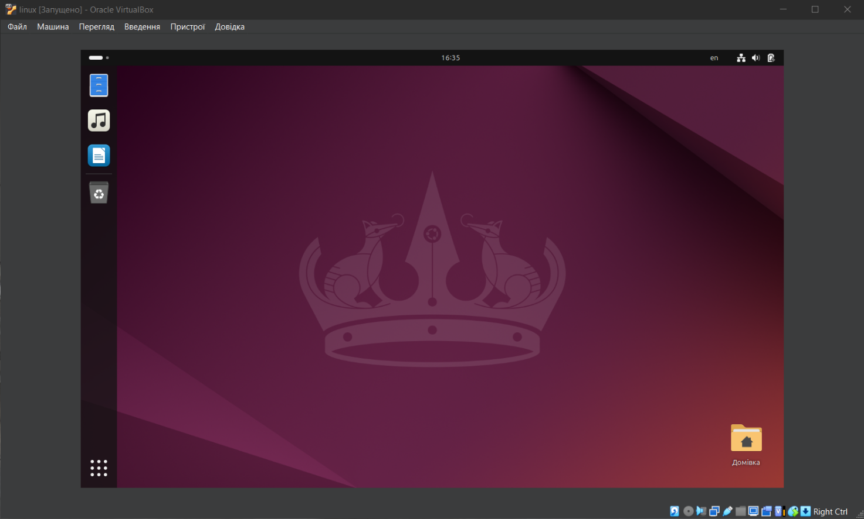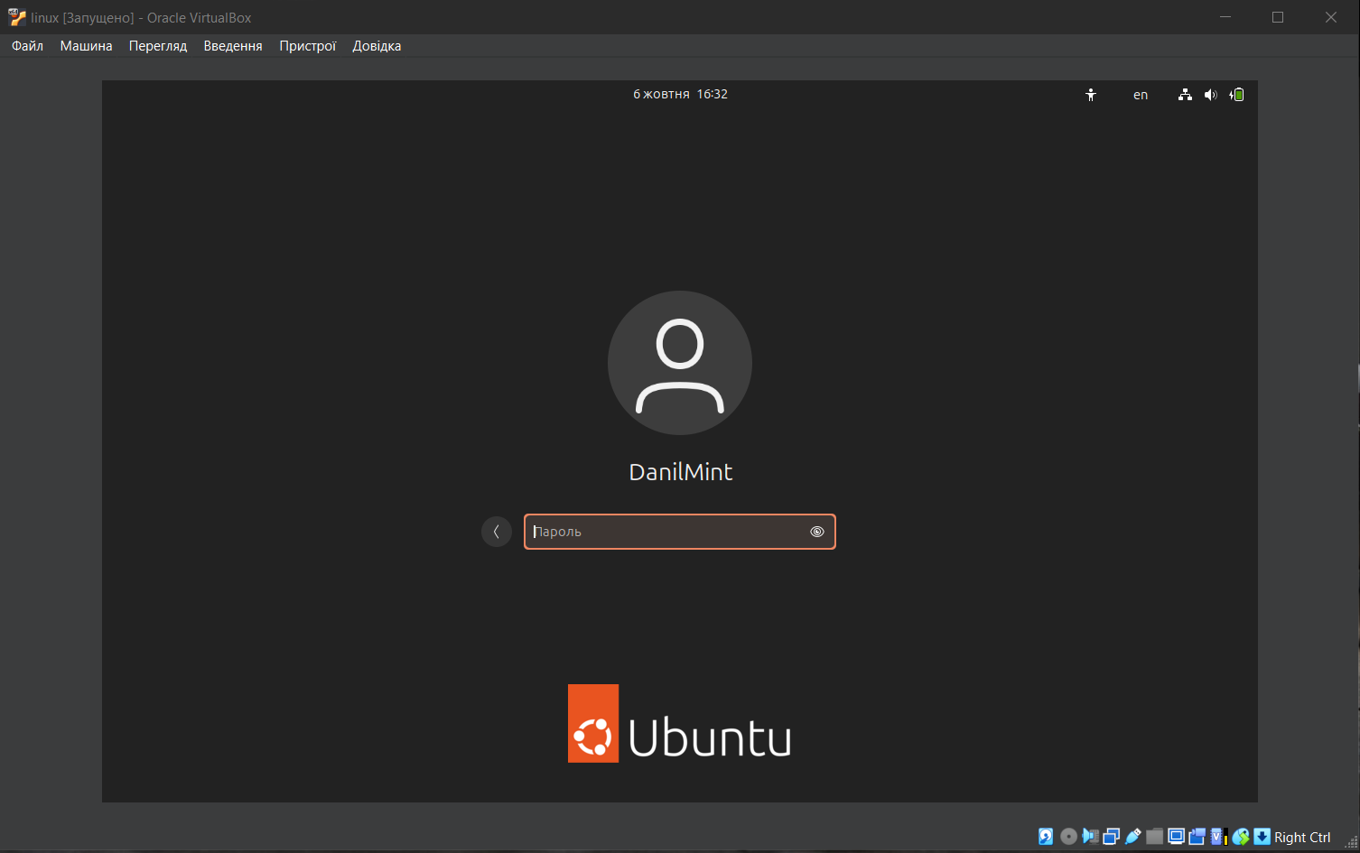As a result (We can go to the GNOME shell):
4. If we want to change the shell, in our case, sudo systemctl disable gdm3, and sudo systemctl start sddm
5. 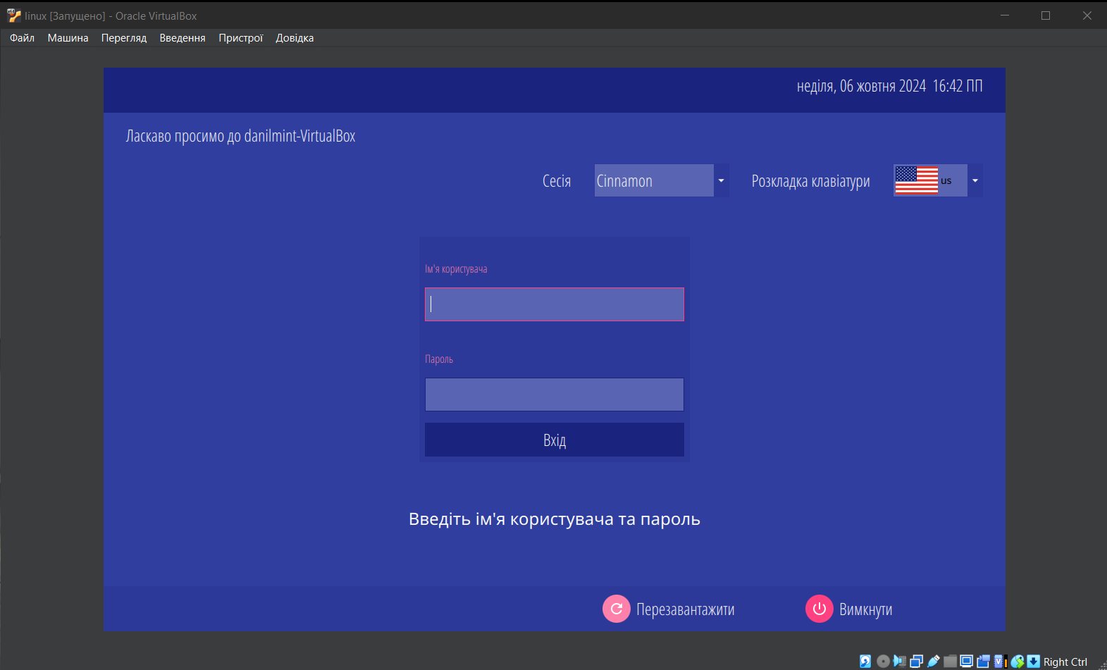 We need to write the login and password, and then we returned to Mint.

**GNOME** and **SDDM** serve different purposes within the Linux environment, but they are often compared due to their roles in user experience.

**GNOME (Desktop Environment)**

* **Purpose**: GNOME is a full desktop environment providing a graphical user interface (GUI) for interacting with the system.
* **Features**:
  + **Activities Overview**: A unified workspace for managing open windows, virtual desktops, and launching applications.
  + **Customization**: Supports themes, extensions, and layout changes via GNOME Tweaks.
  + **File Manager**: Offers a built-in file manager (Nautilus) for browsing and managing files.
  + **System Settings**: Comprehensive system settings for adjusting appearance, network, power management, and more.
  + **Accessibility**: Features high contrast themes, screen readers, and keyboard accessibility options.

GNOME is suitable for users who want a complete, integrated desktop experience with a focus on simplicity and productivity.

**SDDM (Simple Desktop Display Manager)**

* **Purpose**: SDDM is a **display manager** that handles user logins and session management before entering the desktop environment.
* **Features**:
  + **Login Screen**: Provides a customizable login screen for selecting users and desktop environments.
  + **Lightweight**: SDDM is designed to be minimal, making it fast and efficient.
  + **Theme Support**: Offers theming options for customizing the appearance of the login screen.
  + **Wayland and X11 Support**: Compatible with both display protocols, making it flexible for different setups.

SDDM is commonly used with desktop environments like **KDE Plasma** and **LXQt**, providing a simple way to log in and start a session.

**Comparison:**

* **Scope**: GNOME is a full desktop environment, while SDDM is solely a login manager.
* **Customization**: GNOME offers more customization for desktop appearance and functionality, whereas SDDM focuses on the login screen.
* **Use Case**: GNOME is used for everyday interaction with the system, while SDDM is responsible for session management at the login stage.

In summary, GNOME is a comprehensive interface for user interaction, while SDDM is a lightweight display manager for managing user logins.

*To change the display manager, we can use command:*