NATIONAL AERONAUTICS AND SPACE ADMINISTRATION
Research Opportunities in Space and Earth Sciences (ROSES)
Remote Sensing Final Project Report
Program Element | Earth System Science Pathfinder: Earth Venture Mission (EVM) class; science: ROSES A.17 Terrestrial Hydrology
Requested Budget | Stage 1 (now): US$ 217,882 retrieval study (Table 8). Stage 2: ARMO mission ≈ US$ 150 M incl. launch, operations and 30 % reserve (Table 9)
Proposed Duration | Stage 1: 2 years (2027–2028). Stage 2: 5-year development to launch (≈ 2033) and a 3-year science mission
Submission Date | 5 November 2026
Title | Do field-scale radars blink through the rain? Ground-truth evaluation of Sentinel-1 and NISAR revisit against 3,340 soil-moisture wetting events at 120 U.S. Climate Reference Network stations, and requirements for ARMO, a targeted L-band revisit mission
Principal Investigator | Tang Zhen Ian [confirm]
Co-Investigators | [Group members to be added]
Proposal Category | Water Resources; Agriculture and Food Security

1 Scientific/Technical Merit & Objectives
Every rain storm writes a brief signal into the top few centimetres of soil: moisture jumps within hours, then drains and evaporates over the following days. That transient state decides how much of the next storm runs off, how much water a crop actually received, and how the land surface feeds back on the weather. Field-scale (≤ 200 m) soil moisture can be mapped from orbit only by synthetic aperture radar (SAR); L-band radiometers such as SMAP revisit every 2–3 days but see ~40 km footprints. SAR missions revisit a given field only every 6–12 days. If wetting events fade within one or two days, the field-scale radar fleet is blind to most of them however accurate each image is. Before arguing for a new satellite, we test that concern against independent hourly ground truth.
Primary objective: Our primary objective is to determine whether today's field-scale radar fleet (Sentinel-1 and NISAR) observes the rain-driven wetting events that dominate near-surface soil-moisture variability across the contiguous United States and, if not, what revisit a dedicated L-band mission (ARMO, the Agricultural Rapid Moisture Observatory) would need to capture at least 80 % of them.
Hypotheses. H1: rain-driven 5 cm wetting events are shorter than the revisit of today's field-scale radar fleet, so the fleet misses most of them. H2: when an event is sampled, its signal is smaller than the change noise of current radar retrievals. H3: a dedicated L-band revisit mission would raise event capture to ≥ 80 %. They address the 2017 Decadal Survey hydrology question H-4 ("how do we improve preparedness and mitigation of water-related extreme events?"; objectives H-4b flash floods and H-4c drought monitoring) and Targeted Observable TO-17 Soil Moisture, which the survey left unallocated because the programme of record "does not include coverage after SMAP and SMOS" (National Academies, 2018). Proposal type: two stages: a 2-year retrieval study, then an Earth Venture-class flight mission. It measures the problem against ground truth, derives what ARMO must achieve, and sizes and costs the spacecraft.
1. Measure the duration and amplitude of rain-driven 5 cm wetting events from hourly in-situ ground truth at 120 NOAA USCRN stations (warm seasons 2025–2026).
2. Quantify the fraction of these events captured by regular 1–12-day revisits and by the actual 2025–2026 Sentinel-1 and NISAR acquisition records.
3. Test observability: compare Sentinel-1 C-band backscatter, NISAR L-band soil moisture, the SMAP L-band radiometer and a no-satellite model (ERA5-Land) against ground truth when an event is sampled, by vegetation cover.
4. Derive the revisit and noise requirements and the marginal value of ARMO over current and planned missions, and decide (YES / CONDITIONAL / NO) whether a new satellite is justified.
Key finding. Half of all wetting events stay above half their peak for less than 1.8 days. Even if every look were a perfect measurement, the combined 2026 Sentinel-1 + NISAR fleet captured only 52 % (95 % CI 47–56 %) of 979 events; ≥ 80 % needs a regular ≈ 1.5-day revisit on its own, or a 2-day ARMO added to today's fleet. When sampled, Sentinel-1 registered 33 % of events and NISAR 23–37 %; 70 % needs change noise ≤ 0.038 m³/m³, a 3.8-fold reduction at L-band. Two L-band smallsats would lift fleet capture to 81 %. Scored alone on the same events, ARMO captures 76 %, against 38 % for NISAR and 38–61 % for ROSE-L (6- or 3-day revisit); at its detection requirement it would register 4–6× as many events as NISAR does today. With ROSE-L (≥ 2030) at ESA's documented 6-day revisit the fleet reaches 64 % and ARMO still adds 13–18 points. We therefore propose ARMO in two stages. Stage 1 funds event-level retrieval research now (US$ 217,882, 2 years); its result sets how capable ARMO's sensor must be. Stage 2 builds and launches ARMO either way: two ≈ 251 kg L-band smallsats on one launcher, ≈ US$ 150 M including launch, operations and a 30 % reserve, inside the US$ 190 M Earth Venture Mission cap. If retrieval succeeds, ARMO registers 4–6× NISAR's events; if not, its revisit alone still doubles them (Section 3.4).

2 Background & Motivation
Physical basis. Microwave backscatter from soil is controlled by its dielectric constant, which rises from ~3–5 for dry soil to > 20 for wet soil because liquid water has εᵣ ≈ 80 (Ulaby et al., 2014). For bare or sparsely vegetated surfaces σ⁰ in dB increases roughly linearly with volumetric soil moisture, which is the basis of change detection: with roughness and vegetation nearly constant between two looks from the same orbit, a backscatter increase maps to wetting (Wagner et al., 1999; Bauer-Marschallinger et al., 2019). Vegetation adds volume scattering and attenuates the soil signal; the effect is far stronger at C-band (5.4 GHz, λ ≈ 5.6 cm; senses ~1–2 cm) than at L-band (1.26 GHz, λ ≈ 24 cm; ~5 cm), which is why soil-moisture missions favour L-band (Entekhabi et al., 2010; Kim et al., 2017). SAR achieves 10–200 m resolution by aperture synthesis, but its swath (~250 km) is a small fraction of the orbit-to-orbit spacing (Luo et al., 2017), so a single SAR revisits a site only every 6–12 days (ESA, 2026; NISAR Science Team, 2023).
What is known. Satellite drydown studies find exponential decay time scales of a few days, shorter over sandier and more arid soils (McColl et al., 2017; Jiang et al., 2025), and SMAP dries faster than in-situ probes because it senses a thinner layer (Shellito et al., 2016). SMAP's 3-day revisit requirement was tied to inter-storm periods at 10–40 km (Entekhabi et al., 2010). At field scale, irrigation-detection studies show that ≤ 2–4-day sampling is needed (Le Page et al., 2020; Filippucci et al., 2020; Zappa et al., 2022), and 6-day Sentinel-1 sampling cannot separate an old heavy storm from recent light rain (Bazzi et al., 2019). Sentinel-1 backscatter has been regressed against USCRN data (Chatterjee et al., 2020). NISAR (launched 30 July 2025) now distributes a free 200 m L-band soil-moisture product (SME2) with an accuracy goal of 0.06 m³/m³ where vegetation water content < 5 kg/m², provided about twice per 12 days (NISAR Science Team, 2023; ASF, 2026). ESA's two-satellite ROSE-L targets a revisit of 6 days over global land and 3 days over Europe (Davidson, 2023; Davidson et al., 2026; a secondary summary lists 3 days for soil moisture, eoPortal, 2026) and is listed for launch ≥ 2030 (WMO OSCAR, 2026).
Knowledge gap. Existing revisit studies concern irrigation at one or a few sites, often by synthetic subsampling of in-situ series (Filippucci et al., 2020; Zappa et al., 2022; Le Page et al., 2020). We found no multi-climate quantification of how many rain-driven wetting events the actual field-scale radar fleet captures, measured against hourly ground truth, nor any estimate of what a new mission would add once NISAR and ROSE-L are counted. Without those numbers, neither ROSE-L's revisit nor a new mission can be traced to an observed requirement. Table 1 summarises the capabilities that any new mission must beat.
Table 1. Existing and planned soil-moisture-relevant missions (operational status as of November 2026). Sources: mission pages listed in References.
Mission (agency) | Status | Sensor | SM / backscatter resolution | Revisit (mid-latitude) | Key limitation for field-scale events
SMAP (NASA) | Operating since 2015; radar failed 2015 | L-band radiometer | ~40 km (9 km grid) | 2–3 d | Too coarse for fields
Sentinel-1C/1D (ESA/EU) | Operating; 1A ended operations Jun 2026 | C-band SAR | 5 × 20 m; no official SM product outside Europe | 6 d pair, 12 d per satellite | C-band attenuated by crops
NISAR (NASA–ISRO) | Launched Jul 2025; provisional data since Jun 2026 | L- + S-band SAR | SME2 200 m | 12 d repeat; SM ~2 per 12 d | Revisit; provisional accuracy
ROSE-L (ESA) | Planned, launch ≥ 2030 | L-band SAR (2 sats) | SM goal 25–50 m | 6 d global land; 3 d Europe | Not yet in orbit
SAOCOM-1A/1B (CONAE) | Past 5-yr design life | L-band SAR | 10–100 m | 8 d pair | Restricted access
ALOS-4 (JAXA) | Operating since 2024 | L-band SAR | 3 m (200 km swath) | 14 d | Limited free data, no SM product
CIMR (ESA) | Planned 2029 | Multi-band radiometer | L-band ~58 km | ~daily | Coarse
BIOMASS (ESA) | Launched Apr 2025 | P-band SAR (435 MHz) | Forest products 200 m | Global map every 228 d | Barred over N. America (SOTR)
Spire; Planet (commercial) | Operating | Models from GNSS-R, radiometers | 500 m; 1 km (100 m discontinued) | Daily | Modelled from coarse sensors; closed

ARMO's niche. No open, all-weather system observes field-scale (≤ 200 m) soil moisture faster than every ~6 days over the US. NISAR's 200 m product matches ARMO's resolution but not its revisit; commercial daily products are modelled from 9 km or coarser sensors and are not open (Spire, 2024; Planet, 2026); P-band SAR may not operate over North America (Quegan et al., 2019); and optical sensors get a clear look inside only 56 % of event windows even when imaging daily (Section 3.4). ARMO's novelty is therefore revisit, not resolution: NISAR-class L-band retrieval at ≈ 1.4-day sampling, matched to events that last 1.8 days.
Study area. We use the NOAA U.S. Climate Reference Network (USCRN; Bell et al., 2013), the most rigorous open soil-moisture network available: triplicate probes at 5 cm, hourly reporting, co-located rain gauges and soil temperature. USCRN is used to validate, not calibrate, satellite products, so it is independent of every retrieval tested here. Its 121 qualifying stations (120 with wetting events) span arid rangeland to humid forest (Figure 1b), so a requirement derived from them is not tied to one climate. By ESA WorldCover, 60 stations sit in grassland, 36 in tree cover and only 9 in cropland (Section 3.4).
Where the need is (Figure 1). Mapped in Earth Engine and calibrated with USCRN, Sentinel-1's actual 2026 revisit is 5.6 days at the median cell and 8–16 days over much of the Midwest and East (a), where gridMET storms (Abatzoglou, 2013) bring the most wetting events (b). Sentinel-1 misses ≈ 9 events per season at the median cell (c) and ≈ 12 on cropland, where ARMO would recover ≈ 9, mostly in the Corn Belt and Mississippi Delta (d; MODIS MCD12Q1, Friedl and Sulla-Menashe, 2022): the longest gaps fall where events and farms are densest.
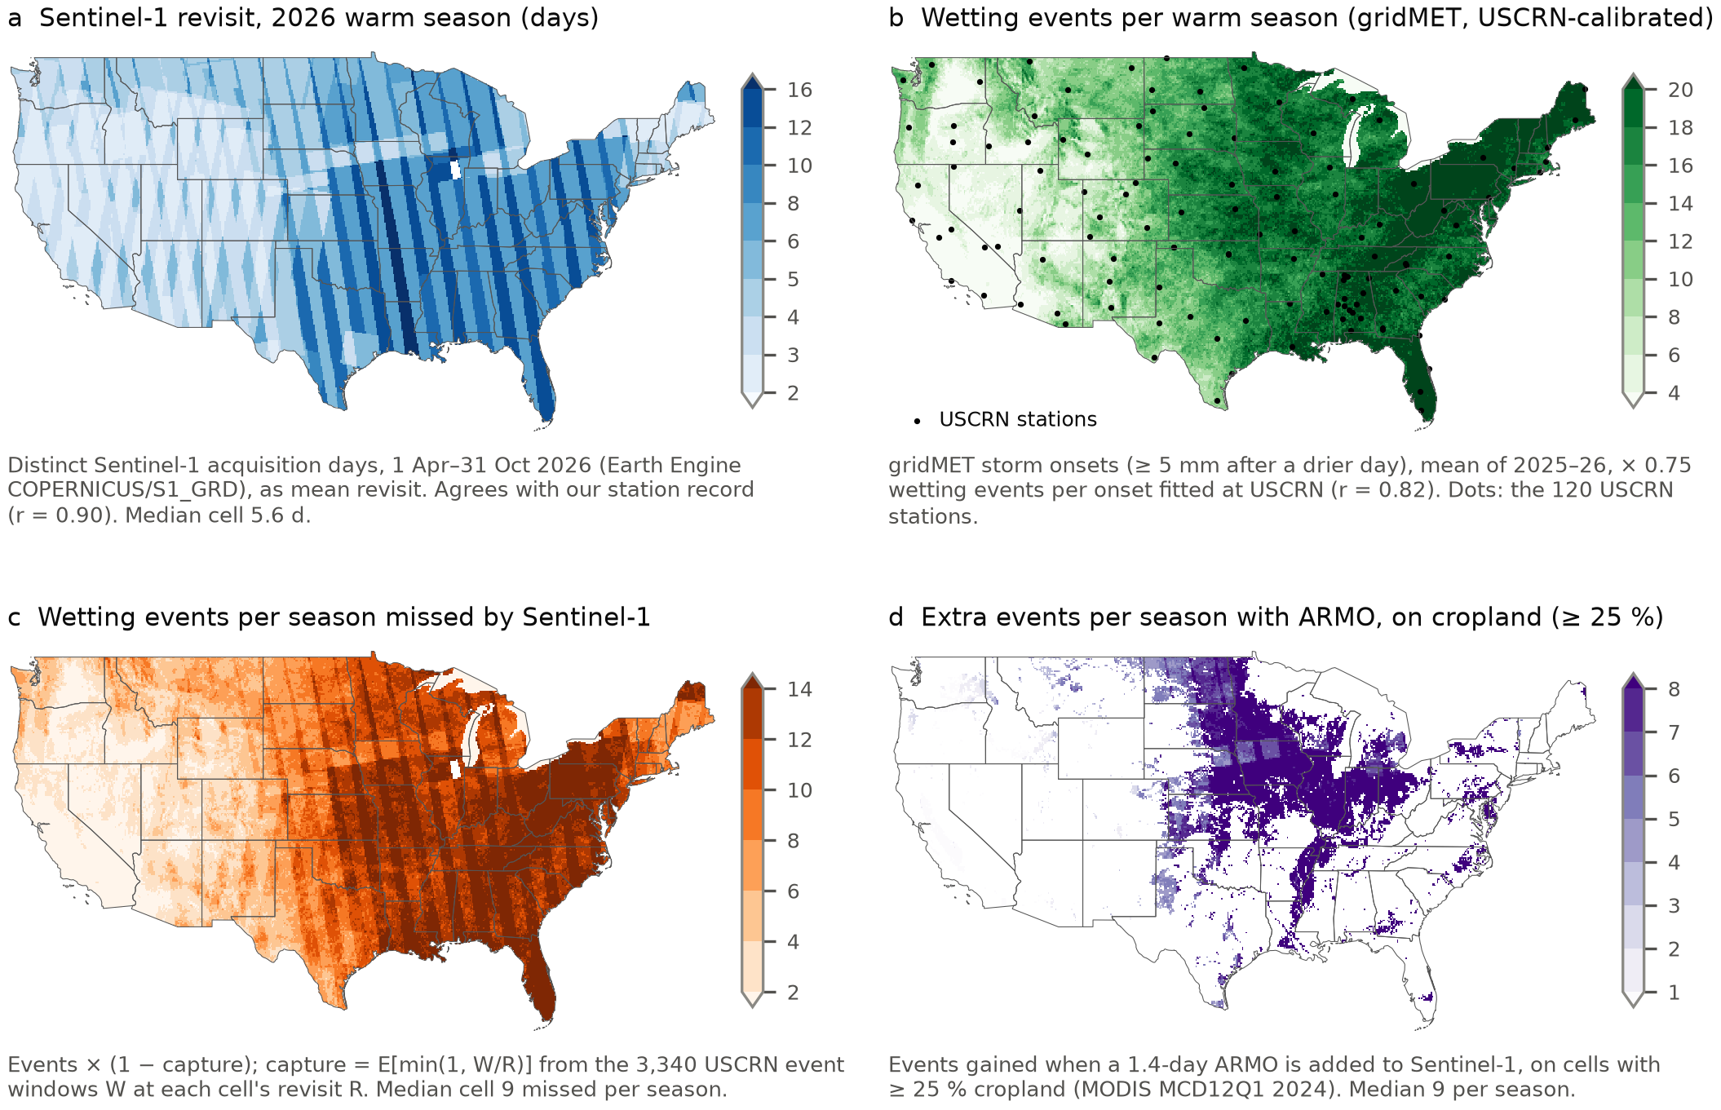
Figure 1. The need, mapped in Google Earth Engine at 0.1° and calibrated with USCRN ground truth; each panel's caption gives its data and method. Panel b also shows the 120 USCRN stations of this study.

3 Methodology & Work Plan
The analysis has three phases (Table 7 gives the two-stage schedule). This proposal reports the completed proof of concept (Phases 1–3 applied to the warm seasons of 2025 and 2026); the funded work extends it (Section 3.4).

3.1 Phase 1: Data Assembly and Pre-processing
Table 2. Datasets. All are free; NISAR downloads need a NASA Earthdata login and the Earth Engine (GEE) products a free non-commercial Earth Engine account.
Dataset / product | Variable and resolution | Dates used | Access | Why chosen
NOAA USCRN hourly02 | 5 cm SM (m³/m³, mean of 3 probes), rain (mm), soil T; point, hourly | Apr–Oct 2025, 2026 | NCEI HTTPS (open) | Independent ground truth
Sentinel-1 GRD catalogue | Acquisition time, platform, orbit | Mar 2025–Oct 2026 | Planetary Computer STAC (anonymous) | Actual C-band revisit
Sentinel-1 RTC | γ⁰ VV, VH; 10 m (11 × 11 px window) | Apr–Oct 2025, 2026 | Planetary Computer (anonymous token) | C-band observability
NISAR L3 SME2 / L2 GCOV | Times, tracks; SM 200 m; L-band σ⁰ HH, HV | Oct 2025–Oct 2026 | CMR (open) / ASF (Earthdata login) | Actual L-band revisit and accuracy
SMAP Enhanced L3 V006 | SM 9 km grid, 06:00 and 18:00 passes; quality flag; vegetation water content | Apr–Oct 2025, 2026 | Google Earth Engine | Frequent but coarse L-band benchmark
MODIS MOD13Q1 V6.1; ESA WorldCover 2021; USDA CDL 2025 | NDVI 250 m, 16-day; land cover 10 m; crop type 30 m | 2021–2026 | Google Earth Engine | Vegetation at each event and station
gridMET; Sentinel-1 GRD; MODIS MCD12Q1 V6.1 | Daily rain 4 km; S1 acquisition days; land cover 500 m | Apr–Oct 2025, 2026; 2024 | Google Earth Engine | CONUS need maps (Figure 1)
ERA5-Land (Open-Meteo) | 0–7 cm SM, 9 km, hourly; ERA5 rain | Apr–Oct 2025, 2026 | Open-Meteo archive API | No-satellite baseline

Pre-processing. (i) NOAA files contained runs of NUL bytes that silently corrupted parsing; we strip them and keep only well-formed 38-field records. (ii) Missing-value sentinels are removed and SM outside 0–0.6 m³/m³ is rejected. (iii) Hours with 5 cm soil temperature ≤ 1 °C are masked, because frozen water invalidates both the probe and the radar dielectric signal. (iv) A station-season is kept only with ≥ 70 % valid hours, leaving 227 station-seasons. (v) Gaps ≤ 3 h are interpolated; longer gaps are left empty. (vi) Each satellite look is matched to the hour-ending USCRN value that follows it, and looks with rain in the preceding 3 h are excluded (wet canopy and ponding). (vii) Adjacent catalogue frames of one pass are merged into one look. The warm season avoids snow and frozen soil; 2025 and 2026 bracket the arrival of Sentinel-1C/1D and NISAR.

3.2 Phase 2: Analysis
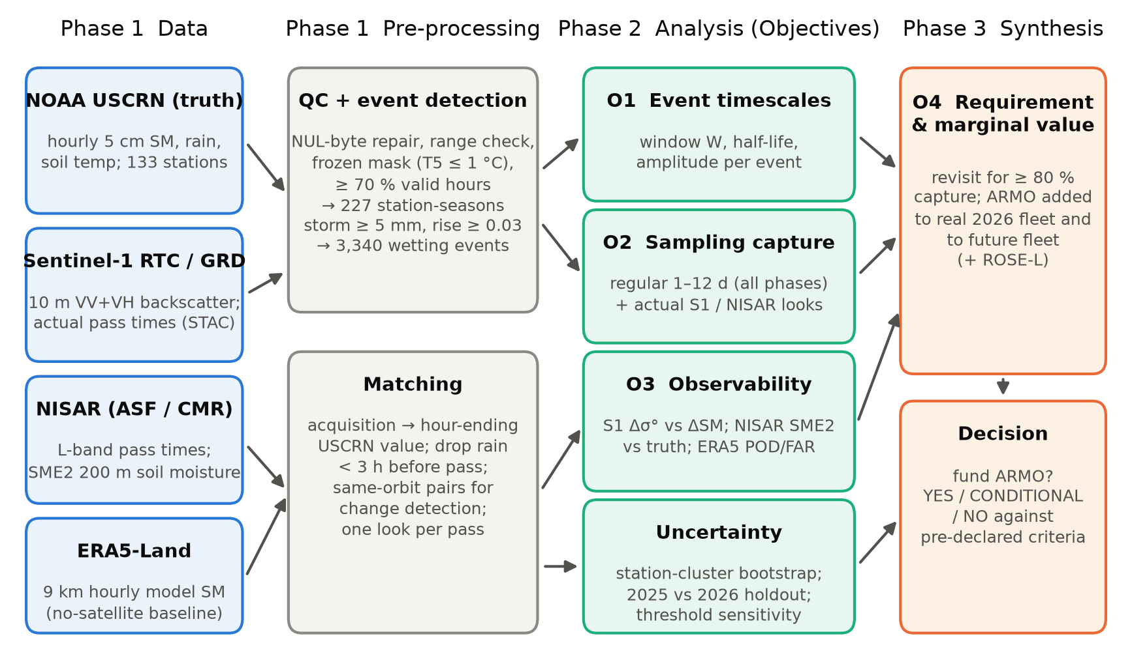
Figure 2. Analysis workflow from data to mission decision.
Wetting events (O1). A storm is a run of hours with ≥ 0.2 mm rain, with gaps < 24 h merged; it is an event if total rain ≥ 5 mm and 5 cm SM rises by A ≥ 0.03 m³/m³ above its 3-h pre-storm mean (a rise comparable to retrieval targets of 0.04–0.06 m³/m³). These thresholds were fixed before any satellite data were examined and are varied in a sensitivity test. The event window W is the time during which the anomaly stays ≥ 50 % of A; a second definition uses an absolute anomaly ≥ 0.03 m³/m³. Windows are censored at the next storm, because a later look would see a different event.
Capture (O2). An event is captured if at least one acquisition falls inside its window. This is an upper bound on detection, since it assumes a perfect sensor. For regular revisits R = 1–12 days we average over every start-day phase and both dawn and dusk overpasses (all missions here fly dawn–dusk orbits). For a randomly phased periodic sampler the expected capture is E[min(1, W/R)], which we use as an analytical check. For the real fleet we use the actual 2025–2026 acquisition times over each station. The decisive marginal-value test (O4) adds a regular ARMO schedule, at random phase, to the real 2026 fleet and to a future fleet that includes ROSE-L at ESA's documented 6-day revisit over global land (3 days, planned only for Europe, as an optimistic check).
Observability (O3). Within each station × relative orbit (fixed geometry), we compute the temporal correlation of Sentinel-1 σ⁰VV with 5 cm SM, the backscatter noise floor from same-orbit pairs with |ΔSM| < 0.01 m³/m³, and the probability that an event sampled inside its window raises σ⁰ above that noise (1σ). The same tests are applied to NISAR SME2 soil moisture and L-band σ⁰HH (same track), and to SMAP (same overpass, ≤ 3.5 days apart), together with absolute accuracy (bias, unbiased RMSE). Detection is split by MODIS NDVI at the event and by land cover. To turn detection into a requirement, we model a sampled event of size A as detected with probability Φ(kA/n − 1), where n is the sensor's change noise in soil-moisture units and k a single factor fitted across all four sensors. ERA5-Land events are detected with the same rules on its own SM and rainfall and matched to ground truth within ± 24 h (POD, FAR, CSI).
Uncertainty and validation. Confidence intervals come from a 2,000-member cluster bootstrap over stations, because events at one station are not independent. 2025 serves as development data and 2026 as an independent holdout. Nine alternative event definitions test threshold dependence. Beyond the tutorials: cloud-native range reads of Sentinel-1 COGs and NISAR HDF5 at 120 stations (no full scenes downloaded), Earth Engine time-series extraction, event-based sampling theory checked against simulation, real-schedule mission emulation, a cross-sensor detection model, and bootstrap inference.

3.3 Phase 3: Results and Synthesis
O1: Wetting events are short. We detected 3,340 events at 120 stations. The median event peaked 16 h after rain began and rose by 0.089 m³/m³. Its half-amplitude window lasted 1.8 days (interquartile range 0.9–3.1 d), and 55 % of events lasted < 2 days (Figure 3, Figure 4a). The absolute-threshold window was longer (median 2.5 d). These are event-level half-lives at 5 cm, not the exponential drydown time scales fitted to satellite data, so the two are not directly comparable.
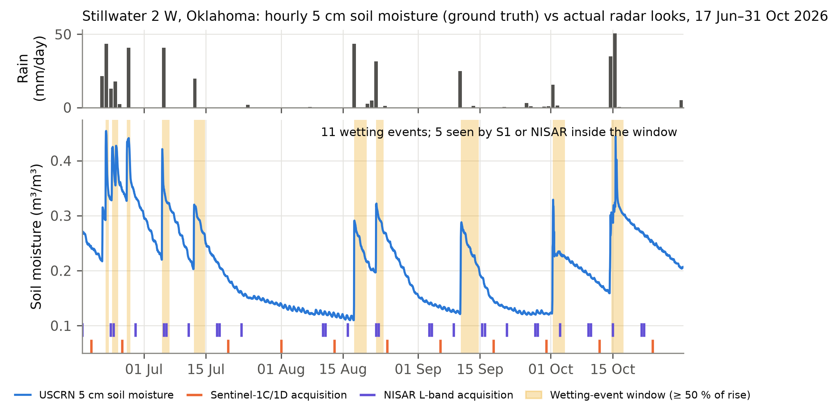
Figure 3. Example from Stillwater 2 W, Oklahoma. Most wetting windows (shaded) fall between Sentinel-1 (orange) and NISAR (violet) looks. NISAR's three tracks over this site give looks in pairs on consecutive days, followed by multi-day gaps.
O2: The fleet misses about half of all events. Regular sampling captures 87 % of events at 1 day, 72 % at 2 days, 60 % at 3 days, 37 % at 6 days and 20 % at 12 days (Figure 4b). The analytical model E[min(1, W/R)] reproduces the simulation within 0.2 percentage points, and the 2026 holdout agrees with 2025 (6 days: 36 % vs 38 %). The pre-declared decision criterion (≥ 20-point gain from 6- to 3-day sampling) is met: +23 points. Across the nine alternative event definitions, 6-day capture stays within 34–40 %. Measured against actual acquisitions, Sentinel-1 captured 33 % of events in 2025 and 30 % in 2026. In the NISAR era (979 events, 107 stations), NISAR alone captured 38 % and the combined fleet 52 %, with station-to-station spread 27–90 % (10th–90th percentile). The combined fleet's median gap is 2.7 days, but its looks cluster: a regular 2.7-day schedule would capture ≈ 64 %. Uncoordinated timing therefore costs ≈ 12 points.
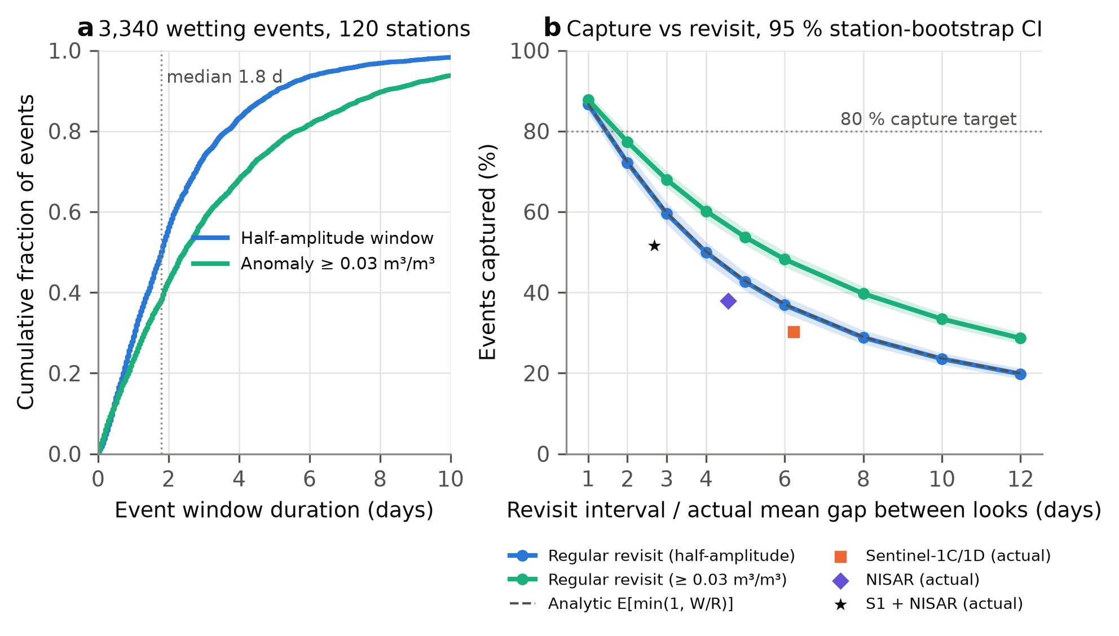
Figure 4. (a) Cumulative distribution of event-window durations. (b) Event capture versus revisit interval for regular sampling (bands = 95 % station-bootstrap CI; dashed = analytical model) and for the actual fleets, plotted at their median gap between looks (half-amplitude criterion).
O3: Sampling is not the only loss. Over 8,074 matched Sentinel-1 looks at 119 stations, the median temporal correlation of σ⁰VV with 5 cm SM was r = 0.33. Across 6,565 same-orbit pairs, the backscatter change tracked the ground-truth change at r = 0.32, with a sensitivity of 0.77 dB per 0.1 m³/m³ (Figure 5a). Pairs without moisture change still scatter by 0.99 dB (speckle, vegetation growth and roughness), equivalent to ≈ 0.13 m³/m³ of soil moisture, larger than the median event amplitude. When a Sentinel-1 look did fall inside a window (624 events), σ⁰ rose above the 1σ noise in only 33 % of cases (false-alarm rate 9 %; wet-up discrimination AUC = 0.67). End to end, Sentinel-1 therefore registers ≈ 10 % of wetting events (Figure 5c). L-band does not yet outperform C-band at event scale. Across 1,991 same-track NISAR pairs, the change in L-band σ⁰HH correlated with the ground-truth change at r = 0.42 (C-band: 0.32), with a sensitivity of 0.98 dB per 0.1 m³/m³. However, its no-change noise (1.45 dB) is equivalent to ≈ 0.148 m³/m³, no better than C-band, and only 23 % of sampled events rose above it. NISAR's provisional SME2 product (2,022 recommended retrievals at 86 stations) meets its 0.06 m³/m³ goal at 76 % of stations (median per-station unbiased RMSE 0.045; pooled 0.105, bias +0.044). Its same-track changes have a noise floor of only 0.032 m³/m³ (r = 0.46), but the retrieved change is damped to 0.30 of the true change, so it registered just 37 % of the 139 sampled events with a valid retrieval pair (21 % if looks without a recommended retrieval count as misses). Absolute accuracy is therefore not the binding constraint. Event sensitivity is. The no-satellite baseline is continuous in time but unreliable at event scale. ERA5-Land tracks the seasonal cycle (median r = 0.70; daily-change r = 0.52) and its rainfall registers 87 % of gauge storms, yet it reproduced only 60 % of ground-truth wetting events, and 52 % of its own events had no ground counterpart (CSI 36 %). Storm magnitude and soil response are wrong at the field, not storm timing.
Why sampled events are missed, and what would fix it. Detection falls with vegetation for every sensor (Figure 5b): from 39 % to 24 % for Sentinel-1 and from 52 % to 10 % for NISAR HH between sparse (NDVI < 0.35) and dense (NDVI ≥ 0.6) cover. Dense cover holds half or more of all sampled events, and the large group of stations in tree cover fares poorly (Sentinel-1 17 %, NISAR HH 8 %). L-band backscatter beats C-band only where vegetation is sparse, and those groups are small; NISAR's soil-moisture product is not worse than Sentinel-1 under dense cover (31 % vs 24 %, overlapping intervals). The SMAP radiometer, with twice-daily looks and change noise of 0.042 m³/m³, has a look inside 77 % of event windows, registers 53 % of sampled events (false alarms 8 %) and 41 % end to end, but on a 9 km grid that cannot resolve fields. One detection model with a single fitted factor (k = 0.66) reproduces all four sensors' rates within 3 points on average (Figure 5d). Solving it for 70 % detection of the observed events gives a change-noise requirement of ≤ 0.038 m³/m³: 0.38 dB at L-band against 1.45 dB today. If that noise is speckle, it needs ≈ 15× more independent looks, a trade between resolution and noise that ARMO's design must resolve.
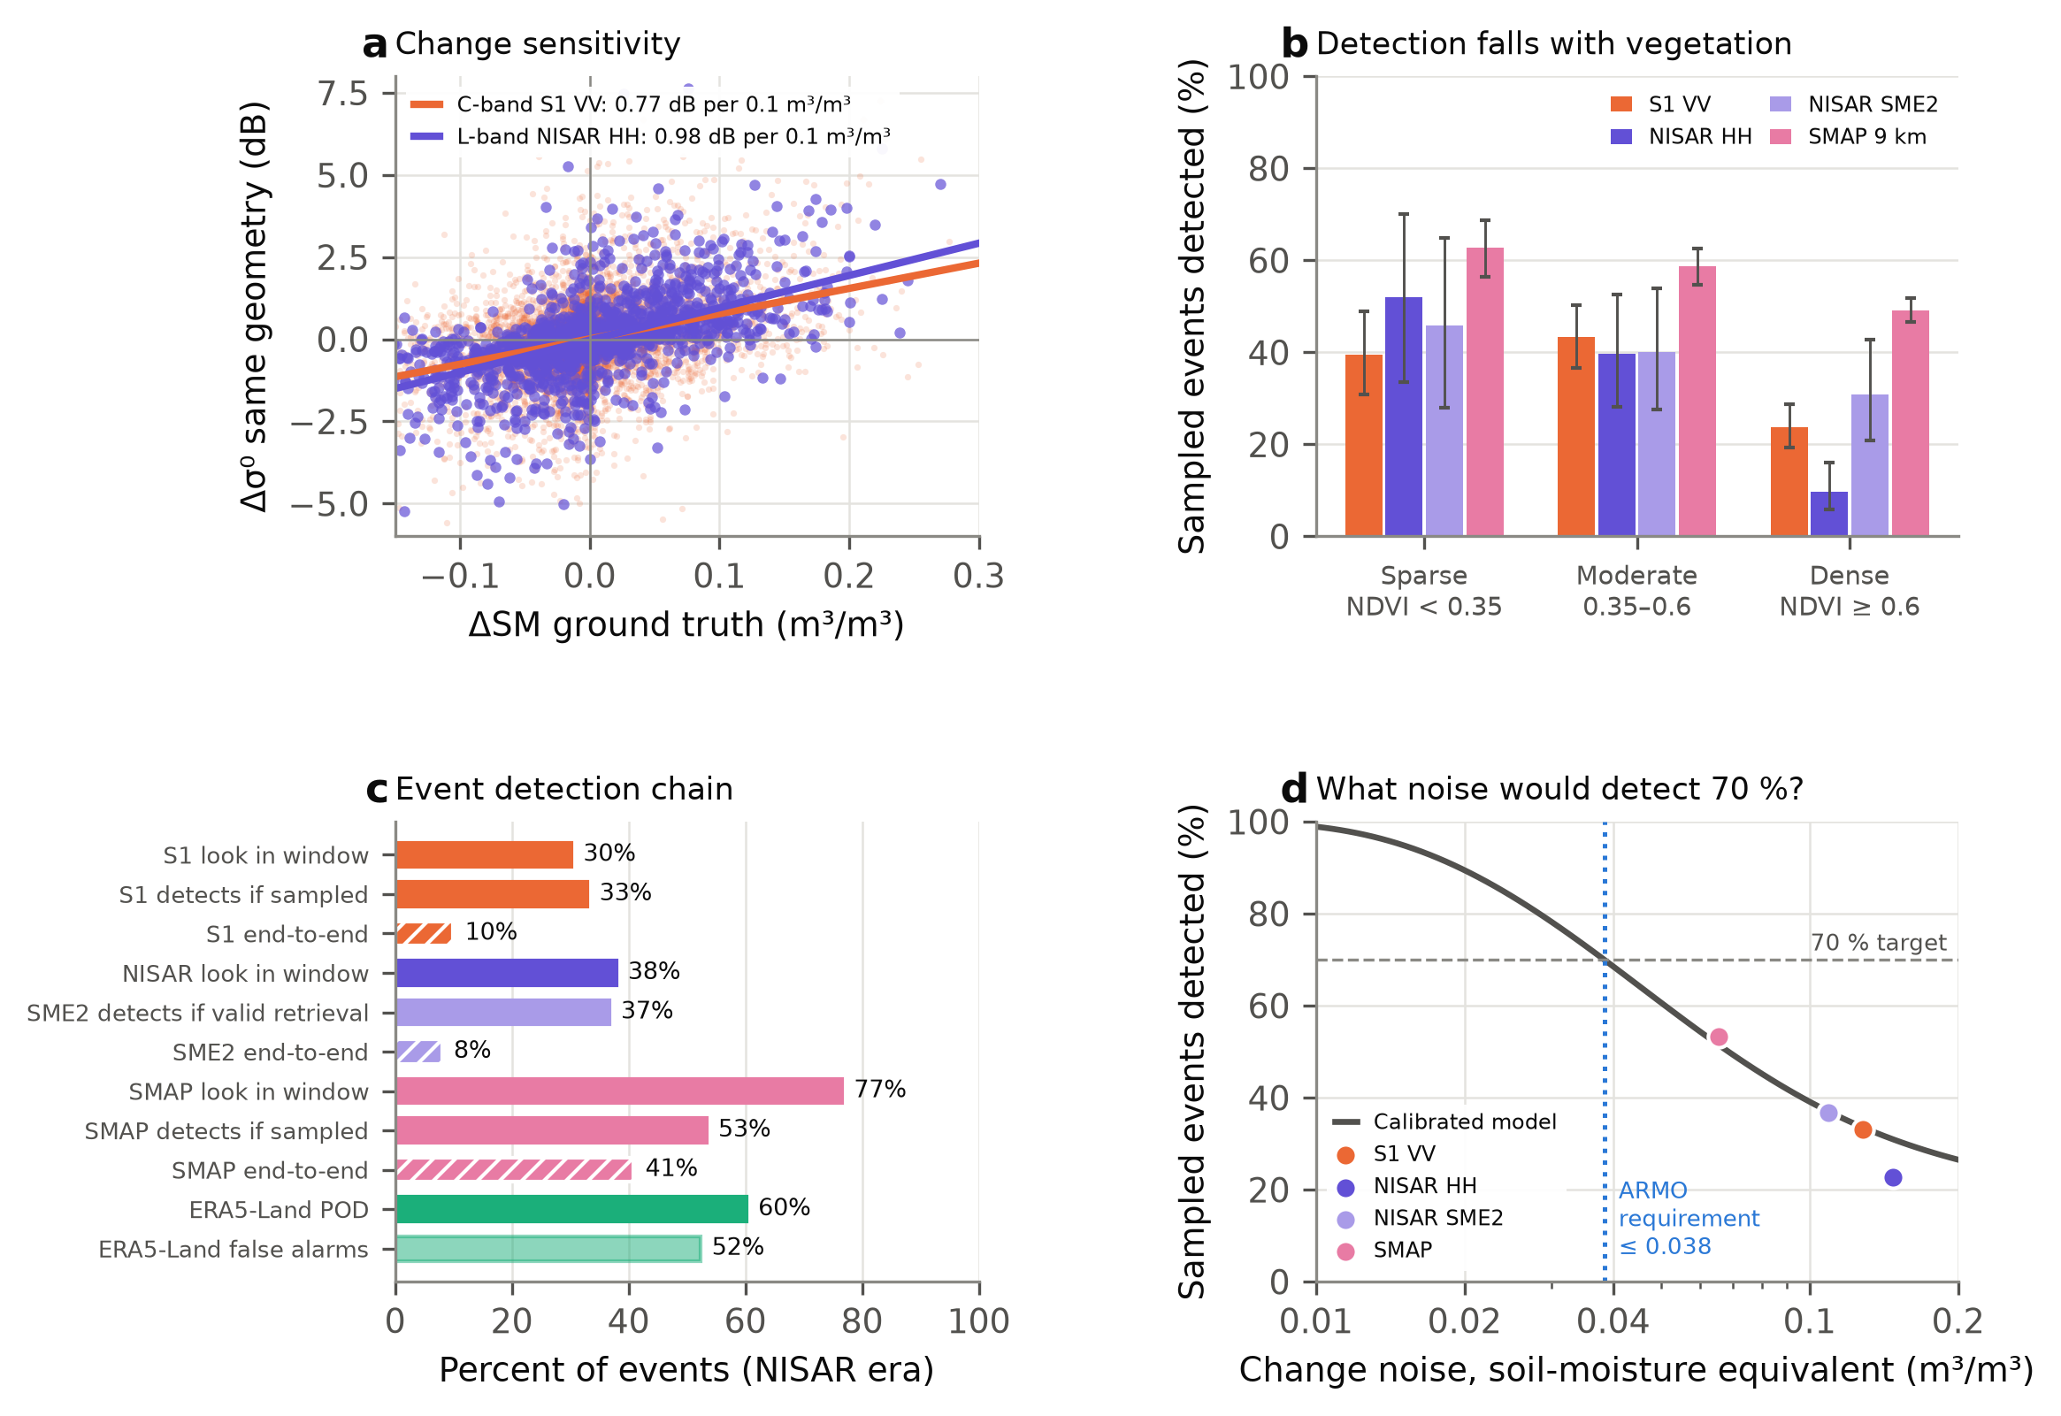
Figure 5. (a) Same-geometry backscatter change against ground-truth soil-moisture change, C-band Sentinel-1 VV and L-band NISAR HH. (b) Sampled events detected (1σ above no-change noise) by MODIS NDVI at the event; bars = 95 % CI. (c) Detection chain in the NISAR era: look in window, detection when sampled, their product, and ERA5-Land POD and false alarms. (d) Detection versus change noise: observed sensors and a detection model calibrated on them, giving ARMO's noise requirement.
O4: Requirement and marginal value of ARMO (Figure 6). Capturing ≥ 80 % of events requires a regular revisit of ≈ 1.5 days from a single system. Added to the current fleet, a 2-day ARMO raises capture from 52 % to 80 % (76–83 %), and a 3-day ARMO to 73 %. A future fleet with ROSE-L at ESA's documented 6-day revisit over global land would reach 64 % (60–68 %), and ARMO would add 13 (3-day) to 18 (2-day) points to it; at 3 days the fleet would reach 73 % and a 2-day ARMO would add 10.
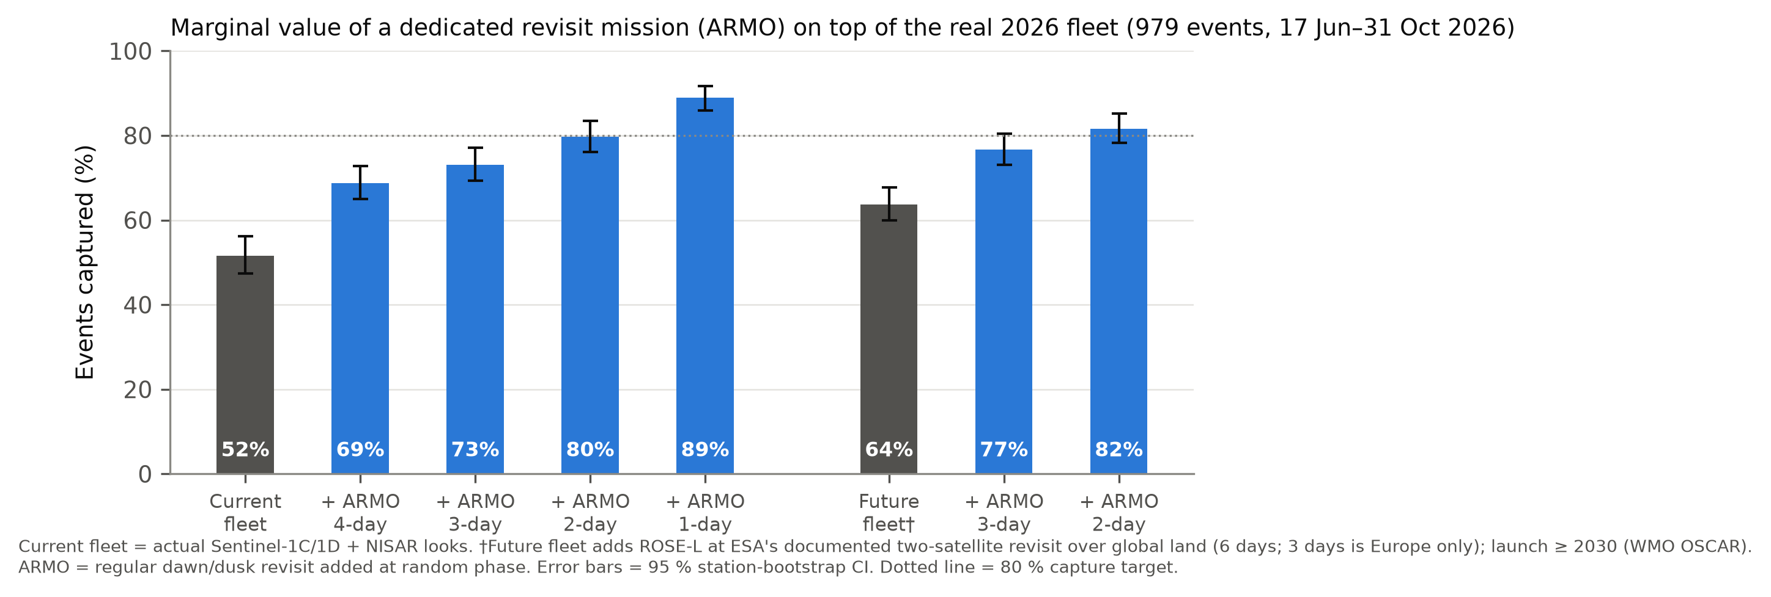
Figure 6. Event capture by the real 2026 fleet, with ARMO added at 1–4-day revisit, and by a future fleet including ROSE-L at its documented 6-day global-land revisit. Error bars = 95 % station-bootstrap CI.
Mission feasibility: can a real orbit deliver this? Idealised schedules ignore orbital geometry, so we flew five candidate ARMO designs for the 136-day NISAR era (Table 3). The model is a circular dawn–dusk sun-synchronous orbit at 620 km (inclination 97.87°, J2 nodal precession, 10 s steps) with a side-looking L-band ScanSAR imaging 25–45° off-nadir, a 362 km access swath comparable to ALOS-4's wide modes (JAXA, 2024). A station is imaged at broadside when it lies inside the access swath, and a SAR images only one side per pass. Each design's simulated passes were added to the real Sentinel-1 + NISAR passes and scored against the same 979 ground-truth events, averaged over eight orbital phases. One satellite reaches 71–77 %, and rolling to look both ways does not shorten its revisit (design B). Only two right-looking satellites 180° apart (design D) clear the 80 % target (81 %, range 81–82 % over phases; +30 points). We therefore define design D as the baseline mission and design C (one satellite, wider access) as the threshold mission: the least capable configuration that still lifts capture to 77 %. Its mass, power and cost are sized below.
Table 3. ARMO orbit and design trade (simulated, 17 Jun–31 Oct 2026; 620 km dawn–dusk SSO). Capture is for the real fleet plus ARMO; the current fleet alone captures 52 %.
Design | Satellites / look | Access swath | ARMO revisit | Capture (phase range) | Gain | CONUS duty
A | 1 / right only | 362 km (25-45°) | 2.8 d | 71 % (70–73) | +19 pts | 1.5 %
B | 1 / roll L/R alternate orbits | 362 km (25-45°) | 2.8 d | 70 % (70–71) | +19 pts | 1.6 %
C | 1 / roll L/R alternate orbits | 574 km (20-50°) | 1.8 d | 77 % (77–78) | +26 pts | 1.7 %
D | 2 / right only | 362 km (25-45°) | 1.4 d | 81 % (81–82) | +30 pts | 1.5 %
E | 2 / roll L/R alternate orbits | 362 km (25-45°) | 1.4 d | 77 % (77–78) | +26 pts | 1.6 %

Performance against NISAR and ROSE-L (Table 4). Scored alone on the same 979 events, design D captures 76 % (72–79 %), twice NISAR's 38 % and above ROSE-L at either 6 days (38 %) or 3 days (61 %). The gain is revisit, not resolution: both are L-band on a 200 m grid, but ARMO samples a US station every 1.4 days against NISAR's median gap of 4.6 days, and NISAR SME2 is delivered within 72 h (ASF, 2026) against ARMO's ≤ 24 h requirement. Detection decides how much reaches users: at NISAR's measured 23–37 %, NISAR registers 9–14 % of events; ARMO at its 70 % requirement would register 53 %.
Table 4. ARMO against NISAR and ROSE-L on the same 979 ground-truth wetting events (17 Jun–31 Oct 2026). Capture = a look inside the event window; registered = capture × detection when sampled. ROSE-L detection is assumed equal to NISAR's measured rate; ARMO's is its requirement, not yet demonstrated.
System (L-band SAR) | Revisit at US stations | Capture alone (95 % CI) | Capture with the fleet | Detection when sampled | Events registered
NISAR (real 2026 passes) | median gap 4.6 d | 38 % (34–42) | 52 % with Sentinel-1 | 23–37 % (measured) | 9–14 %
ROSE-L, 6 d (ESA, global land) | 6 d | 38 % (35–41) | 64 % | as NISAR (assumed) | 9–14 %
ROSE-L, 3 d (Europe; eoPortal) | 3 d | 61 % (58–65) | 73 % | as NISAR (assumed) | 14–22 %
ARMO, design D (2 smallsats) | 1.4 d (simulated) | 76 % (72–79) | 81 %; 83 % with ROSE-L | ≥ 70 % (requirement) | 53 %

Table 5. Science traceability matrix for ARMO: objectives flow to physical parameters, measurement and mission requirements. P = shown by this study; L = literature; U = unverified (future work).
Objective / hypothesis | Physical parameter | Measurement / instrument requirement | Mission requirement | Evidence | Status
O2, H1, H3: capture ≥ 80 % of wetting events | 5 cm SM rise ≥ 0.03 m³/m³; window median 1.8 d | At least one look inside the event window | Revisit ≤ 2 d, with or without ROSE-L. Baseline: 2 sats, 620 km dawn–dusk SSO, 180° apart (D). Threshold: 1 sat, 20–50° access (C) | Figure 6: 80 % today, 82 % with ROSE-L; Table 3: D 81 %, C 77 % | P
O3, H2: detect ≥ 70 % of sampled events at ≤ 10 % false alarms (critical) | Event ΔSM (median 0.089 m³/m³) against change noise | Change noise ≤ 0.038 m³/m³, i.e. L-band Δσ⁰ noise ≤ 0.38 dB (today 1.45 dB) | ≈ 15× more independent looks per product if speckle-limited | Figure 5d model; today S1 33 %, NISAR 23–37 %, SMAP 53 % | U
Vegetated fields | SM beneath NDVI ≥ 0.6 canopy | L-band (~1.26 GHz), HH + HV, 25–45° incidence | – | Ulaby et al. (2014); Figure 5b: L-band ahead only in sparse cover | L/U
Field scale | SM of individual fields | Product 100–200 m (ScanSAR, multi-looked); trades against row 2 | 362 km access swath | NISAR SME2 grid; SMAP's 9 km cannot resolve fields | L
Applications (Section 4) | Antecedent wetness for flood forecasts | – | Latency ≤ 24 h; CONUS imaging ≈ 1.5 % of each orbit | Table 3; forecast cycles | P/U
Implementation | – | L-band ScanSAR, 5.9 m mesh reflector, 498 W peak RF | 2 × 251 kg, one launch; ≈ US$ 150 M | Table 6 (sizing) | Estimate

Spacecraft sizing (Table 6). At 45° off-nadir, the far edge of the access range, L-band ambiguity limits require at least 27 m² of aperture (Freeman et al., 2000), so each satellite carries a 5.9 m deployable mesh reflector, half NISAR's 12 m (Rosen et al., 2015). With that gain, a noise floor of −25 dB, 2 dB better than NISAR's ≈ −23 dB requirement (Fattahi et al., 2026), needs only ≈ 50 W of average radio power (radar equation, Ulaby et al., 2014; 3 dB ScanSAR margin). Because the radar images only the US (22 min per day), the orbit-average power is ≈ 155 W and the data volume 45 GB per day, downlinked in 15 min to polar ground stations that see a dawn–dusk orbit every pass, so the 24 h latency requirement has ample margin. A bottom-up mass budget gives ≈ 251 kg per satellite with a 30 % growth margin, so both fit one small launcher (Firefly Alpha: 630 kg to 500 km SSO; Firefly, 2026).
Table 6. ARMO spacecraft and mission sizing (per satellite unless stated). Physics from the radar equation and the orbit model; masses below the reflector are our engineering estimates (code/22_armo_sizing.py).
Element | Value | Basis
Orbit | 620 km dawn–dusk SSO; 2 satellites 180° apart; 1.4-day revisit | Orbit simulation (Table 3)
Antenna | 5.9 m mesh reflector (27 m²); L-band 1.26 GHz, HH + HV | A ≥ 27 m² at 45° (Freeman et al., 2000)
Radar power | 50 W average, 498 W peak RF; 292 W DC while imaging | NESZ −25 dB, 20 MHz, 9 dB losses + margin
Spacecraft power | 155 W orbit average; 0.7 m² array; 246 Wh battery | Imaging 1.5 % of each orbit
Data | 269 Mbit/s while imaging; 45 GB/day; 15 min/day X-band | 4-bit BAQ, 2 polarisations
Mass | 183 kg dry (best estimate), 238 kg with 30 % margin, 251 kg wet | Reflector scaled from < 8 kg at 3.35 m (Sushko et al., 2021)
Launch | Both satellites (503 kg) on one small launcher; 120 m/s for phasing and de-orbit | Firefly (2026)
Cost | ≈ US$ 150 M incl. launch, 3-yr operations, 30 % reserve; threshold (1 sat) ≈ US$ 111 M | Section 5; EVM cap US$ 190 M

3.4 Limitations and Way Forward
• Point vs footprint. A 5 cm probe samples about 1 m²; a SAR pixel samples 10–200 m. Station-to-pixel mismatch inflates apparent noise in O3 (Crow et al., 2012). Fix: the Stage 1 heterogeneity campaign (4 extra probe profiles at 2 sites) and triple collocation.
• Retrieval: the critical risk, and the payoff if it is met. O3 shows that L-band change noise must fall ≈ 4-fold (Table 5) to detect 70 % of sampled events, a number from a model fitted on four sensors and 4.5 months of provisional NISAR data. If it is met, ARMO alone registers ≈ 53 % of all wetting events, 4–6× NISAR today (9–14 %), and flood forecasters receive a field-scale wetness update every 1.4 days within 24 h. If it is not, revisit still doubles the result: at NISAR's measured detection ARMO registers 17–28 %, because the revisit gain does not depend on retrieval. Fix: Stage 1 funds this research first, on the validated NISAR release; its result sets ARMO's sensor (looks, bandwidth, power), not whether ARMO flies (Table 7).
• Engineering and cost risk. A 5.9 m reflector has not flown on a 251 kg spacecraft. NISAR flies 12 m and small-SAR reflectors of 3.35 m weigh < 8 kg, so the technology exists, but deployment is the top engineering risk. The cost is a ± 40 % estimate by analogy with ≈ 27 % headroom under the cap. Fix: a reflector deployment test in Stage 2 before the build; if cost grows, descope to the one-satellite threshold mission (≈ US$ 111 M, 77 % capture).
• Representativeness. CONUS, warm seasons, two years; only 9 of 121 stations sit in cropland, so detection over crops is barely sampled. Fix: add cropland networks (USDA SCAN, ISMN, SMAP core sites) and extend to 2015–2026.
• Future-fleet assumption. ROSE-L is simulated at ESA's 6-day global-land revisit (3 days is Europe); eoPortal (2026), a secondary source, lists 3 days for soil moisture, at which ARMO still adds 12 points (Table 4). Fix: rerun when ESA publishes ROSE-L's US acquisition plan.
• Alternatives without a new satellite fall short. Coordinated phasing of existing passes recovers only ≈ 12 points; SMAP (9 km) and ERA5-type models cannot resolve fields; commercial daily products (Spire, Planet) are modelled from coarse sensors. Optical sensors need clear sky: in MODIS cloud masks at our stations only 56 % of events had a clear look even with daily imaging, and 16 % at a 5-day revisit against 43 % for radar. Fix: optical data serve as vegetation and land-cover inputs; commercial products are tested against USCRN events in Stage 1.
• Frequency: why not P-band or UHF? Longer wavelengths see deeper: ≈ 7 cm at P-band against ≈ 5 cm at L-band, and > 10 cm below 0.5 GHz (Shen et al., 2021). Depth does not relax the revisit requirement: on USCRN's 10 cm probes, events last 1.9 instead of 1.8 days and a 2-day revisit captures 73 % (5 cm: 72 %). (i) P-band SAR shares 432–438 MHz with US space-object tracking radars, so BIOMASS may not operate over North America and Europe; it also needs a 12 m reflector and ionospheric correction (Quegan et al., 2019). (ii) UHF/P-band signals of opportunity reuse communications-satellite signals, so need no transmitter or licence. A tower test at 260 MHz matched the top 10 cm within 0.02 m³/m³ (Yueh et al., 2020), but a seven-satellite SoOp SAR reaches ≈ 200 m only at the swath edge and ≈ 1 km at its centre, relying on US Navy MUOS transmitters (Yueh et al., 2021); only the SNOOPI CubeSat has flown (Garrison et al., 2024). Fix: L-band is the baseline; a UHF SoOp receiver is studied in Stage 1 as a hosted payload for root-zone moisture.
Two-stage path to launch (Table 7). Stage 1 (2027–28, US$ 217,882): event-sensitive change-detection retrieval against USCRN on the validated NISAR release, a multi-year climatology with cropland networks, a field campaign, and the frequency, tasking and commercial-product tests. Its output is the change noise ARMO's sensor must reach, which sets looks, bandwidth and power. If 70 % proves out of reach, the retrieval still improves NISAR and ROSE-L products and ARMO still doubles the events registered, so Stage 2 proceeds either way. Stage 2 (2029–36): build, test (including reflector deployment) and launch both satellites together (≈ 2033) within the 5-year Earth Venture limit; then 3 years of operations with open products for NOAA and USDA within 24 h.
Table 7. Two-stage schedule (Year 1 = 2027). ◆ = milestone. Stage 2 proceeds whatever Stage 1 finds.
Stage / phase / milestone | Y1 | Y2 | Y3 | Y4 | Y5 | Y6 | Y7 | Y8 | Y9 | Y10
Stage 1: event retrieval vs USCRN (validated NISAR), climatology, field campaign, trades | ■ | ■
Stage 1 result sets the sensor: target change noise → looks, bandwidth, power |  | ◆
Stage 2, Phases A–B: requirements, reflector deployment test, preliminary design |  |  | ■ | ■
Stage 2, Phases C–D: build and test two spacecraft; launch together (◆ ≈ 2033) |  |  |  |  | ■ | ■ | ◆
Stage 2, Phase E: operations; products to NOAA and USDA within 24 h |  |  |  |  |  |  |  | ■ | ■ | ■
Publications, open data and code | ■ | ■ |  |  |  |  |  | ■ | ■ | ■

4 Relevance to Society
Challenge (Water Resources; Agriculture). Irrigation is the largest US freshwater withdrawal: 118 billion gallons per day in 2015, 42 % of total freshwater withdrawals (Dieter et al., 2018). The 2012 flash drought (Otkin et al., 2018) caused nearly US$30 billion in damage (NOAA, 2013), and crop-insurance indemnities for that year reached a record US$17 billion (Hagstrom Report, 2013). Both droughts and floods turn on how fast the top layer wets and dries.
Users and decisions. (1) NOAA National Water Model / flood forecasters: the model routes hourly flows on > 2.7 million river reaches. Whether a basin's soils are still wet from a storm two days earlier decides the runoff from the next one, so a 6–12-day-old soil-moisture map initialises it with the wrong state. (2) USDA NASS Crop-CASMA and FAS crop forecasting already ingest SMAP at 1–9 km; field-scale event information would let them separate rain-fed from irrigated responses. (3) Water managers and agricultural insurers need evidence of when, and how much, water reached a field. (4) Weather centres (ECMWF operationally assimilates ASCAT and SMOS soil moisture; Weston et al., 2024) would gain observations at the moments the land state changes fastest.
Why remote sensing, and its limits. A farmer's probe measures one field perfectly; the 120 USCRN stations cover the contiguous US at one point per ~67,000 km². Only satellites map every field. Weekly products such as the US Drought Monitor do not need 2-day revisit, so the users who benefit are event-scale ones: flood forecasting, irrigation accounting and model calibration. Results would reach them as open ARMO soil-moisture maps within 24 h of each pass, a NISAR validation dataset, and the code that NASA's Applied Sciences and SMAP/NISAR Early Adopter communities can re-run.

5 Budget Summary
The request has two stages. Stage 1, requested now (Table 8): US$ 217,882 for the 2-year retrieval study. Personnel: 0.5 FTE analyst plus 0.1 FTE PI at the BLS May 2025 median geoscientist salary of US$ 101,920 = US$ 61,152/yr; computing: 2,000 h/yr of an AWS m6i.2xlarge at US$ 0.384/h plus 2 TB of S3 = US$ 1,333/yr; fieldwork: 12 HydraProbe sensors at US$ 545; publication: IEEE JSTARS open-access fee (US$ 2,160) and one AGU meeting (US$ 825); indirect costs at 62 %, the MIT FY2026 federal rate (no public NTU rate exists). All data are free; the alternative, commercial X-band tasking for the same 120 stations, would cost ≈ US$ 19–20 M (SkyWatch list prices) and senses only ~1 cm, so it was rejected. Stage 2 (Table 9): ≈ US$ 150 M for the ARMO mission, inside the US$ 190 M Earth Venture Mission cap, which includes launch (NASA ESSP, 2020; FY2022 dollars). The flight system (US$ 70 M) is estimated by analogy with NovaSAR-1 (≈ £45 M build and launch; SSTL, 2011; eoPortal, 2024) and CYGNSS (US$ 102 M excluding launch; Ruf et al., 2013); launch ≈ US$ 15 M (Firefly, 2026; secondary price sources); management and ground lines are our estimates. Cost drivers: personnel in Stage 1 (91 % of direct costs), the flight system in Stage 2 (47 %); the one-satellite threshold mission would cost ≈ US$ 111 M, against US$ 1,174 M for NISAR (GAO, 2026).
Table 8. Stage 1 budget summary (US$), requested now. Year 3 is zero because the study lasts 2 years.
Budget category | Year 1 | Year 2 | Year 3 | Total
Personnel (0.5 FTE analyst, 0.1 FTE PI) | 61,152 | 61,152 | 0 | 122,304
Computing and storage | 1,333 | 1,333 | 0 | 2,666
Fieldwork and validation | 0 | 6,540 | 0 | 6,540
Travel and publication | 0 | 2,985 | 0 | 2,985
Total Direct Costs | 62,485 | 72,010 | 0 | 134,495
Indirect Costs (62 %, MIT FY2026 federal rate) | 38,741 | 44,646 | 0 | 83,387
Total Requested Funding | 101,226 | 116,656 | 0 | 217,882

Table 9. Stage 2 mission cost estimate (FY2026 US$ M, ± 40 %). Phases A–D = 2029–33 (launch ≈ 2033); Phase E = 2034–36. Line items and bases: code/22_armo_sizing.py.
Budget category | Phases A–D | Phase E | Total
Flight system: 2 spacecraft with L-band SAR; management, integration and test | 84.0 | 0.0 | 84.0
Launch (one small launcher, both satellites) | 15.0 | 0.0 | 15.0
Science team, ground and data systems, operations | 8.5 | 8.7 | 17.2
Reserves (30 % Phases A–D; 15 % Phase E) | 32.2 | 1.3 | 33.6
Total | 139.7 | 10.0 | 149.8

References
Abatzoglou, J. T. (2013). Development of gridded surface meteorological data for ecological applications and modelling. Int. J. Climatol., 33(1), 121–131. https://doi.org/10.1002/joc.3413
ASF (2026). NISAR Soil Moisture (SME2) product guide and provisional known issues. Alaska Satellite Facility. https://nisar-docs.asf.alaska.edu/sme2/
Bauer-Marschallinger, B., et al. (2019). Toward global soil moisture monitoring with Sentinel-1: harnessing assets and overcoming obstacles. IEEE Trans. Geosci. Remote Sens., 57(1), 520–539. https://doi.org/10.1109/TGRS.2018.2858004
Bazzi, H., Baghdadi, N., El Hajj, M., & Zribi, M. (2019). Potential of Sentinel-1 surface soil moisture product for detecting heavy rainfall in the south of France. Sensors, 19(4), 802. https://doi.org/10.3390/s19040802
Bell, J. E., et al. (2013). U.S. Climate Reference Network soil moisture and temperature observations. J. Hydrometeorol., 14, 977–988. https://doi.org/10.1175/JHM-D-12-0146.1
BLS (2026). Occupational Outlook Handbook: Geoscientists (median pay, May 2025). https://www.bls.gov/ooh/life-physical-and-social-science/geoscientists.htm
Chatterjee, S., Huang, J., & Hartemink, A. E. (2020). Establishing an empirical model for surface soil moisture retrieval at the U.S. Climate Reference Network using Sentinel-1 backscatter and ancillary data. Remote Sens., 12(8), 1242. https://doi.org/10.3390/rs12081242
Crow, W. T., et al. (2012). Upscaling sparse ground-based soil moisture observations for the validation of coarse-resolution satellite soil moisture products. Rev. Geophys., 50, RG2002. https://doi.org/10.1029/2011RG000372
Davidson, M. (2023). ROSE-L mission in brief (ESA Land Training Course, slide 6: revisit with 2 satellites 6 days global land, 3 days Europe). https://eo4society.esa.int/wp-content/uploads/2023/11/ROSEL_TrainingCourseLandRS_Malcolm-Davidson.pdf
Davidson, M., Iannini, L., Kubanek, J., et al. (2026). ROSE-L mission objectives and science status. ESA Fringe 2026, Kraków, 16 June 2026. https://fringe2026.esa.int/iframe-agenda/files/ID_534.pdf
Didan, K. (2021). MODIS/Terra Vegetation Indices 16-Day L3 Global 250m SIN Grid V061. NASA LP DAAC. https://doi.org/10.5067/MODIS/MOD13Q1.061
Dieter, C. A., Maupin, M. A., Caldwell, R. R., et al. (2018). Estimated use of water in the United States in 2015. USGS Circular 1441. https://doi.org/10.3133/cir1441
Entekhabi, D., et al. (2010). The Soil Moisture Active Passive (SMAP) mission. Proc. IEEE, 98(5), 704–716. https://doi.org/10.1109/JPROC.2010.2043918
eoPortal (2024). NovaSAR-1 (430 kg S-band SAR smallsat; 3 m × 1 m antenna). https://eoportal.org/satellite-missions/novasar-1
eoPortal (2026). ROSE-L (Radar Observing System for Europe in L-band). https://www.eoportal.org/satellite-missions/rose-l (secondary source)
ESA (2025). ESA's Biomass mission launches on Vega-C (29 April 2025). https://www.esa.int/ESA_Multimedia/Videos/2025/04/ESA_s_Biomass_mission_launches_on_Vega-C
ESA (2026). Sentinel-1 facts and figures; ROSE-L contract and mission pages. https://www.esa.int/Applications/Observing_the_Earth/Copernicus/Sentinel-1/Facts_and_figures
Fattahi, H., Ghaemi, H., Hawkins, B. P., et al. (2026). NISAR L-band product status: from raw echoes to analysis-ready science data products (NESZ requirement ~ −23 dB). ESA Fringe 2026. https://fringe2026.esa.int/iframe-agenda/files/ID_282.pdf
Filippucci, P., et al. (2020). Soil moisture as a potential variable for tracking and quantifying irrigation. Adv. Water Resour., 136, 103502. https://doi.org/10.1016/j.advwatres.2019.103502
Firefly Aerospace (2026). Alpha launch vehicle: 630 kg to 500 km SSO. https://fireflyspace.com/alpha/
Freeman, A., Johnson, W. T. K., Huneycutt, B., et al. (2000). The "myth" of the minimum SAR antenna area constraint. IEEE Trans. Geosci. Remote Sens., 38(1), 320–324. https://doi.org/10.1109/36.823926
Friedl, M., & Sulla-Menashe, D. (2022). MODIS/Terra+Aqua Land Cover Type Yearly L3 Global 500 m SIN Grid V061 (MCD12Q1). NASA LP DAAC. https://doi.org/10.5067/MODIS/MCD12Q1.061
GAO (2026). NASA: Assessments of Major Projects, GAO-26-108556 (NISAR current life-cycle cost estimate). https://files.gao.gov/reports/GAO-26-108556/index.html
Garrison, J. L., Vega, M. A., Shah, R., et al. (2024). SNOOPI: Demonstrating Earth remote sensing using P-band signals of opportunity (SoOp) on a CubeSat. Adv. Space Res., 73(6), 2855–2879. https://doi.org/10.1016/j.asr.2023.10.050
Gorelick, N., Hancher, M., Dixon, M., Ilyushchenko, S., Thau, D., & Moore, R. (2017). Google Earth Engine: Planetary-scale geospatial analysis for everyone. Remote Sens. Environ., 202, 18–27. https://doi.org/10.1016/j.rse.2017.06.031
Hagstrom Report (2013). Crop indemnities reach almost $17 billion (23 April 2013). https://hagstromreport.com/2013news_files/2013_0423_crop-indemnities-reach-almost-17-billion.html
JAXA (2024). ALOS-4 (DAICHI-4) overview and observation modes. https://www.eorc.jaxa.jp/ALOS/en/alos-4/a4_about_e.htm ; CEOS WGISS-60 JAXA agency report (ScanSAR ~700 km). https://ceos.org/document_management/Working_Groups/WGISS/Meetings/WGISS-60/Presentations/2.3_Agency%20Report%20JAXA_Makoto%20NATSUISAKA_v1.pdf
Jiang, H., Lv, S., Hu, Y., & Wen, J. (2025). Contrasting drydown time scales: SMAP L-band vs. AMSR2 C-band brightness temperatures against ground observations and SMAP products. Remote Sens., 17, 3307. https://doi.org/10.3390/rs17193307
Kim, S., et al. (2017). Surface soil moisture retrieval using the L-band synthetic aperture radar onboard the Soil Moisture Active–Passive satellite and evaluation at core validation sites. IEEE Trans. Geosci. Remote Sens., 55(4), 1897–1914. https://doi.org/10.1109/TGRS.2016.2631126
Le Page, M., et al. (2020). Potential for the detection of irrigation events on maize plots using Sentinel-1 soil moisture products. Remote Sens., 12(10), 1621. https://hal.inrae.fr/hal-02613686v1
Luo, X., Wang, M., Dai, G., & Chen, X. (2017). A novel technique to compute the revisit time of satellites and its application in remote sensing satellite optimization design. Int. J. Aerospace Eng., 2017, 6469439. https://doi.org/10.1155/2017/6469439
McColl, K. A., et al. (2017). Global characterization of surface soil moisture drydowns. Geophys. Res. Lett., 44, 3682–3690. https://doi.org/10.1002/2017GL072819
Microsoft (2026). Planetary Computer STAC: sentinel-1-grd and sentinel-1-rtc collections. https://planetarycomputer.microsoft.com/
MIT (2026). Facilities and administrative (F&A) rates, FY2026. https://ras.mit.edu/facilities-and-administrative-fa-rates
Muñoz-Sabater, J., et al. (2021). ERA5-Land: a state-of-the-art global reanalysis dataset for land applications. Earth Syst. Sci. Data, 13, 4349–4383. https://doi.org/10.5194/essd-13-4349-2021
NASA ESSP (2020). Earth Venture Mission-3 (EVM-3) Announcement of Opportunity: cost cap US$ 190 M (FY2022), including launch. https://essp.larc.nasa.gov/EVM-3/
National Academies of Sciences, Engineering, and Medicine (2018). Thriving on Our Changing Planet: A Decadal Strategy for Earth Observation from Space. The National Academies Press. https://doi.org/10.17226/24938 (Table 6.1, H-4; Appendix C, TO-17)
NISAR Science Team (2023). NISAR L3 Soil Moisture Algorithm Theoretical Basis Document, JPL D-107679 Rev. 3.3; NISAR Provisional Soil Moisture V1, https://doi.org/10.5067/NIL3SME2-P1
NOAA (2013). 2012 ranks as 2nd costliest year with 11 billion-dollar disasters (NOAA Research, 13 June 2013). https://research.noaa.gov/2013/06/13/
NOAA NCEI (2026). U.S. Climate Reference Network hourly02 product. https://www.ncei.noaa.gov/pub/data/uscrn/products/hourly02/
NOAA OWP (2026). National Water Model. https://water.noaa.gov/about/nwm
NSIDC DAAC (accessed 2026). SMAP Enhanced L3 Radiometer Global and Polar Grid Daily 9 km EASE-Grid Soil Moisture, Version 6 (SPL3SMP_E). https://doi.org/10.5067/M20OXIZHY3RJ ; via Google Earth Engine NASA/SMAP/SPL3SMP_E/006
Otkin, J. A., et al. (2018). Flash droughts: a review and assessment of the challenges imposed by rapid-onset droughts in the United States. Bull. Amer. Meteor. Soc., 99, 911–919. https://doi.org/10.1175/BAMS-D-17-0149.1
Planet (2026). Soil Water Content technical specification (20 m and 100 m sales discontinued; 1 km). https://docs.planet.com/data/planetary-variables/soil-water-content/techspec/
Quegan, S., Le Toan, T., Chave, J., et al. (2019). The European Space Agency BIOMASS mission: Measuring forest above-ground biomass from space. Remote Sens. Environ., 227, 44–60. https://doi.org/10.1016/j.rse.2019.03.032
Rosen, P. A., Hensley, S., Shaffer, S., et al. (2015). The NASA-ISRO SAR mission: an international space partnership for science and societal benefit. 2015 IEEE Radar Conference, 1610–1613. https://doi.org/10.1109/RADAR.2015.7131255
Ruf, C., Gleason, S., Jelenak, Z., et al. (2013). The NASA EV-2 Cyclone Global Navigation Satellite System (CYGNSS) mission. 2013 IEEE Aerospace Conference, 1–7. https://doi.org/10.1109/AERO.2013.6497202
Shellito, P. J., et al. (2016). SMAP soil moisture drying more rapid than observed in situ following rainfall events. Geophys. Res. Lett., 43, 8068–8075. https://doi.org/10.1002/2016GL069946
Shen, X., Walker, J. P., Ye, N., et al. (2021). Soil moisture retrieval depth of P- and L-band radiometry: predictions and observations. IEEE Trans. Geosci. Remote Sens., 59(8), 6814–6822. https://doi.org/10.1109/TGRS.2020.3026384
SkyWatch (2026). ICEYE and Capella Space pricing. https://skywatch.com/geospatial-data-providers/iceye/ ; https://skywatch.com/geospatial-data-providers/capella-space/
Spire Global (2024). Soil Moisture Insights (500 m, daily; company product page, 30 April 2024). https://spire.com/?p=14420
SSTL (2011). Government investment brings low cost radar satellites to market (NovaSAR build and launch ≈ £45 M). https://sstl.co.uk/media-hub/latest-news/2011/government-investment-brings-low-cost-radar-satellites-to-market
Sushko, O., Medzmariashvili, E., Tserodze, S., et al. (2021). Design and analysis of light-weight deployable mesh reflector antenna for small multibeam SAR satellite. EUSAR 2021, VDE Verlag. https://www.tib.eu/en/search/id/vde:455457092
Ulaby, F. T., Long, D. G., et al. (2014). Microwave Radar and Radiometric Remote Sensing. University of Michigan Press.
USDA NASS (2026). Crop-CASMA metadata. https://www.nass.usda.gov/Research_and_Science/Cropland/metadata/metadata_cropcasma.htm
USDA NASS (2026). Cropland Data Layer, 2025. https://www.nass.usda.gov/Research_and_Science/Cropland/SARS1a.php
Vermote, E., & Wolfe, R. (2021). MODIS/Terra (MOD09GA) and Aqua (MYD09GA) Surface Reflectance Daily L2G Global 1 km and 500 m SIN Grid V061 (state_1km cloud mask). NASA LP DAAC. https://doi.org/10.5067/MODIS/MOD09GA.061
Wagner, W., Lemoine, G., & Rott, H. (1999). A method for estimating soil moisture from ERS scatterometer and soil data. Remote Sens. Environ., 70, 191–207.
Weston, P., de Rosnay, P., & Fairbairn, D. (2024). Soil moisture data assimilation at ECMWF. EGU General Assembly 2024, EGU24-1769. https://meetingorganizer.copernicus.org/EGU24/EGU24-1769.html
WMO OSCAR (2026). Satellite: ROSE-L A (updated 19 October 2026). https://space.oscar.wmo.int/satellites/view/rose_l_a
Yueh, S. H., Shah, R., Xu, X., Elder, K., & Starr, B. (2020). Experimental demonstration of soil moisture remote sensing using P-band satellite signals of opportunity. IEEE Geosci. Remote Sens. Lett., 17(2), 207–211. https://doi.org/10.1109/LGRS.2019.2918764
Yueh, S. H., Shah, R., Xu, X., Stiles, B., & Bosch-Lluis, X. (2021). A satellite synthetic aperture radar concept using P-band signals of opportunity. IEEE J. Sel. Topics Appl. Earth Observ. Remote Sens., 14, 2796–2816. https://doi.org/10.1109/JSTARS.2021.3059242
Zanaga, D., Van De Kerchove, R., Daems, D., et al. (2022). ESA WorldCover 10 m 2021 v200. Zenodo. https://doi.org/10.5281/zenodo.7254221
Zappa, L., et al. (2022). How accurately can we retrieve irrigation timing and water amounts from (satellite) soil moisture? Int. J. Appl. Earth Obs. Geoinf., 113, 102979. https://doi.org/10.1016/j.jag.2022.102979
Unit costs: AWS EC2 m6i.2xlarge (https://www.doit.com/compute/spot/us-east-1/m6i.2xlarge); AWS S3 (https://aws.amazon.com/s3/pricing/); Stevens HydraProbe (https://www.fondriest.com/stevens-hydraprobe-soil-moisture-sensors.htm); IEEE 2026 APC list (https://journals.ieeeauthorcenter.ieee.org/wp-content/uploads/sites/7/2026-07-30-IEEE-Article-Processing-Charges-List.pdf); AGU 2024 registration and abstract fees (https://agu.org/annual-meeting-2024/attend; https://www.agu.org/annual-meeting-2024/About).

Data and Code Availability
All analysis code (Python 3.14; scripts 01–23, run in order) is in the project folder `code/` and is reproducible from public data. Ground truth: NOAA USCRN hourly02 (https://www.ncei.noaa.gov/pub/data/uscrn/products/hourly02/). Sentinel-1: Microsoft Planetary Computer STAC collections `sentinel-1-grd` and `sentinel-1-rtc`. NISAR: NASA CMR collections NISAR_L2_GCOV_*_V1 and NISAR_L3_SME2_PROVISIONAL_V1 via ASF (Earthdata login). SMAP SPL3SMP_E V006, MODIS MOD13Q1 V6.1, ESA WorldCover v200 and USDA CDL 2025: Google Earth Engine (scripts 14–17, 23; gridMET IDAHO_EPSCOR/GRIDMET, COPERNICUS/S1_GRD, MODIS/061/MCD12Q1). ERA5-Land: Open-Meteo archive API. Repository: [public GitHub link to be added before submission].

Individual Contribution Statements (half a page each)
[Each team member writes their own half-page statement here: scripts, analyses, figures and report sections produced, a brief reflection on their role and what they would do differently.]
Team Member 1: [Name]
[Half-page statement]
Team Member 2: [Name]
[Half-page statement]
Team Member 3: [Name]
[Half-page statement]

