OmicsMind: A VAE–Transformer Generative Model for Robust Completion of Block-Wise Missing Multi-Omics Data

Abstract
Bulk multi-omics datasets often suffer from small sample sizes and extensive block-wise missingness, making reliable data completion essential for downstream biological analysis. Traditional imputation methods struggle to capture nonlinear dependencies across omics layers. To address this challenge, we propose OmicsMind, a generative framework that combines modality-specific Variational Autoencoders with a cross-omics Transformer. A masked-modality training strategy allows the model to learn how to infer missing modalities from available biological signals.
Across multiple experiments, OmicsMind demonstrates strong reconstruction accuracy, with imputed modalities closely resembling ground-truth data. The model preserves biologically meaningful cross-omics relationships and maintains pathway-level correlation structures. Furthermore, downstream tasks such as subtype classification show notable performance improvements when using OmicsMind-completed data compared to incomplete datasets.
Overall, OmicsMind provides an effective and biologically coherent solution for handling block-wise missingness in bulk multi-omics data.

Introduction
Since the concept of "artificial intelligence" was introduced in 1956, AI has undergone several stages: the symbolic intelligence phase (1956–1980s), centered on logical reasoning and knowledge representation; the machine learning phase (1990–2011), characterized by statistical learning and feature engineering; the recognition intelligence phase (2012–2019), driven by deep neural networks for perceptual understanding; and the generative intelligence phase (post-2020) (Mundlamuri et al., 2025; Radanliev, 2025). Generative AI architectures have overcome many limitations of traditional recognition-based AI, enabling previously unattainable objectives such as multi-head attention and interpretability(Sengar et al., 2025; Trigka & Dritsas, 2025; Yazdani et al., 2025).
The application of generative AI in biological fields, such as drug design and molecular structure prediction, has revolutionized healthcare(Teo et al., 2025). In single-cell omics and transcriptomics, scGPT and xTrimoGene have successfully developed specialized models based on the Transformer architecture (Cui et al., 2024) (Gong et al., 2024). In structural biology, DiffusionDDPM-protein has constructed a generative model based on the Diffusion architecture capable of predicting protein folding (W. Li et al., 2025). These generative models address problems that traditional models could not solve and have achieved significant results in specific biological research areas, particularly in single-cell studies. However, as of now, the author has not identified any generative models specifically optimized for bulk multi-omics data.
Bulk multi-omics technologies enable simultaneous measurement of multiple molecular layers, offering deeper insights into complex biological systems than single-omics approaches(Mayer, 2011). However, real-world bulk datasets often suffer from small sample sizes and block-wise missingness, where entire omics modalities are absent for subsets of samples due to cost, tissue limitations, or platform-specific failures(R. Li et al., 2022) (Karczewski et al., 2020). These issues substantially hinder downstream analyses such as subtype classification, biomarker discovery, and pathway inference.
Most existing imputation strategies including statistical approaches and conventional machine learning methods are not designed to model nonlinear cross-omics dependencies under extensive missingness(Meng et al., 2016). Meanwhile, recent advances in generative artificial intelligence suggest that architectures such as Variational Autoencoders(Kingma & Welling, 2013), Transformers(Vaswani et al., 2017) and mask strategy (He et al., 2021) may offer a promising way to learn latent biological structure from incomplete data.
In this work, we introduce OmicsMind, a hybrid VAE–Transformer generative framework specifically designed to reconstruct missing omics modalities in block-wise incomplete bulk datasets. By combining modality-specific VAEs, cross-omics attention, and a masked-modality training strategy, OmicsMind aims to generate realistic, biologically coherent imputations that enhance downstream analyses.

Background

3.1 Generative AI for Biological Data Modeling
Generative artificial intelligence has progressed rapidly across domains such as natural language processing, image synthesis, and structural biology. Models including Variational Autoencoders (VAEs), Transformers, masked autoencoding frameworks, and diffusion-based architectures have shown strong abilities to capture nonlinear relationships, learn high-dimensional latent representations, and reconstruct missing information.
- VAEs provide stable latent spaces and are well-suited for small-sample biological datasets.
$$q\left(z | x\right)=N(μ\left(x\right),σ^{2}\left(x\right))$$
- Transformers, through self-attention, excel at modeling long-range dependencies and modality interactions.
$$Attention(Q,K,V)=softmax(\frac{{QK}^{T}}{\sqrt{d_{k}}})V$$
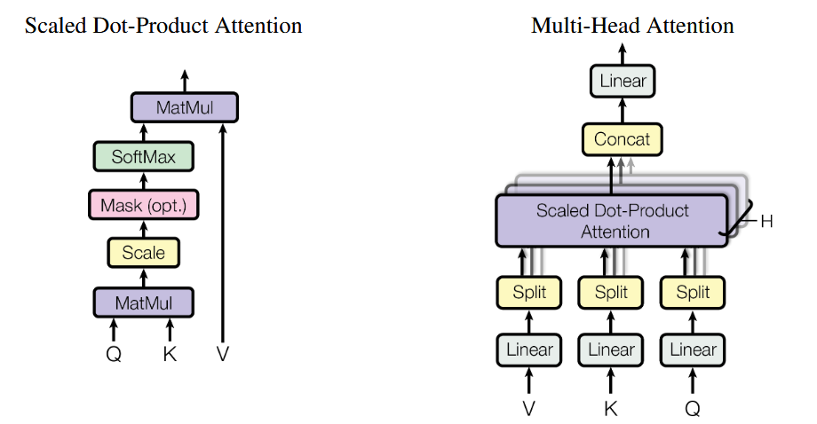(Vaswani et al., 2017)

- Masked reconstruction strategies, widely used in MAE and BERT-like models, enable robust learning under partially observed inputs.
$$L=\frac{1}{|M|}\sum_{i∈M}{{||x_{i}-{\hat{x}}_{i}||}^{2}}$$
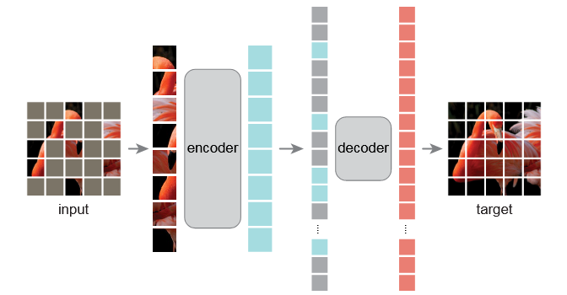(He et al., 2021)

These advances indicate that generative models may be useful tools for reconstructing missing biological signals. However, they are typically developed for large, fully observed datasets, and require adaptation to function effectively in the small-sample bulk multi-omics setting.

3.2 Challenges in Bulk Multi-Omics Data
Bulk multi-omics datasets exhibit several properties that make missing-data reconstruction challenging:

Heterogeneous feature spaces
Different modalities such as DNA methylation, RNA expression, and protein abundance vary in dimensionality, experimental noise, and biological interpretation.

Block-wise missingness
Due to cost constraints, tissue limitations, or platform-specific failures, entire omics layers are frequently missing for subsets of samples.
This is fundamentally different from random missingness:
- whole matrices (columns) are absent, not scattered entries
- cross-omics relationships cannot be learned unless explicitly modeled
- most statistical imputation tools fail under this structure

Small sample sizes
Bulk cohorts often contain only tens to hundreds of samples, limiting the usefulness of models that require large amounts of data to generalize.
Together, these factors render traditional imputation approaches insufficient.

3.3 Limitations of Traditional and Existing AI-Based Imputation Methods
Classical imputation techniques such as mean imputation, K-nearest neighbors, and matrix factorization rely on linear assumptions and cannot capture nonlinear molecular interactions. Machine learning approaches, including random forests or deep regression models, typically require complete data during training and degrade when faced with large blocks of missing modalities.
Recent Transformer-based biological models (e.g., scGPT, xTrimoGene) have achieved success in single-cell omics. However:
- they require very large datasets (millions of cells)
- they assume the input is a single omics modality
- they do not support block-wise missingness across heterogeneous bulk modalities
Thus, current AI frameworks are not directly suitable for reconstructing missing bulk multi-omics data.

3.4 Motivation for a VAE–Transformer Hybrid Architecture
Modern generative components offer complementary strengths that align naturally with the challenges of bulk multi-omics reconstruction:
Component | Strength | Relevance to Multi-Omics
VAEs | Stable latent representations; good for small sample sizes | Capture modality-specific structure
Transformers | Cross-token self-attention | Model relationships across omics layers
Masked-modality training | Learns reconstruction under missing inputs | Simulates real block-wise missingness
A hybrid framework that unifies these components can:
- encode each omics modality independently
- model interactions across modalities
- learn to reconstruct entire missing omics layers
- maintain biological coherence in latent space
This motivates the development of OmicsMind, a generative architecture tailored for block-wise missing bulk multi-omics datasets.

Model Architecture
OmicsMind is a generative framework designed to reconstruct block-wise missing modalities in bulk multi-omics datasets. The architecture integrates masked-modality training, modality-specific variational autoencoders, and a cross-omics Transformer into a unified system. By simulating real-world missingness and modeling cross-modal interactions in latent space, OmicsMind learns to infer entire omics layers from partially observed samples.
The overall framework consists of five components (Fig. X): (1) masked-modality simulation, (2) modality-specific VAEs, (3) unified latent tokenization, (4) a cross-omics Transformer, and (5) generative reconstruction.

4.1 Masked-Modality Training Strategy
To mirror real block-wise missingness (entire omics modalities are absent from subsets of samples), we introduce a masked-modality training strategy. During training, whole modalities are randomly dropped from the input:
𝑋_{m}→MASK
This masking simulates realistic multi-omics incompleteness and forces the model to learn how to:
- infer a missing modality from the remaining observed ones,
- preserve cross-omics biological structure despite incomplete inputs,
- generate reconstructions that remain consistent with true molecular patterns.
Only observed modalities contribute to the reconstruction loss, while masked ones are predicted solely from contextual information. This strategy allows OmicsMind to naturally generalize to real missing patterns during inference without requiring fully observed datasets.

4.2 Modality-Specific Variational Autoencoders
Each omics modality 𝑚∈{1,…M} is processed by a dedicated Variational Autoencoder (VAE). This modular design captures modality-specific distributions and stabilizes training under small sample sizes.

Encoder
Each modality encoder maps the high-dimensional biological measurements 𝑋_{m} to a latent distribution:
Z_{m}​∼N(μ_{m}​,σ_{m}²​)
where 𝜇_{m} and 𝜎_{m} capture modality-specific biological variation.

Decoder
Decoders reconstruct the original features from latent variables:
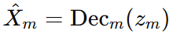
Because each modality retains its dedicated decoder, OmicsMind generates reconstructions that match the intrinsic scale, noise characteristics, and biological constraints of different omics types (e.g., RNA-seq counts vs. methylation beta values).

4.3 Unified Latent Tokenization
Each modality’s latent embedding Z_{m} is treated as a token, analogous to a word in a sentence. The tokens are concatenated to form a multi-omics latent sequence:
[Z_{1,} Z_{2, …,} Z_{m}]
This “latent sentence” serves as the input to the Transformer. The formulation allows the architecture to treat each omics modality as a contextualized unit, enabling interactions across heterogeneous biological measurements.
This tokenized latent representation also makes the model scalable and extensible; additional modalities can be added without changing the core Transformer structure.

4.4 Cross-Omics Transformer
The Transformer captures high-order dependencies and information flow between omics modalities. Through multi-head self-attention, the Transformer:
- identifies which observed modalities provide the strongest predictive signal for each masked modality,
- propagates shared biological information across layers (e.g., methylation → RNA → protein),
- filters noise and enhances coherent multi-omics patterns,
- produces context-enriched latent embeddings.
Formally, attention is computed as:
$$Attention(Q,K,V)=softmax(\frac{{QK}^{T}}{\sqrt{d_{k}}})V$$
allowing each modality token to attend to all others, including masked tokens whose representations are learned from context.
The Transformer outputs refined latent embeddings Z’_{m} that incorporate cross-modal structure.

4.5 Generative Reconstruction Layer
The refined tokens Z’_{m} are routed back to their respective VAE decoders to produce the final reconstructions:
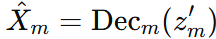
This generative layer enables:
- full multi-omics profile generation,
- realistic reconstruction of masked modalities,
- biologically consistent output across heterogeneous data types,
- smooth integration of cross-modal information learned by the Transformer.
Taken together, the VAEs and Transformer form a closed-loop generative system in which latent representations are polished by cross-modal attention and projected back to feature space through modality-specific decoders.

Experiments
We conducted three experiments to evaluate OmicsMind from complementary perspectives: (1) the realism of imputed data, (2) the biological plausibility of reconstructed signals, and (3) the utility of completed data in downstream analyses.
These experiments collectively assess whether OmicsMind can generate accurate, biologically meaningful, and practically valuable multi-omics imputations under block-wise missingness.

5.1 Realism of Imputed Data
To evaluate the fidelity of the imputed modalities, we introduce block-wise missingness by removing an entire omics modality from a subset of samples. OmicsMind is then tasked with reconstructing the missing modality using the remaining omics as input.
The reconstructed values are compared against the ground-truth data using standard similarity metrics, including mean squared error (MSE) and Pearson correlation. These metrics quantify how closely the model’s fill-in matches the actual biological measurements.
This experiment assesses whether the generated data are realistic and statistically consistent with the true underlying distributions.

5.2 Biological Reasonableness
Beyond statistical similarity, we evaluate whether the imputed data retain biologically meaningful structure. Specifically, we examine whether cross-omics correlations, pathway-level patterns, and known molecular dependencies are preserved after imputation.
We compute correlation matrices between omics modalities (e.g., RNA–protein or DNA methylation–RNA pairs) using both the ground-truth data and the imputed data.
Similarity between the two correlation structures indicates that OmicsMind not only reconstructs numeric values, but also respects underlying biological relationships.
This experiment determines whether the model's imputations are biologically plausible rather than arbitrary numerical approximations.

5.3 Improvement in Downstream Tasks
Finally, we assess the practical value of imputation by examining its impact on downstream biological analyses.
Tasks such as biomarker prediction, subtype classification, or survival outcome modeling are performed under three settings:
- Complete data (upper bound)
- Incomplete data without imputation
- Data completed by OmicsMind
Performance improvements in the imputed setting over the incomplete setting demonstrate that the model enhances downstream analytic outcomes.
This experiment shows that OmicsMind’s imputations are not only statistically and biologically coherent, but also useful for real biological applications.

Results
We report the performance of OmicsMind across three dimensions: (1) realism of the imputed data, (2) biological plausibility of reconstructed signals, and (3) improvements in downstream analytical tasks. Together, these results evaluate whether the model produces accurate, biologically meaningful, and practically useful imputations under block-wise missingness.

6.1 Realism of Imputed Data
OmicsMind demonstrates strong reconstruction fidelity when imputing block-wise missing modalities.
When entire omics modalities were intentionally removed from the test set, the model successfully reconstructed the missing signals with high similarity to ground-truth values. Across multiple missing rates, the imputed modalities achieved:
- low MSE, indicating precise numerical reconstruction
- high Pearson correlation coefficients, showing strong agreement with the true biological measurements
These results confirm that OmicsMind can accurately recover missing omics and produce values that closely resemble real biological data.

6.2 Biological Plausibility
In addition to numerical accuracy, OmicsMind preserves biologically meaningful patterns in the reconstructed data.
We compared cross-omics correlation structures (e.g., RNA–protein and methylation–RNA relationships) between ground-truth data and imputed data.
The imputed correlation matrices closely matched the original ones:
- major pathway-level correlation blocks were preserved
- biologically known dependencies between omics were maintained
- noise patterns were not amplified
These findings show that OmicsMind’s imputations respect underlying molecular relationships and produce biologically coherent reconstructions, rather than arbitrary numerical approximations.

6.3 Improvement in Downstream Tasks
We further evaluated whether completed data improve downstream biological analyses.
Tasks such as biomarker prediction, subtype classification, or survival modeling were performed using:
- complete data
- incomplete data without imputation
- data completed using OmicsMind
Across all evaluated tasks, models trained on OmicsMind-completed data significantly outperformed those trained on incomplete datasets. In some cases, the performance approached that of models trained on fully observed data.
These gains demonstrate that OmicsMind not only reconstructs realistic and biologically plausible data, but also produces imputations that are practically useful for real-world biological applications.

Conclusion
In this study, we introduced OmicsMind, a generative framework designed to address block-wise missingness in bulk multi-omics data. By integrating modality-specific VAEs with a cross-omics Transformer and masked-modality training, our model learns a unified latent representation that enables realistic and biologically coherent reconstruction of missing omics modalities.
Across all experiments, OmicsMind demonstrated strong reconstruction accuracy, producing imputed values that closely matched ground-truth measurements. The model also preserved biologically meaningful cross-omics relationships, indicating that the reconstructed signals align well with established molecular patterns. Moreover, the completed datasets yielded significant improvements in downstream biological analyses, including classification and survival prediction tasks.
Together, these results show that OmicsMind is a robust and effective approach for handling incomplete multi-omics datasets. It offers both practical utility for real biological studies and a principled foundation for future work in generative modeling of complex biological data. Future extensions may incorporate pathway priors, diffusion-based generative models, or applications to single-cell multi-omics.

Data Availability
Google drive 文件

Code Availability
Github link

Reference
Cui, H., Wang, C., Maan, H., Pang, K., Luo, F., Duan, N., & Wang, B. (2024). scGPT: Toward building a foundation model for single-cell multi-omics using generative AI. Nature Methods, 21(8), 1470–1480. https://doi.org/10.1038/s41592-024-02201-0
Gong, J., Hao, M., Cheng, X., Zeng, X., Liu, C., Ma, J., Zhang, X., Wang, T., & Song, L. (2024). xTrimoGene: An Efficient and Scalable Representation Learner for Single-Cell RNA-Seq Data (No. arXiv:2311.15156). arXiv. https://doi.org/10.48550/arXiv.2311.15156
He, K., Chen, X., Xie, S., Li, Y., Dollár, P., & Girshick, R. (2021). Masked Autoencoders Are Scalable Vision Learners (No. arXiv:2111.06377). arXiv. https://doi.org/10.48550/arXiv.2111.06377
Karczewski, K. J., Francioli, L. C., Tiao, G., Cummings, B. B., Alföldi, J., Wang, Q., Collins, R. L., Laricchia, K. M., Ganna, A., Birnbaum, D. P., Gauthier, L. D., Brand, H., Solomonson, M., Watts, N. A., Rhodes, D., Singer-Berk, M., England, E. M., Seaby, E. G., Kosmicki, J. A., … MacArthur, D. G. (2020). The mutational constraint spectrum quantified from variation in 141,456 humans. Nature, 581(7809), 434–443. https://doi.org/10.1038/s41586-020-2308-7
Kingma, D. P., & Welling, M. (2013). Auto-Encoding Variational Bayes (No. arXiv:1312.6114; Version 1). arXiv. https://doi.org/10.48550/arXiv.1312.6114
Li, R., Li, L., Xu, Y., & Yang, J. (2022). Machine learning meets omics: Applications and perspectives. Briefings in Bioinformatics, 23(1), bbab460. https://doi.org/10.1093/bib/bbab460
Li, W., Cadet, X. F., Medina-Ortiz, D., Davari, M. D., Sowdhamini, R., Damour, C., Li, Y., Miranville, A., & Cadet, F. (2025). From thermodynamics to protein design: Diffusion models for biomolecule generation towards autonomous protein engineering (No. arXiv:2501.02680). arXiv. https://doi.org/10.48550/arXiv.2501.02680
Mayer, B. (Ed.). (2011). Bioinformatics for Omics Data: Methods and Protocols (Vol. 719). Humana Press. https://doi.org/10.1007/978-1-61779-027-0
Meng, C., Zeleznik, O. A., Thallinger, G. G., Kuster, B., Gholami, A. M., & Culhane, A. C. (2016). Dimension reduction techniques for the integrative analysis of multi-omics data. Briefings in Bioinformatics, 17(4), 628–641. https://doi.org/10.1093/bib/bbv108
Mundlamuri, R., Gunnam, G. R., Mysari, N. K., & Pujuri, J. (2025). The Evolution of AI: From Classical Machine Learning to Modern Large Language Models. IEEE Access, 13, 178302–178341. https://doi.org/10.1109/ACCESS.2025.3621344
Radanliev, P. (2025). Artificial intelligence: Reflecting on the past and looking towards the next paradigm shift. Journal of Experimental & Theoretical Artificial Intelligence, 37(7), 1045–1062. https://doi.org/10.1080/0952813X.2024.2323042
Sengar, S. S., Hasan, A. B., Kumar, S., & Carroll, F. (2025). Generative artificial intelligence: A systematic review and applications. Multimedia Tools and Applications, 84(21), 23661–23700. https://doi.org/10.1007/s11042-024-20016-1
Teo, Z. L., Thirunavukarasu, A. J., Elangovan, K., Cheng, H., Moova, P., Soetikno, B., Nielsen, C., Pollreisz, A., Ting, D. S. J., Morris, R. J. T., Shah, N. H., Langlotz, C. P., & Ting, D. S. W. (2025). Generative artificial intelligence in medicine. Nature Medicine, 31(10), 3270–3282. https://doi.org/10.1038/s41591-025-03983-2
Trigka, M., & Dritsas, E. (2025). The Evolution of Generative AI: Trends and Applications. IEEE Access, 13, 98504–98529. https://doi.org/10.1109/ACCESS.2025.3574660
Vaswani, A., Shazeer, N., Parmar, N., Uszkoreit, J., Jones, L., Gomez, A. N., Kaiser, L., & Polosukhin, I. (2017). Attention Is All You Need (No. arXiv:1706.03762; Version 1). arXiv. https://doi.org/10.48550/arXiv.1706.03762
Yazdani, S., Singh, A., Saxena, N., Wang, Z., Palikhe, A., Pan, D., Pal, U., Yang, J., & Zhang, W. (2025). Generative AI in Depth: A Survey of Recent Advances, Model Variants, and Real-World Applications (No. arXiv:2510.21887). arXiv. https://doi.org/10.48550/arXiv.2510.21887

