# Outlook自动转发给NiFi和实现带附件全部答复的宏VBA

首先调出Developer选项卡，把Macro Security调成第三个选项。

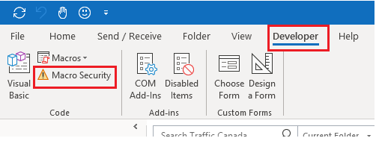

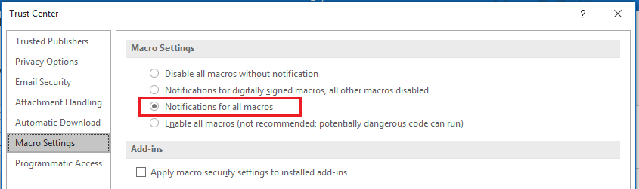

每次重新打开Outlook之后，第一次运行宏的时候会有以下提示，注意选择Enable Macros

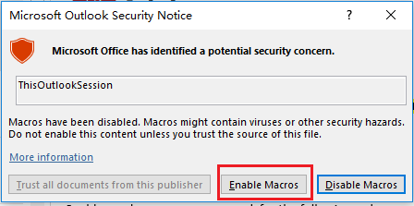

进入Visual Basic界面后只需粘贴最后两个宏即可。

其他的宏都是我在学习时，逐渐尝试各种功能时写的，感兴趣的可以看看。

两个参考学习链接：

<https://docs.microsoft.com/zh-cn/previous-versions/office/ee814736(v=office.14)?redirectedfrom=MSDN>

<https://docs.microsoft.com/zh-CN/office/vba/api/outlook.selection.item>

‘(1)此宏的作用是显示四次提示框。

Sub Test()

Dim Response

Response = MsgBox("Hello World", vbYesNo + vbCritical)

Response = MsgBox("Argument not optional", vbExclamation)

Response = MsgBox("", vbInformation)

Response = MsgBox("", vbQuestion)

End Sub

‘(2)此宏的作用是测试当前弹出窗口邮件的附件数量

Sub TestAttachment()

Dim myinspector As Outlook.Inspector

Dim myItem As Outlook.MailItem

Dim myAttachments As Outlook.Attachments

Dim myAttachment As Attachment

Set myinspector = Application.ActiveInspector

If Not TypeName(myinspector) = "Nothing" Then

Set myItem = myinspector.CurrentItem

Set myAttachments = myItem.Attachments

myItem.Display

MsgBox (myAttachments.Count & " attachment(s)")

For Each myAttachment In myAttachments

Debug.Print ("Index: " & myAttachment.Index)

Debug.Print ("DisplayName: " & myAttachment.DisplayName)

Debug.Print ("FileName: " & myAttachment.FileName)

Debug.Print ("Size: " & myAttachment.Size)

Debug.Print ("Type: " & myAttachment.Type & vbLf)

Next

Else

MsgBox ("There is no active inspector")

End If

End Sub

‘(3)此宏的作用是转发当前弹出窗口的邮件给NiFi

Sub AutoForward_OneMail()

Dim myinspector As Outlook.Inspector

Dim myItem As Outlook.MailItem

Set myinspector = Application.ActiveInspector

If Not TypeName(myinspector) = "Nothing" Then

Set myItem = myinspector.CurrentItem.Forward

myItem.Display

myItem.Recipients.Add ("CustAutoQuote@synnex.com")

Debug.Print "Forwarded: " & myItem.Subject

myItem.Send

'Debug.Print "Send: " & myItem.Subject 把Debug.Print放在这一行会报错，应该是send后MailItem对象就没了

Else

MsgBox ("There is no active inspector")

End If

Set myinspector = Nothing

Set myItem = Nothing

End Sub

‘(4)此宏的作用是选择一个邮箱文件夹在新窗口打开

Sub DisplayFolder()

Dim myNameSpace As NameSpace

Dim myFolder As Folder

Dim myEntryID As String

Dim myStoreID As String

Dim myNewFolder As Outlook.Folder

Set myNameSpace = Application.GetNamespace("MAPI")

' Set myFolder = myNameSpace.GetDefaultFolder(olFolderInbox)

' myFolder.Display

' Set myFolder = Application.Session.GetDefaultFolder(olFolderTasks)

Set myFolder = myNameSpace.PickFolder

myEntryID = myFolder.EntryID

myStoreID = myFolder.StoreID

Debug.Print ("EntryID:" & myFolder.EntryID & " StoreID:" & myFolder.StoreID)

Set myNewFolder = Application.Session.GetFolderFromID(myEntryID, myStoreID)

myNewFolder.Display

End Sub

‘(5)此宏的作用是把某个文件夹里的邮件转发给NiFi

Sub AutoForwardFolder()

Dim myNameSpace As NameSpace

Dim myFolder As Folder

Dim myItem As Outlook.MailItem

Dim myNewItem As Outlook.MailItem

Set myNameSpace = Application.GetNamespace("MAPI")

Set myFolder = myNameSpace.PickFolder

Debug.Print ("Items: " & myFolder.Items.Count)

If myFolder.Items.Count < 50 Then

For Each myItem In myFolder.Items

Set myNewItem = myItem.Forward

myNewItem.Display

myNewItem.Recipients.Add ("CustAutoQuote@synnex.com")

Debug.Print ("Forwarded: " & myNewItem.Subject)

myNewItem.Send

Next

Else

MsgBox ("Error: More than 50 items")

End If

End Sub

‘(6)此宏的作用是把某个文件夹里的邮件带附件回复打开。注意更改路径

Sub ReplyWithAttachmentsFolder()

Dim myNameSpace As NameSpace

Dim myFolder As Folder

Dim myItem As Outlook.MailItem

Dim myNewItem As Outlook.MailItem

Dim myAttachment As Attachment

Set myNameSpace = Application.GetNamespace("MAPI")

Set myFolder = myNameSpace.PickFolder

Debug.Print ("Items: " & myFolder.Items.Count)

If myFolder.Items.Count < 20 Then

For Each myItem In myFolder.Items

If myItem.Attachments.Count < 100 Then

Set myNewItem = myItem.ReplyAll

For Each myAttachment In myItem.Attachments

If Left(myAttachment.FileName, 6) <> "image0" Then

'If a file with the same name already exists in the destination folder, it will be overwritten with this copy of the file.

myAttachment.SaveAsFile ("C:\Users\ronf\Documents\AttachmentsCache\" & myAttachment.FileName)

myNewItem.Attachments.Add ("C:\Users\ronf\Documents\AttachmentsCache\" & myAttachment.FileName)

End If

Next

Debug.Print ("DisplayReplyAll: " & myNewItem.Subject)

myNewItem.Display

Else

Debug.Print ("Error Over 100 Attachments: " & myItem.Subject)

MsgBox ("Error Over 100 Attachments: " & myItem.Subject)

End If

Next

Else

MsgBox ("Error: Up to 20 Items Once")

End If

End Sub

‘(7)此宏的作用是把当前弹出窗口邮件带附件回复打开。注意更改路径

Sub ReplyWithAttachments_OneMail()

Dim myinspector As Outlook.Inspector

Dim myNewItem As Outlook.MailItem

Dim myAttachment As Attachment

Set myinspector = Application.ActiveInspector

If Not TypeName(myinspector) = "Nothing" Then

If myinspector.CurrentItem.Attachments.Count < 100 Then

Set myNewItem = myinspector.CurrentItem.ReplyAll

For Each myAttachment In myinspector.CurrentItem.Attachments

If Left(myAttachment.FileName, 6) <> "image0" Then

'If a file with the same name already exists in the destination folder, it will be overwritten with this copy of the file.

myAttachment.SaveAsFile ("C:\Users\ronf\Documents\AttachmentsCache\" & myAttachment.FileName)

myNewItem.Attachments.Add ("C:\Users\ronf\Documents\AttachmentsCache\" & myAttachment.FileName)

End If

Next

Debug.Print ("DisplayReplyAll: " & myNewItem.Subject)

myNewItem.Display

Else

Debug.Print ("Error Over 100 Attachments: " & myItem.Subject)

MsgBox ("Error Over 100 Attachments: " & myItem.Subject)

End If

Else

MsgBox ("There is no active inspector")

End If

Set myinspector = Nothing

Set myNewItem = Nothing

End Sub

‘。。。。。分页符分割线。。。。。以下两个宏实现两个主要功能，也就是说复制以下两个宏即可

‘(8)此宏的作用是把选中的邮件带附件回复打开。注意更改路径。原理是把附件保存到电脑的本地文件夹里，再从本地文件夹拖到附件。

Sub ReplyWithAttachments_Explorer()

Dim myOlExp As Outlook.Explorer

Dim myOlSel As Outlook.Selection

Dim myMail As Outlook.MailItem

Dim myAttachment As Attachment

Dim myNewMail As Outlook.MailItem

Dim x As Long

Set myOlExp = Application.ActiveExplorer

Set myOlSel = myOlExp.Selection

If myOlSel.Count = 0 Then

MsgBox ("Error: Selected Nothing")

‘下面这条语句限制一次最多打开10个回复邮件窗口

ElseIf myOlSel.Count <= 10 Then

Debug.Print ("Items: " & myOlSel.Count)

For x = 1 To myOlSel.Count

If myOlSel.Item(x).Class = OlObjectClass.olMail Then

Set myMail = myOlSel.Item(x)

If myMail.Attachments.Count < 100 Then

Set myNewMail = myMail.ReplyAll

For Each myAttachment In myMail.Attachments

‘下面这条语句是判断附件文件名是否以image0作为开头，因为我发现HTML格式的outlook邮件正文中的图片也是以附件形式保存在电脑中的，并且命名是从image001开始的。正文图片附件不需要保存。如果万一遇到以image0作为文件名开头的附件，则需要手动复制。

If Left(myAttachment.FileName, 6) <> "image0" Then

'If a file with the same name already exists in the destination folder, it will be overwritten with this copy of the file.

myAttachment.SaveAsFile ("C:\Users\ronf\Documents\AttachmentsCache\" & myAttachment.FileName)

myNewMail.Attachments.Add ("C:\Users\ronf\Documents\AttachmentsCache\" & myAttachment.FileName)

End If

Next

Debug.Print ("DisplayReplyAll: " & myNewMail.Subject)

myNewMail.Display

Else

Debug.Print ("Error Over 100 Attachments: " & myMail.Subject)

End If

Else

Debug.Print ("Error: Not a Mail, Index (" & x & ")")

End If

Next x

Else

MsgBox ("Error: Please select not more than 10 Items; Selected: " & myOlSel.Count)

End If

End Sub

‘(9)此宏的作用是把选中的邮件转发给NiFi

Sub AutoForward_Explorer()

Dim myOlExp As Explorer, myOlSel As Selection, myNewMail As MailItem

Dim x As Long

Set myOlExp = Application.ActiveExplorer

Set myOlSel = myOlExp.Selection

If myOlSel.Count = 0 Then

MsgBox ("Error: Selected Nothing")

‘下面这条语句限制一次最多转发30封邮件给NiFi

ElseIf myOlSel.Count <= 30 Then

If MsgBox("Confirm Forward it to CustAutoQuote(机器人NiFi) ?", vbYesNo + vbInformation) = vbYes Then

Debug.Print ("Items: " & myOlSel.Count)

For x = 1 To myOlSel.Count

If myOlSel.Item(x).Class = OlObjectClass.olMail Then

Set myNewMail = myOlSel.Item(x).Forward

myNewMail.Recipients.Add ("CustAutoQuote@synnex.com")

myNewMail.Display

Debug.Print ("Forwarded: " & myNewMail.Subject)

myNewMail.Send

Else

Debug.Print ("Error: Not a Mail, Index (" & x & ")")

End If

Next x

End If

Else

MsgBox ("Error: Please select not more than 30 Items; Selected: " & myOlSel.Count)

End If

End Sub