**Project Summary**

·

**Target Audience**

Our Target Audience for this project is the **Committee on Transport, Industry, Communications, Energy, Science and Technology of the African Union**. This committee is is one of the ten permanent committees of the Pan-African Parliament, which is the legislative body of the African Union.

We want to convince our target audience to move away from non-renewables and move into renewables even when they are a developing nation. As such, we feel our target audience would be most appropriate and would be in a position to push for renewable energy policies in their respective countries.

We are planning to demonstrate based on the energy consumption and production trends of the world over the years, that investing in cleaner solar energy and other renewable sources of energy during the early phase of economic development is not only beneficial but essential for the long term prosperity of African nations.

**Data Sources and description**

Our data sources come from the following:

* U.S. Energy Information Administration. (Oct 2008). International Energy Statistics / Total Primary Energy Consumption [Data file]. Retrieved Oct 30, 2016. Available from <https://goo.gl/Hzs1Oy>
* U.S. Energy Information Administration. (Oct 2008). International Energy Statistics / Total Primary Energy Production [Data file]. Retrieved Oct 30, 2016. Available from<https://goo.gl/p1NruF>
* The World Energy Council. (2011). Solar Installed Capacity by region. [Online Resource]. Retrieved December 10. Available from [https://goo.gl/dIieV4](https://www.worldenergy.org/data/resources/resource/solar/)

We processed the data differently for different analyses, however there were some common data cleaning and processing steps. We removed all empty rows replaced the values that were listed N/A with zeroes. The names of some countries were changed to their present name. Some countries were merged into one. The rows and columns had to transposed in order to process the data easily in R.

· **Sample plot from the analysis**

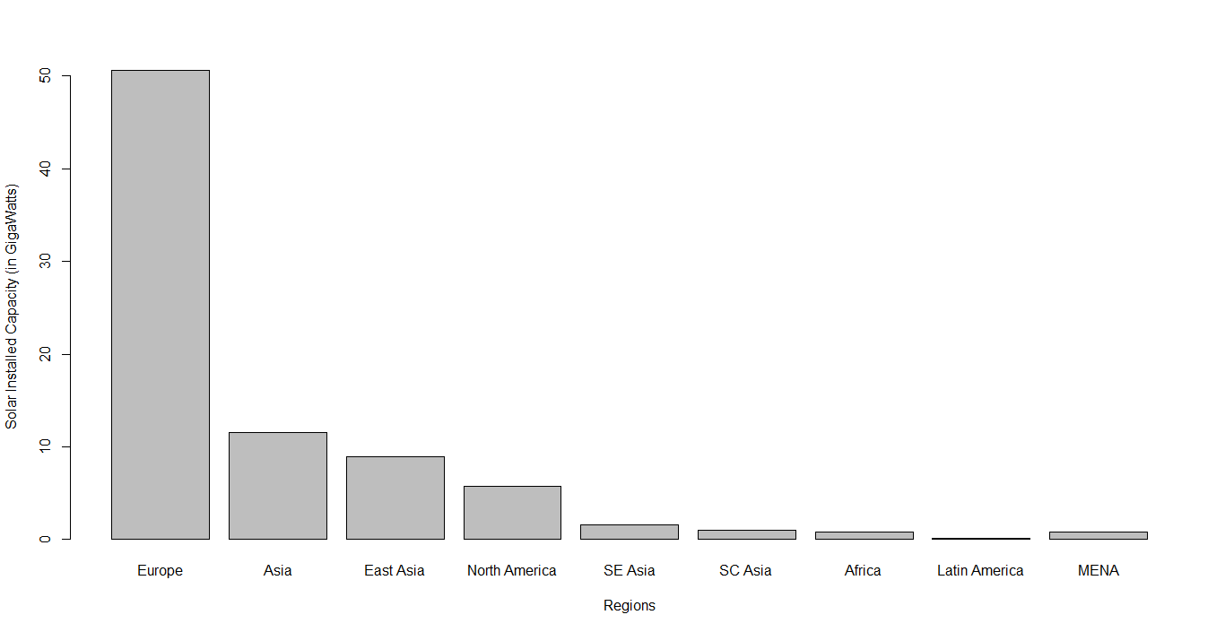

· **Interpretation**

Europe is leading the world in solar power while Africa is severely lagging. When we couple this with the region wise and nation wise energy consumption and production trends, it is clear that there is a lot of potential for solar power in Africa. Africa is tied with Australia for continents with the most solar exposure so the data above can only be explained by a lack of investments in solar energy infrastructure, or a lack of political will to do so.

· **Arguments and decisions to be made**

The argument we are trying to make to our target audience is simply the following. The trend is clear that the energy consumption will likely go up and most energy sources today are detrimental to the climate and the environment.

Early investment in renewables by developing African nations have many advantages. First, it helps in combating climate change. We know that the most disastrous effects like droughts, floods will affect developing countries. Second, it helps create millions of new jobs in the green energy sector. Transmission infrastructure problems are avoided by using solar panels. Thirdly green energy ensures energy independence.