Vicente Thesis Review
Version 1.0, June 16, 2026
- 4/106, abstract: I think the structure of the thesis is not fully clear in the abstract. The problem in the area that you are trying to solve should be highlighted more specifically, as well as your solution/proposal to address this using graph theory. I feel that you jump between PIP and OCS without any logical connection and common background. These three paragraphs can be improved, let’s take a look.
This abstract logic is changed to:
Background:
Silicon photonic advantage -> PIP flexibility and reconfigurable for networking applications -> Specially for OCS application
Issue to address within network scaling:
- Automatic circuit control on PIP
- PIP hardware design for high radix switching
- System practical deployment in network
What we did:
Using graph theory to model PIP hardware as mathematic abstraction for:
- Circuit routing algorithm and auto control on multipurpose PIP
- PIP hardware design for high radix switching circuit
And:
- Based on circuit control implement SDN layer
Work contribution.
- 11/106: very emotional acks.
- 15:106, contents: looking at the thesis structure, I think you must clearly specify when doing networking in hex meshes (chapter 3) vs in dedicated switching meshes (chapter 4). Maybe rename chapter 3 to: Optical Networking Applications Based on Multi-purpose Programmable Photonics.
The chapter renamed
- 23/106 Intro 1.1: Specifically, PICs can offer potentially lower power
Changed
- 23/106: intro 1.1: The core of PIP lies in its reconfigurable architectures, typically based on integrated waveguide meshes that cascaded by Mach-Zehnder interferometers
Changed
- 23/106: intro 1.1: I think you can add a image here about how PIP works. If you don’t want to make it complex use fig 1 of our NPJ paper: https://www.nature.com/articles/s44310-025-00075-4
Figure added and paraphs rephrased.
- 23/106 intro 1.1: Programmable integrated photonics offers a reconfigurable and high bandwidth hardware photonic platform, and its importance is particularly significant in emerging interconnect scenarios where. In modern large scale computing systems, and data movement across nodes has have become a dominant bottleneck in both performance and energy efficiency
Rephrased (24/108)
- 24/106 intro 1.2: with on-chip and network level communication mechanisms increasingly adopting similar paradigms for scalability and performance
Typo fixed (25/108)
- 24/106 intro 1.2: At the lowest level, intra package integration and chiplet links such as NVLink C2C enable high bandwidth no sure if the chiplet interconnection is called also NVLink, you can highlight HBM at the chip level and then you only talk about NVLink when talking about GPUs scape-up in a rack. Also, note that NVLink is proprietary of Nvidia, so name it. AMD’s one is UALink, and ethernet is working on faster and more AI-driven interconnects as well.
(25/108)
Nvidia had chiplet interconnection called NVLink C2C (communication between CPU and GPUs).
HBM is highlighted.
Nvidia named is mentioned.
UALink and ethernet interconnect for scale up are added.
- 24/106 Intro 1.2 I would re-name this section to Networking interconnects in AI infrastructure
Renamed (25/108)
- 25/106 Intro 1.3: when talking about classical OCS, apart from MEMs you can also introduce piezo-electric (Polatis) and liquid-crystal-on-silicon (coherent)
piezo-electric (Polatis) and LCoS (coherent) mentioned and cited (26/108)
- 26/106 Intro 1.3: you name programmable integrated silicon photonic circuit, use PIP that you have defined before, maybe: Taken together, these properties make silicon PIP a suitable foundation for realizing flexible and efficient OCS in AI driven communication scenarios. Overall like point 1 of the intro and how PIP and AI/switches converges at the end of the section.
Renamed to PIP (27/108)
Recalled the section 1.1, take advantage of SiPh + PIP
- 27/106: programmable integrated photonics has been already described, use PIP every time, there are more examples after
Renamed with PIP (28/108)
- 28/106: figure 1.2 is very powerful as it summarizes the thesis, please remake with good quality and visuals, could be improved
Figure reupdated (29/108)
- 28/106: Architecture design methodology: Using the unified graph based abstraction methodology.. don’t fully understand this part, is the same methodology applied for the first point?. Maybe here you should specify how we make use of the graphs not only for circuit abstraction and synthesis but for architecture design. Comment briefly on how you do that.
(29/108: Architecture design methodology) Enrich the paraph, descript we use graph to abstract different OCS architectures, and apply with developed routing algorithm to evaluated blocking rate, as well as optical performance, etc.
- 29/106: Chapter 2: Theoretical Foundations and Programming Methodologies for PIP Circuits This chapter presents the theoretical foundations for programmable photonic integrated circuits. Redundant, write it in a different way or remove it.
(33/108) Removed
- 29/106: Overall, I think you use many words like framework which is, for me at least, quite generic. When describing how you use graphs for circuit synthesis you must describe specifically how this “framework” looks like, what is exactly. The same think when you say “framework” for the scalability of OCS architectures. For example, when you say “develops a graph-theory-based modeling and benchmarking approach…” approach again is generic, and kind of complex way to describe it.. maybe is easier to say “we use graph-theory to model architectures and compare them”. That’s it. Sometimes you define it later, is okay, but some others feels generic.
In structure of thesis (chapter 3), briefly described with how we did
- 31/106: enabling automated routing, path computation, and configuration synthesis
Changed
- 31/106: 2.1.1 50:50 power splitter (include the word power)
(33/108) Power splitter added (same for other parts)
- 32/106: when talking about DCs, the main drawback is they are not broadband as they provide narrow bandwidth operation of a few nanometers. You can discuss here that are strategies to increase that as adiabatic couplers or rapid adiabatic couplers, but standard DCs are not suitable for WDM communications in DC.
(34/108) part of DC. Added narrow bandwidth drawback
- 32/106: also the loss of DC can go way below 0.1 dB in some cases. The good thing is that they are very low loss but narrow BW.
(34/108) part of DC. Narrow bandwidth drawback mentioned
- 32/106: similarly, MMIs are higher loss but also they provide broaden BW operation, you already included this in the second paragraph.
- 33/106: maybe would be nice to include the mathematical transfer matrix function of the 50:50 power splitter
(34/108) Transfer matrix function added. [2.1]
- 33/106: phase-shifters, you can also comment on the trade-off between Ppi vs reconfiguration speed. Provide some numbers for full suspended (hundreds of us) vs non-suspended PS (10’s us only), 10x improvement.
(36/108) The trade-off between Ppi vs reconfiguration speed added, for both full suspended and non-suspended PS
- 35/106 PUCs, I would include also in the last paragraph that the MZI is balanced (the two arms of the same length) in typical programmable photonic applications to provide high bandwidth operation
(38/108) Added. “…the PUC is designed in a balanced configuration with equal arm lengths to enable broadband operation by minimizing wavelength dependent phase errors and group delay mismatch.”
- 39/106 BUL is the PUC basic unit length, “T” is missing in unit
Typo fixed
- 40/106 when talking about graphs and feedforward meshes, you introduce Benes and PLOSS “Conversely, for feedforward architectures, such as Benes or PILOSS meshes”, but you don’t explain what they are and later Fig. 2.8 is about it. Maybe intro them a bit saying they are switching meshes or use more standard feedforward ones as Clements or triangular.
The Benes, PILOSS, Banyan, architectures are mentioned in 2.2.1
- 40/106 “Moreover, this detailed model explicitly accounts for waveguide crossings” you are talking about the PUC graph modelling and jump to the “crossing” level in the high-resolution abstraction. It is a bit confusing. Maybe you can separate section 2.3 in two subsections talking about graphs for multi-purpose programmable meshes and graphs for switching meshes, and talk about different types and differences, expand a bit. Like the idea of complex graph models for recirculating and simplified graphs for feedforward/switching but now is confusing you jump between the two and don’t differentiate.
Graph modelling are separated in 2 subsections for “Feedforward mesh graph” and “Recirculating mesh graph”
- 41/106 Would ask help from Carlos/Lluis in the SDN part 2.4 section
Reviewed by Carlos
- 46/106 when you talk about figure 3.2, maybe I am missing a bit intro on the smart light processor, or at least what is the architecture of the processor. It feels like “magic” you have an hexagonal mesh and suddenly there is matrix of optical power out of nowhere. Consider talking about Smartlight and introducing it, give more details on the chip, device, whatever, maybe show the die image (In the fundamentals section, 2.3 section? Before graphs) before showing the results and optical measurements.
(41/108) The Smartlight introduction is added in section 2.2.2
- 47/106 figure 3.2 of interconnect is in the section of multicast, seems weird to find it when you are talking about multicast. Consider including it before in a single figure together with 3.1
(49/108)The figure is sorted, all figures of multicasting are included in 3.2
- 56/106 when you talk about figure 4.1 you mention Benes network but it is not in the figure
Benes figure added
- 57/106 You previously said rearrangement is not allowed to do not interrupt already stablished connections, that is okay. However, here “Nevertheless, for scheduled traffic [30], RNB networks might still find an application and that is the reason why they are included in the study.” Seems like you are saying now rearrangeability is permitted, which is not true. Simply say that low blocking architectures might find applications, but RNB is always forbidden.
(58/108) Reprhased. “Nevertheless, for scheduled traffic [33], low blocking networks might still find applications and that is the reason why they are included in the study.”
- 57/106 would be nice to include also the first figure of the paper? Showing the photonic circuit and the corresponding graph
The feedforward PIP abstract to graph have been demonstrated already in 2.3.1, so I decided not included it.
- 61/106 in the table you say “Silicon Nitre” is Nitride
Typo fixed
- 65/106 change 4.5 section title to Architecture comparative analysis
(67/108) Title changed.
- 65/106 when talking about footprints, “assuming footprints” you can say that numbers are typical in the literature table 4.1
(67/108) Assuming footprints explanation added: “which are typical values reported in the literature from Table 4.1.”
- 69/106 I did not review chapter 5 in detail as I am not an expert in this field, please check with Carlos or Lluis. I read it and seems ok for me.
Carlos reviewed.
- 70/106 in general in this chapter, maybe because im not an expert on this, but I miss an introductory image to better understand and secure the concepts of YANG model, gNMI protocols and SDN, and how these concepts interact between each other. Figure 5.1 falls short in this regard, in my view. Similar to Figure 5.3 but more introductory, showing a data center a switch, etc.
The SDN part (yang, gnmi, sdn) is introduced in 2.4
- 70/106 similarly to what happened with Smartlight, in this page you talk about the ONE, fig 5.1 you talk about the tech stack, without introducing it properly. Maybe im missing here couple of extra information about the switch device.
(26/108) The brief SiPh OCS and its related component added in the introduction chapter
And paraph of page 72 recall SiPh OCS.
- 70/106 the yang model figure 5.2 cannot be summarized or sketched? Instead of showing directly the code, just asking.
This is the typical way to demonstrated yang model
- 72/106: What does gNMI mean? Is it an acronym?
gNMI acronym is shown in section 2.4
- 79/106 “architectural design” better say “architecture design”
Changed to architecture design
- 81/106 maybe in the discussion you can include the BER matrix of loss and crosstalk from VPI simulations, since you are talking about these to impairment factors
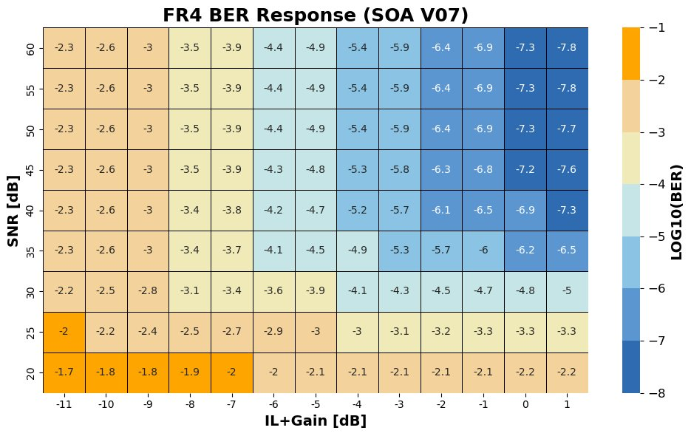
I have decided don’t included this part, since to explain this figure should better explain the setup, modelling of component and configuration of link…
- 83/106 you discuss ab out calibration for crosstalk optimization, maybe this is something we don’t want to mention yet as this is new an could be critical for future SNR developments, not sure
Pending discuss with Dani
- 84/106 similarly, you talk in section 6.2 about the modular OCS, this would be the first time we mention that, not sure, to discuss with Dani
Pending discuss with Dani
- 85/106 in the conclusions section 6.3, multi-disciplinary thesis, is key for the reviewers to identify what exactly is your contribution to each chapter of the thesis, you cover a lot of fields from photonic design to SDN.
- 87/106 include also the JLT paper now accepted!!!
JLT paper included

