

实验报告

课程名称 移动应用软件综合开发

开课学期 2020秋季

指导教师 林奕森

实 验 室 巡天楼308

班 级 17软件工程4班

学 号 2017070030429

姓 名 钟祯

成绩： （五级）

实验课程 评分表标准
 | 全勤、学习态度端正、实验认真、积极回答问题、操作过程正确，结果准确，实验报告内容规范 | 偶有缺勤、实验认真、回答问题较积极、操作过程正确，结果准确，实验报告内容规范 | 旷课2次以内、偶有迟到、实验认真、回答问题较好、操作过程基本正确，结果基本准确，实验报告内容较规范 | 旷课2次以上、学习态度一般、基本能回答出问题、操作过程较正确，结果基本准确，实验报告内容基本规范 | 经常旷课，实验过程不认真、问题回答不积极、实验报告不符合要求或未交
 | 优秀（90-100） | 良好（80-89） | 中（70-79） | 及格（60-69） | 不及格(<59)
实验一
实验二
实验三
实验四
实验五
实验成绩总评（五级制）

说明：1．每次实验结束，学生完成一份实验报告，课程结束后汇总,加封面装订成册存档；2．各任课教师可在以上五项栏目的基础上，可根据实验课程和实验项目的具体需要，调整项目内容，但封面格式须统一；3．可根据实验数量自行添加行数。打印到封面背面

桂林航天工业学院学生实验报告
课程名称 | 移动应用软件综合开发 |  |  | 实验项目名称 |  | 实验一 菜单与对话框实例实验
开课教学单位及实验室 |  | 计算机科学与工程学院 巡天楼308 |  |  |  | 实验日期 |  | 年 月 日
学生姓名 | 钟祯 |  | 学号 |  | 2017070030429 | 专业班级 |  | 17软件工程4班
指导教师 | 林奕森 |  |  |  | 实验成绩
一、实验目的
1、实现手势交互功能案例实验使用功能。
二、实验原理
1、使用Android Studio创建工程及类，编写程序。
2、调试程序，并在Genymotion中运行程序。
三、实验操作方法和步骤
1、完成实例006明日学院消息通知
2、完成实例009彩虹式菜单
四、实验结果与分析
实例006部分关键源码：
public class MainActivity extends AppCompatActivity {
final int NOTIFYID = 0x123;

@Override
protected void onCreate(Bundle savedInstanceState) {
super.onCreate(savedInstanceState);
setContentView(R.layout.activity_main);
NotificationManager notificationManager = (NotificationManager) getSystemService(NOTIFICATION_SERVICE);
NotificationCompat.Builder notification = new NotificationCompat.Builder(MainActivity.this);
notification.setAutoCancel(true);
notification.setTicker("安卓课程第一季上线啦！");
notification.setSmallIcon(R.mipmap.ic_launcher);
notification.setLargeIcon(BitmapFactory.decodeResource(getResources(), R.mipmap.ic_launcher));
notification.setContentTitle("Android入门第一季！");
notification.setContentText("点击查看详情！");
notification.setWhen(System.currentTimeMillis());
Intent intent = new Intent(MainActivity.this, MessageActivity.class);
PendingIntent pi = PendingIntent.getActivity(MainActivity.this, 0, intent, 0);
notification.setContentIntent(pi);
assert notificationManager != null;
notificationManager.notify(NOTIFYID, notification.build());
}
}

实例006实验结果：
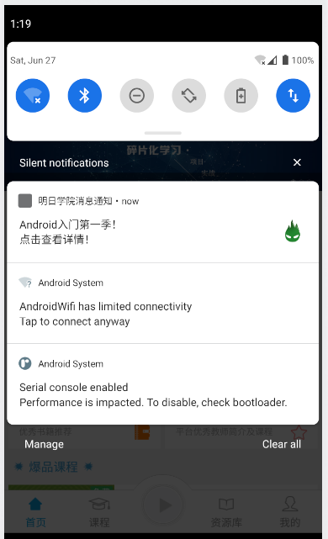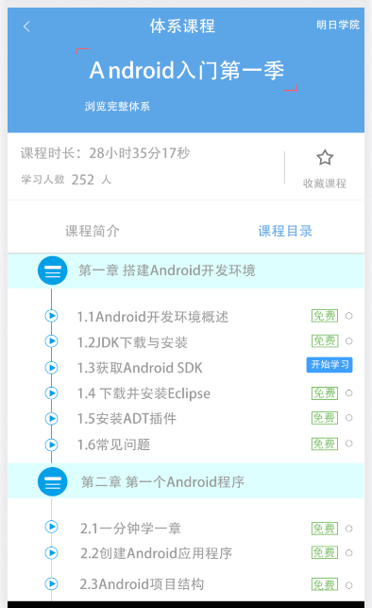
实例009部分关键源码：
public class MainActivity extends AppCompatActivity {
private RelativeLayout l2, l3;

private boolean isl2Show = true;
private boolean isl3Show = true;

@Override
protected void onCreate(Bundle savedInstanceState) {
super.onCreate(savedInstanceState);
setContentView(R.layout.activity_main);

ImageButton imageButton_a1 = (ImageButton) findViewById(R.id.a_1);
ImageButton imageButton_b2 = (ImageButton) findViewById(R.id.b_2);

l2 = (RelativeLayout) findViewById(R.id.level_2);
l3 = (RelativeLayout) findViewById(R.id.level_3);

imageButton_b2.setOnClickListener(new View.OnClickListener() {
@Override
public void onClick(View v) {
if (isl3Show) {
MyAnimation.animationOUT(l3, 500, 0);
} else {
MyAnimation.animationIN(l3, 500);
}

isl3Show = !isl3Show;
}
});

imageButton_a1.setOnClickListener(new View.OnClickListener() {
@Override
public void onClick(View v) {
if (!isl2Show) {
MyAnimation.animationIN(l2, 500);
} else {
if (isl3Show) {
MyAnimation.animationOUT(l3, 500, 0);
MyAnimation.animationOUT(l2, 500, 500);
isl3Show = !isl3Show;
} else {
MyAnimation.animationOUT(l2, 500, 0);
}
}
isl2Show = !isl2Show;
}
});
}
}

public class MyAnimation {
public static void animationIN(ViewGroup viewGroup, int duration) {
for (int i = 0; i < viewGroup.getChildCount(); i++) {
viewGroup.getChildAt(i).setVisibility(View.VISIBLE);
viewGroup.getChildAt(i).setFocusable(true);
viewGroup.getChildAt(i).setClickable(true);
}

Animation animation;
animation = new RotateAnimation(
-180, 0,
Animation.RELATIVE_TO_SELF, 0.5f,
Animation.RELATIVE_TO_SELF, 1.0f);
animation.setFillAfter(true);
animation.setDuration(duration);
viewGroup.startAnimation(animation);
}

public static void animationOUT(final ViewGroup viewGroup, int duration, int startOffSet) {
Animation animation;
animation = new RotateAnimation(
0, -180,
Animation.RELATIVE_TO_SELF, 0.5f,
Animation.RELATIVE_TO_SELF, 1.0f);
animation.setFillAfter(true);
animation.setDuration(duration);
animation.setStartOffset(startOffSet);
animation.setAnimationListener(new Animation.AnimationListener() {
@Override
public void onAnimationStart(Animation animation) {
// TODO Auto-generated method stub
}

@Override
public void onAnimationRepeat(Animation animation) {
// TODO Auto-generated method stub
}

@Override
public void onAnimationEnd(Animation animation) {
for (int i = 0; i < viewGroup.getChildCount(); i++) {
viewGroup.getChildAt(i).setVisibility(View.GONE);
viewGroup.getChildAt(i).setFocusable(false);
viewGroup.getChildAt(i).setClickable(false);
}
}
});
viewGroup.startAnimation(animation);
}
}
实例009实验结果：
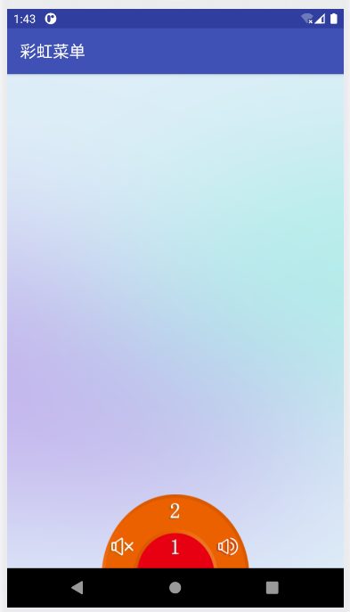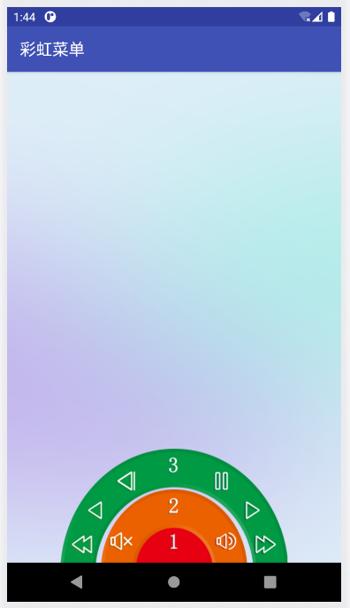

结果分析：

实例006中，使用NotificationManager来管理Notification.Builder发送通知。
实例009中，使用onClick事件处理，还使用了动画方法。

桂林航天工业学院学生实验报告
课程名称 | 移动应用软件综合开发 |  |  | 实验项目名称 |  | 实验二 Android常用控件应用
开课教学单位及实验室 |  | 计算机科学与工程学院 巡天楼308 |  |  |  | 实验日期 |  | 年 月 日
学生姓名 | 钟祯 |  | 学号 |  | 2017070030429 | 专业班级 |  | 17软件工程4班
指导教师 | 林奕森 |  |  |  | 实验成绩
一、实验目的
1、实现手势交互功能案例实验使用功能。
二、实验原理
1、使用Android Studio创建工程及类，编写程序。
2、调试程序，并在Genymotion中运行程序。
三、实验操作方法和步骤
1、完成实例019弹出智能提示信息的搜索框
2、完成实例020页面垂直滚动公告条
四、实验结果与分析
实例019部分关键源码：
public class Book {
private String bookname;

public String getBookname() {
return bookname;
}

public void setBookname(String bookname) {
this.bookname = bookname;
}

@Override
public String toString() {
return bookname;
}
}

public class MainActivity extends AppCompatActivity {
private List<Book> booknames;

private String[] bookList = {"书籍：Android 移动开发", "书籍：Java 从入门到精通", "书籍：Java Web 程序设计",
"书籍：JSP 程序设计", "书籍：PHP 程序设计", "书籍：C# 程序设计", "书籍：SQL Server 数据库管理与开发",
"书籍：ASP.NET 开发实例大全", "书籍：Visual Basic 开发实例大全", "书籍：Visual C++ 开发实例大全",
"书籍：Oracle 数据库管理与开发", "书籍：Java 开发实例大全", "书籍：Java Web 开发实例大全",
"书籍：C# 开发实例大全", "书籍：Android 程序开发范例宝典", "书籍：HTML5 程序开发范例宝典"
};

@Override
protected void onCreate(Bundle savedInstanceState) {
super.onCreate(savedInstanceState);
setContentView(R.layout.activity_main);
initData();
initView();
}

private void initView() {
AutoCompleteTextView autoCompleteTextView = (AutoCompleteTextView) findViewById(R.id.autocomplete_country);
MyAdapter bookAdapter = new MyAdapter(booknames, this);
autoCompleteTextView.setAdapter(bookAdapter);
}

private void initData() {
booknames = new ArrayList<>();
for (String s : bookList) {
Book book = new Book();
book.setBookname(s);
booknames.add(book);
}
}
}

public class MyAdapter extends BaseAdapter implements Filterable {
private Context context;
private List<Book> books;
private ArrayFilter mArrayFilter;
private ArrayList<Book> mFilterBooks;

public MyAdapter(List<Book> mList, Context context) {
this.books = mList;
this.context = context;
}

@Override
public int getCount() {
return books == null ? 0 : books.size();
}

@Override
public Object getItem(int position) {
return books.get(position);
}

@Override
public long getItemId(int position) {
return position;
}

@Override
public View getView(int position, View convertView, ViewGroup parent) {
View view;
ViewHolder holder;
if (convertView == null) {
view = View.inflate(context, R.layout.list_item, null);
holder = new ViewHolder();
holder.tv_name = (TextView) view.findViewById(R.id.bookname);
view.setTag(holder);
} else {
view = convertView;
holder = (ViewHolder) view.getTag();
}
Book bookname = books.get(position);
holder.tv_name.setText(bookname.getBookname());
return view;
}

static class ViewHolder {
public TextView tv_name;
}

@Override
public Filter getFilter() {
if (mArrayFilter == null) mArrayFilter = new ArrayFilter();
return mArrayFilter;
}

private class ArrayFilter extends Filter {
@Override
protected FilterResults performFiltering(CharSequence constraint) {
FilterResults results = new FilterResults();
if (mFilterBooks == null) mFilterBooks = new ArrayList<>(books);
if (constraint == null || constraint.length() == 0) {
results.values = mFilterBooks;
results.count = mFilterBooks.size();
} else {
List<Book> retList = new ArrayList<>();
String str = constraint.toString().toLowerCase();
for (Book book : mFilterBooks) {
if (book.getBookname().contains(str)) retList.add(book);
}
results.values = retList;
results.count = retList.size();
}
return results;
}

@Override
@SuppressWarnings("unchecked")
protected void publishResults(CharSequence constraint, FilterResults results) {
books = (List<Book>) results.values;
if (results.count > 0) {
notifyDataSetChanged();
} else {
notifyDataSetInvalidated();
}
}
}
}
实例019实验结果：
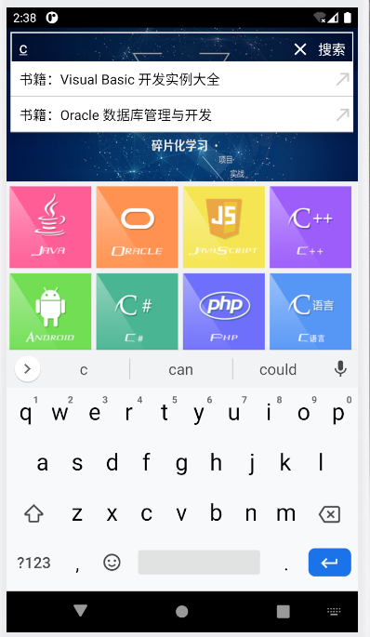

实例020部分关键源码：
public class MainActivity extends AppCompatActivity {
@Override
protected void onCreate(Bundle savedInstanceState) {
super.onCreate(savedInstanceState);
setContentView(R.layout.activity_main);
VerTextView tv_ver = (VerTextView) findViewById(R.id.tv_ver);
tv_ver.setListener(new VerTextView.onTouchListener() {
@Override
public void touchListener(String s) {
Toast.makeText(MainActivity.this, s, Toast.LENGTH_LONG).show();
}
});
}
}

public class VerTextView extends View {

private Paint mPaint;
private float x, startY, endY, firstY, nextStartY, secondY;
private String[] text = {"Android移动开发（慕课版）", "明日科技出新书了"};
private float textWidth, textHeight;
private float speech = 0;
private static final int CHANGE_SPEECH = 0x01;
private boolean isScroll = false;

@SuppressLint("HandlerLeak")
private Handler mHandler = new Handler() {
@Override
public void handleMessage(Message msg) {
super.handleMessage(msg);
if (msg.what == CHANGE_SPEECH) speech = 1f;
}
};

public VerTextView(Context context, AttributeSet attrs) {
super(context, attrs);
mPaint = new Paint();
mPaint.setColor(Color.RED);
mPaint.setTextSize(30f);
Rect rect = new Rect();
mPaint.getTextBounds(text[0], 0, text[0].length(), rect);
textWidth = rect.width();
textHeight = rect.height();
x = getX() + getPaddingLeft();
startY = getTop() + textHeight + getPaddingTop() - 5;
endY = startY + textHeight + getPaddingBottom();
nextStartY = getTop() - 5;
firstY = startY;
secondY = nextStartY;
}

@Override
protected void onMeasure(int widthMeasureSpec, int heightMeasureSpec) {
super.onMeasure(widthMeasureSpec, heightMeasureSpec);
int width = measureWidth(widthMeasureSpec);
int height = measureHeight(heightMeasureSpec);
setMeasuredDimension(width, height);
}

private int measureHeight(int heightMeasureSpec) {
int result = 0;
int size = MeasureSpec.getSize(heightMeasureSpec);
int mode = MeasureSpec.getMode(heightMeasureSpec);
if (mode == MeasureSpec.EXACTLY) {
result = size;
} else {
result = (int) (getPaddingTop() + getPaddingBottom() + textHeight);
if (mode == MeasureSpec.AT_MOST) {
result = Math.min(result, size);
}
}
return result;
}

private int measureWidth(int widthMeasureSpec) {
int result = 0;
int size = MeasureSpec.getSize(widthMeasureSpec);
int mode = MeasureSpec.getMode(widthMeasureSpec);
if (mode == MeasureSpec.EXACTLY) {
result = size;
} else {
result = (int) (getPaddingLeft() + getPaddingRight() + textWidth);
if (mode == MeasureSpec.AT_MOST) {
result = Math.min(result, size);
}
}
return result;
}

@Override
protected void onDraw(Canvas canvas) {
super.onDraw(canvas);
if (!isScroll) {
mHandler.sendEmptyMessageDelayed(CHANGE_SPEECH, 2000);
isScroll = true;
}
if (startY > endY || nextStartY > endY) {
if (startY > endY) {
startY = secondY;
nextStartY = firstY;
} else if (nextStartY > endY) {
startY = firstY;
nextStartY = secondY;
}
speech = 0;
isScroll = false;
} else {
canvas.drawText(text[0], x, startY, mPaint);
canvas.drawText(text[1], x, nextStartY, mPaint);
startY += speech;
nextStartY += speech;
}
invalidate();
}

public onTouchListener listener;

public interface onTouchListener {
void touchListener(String s);
}

public void setListener(onTouchListener listener) {
this.listener = listener;
}

@Override
public boolean dispatchTouchEvent(MotionEvent event) {
if (event.getAction() == MotionEvent.ACTION_DOWN) {
if (listener != null) {
if (startY == firstY) {
listener.touchListener(text[0]);
} else {
listener.touchListener(text[1]);
}
}
}
return true;
}
}

实例020实验结果：


结果分析：

实例019中，我使用了迭代的方式（在 initData方法中）替代了传统的逐行添加，增加了可读性，可扩展性。
实例020中，使用了VerTextView，主要使用Paint 画笔绘制页面。

桂林航天工业学院学生实验报告
课程名称 | 移动应用软件综合开发 |  |  | 实验项目名称 |  | 实验三 手势交互功能案例实验
开课教学单位及实验室 |  | 计算机科学与工程学院 巡天楼308 |  |  |  | 实验日期 |  | 年 月 日
学生姓名 | 钟祯 |  | 学号 |  | 2017070030429 | 专业班级 |  | 17软件工程4班
指导教师 | 林奕森 |  |  |  | 实验成绩
一、实验目的
1、实现手势交互功能案例实验使用功能。
二、实验原理
1、使用Android Studio创建工程及类，编写程序。
2、调试程序，并在Genymotion中运行程序。
三、实验操作方法和步骤
1、完成 实例044 手势打电话
2、完成 实例046 图片的放大
3、完成 实例047 长按碎屏效果
四、实验结果与分析
实例044部分关键源码：
public class MPermissionsActivity extends AppCompatActivity {
private int REQUEST_CODE_PERMISSION = 0x00099;

public void requestPermission(String[] permissions, int requestCode) {
this.REQUEST_CODE_PERMISSION = requestCode;
if (checkPermissions(permissions)) {
permissionSuccess(REQUEST_CODE_PERMISSION);
} else {
List<String> needPermissions = getDeniedPermissions(permissions);
ActivityCompat.requestPermissions(this, needPermissions.toArray(new String[0]), REQUEST_CODE_PERMISSION);
}
}

private boolean checkPermissions(String[] permissions) {
if (Build.VERSION.SDK_INT < Build.VERSION_CODES.M) return true;
for (String permission : permissions) {
if (ContextCompat.checkSelfPermission(this, permission) != PackageManager.PERMISSION_GRANTED) {
return false;
}
}
return true;
}

private List<String> getDeniedPermissions(String[] permissions) {
List<String> needRequestPermissionList = new ArrayList<>();
for (String permission : permissions) {
if (ContextCompat.checkSelfPermission(this, permission) != PackageManager.PERMISSION_GRANTED || ActivityCompat.shouldShowRequestPermissionRationale(this, permission)) {
needRequestPermissionList.add(permission);
}
}
return needRequestPermissionList;
}

@Override
public void onRequestPermissionsResult(int requestCode, @NonNull String[] permissions, @NonNull int[] grantResults) {
super.onRequestPermissionsResult(requestCode, permissions, grantResults);
if (requestCode == REQUEST_CODE_PERMISSION) {
if (verifyPermissions(grantResults)) {
permissionSuccess(REQUEST_CODE_PERMISSION);
} else {
permissionFail(REQUEST_CODE_PERMISSION);
showTipsDialog();
}
}
}

private boolean verifyPermissions(int[] grantResults) {
for (int grantResult : grantResults) {
if (grantResult != PackageManager.PERMISSION_GRANTED) return false;
}
return true;
}

private void showTipsDialog() {
new AlertDialog.Builder(this)
.setTitle("提示信息")
.setMessage("当前应用缺少必要权限，该功能暂时无法使用。如若需要，请单击【确定】按钮前往设置中心进行权限授权。")
.setNegativeButton("取消", new DialogInterface.OnClickListener() {
@Override
public void onClick(DialogInterface dialog, int which) {
}
})
.setPositiveButton("确定", new DialogInterface.OnClickListener() {
@Override
public void onClick(DialogInterface dialog, int which) {
startAppSettings();
}
}).show();
}

private void startAppSettings() {
Intent intent = new Intent(Settings.ACTION_APPLICATION_DETAILS_SETTINGS);
intent.setData(Uri.parse("package:" + getPackageName()));
startActivity(intent);
}

public void permissionSuccess(int requestCode) {
Log.e("------", "获取权限成功=" + requestCode);
}

public void permissionFail(int requestCode) {
String TAG = "MPermissions";
Log.d(TAG, "获取权限失败=" + requestCode);
}
}

public class CreateGestureActivity extends Activity {
private static final float LENGTH_THRESHOLD = 120.0f;

private Gesture mGesture;
private View mDoneButton;

@SuppressLint("ResourceAsColor")
@Override
protected void onCreate(Bundle savedInstanceState) {
super.onCreate(savedInstanceState);
setContentView(R.layout.create_gesture);
mDoneButton = findViewById(R.id.done);
GestureOverlayView overlay = (GestureOverlayView) findViewById(R.id.gestures_overlay);
overlay.setGestureStrokeType(GestureOverlayView.GESTURE_STROKE_TYPE_MULTIPLE);
overlay.setFadeOffset(2000);
overlay.setGestureColor(R.color.black);
overlay.setGestureStrokeWidth(8);
overlay.addOnGestureListener(new GesturesProcessor());
}

@Override
protected void onSaveInstanceState(Bundle outState) {
super.onSaveInstanceState(outState);
if (mGesture != null) outState.putParcelable("gesture", mGesture);
}

@Override
protected void onRestoreInstanceState(Bundle savedInstanceState) {
super.onRestoreInstanceState(savedInstanceState);
mGesture = savedInstanceState.getParcelable("gesture");
if (mGesture != null) {
final GestureOverlayView overlay = (GestureOverlayView) findViewById(R.id.gestures_overlay);
overlay.post(new Runnable() {
public void run() {
overlay.setGesture(mGesture);
}
});
mDoneButton.setEnabled(true);
}
}

public void addGesture(View v) {
if (mGesture != null) {
final TextView input = (TextView) findViewById(R.id.gesture_name);
final CharSequence name = input.getText();
if (name.length() == 0) {
input.setError(getString(R.string.error_missing_name));
return;
}
final GestureLibrary store = GestureBuilderActivity.getStore();
store.addGesture(name.toString(), mGesture);
store.save();
setResult(RESULT_OK);
final String path = new File(Environment.getExternalStorageDirectory(), "gestures").getAbsolutePath();
Toast.makeText(this, getString(R.string.save_success, path), Toast.LENGTH_LONG).show();
} else {
setResult(RESULT_CANCELED);
}
finish();
}

public void cancelGesture(View v) {
setResult(RESULT_CANCELED);
finish();
}

private class GesturesProcessor implements GestureOverlayView.OnGestureListener {
public void onGestureStarted(GestureOverlayView overlay, MotionEvent event) {
mDoneButton.setEnabled(false);
mGesture = null;
}

public void onGesture(GestureOverlayView overlay, MotionEvent event) {
}

public void onGestureEnded(GestureOverlayView overlay, MotionEvent event) {
mGesture = overlay.getGesture();
if (mGesture.getLength() < LENGTH_THRESHOLD) overlay.clear(false);
mDoneButton.setEnabled(true);
}

public void onGestureCancelled(GestureOverlayView overlay, MotionEvent event) {
}
}
}

实例044实验结果：
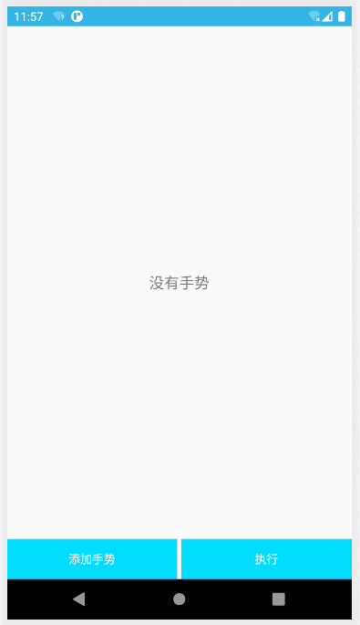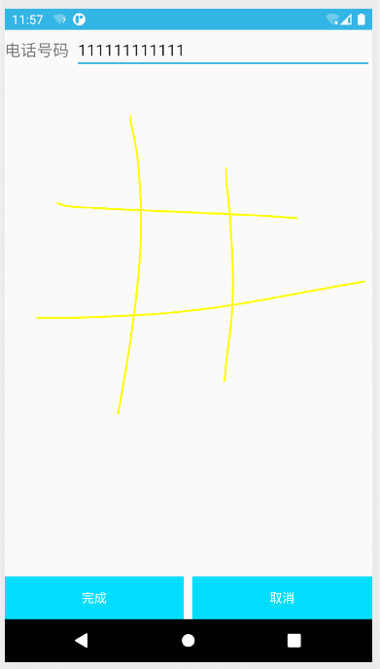
实例046部分关键源码：
public class ZoomImageView extends View implements Observer {
private final Paint mPaint = new Paint(Paint.FILTER_BITMAP_FLAG);
private final Rect mRectSrc = new Rect();
private final Rect mRectDst = new Rect();
private final AspectQuotient mAspectQuotient = new AspectQuotient();
private Bitmap mBitmap;
private ZoomState mState;

public ZoomImageView(Context context, AttributeSet attrs) {
super(context, attrs);
BasicZoomControl mZoomControl = new BasicZoomControl();
BasicZoomListener mZoomListener = new BasicZoomListener();
mZoomListener.setZoomControl(mZoomControl);
setZoomState(mZoomControl.getZoomState());
setOnTouchListener(mZoomListener);
mZoomControl.setAspectQuotient(getAspectQuotient());
}

public void setImage(Bitmap bitmap) {
mBitmap = bitmap;
mAspectQuotient.updateAspectQuotient(getWidth(), getHeight(), mBitmap.getWidth(), mBitmap.getHeight());
mAspectQuotient.notifyObservers();
invalidate();
}

private void setZoomState(ZoomState state) {
if (mState != null) mState.deleteObserver(this);
mState = state;
mState.addObserver(this);
invalidate();
}

private AspectQuotient getAspectQuotient() {
return mAspectQuotient;
}

@Override
protected void onDraw(Canvas canvas) {
if (mBitmap != null && mState != null) {
final float aspectQuotient = mAspectQuotient.get();
final int viewWidth = getWidth();
final int viewHeight = getHeight();
final int bitmapWidth = mBitmap.getWidth();
final int bitmapHeight = mBitmap.getHeight();
final float panX = mState.getPanX();
final float panY = mState.getPanY();
final float zoomX = mState.getZoomX(aspectQuotient) * viewWidth / bitmapWidth;
final float zoomY = mState.getZoomY(aspectQuotient) * viewHeight / bitmapHeight;
mRectSrc.left = (int) (panX * bitmapWidth - viewWidth / (zoomX * 2));
mRectSrc.top = (int) (panY * bitmapHeight - viewHeight / (zoomY * 2));
mRectSrc.right = (int) (mRectSrc.left + viewWidth / zoomX);
mRectSrc.bottom = (int) (mRectSrc.top + viewHeight / zoomY);
mRectDst.left = 0;
mRectDst.top = 0;
mRectDst.right = getWidth();
mRectDst.bottom = getHeight();
if (mRectSrc.left < 0) {
mRectDst.left += -mRectSrc.left * zoomX;
mRectSrc.left = 0;
}
if (mRectSrc.right > bitmapWidth) {
mRectDst.right -= (mRectSrc.right - bitmapWidth) * zoomX;
mRectSrc.right = bitmapWidth;
}
if (mRectSrc.top < 0) {
mRectDst.top += -mRectSrc.top * zoomY;
mRectSrc.top = 0;
}
if (mRectSrc.bottom > bitmapHeight) {
mRectDst.bottom -= (mRectSrc.bottom - bitmapHeight) * zoomY;
mRectSrc.bottom = bitmapHeight;
}
mRectDst.left = 0;
mRectDst.top = 0;
mRectDst.right = viewWidth;
mRectDst.bottom = viewHeight;
canvas.drawBitmap(mBitmap, mRectSrc, mRectDst, mPaint);
}
}

@Override
protected void onLayout(boolean changed, int left, int top, int right, int bottom) {
super.onLayout(changed, left, top, right, bottom);
mAspectQuotient.updateAspectQuotient(right - left, bottom - top, mBitmap.getWidth(), mBitmap.getHeight());
mAspectQuotient.notifyObservers();
}

@Override
public void update(Observable observable, Object data) {
invalidate();
}

private static class BasicZoomListener implements OnTouchListener {
private BasicZoomControl mZoomControl;
private float mFirstX = -1;
private float mFirstY = -1;
private float mSecondX = -1;
private float mSecondY = -1;
private int mOldCounts = 0;

public void setZoomControl(BasicZoomControl control) {
mZoomControl = control;
}

@SuppressLint("ClickableViewAccessibility")
public boolean onTouch(View v, MotionEvent event) {

switch (event.getAction()) {
case MotionEvent.ACTION_DOWN:
mOldCounts = 1;
mFirstX = event.getX();
mFirstY = event.getY();
break;
case MotionEvent.ACTION_MOVE: {
float fFirstX = event.getX();
float fFirstY = event.getY();
int nCounts = event.getPointerCount();
if (1 == nCounts) {
mOldCounts = 1;
float dx = (fFirstX - mFirstX) / v.getWidth();
float dy = (fFirstY - mFirstY) / v.getHeight();
mZoomControl.pan(-dx, -dy);
} else if (1 == mOldCounts) {
mSecondX = event.getX(event.getPointerId(nCounts - 1));
mSecondY = event.getY(event.getPointerId(nCounts - 1));
mOldCounts = nCounts;
} else {
float fSecondX = event.getX(event.getPointerId(nCounts - 1));
float fSecondY = event.getY(event.getPointerId(nCounts - 1));
double nLengthOld = getLength(mFirstX, mFirstY, mSecondX, mSecondY);
double nLengthNow = getLength(fFirstX, fFirstY, fSecondX, fSecondY);
float d = (float) ((nLengthNow - nLengthOld) / v.getWidth());
mZoomControl.zoom((float) Math.pow(20, d), ((fFirstX + fSecondX) / 2 / v.getWidth()), ((fFirstY + fSecondY) / 2 / v.getHeight()));
mSecondX = fSecondX;
mSecondY = fSecondY;
}
mFirstX = fFirstX;
mFirstY = fFirstY;
break;
}

}

return true;
}

private double getLength(float x1, float y1, float x2, float y2) {
return Math.sqrt(Math.pow(x1 - x2, 2) + Math.pow(y1 - y2, 2));
}
}

private static class BasicZoomControl implements Observer {
private static final float MIN_ZOOM = 1;
private static final float MAX_ZOOM = 16;
private final ZoomState mState = new ZoomState();
private AspectQuotient mAspectQuotient;

public void setAspectQuotient(AspectQuotient aspectQuotient) {
if (mAspectQuotient != null) mAspectQuotient.deleteObserver(this);
mAspectQuotient = aspectQuotient;
mAspectQuotient.addObserver(this);
}

public ZoomState getZoomState() {
return mState;
}

public void zoom(float f, float x, float y) {
final float aspectQuotient = mAspectQuotient.get();
final float prevZoomX = mState.getZoomX(aspectQuotient);
final float prevZoomY = mState.getZoomY(aspectQuotient);
mState.setZoom(mState.getZoom() * f);
limitZoom();
final float newZoomX = mState.getZoomX(aspectQuotient);
final float newZoomY = mState.getZoomY(aspectQuotient);
mState.setPanX(mState.getPanX() + (x - .5f) * (1f / prevZoomX - 1f / newZoomX));
mState.setPanY(mState.getPanY() + (y - .5f) * (1f / prevZoomY - 1f / newZoomY));
limitPan();
mState.notifyObservers();
}

public void pan(float dx, float dy) {
final float aspectQuotient = mAspectQuotient.get();
mState.setPanX(mState.getPanX() + dx / mState.getZoomX(aspectQuotient));
mState.setPanY(mState.getPanY() + dy / mState.getZoomY(aspectQuotient));
limitPan();
mState.notifyObservers();
}

private float getMaxPanDelta(float zoom) {
return Math.max(0f, .5f * ((zoom - 1) / zoom));
}

private void limitZoom() {
if (mState.getZoom() < MIN_ZOOM) {
mState.setZoom(MIN_ZOOM);
} else if (mState.getZoom() > MAX_ZOOM) {
mState.setZoom(MAX_ZOOM);
}
}

private void limitPan() {
final float aspectQuotient = mAspectQuotient.get();
final float zoomX = mState.getZoomX(aspectQuotient);
final float zoomY = mState.getZoomY(aspectQuotient);
final float panMinX = .5f - getMaxPanDelta(zoomX);
final float panMaxX = .5f + getMaxPanDelta(zoomX);
final float panMinY = .5f - getMaxPanDelta(zoomY);
final float panMaxY = .5f + getMaxPanDelta(zoomY);
if (mState.getPanX() < panMinX) mState.setPanX(panMinX);
if (mState.getPanX() > panMaxX) mState.setPanX(panMaxX);
if (mState.getPanY() < panMinY) mState.setPanY(panMinY);
if (mState.getPanY() > panMaxY) mState.setPanY(panMaxY);
}

public void update(Observable observable, Object data) {
limitZoom();
limitPan();
}
}

private static class AspectQuotient extends Observable {
private float mAspectQuotient;

public float get() {
return mAspectQuotient;
}

public void updateAspectQuotient(float viewWidth, float viewHeight, float contentWidth, float contentHeight) {
final float aspectQuotient = (contentWidth / contentHeight) / (viewWidth / viewHeight);
if (aspectQuotient != mAspectQuotient) {
mAspectQuotient = aspectQuotient;
setChanged();
}
}
}

private static class ZoomState extends Observable {
private float mZoom;
private float mPanX;
private float mPanY;

public float getPanX() {
return mPanX;
}

public float getPanY() {
return mPanY;
}

public float getZoom() {
return mZoom;
}

public float getZoomX(float aspectQuotient) {
return Math.min(mZoom, mZoom * aspectQuotient);
}

public float getZoomY(float aspectQuotient) {
return Math.min(mZoom, mZoom / aspectQuotient);
}

public void setPanX(float panX) {
if (panX != mPanX) {
mPanX = panX;
setChanged();
}
}

public void setPanY(float panY) {
if (panY != mPanY) {
mPanY = panY;
setChanged();
}
}

public void setZoom(float zoom) {
if (zoom != mZoom) {
mZoom = zoom;
setChanged();
}
}
}

}

public class MainActivity extends AppCompatActivity {
@Override
protected void onCreate(Bundle savedInstanceState) {
super.onCreate(savedInstanceState);
setContentView(R.layout.activity_main);
ZoomImageView zoomImg = (ZoomImageView) findViewById(R.id.image);
Bitmap bitmap = BitmapFactory.decodeResource(this.getResources(), R.mipmap.c);
zoomImg.setImage(bitmap);
}
}

实例046实验结果：


实例047部分关键源码：
public class MainActivity extends AppCompatActivity {

private BrokenView mBrokenView;
private RelativeLayout parentLayout;
private ImageView imageView;
private boolean hasAlpha;
private int[] resids;
private BrokenTouchListener colorfulListener, whiteListener;

protected void onCreate(Bundle savedInstanceState) {
super.onCreate(savedInstanceState);
setContentView(R.layout.activity_main);
initView();
mBrokenView = BrokenView.add2Window(this);
Paint whitePaint = new Paint();
whitePaint.setColor(0xffffffff);
colorfulListener = new BrokenTouchListener.Builder(mBrokenView).build();
whiteListener = new BrokenTouchListener.Builder(mBrokenView).setPaint(whitePaint).build();
setOnTouchListener();
}

private void initView() {
parentLayout = (RelativeLayout) findViewById(R.id.demo_parent);
imageView = (ImageView) findViewById(R.id.demo_image);
ImageButton imageButton = (ImageButton) findViewById(R.id.action_refresh);
imageButton.setOnClickListener(new View.OnClickListener() {
@Override
public void onClick(View v) {
if (v.getId() == R.id.action_refresh) {
mBrokenView.reset();
refreshDate();
setOnTouchListener();
setViewVisible();
}
}
});
@SuppressLint("Recycle") TypedArray ar = getResources().obtainTypedArray(R.array.imgArray);
int len = ar.length();
resids = new int[len];
for (int i = 0; i < len; i++) resids[i] = ar.getResourceId(i, 0);
refreshDate();
}

private void setViewVisible() {
parentLayout.setVisibility(View.VISIBLE);
imageView.setVisibility(View.VISIBLE);
}

public void refreshDate() {
Random rand = new Random();
int pos = rand.nextInt(resids.length);
imageView.setImageResource(resids[pos]);
hasAlpha = pos == 0 || pos == 1 || pos == 2;
}

@SuppressLint("ClickableViewAccessibility")
public void setOnTouchListener() {
parentLayout.setOnTouchListener(colorfulListener);
if (hasAlpha) {
imageView.setOnTouchListener(whiteListener);
} else {
imageView.setOnTouchListener(colorfulListener);
}
}
}

public class BrokenTouchListener implements View.OnTouchListener {
private BrokenView brokenView;
private BrokenConfig config;

private BrokenTouchListener(Builder builder) {
brokenView = builder.brokenView;
config = builder.config;
}

public static class Builder {
private BrokenConfig config;
private BrokenView brokenView;

public Builder(BrokenView brokenView) {
this.brokenView = brokenView;
config = new BrokenConfig();
}

public Builder setPaint(Paint paint) {
config.paint = paint;
return this;
}

public BrokenTouchListener build() {
return new BrokenTouchListener(this);
}
}

@SuppressLint("ClickableViewAccessibility")
@Override
public boolean onTouch(View v, MotionEvent event) {
if (brokenView.isEnable()) {
BrokenAnimator brokenAnim;
switch (event.getAction()) {
case MotionEvent.ACTION_DOWN:
if (config.childView != null) {
config.region = new Region(config.childView.getLeft(),
config.childView.getTop(),
config.childView.getRight(),
config.childView.getBottom());
}
if (config.region == null || config.region.contains((int) event.getX(), (int) event.getY())) {
Point point = new Point((int) event.getRawX(), (int) event.getRawY());
brokenAnim = brokenView.getAnimator(v);
if (brokenAnim == null)
brokenAnim = brokenView.createAnimator(v, point, config);
if (brokenAnim == null) return true;
if (!brokenAnim.isStarted()) {
brokenAnim.start();
brokenView.onBrokenStart(v);
} else if (brokenAnim.doReverse()) {
brokenView.onBrokenRestart(v);
}
v.getParent().requestDisallowInterceptTouchEvent(true);
} else {
return false;
}
break;
case MotionEvent.ACTION_UP:
brokenAnim = brokenView.getAnimator(v);
if (brokenAnim != null && brokenAnim.isStarted()) {
if (brokenAnim.doReverse()) brokenView.onBrokenCancel(v);
}
break;
}
return true;
} else {
return false;
}
}
}

实例047实验结果：
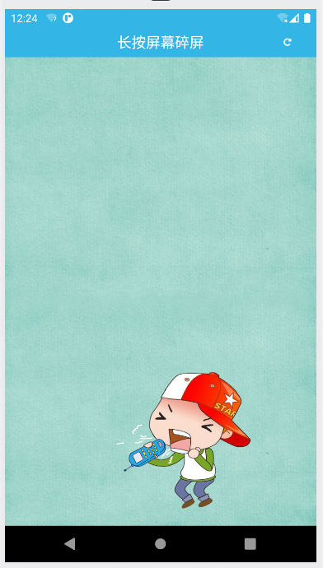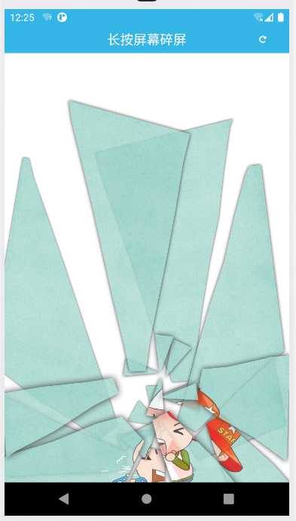

结果分析：
实例044中，使用了Paint画笔，结合手机权限，申请存储空间，存储手势在手机内存。但在执行手势的过程中遇到了权限申请错误，研究了一会但还是没有成功。
实例046中，使用了 Paint 和 Bitmap工具，实现对图片的放大缩小功能。
实例047中，使用了 Paint 和 Bitmap工具，还涉及到了长按事件处理。

桂林航天工业学院学生实验报告
课程名称 | 移动应用软件综合开发 |  |  | 实验项目名称 |  | 实验四 图片处理
开课教学单位及实验室 |  | 计算机科学与工程学院 巡天308 |  |  |  | 实验日期 |  | 年 月 日
学生姓名 | 钟祯 |  | 学号 |  | 2017070030429 | 专业班级 |  | 17软件工程4班
指导教师 | 林奕森 |  |  |  | 实验成绩
一、实验目的
1、实现图像处理使用功能。
二、实验原理
1、使用Android Studio创建工程及类，编写程序。
2、调试程序，并在Genymotion中运行程序。
三、实验操作方法和步骤
1、完成 实例050浏览朋友圈图片

四、实验结果与分析
实例050部分关键源码：
public class ShowImageActivity extends AppCompatActivity {
private int index = 0;

@RequiresApi(api = Build.VERSION_CODES.KITKAT)
@Override
protected void onCreate(Bundle savedInstanceState) {
super.onCreate(savedInstanceState);
requestWindowFeature(Window.FEATURE_NO_TITLE);
setContentView(R.layout.show_image_layout);
init();
}

@RequiresApi(api = Build.VERSION_CODES.KITKAT)
private void init() {
final Intent intent = getIntent();
ViewPager viewPager = (ViewPager) findViewById(R.id.show_view_pager);
List<View> listViews = new ArrayList<>();
for (int i = 0; i < Objects.requireNonNull(intent.getIntArrayExtra("image")).length; i++) {
View view = LayoutInflater.from(getApplicationContext()).inflate(R.layout.view_pager_item, null);
ImageView iv = (ImageView) view.findViewById(R.id.view_image);
iv.setBackgroundResource(Objects.requireNonNull(intent.getIntArrayExtra("image"))[i]);
listViews.add(view);
iv.setOnLongClickListener(new View.OnLongClickListener() {
@Override
public boolean onLongClick(View v) {
Toast.makeText(ShowImageActivity.this, "这是第" + (index + 1) + "图片", Toast.LENGTH_SHORT).show();
return false;
}
});
}
MyPagerAdapter adapter = new MyPagerAdapter(listViews);
viewPager.setAdapter(adapter);
viewPager.setOnPageChangeListener(new PageChangeListener());
viewPager.setCurrentItem(intent.getIntExtra("id", 0));
}

private class PageChangeListener implements ViewPager.OnPageChangeListener {

@Override
public void onPageScrollStateChanged(int arg0) {

}

@Override
public void onPageScrolled(int arg0, float arg1, int arg2) {

}

@Override
public void onPageSelected(int arg0) {
index = arg0;
}
}
}

public class MainActivity extends AppCompatActivity {
private ListView listView;

@Override
protected void onCreate(Bundle savedInstanceState) {
super.onCreate(savedInstanceState);
setContentView(R.layout.activity_main);
findID();
init();
}

private void init() {
MyListViewAdapter listViewAdapter = new MyListViewAdapter(this);
listView.setAdapter(listViewAdapter);
}

private void findID() {
listView = (ListView) findViewById(R.id.list_view);
}
}

实例050实验结果：
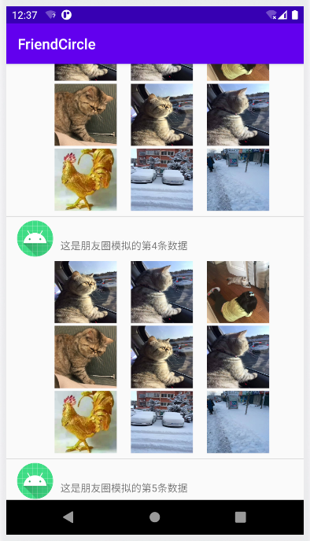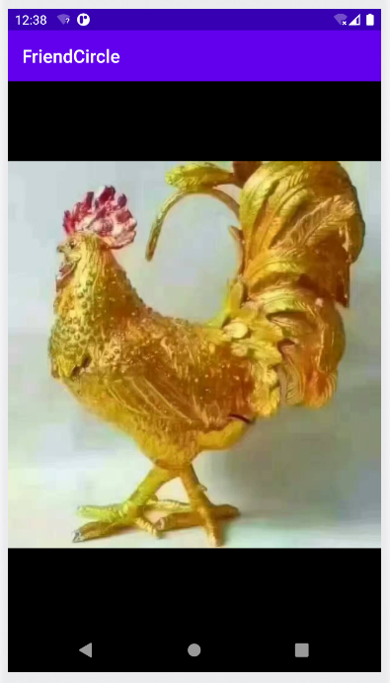

结果分析：
实例050中，重写了adpter的方法，实现朋友圈的布局。使用列表嵌套fragment，实现图片单击事件，此外还使用了ViewPage实现列表滑动。

桂林航天工业学院学生实验报告
课程名称 | 移动应用软件综合开发 |  |  | 实验项目名称 |  | 实验五 摄像头案例实验
开课教学单位及实验室 |  | 计算机科学与工程学院 巡天308 |  |  |  | 实验日期 |  | 年 月 日
学生姓名 | 钟祯 |  | 学号 |  | 2017070030429 | 专业班级 |  | 17软件工程4班
指导教师 | 林奕森 |  |  |  | 实验成绩
一、实验目的
1、实现图像处理使用功能。
二、实验原理
1、使用Android Studio创建工程及类，编写程序。
2、调试程序，并在Genymotion中运行程序。
三、实验操作方法和步骤
1、完成 实例066调用系统相机获取图像
2、完成 实例070扫描与生成二维码

四、实验结果与分析
实例066部分关键源码：
public class MainActivity extends AppCompatActivity {
private TextView txt;
private ImageView image;
private File file;

@Override
protected void onCreate(Bundle savedInstanceState) {
super.onCreate(savedInstanceState);
setContentView(R.layout.activity_main);
txt = (TextView) findViewById(R.id.txt);
image = (ImageView) findViewById(R.id.show_image);
Button btn = (Button) findViewById(R.id.button);
btn.setOnClickListener(v -> {
if (Build.VERSION.SDK_INT >= Build.VERSION_CODES.M) {
if (ContextCompat.checkSelfPermission(this, Manifest.permission.WRITE_EXTERNAL_STORAGE) != PackageManager.PERMISSION_GRANTED) {
if (ActivityCompat.shouldShowRequestPermissionRationale(this, Manifest.permission.WRITE_EXTERNAL_STORAGE)) {
AlertDialog.Builder alert = new AlertDialog.Builder(this);
alert.setTitle("重要提示");
alert.setMessage("该权限用于SD卡的读写操作，如果取消将影响程序的功能使用！");
alert.setPositiveButton("我知道了", (dialog, which) -> applyForPermission());
alert.create();
alert.show();
} else {
applyForPermission();
}
} else {
setDialog();
}
} else {
setDialog();
}
});
}

private void applyForPermission() {
ActivityCompat.requestPermissions(this, new String[]{Manifest.permission.WRITE_EXTERNAL_STORAGE, Manifest.permission.READ_EXTERNAL_STORAGE}, 1000);
}

private void setDialog() {
AlertDialog.Builder alertDialog = new AlertDialog.Builder(this);
alertDialog.setTitle("提示");
alertDialog.setMessage("是否使用系统相机进行拍照？");
alertDialog.setPositiveButton("确定",
(dialog, which) -> {
Toast.makeText(this, "点击了确认", Toast.LENGTH_SHORT).show();
getPictureFromCamera();
});
alertDialog.setNeutralButton("取消", (dialog, which) -> Toast.makeText(this, "点击了取消", Toast.LENGTH_SHORT).show());
alertDialog.create();
alertDialog.show();
}

private void getPictureFromCamera() {
if (!hasSdcard()) {
Toast.makeText(this, "储存卡不可用", Toast.LENGTH_SHORT).show();
return;
}
Intent intent = new Intent("android.media.action.IMAGE_CAPTURE");
file = new File(Environment.getExternalStorageDirectory(), "my_image");
intent.putExtra(MediaStore.EXTRA_OUTPUT, Uri.fromFile(file));
startActivityForResult(intent, 1000);
}

private boolean hasSdcard() {
return Environment.getExternalStorageState().equals(Environment.MEDIA_MOUNTED);
}

@SuppressLint("SetTextI18n")
@Override
protected void onActivityResult(int requestCode, int resultCode, Intent data) {
super.onActivityResult(requestCode, resultCode, data);
if (resultCode != RESULT_OK) return;
switch (requestCode) {
case 1000:
crop(Uri.fromFile(file));
break;
case 2000:
image.setImageBitmap(BitmapFactory.decodeFile(file.getPath()));
txt.setText("图片的保存路径【" + file.getAbsolutePath() + "】");
break;
default:
break;
}
}

private void crop(Uri uri) {
Log.e("URI", Objects.requireNonNull(uri.getPath()));
Log.e("URI", uri.toString());
Intent intent = new Intent("com.android.camera.action.CROP");
intent.setDataAndType(uri, "image/*");
intent.putExtra("crop", "true");
intent.putExtra("aspectX", 1);
intent.putExtra("aspectY", 1);
intent.putExtra("outputX", 150);
intent.putExtra("outputY", 150);
intent.putExtra("scale", true);
intent.putExtra(MediaStore.EXTRA_OUTPUT, Uri.fromFile(file));
intent.putExtra("outputFormat", Bitmap.CompressFormat.JPEG.toString());
intent.putExtra("noFaceDetection", true);
intent.putExtra("return-data", true);
startActivityForResult(intent, 2000);
}

@Override
public void onRequestPermissionsResult(int requestCode, @NonNull String[] permissions, @NonNull int[] grantResults) {
super.onRequestPermissionsResult(requestCode, permissions, grantResults);
if (requestCode == 1000) {
Log.i("申请权限个数", grantResults.length + "");
if (grantResults[0] == PackageManager.PERMISSION_GRANTED) {
setDialog();
} else {
Toast.makeText(this, "未获得权限", Toast.LENGTH_SHORT).show();
}
}
}
}

实例066实验结果：
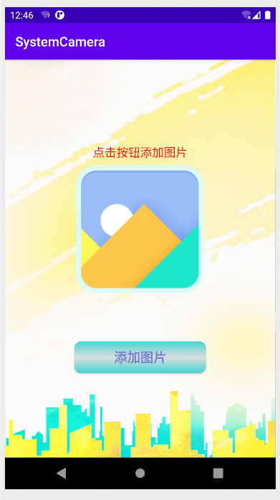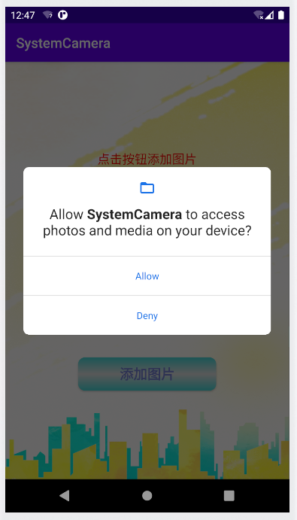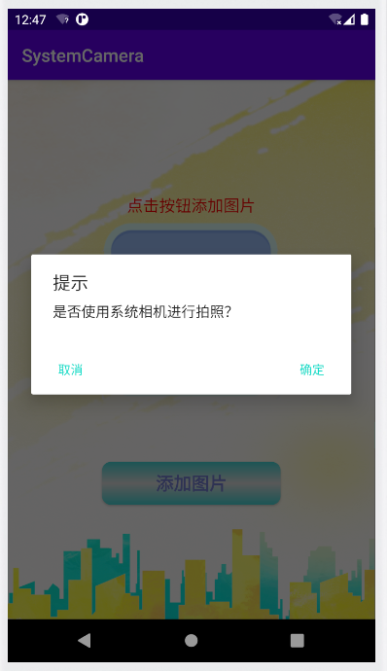

实例070部分关键源码：
public class MainActivity extends MPermissionsActivity {

private static final int SCANCODE = 1;
private TextView scanMessage;
private ImageView enCodeImage1, enCodeImage2;
private EditText editText;

@SuppressLint("ClickableViewAccessibility")
@Override
protected void onCreate(Bundle savedInstanceState) {
super.onCreate(savedInstanceState);
setContentView(R.layout.activity_main);
scanMessage = (TextView) findViewById(R.id.scan_txt);
enCodeImage1 = (ImageView) findViewById(R.id.code_image1);
enCodeImage2 = (ImageView) findViewById(R.id.code_image2);
editText = (EditText) findViewById(R.id.input_txt);
LinearLayout linearLayout = (LinearLayout) findViewById(R.id.ll);
linearLayout.setOnTouchListener(new View.OnTouchListener() {
@Override
public boolean onTouch(View v, MotionEvent event) {
if (event.getAction() == MotionEvent.ACTION_DOWN) {
View view = getCurrentFocus();
if (view != null) {
((InputMethodManager) getSystemService(Context.INPUT_METHOD_SERVICE)).hideSoftInputFromWindow(view.getWindowToken(), InputMethodManager.HIDE_NOT_ALWAYS);
}
}
return false;
}
});
}

public void scanCode(View view) {
requestPermission(new String[]{Manifest.permission.CAMERA}, 1000);
}

@Override
public void permissionSuccess(int requestCode) {
super.permissionSuccess(requestCode);
if (requestCode == 1000) {
startActivityForResult(new Intent(this, CaptureActivity.class), SCANCODE);
}
}

public void enCode1(View view) {
if ("".equals(editText.getText().toString())) {
Toast.makeText(this, "请在输入框中输入内容", Toast.LENGTH_SHORT).show();
return;
}
Bitmap codeBitmap = EncodingUtils.createQRCode(editText.getText().toString(), 500, 500, null);
enCodeImage1.setImageBitmap(codeBitmap);
}

public void enCode2(View view) {
Bitmap logoBitmap = BitmapFactory.decodeResource(getResources(), R.mipmap.mrkj);
Bitmap codeBitmap = EncodingUtils.createQRCode("http://www.mingrisoft.com/", 500, 500, logoBitmap);
enCodeImage2.setImageBitmap(codeBitmap);
}

@Override
protected void onActivityResult(int requestCode, int resultCode, Intent data) {
super.onActivityResult(requestCode, resultCode, data);
if (resultCode != RESULT_OK) return;
if (requestCode == SCANCODE) scanMessage.setText(data.getStringExtra("result"));
}
}

public class MPermissionsActivity extends AppCompatActivity {
private final String TAG = "MPermissions";
private int REQUEST_CODE_PERMISSION = 0x00099;

public void requestPermission(String[] permissions, int requestCode) {
this.REQUEST_CODE_PERMISSION = requestCode;
if (checkPermissions(permissions)) {
permissionSuccess(REQUEST_CODE_PERMISSION);
} else {
List<String> needPermissions = getDeniedPermissions(permissions);
ActivityCompat.requestPermissions(this, needPermissions.toArray(new String[0]), REQUEST_CODE_PERMISSION);
}
}

private boolean checkPermissions(String[] permissions) {
if (Build.VERSION.SDK_INT < Build.VERSION_CODES.M) return true;
for (String permission : permissions) {
if (ContextCompat.checkSelfPermission(this, permission) != PackageManager.PERMISSION_GRANTED) {
return false;
}
}
return true;
}

private List<String> getDeniedPermissions(String[] permissions) {
List<String> needRequestPermissionList = new ArrayList<>();
for (String permission : permissions) {
if (ContextCompat.checkSelfPermission(this, permission) !=
PackageManager.PERMISSION_GRANTED ||
ActivityCompat.shouldShowRequestPermissionRationale(this, permission)) {
needRequestPermissionList.add(permission);
}
}
return needRequestPermissionList;
}

@Override
public void onRequestPermissionsResult(int requestCode, @NonNull String[] permissions, @NonNull int[] grantResults) {
super.onRequestPermissionsResult(requestCode, permissions, grantResults);
if (requestCode == REQUEST_CODE_PERMISSION) {
if (verifyPermissions(grantResults)) {
permissionSuccess(REQUEST_CODE_PERMISSION);
} else {
permissionFail(REQUEST_CODE_PERMISSION);
showTipsDialog();
}
}
}

private boolean verifyPermissions(int[] grantResults) {
for (int grantResult : grantResults) {
if (grantResult != PackageManager.PERMISSION_GRANTED) return false;
}
return true;
}

private void showTipsDialog() {
new AlertDialog.Builder(this)
.setTitle("提示信息")
.setMessage("当前应用缺少必要权限，该功能暂时无法使用。如若需要，请单击【确定】按钮前往设置中心进行权限授权。")
.setNegativeButton("取消", new DialogInterface.OnClickListener() {
@Override
public void onClick(DialogInterface dialog, int which) {
}
})
.setPositiveButton("确定", new DialogInterface.OnClickListener() {
@Override
public void onClick(DialogInterface dialog, int which) {
startAppSettings();
}
}).show();
}

private void startAppSettings() {
Intent intent = new Intent(Settings.ACTION_APPLICATION_DETAILS_SETTINGS);
intent.setData(Uri.parse("package:" + getPackageName()));
startActivity(intent);
}

public void permissionSuccess(int requestCode) {
Log.d(TAG, "获取权限成功=" + requestCode);

}

public void permissionFail(int requestCode) {
Log.d(TAG, "获取权限失败=" + requestCode);
}
}

实例070实验结果：
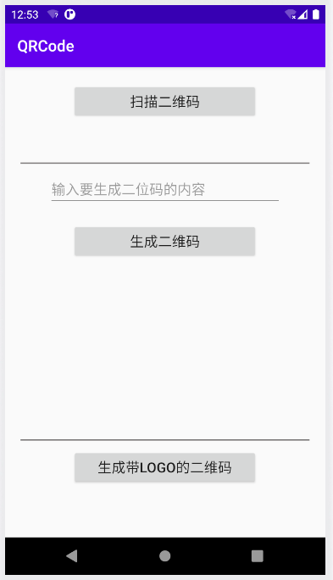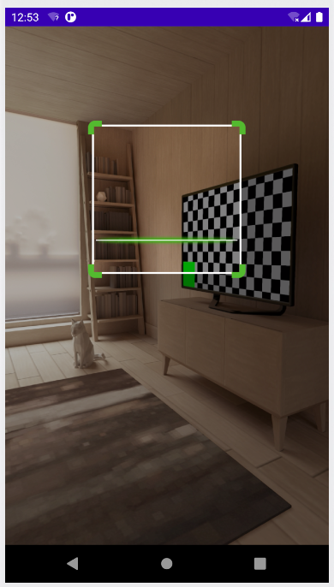

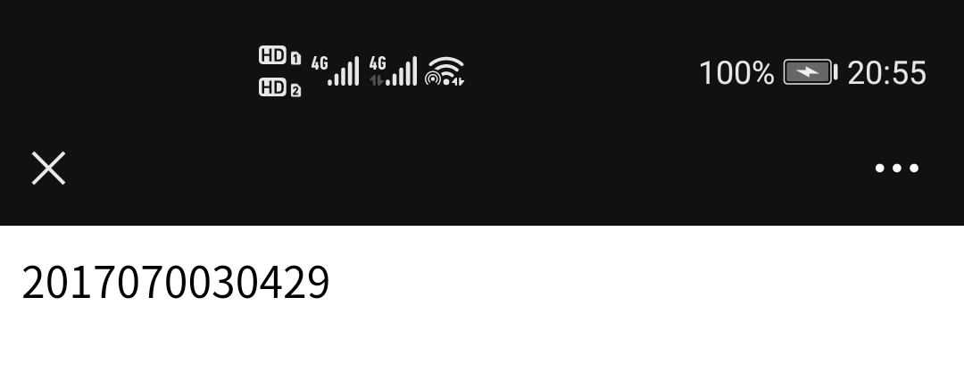
结果分析：
实例066中，使用了权限请求功能，在用户允许软件的权限请求后，理论可以调用系统相机拍照。但在实际使用中，还是遇到了权限请求失败问题。
实例070中，使用了第三方库：zing包，通过zing包来识别和生成二维码。

