Project Report

January 8th, 2023

# Student

Zhu Zhen (2022214656)

# Abstract

Nickel-based metal, such as Inconel 718 is hard to machined. In order to find optimal cutting parameters and tools, it is necessary to investigate the cutting process and process output parameters i.e. cutting force and feed force, temperature, chip thickness and chip morphology. With the help of the finite element method, the thermomechanical simulated model of machining Inconel 718 is established; the results are analyzed; and the above parameters are given a great insight. In order to check the validity of the developed model, the results are also compared with experimental and simulated results obtained from a reference thesis, and the reasons of the discrepancies are discussed.

# 1. Introduction

Inconel 718 (IN 718), a nickel-based super alloy, is widely applied in various engineering fields, particularly where properties such as high temperature resistance, corrosion resistance, creep resistance, ductile to brittle transition temperatures when applied at low temperatures, as well as strength to weight are important. Usually, it is used for the manufacture of parts for gas turbine engines, such as turbine blades, combustion chambers, etc.

However, having properties such as high temperature strength, hardness, and chemical wear resistance, IN 718 proves to be a challenge in terms of machining. According to Rahman et al.[1], there are two main reasons why machining IN 718 has the aforementioned difficulties. These are the decrease in tool life resulting from the work hardening and attrition properties of the alloy, and the metallurgical damage caused by high cutting forces that result in surface tearing and distortion.

In order to improve surface integrity and extend tool life, it is essential to identify the crucial process output parameters that are responsible for machinability. And finite element simulations can be used to study parameter values. To begin this process, it is crucial to develop a reliable computer model of the cutting process.

# 2. Experimental method

## 2.1 Experimental setup

In order to determine the accuracy of the simulations, a comparison of the simulated orthogonal cutting results with experimental cutting forces, chip geometries, and machined surface temperatures is necessary. Based on Rex Bedzra’s thesis[2], orthogonal cutting tests were conducted at the Werkzeugmaschinenlabor (WZL) at RWTH Aachen University. The setup for the orthogonal cutting test is shown in Fig. 2-1.

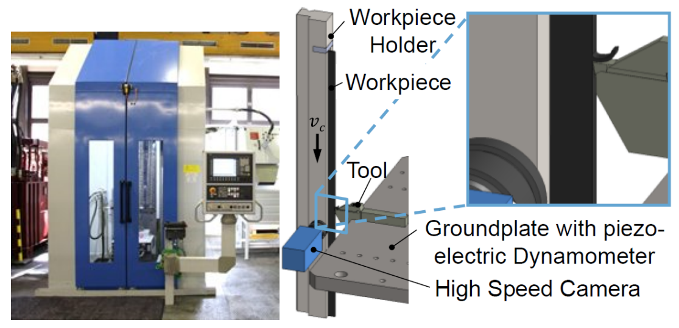

Fig. 2-. Setup for orthogonal cutting test (courtesy WZL)[2]

The broaching operation was carried out on a Forst RASX 8x2200x600M/CNC machine. It is equipped with a workpiece holder that moves as the cutting tool is held in place by a groundplate that includes a piezoelectric dynamometer that measures the forces acting on the tool. Additionally, a high speed camera is used to capture the process of chip formation. The experimental cutting test was performed on an aged nickel-based superalloy Inconel 718 measures 100 mm in length, 50 mm in width, and 3.5 mm in thickness.

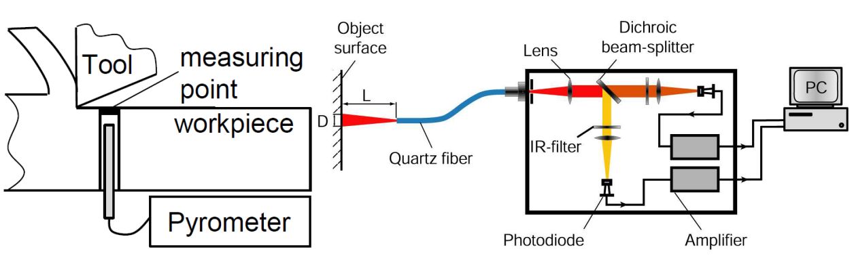

Fig. 2-. Setup for the determination of the machined surface temperature (courtesy WZL)[2]

A two-color pyrometer was used to measure cutting temperatures on the workpiece. At the base of the workpiece, a hole was drilled to accommodate the optical fiber that transmited the wave spectrum from the measuring spot to the analyzer. Through the optical cable, the infrared spectrum was transferred to an analyzer for signal analysis and amplification, and then converted to the measured temperatures on a computer. The whole temperature measuring setup is shown in Fig. 2-2.

The cutting tools used in the test were uncoated carbide grade inserts (H13A). All tool rake angles were 0°, all tool flank angles were 10° and the cutting edge radii were rβ = 10 µm, 20 µm and 30 µm. The tool rake faces were flat, no chip formers were employed. In addition, the cutting velocities were Vc = 20 m/min, 40 m/min and 80 m/min and the feed was f = 0.05 mm.

A total of nine sets of cutting operations were carried out under various cutting conditions within the experimental design of the cutting tests, as shown in Table 2-1. For statistical validity, each parameter set's cutting test was repeated three times. A coolant was not used during any of the experiments in order to simplify the finite element simulation.

Table 2-. Experimental plan for cutting test[2]

|  |  |  |  |
| --- | --- | --- | --- |
| **Parameter set** | **rβ(µm)** | **f(mm)** | **Vc(m/min)** |
| 1, 2, 3 | 10 | 0.05 | 20, 40, 80 |
| 4, 5, 6 | 20 | 0.05 | 20, 40, 80 |
| 7, 8, 9 | 30 | 0.05 | 20, 40, 80 |

## 2.2 Finite element method

For machining process, many analytical methods, such as the slip-line field model and shear zone model, do not take into account strain hardening of the workpiece material and temperature dependent properties of the material. Therefore, any accurate model of the metal cutting process will have to be able to cope with a coupled problem of mechanical (plasticity) and thermal transfer problem. In such a case, the finite element method (FEM) is suitable.

The finite element method is used for the approximate solution of field problems. The term ‘field problems’ refers to the mathematical problems in which a continuum is described by partial differential equations with a dependence on both time and space. The field variables within a body are a function of every generic point. As a result, there are an infinite number of unknowns in problems of this type.

In order to solve the thermomechanical problem of the orthogonal cutting of IN 718, the finite element simulation is conducted. My simulated results will be compared with the experimental and simulated results in the thesis. The compared results include cutting fore and feed force, temperature, chip morphology and chip thickness. Limited by computer performance, only three cutting operations (Set 1, 2, 3) in Table 2-1 were carried out in my simulation work, so I only use these three sets’ results.

# 3. Simulation procedure

## 3.1 Assumptions

In this work, some assumptions are set in order to simplify the simulation model.

1. The whole machining process is considered as a thermomechanical process. This means both mechanical and thermal models are set for the two bodies, i.e. workpiece and tool, as well as the contact between them.
2. The tool is treated as a rigid body in the simulation but still has the ability to transfer heat. As a result, it is necessary to specify thermal properties.
3. Heat transfer between the tool and chip is assumed to be thermally perfect. Also, boundaries of the workpiece and cutting tool away from the cutting zone are assumed at room temperature (20℃).
4. Convection and radiation losses are not considered.

## 3.2 Main operations

If not explicitly stated, most of the parameter values in here is obtained from Bedzra[2]. The corresponding formulas of each model are neglected here, which can also be found in the aforementioned thesis.

(Description of important steps, such as software, boundary conditions and meshing. About 1 page.)

### 3.1.1 Finite element software

Regarding machining, some of the FEM programs have been used for the simulation of machining process include: ABAQUS, FORGE 2, DEFORM 2D/3D, LS-DYNA, AdvantEdge etc. ABAQUS is a general-purpose finite element program that permits a user to analyze complex systems with great detail. I choose ABAQUS primarily because I’m most familiar with this one.

### 3.1.2 Discretization method of the continuum

The essence of the finite element method is the division of a continuum into a finite number of discrete and interdependent problems. For the discretization of the continuum, a Lagrangian approach is chosen for the cutting process in this report work. This approach has the advantage of generating the chip geometry directly through simulation, while the Eulerian approach requires predetermination of the initial chip geometry.

### 3.1.3 Explicit and implicit integration scheme

For time integration scheme, the explicit integration scheme is chosen in this work. In this problem, a dynamic, temp-disp step in Abaqus/Explicit is set to solve the problem history. The time period is related to the cutting velocity and the length of the workpiece. For example, with the cutting velocity of 80 m/min, a 2mm surface of the workpiece will be removed in 0.0015 seconds. Then a 0.0015 second time period is set for the step, as shown in Fig. 3-1.

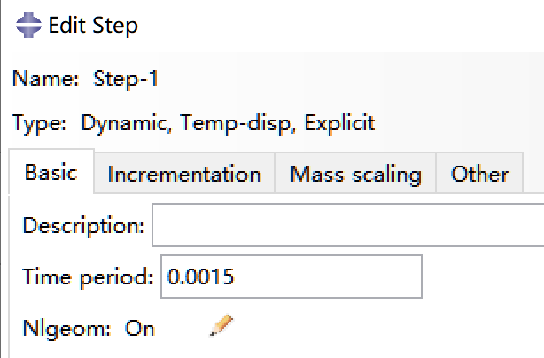

Fig. 3- Step setting

### 3.1.4 Finite element model

To reduce the computation time, I have simplified the geometric dimensions of the model. The geometric parameters of workpiece and cutting tool are illustrated in Table 3-1 and Table 3-2, respectively. Fig. 3-2 shows intuitively the difference between my assembly and the thesis’ assembly in size.

Table 3- Workpiece dimension

|  |  |  |
| --- | --- | --- |
| **Length** | **Height** | **Feed** |
| 5mm | 2mm | 0.1mm |

Table 3- Tool dimension

|  |  |  |
| --- | --- | --- |
| **Rake angle** | **Flank angle** | **Radius** |
| 0**°** | 10**°** | 10μm |

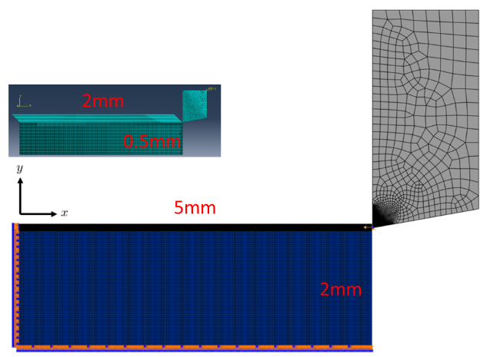

Fig. 3-. Comparison of my assembly (upper) and the thesis’s assembly (lower) in size

The workpiece is meshed with 4-node plane strain thermally coupled quadrilateral, bilinear displacement temperature, reduced integration elements (CPE4RT) available in ABAQUS/explicit. The workpiece is separated into two parts. The upper part, known as feed where most essential response occur, is seeded by edge with lengths of 4 µm while the lower part, where process response are not that important, is seeded with lengths of 40 µm. This can reduce computational time and effort. Fig. 3-3 shows the meshed workpiece and a magnification of part of the finely meshed region (feed), respectively.

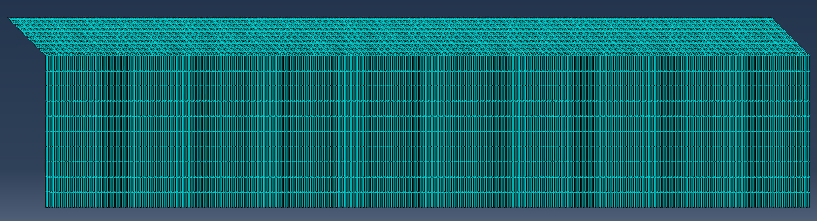

1. Meshed workpiece

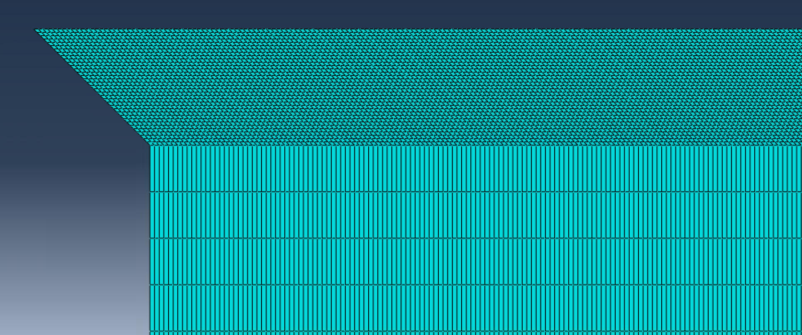

1. Part of the finely meshed region (feed)

Fig. 3-. Mesh of workpiece

The cutting tool is meshed with CPE4RT and CPE3T elements. The cutting edges are seeded with lengths of 5 µm while 20 µm for the other two edges. The fine meshing of the cutting edges ensures the precise calculation of the heat transfer between workpiece and cutting tool interface. The tool is set as a rigid body using *Rigid body* constraint and only has the temperature degree of freedom. Fig. 3-4 shows the meshed cutting tool and finely meshed area around the tool tip.



Fig. 3- Meshed cutting tool

Fig. 3-5 displays the cutting tool moves in a cutting velocity Vc relative to the workpiece which stays stationary. The cutting movement happens in small time increments, which specified by ABAQUS/explicit automatically. But we can specify the time period for the whole dynamic simulation. Table lists the cutting speeds and their corresponding time periods for a length of cut of 2mm. In addition, the bottom and the left side of the workpiece are fixed. A penalty contact is specified between the workpiece and the cutting edges of the tool.

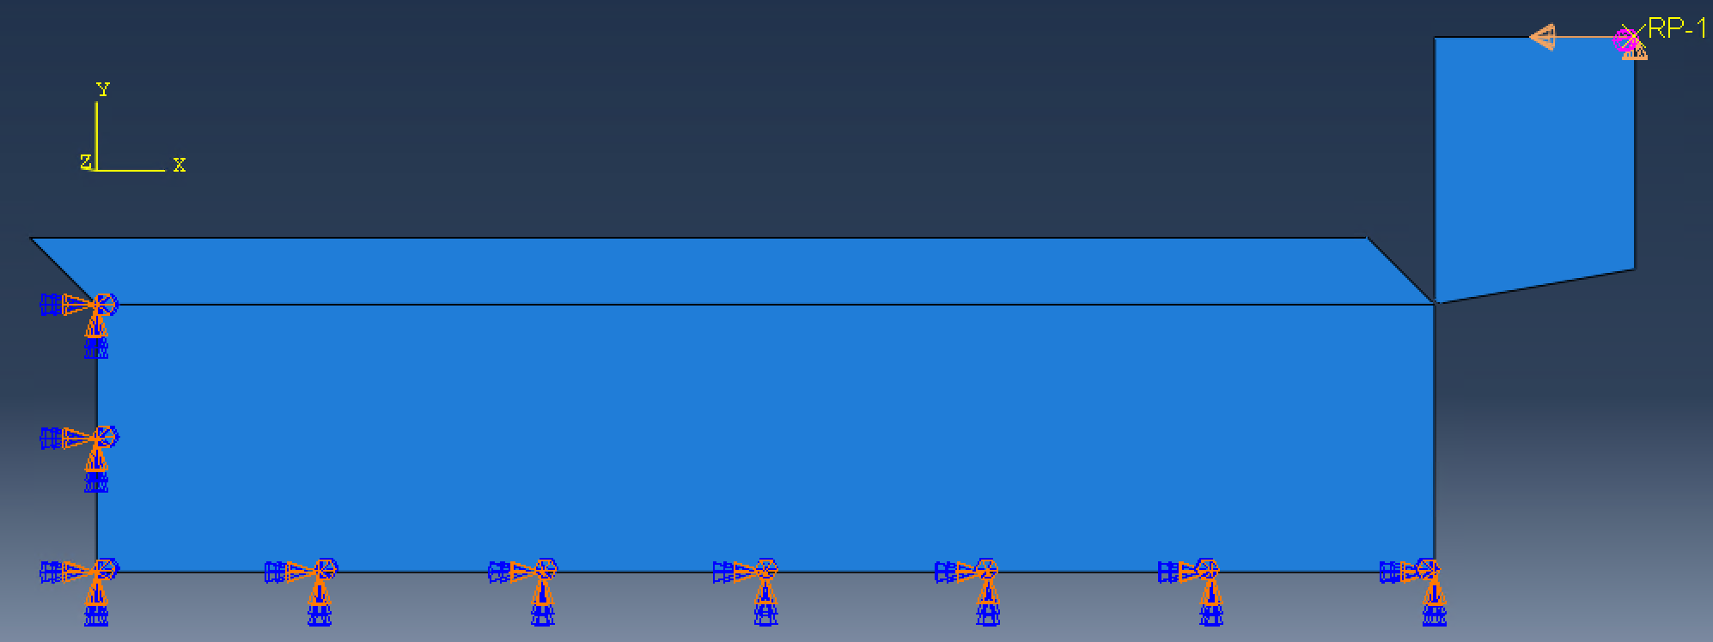

Fig. 3- Assembly and boundary conditions

Table 3- Cutting speeds and their corresponding time for a length of cut of 2mm

|  |  |
| --- | --- |
| **Vc (m/min)** | **Time(s)** |
| 20 | 0.006 |
| 40 | 0.003 |
| 80 | 0.0015 |

### 3.1.5 Workpiece thermal model

The workpiece thermal model abides by the first law of thermodynamics and can be expressed by three parameters, i.e. temperature dependent specific heat capacity cp, thermal conductivity λ, and the Taylor-Quinney empirical constant (inelastic heat fraction in Abaqus) ηp = 0.9. The values of the first two parameters are shown in Table 3-4 and Table 3-5, respectively.

Table 3- Temperature dependent specific heat capacity of workpiece

|  |  |  |  |  |  |  |  |  |  |  |  |  |  |
| --- | --- | --- | --- | --- | --- | --- | --- | --- | --- | --- | --- | --- | --- |
| **T (℃)** | 0 | 100 | 200 | 300 | 400 | 500 | 600 | 700 | 800 | 900 | 1000 | 1100 | 1200 |
| **cp(J/(kg·℃))** | 440 | 470 | 480 | 490 | 500 | 520 | 550 | 600 | 660 | 650 | 660 | 700 | 710 |

Table 3- Temperature dependent conductivity of workpiece

|  |  |  |  |  |  |  |  |  |  |  |  |  |  |
| --- | --- | --- | --- | --- | --- | --- | --- | --- | --- | --- | --- | --- | --- |
| **T (℃)** | 0 | 100 | 200 | 300 | 400 | 500 | 600 | 700 | 800 | 900 | 1000 | 1100 | 1200 |
| **λ(N/(s·℃))** | 10 | 11 | 13 | 15 | 18 | 19 | 21 | 25 | 26 | 25 | 25 | 29 | 31 |

### 3.1.6 Workpiece mechanical model

The workpiece mechanical model consists of three sub-models: elasticity model, plasticity model, and material separation model.

First, Hooke's law is used to model the temperature-dependent elastic response of the workpiece material. Temperature dependent Young’s modulus E, Poisson’s ratio ν ,and coefficient of thermal expansion α are needed to describe the elastic behavior, whose values are given in Table 3-6 and Table 3-7, respectively.

Table 3- Temperature dependent Young’s modulus E and Poisson’s ratio of workpiece

|  |  |  |
| --- | --- | --- |
| **T (℃)** | **E (GPa)** | **ν** |
| 20 | 217 | 0.3 |
| 871 | 155.9 | 0.3 |

Table 3- Temperature dependent thermal expansion α of workpiece

|  |  |  |  |  |  |  |  |  |  |  |  |  |  |  |  |
| --- | --- | --- | --- | --- | --- | --- | --- | --- | --- | --- | --- | --- | --- | --- | --- |
| **T (℃)** | 0 | 50 | 100 | 150 | 200 | 250 | 300 | 350 | 400 | 450 | 500 | 550 | 600 | 650 | 700 |
| **α(10-6/℃)** | 13 | 13.05 | 13.1 | 13.3 | 13.5 | 13.7 | 13.8 | 13.9 | 14.1 | 14.25 | 14.3 | 14.6 | 15 | 15.3 | 15.8 |

Then, the Johnson-Cook plasticity model is utilized to account for strain rate-dependent plastic behavior of the workpiece material. For IN 718, different literatures provide different coefficient values (A, B,C , m, n). In this report, the coefficients identified by Klocke et al.[3] are adopted, which are shown in Table 3-8.

Table 3- Johnson-Cook flow stress material parameters for IN 718[3]

|  |  |  |  |  |  |  |  |
| --- | --- | --- | --- | --- | --- | --- | --- |
| **(1/s)** | **T0 (℃)** | **Tm (℃)** | **A(MPa)** | **B(MPa)** | **C(MPa)** | **n** | **m** |
| 10-3 | 20 | 1297 | 1485 | 904 | 0.015 | 0.777 | 1.689 |

Finally, in order to simulate chip formation, material separation needs to be considered during the machining simulation. The Johnson-Cook damage model is applied in this work, which defines failure strain εf as a criterion for physical separation of materials. For simplicity, the stress triaxiality term (σm/σvM) and the temperature term are not considered in parameter identification, and the value of d1 is also ignored. Therefore, only d2 and d4 had to be specified. The specified plastic material parameters are summarized in Table 3-9.

Table 3- Constants of Johnson-Cook damage model for IN 718[2]

|  |  |
| --- | --- |
| **d2** | **d4** |
| 2.031 | 0.014 |

### 3.1.7 Mechanical and thermal properties of cutting tool

The cutting tool is tungsten carbide and is considered as a rigid body in the simulation but has the ability to conduct heat. Therefore, it is essential to specify thermal properties. Moreover, for explicit finite element analysis, the material density of the cutting tool needs to be specified in order to convert the heat capacity to the specific heat capacity. Table show the values of density ρ and thermal expansion α, temperature dependent specific heat capacity cp, thermal conductivity λ of tool, respectively.

Table 3- Tungsten carbide cutting tool material properties[2]

|  |  |
| --- | --- |
| **ρ(kg/m3)** | **α(10-6/℃)** |
| 15.8× 103 | 540 |

Table 3- Temperature dependent specific heat capacity of tool[2]

|  |  |  |  |  |  |  |  |  |  |  |  |  |  |
| --- | --- | --- | --- | --- | --- | --- | --- | --- | --- | --- | --- | --- | --- |
| **T (℃)** | 0 | 100 | 200 | 300 | 400 | 500 | 600 | 700 | 800 | 900 | 1000 | 1100 | 1200 |
| **cp(J/(kg·℃))** | 200 | 210 | 220 | 240 | 245 | 250 | 255 | 260 | 260 | 260 | 260 | 260 | 260 |

Table 3- Temperature dependent conductivity of tool[2]

|  |  |  |  |  |  |  |  |  |  |  |  |  |  |
| --- | --- | --- | --- | --- | --- | --- | --- | --- | --- | --- | --- | --- | --- |
| **T (℃)** | 0 | 100 | 200 | 300 | 400 | 500 | 600 | 700 | 800 | 900 | 1000 | 1100 | 1200 |
| **λ(N/(s·℃))** | 100 | 94 | 90 | 82 | 76 | 69 | 66 | 65 | 65 | 65 | 65 | 65 | 65 |

### 3.1.8 Friction between tool and workpiece

The modeling of friction at the interface between the chip and the tool's rake face is as important as the modeling of the workpiece material. The Coulomb friction law is employed to describe the friction between tool and workpiece and the coefficient of friction between tool and workpiece is set as µ = 0.5 for all simulations.

# 4. Results and discussion

(Description of the results of simulation and experiment About 3-5 pages.)

If not explicitly state, the simulated result refers to the thesis’s simulation result, and my simulated result refers to my work.

In this section, my simulation results are compared with the thesis’s simulated and experimental results. Compared items include the predicted cutting forces, feed forces, workpiece temperature profile, chip morphology and chip thickness.

## 4.1 Cutting forces and feed forces

The simulated cutting forces and feed forces are acquired by averaging the output forces over a period of time. Fig. 4-1 shows the variation of output forces under different cutting velocities. The red dashed line indicates the start of the averaging time period.

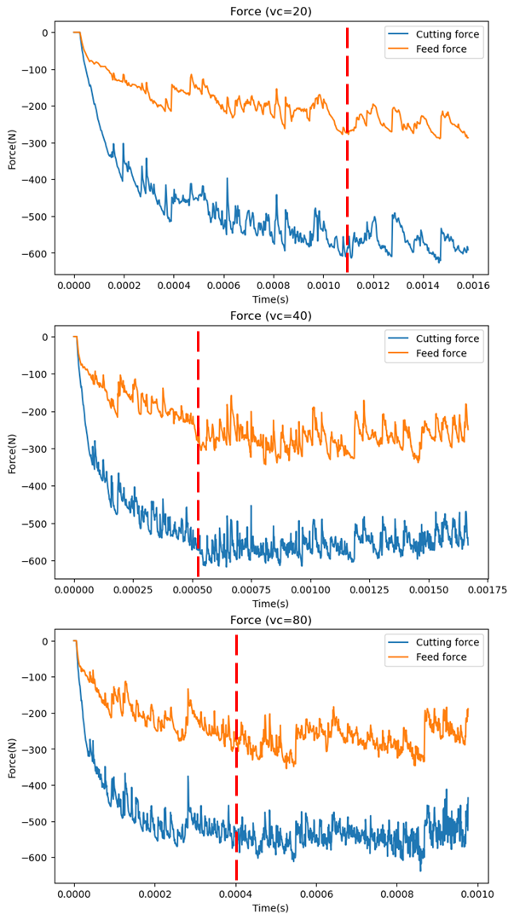

Fig. 4- Variation of cutting and feed forces under three cutting velocities

Table 4-1 shows a comparison of different averaged cutting forces results from experiment, thesis’s simulation and my simulation. It is clear that the simulated and experimental cutting forces are quite close, with the highest difference 11% occurring at a cutting speed of 40 m/min. However, my simulated cutting forces are almost as twice as the simulated results, far away from the experimental results too. This may be due to the great reduction in size of the simulated model. The shrunken workpiece may be not strong and robust enough to resist the tool. As a result, the much greater cutting forces occur in the cutting zone.

Table 4- Comparison between experimental, simulated, my simulated cutting forces

|  |  |  |  |  |  |  |  |  |  |  |
| --- | --- | --- | --- | --- | --- | --- | --- | --- | --- | --- |
|  |  | **Vc=20 m/min** | | | **Vc=40 m/min** | | | **Vc=80 m/min** | | |
|  |  | Exp | Sim | My | Exp | Sim | My | Exp | Sim | My |
|  | Average  cutting force(N) | 269 | 285.42 | 569.53 | 234 | 259.83 | 557.52 | 232 | 254.90 | 537.16 |

Table 4-2 shows a comparison among experimental, simulated and my simulated averaged feed forces. The obtained simulation feed forces are underestimated compared by their corresponding experimental results. A possible explanation may be attributed to tool wear which is not considered in the simulations. In contrast, my simulated feed forces are just the opposite. The results are overestimated in comparison with the others. This may be due to the over-simplified model too.

Table 4- Comparison between experimental, simulated, my simulated feed forces

|  |  |  |  |  |  |  |  |  |  |  |
| --- | --- | --- | --- | --- | --- | --- | --- | --- | --- | --- |
|  |  | **Vc=20 m/min** | | | **Vc=40 m/min** | | | **Vc=80 m/min** | | |
|  |  | Exp | Sim | My | Exp | Sim | My | Exp | Sim | My |
|  | Average  feed force(N) | 235 | 128.09 | 247.29 | 192 | 113.06 | 270.24 | 181 | 104.74 | 264.24 |

It is observed that by increasing cutting velocity, both cutting forces and feed forces in simulations and experiments decrease, except for my predicted feed force at the speed of 20 m/min, as shown in Fig. 4-2. This can be attributed to insufficient output data. In the first subplot of Fig. 4-1, which is under 20 m/min cutting velocity, it is obvious that the cutting forces and feed forces have not reached a stable status and keep decreasing. Therefore, the averaged data behind the red dashed line is invalid. This problem can be solved by obtaining more output forces through the simulation. However, due to the poor computer performance, my simulation work collapsed after a period time and failed to continue.

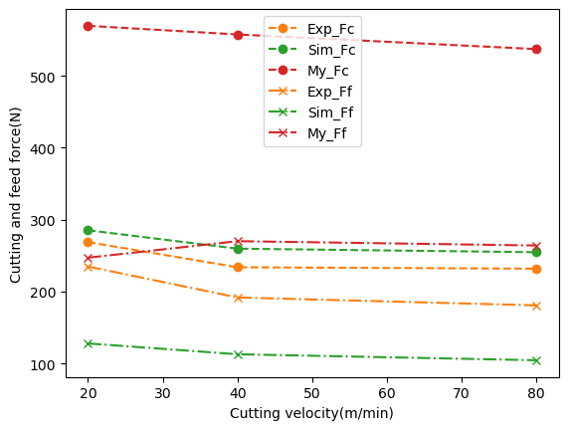

Fig. 4- Cutting forces and feed forces under different cutting velocities

## 4.2 Workpiece temperature profile

Figure 4.13 shows a plot comparing simulated temperature distribution profile measured at a distance of 3.5 mm behind the tool edge up to a depth of 500 µm and experimental temperature distribution profile measured at a distance of 4.5 mm behind the tool edge up to a depth of 500 µm using a tool edge radius of rβ = 10 µm and a cutting speed of Vc = 40 m/min

Figure shows a plot comparing the simulated and experimental temperature distribution profiles measured at a distance behind 3.5 mm behind the tool edge with a depth of 500 µm, while figure shows my simulated temperature distribution profile measured at a distance of 1 mm due to the restriction of my workpiece length. The highest temperature and the slope are higher in my profile, compared with the other two distributions. This is reasonable since my measuring point is closer to the cutting zone.

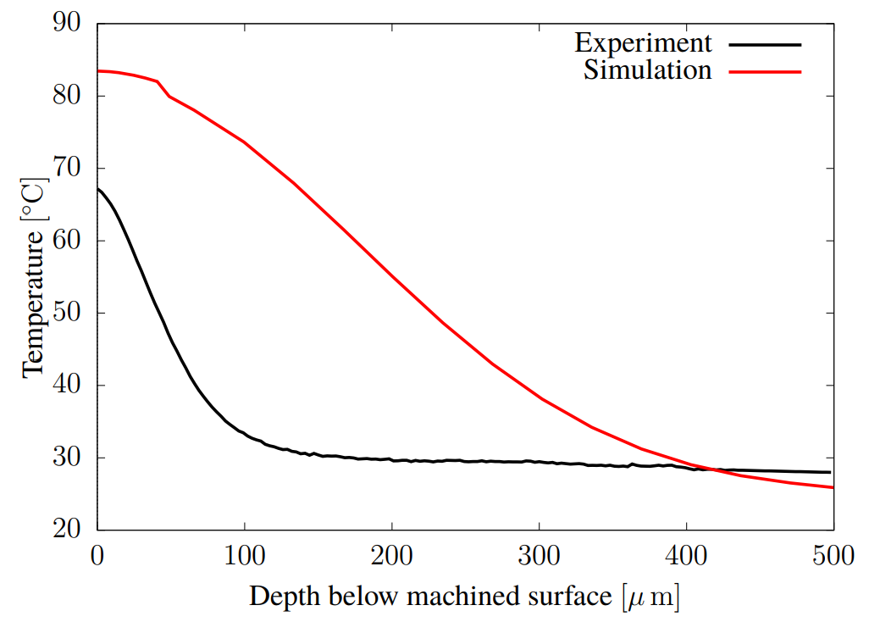

Fig. 4- Comparison between simulated and experimental temperature[2]

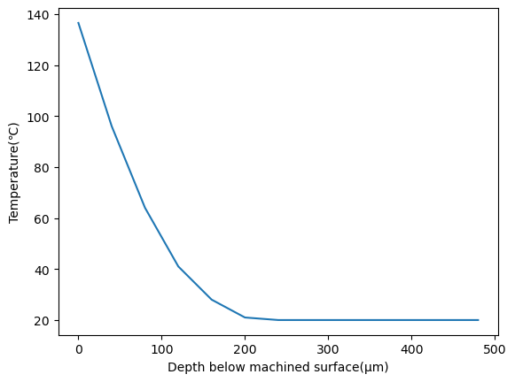

Fig. 4- My simulated temperature distribution

## 4.3 Chip thickness and chip morphology

The chip thicknesses are similar under different cutting speeds, as shown inTable 4-3. However, there is some discrepancy between my work and the reference simulation. This is probably due to the different model size. And continuous chips are observed in three conditions, as shown in Fig. 4-5.

Table 4- Measured chip thickness

|  |  |  |  |  |  |  |
| --- | --- | --- | --- | --- | --- | --- |
|  | **Vc=40 m/min** | | | **Vc=80 m/min** | | |
|  | Exp | Sim | My | Exp | Sim | My |
| Chip thickness(mm) | 0.13 | 0.079 | 0.39 | 0.11 | 0.077 | 0.45 |

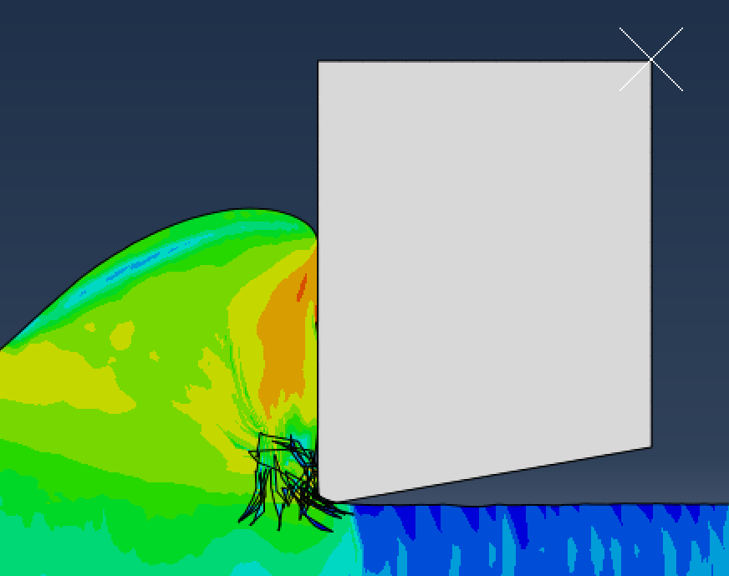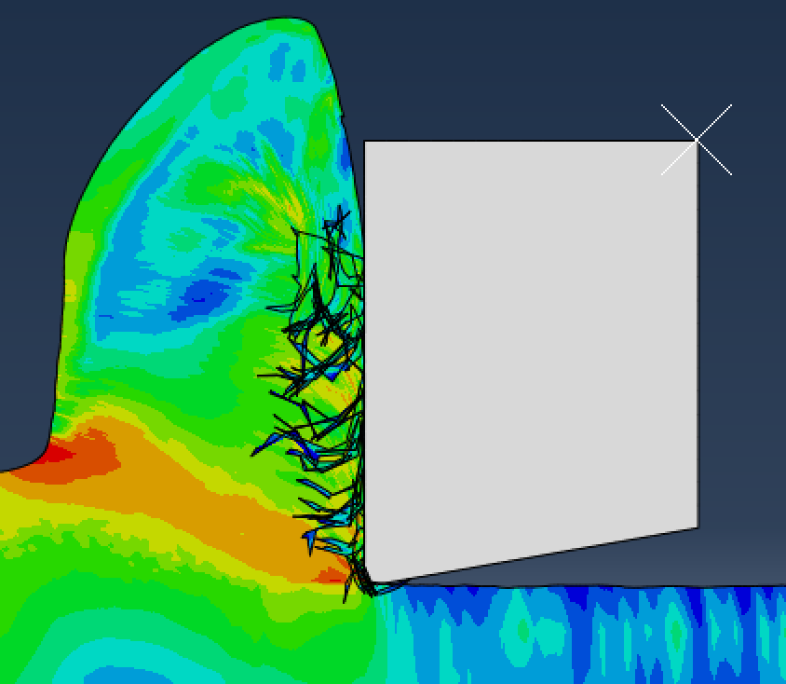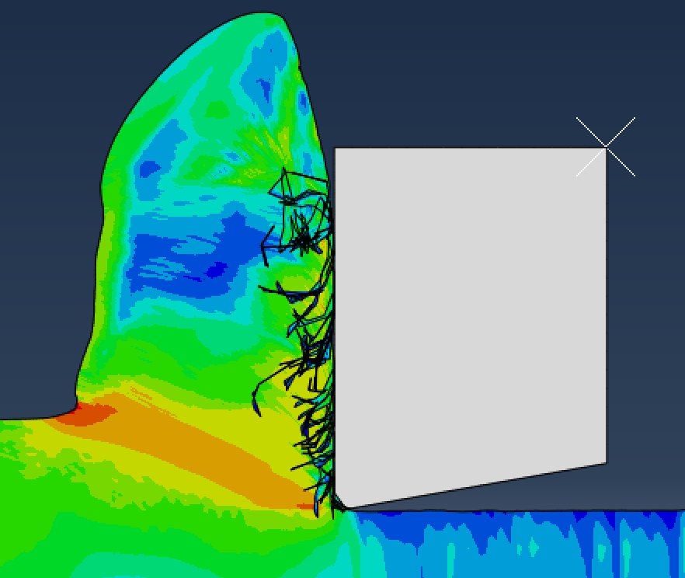

1. Vc=20m/min (b) Vc=40m/min (c) Vc=80m/min

Fig. 4- Chip morphology under different cutting velocities

# References

[1] Rahman M, Seah W K H, Teo T T. The machinability of inconel 718[J]. Journal of Materials Processing Technology, 1997, 63: 199-204.

[2] Bedzra R. Finite element simulation of two dimensional orthogonal cutting process and comparison with experiments[D]. GER: RWTH Aachen University, 2013.

[3] Klocke F, Lung D, Buchkremer S. Inverse Identification of the Constitutive Equation of Inconel 718 and AISI 1045 from FE Machining Simulations[J]. Procedia CIRP, 2013, 8: 212-217.