A genome project:

Experiment design
The study focused on understanding the diversity of the wheat A genome among the different polyploid wheats and its evolution during polyploidization. I systematically compared the A genomes from species with different ploidy levels to reveal the variation of gene and TE content in A genomes, which illuminated possible mechanisms for variations. The analysis was performed following three aspects, such as chromosomal distribution, function and evolution.

Methods
After annotation, statistics in terms of category number, content, sequence proportion of TE was conducted on diploid, tetraploid and hexaploid wheat A genomes; the variation of TEs in three A genomes were evaluated through statistical approaches to explain the mechanism of variations. Then the genome wide survey of TE insertion/excision was conducted by identifying TE polymorphisms near orthologous genes and TE distribution was plotted. The variation was further explained by studying the burst of LTR-retrotransposons activity, which was realized by calculating the evolutionary distance of 5’ and 3’ solo LTR of intact LTR-retrotransposons. To investigate whether TE insertion/excision affect neighboring genes, expression level of genes that have intact TE sequences on 3 kb upstream or downstream areas were compared with that of genes that have no intact TE sequences upstream or downstream by using a significance test.

Contribution
In comparison of transposable elements in A genomes from diploid, tetraploid and hexaploid wheat, statistical result and TE burst activity showed that some Gypsy families of LTR retrotransposon were reactivated in the tetraploidization, undergoing distinct selection pressures, and that some Copia families of LTR retrotransposon were eliminated. Change induced by the hexaploidization was not detected in any TE family. The results provide an important clue for the genome evolution of wheat, and also reveals an interesting phenomenon: in the process of polyploidization, the doubling of genome triggers a weaker restriction on counter-selective of harmful TE insertions, while other TEs were eliminated to create an overall balance of repetitive sequences in genomes. Therefore, three A genomes have similar repetitive sequence proportion at around 85%.

Fig. 1 | TE proportion in genome level, TE that shows preferential insertion on chromosome, full length LTR percentage corresponding to each family and insertion time of overall RLG families. Red (T. urartu), yellow (emmer), blue (Ta) a. Proportion of TE sequence to whole genome in every RLG (Gypsy) family. Only exhibit 15 families that account for over 1% of whole genome. The RLG families that have significant TE proportion variation between three A genomes are marked with “*” at top of the bar. b. Percentage of full length LTR retrotransposons in every RLG family. Families showing TE proportion variation are marked with “*”. c. Distribution of RLG_famc8.3 (Ceraba) on 6A chromosome 6A (Mb). y axis represents for total number of TEs within each bin, x axis stands for physical position of 6A chromosome. An insertion accumulation in centromere region is witnessed in emmer and Ta. d. Insertion time of overall RLG families. x axis represents insertion time (Mya), y axis represents TE number. An insertion burst at around 0.4 Mya in emmer and Ta is clearly showed.
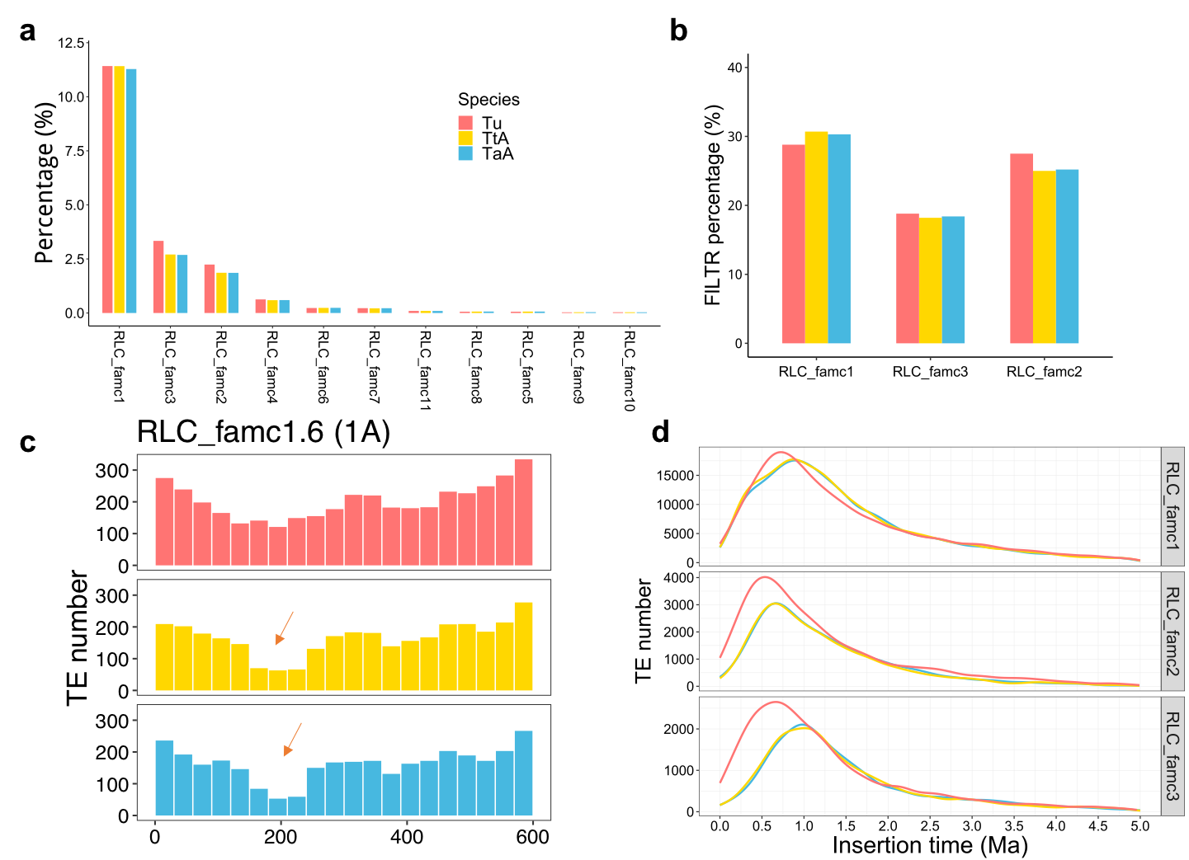

Fig. 2 | TE proportion in every RLC (Copia) family, TE distribution of RLC_famc1.6 in 1A chromosome, full length LTR percentage corresponded to RLC families, and the insertion time density plot in RLC_famc1, RLC_famc2 and RLC_famc3 among three species. Red (T. urartu), yellow (emmer), blue (Ta) a. Proportion of TE sequence to whole genome of every RLC (Copia) family. b. Full length LTR percentage of RLC families that account for over 1% of genome. c. Distribution of RLC_famc1.6 in chromosome 1A. y axis stands for total TE number mined in each chromosome bin (bin length 30 Mb), x axis stands for physical position of chromosome 1A. In emmer (yellow bar) and Ta (blue bar), a decreasing number of TE is in centromere region (200 Mb location). d. Insertion time of full length retrotransposons LTR in RLC_famc1, RLC_facm2 and RLC_famc3. x axis stands for insertion time (Mya), y axis represents number of TEs. T. urartu has higher amplification bursts in RLC_famc2 and RLC_famc3 during 0~1.0 Mya.

Wheat cultivar KN9204 project
Experiment design
The study focused on understanding the process of breeding and developmental biology associated with agronomically important traits of hexaploid wheat cultivar KN9204. I investigated the TE on A, B and D subgenomes to reveal variations of TE content and evolutionary clues that could reflect the occurrence of polyplidization events. TE distribution and variation on cultivar KN9204 were compared with that of KN9204’s ancestral lines adopted in breeding to reveal selection occurred during the cultivation process.

Methods
In this project, TEs were annotated through TriAnnot pipeline developed at the GDEC institute, and the CLARITE program was utilized to model TEs and reconstruct their nested structure; the variations of TEs on A, B and D subgenomes of KN9204 were revealed by plotting TE distribution, identifying TE polymorphisms, and the analyzing the overall completeness level of TE sequence included the proportion of full-length LTR-retrotransposons, TE content, and order of internal domains. The mechanism of variations was further explained by calculating the evolutionary distance of LTR-retrotransposons; apart from this, the statistics information from KN9204 was compared with Triticum aestivum cv. Chinese spring in terms of TE contents, TE categories, insertion date of LTR-retrotransposons, and TE distribution along 21 chromosomes. Because KN2904 was a breeding cultivar, the distribution of TE was compared with that in Chinese spring according to KN9204’s resequencing data of ancestral lines to verify exogenous segments. Finally, the research focus investigated the repetitive pattern of a tandem repeat sequence in D subgenomes, although the sequence shares high level of similarity with BAC clone (Gene bank No: AY249985.1) reported in Aegilops tauschii, which was the ancestor of the D subgenome, the composition of the repeat still remains unknown.

Contribution
Although the overall statistics show that KN9204 share high similarities with Chinese spring in terms of TE categories, TE content and sequence proportion in genome scope, evolutionary distance of LTR-retrotransposon reveals that a group of TE families have replicated at around 0.5 mya, which was not observed in Chinese spring. Although other distinctions related with 0.5 mya in genomic aspects have not been found, it still provided proof that wheat cultivar KN9204 and Chinese spring were derived from non-homologous ancestry. Moreover, biased TE distribution on short and long arm of chromosome 1B supports the fact that KN9204’s short arm of 1B is exogenous segment from chromosome 1 of Rye. Finally, the composition of tandem repeat in D subgenome was discovered to be a type of repetitive pattern with further repetitive circles in each pattern, which will be helpful to conduct in-depth research to discover if these conservative sequences have any regulation or effect on genes in expression or epigenetics level.

Figure:
a. Distribution of tandem repeats in D subgenome of KN9204, Chinese spring and Ae. Tauschii. X axis represents physical positon in Mb of each chromosome.
b. The structure of tandem repeat. Yellow, blue and red boxes stand for 174 bp, 137 bp, and 57 bp subunit in each tandem repeat unit. The graph shows tandem repeats in chromosome 1D in KN9204.

