NestFinder SG Multi Agent Rental Assistance System
  - System Architecture and Core Agent Design Report
Group 42 | Implementation reviewed on 24 October 2026

Report Abstract
NestFinder SG organises conversational property search, interpretation of recommendations and subsequent enquiries into a continuing application workflow. An Orchestrator coordinates four specialist agents. Structured state preserves requirements across turns, controlled tools connect recommendation and data services, traceable evidence supports property introductions, and human confirmation and behavioural feedback connect later actions. This report examines the application architecture and its agent mechanisms: how role contracts, system prompts, skills, selected examples, tool permissions and feedback checks work together. Each chapter explains the design problem, the division between model interpretation and code execution, and the resulting engineering benefit. Recommendation algorithms and data construction are integrated as separate modules; their interfaces are described without expanding their internal methods.

Contents
1 Design Objectives and Technical Perspective
2 Layered Architecture and Agent Control Mechanisms
3 Intent Orchestration and Reliable Context
4 Requirement Agent Semantic Compilation and Feedback
5 Explanation Agent Evidence Reasoning and Generation Control
6 Follow Up Agent Layered Execution and Knowledge Support
7 Interface Design and Behaviour Feedback Quality
8 Engineering Improvements and Verification Evidence
9 Design Value and Further Development
References
Appendix A Implementation Evidence Index

1 Design Objectives and Technical Perspective

1.1 From a Single Answer to a Continuing Task
Rental assistance often begins with an incomplete brief and continues through revisions, comparisons, enquiries and viewing discussions. If a single conversational model handles everything through free text, current requirements, property references and action progress can become entangled. “Change it to 2500” or “contact the second home” may then lose its precise meaning. The system separates conversational interpretation from business state so that each response refers to a requirement version, a recommendation round and a valid next step. The architectural objective is to sustain the rental task, rather than merely produce a plausible answer.

1.2 Organising the Design Around Agent Mechanisms
An agent description needs to explain its role, information inputs, planning, actions and feedback. The survey by Wang et al. organises agent architecture around profiling, memory, planning and action, providing a useful analytical framework. [R1] This system is examined through five corresponding dimensions: roles and contracts define the task; context and evidence supply information; orchestration and state machines determine execution; tools and permissions connect the environment; validation, repair and human confirmation provide feedback. This makes the technical design inspectable beyond a list of rental features.
ReAct connects external actions and observations to subsequent processing. AutoGen shows how models, tools and human input can be combined through defined interaction patterns. Reflexion demonstrates the use of linguistic feedback to improve later attempts. [R2–R4] These works motivate the discussion; they do not imply that this project uses AutoGen, reproduces the full ReAct method or implements Reflexion’s episodic reflection memory. The implementation uses LangGraph runners, persistent tasks and bounded feedback loops to address semantic consistency, factual support and controlled actions in rental assistance.

1.3 Design Objectives That Can Be Checked
Four quality objectives guide the design. Requirement revisions should retain uncancelled conditions and distinguish mandatory constraints from preferences. Property guidance should reveal useful differences while keeping every number and selling point traceable. Drafting, sending and viewing confirmation should have separate states so that generated language cannot substitute for authorisation. Interruptions, retries and late results should also leave the current conversation consistent. The following sections explain how prompts, structured contracts, programmatic checks and persistence jointly support these objectives. Implementation records establish engineering behaviour, rather than measured improvements in satisfaction or recommendation accuracy.

2 Layered Architecture and Agent Control Mechanisms

2.1 System Layers and Four Specialist Roles
The four agents handle requirement interpretation, recommendation adoption, property guidance and follow-up. They are separated because their standards of correctness differ. Requirement interpretation concerns meaning and update scope; recommendation adoption concerns contract and ordering consistency; explanation concerns support between facts and language; follow-up additionally concerns authority, time and action state. Separate roles allow different prompts, information sources and tool permissions, reducing ambiguity about which component may interpret, rank or commit an action. [E2–E5]
Table 1 Agent responsibilities and technical interfaces
Role | Core processing | Interface and execution boundary
Requirement A | Semantic intake, update compilation and refinement | Produces accepted requirements; does not invent homes
Recommendation B | Strict adaptation, archiving and result adoption | Connects the independent core and preserves order/status
Explanation C | Evidence organisation, cohort comparisons and guidance | Enriches selected homes read-only; does not rerank
Follow-up D | Action coordination, reply understanding and knowledge | Separates drafts from execution and confirmed commitments

The runtime separates the browser workspace, same-origin FastAPI interface, TypeScript business runtime and service adapters. The browser hosts conversation, details, refinement and follow-up controls. FastAPI serves the interface and proxies requests. LangGraph runners and WorkflowService accept tasks, invoke roles and advance state. Adapters connect recommendation, property/place data and local retrieval services. Application PostgreSQL stores sessions, tasks and events, while property SQL and Neo4j are accessed through the data service. Separating application state from property facts supports independent module evolution with clear integration points.
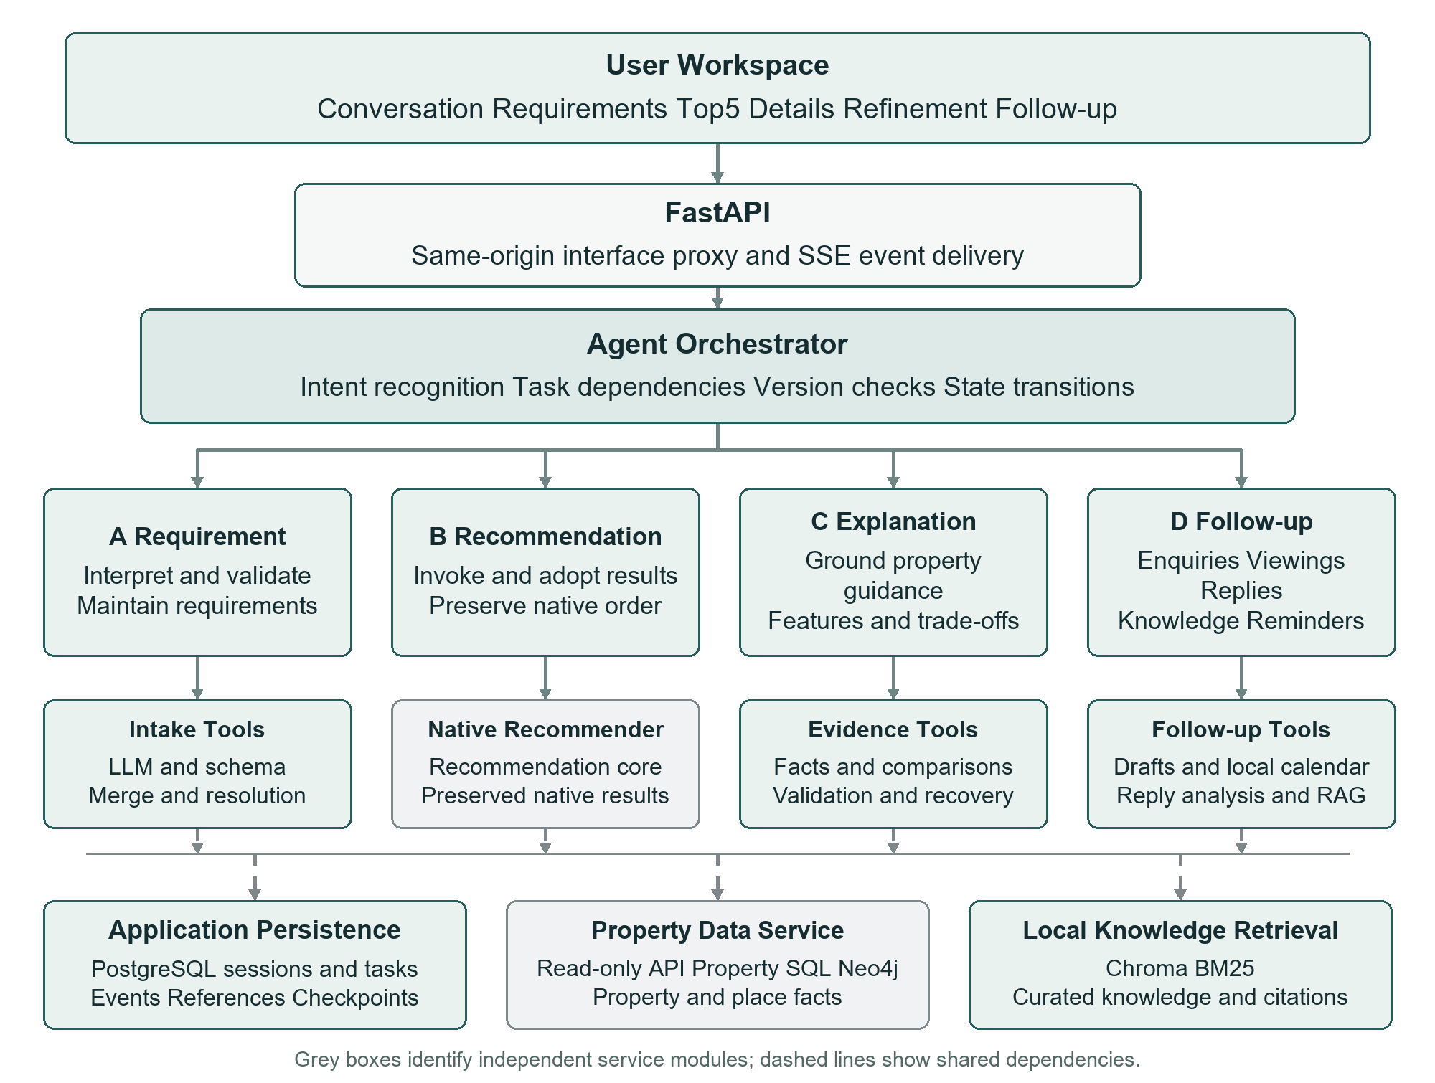
Figure 1 System layers and implemented service dependencies
Figure 1 redraws the proposal around the dependencies actually used. The generic Email, cloud-calendar and Drive column is removed. The core follow-up path uses manually sent drafts, a local viewing calendar and file export. The broad OneMap label is replaced by the actual data service and place catalogue, avoiding the implication that spatial lookup already provides route planning. Optional messaging executors remain extension points in the code; credentials and live-delivery verification are deployment conditions.

2.2 Layered Role Contracts and Prompt Context
A “property assistant” identity alone is insufficient to constrain behaviour reliably. The system therefore separates several control layers. A role contract defines inputs, authority and prohibitions. The system prompt turns those principles into task instructions. A skill stores versioned domain guidance. Few-shot pairs demonstrate structure and expression. Current context supplies the material available for this task. Schemas and executors enforce checks outside the model. These mechanisms cooperate but have different effects: prompts guide generation, whereas code decides whether a result may be saved or a tool invoked. [E2, E6, E8]
Table 2 Agent control layers and their functions
Layer | Stored content | How it works
Role contract | Identity, inputs, authority and prohibitions | Defines the task and limits of responsibility
System prompt | Task steps, semantics, output and expression rules | Turns the role objective into generation instructions
Skill | Versioned domain guidance and boundaries | Loaded by dedicated generators with a traceable hash
Few-shot | Paired inputs and accepted example outputs | Demonstrates structure/style, not current facts
Task context | Current requirements, sources and evidence | Defines the information available for this response
Code and feedback | Schemas, permissions, factual and semantic checks | Controls adoption, execution and bounded repair

AGENT_PROFILES registers each role’s tools and skill. loadProfile computes a SHA256 hash of the loaded guidance and records it in the task trace. Requirement and Explanation generators then assemble their contract, skill, examples and current input into model messages. The guidance and examples behind an output are therefore traceable, and prompt revisions need not alter recommendation algorithms. Follow-up executes core actions through business services and uses a dedicated extraction prompt for reply understanding. Shared role registration does not require every role to use the same unconstrained reasoning loop.

2.3 Orchestrator Planning and Dependency Management
The Orchestrator first determines what the current turn requires, rather than asking every agent to interpret it independently. New searches and revisions enter Requirement; questions about existing results enter Explanation; knowledge, contact, viewing and summary requests enter Follow-up. Recommendation normally follows accepted requirements. When search and summary are requested together, the plan records their dependency so that the summary waits for Requirement, Recommendation and Explanation. This avoids unnecessary recommendation runs and ensures that dependent work uses the correct result version.
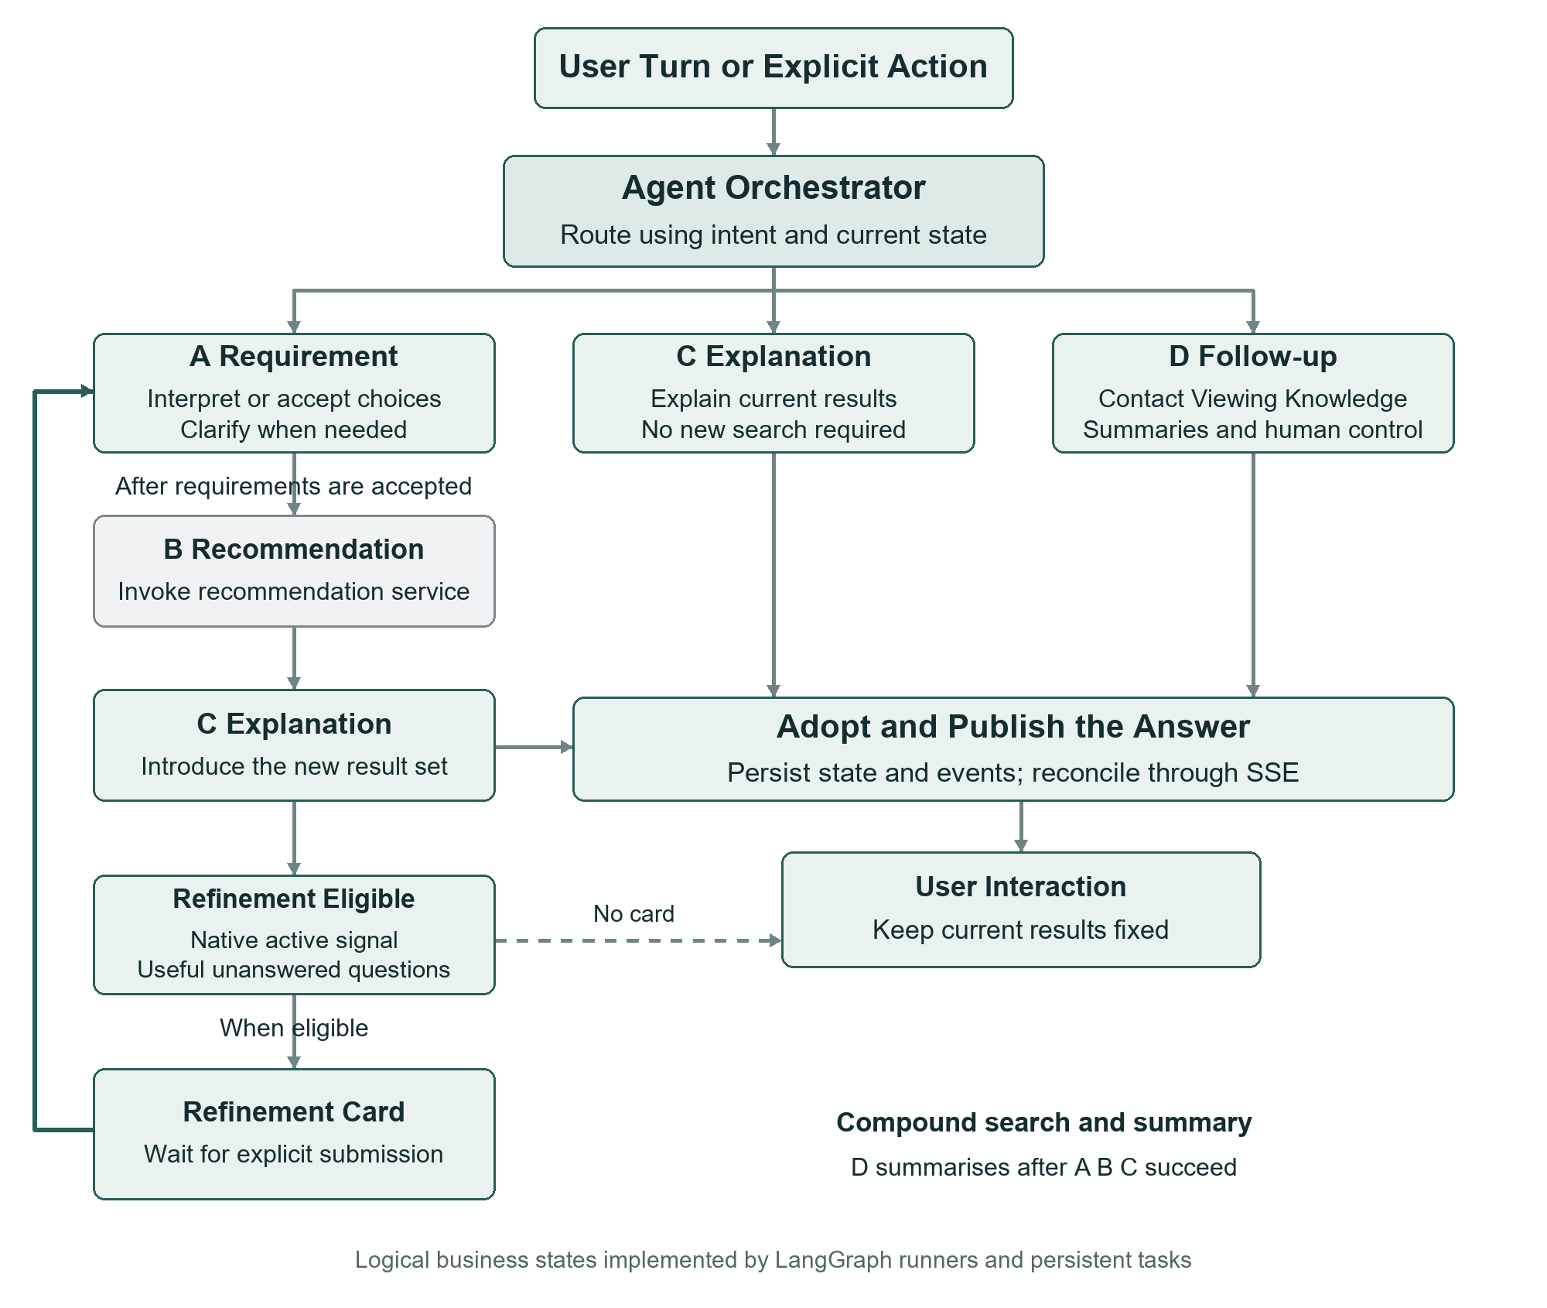
Figure 2 Logical state flow with intent routing and user participation
Figure 2 presents logical business states implemented jointly by the LangGraph master and role runners, PostgreSQL tasks and WorkflowService. Refinement is not an autonomous loop of repeated questions. After Explanation publishes, a valid native cold-start signal and useful unanswered fields may produce a card. The system then waits for explicit submission before another A→B→C cycle. This wait incorporates the user’s decision and keeps the current list stable while it is being read.

2.4 Strict Recommendation Adaptation and Source Consistency
Recommendation is integrated as an independent core. The application ensures consistency among requests, original responses and downstream use. The adapter validates contracts, archives the native exchange and preserves original order, condition outcomes, selection reasons and the cold_start signal. A shared display projection limits the current result to five homes, or fewer when fewer are available. Requirement version, request_id and dataset identity continue into explanations, details and drafts. This allows algorithm updates while preventing cross-module faults such as five introductions alongside nine cards or new results carrying old reasons. [E5]

3 Intent Orchestration and Reliable Context

3.1 Complementary Intent Channels and Task Boundaries
The same topic can imply different actions. “How are deposits usually paid?” is a knowledge question, whereas “ask the second home about its deposit” is an enquiry. Asking why homes were recommended should not start a new search. The intent module combines LLM interpretation, vector templates and lightweight patterns, normally weighted at 0.7, 0.2 and 0.1. Its prompt defines boundaries between search, revision, explanation, knowledge, contact, viewing and summaries, with examples. The model receives the last three messages and current structured state to interpret elliptical requests. [E3]
The vector channel uses 42 templates for semantic similarity, while patterns add explicit operational cues. Code aggregates task groups before selecting a specific intent; low confidence leads to clarification, and channel failures retain provenance. Cache identity includes the message, short history, structured context and template version, preventing reuse when the same words mean something different in a new state. The channels provide complementary routing information and observable fallback behaviour. They do not make keyword rules the final authority over requirement semantics.

3.2 Task Relevant Context and Structured Memory
Multi-turn search needs memory, but repeatedly inserting the entire conversation increases length and mixes obsolete conditions with the current brief. The system distinguishes original conversation, canonical requirements, pending clarification, role checkpoints and task input. Original messages support traceability; requirements represent the active brief; pending state retains unresolved content; checkpoints are isolated by session and role. Each model receives relevant material: short history for routing, current conditions and the new change for intake, and a current evidence bundle for explanation. This turns conversational memory into explicit data responsibilities. [E4, E10]
Continuity currently comes mainly from persistent state, rather than an automatically generated long-term memory summary. A user-requested conversation summary is a separate artifact and does not replace the active brief. Pending intake exceeding 32 messages or 16,000 characters requires consolidation and resubmission, avoiding silent truncation. The resulting capability is precise: the system preserves and resumes structured tasks, without claiming automatic memory compression or long-term self-learning.

3.3 Version Association and Atomic State Updates
Concurrent requests, retries and slow model calls can cause old work to finish after a new request. Each task therefore binds session_id, operation_id, requirements_version and the recommendation source request_id. Requirement version alone is insufficient because new behavioural feedback may produce another round without changing explicit conditions. Result adoption checks these associations and source identity, as do details and references such as “the second home”. Version control is therefore part of semantic correctness: it keeps generated guidance and user actions attached to the same properties.
DomainStore updates business state, records consumed results, queues dependent tasks and writes events in the same SQL transaction. Task inputs and outputs use saved references and stable hashes; messages, steps and feedback have their own idempotency identities. Queued work can resume after interruption, while superseded results no longer affect the active state. Cross-agent cooperation becomes a recoverable state transition instead of relying on a model to remember where execution stopped. [E4]

3.4 Event Driven Publication and Display Recovery
Successful background generation does not mean that the user has seen the answer. An earlier symptom, where an answer appeared only after another question, exposed a gap between generation, persistence and interface refresh. A durable event log and Server Sent Events, or SSE, now communicate phase changes and results. Events have increasing sequence numbers; the frontend retains a cursor and resumes after reconnection, then reconciles authoritative state on completion or change. Business-mode delivery reads the ordered log so a newer notification cannot cause the client to skip an earlier result. [E4, E11]
Explanation prose is published as a complete answer after validation and adoption, while progress and connection states remain visible. This gives timely task feedback without exposing unchecked numbers token by token. Recovery covers the generation, adoption, persistence and display chain, removing dependence on another user action to reveal a completed answer. SSE is an application event transport, distinct from serverless deployment or token streaming.

3.5 Tool Interfaces and Execution Governance
Tools give agents practical capabilities to obtain facts and advance work. Requirement uses resolve_place for real place identities; Explanation uses listing_detail and listing_context for selected properties and nearby records; Follow-up has knowledge and draft-preparation capabilities. These interfaces connect language interpretation to databases and business services, reducing reliance on model guesses about IDs, property facts or execution results. Each tool has a role scope, and fact retrieval is separated from actions. [E2, E9]
Permissions are enforced outside the prompt. ToolExecutor checks the role allowlist before looking up cached results. Cache identity includes session, role, dataset, tool and arguments, so a cache hit cannot bypass authority or borrow another session’s data. The executor applies call budgets and a failure circuit breaker, adapters apply request timeouts, and traces record latency, status and cache use. Prompts explain appropriate use; the executor decides whether use is permitted. This supports controlled capabilities and distinguishes missing data, service failure and interpretation errors during diagnosis.

4 Requirement Agent Semantic Compilation and Feedback

4.1 Translating Open Language Into Executable Requirements
Requirement connects open user language to the recommendation interface’s finite fields. The same request may use different word order, modifiers and negation, so the LLM interprets meaning before code constructs executable conditions. The pipeline separates model proposal, programmatic compilation, real-place resolution, effective-state preview and semantic review. The model handles meaning; code handles units, fields, identities and persistence rules. This division combines linguistic flexibility with deterministic execution and helps locate failures in interpretation, resolution or merging. [E6–E7]

4.2 Role Contract and System Prompt Dimensions
The role contract identifies the model as a Singapore residential-rental requirement interpreter. It authorises semantic interpretation, verbatim provenance and retention of explicit requests, while leaving search, ranking and contact execution to later modules. Explicit but currently unverifiable requirements, such as exclusive bathroom use or actual commute duration, are retained so the model does not simplify the brief to fit the dataset. The structured contract is embedded in the system prompt, while the skill supplies domain guidance. intakeSystemPrompt combines them at runtime.
The system prompt develops five dimensions. Task scope limits output to current additions, changes, removals and necessary clarification. Logical semantics distinguishes hard/soft, OR/AND, cancellation versus an inverse requirement, and radius limits versus closer-is-better. Field semantics distinguishes 1B1B, HDB models, rental duration, ownership tenure and private bathroom use. Factual authority leaves real place IDs to lookup tools after the model proposes names or categories. Provenance and interaction require verbatim quotes and at most three questions for genuine ambiguity. Current Singapore date, field registry, controlled enums and existing requirements make these instructions specific to the actual state.
For example, “preferably an MRT station or bus stop within one kilometre” needs both soft strength and an alternative relation. “I do not require a private bathroom” removes a constraint rather than requiring its absence. These examples show that the prompt governs the mapping between language and fields, rather than prescribing fixed user sentences. The skill reinforces that unknown data do not erase a request, while the output schema fixes the permitted fields and operations. Model interpretation and interface enforcement work together to reduce omissions across varied expressions.

4.3 Dynamic Few Shot and Example Fact Isolation
Abstract instructions alone may not prevent confusion between “at least” and “exactly”, or deletion of earlier conditions. The example library therefore stores a complete input, base requirements and expected structured output. selectIntakeExamples uses a lightweight relevance score based on term frequency, inverse document frequency and length normalisation to select two pairs; Chinese characters and bigrams also support retrieval. This mechanism chooses demonstrations only. It does not generate the user’s requirements.
Messages contain system guidance, two paired demonstrations and the actual input, which remains authoritative during repair. Instructions distinguish learning structure from copying facts, and code checks provenance against the real words. A request for at least 55 square metres must not inherit a 70-square-metre cap from a demonstration. The independent reviewer receives no few-shot examples: it checks the actual input and proposal. This separates teaching examples from factual authority and limits contamination by example numbers or destinations.

4.4 Strict Structure and Two Stage Semantic Validation
The model submits a versioned result through strict function calling instead of producing prose that later rules must guess into fields. The schema separates attributes, locations, removals, clarifications and coverage, with controlled fields, operators, units and enums. Required keys use null or empty arrays when inapplicable. compileIntake checks quotations, conversions, weights, targets and duplicates. Coverage records whether each substantive clause was extracted, removed, clarified or treated as context, making omissions such as a captured budget but lost transport preference inspectable.
Valid JSON may still encode the wrong meaning. Before saving, code resolves locations and computes a complete merged preview. An independent LLM then reviews the actual input, old conditions, proposal and preview. Its prompt targets omissions or unsupported additions, logic and strength errors, incorrect cancellation/replacement scope, and unnecessary clarification. Reviewing the final state matters: removing an old cap and adding a new cap is a valid replacement, not automatically a lost requirement. The reviewer therefore examines the semantics that would be saved, rather than the surface form of a removal list.
Correctable failures return specific reasons to the generator, which must resubmit a complete proposal without dropping genuine requests. Production configuration allows at most three attempts within 90 seconds. Generation and review form a bounded loop; three attempts do not mean only three model requests in total. Attempt records retain example IDs, latency, review results and repair notes. Explicit stopping conditions bound latency and cost while keeping model interpretation, place resolution and state adoption separately diagnosable.

4.5 Place Resolution and Incremental State Merging
A place has both linguistic meaning and a catalogue identity. The model distinguishes neighbourhoods, universities, stations and generic amenity categories; the resolver then looks up a real entity and binds a stable ID. Chinatown and Holland Village retain neighbourhood meaning unless MRT or station is explicitly requested. Radius, proximity preference, walking distance and whole-journey duration are stored separately. This grounds location interpretation in data without introducing namesake stations or treating straight-line measurements as unrequested travel conditions.
Updates merge by field, target and strength. With a 3000 budget and at least two bedrooms, a budget-only revision retains the bedroom constraint. Switching to Holland Village replaces the old destination’s radius and proximity preference; also wanting Holland Village adds a target. Without route evidence, commute requirements remain unverified instead of receiving guessed minutes. Code performs the merge, the prompt guides the proposed change, and review checks the final meaning. This is easier to keep consistent across turns than asking the model to rewrite the entire state.

4.6 Structured Refinement and the Human Feedback Loop
When the current brief provides limited differentiation, a card makes further choices easier than requiring another free-text message. Its trigger is selection.cold_start.active from Recommendation, checked against the current pool and unanswered fields. It does not merely count conditions or invent another recommendation score. The planner prioritises budget, bedrooms, property type, listed area, preferred rent and closer homes within a range, with at most three questions. Data-dependent questions require at least 75 percent valid coverage and meaningful variation, so they are answerable and potentially useful for distinguishing the current homes.
Card options already encode fields, operators, units and strength. Submission therefore enters server validation and the same merge logic directly, without asking a model to extract a generated summary again. Keeping the existing budget cap is a distinct operation from adding preferred rent, avoiding an “unlimited budget” interpretation. Plans and answers persist with their source request and requirement version. Explicit conditions are not asked again, and skipped or exhausted fields stop producing questions. Structured human input complements language interpretation while removing an unnecessary model call and another opportunity for semantic drift.

5 Explanation Agent Evidence Reasoning and Generation Control

5.1 From Filter Recaps to Grounded Property Guidance
Several homes may satisfy the same budget and bedroom constraints, so repeating “meets your requirements” does little to help selection. Explanation is therefore defined as a property-selection adviser for the current homes. It describes their features, positions within the group and relevant trade-offs, adding evidenced facts the user did not explicitly request. It translates recommendations into understanding; Recommendation retains ownership of membership and order. This separation allows better guidance without changing the original decision. [E8–E9]
The role contract fixes this position through explicit inputs, authority and prohibitions. Inputs include the question, brief, original recommendation and selected-home evidence. Authority covers real features, additional decision information, flexible paragraphs and accurate ranking explanations. Prohibitions cover changed membership/scores, invented amenities or routes, and presenting cheap rent as a ranking cause without support. Output responsibility is a per-home introduction with necessary uncertainty. The contract is versioned as 3.1 in prompt.ts, and the skill stores matching domain guidance. Together they provide traceable control beyond an instruction to “sound like a salesperson”.

5.2 Evidence Bundles and Model Input Organisation
Useful introductions need richer material, but passing global state or raw database rows adds noise and encourages cross-property confusion. Code first fixes target listing IDs, display order and condition outcomes from the current recommendation. Details and nearby records are then read only for those IDs. makeExplanationBundle and addDecisionSupport organise condition observations, listing facts, supplements, comparisons and cautions. Each fact retains references, entity ownership, numeric allowances and source chains. The model receives an organised evidence set rather than guessing which raw records belong to which home.
Each home’s profile separates core_refs, additional_refs, highlight_refs and caution_refs. Known rent and listed area form a backbone; additional facts support information beyond the brief; comparison highlights identify distinctions; cautions preserve unknown hard conditions and conflicts. Supplementary records cannot overwrite a conflicting adopted value or turn bathroom count into verified exclusive use. This permits “the details list two bathrooms” and “exclusive use still needs confirmation” to coexist, enriching guidance while preserving the meaning of each source.
To reduce prompt length, explanationModelInput maps long internal references to short aliases and omits low-level numeric allowances and expanded source metadata from the model-facing representation. The complete validator bundle remains on the server. General guidance receives relevant cohort comparisons; focused comparisons retain the needed pairwise material. Output references are mapped back afterwards. This compresses representation rather than summarising away facts or unknowns, limiting context length while preserving traceability.

5.3 Programmatic Comparisons With Model Written Guidance
To make differences easier to understand, code first calculates each home’s relative position within the displayed group; the model then explains its implications. cohort.ts derives minimum, maximum, median, ties and lower/middle/higher positions from comparable known values, retaining total and known counts. Missing values are excluded from arithmetic but affect completeness. A clustered flag identifies close values; stands_out identifies a salient gap. Distances are compared only within the same destination, metric and comparable group. “Lowest”, “joint lowest” and “lowest among known records” therefore have explicit support rather than depending on model arithmetic.
The system prompt turns these computations into writing rules: prefer whole-group positions, highlight budget headroom for a clearly low rent and avoid exaggerating small gaps. Named peer differences are reserved for explicit comparisons or genuinely similar homes. If one home costs SGD 1500 while the others are above 2000, the useful point is that it has the lowest rent here and leaves more budget, not an arbitrary pairwise subtraction. Code supplies comparison facts, the prompt defines editorial principles, and the LLM selects emphasis and connecting language. Their cooperation produces grounded but flexible guidance.
Unit rent is also screened in code. It requires an explicit consistent rental scope and at least two valid rent/area records. Only a comparable high or low value at least 15 percent from the median becomes an optional highlight. The prompt then requires its value, cohort position and implication for the cost of the same amount of space. Users can understand that a higher space cost warrants weighing other features, rather than seeing an isolated number. This is editorial evidence, not another score or proof of best overall value.

5.4 Cooperation Between Prompt Skill and Selected Examples
Explanation’s system prompt governs six dimensions: targets/order, core coverage, comparison scope, facts and metrics, writing style, and necessary cautions. Paragraphs bind to listing_id to separate same-name homes. Known rent and area form a common backbone without fixing sentence order. The model chooses one to three useful angles such as space, bathrooms, transport or shopping. It must connect facts into trade-offs instead of listing rent, area, distance and year. The skill stores guidance for general introductions, focused comparisons, empty results and recovery, giving linguistic flexibility a defined boundary.
Few-shot pairs demonstrate how to turn evidence into understandable guidance. Each includes a question, teaching facts and a complete referenced output. Cases cover clear low-rent advantages, mixed verification status, multiple preferences, behavioural ordering and bathroom count versus exclusive use. The selector combines question tags with runtime context, prioritises a matching scenario and chooses two examples. Even a generic “why these homes?” can receive an outlier example when the current evidence contains one. Demonstrations teach structure and style; current homes, values and references still come from the actual bundle.

5.5 Factual Validation Semantic Review and Bounded Repair
Generated language can contain a wrong number or draw an excessive conclusion from correct numbers, so two complementary checks are used. Programmatic validation checks strict output structure, target membership/order, reference ownership, core coverage, numbers, units and unsupported route or booking assertions. Internal support_refs provide an entry point for checking each paragraph, while users see connected prose. Deterministic checks handle matters that can be judged precisely instead of delegating every factual check to another model.
Independent semantic review reads the current bundle and draft, checking support, comparison scope, ranking attribution and unknowns. Generation and review may use the same base model; independence lies in separate prompts, inputs and responsibilities. The reviewer returns only genuine issues requiring correction, avoiding repeated rejection for stylistic preferences. A named supermarket can support “another grocery option”, and two bathrooms can coexist with unverified exclusive use. Shared factual boundaries let writer and reviewer support natural guidance while blocking excessive conclusions.
Correctable generation or review errors return specific feedback and the prior draft for complete rewriting against the original evidence. Production allows at most three writing attempts within a 90-second budget. If identity and sources remain valid but writing fails, diagnostics are saved and accepted facts form a recovery introduction that is validated again. Metadata records evidence_recovery and semantic_audit=not_run, distinct from generation plus successful model review. This preserves an available shortlist while keeping quality status traceable; source or identity failures still stop processing.

5.6 Balancing Natural Language and Checkable Facts
Transport and amenity wording needs to translate engineering fields into useful meaning. The model can describe a named station and its reported distance, or a supermarket about 360 metres away in a straight line as another grocery option, while retaining the metric. Straight-line, property-reported and route measurements remain distinct. Without route data, prompts and validation constrain claims about walking minutes, service frequency and commute speed. A hard radius and nearer preference for the same destination share one distance description with both references, reducing repetition without losing conditions.
For a home with relatively low rent, smaller listed area and a nearby supermarket, useful guidance connects budget headroom, whether the space is sufficient and another shopping option. This does not create a new ranking rule; it interprets computed positions and recorded amenities as trade-offs. Different homes may open with price, space or neighbourhood features while still covering known core facts. Evidence and coverage provide comparability, while the model’s choice of emphasis provides flexibility without a universal script.
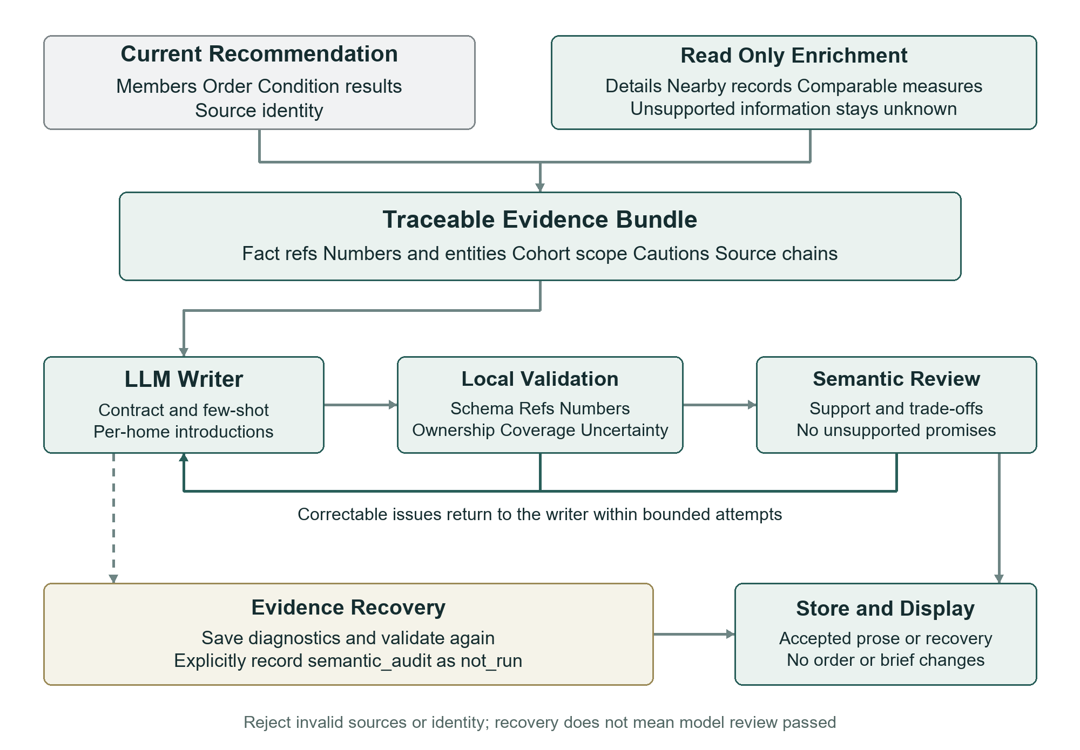
Figure 3 Evidence organisation and Explanation generation checks

6 Follow Up Agent Layered Execution and Knowledge Support

6.1 Role Tool and Business State Layers
Follow-up turns interest in a selected home into an enquiry that can continue, rather than another isolated chat response. It needs language understanding but also property identity, draft revision, correspondence records and bilateral commitments. The design separates role guidance, tools and domain services, action state, and dedicated models for reply understanding or knowledge answers. This lets uncertain language processing and precise operational steps use different mechanisms. [E12–E13]
The salesperson-followup skill binds selection to the original request_id, includes unknown conditions in verification questions, separates drafting from execution and defines time/confirmation semantics. Role configuration provides detail, knowledge and preparation capabilities. WorkflowService dispatches by kind to ActionService, ManualFollowupService or knowledge services. Core drafts, calendars and summaries use deterministic code. Skill loading supplies role guidance and version traceability; these branches are not all unconstrained LLM tool loops. Dedicated prompts are used where language understanding is required.

6.2 Typed Action Contracts and State Machines
The enquiry target must be a home the user actually saw. Stable IDs and display numbers are resolved before checking recommendation source and requirement version. Typed actions store message content, recipient, revision, time interval and hashes, with server validation. Unknown availability, furnishing and lease terms become questions rather than promises. A later search cannot silently redirect an old draft to a new home. These contracts turn agent output into a reviewable business object shared by user edits and backend execution.
The state machine separates drafting, review, sent correspondence, replies and confirmation. In the core path, users copy a draft, send it themselves, confirm sending and paste the received original. Preparation saves reviewed content and a requirement snapshot; sending confirmation checks revision and hash against that content. Viewing times use Asia/Singapore and validate future intervals, ordering, a four-hour maximum and conflicts. Final confirmation records both parties’ explicit agreement. A button click therefore cannot be mistaken for message delivery or a completed appointment.
Optional platform executors follow the same principle. Content, recipient or time edits invalidate earlier approval; a persistent outbox and execution identity distinguish queued, accepted, failed and unknown results. An uncertain timeout requires checking before another send, avoiding duplicate contact. The technical value is separate modelling of model suggestions, user authority and external outcomes. This retains future integration points while allowing the manual workflow to operate independently of platform credentials.

6.3 Source Bound Reply Understanding and Local Memory
Agent replies often combine price, furniture, charges and viewing discussions in one message. Structured function calling first extracts claims with verbatim quotations; code then compares them with requirements at sending time instead of asking the model to declare full compliance. The dedicated prompt defines topics such as availability, rent, exclusive bathroom use, minimum lease, furnishing and utilities, with yes/no/unknown/amount verdicts. Negation, questions and contradictions are retained. Numeric values are permitted only for monthly rent and minimum lease, reducing confusion between deposits and rent.
“Minimum six months, utilities included, bring your own bedding” should yield three separate statements, not no other charges or a confirmed viewing. Code checks quotations, combines topic information and protects explicit negative or uncertain statements detected by conservative rules. If the model is unavailable, the original and rule result remain saved. buildReplyAnalysis derives matches, conflicts, unknowns, next questions and a suggested reply. The model interprets language; rules protect explicit facts and construct workflow results. This hybrid design supports traceability and degraded operation.
Reply history is scoped by user, property, recommendation request and requirement version. A new draft reads analysed history from that scope to avoid repeating answered lease or furniture questions. Pending analysis waits rather than drafting from stale state. Comparison uses the sending-time snapshot, so a later budget change does not rewrite the meaning of earlier correspondence. This is task-related interaction memory; it does not write agent statements directly into property facts or automatically turn them into formal verification.

6.4 Retrieval Augmented Answers and Claim Level Support
General rental knowledge differs from current property facts and is better retrieved from maintainable material than recalled from model memory. Eight rental/workspace documents are chunked with sources, headings, revisions and review dates. Retrieval retains the original query, adds at most three rewrites, combines local multilingual vectors and BM25 through RRF, and may rerank with a model. Lexical retrieval supports exact terms, vector retrieval supports paraphrases, and local embeddings avoid a paid embedding request for each question. [E13]
The generation prompt restricts answers to retrieved excerpts and distinguishes legal requirements, contractual negotiation and project guidance. Each factual claim binds to a chunk and exact quote. Code checks sources, quotations and numbers; semantic review then retains supported claims. The original question survives rewrite failure, and unsupported matters remain unknown. Knowledge assistance therefore separates retrieval, evidence organisation, generation and checking, with visible sources. It supports enquiry decisions without replacing property-graph construction or real-time verification.

6.5 Persistent Records and Subsequent Task Generation
Replies, analyses, action changes and reminders persist separately so an enquiry can continue across interactions. Reply receipt has an idempotent identity; analysis runs outside the transaction and is later associated with the original action. Retries should not duplicate records or overwrite user-edited drafts. Saved times produce in-app reminders, while summaries combine the day’s original conversation, events and current state into exportable documents. State and templates generate these artifacts, reducing dependence on free-form model narration of execution status.
The layers provide clear feedback: which questions were answered, which statements conflict with requirements and what should be discussed or confirmed next. Model interpretation produces usable information, the state machine preserves action meaning and persistence supports continuation. Follow-up is therefore a role with sources, execution conditions and task memory, rather than a collection of contact buttons. Its capability comes from combining language processing with engineering control.

7 Interface Design and Behaviour Feedback Quality

7.1 A Workspace With Stable Comparison Targets
The frontend determines whether users can understand and act on agent output consistently. The workspace brings conversation, current requirements, Top5, property details and follow-up together. Compact cards retain rent, observed matches, necessary unknowns and actions; details show photos and known information. Numbered navigation returns to a chosen home, and closing details restores list position. Cards, navigation and explanations share one display projection, addressing inconsistent counts and membership caused by separate result assembly. [E11]
A pause in scrolling or exit from details may still be part of comparison, so neither triggers visible reranking. Interest data can accumulate, but a new result is generated only after an explicit recommendation request, requirement revision or card submission. This rule applies both to interface behaviour and backend request timing, rather than merely hiding a background replacement. Stable results preserve the user’s reference points and give feedback a clear reuse boundary.

7.2 Capturing and Validating Active Viewing Segments
Detail viewing is more deliberate than passing a card, but an open page is not continuous reading. Timing therefore requires loaded, displayed details, document visibility, window focus and recent deliberate activity. Hidden tabs, lost focus and extended inactivity pause capture. A monotonic clock records active segments without crediting an entire suspended interval. A photo dialog retains the same property identity, while unrelated dialogs pause the reading surface. These conditions create a constrained interest proxy, not a claim to measure gaze. [E14]
The server additionally validates that the property was displayed in the conversation, the source request, event identity, sequence, timing lease and real elapsed time. A client outbox retries with the same event ID to reduce loss without duplicate accumulation. Current eligibility requires at least 15 seconds per home, two homes and 60 seconds in total. These thresholds govern signal quality, not automatic refresh while reading. Client and server checks make captured duration more interpretable than an unverified browser total.

7.3 Structured Viewing Intentions and Recommendation Context
A Contact agent click may be exploratory; a saved draft with valid times provides stronger evidence. Book Viewing Listing is recorded after explicit saving of message content and a valid future interval, and withdrawn on cancellation or removed times. It records viewing_draft_saved with appointment_confirmed fixed to false, separating intention from bilateral confirmation. The signal’s meaning follows the save action and server checks, so recommendation need not infer commitment from a click.
At the start of an explicit new operation, the server creates a cutoff snapshot containing per-home durations, eligibility, sources and saved viewing intentions. behavior_context travels alongside explicit requirements to Recommendation. It may be empty initially, and the recommendation core decides how features affect ranking. A fixed cutoff makes an input reproducible and prevents ongoing browsing from changing a calculation mid-run. The loop connects interaction, data quality and the recommendation contract without pretending implicit interest is a mandatory user constraint.
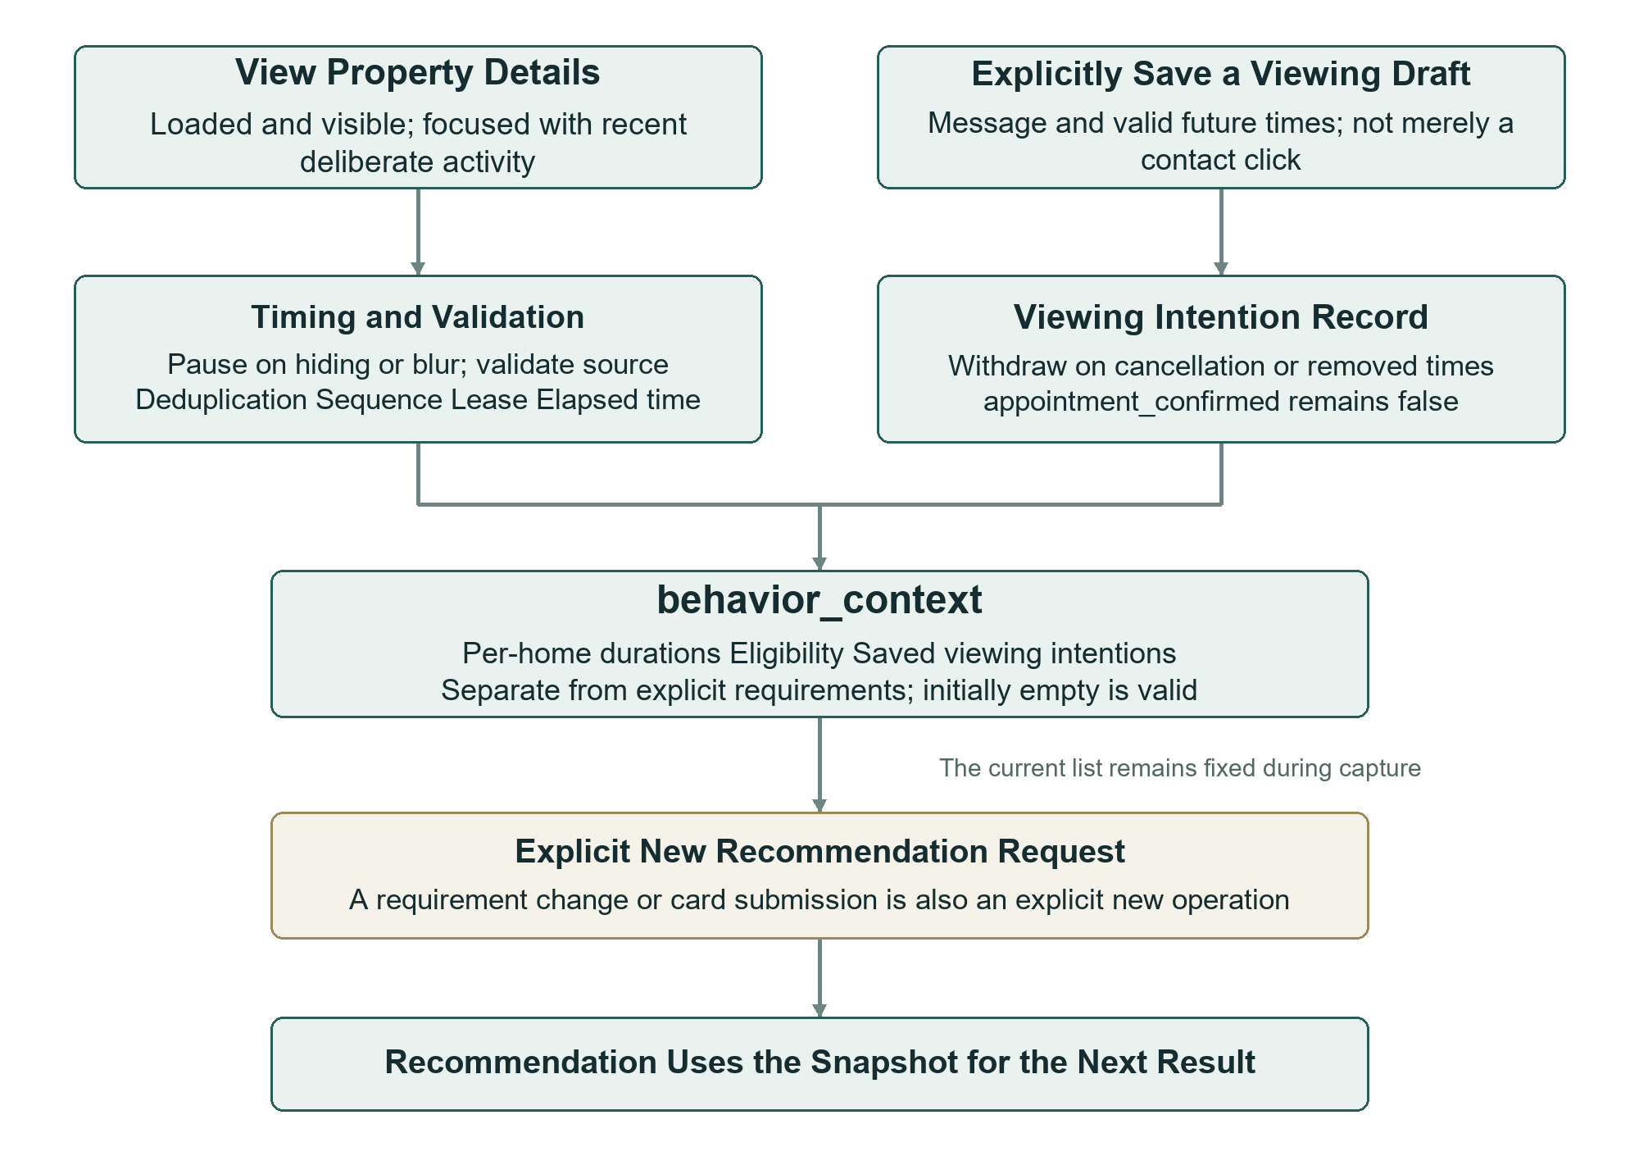
Figure 4 Behaviour capture and the next explicit recommendation

7.4 Modular Interaction and Language Edition Maintenance
Refinement, date selection, details, navigation and synchronisation are separate frontend modules, allowing focused interaction fixes without altering the recommendation core. Conversation deletion cancels relevant unfinished work and blocks later access, avoiding hidden entries that still receive updates. The English edition translates interface, prompts and knowledge content in a separate sibling directory and adapts layout for longer labels while retaining field and business semantics. Modularity and edition isolation reduce the scope of changes across interface, state and algorithms.

8 Engineering Improvements and Verification Evidence

8.1 Technical Improvements From Observed Failure Modes
Iteration turns observed failures into inspectable mechanisms. Missing transport preferences motivated model-first proposals and coverage. Lost conditions motivated effective-state previews. Field-dump introductions motivated evidence bundles and cohort comparisons. Writer failure despite available homes motivated validated recovery, while delayed display motivated durable events and frontend reconciliation. Table 3 links each issue to its change and observable effect. The value is better cooperation across meaning, facts, execution and display, rather than a larger number of agents.
Table 3 Main issues and technical improvements
Issue | Mechanism | Observable effect
Missed paraphrases/preferences | LLM proposals, coverage and semantic review | Inspect completeness and hard/soft meaning
Lost/obsolete conditions | Incremental compilation and state preview | Update intended targets and retain other conditions
Filter-only explanations | Enrichment, cohort positions and selected examples | Explain features and meaningful trade-offs
Writer failure blocks results | Saved diagnostics and validated recovery | Available homes retain grounded introductions
Delayed visible results | Durable events, SSE cursors and reconciliation | Reconcile the interface after completion
Mock refinement trigger | Native active signal, pool and field checks | Trigger valid cards and stop inactive/exhausted cases
Five texts versus nine cards | Shared Top5 projection and source checks | Use the same cohort across modules
Ambiguous behavioural signals | Validated segments and saved viewing drafts | Separate hidden time, active viewing and intention
Coupled module updates | Contract adaptation and versioned exchanges | Evolve recommendation and application independently

8.2 A Refinement Loop Against Real Data
A saved isolated integration run began with homes within three kilometres of NUS and rent at most SGD 2500, using real PostgreSQL, Neo4j, data HTTP and recommendation HTTP. From 21,431 candidates, the first round recorded 239 hard-eligible homes, displayed five and returned active=true. The card asked about bedrooms, preferred rent and closer homes. Selecting one bedroom, keeping the budget and preferring closer homes submitted structured input through A→B→C. The next display again contained five, retained the cap without adding preferred rent, and returned active=false, stopping further cards. This verifies connections among the signal, interaction and agent transitions. [E15]
The browser did not intercept APIs to fabricate this chain, but native tool scheduling used deterministic test mode and Explanation deliberately exercised evidence recovery. The run supports real dependencies and state integration, rather than independently proving live generation and semantic-review quality. Separating these acceptance layers makes it easier to control cost and locate problems in service integration, task progression or model output.

8.3 Layered Checks and Evaluation Scope
Verification includes contracts/unit checks, isolated database workflows, real-service integration and browser interactions. Saved English-migration records report 331 passing Node cases, 22 configured skips and no failures. Database tests cover duplicate submission, ownership, stale cards, budget preservation and exhausted fields; desktop, tablet and mobile checks cover Top5, details, photo dialogs and active viewing. [E15–E16] These records establish tested implementation behaviour. Claims about decision efficiency or recommendation quality would require user studies, quality annotation and controlled comparisons, rather than being inferred from test counts.

9 Design Value and Further Development

9.1 From Role Separation to a Reliable Workflow
The central technical value is embedding open language capability within explicit application mechanisms. Contracts and prompts define tasks; selected examples demonstrate semantics and natural expression; context and evidence bound information; tools and state machines connect services; programmatic and semantic feedback check and repair outputs. Four roles cooperate through versioned exchanges, while users participate through refinement and action confirmation. The recommendation core remains independent within a continuous, traceable experience. Agent capability therefore comes from the interaction of models, data and execution mechanisms, rather than a long system prompt alone.

9.2 Current Boundaries and Further Evaluation
The current deployment uses historical listings, so availability needs confirmation, and actual walking, driving and transit routes are not default integrations. Validated viewing duration is still an interest proxy requiring user research. Generation and review can share errors, motivating controlled quality samples and targeted regression. Further evaluation can separately measure requirement completeness, factual error, effective repair, latency and user selection efficiency, distinguishing normal generation from recovery. These measures align with individual mechanisms and help identify whether prompts, tools or workflow need improvement.
Operational deployment also requires formal identity/access management, monitoring, data updates and external-platform acceptance. Local calendar, file export and manual sending already provide the core workflow. External integrations should retain the same source, version, authorisation and state separation. These boundaries let capabilities grow from a verifiable implementation instead of relying on a model’s statement that an action succeeded.

References
These papers support the discussion of agent mechanisms. Appendix A identifies implementation sources; the text distinguishes research methods from the project implementation.
[R1] Lei Wang et al. A Survey on Large Language Model based Autonomous Agents. arXiv:2308.11432. Architecture discussion in version 6, 2024.
https://arxiv.org/html/2308.11432v6
[R2] Shunyu Yao et al. ReAct: Synergizing Reasoning and Acting in Language Models. ICLR 2023. arXiv:2210.03629.
https://arxiv.org/abs/2210.03629
[R3] Qingyun Wu et al. AutoGen: Enabling Next-Gen LLM Applications via Multi-Agent Conversation. 2023. arXiv:2308.08155.
https://arxiv.org/abs/2308.08155
[R4] Noah Shinn et al. Reflexion: Language Agents with Verbal Reinforcement Learning. 2023. arXiv:2303.11366.
https://arxiv.org/abs/2303.11366

Appendix A Implementation Evidence Index
The following internal project sources support the report. E1 refers to the original course proposal; other paths are relative to the current project root. References identify implementation or saved records, not newly repeated historical tests.

[E1] Original architecture proposal
Project Proposal Presentation proto.pptx
Historical architecture source; figures are redrawn for the current implementation.

[E2] Application runtime
src/​server.ts; api/​main.py; src/​agents/​profiles.ts
Role registration, service composition, interfaces and permissions.

[E3] Intent and routing
src/​agents/​orchestrator/​agent-orchestrator.ts; src/​agents/​orchestrator/​intent-recognizer.ts; src/​agents/​orchestrator/​intent-templates.ts
Complementary intent channels, grouping, routing and caching.

[E4] Task and state transitions
src/​agents/​master.ts; src/​agents/​worker.ts; src/​domain/​workflow.ts; src/​stores/​domain.ts
Persistent work, transitions, context, versions and idempotency.

[E5] Recommendation boundary
src/​adapters/​native-recommendation.ts; src/​contracts/​recommendation-native.ts; src/​shared/​recommendation-display.ts
Strict contracts, native archiving and Top5 projection.

[E6] Requirement semantics
src/​agents/​requirement/​extractor.ts; src/​agents/​requirement/​prompt.ts; src/​agents/​requirement/​contracts.ts; skills/​rental-requirement-intake/​SKILL.md; src/​agents/​requirement/​few-shot.ts
Structured intake, provenance, review and repair.

[E7] Requirement refinement
src/​agents/​requirement/​refinement/​trigger.ts; src/​agents/​requirement/​refinement/​planner.ts; src/​agents/​requirement/​refinement/​answers.ts; src/​agents/​requirement/​refinement/​service.ts
Native trigger, planning, structured merge and lifecycle.

[E8] Explanation generation
src/​agents/​explanation/​prompt.ts; src/​agents/​explanation/​decision-support.ts; src/​agents/​explanation/​generator.ts; src/​agents/​explanation/​validation.ts; src/​agents/​explanation/​recovery.ts; src/​agents/​explanation/​few-shot.ts; src/​agents/​explanation/​cohort.ts; src/​agents/​explanation/​model-input.ts; skills/​evidence-based-explanation/​SKILL.md
Flexible guidance, grounding, model review and recovery.

[E9] Supplementary evidence
src/​agents/​explanation/​enrichment.ts; src/​agents/​explanation/​evidence.ts; src/​domain/​listing-presentation.ts; src/​tools/​executor.ts
Read-only enrichment of selected IDs and tool governance.

[E10] Persistence and references
src/​agent-task-store.ts; src/​session-store.ts; migrations/​001-business.sql; migrations/​005-requirement-refinement.sql; migrations/​006-session-behavior-context.sql
Tasks, events, plans and behaviour persistence.

[E11] Interaction and display
frontend/​app.js; frontend/​session-sync.js; frontend/​property-detail-view.js; frontend/​requirement-refinement.js; frontend/​listing-navigator.js
Workspace, details, cards and reconciliation.

[E12] Follow-up
src/​domain/​actions.ts; src/​domain/​manual-followup.ts; src/​domain/​reply-analysis.ts; src/​domain/​followup.ts; src/​shared/​followup-message.ts; skills/​salesperson-followup/​SKILL.md
Drafts, replies, approval, reminders and calendar.

[E13] Retrieval augmented knowledge
src/​domain/​knowledge.ts; retrieval/​index.py; retrieval/​hybrid.py; knowledge/​rental/​
Knowledge indexing, hybrid recall and grounded answers.

[E14] Behaviour capture and transport
frontend/​view-tracker.js; frontend/​behavior-outbox.js; src/​domain/​behavior.ts; src/​domain/​behavior-context.ts; src/​contracts/​behavior-context.ts
Duration, validation, saved intentions and context snapshots.

[E15] Real integration record
evaluation/​reports/​requirement-refinement-real.json; scripts/​check_refinement_real.ts; scripts/​test_refinement_real_ui.py
Real dependencies, deterministic controller, no API interception and recovery scope.

[E16] English edition regression record
docs/​English_Edition_Migration.md; tests/​english-edition.test.ts; tests/​requirement-refinement-db.test.ts; scripts/​test_english_edition_ui.py
Saved regression/browser checks; not new live-model acceptance.

