Solutions to Chapter 4

Hands-On:

  - Use Wireshark or similar software to capture packets for couple seconds. Find an ARP packet and IP packet. Compare the difference between the MAC header of these two packets. Can you find the protocol ID for ARP and IP? Is the destination address of the ARP packet a broadcast address or unicast address? Is this ARP packet a request or reply packet? Examine the payload of this ARP packet.
Answer:
- Follow the same guidelines of exercise 2.
- The protocol type of ARP is 0x0806
- The protocol type of IP is 0x0800
- ARP request is a broadcast packet with destination of 0xFFFFFFFFFFFF (MAC address).
- ARP reply is an unicast packet

- Use virtual route or traceroute to find out the infrastructure of your domain and routes to foreign countries.
Answer:
- Run traceroute to different hosts outside of your domain; you will see a list of routers after each run.
- The first router returned is the router of your subnet
- Try to identify some intermediate routers in your domain from the list of routers. (Hint: they share the same IP prefix.)
- Try to identify the border router of your domain.
- Draw a graph which shows the connection of routers in your domain.
- From the traceroute to foreign hosts in different countries, you can also identify the border router to different foreign countries.

- Trace ip_route_input() and ip_route_output_key() in the source codes of Linux. Describe how packets are forwarded to upper layer and next hop, respectively.
Answer:
Both functions can be found in net/ipv4/route.c. The flow chart of ip_route_input() is given as follows:
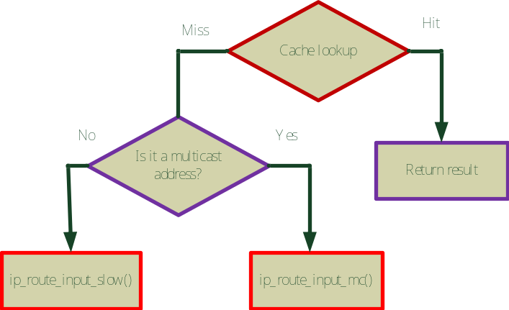
It first checks if the destination is in the cache. If yes, the routing entry is returned. Otherwise, it checks if the destination address is a multicast address. If yes, ip_route_input_mc() is called to find the routing entry for this packet. Otherwise, ip_route_input_slow() is called which in turn calls fib_lookup(), as described in open source implementation 3.2.

Similar to ip_route_input(),ip_route_output_key() checks the routing cache first, as shown in the following flow chart. In case of a cache miss, ip_route_output_slow() is called which is the major route resolver routine. ip_route_output_slow() also calls fib_lookup() at the end.
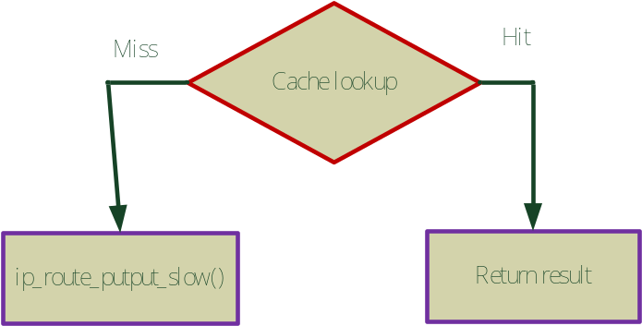

Written:

- What would be the problems when two hosts use the same IP address and ignore the existence of each other?
Answer:
Both hosts will reply ARP request of the same IP address. As a consequence, other hosts in the same subnet may map the IP address to the MAC address of one of these two hosts at one time and to that of the other at another time. This will cause packets sent to the wrong host. In general, protocols above IP layer will be affected. Most operating systems will detect duplicate IP addresses in a subnet by observing ARP reply messages and send warning messages to users.

- Consider an IP packet traversing a router:
  - Which fields in the IP header must be changed by a router when an IP packet traversed through the router?
  - Which fields in the IP header may be changed by a router?
  - Design an efficient algorithm for re-calculating the checksum field. (Hint: think about how these fields are changed?)
Answer:
- TTL must be decreased by 1; this would also change the checksum field.
- The more bit could be changed if the IP packet is fragmented at the router. This also change the offset field.
- Detailed algorithm could be found in RFC 1071 and RFC 1141. Let C be the original checksum and C’ be the new one. Let m be the original 16-bit integer that consists of the TTL field and the protocol id field (see the IPv4 header) and m’ be the integer of the same fields but with TTL decreased by 1. For 2's complement machines, the new 1’s complement of the checksum can be computed using follow equation:
~C' = ~(C + (-m) + m') = ~C + (m - m') = ~C + m + ~m'

- Consider a company is assigned an IP prefix of 163.168.80.0/22. This company owns three branches; each has 440, 70, and 25 computers, respectively. A router with two WAN interfaces is allocated at each branch to provide internetworking such that three routers are fully connected. If you are asked to plan subnet addresses for these three branches as well as addresses for router interfaces, what would you do? (Hint: a subnet is also required for each link between two routers.)
Answer:
Subnet address for branch A: 163.168.80.0/23; broadcast address: 163.168.81.255; Host ranges: 163.168.80.0-163.168.81.254
Subnet address for branch B: 163.168.82.0/25; broadcast address: 163.168.82.127; Host ranges: 163.168.82.1-163.168.82.126
Subnet address for branch C: 163.168.82.128/27; broadcast address: 163.168.82.159; Host ranges: 163.168.82.129-163.168.82.158
Router between A-B: 163.168.82.160/30; broadcast address: 163.168.82.163; Host ranges: 163.168.82.161-163.168.82.162
Router between A-C: 163.168.82.164/30; broadcast address: 163.168.82.167; Host ranges: 163.168.82.165-163.168.82.166
Router between B-C: 163.168.82.168/30; broadcast address: 163.168.82.171; Host ranges: 163.168.82.169-163.168.82.170
(Note that this is the most compact assignment, the planning could be less compact as long as it fits the 163.168.80.0/22 address space.)

- Compare the differences of ICMPv4 and ICMPv6. Do we still need DHCP, ARP and IGMP in IPv6?
Answer:
    - type and code numbers are re-assigned such that error messages have a type less than 127 and informational messages have a type larger than 127 but less than 256 in ICMPv6.
    - More functionalities are supported in ICMPv6, such as address auto-configuration, multicast membership management, and mobility management.
No, we do not need ARP and IGMP in IPv6 as they are already supported by ICMPv6. Whether DHCP needs to deployed depends on requirements of stateless or stateful automatic IPv6 address configuration. DHCPv6 is needed if stateful configuration is desired.

- Consider the following LAN with one Ether switch, S, one intradomain router, R, and two hosts, X, Y. Assume switch S has been just powered on.
  - Describe the routing and address resolution steps performed at X, Y, and S when X sends an IP packet to Y.
  - Describe the routing and address resolution steps performed at X, Y, and S when Y replies an IP packet to X.
  - Describe the routing and address resolution steps performed at X, S and R when X sends an IP packet to a host that is outside the domain. (Hint: do not forget to explain how does X know of the router R.)
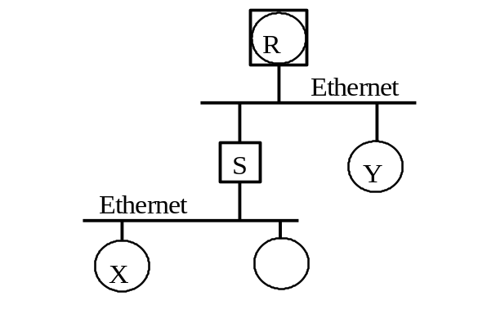
Answer:
- When X wants to send a packet to Y, it performs IP routing by checking whether they are in the same subnet. The answer is yes, therefore, X invokes an ARP request to find Y’s MAC address. Since the ARP request is broadcasted, switch S will forward it to Y (while remember the incoming port for X at the same time). When Y replies X’s ARP request, it knows X’s MAC address directly from X’s ARP request. So Y will reply a unicast ARP response to X. Upon receiving the packet, switch S already has X’s port information. Therefore, S will forward the packet to X on the appropriate port.
- Similar to answer (a), when Y wants to send an IP packet to X, it also checks whether X and Y are in the same subnet. Since they are in the same subnet and Y already has X’s MAC address in its ARP cache, it can send the packet to X directly. Again, no routing is required in this case.
- X first checks if the destination is within the same IP subnet. Since it is not, X then searches its routing table to find the next hop router toward this destination. In most cases, X will use the default router. Once the next hop router is determined, X then sends an ARP request to ask for the router’s MAC address. Since switch S does not know where the router is, it will broadcast the ARP request. The router, R, will reply the ARP request by unicast. Since switch S knows X already, the ARP reply is forwarded to X directly. Upon receiving the ARP reply, X then sends the packet to the router with the destination IP in the IP header and router’s MAC address in the Ethernet header.

- Consider the following network topology. Show how node A constructs its routing table using Link-State routing and Distance Vector routing, respectively.
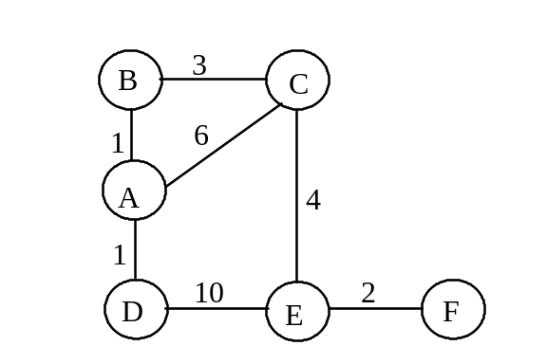
Answer:
Link-State routing:
Dijkstra’s algorithm for node A:
Iteration | T | C(B),p(B) | C(C),p(C) | C(D),p(D) | C(E),p(E) | C(F),p(F)
0 | A | 1,A | 6,A | 1,A | ∞ | ∞
1 | AB |  | 4,B | 1,A | ∞ | ∞
2 | ABD |  | 4,B |  | 11,D | ∞
3 | ABDC |  |  |  | 8,C | ∞
4 | ABDCE |  |  |  |  | 10,E
5 | ABDCEF

Distance Vector routing:
Routing table of node A after each step:
Initial Step:
Destination | Cost | Next Hop
B | 1 | B
C | 6 | C
D | 1 | D
E
F
Step1:
Destination | Cost | Next Hop
B | 1 | B
C | 4 | B
D | 1 | D
E | 10 | C
F
Step2:
Destination | Cost | Next Hop
B | 1 | B
C | 4 | B
D | 1 | D
E | 8 | B
F | 12 | C
Step3:
Destination | Cost | Next Hop
B | 1 | B
C | 4 | B
D | 1 | D
E | 8 | B
F | 10 | B

The final routing table of node A is: (both algorithms)
Destination | Cost | Next Hop
B | 1 | B
C | 4 | B
D | 1 | D
E | 8 | B
F | 10 | B

- Distance vector routing algorithm is adopted in intra-domain routing (e.g., RIP) as well as inter-domain routing (e.g., BGP), but is implemented with different concerns and additional features. Compare the differences between intra-domain routing and inter-domain routing when both of them use the distance vector algorithm.
Answer:
  - Looping needs to be avoided in inter-domain routing, so we usually use path vector routing instead of distance vector routing.
  - As an intra-domain routing protocol, RIP aims to find least cost paths. In particular, the link cost for each link is set to unity. However, since different domain may use different cost metric, BGP, as an inter-domain routing protocol, has very different concerns, such as local preference, hop count, etc.
  - Inter-domain routing needs to perform policy routing. Reachability is more important than cost optimization.

- Show the multicast tree built by DVMRP in the following network topology.
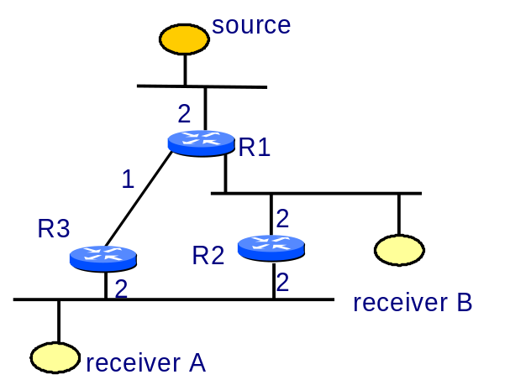
Answer:
