Solutions to Chapter 5

Hands-On: (25 points each)

- NS-2 is the most popular simulator for TCP research. It includes a package called NAM that can visually replay the whole simulation at all timescales. Many websites that introduce ns-2 can be found at [13]. Use NAM to observe a TCP running from a source to its destination, with and without buffer overflow at one intermediate router.
  - Step 1: Search the ns-2 website and download suitable version for your target platform.
  - Step 2: Follow the installation instructions to install the all the packages.
  - Step 3: Build a scenario consisting of three cascaded nodes, one for the Reno TCP source, one for an intermediate gateway, and one for the destination. The links to connect them are full-duplex 1Mbps.
  - Set the gateway to have large buffer. Run a TCP source towards the destination.
  - Set the gateway to have small buffer. Run a TCP source towards the destination.
For all the Reno TCP state that the Reno TCP source in the above two tests enter, screen dump them and indicate which state the TCP source is in. The figures should be correlated. For example, to represent the slow-start behavior you may display it by two figures: (1) an ACK is coming back; (2) the ACK triggers out two new data segments. Carefully organize the figures so that the result of this exercise is no more than one A4 page. Only display necessary information in the screen dumps. Pre-process the figures so that no window decorations (window border, NAM buttons) are displayed.
Answer:
Large Buffer
Because the buffer size is big, and the bandwidth of 0->1 and 1->2 are equal, there is no packet lose, and it will not enter Fast Retransmit or Fast Recovery state
- Slow Start:
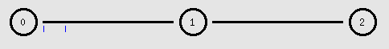
Receiving 2 ACKs
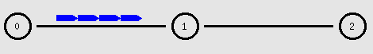
Sending 4 packets
- Congestion Avoidance
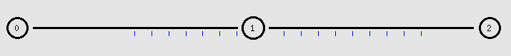
Receiving 16 ACKS
Sending 20 packets
Small Buffer (queue-limit of node 1 and 2 is 2, and bandwidth 0->1 is 2M, 1->2 is 1M)
- Fast Retransmit
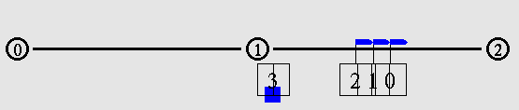
TCP packet lost because of buffer overflow
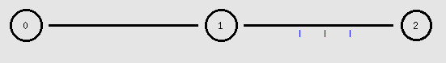
Three ACKs for packet 0-2
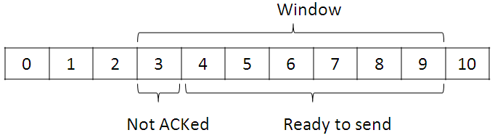
After receiving three ACKs, The window of 0 is 4+3=7
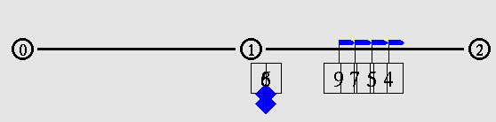
The host 1 transmits 4-9 packets
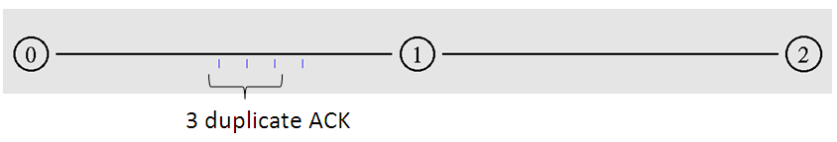
3 duplicate ACK back to host 0, then host 0 enter to Fast Retransmit state
- Fast Recovery
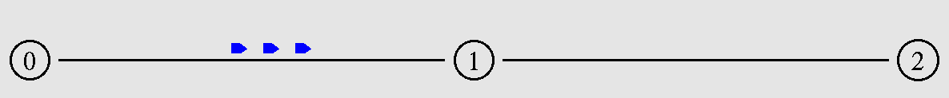
Sending missing packet
- Retransmit timeout
I add a timer after it sends out Fast Recovery packet, sets the queue size of 1->2 is 1, so the retransmit packet will lost.
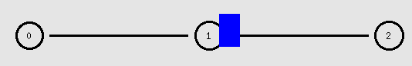
Packet lost
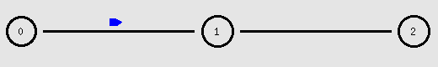
Timeout, node 0 sets cwnd=1 and starts from slow start

Sample script for ns2
#Create a simulator object
set ns [new Simulator]

#Define different colors for data flows (for NAM)
$ns color 1 Blue

#Open the NAM trace file
set nf [open out.nam w]
$ns namtrace-all $nf
#$ns trace-all $nf
#Define a 'finish' procedure
proc finish {} {
global ns nf
$ns flush-trace
#Close the NAM trace file
close $nf
#Execute NAM on the trace file
exec nam out.nam &
exit 0
}

#Create four nodes
set n0 [$ns node]
set n1 [$ns node]
set n2 [$ns node]

#Create links between the nodes
$ns duplex-link $n0 $n1 2Mb 50ms DropTail
$ns duplex-link $n1 $n2 1Mb 50ms DropTail
#Set Queue Size of link (n2-n3) to 2
$ns queue-limit $n1 $n2 2

#Give node position (for NAM)
$ns duplex-link-op $n0 $n1 orient right
$ns duplex-link-op $n1 $n2 orient right

#Monitor the queue for link (n2-n3). (for NAM)
$ns duplex-link-op $n1 $n2 queuePos 0.5
$ns duplex-link-op $n0 $n1 queuePos 0.5

#Setup a TCP connection
set tcp [new Agent/TCP/Reno]
$tcp set class_ 2
$ns attach-agent $n0 $tcp
set sink [new Agent/TCPSink]
$ns attach-agent $n2 $sink
$ns connect $tcp $sink
$tcp set fid_ 1

#Setup a FTP over TCP connection
set ftp [new Application/FTP]
$ftp attach-agent $tcp
$ftp set type_ FTP

#Schedule events for the CBR and FTP agents
$ns at 0.0 "$ftp start"
#$ns at 0.88 "$ns queue-limit $n1 $n2 1"
$ns at 40.0 "$ftp stop"

#Detach tcp and sink agents (not really necessary)
#$ns at 4.5 "$ns detach-agent $n0 $tcp ; $ns detach-agent $n2 $sink"

#Call the finish procedure after 5 seconds of simulation time
$ns at 40.0 "finish"

#Run the simulation
$ns run

- Linux Packet Socket is a useful tool when you want to generate arbitrary types of packets. Find and modify an example program to generate a packet and sniff the packet with the same program.
Answer:
We use the following UDP server/client as an example.
The client sends the message about “0x00,0x01,0x02,0x03,0x04,0x05” to the server.
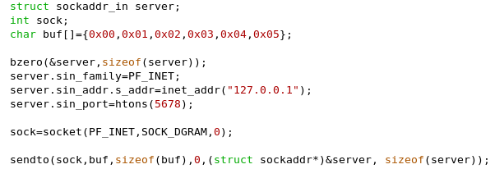

When the server receives the message, it prints out the results.
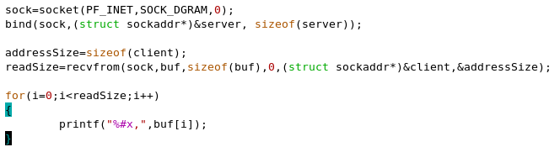
The output is as follows.
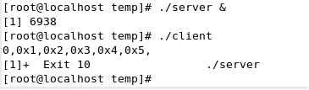

- What transport protocols are used in MS Media Player or RealMedia? Please use Wireshark to observe and find out the answer.
Answer:
Protocols used by MS Windows Media Player:
HTTP, Microsoft Media Server (MMS) Protocol, Real Time Streaming Protocol, Media Transfer Protocol, Picture Transfer Protocol
Protocols used by RealMedia:
HTTP, Real Time Streaming Protocol, Progressive Network Streaming Protocol, Microsoft Windows Media Streaming Protocol
Written: (10 points each)
- Consider that a mobile TCP receiver is receiving data from its TCP sender, what will the smoothed RTT and the RTO evolve when the receiver gets farer and then nearer? Assume the moving speed is very fast such that the propagation delay ranges from 100 ms to 300 ms within 1 second.
Answer:
Whenever the receiver gets farer and nearer, the difference between the real RTT and the smoothed RTT becomes larger gradually, and the RTO/RTT will be increased too because of the increasing variation of RTT.

- Given that the throughput of a TCP connection is inversely proportional to its RTT, connections with heterogeneous RTTs sharing the same queue will get different bandwidth shares. What will be the eventual proportion of the bandwidth sharing among three connections if their propagation delays are 10 ms, 100 ms, 150 ms, and the service rate of the shared queue is 200 kbps? Assume that the queue size is infinite without buffer overflow (no packet loss), and the max window of the TCP sender is 20 packets, with each packet having 400 bytes. (1k=1000)

Answer:
Total bandwidth=200kbps, Assume the constant is k
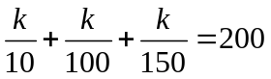
k=1714.3
Thus, the bandwidth for these connections is 171.4kbps, 17.1kbps, and 11.4kbps, respectively.

- If the smoothed RTT kept by the TCP sender is currently 30 msec and the following measured RTT are 26, 32, and 24 msec, respectively. What is the new RTT estimate?
Answer:
After 26 ms: (30-(30>>3))+(26>>3)=30 ms
After 32 ms: (30-(30>>3))+(32>>3)=31 ms
After 24 ms: (31-(31>>3))+(24>>3)=31 ms

- Suppose you are going to design a real-time streaming application over the Internet that employs RTP on top of TCP instead of UDP, what situations will the sender and the receiver encounter in each TCP congestion control state shown in Figure 4.9? Compare your expected situations with those designed on top of UDP in a table format.
Answer:
They may suffer the lagged-screen problem when the state changes from fast-retransmission to fast-recovery because the bandwidth is used to retransmitting packets which are out-of-date for streaming playback, and when the state enters the retransmission timeout state because no packets are received for a long time. Besides, longer latency may be experienced by interactive streaming users when RTP is running over TCP than UDP, because of the oscillatory rate resulted from the behavior in the congestion avoidance state.

State | TCP | UDP
Slow Start | The cwnd is exponentially increasing. The quality is also increased. | Only limited by link bandwidth and processing speed
Congestion Avoidance | The cwnd is linearly increasing. The quality is increased slowly. | Only limited by link bandwidth and processing speed
Fast Retransmission | The cwnd is linearly increasing | No retransmission
Fast Recovery | The retransmission might not meet the real-time demand | No retransmission
Retransmission Timeout | The cwnd is set to 1 and the quality is dramatically decreased | No retransmission and No affect on the quality

- The text spends a great amount of pages introducing the different versions of TCP. Identify three more TCP versions by searching http://www.lib.nctu.edu.tw/n_service/abi.html. Itemize them and highlight their contributions within three lines of words with each TCP version.
Answer:
FAST TCP: for long-distance and high latency links
TCP-WELCOME: able to recognize different styles of data losses within MONET (i.e. link failure, wireless channel errors, congestion)
SIMD TCP: efficiently available-bandwidth probing and fast convergence behavior, suitable to carry variable-rate streaming traffic.

