**Problem 1**

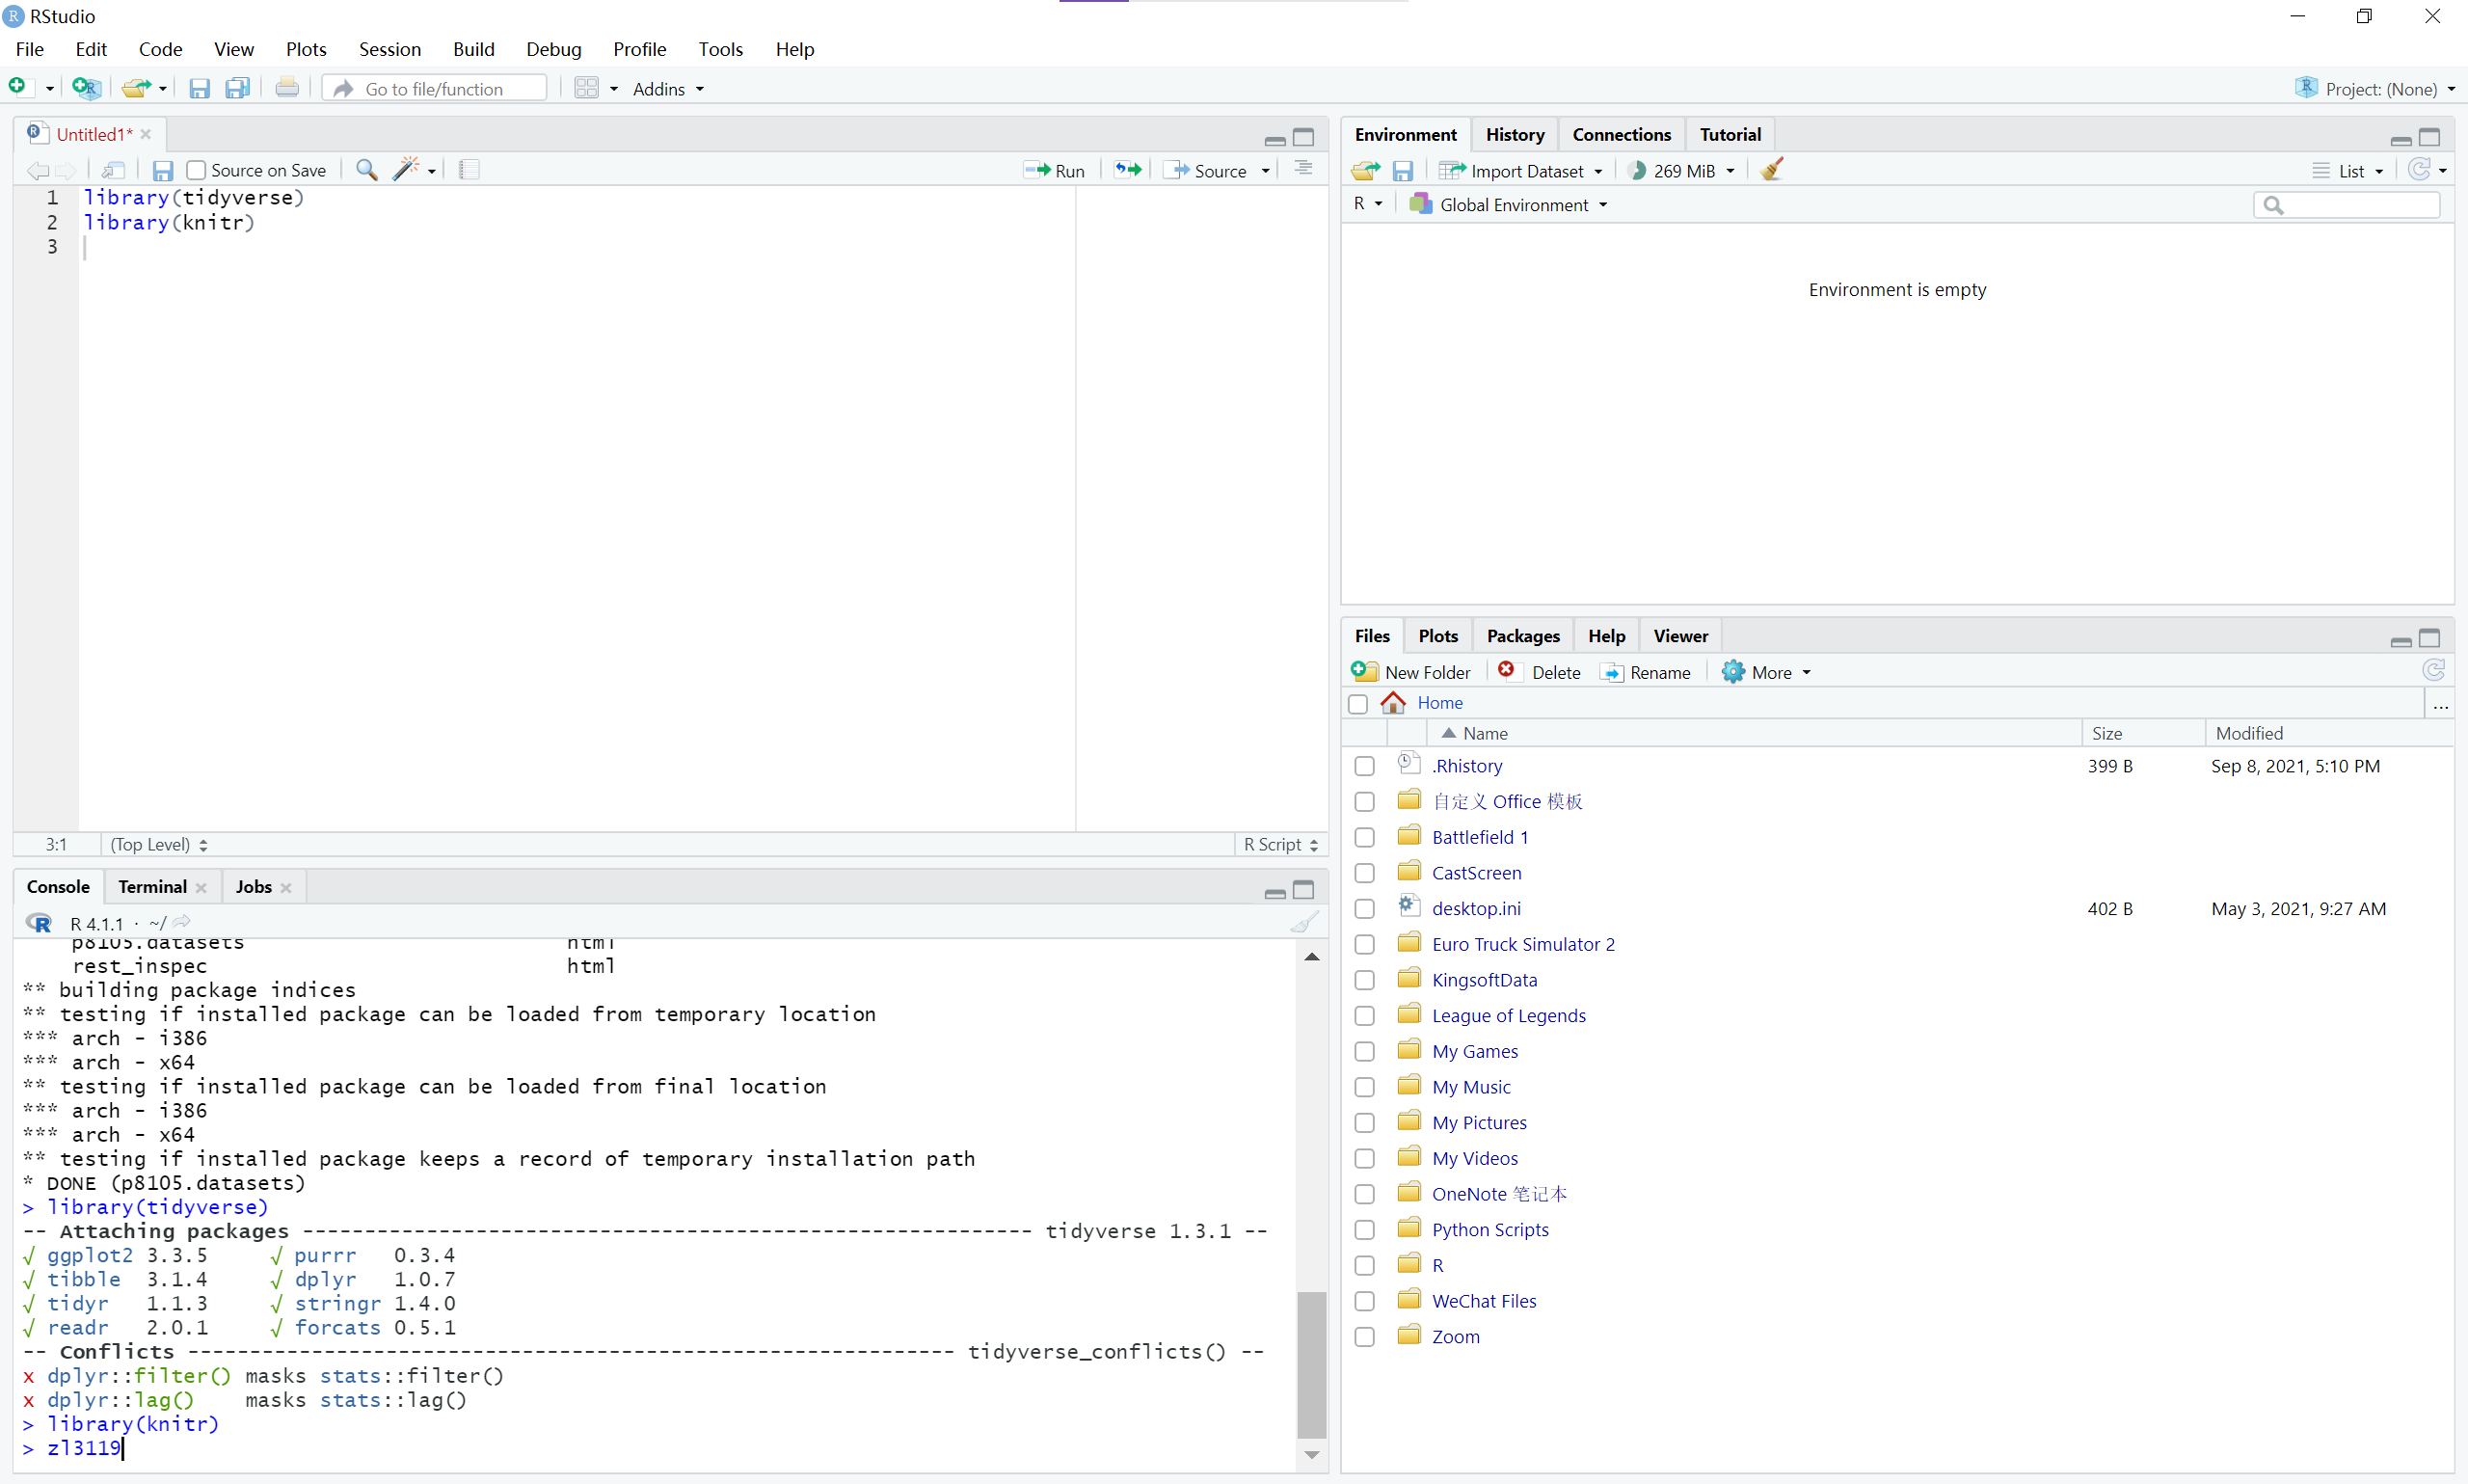

**Problem 2**

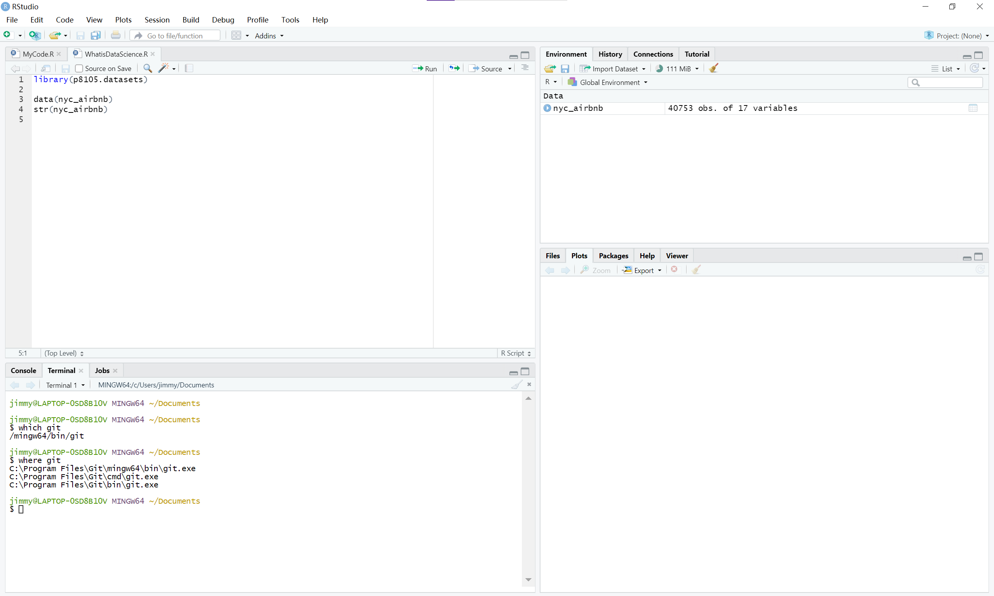

**Problem 3**

Github Username:zheyanliu99