**Problem 1**

**a)** According to Bayes rule:

$p(φ_{ij}|r_{ij},u_{i}{,v}_{j})$ = $\frac{p({r_{ij}|φ}_{ij}) p(φ_{ij}|u_{i}, v_{j})}{\int{p({r_{ij}|φ}_{ij}) p(φ_{ij}|u_{i}, v_{j})}dφ_{ij}}$

According to the model ri,j = sign(φi,j):

=

=

Therefore, when ri,j = 1, p(φij|rij, ui, vj) = TN1(uiTvj, σ2) and when rij = -1, p(φij|rij, ui, vj) = TN-1(uiTvj, σ2)

Then, we can derive q(φ) by :

q(φ) = $\prod_{ij∈Ω}{q(}φ_{ij})$

= $\prod_{ij∈Ω}{p(}φ_{ij}|r_{ij},u_{i}{,v}_{j})$

= $\prod_{ij∈Ω}{{TN}_{r_{ij}}(}u_{i}^{T}v_{j},σ^{2})$

**b)** According to EM algorithm:

☹ (U, V) = $\int{q\left(φ\right)ln\frac{p(R,U,V,φ)}{q\left(φ\right)}d}φ$

According to Bayes rule:

☹ (U, V) = $\int{q\left(φ\right)(lnp\left(U,V\right)+lnp(R|}φ)+ln⁡p(φ|U,V))dφ-E_{q}[lnq(φ)]$

Since ${q(φ}_{i,j})={TN}_{r_{i,j}}(u_{i}^{T}v_{j},σ^{2})$ is only defined on values of $φ_{ij}$ when $sign(φ_{ij})=r_{ij}$, lnp(R|) = 0. And $E_{q}[lnq(φ)]$ is a constant . Then we can get:

   ☹ (U, V) $=ln{p(U, V)}+E_{q}[\ln{p\left(φ | U,V\right)}]-E_{q}[lnq(φ)]$

Because of the independence of each ui, vj:

Then we can get:

☹ (U, V) $=-\frac{1}{2c}(\sum_{i=1}^{M}{u_{i}^{T}u_{i}}+\sum_{j=1}^{N}{v_{j}^{T}v_{j})}+\sum_{i,j∈Ω}{E_{q}\left[-\frac{{\left(φ_{ij}-u_{i}^{T}v_{j}\right)}^{2}}{2σ^{2}}\right]+const}$

= $-\frac{1}{2c}(\sum_{i=1}^{M}{u_{i}^{T}u_{i}}+\sum_{j=1}^{N}{v_{j}^{T}v_{j})}+\sum_{i,j∈Ω}{{\frac{1}{2σ^{2}}({2u}_{i}^{T}v_{j}E}_{q}\left[φ_{ij}\right]-}{(u_{i}^{T}v_{j})}^{2})+const$

**c)**

Solving for ▽U,V ☹(U, V) = 0, we can find that one solution is:

**d)**

1. Initializing U0, V0 to vectors generated from normal distribution

2.For interation t = 1,2, …, T

(a)E-step: Calculate E = {$E_{q}[φ_{i,j}]$}, where

$u_{i(t-1)}^{T}v_{j(t-1)}+σ×\frac{Φ^{'}(-\frac{u_{i\left(t-1\right)}^{T}v_{j\left(t-1\right)}}{σ})}{1-Φ(-\frac{u_{i\left(t-1\right)}^{T}v_{j\left(t-1\right)}}{σ})}$ if rij = 1

$E_{q}[φ_{ij}]$ =

$u_{i(t-1)}^{T}v_{j(t-1)}+σ×\frac{{-Φ}^{'}(-\frac{u_{i\left(t-1\right)}^{T}v_{j\left(t-1\right)}}{σ})}{Φ(-\frac{u_{i\left(t-1\right)}^{T}v_{j\left(t-1\right)}}{σ})}$ if rij = -1

(b)M-step: Update vector U, V using the expectations above in the following equations

$$u_{it}={(\frac{1}{c}I+\sum_{(i,j)∈Ω}{{v_{j(t-1)}v_{j(t-1)}}^{T}/σ^{2}})}^{-1}\sum_{(i,j)∈Ω}{E_{qt}\left[φ_{ij}\right]v_{j(t-1)}/σ^{2}}$$

$$v_{jt}={(\frac{1}{c}I+\sum_{(i,j)∈Ω}{{u_{it}u_{it}}^{T}/σ^{2}})}^{-1}\sum_{(i,j)∈Ω}{E_{qt}\left[φ_{ij}\right]u_{it}/σ^{2}}$$

(c)Calculate ln p(U,V,R) using the equation

ln p(U,V,R)= $-\frac{\left(M+N\right)d}{2}ln2πc-\frac{1}{2c}(\sum_{i=1}^{M}{u_{i}^{T}u_{i}}+\sum_{j=1}^{N}{v_{j}^{T}v_{j})}+\sum_{i,j∈Ω}{ln⁡(u\left(-r_{ij}\right)+r_{ij}}Φ(\frac{u_{i}^{T}v_{j}}{σ}))$

u(x) is the step function

**Problem 2**



Value of ln p(U,V,R) for iterations 2 through 100

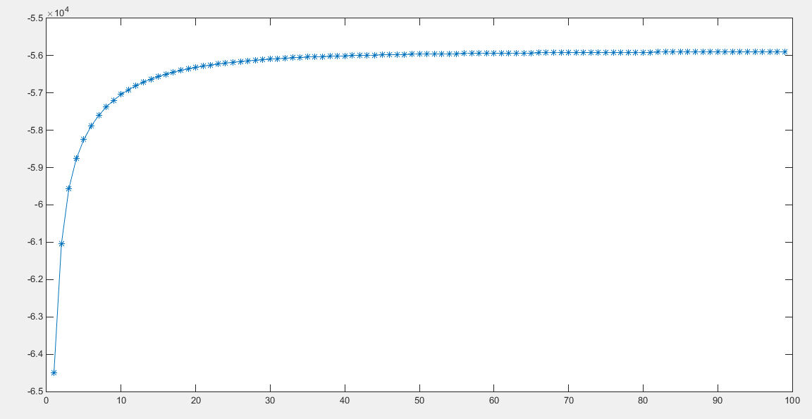

**b)**

Value of ln p(U,V,R) for iterations 20 through 100 with 5 random starting points

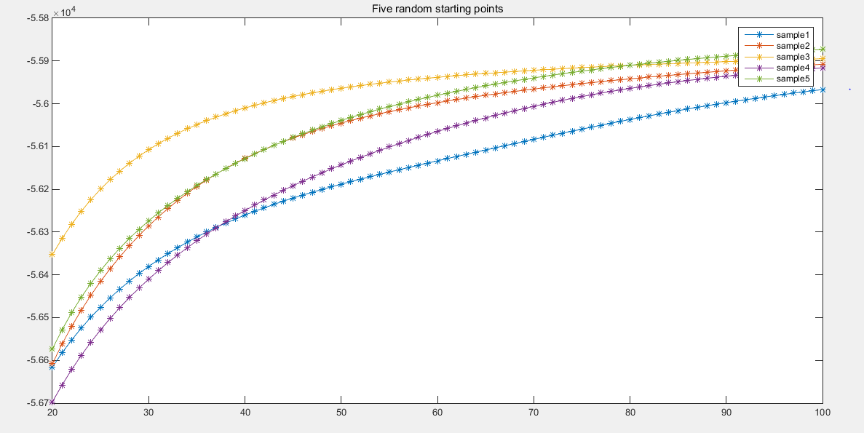

**c)**

confusion matrix:

predicted_like predicted_dislike

______________ _________________

like 2145 589

dislike 824 1442