**Problem 1**

1. According to the note

$q\left(ω\right)∝exp\{E_{q\left(α_{1},{…,α}_{d},λ\right)}\left[lnp\left(y | x,ω,λ\right)+lnp\left(α_{1},{…,α}_{d}\right)+lnp\left(ω|α_{1},{…,α}_{d}\right)+lnp\left(λ\right)\right]\}$

$∝\exp\left\{\sum_{i=1}^{N}{E_{q\left(λ\right)}[} lnp\left(y_{i} | x_{i},ω,λ\right)\right]+E_{q\left(α_{1},{…,α}_{d}\right)}[lnp\left(ω|α_{1},{…,α}_{d}\right)]\}$

$∝[\prod_{i=1}^{N}{e^{\frac{1}{2}E\left[λ\right]}e^{-\left(\frac{E_{q\left(λ\right)}\left[λ\right]}{2}\right){\left(y_{i}-x_{i}^{T}ω\right)}^{2}}}]e^{-\frac{1}{2}\sum_{k=1}^{d}{E_{q\left(α_{k}\right)}[α_{k}]ω_{k}^{2}}}$

Therefore $q\left(ω\right)=Normal(ω|μ^{'},Σ^{'})$

$μ^{'}=Σ^{'}(E_{q\left(λ\right)}\left[λ\right]\sum_{i=1}^{N}{y_{i}x_{i}})$

$Σ^{'}={(diag\left({E_{q\left(α_{1}\right)}[α}_{1}],{…,E_{q\left(α_{d}\right)}[α}_{d}]\right)+E_{q\left(λ\right)}\left[λ\right]\sum_{i=1}^{N}{x_{i}x_{i}^{T}})}^{-1}$

$$q\left(λ\right)∝exp\{E_{q\left(α_{1},{…,α}_{d},ω\right)}\left[lnp\left(y | x,ω,λ\right)+lnp\left(α_{1},{…,α}_{d}\right)+lnp\left(ω|α_{1},{…,α}_{d}\right)+lnp\left(λ\right)\right]\}$$

$∝exp⁡\{\sum_{i=1}^{N}{E_{q\left(ω\right)}[} lnp\left(y_{i} | x_{i},ω,λ\right)]\}p\left(λ\right)$

$∝[\prod_{i=1}^{N}{λ^{\frac{1}{2}}e^{-\frac{λ}{2}E_{q\left(ω\right)}[{\left(y_{i}-x_{i}^{T}ω\right)}^{2}]}]λ^{e_{0}-1}e^{-f_{0}λ}}$

Therefore $q\left(λ\right)=Gamma(λ|e^{'}, f^{'})$

$e^{'}=e_{0}+\frac{N}{2}$, $f^{'}=f_{0}+\frac{1}{2}\sum_{i=1}^{N}{E_{q\left(ω\right)}[}{\left(y_{i}-x_{i}^{T}ω\right)}^{2}]$

For k=1,…,d

$$q\left(α_{k}\right)∝exp\{E_{q\left(ω,λ\right)\prod_{j≠k}^{d}{q\left(α_{j}\right)}}\left[lnp\left(y | x,ω,λ\right)+lnp\left(α_{1},{…,α}_{d}\right)+lnp\left(ω|α_{1},{…,α}_{d}\right)+lnp\left(λ\right)\right]\}$$

$∝exp⁡\{lnp\left(α_{k}\right)-\frac{1}{2}{(-lnα_{k}+E}_{q\left(ω\right)\prod_{j≠k}^{d}{q\left(α_{j}\right)}}\left[ω^{T}diag\left(α_{1},{…,α}_{d}\right)ω\right])\}$

$∝e^{-\frac{1}{2}{(-lnα_{k}+E}_{q\left(ω\right)\prod_{j≠k}^{d}{q\left(α_{j}\right)}}\left[ω^{T}diag\left(α_{1},{…,α}_{d}\right)ω\right])}α_{k}^{a_{0}-1}e^{-b_{0}α_{k}}$

Therefore $q\left(α_{k}\right)=Gamma(α_{k}|a^{'},b_{k}^{'})$



$b_{k}^{'}=b_{0}+\frac{1}{2}(Σ^{'}(k,k)+{μ^{'}\left(k\right)}^{2})$

$$a^{'}=a_{0}+\frac{1}{2}$$

**Inputs**: Data and definitions $q\left(ω\right)=Normal(ω|μ^{'},Σ^{'})$, $q\left(λ\right)=Gamma(λ|e_{0}^{'}, f_{0}^{'})$ and $q\left(α_{k}\right)=Gamma(α_{k}|a_{0}, b^{'})$

**Outputs**: Values for $μ^{'},{ Σ}^{'}, e^{'}, f^{'}, a^{'} and b_{k}^{'}$

1. initialize $μ_{0}^{'}, Σ_{0}^{'}, e_{0}^{'}, f_{0}^{'}, a_{0}^{'}, b_{k0}^{'}$ in some way
2. For iteration t = 1,…,T

Update q(λ) by setting

$e_{t}^{'}=e_{0}+\frac{N}{2}$, $f_{t}^{'}=f_{0}+\frac{1}{2}(\sum_{i=1}^{N}{{\left(y_{i}-x_{i}^{T}μ_{t-1}^{'}\right)}^{2}}+x_{i}^{T}Σ_{t-1}^{'}x_{i})$

Update q($ω$) by setting

$μ_{t}^{'}=Σ_{t}^{'}(\frac{e_{t}^{'}}{f_{t}^{'}}\sum_{i=1}^{N}{y_{i}x_{i}})$

$Σ_{t}^{'}={(diag\left(\frac{a_{t-1}^{'}}{b_{1(t-1)}^{'}},…,\frac{a_{t-1}^{'}}{b_{d(t-1)}^{'}}\right)+\frac{e_{t}^{'}}{f_{t}^{'}}\sum_{i=1}^{N}{x_{i}x_{i}^{T}})}^{-1}$

Updating q(α) by setting

$$b_{tk}^{'}=b_{0}+\frac{1}{2}(Σ_{t}^{'}(k,k)+{μ_{t}^{'}\left(k\right)}^{2})$$

$$a_{t}^{'}=a_{0}+\frac{1}{2}$$

Evaluate L($e_{t}^{'}, f_{t}^{'}, μ_{t}^{'}, Σ_{t}^{'}, {a_{t}^{'},b}_{t}^{'})$ to access convergence

L($e_{t}^{'}, f_{t}^{'}, μ_{t}^{'}, Σ_{t}^{'}, {a_{t}^{'},b}_{t}^{'})=E_{q}\left[lnp\left(y,ω,λ,α | x\right)\right]-E_{q}\left[lnq\left(ω\right)\right]-E_{q}\left[lnq\left(λ\right)\right]-E_{q}\left[lnq\left(α\right)\right]$

= $\frac{N}{2}\left(ψ\left(e_{t}^{'}\right)-ln2πf_{t}^{'}\right)-\frac{e_{t}^{'}}{f_{t}^{'}}\left(f_{t}^{'}-f_{0}\right)+$

$e_{0}lnf_{0}-lnτ\left(e_{0}\right)-\frac{f_{0}e_{t}^{'}}{f_{t}^{'}}+\left(e_{0}-1\right)\left(ψ\left(e_{t}^{'}\right)-lnf_{t}^{'}\right)+$

$\frac{d}{2}\left(ψ\left(a_{t}^{'}\right)-ln2π\right)-\sum_{k=1}^{d}{\left(\frac{a_{t}^{'}}{b_{kt}^{'}}(b_{kt}^{'}-b_{0})+\frac{1}{2}lnb_{kt}^{'}\right)+}$

$d\left(a_{0}lnb_{0}+\left(a_{0}-1\right)ψ\left(a_{t}^{'}\right)-lnτ\left(a_{0}\right)\right)-\sum_{k=1}^{d}{\left(\frac{b_{0}a_{t}^{'}}{b_{kt}^{'}}+\left(a_{0}-1\right)lnb_{kt}^{'}\right)}+$

$\frac{1}{2}ln\left|{2πeΣ}_{t}^{'}\right|-lnf_{t}^{'}+lnτ\left(e_{t}^{'}\right)+e_{t}^{'}-\left(e_{t}^{'}-1\right)ψ\left(e_{t}^{'}\right)-$

$d\left(\left(a_{t}^{'}-1\right)ψ\left(a_{t}^{'}\right)-lnτ\left(a_{t}^{'}\right)-a_{t}^{'}\right)-\sum_{k=1}^{d}{lnb_{kt}^{'}}$

**Problem 2**

1. For the first dataset

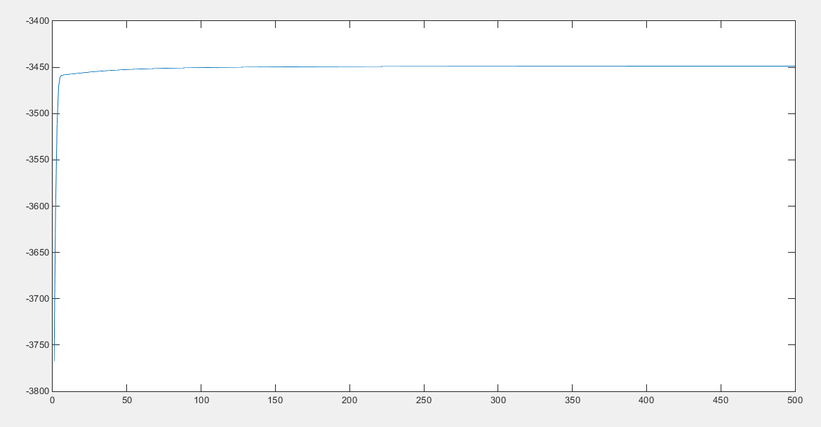

For the second dataset

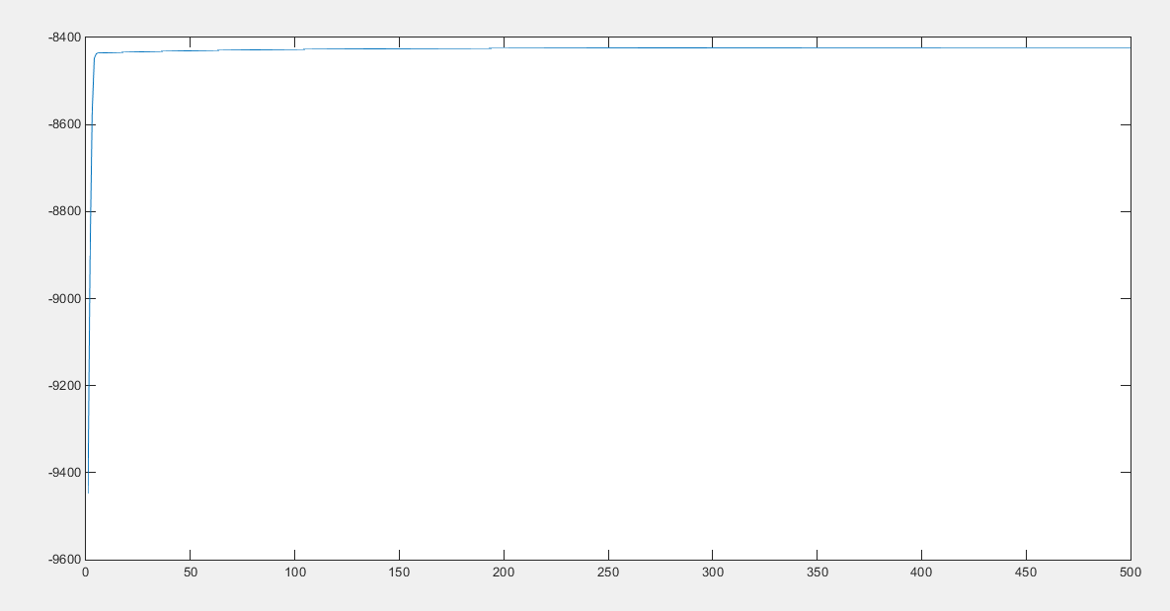

For the third dataset

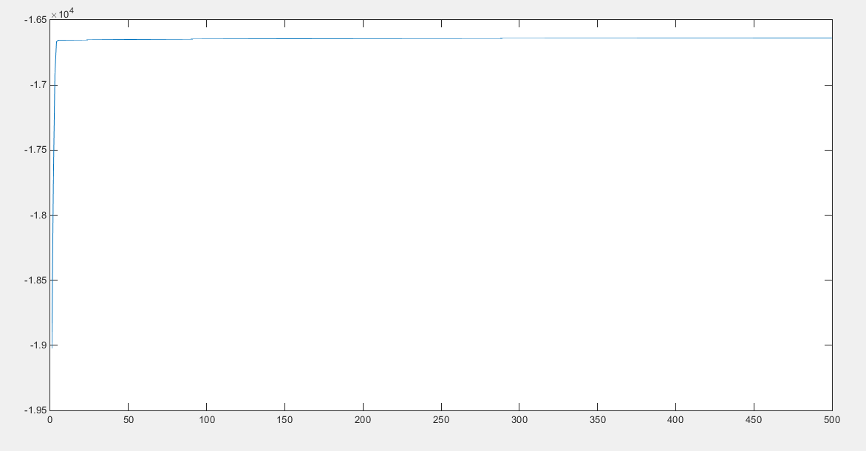

1. For the first dataset

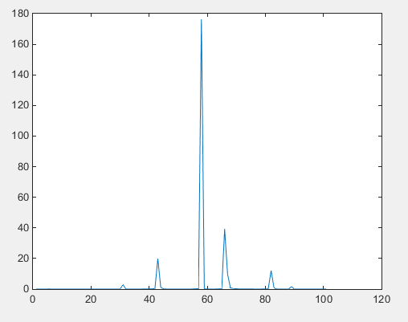

For the second dataset

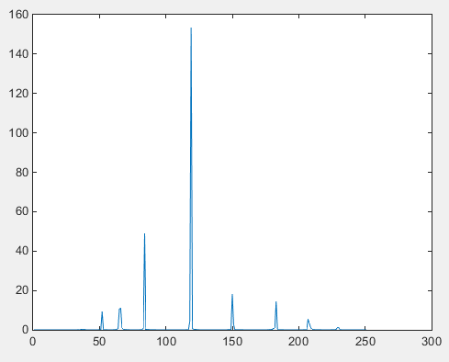

For the third dataset

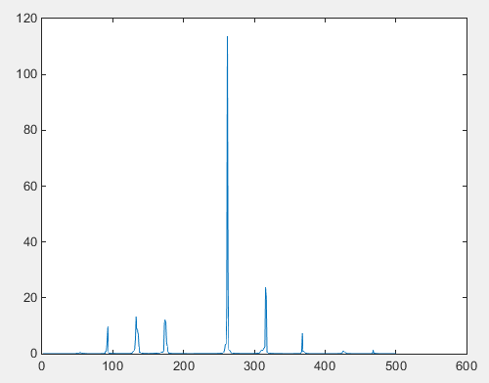

1. For the first dataset



For the second dataset



For the third dataset



1. For the first dataset

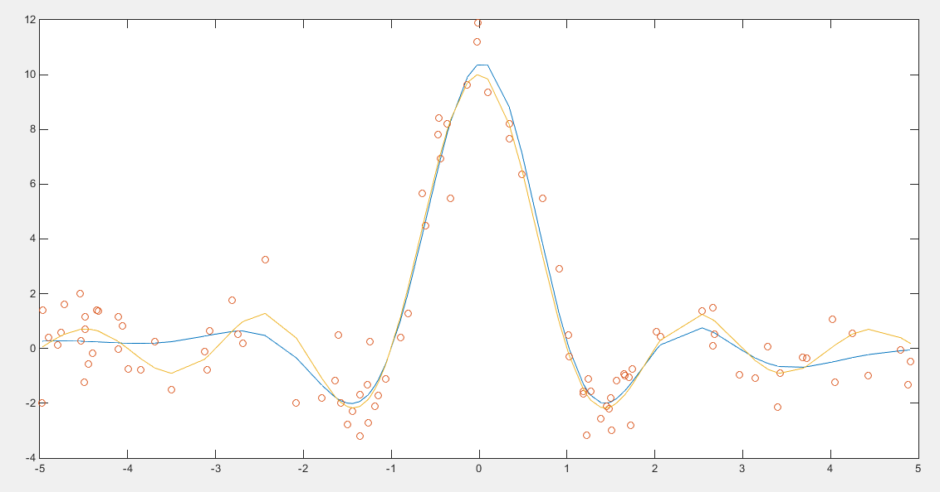

for the second dataset

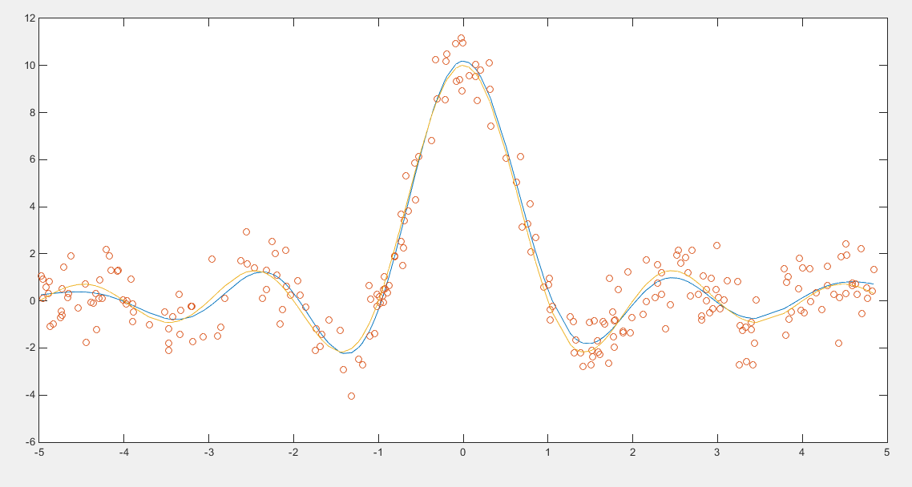

for the third dataset

