**Problem 1**



E-step:

1. Set $q\left(c\right)=p\left(c | π,x,θ\right)$
$$p\left(c | π,x,θ\right)=\prod_{i=1}^{n}{p\left(c_{i} | θ,x_{i},π\right)}$$

$$p\left(c_{i}=k | θ,x_{i},π\right)=\frac{p\left(x_{i} | c_{i}=k,θ\right)p\left(c_{i}=k | π\right)}{\sum_{j=1}^{K}{p\left(x_{i} | c_{i}=j,θ\right)p\left(c_{i}=j | π\right)}}$$

$$=\frac{π_{k}Binomial(x_{i},20,θ_{k})}{\sum_{j=1}^{K}{π_{j}Binomial(x_{i},20,θ_{j})}}=ϕ_{i}(k)$$

2. Calculate

M-step:

1. Initializing**, $π^{0},$ $θ^{0}$**  in some way.

2.For interation t = 1,2, …, T

(a)E-step: for i = 1,2,…,n and k = 1,2,…,K , set:

$$ϕ_{i}^{(t)}(k)=\frac{π_{k}^{(t-1)}{θ^{(t-1)}}_{k}^{x_{i}}{\left(1-θ_{k}^{(t-1)}\right)}^{20-x_{i}}}{\sum_{j=1}^{K}{π_{j}^{(t-1)}{θ^{(t-1)}}_{j}^{x_{i}}{\left(1-θ_{j}^{(t-1)}\right)}^{20-x_{i}}}}$$

(b)M-step: set:

$$n_{k}^{(t)}=\sum_{i=1}^{n}{ϕ_{i}^{(t)}\left(k\right)} , θ_{k}^{(t)}=\frac{\sum_{i=1}^{n}{ϕ_{i}^{(t)}(k)x_{i}}}{20n_{k}^{(t)}} , π_{k}^{(t)}=\frac{n_{k}^{(t)}}{n}$$

(c)Calculate $lnp\left(x | π^{\left(t\right)},θ^{(t)}\right)$ to assess convergence

$$lnp\left(x | π^{\left(t\right)},θ^{(t)}\right)=\sum_{i=1}^{n}{\sum_{k=1}^{K}{ϕ_{i}^{(t)}(k)(ln{θ^{(t)}}_{k}^{x_{i}}{\left(1-θ_{k}^{(t)}\right)}^{20-x_{i}}+lnπ_{k}^{(t)})}}$$

1. Log marginal likehood

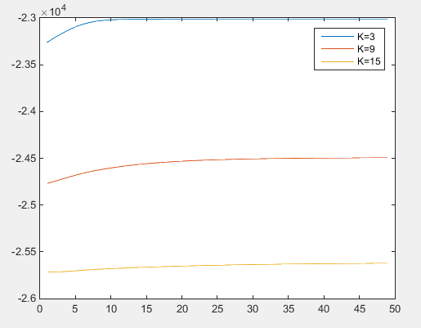

1. Use $q(c|x,θ)$ to find most probable clusters for three model

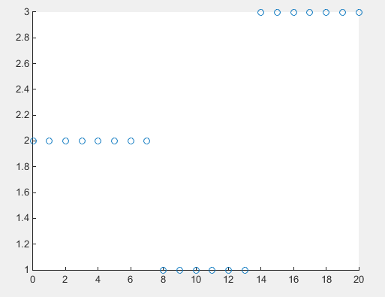

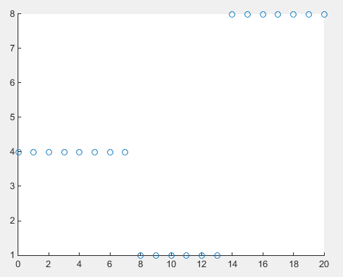

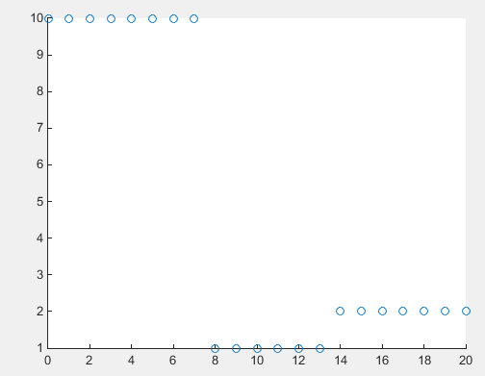

**Problem 2**



$$q\left(c_{i}=j\right)∝e^{E\left[lnp\left(x_{i} | θ_{j}\right)+lnp(c_{i}=j|π)\right]}$$

$$∝e^{E[ln\frac{20!}{x_{i}!\left(20-x_{i}\right)!}θ_{j}^{x_{i}}{\left(1-θ_{j}\right)}^{20-x_{i}}+lnπ_{j}]}$$

$$∝e^{x_{i}E\left[lnθ_{j}\right]+\left(20-x_{i}\right)E[\ln{{(1-θ}_{j}})]+E[{lnπ}_{j}]}$$

$$=Discrete(ϕ_{i})$$

$$q\left(π\right)∝e^{\sum_{i=1}^{n}{E\left[lnp\left(c_{i} | π\right)\right]+lnp\left(π\right)}}$$

$$∝e^{\sum_{i=1}^{n}{\sum_{j=1}^{K}{ϕ_{i}\left(j\right){lnπ}_{j}}+\sum_{j=1}^{K}{\left(α-1\right)lnπ_{j}}}}$$

$$∝\prod_{j=1}^{K}{π_{j}^{α-1+\sum_{i=1}^{n}{ϕ_{i}\left(j\right)}}}$$

$$=Dirichlet(α^{'})$$

$$α_{j}^{'}=α+n_{j} , n_{j}=\sum_{i=1}^{n}{ϕ_{i}\left(j\right)}$$

$$q\left(θ_{j}\right)∝e^{\sum_{i=1}^{n}{E[}lnp(x_{i}|c_{i}=j,θ_{j})]+E[lnp(θ_{j})]}$$

$$∝e^{\sum_{i=1}^{n}{ϕ_{i}\left(j\right)ln\frac{20!}{x_{i}!\left(20-x_{i}\right)!}θ_{j}^{x_{i}}{\left(1-θ_{j}\right)}^{20-x_{i}}}}θ_{j}^{a-1}{\left(1-θ_{j}\right)}^{b-1}$$

$$=Beta(a^{'},b^{'})$$

$$a_{j}^{'}=\sum_{i=1}^{n}{ϕ_{i}\left(j\right)x_{i}}+a , b_{j}^{'}=\sum_{i=1}^{n}{ϕ_{i}\left(j\right){(20-x}_{i})+b}$$

Input: data $x_{1},…,x_{n}$, number of clusters.

Output: parameters for $q\left(θ_{j}\right),q\left(π\right) and q(c_{i})$

1. Initialize $ϕ_{i}^{\left(0\right)},\left(α_{1}^{\left(0\right)},…, α_{K}^{\left(0\right)}\right),{(a}^{\left(0\right)},b^{(0)})$ in some way.
2. At interation t:
3. Update $q\left(c_{i}\right) for i=1,…n$ by setting:

$ϕ_{i}^{(t)}\left(j\right)=\frac{e^{x_{i}\left(ψ\left(a_{j}^{\left(t-1\right)}\right)-ψ\left(a_{j}^{\left(t-1\right)}+b_{j}^{\left(t-1\right)}\right)\right)+\left(20-x_{i}\right)\left(ψ\left(b_{j}^{\left(t-1\right)}\right)-ψ\left(a_{j}^{\left(t-1\right)}+b_{j}^{\left(t-1\right)}\right)\right)+ψ\left(α_{j}^{'}\right)-ψ(\sum_{j}^{K}{{α^{'}}_{j})}}}{\sum_{k=1}^{K}{e^{x_{i}\left(ψ\left(a_{k}^{\left(t-1\right)}\right)-ψ\left(a_{k}^{\left(t-1\right)}+b_{k}^{\left(t-1\right)}\right)\right)+\left(20-x_{i}\right)\left(ψ\left(b_{k}^{\left(t-1\right)}\right)-ψ\left(a_{k}^{\left(t-1\right)}+b_{k}^{\left(t-1\right)}\right)\right)+ψ\left(α_{k}^{'}\right)-ψ(\sum_{j}^{K}{{α^{'}}_{j})}}}}$

1. Set $n_{j}^{(t)}=\sum_{i=1}^{n}{ϕ_{i}\left(j\right)}, for j=1,…,K$
2. Update $q\left(π\right)$ by setting:

$$α_{j}^{(t)}=α+n_{j}^{(t)}$$

$for j=1,…,K$

1. Update $q\left(θ_{j}\right)$ by setting:
$$a_{j}^{(t)}=\sum_{i=1}^{n}{ϕ_{i}^{(t)}\left(j\right)x_{i}}+a , b_{j}^{(t)}=\sum_{i=1}^{n}{ϕ_{i}^{(t)}\left(j\right){(20-x}_{i})+b}$$

2. Calculate Objective function:
$$L=E_{q}\left[lnp\left(x,c,θ ,π\right)\right]-E_{q}\left[lnq\right]$$

$$=\sum_{i=1}^{n}{\sum_{j=1}^{K}{ϕ_{i}^{\left(t\right)}(j)}}\left[x_{i}\left(ψ\left(a_{j}^{\left(t\right)}\right)-ψ\left(a_{j}^{\left(t\right)}{+b}_{j}^{\left(t\right)}\right)\right)+\left(20-x_{i}\right)\left(ψ\left(b_{j}^{\left(t\right)}\right)-ψ\left(a_{j}^{\left(t\right)}{+b}_{j}^{\left(t\right)}\right)\right)+ψ\left(α_{j}^{\left(t\right)}\right)-ψ(\sum_{k}{α_{k}^{\left(t\right)}})\right]$$

$$+\sum_{j=1}^{K}{\left(a-1\right)\left(ψ\left(a_{j}^{\left(t\right)}\right)-ψ\left(a_{j}^{\left(t\right)}{+b}_{j}^{\left(t\right)}\right)\right)+\left(b-1\right)\left(ψ\left(b_{j}^{\left(t\right)}\right)-ψ\left(a_{j}^{\left(t\right)}{+b}_{j}^{\left(t\right)}\right)\right)}$$

$$+\sum_{j=1}^{K}{\left(α-1\right)(ψ\left(α_{j}^{\left(t\right)}\right)-ψ\left(\sum_{k}{α_{k}^{\left(t\right)}}\right))}-\sum_{i=1}^{n}{\sum_{j=1}^{K}{ϕ_{i}^{(t)}\left(j\right)lnϕ_{i}^{(t)}\left(j\right)}}$$

$$+\sum_{j=1}^{K}{lnB(}a_{j}^{\left(t\right)},b_{j}^{\left(t\right)})-\left(a_{j}^{\left(t\right)}-1\right)ψ\left(a_{j}^{\left(t\right)}\right)-\left(b_{j}^{\left(t\right)}-1\right)ψ\left(b_{j}^{\left(t\right)}\right)+\left(a_{j}^{\left(t\right)}+b_{j}^{\left(t\right)}-2\right)ψ(a_{j}^{\left(t\right)}+b_{j}^{\left(t\right)})$$

$$+lnB\left(α^{\left(t\right)}\right)+\left(\sum_{j=1}^{K}{α_{j}^{\left(t\right)}}-K\right)ψ\left(\sum_{j=1}^{K}{α_{j}^{\left(t\right)}}\right)-\sum_{j}^{K}{\left(α_{j}^{\left(t\right)}-1\right)ψ(α_{j}^{\left(t\right)})}$$

3. Objective function

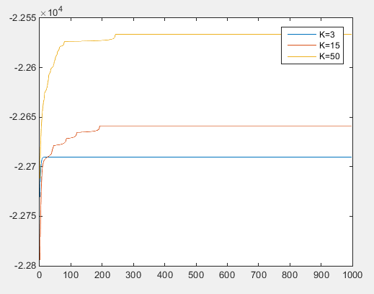

1. Find most probable clusters

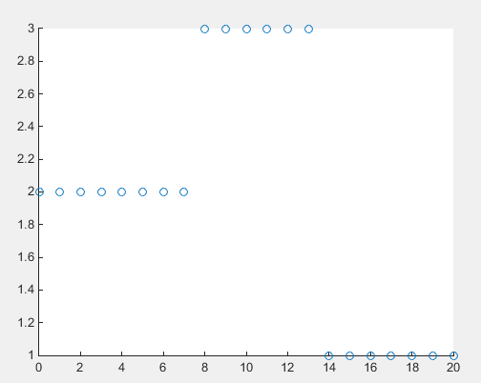

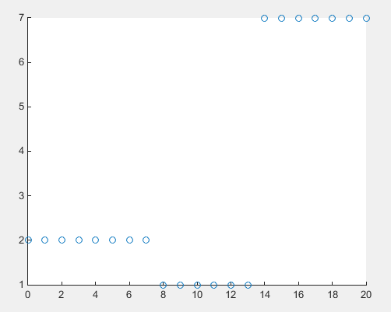

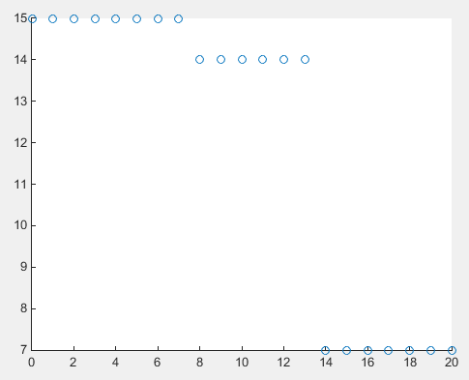

**Problem 3**

**a)**

for all j such that $n_{j}^{\left(-i\right)}>0$

$$p\left(c_{i}=j | x_{i},θ,c_{-i}\right)∝\frac{p\left(x_{i} | θ_{j}\right)n_{j}^{(-i)}}{α+n-1}$$

$$∝\frac{\frac{20!}{x_{i}!\left(20-x_{i}\right)!}θ_{j}^{x_{i}}{\left(1-θ_{j}\right)}^{20-x_{i}}n_{j}^{\left(-i\right)}}{α+n-1}=ϕ_{i}(j)$$

for a new cluster j’

$$p\left(c_{i}=new | x_{i},θ,c_{-i}\right)∝\frac{α}{α+n-1}∫p\left(x_{i} | θ\right)p\left(θ\right)dθ$$

$$∝\frac{α}{α+n-1}\frac{20!}{x_{i}!\left(20-x_{i}\right)!}\frac{B\left(x_{i}+a,20-x_{i}+b\right)}{B\left(a,b\right)}=ϕ_{i}(j')$$

For all cluster

$$p(θ_{j}|{\{x}_{i}:c_{i}=j\})=\frac{∏p({\{x}_{i}:c_{i}=j\}|θ_{j})p(θ_{j})}{∫∏p\left({\{x}_{i}:c_{i}=j\} | θ\right)p\left(θ_{j}\right)dθ_{j}}$$

$$=Beta(a^{'},b^{'})$$

$$a^{'}=\sum_{i:c_{i}=k}{x_{i}}+a , b^{'}=\sum_{i:c_{i}=k}{20-x_{i}+b}$$

**b)**

Six most probable clusters

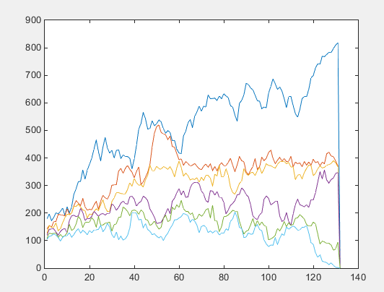

**c)**

Total number of clusters

