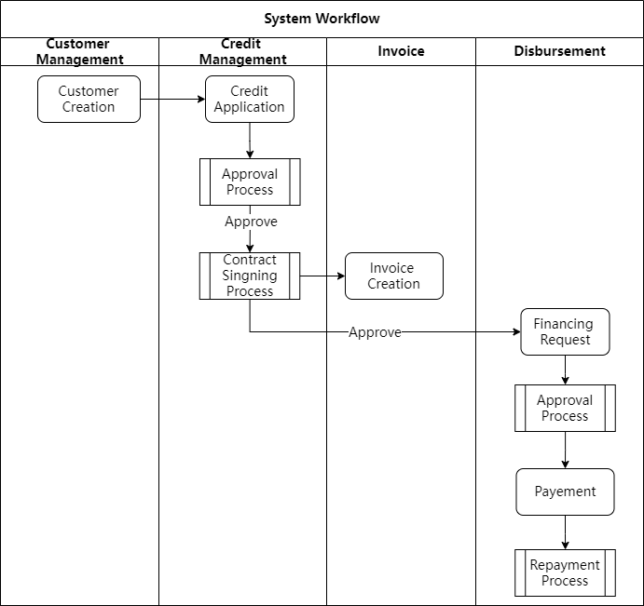

Customer Registration

Our system will support maintaining customer information based on the customer type, including the financing customer, suppliers, buyer, financiers etc.

Credit Management

Maintains the customer's total credit limit, product-specific credit limits allowed under the credit limit, and financial solutions for each product during the credit application process. The financial solutions include information such as duration, various fees, interest, and late payment fines.

Once the credit approval is granted, independent records of the corresponding business contracts are generated for each financial solution.

Contract Management

During the contract processing, the system automatically generates the corresponding contract documents based on the contract file templates configured for each product.  
The content of the contract documents is automatically filled in by the system based on the contract template and bookmarks within the template. Downloading and previewing are supported for generated files, and signed files can be uploaded to the system for storage.

Invoice Registration

For business contracts within their validity period, invoices can be added at any time for association, providing financing evidence for subsequent financing applications. During invoice registration, the system can control based on constraints set in the product configuration and financial solutions.

Financing Management

For business contracts within their validity period, financing applications can be initiated within the available contract credit limit (for invoice financing, invoices that have been approved but not financed must be selected). Approval is conducted according to established procedures, and automatic approval based on corresponding rules is supported. Funds are disbursed after approval. The disbursement amount can be adjusted based on business needs to deduct relevant fees and outstanding amounts from previous transactions.

Repayment Management

The system supports the registration of capital flows, including customer repayment transactions and invoice payment transactions. Both single-entry registration and batch import operations are supported.

Multiple repayment methods, such as one-time repayment and partial repayment, are supported for outstanding financing. Registered capital flow records must be selected during repayment operations. In addition to scheduled repayments, the system also supports partial early repayments or full settlements. During repayment transactions, the system automatically calculates relevant amounts, including principal, interest, overdue interest, and late payment fines.

Each capital flow can be associated with multiple financing transactions for repayment. Surplus funds can be used for repayment operations for subsequent transactions and are also refundable.