Install Nebula on the client (our personal computer).# Download the latest Nebula release for LinuxAMD64wget https://github.com/slackhq/nebula/releases/download/v1.6.1/nebula-linux-amd64.tar.gz

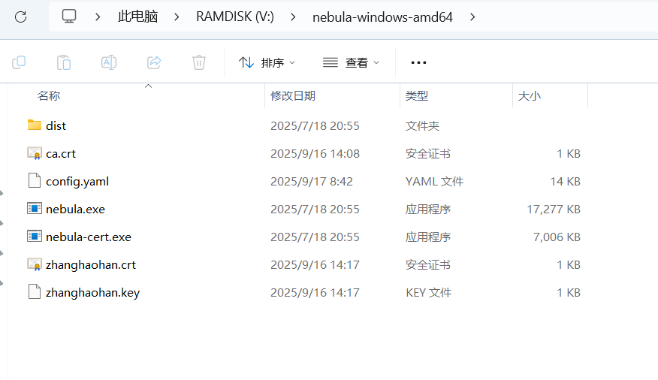

Create a configuration file (config.yaml) for the client.

Place the certificates (ca.crt, {name}.crt, {name}.key) in a directory (e.g., ~/.nebula/).

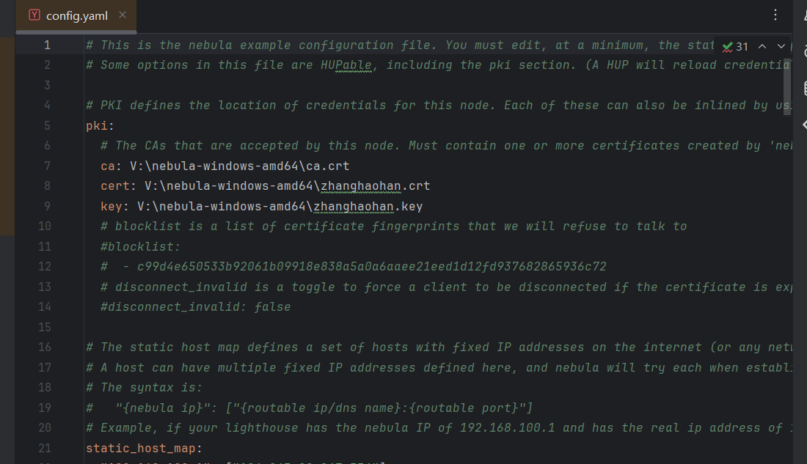



Adjust the configuration file to point to the correct certificates and the lighthouse's public IP and port.

Run Nebula.

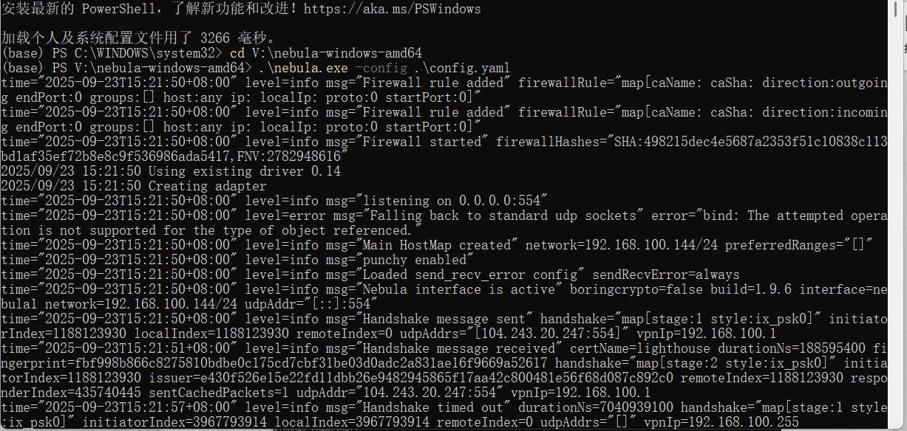

Then The IP address of the light house 192.168.100.1.

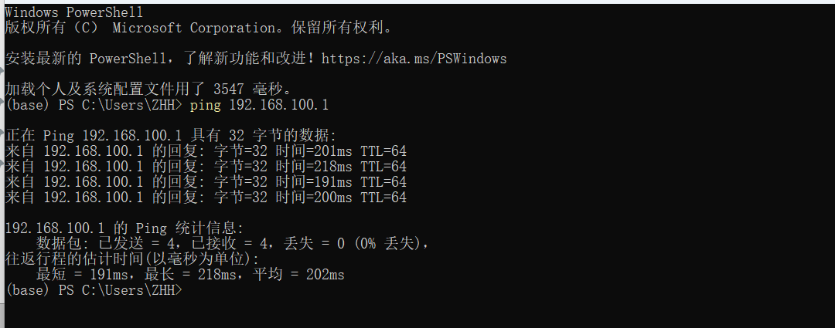

Then ping the [nuist@192.168.100.1](mailto:nuist@192.168.100.1) and check connectivity

