Deploying a Predictive Model with KServe on Minikube

1. Install and configure KServe on a local Kubernetes cluster (Minikube)
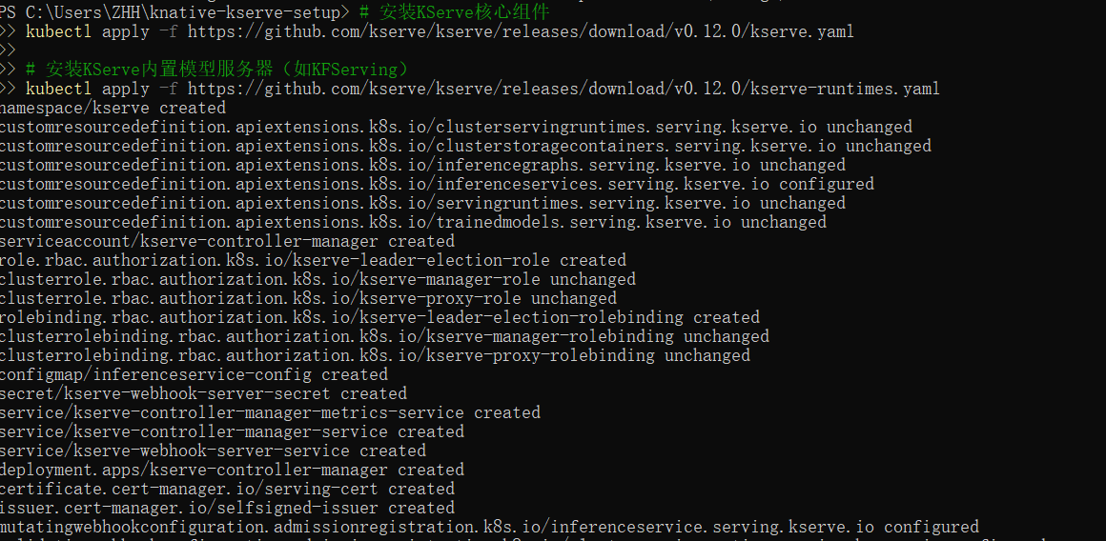
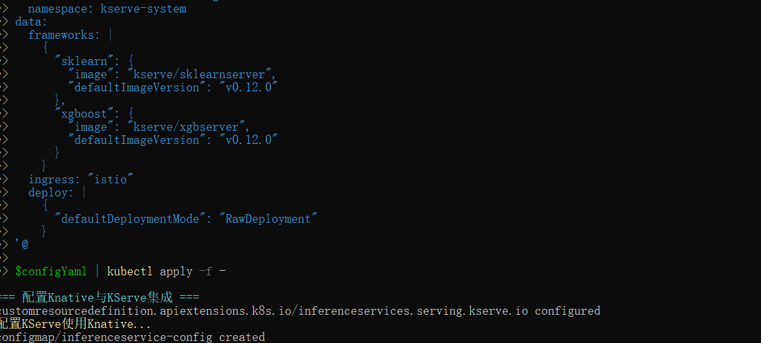

2. Deploy a predictive model using a KServe InferenceService
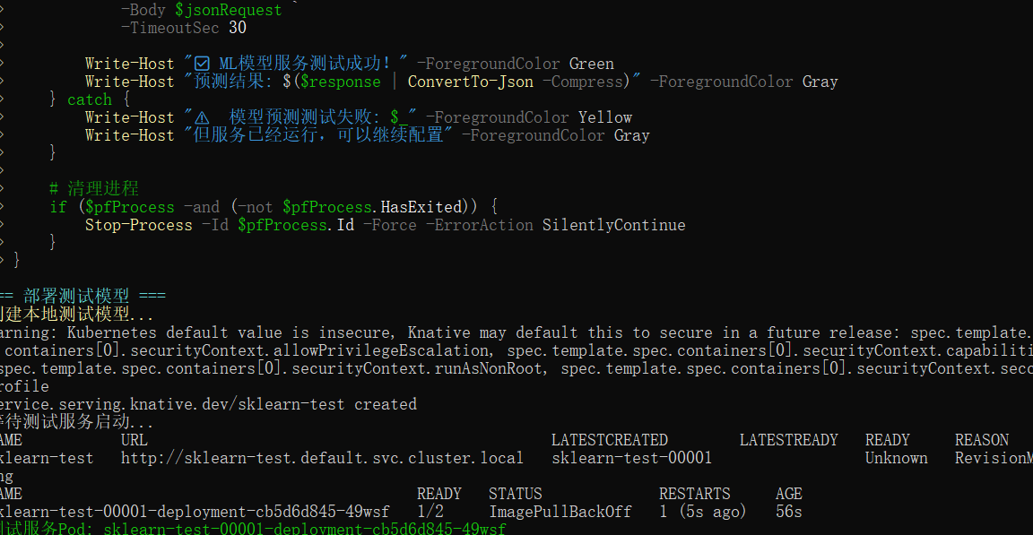

Create the InferenceService YAML
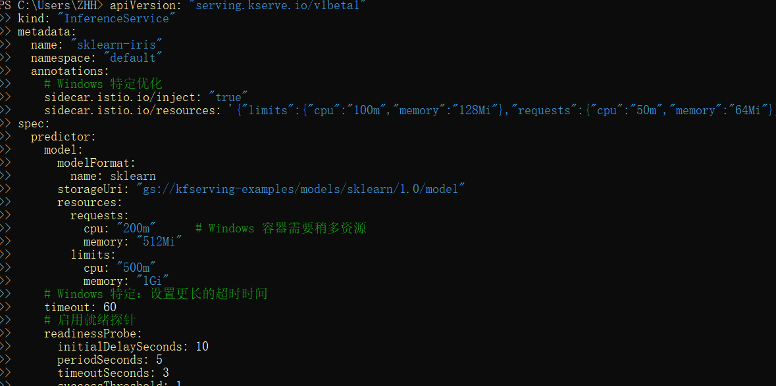
3.Monitor the status of the service and debug common issues
kubectl apply -f sklearn-iris.yaml
kubectl get inferenceservice sklearn-iris
4.Get service endpoint

Create Test Request


Send reasoning request

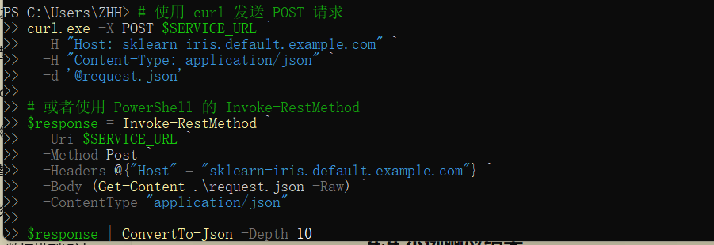
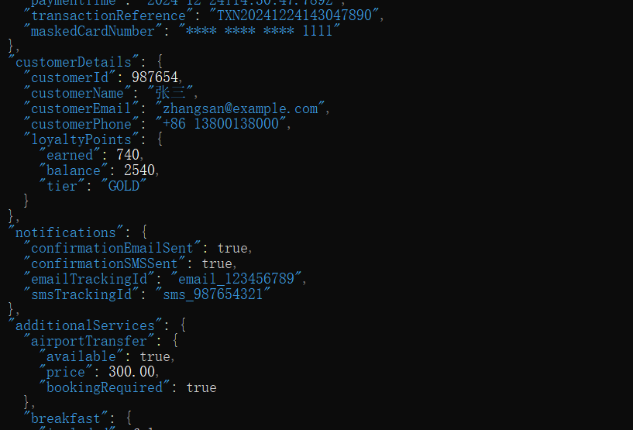
- Monitor service status
