Step 1: Create GitHub Account
Step 2: Create GitHub Pages Repository
After logging in, click "+" → "New repository"
Repository name must be: yourusername.github.io (e.g., johnsmith.github.io)
Select "Public"
Check "Add a README file"
Click "Create repository"
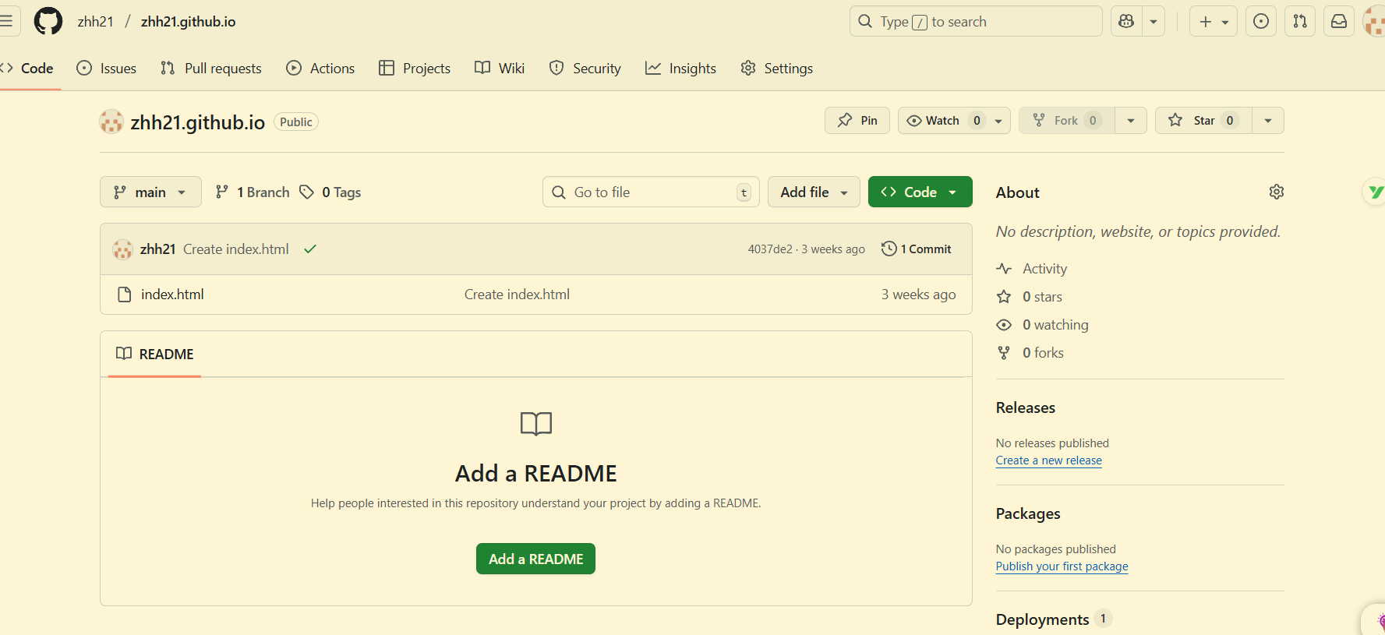
Step 3: Create Website Files
Method A: Using GitHub Web Interface
In repository page, click "Add file" → "Create new file"
Create index.html file
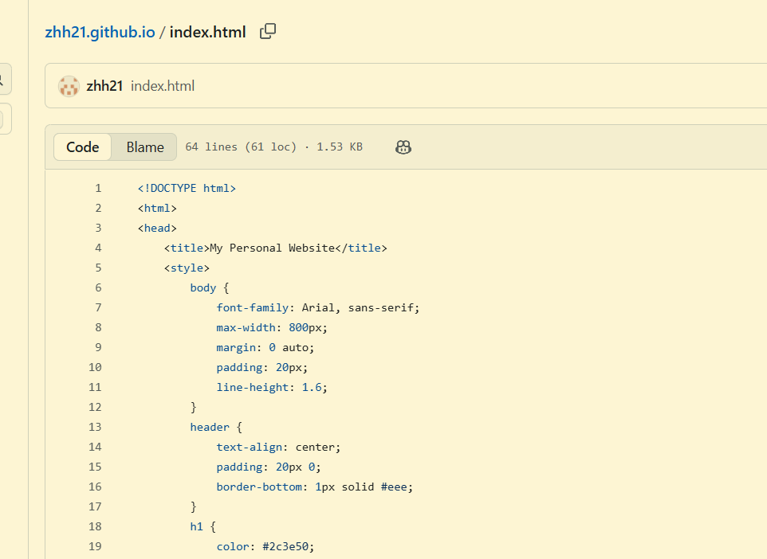
Step 4: Enable GitHub Pages
In repository page, click "Settings" tab
Find "Pages" in left sidebar
In "Source" section, select "Deploy from a branch"
Select branch (usually main or master)
Select folder (usually / (root))
Click "Save"
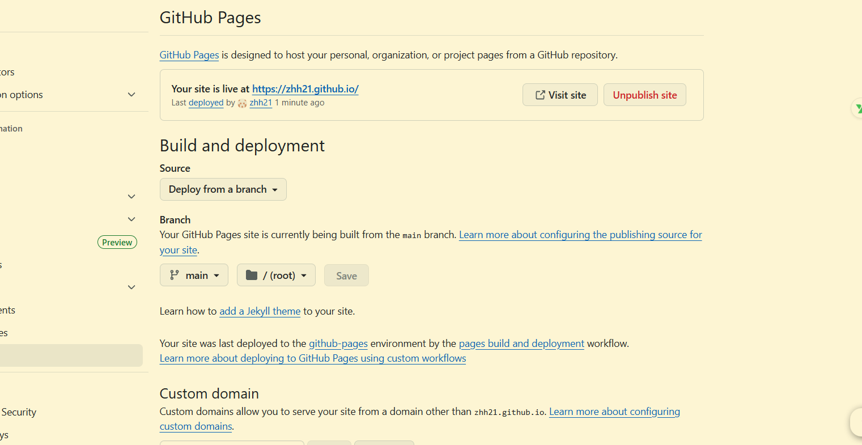
Step 5: Verify Website Accessibility


