Install a networking layer
The following commands install Kourier and enable its Knative integration.

Install the Knative Kourier controller by running the command:

Configure Knative Serving to use Kourier by default by running the command:Fetch the External IP address or CNAME by running the command:
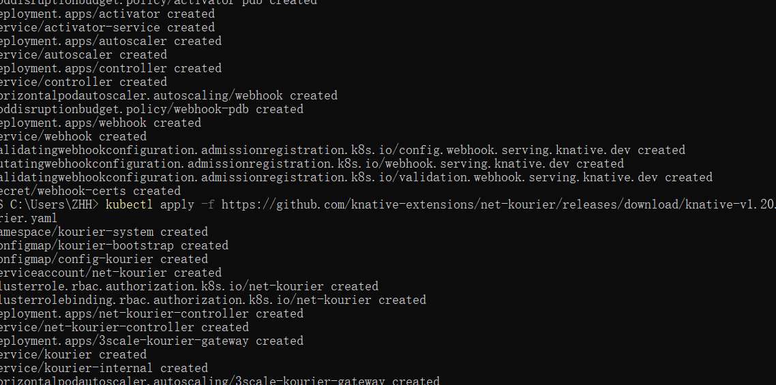
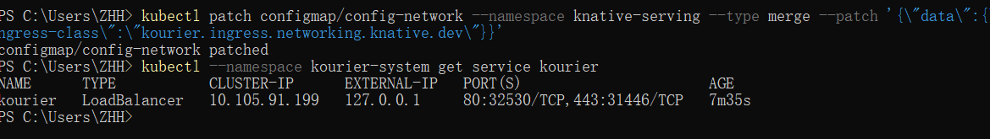
Verify the installation
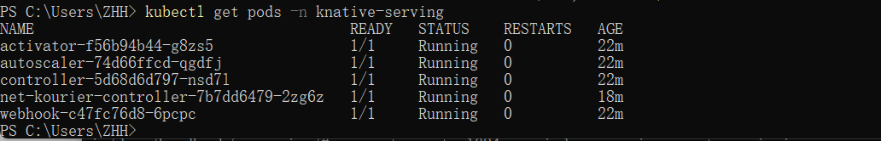

Install the Knative Eventing component¶
To install the Knative Eventing component:

Install the required custom resource definitions (CRDs) by running the command:

Install the core components of Eventing by running the command:
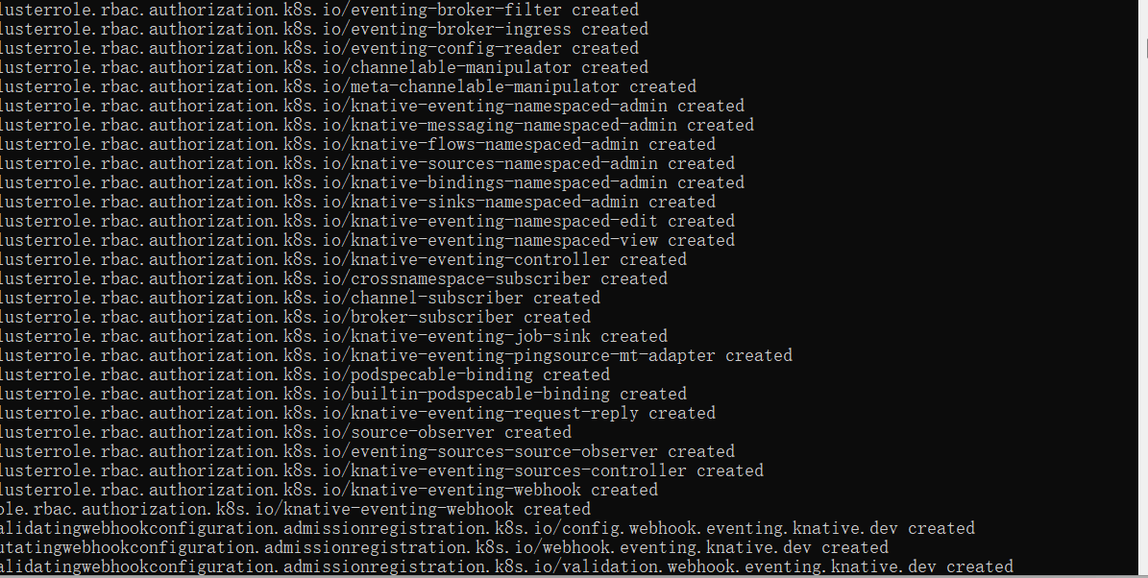
Verify the installation¶
Monitor the Knative components until all of the components show a STATUS of Running or Completed. You can do this by running the following command and inspecting the output:
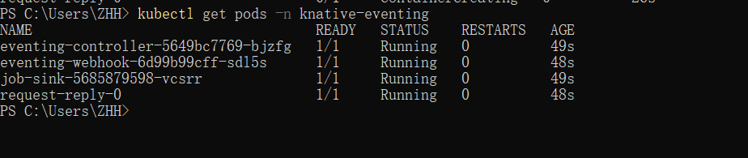
Installing the kn func CLI plugin¶
You can install Knative Functions as a kn CLI plugin, by downloading the executable binary for your system and placing it in the system path.

Download the binary for your system from the func release page.

Rename the binary to kn-func, and make it executable by running the following commands:

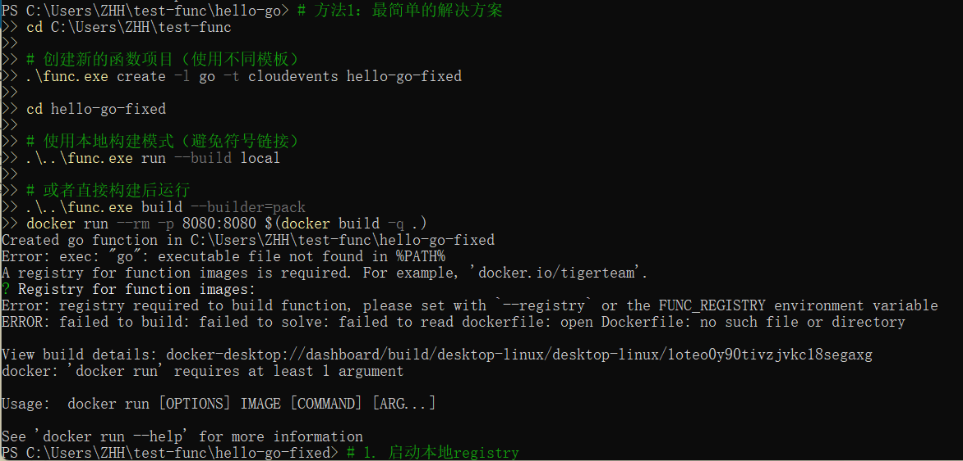
kn plugin
You can install Knative Functions as a kn CLI plugin, by downloading the executable binary for your system and placing it in the system path.

Creating a function
After you have installed Knative Functions, you can create a function project by using the func CLI or the kn func plugin:
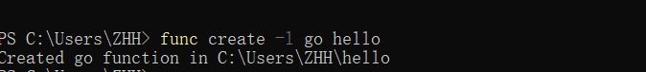

Building, running, or deploying functions
After you have created a function project, you can build, run, or deploy your function, depending on your use case.
Running a function
Running a function creates an OCI container image for your function before running the function in your local environment, but does not deploy the function to a cluster. This can be useful if you want to run your function locally for a testing scenario.
Prerequisites
You have a Docker daemon on your local machine. This is already provided if you have used the Quickstart installation.
Procedure
The run command builds an image for your function if required, and runs this image locally, instead of deploying it on a cluster.
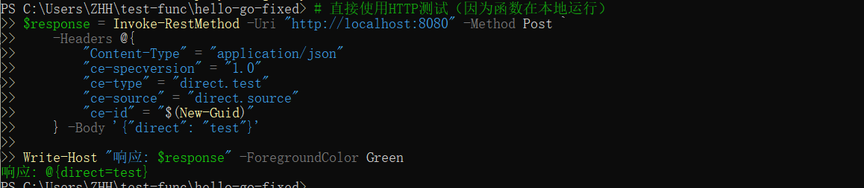

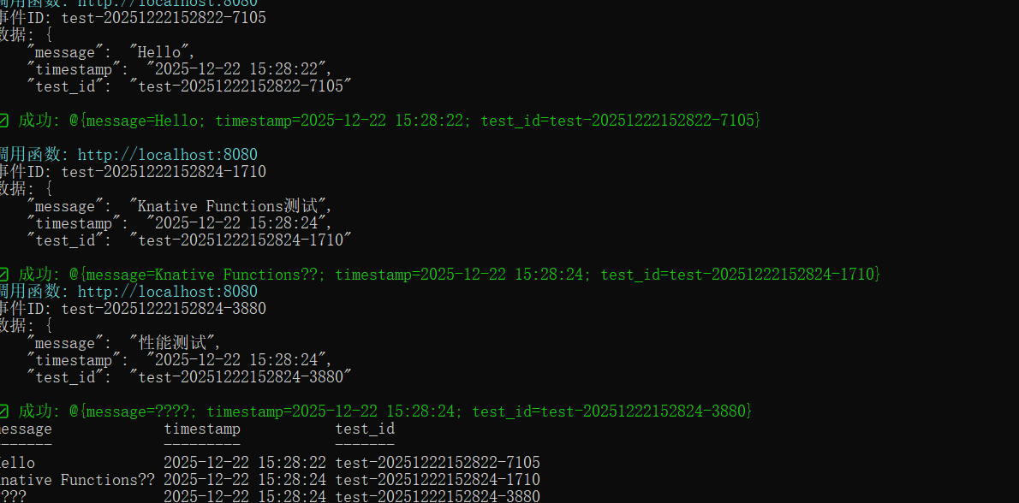

Deploying a Knative Service
In this tutorial, you will deploy a "Hello world" Knative Service that accepts the environment variable TARGET and prints Hello ${TARGET}!
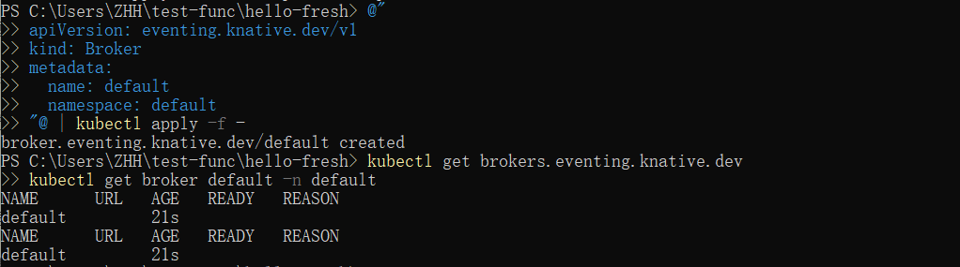

Sources, Brokers, and Triggers
As part of the kn quickstart install, an InMemoryChannel-backed Broker is installed on your kind cluster.
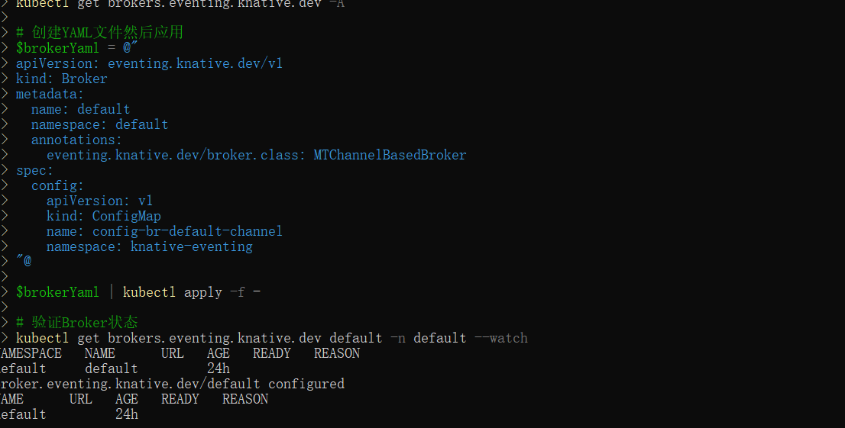

Creating your first source
The CloudEvents Player acts as a Source for CloudEvents by intaking the name of the Broker as an environment variable, BROKER_NAME. If the Broker is located in a different namespace it is possible to also set the BROKER_NAMESPACE environment variable. Alternatively, you can just use the BROKER_URI.
You will send CloudEvents to the Broker through the CloudEvents Player application.
Create the CloudEvents Player Service:
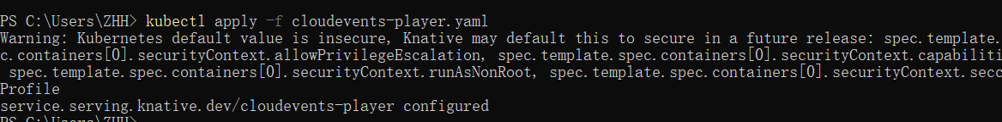
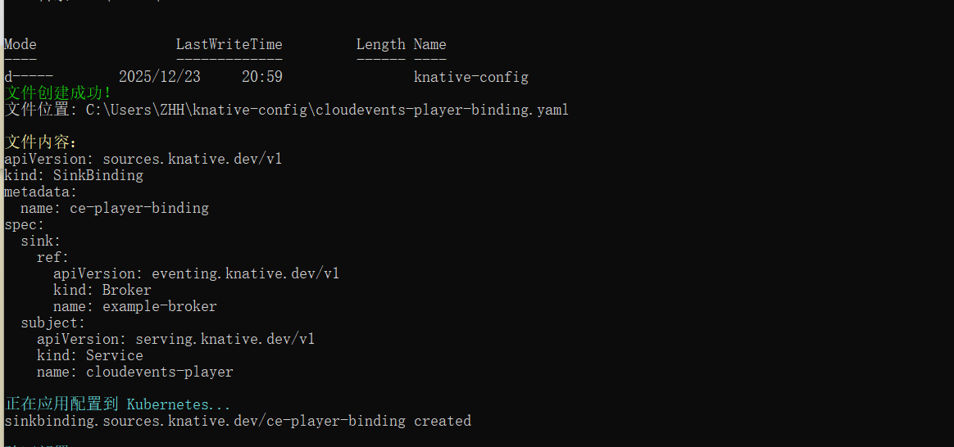
Examining the CloudEvents Player
You can use the CloudEvents Player to send and receive CloudEvents. If you open the Service URL in your browser, the Create Event form appears.
The Service URL is http://cloudevents-player.default.${LOADBALANCER_IP}.sslip.io, for example, http://cloudevents-player.default.127.0.0.1.sslip.io for kind
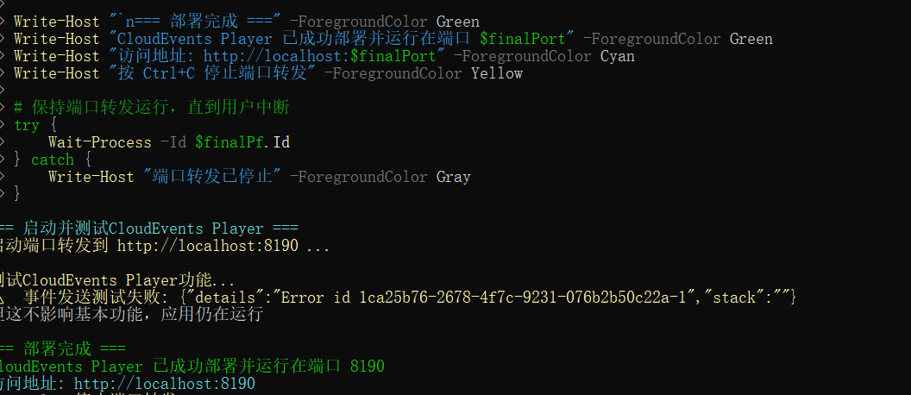
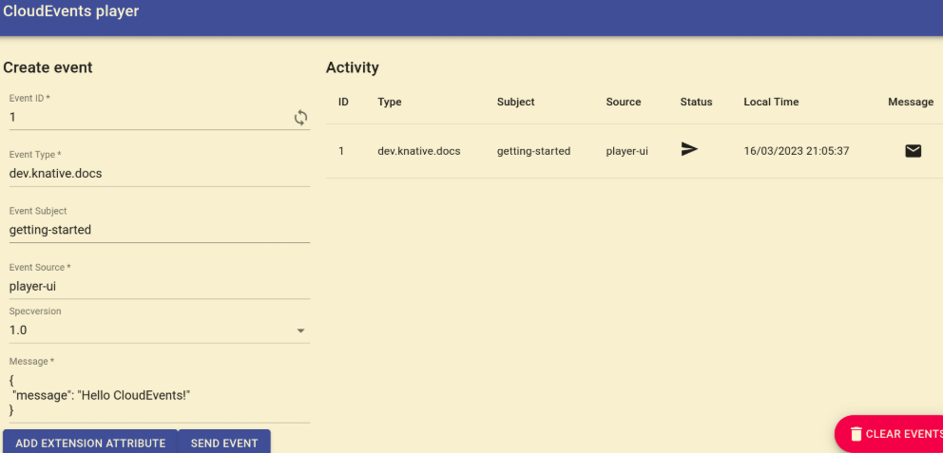
Creating your first Trigger
Create a Trigger that listens for CloudEvents from the event source and places them into the sink, which is also the CloudEvents Player app.
