Open the Bookinfo site in your browser. The URL is http://$GATEWAY_URL/productpage, where $GATEWAY_URL is the External IP address of the ingress, as explained in the Bookinfo doc.

Notice that the reviews part of the page displays with no rating stars, no matter how many times you refresh. This is because you configured Istio to route all traffic for the reviews service to the version reviews:v1 and this version of the service does not access the star ratings service.

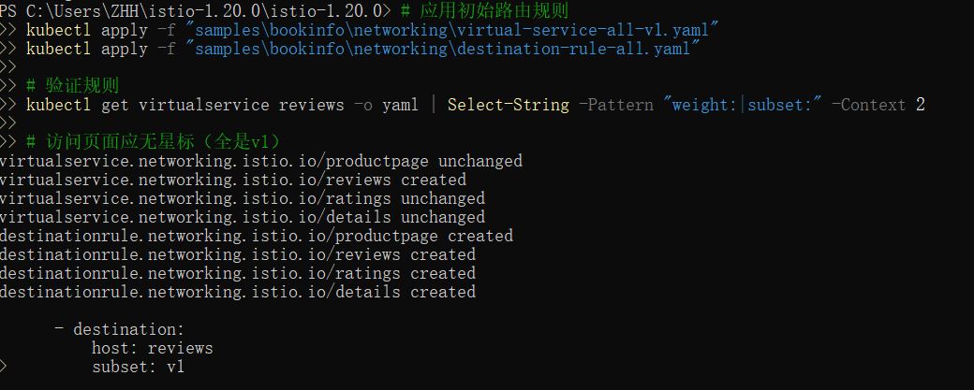
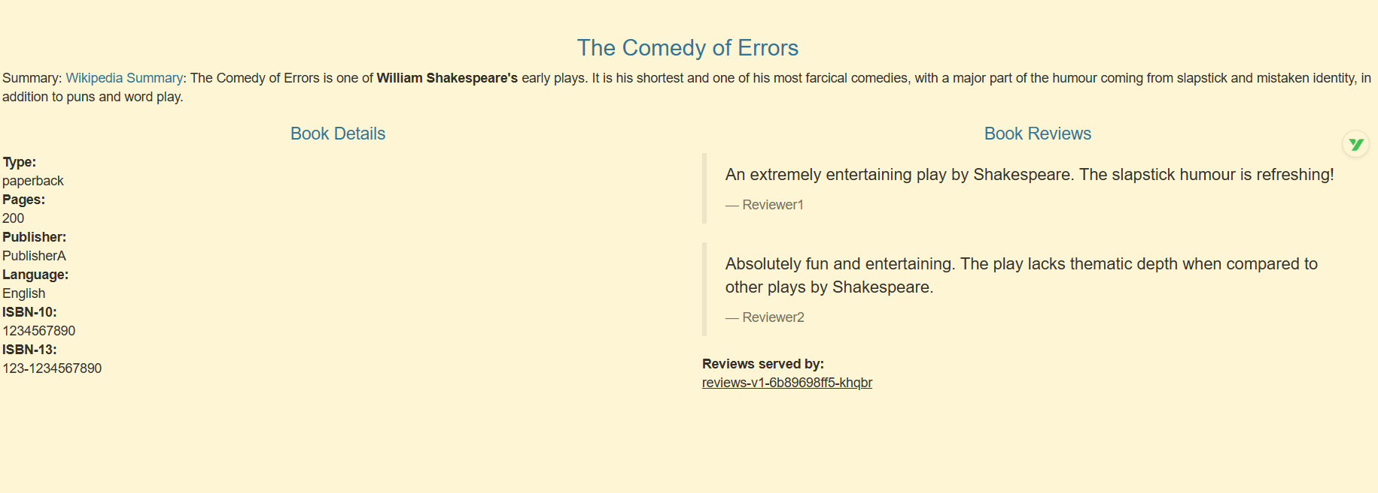

Transfer 50% of the traffic from reviews:v1 to reviews:v3 with the following command:

Istio APIsGateway API
$ kubectl apply -f samples/bookinfo/networking/virtual-service-reviews-50-v3.yaml
Wait a few seconds for the new rules to propagate and then confirm the rule was replaced:

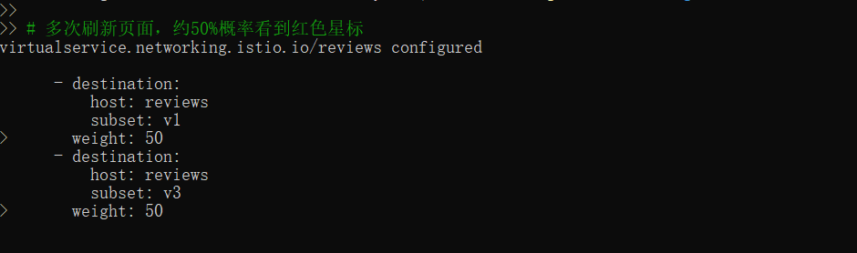
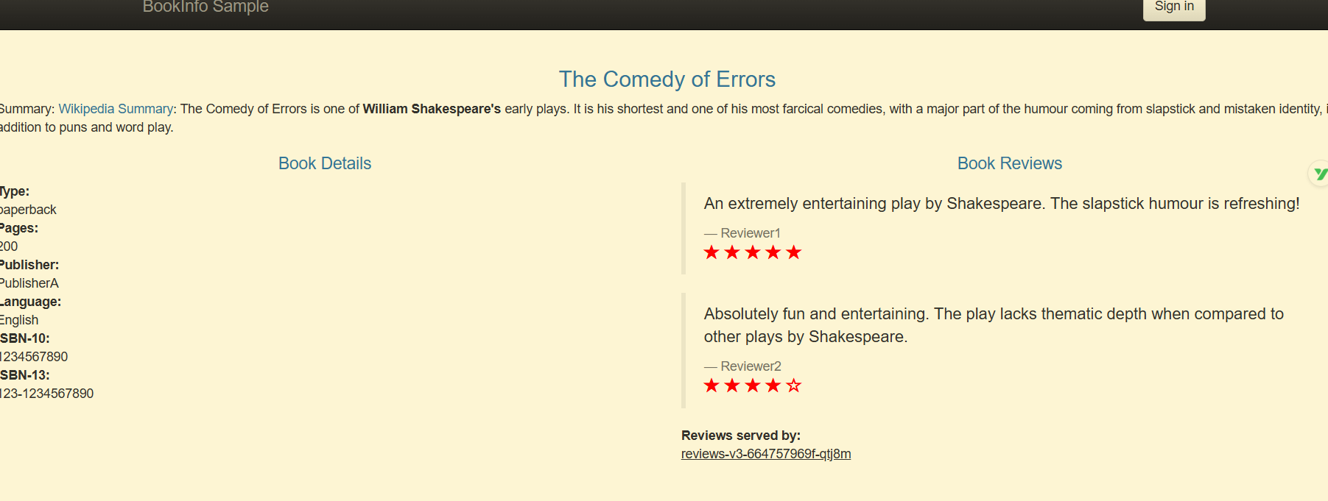

Refresh the /productpage in your browser and you now see red colored star ratings approximately 50% of the time. This is because the v3 version of reviews accesses the star ratings service, but the v1 version does not.
Assuming you decide that the reviews:v3 microservice is stable, you can route 100% of the traffic to reviews:v3 by applying this virtual service:
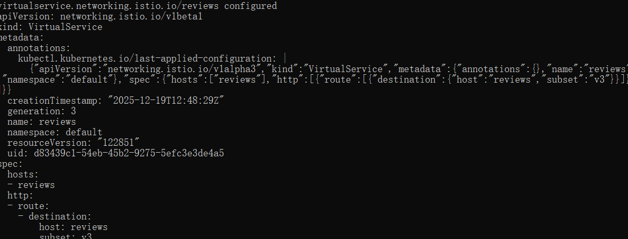


Route to version 1
To route to one version only, you configure route rules that send traffic to default versions for the microservices.
Istio uses virtual services to define route rules. Run the following command to apply virtual services that will route all traffic to v1 of each microservice:Display the defined routes with the following command:
You have configured Istio to route to the v1 version of the Bookinfo microservices, most importantly the reviews service version 1.

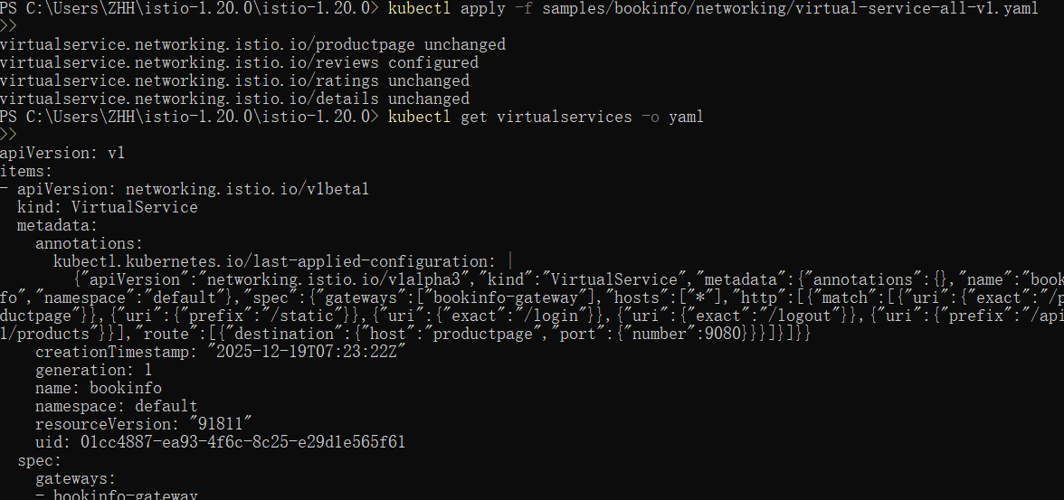

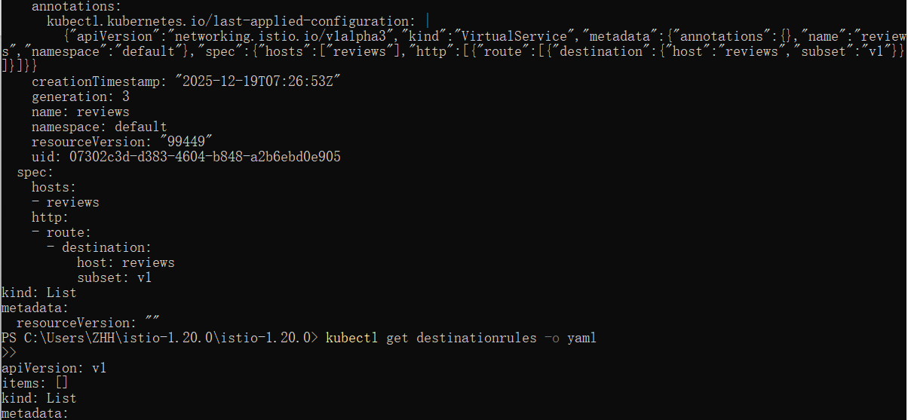

Route based on user identity
Next, you will change the route configuration so that all traffic from a specific user is routed to a specific service version. In this case, all traffic from a user named Jason will be routed to the service reviews:v2.
This example is enabled by the fact that the productpage service adds a custom end-user header to all outbound HTTP requests to the reviews service.
Istio also supports routing based on strongly authenticated JWT on ingress gateway, refer to the JWT claim based routing for more details.
Remember, reviews:v2 is the version that includes the star ratings feature.
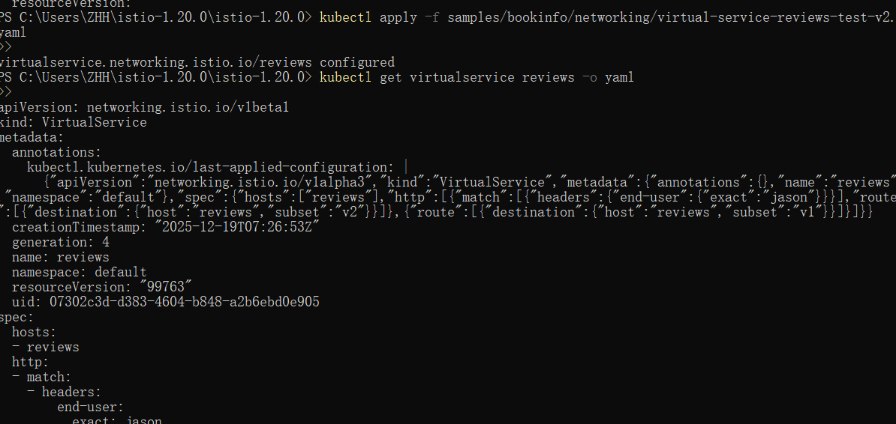

On the /productpage of the Bookinfo app, log in as user jason.

Refresh the browser. What do you see? The star ratings appear next to each review.

Log in as another user (pick any name you wish).

Refresh the browser. Now the stars are gone. This is because traffic is routed to reviews:v1 for all users except Jason

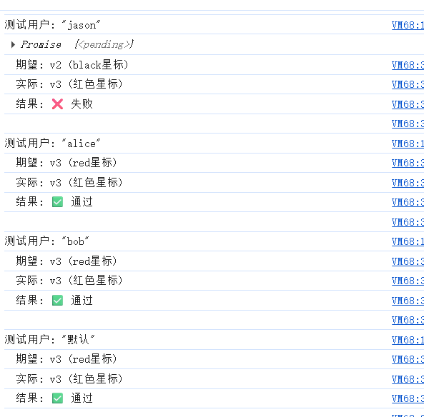
Injecting an HTTP delay fault
To test the Bookinfo application microservices for resiliency, inject a 7s delay between the reviews:v2 and ratings microservices for user jason. This test will uncover a bug that was intentionally introduced into the Bookinfo app.
Note that the reviews:v2 service has a 10s hard-coded connection timeout for calls to the ratings service. Even with the 7s delay that you introduced, you still expect the end-to-end flow to continue without any errors.
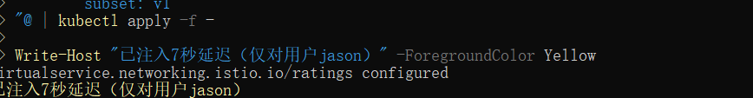

Testing the delay configuration

Open the Bookinfo web application in your browser.

On the /productpage web page, log in as user jason.

You expect the Bookinfo home page to load without errors in approximately 7 seconds. However, there is a problem: the Reviews section displays an error message:
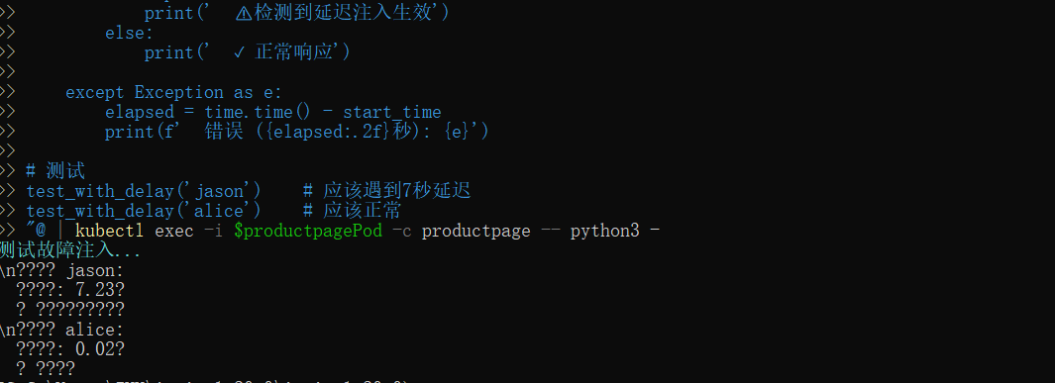

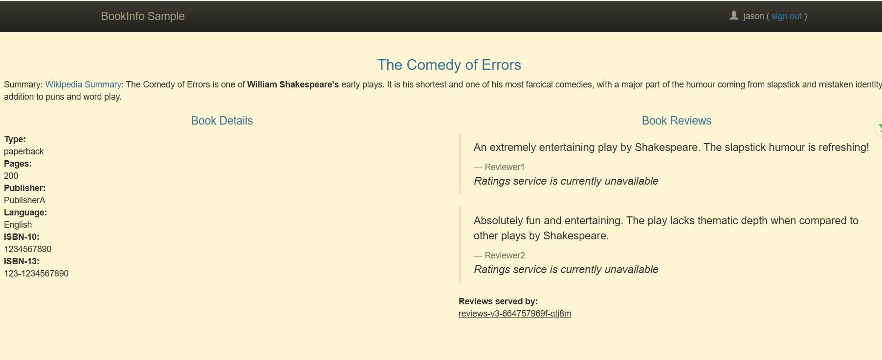

Injecting an HTTP abort fault
Another way to test microservice resiliency is to introduce an HTTP abort fault. In this task, you will introduce an HTTP abort to the ratings microservices for the test user jason.
In this case, you expect the page to load immediately and display the Ratings service is currently unavailable message.
Create a fault injection rule to send an HTTP abort for user jason:
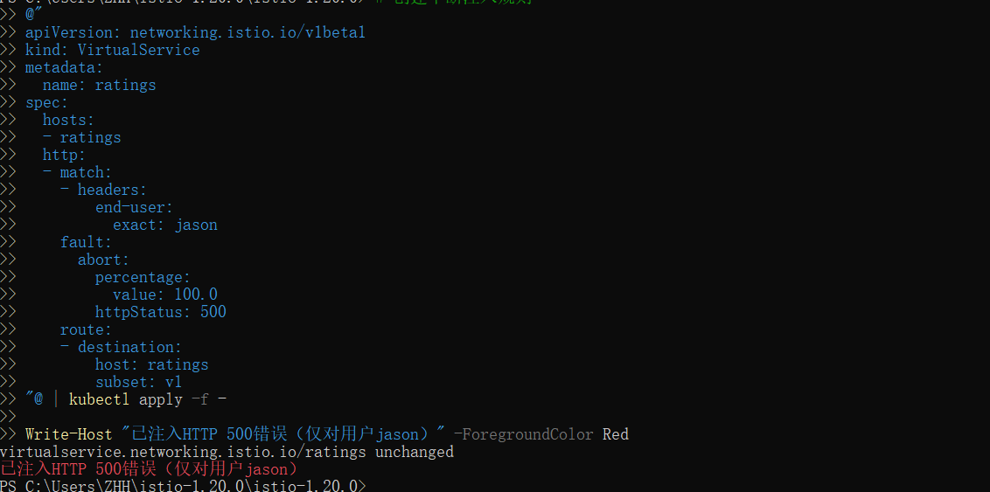
Configuring the circuit breaker
Create a destination rule to apply circuit breaking settings when calling the httpbin service:
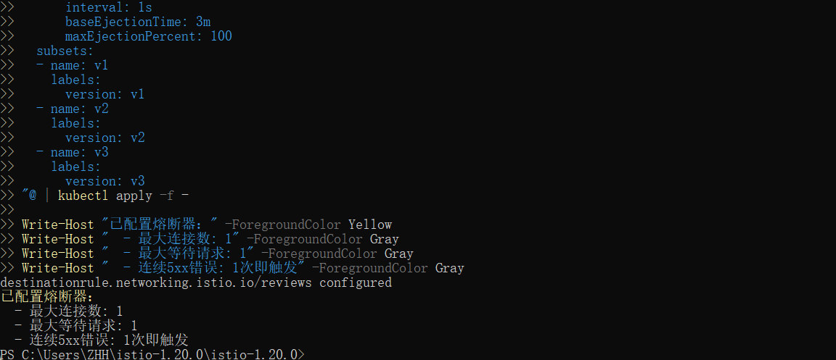

Tripping the circuit breaker
In the settings, you specified and . These rules indicate that if you exceed more than one connection and request concurrently, you should see some failures when the opens the circuit for further requests and connections.DestinationRulemaxConnections: 1http1MaxPendingRequests: 1istio-proxy
Call the service with two concurrent connections () and send 20 requests ():-c 2-n 20
Deploy test client - Create the loadtest-client Pod to send requests
Configure circuit breaker rules - Set up circuit breaker protection for the reviews service:
Maximum connections: 3
Maximum pending requests: 3
Trip the breaker on 1 occurrence of 5xx error
Circuit breaker duration: 30 seconds
Normal traffic test - Send 5 normal requests
Fault injection - Deploy the faulty version of reviews to trigger the circuit breaker
Check circuit breaker status - Inspect Envoy proxy statistics
Professional load testing - Use the Fortio tool for concurrent testing
Check configuration - Verify the DestinationRule settings
