Use the following instructions to run a container.
Open Docker Desktop and select the Search field on the top navigation bar.
Specify welcome-to-docker in the search input and then select the Pull button.
Once the image is successfully pulled, select the Run button.
Expand the Optional settings.
In the Container name, specify welcome-to-docker.
In the Host port, specify 8080.
Select Run to start your container.
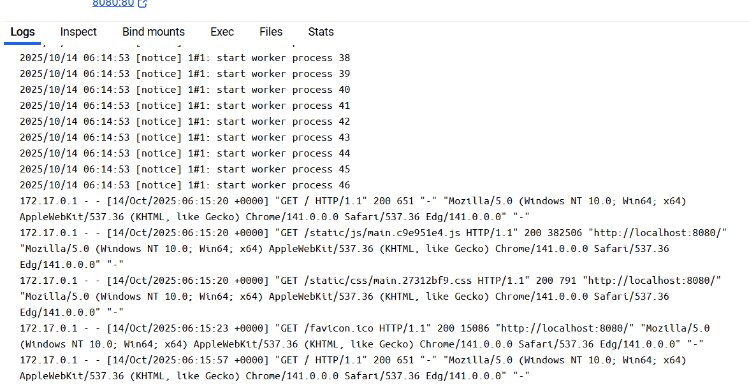



Open the Docker Desktop Dashboard and select the Images view in the left-hand navigation menu.

Select the Search images to run button. If you don't see it, select the global search bar at the top of the screen.

In the Search field, enter "welcome-to-docker". Once the search has completed, select the docker/welcome-to-docker image.

Select Pull to download the image.

Learn about the image
Once you have an image downloaded, you can learn quite a few details about the image either through the GUI or the CLI.

In the Docker Desktop Dashboard, select the Images view.

Select the docker/welcome-to-docker image to open details about the image.
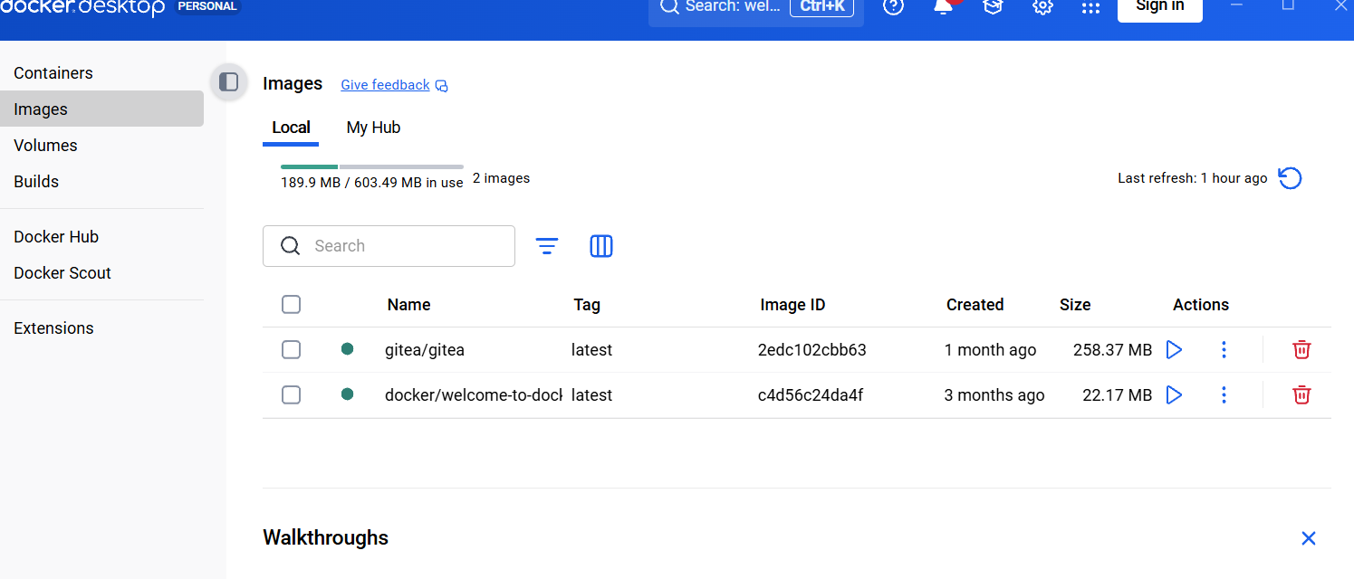

The image details page presents you with information regarding the layers of the image, the packages and libraries installed in the image, and any discovered vulnerabilities.

In this walkthrough, you searched and pulled a Docker image. In addition to pulling a Docker image, you also learned about the layers of a Docker Image.
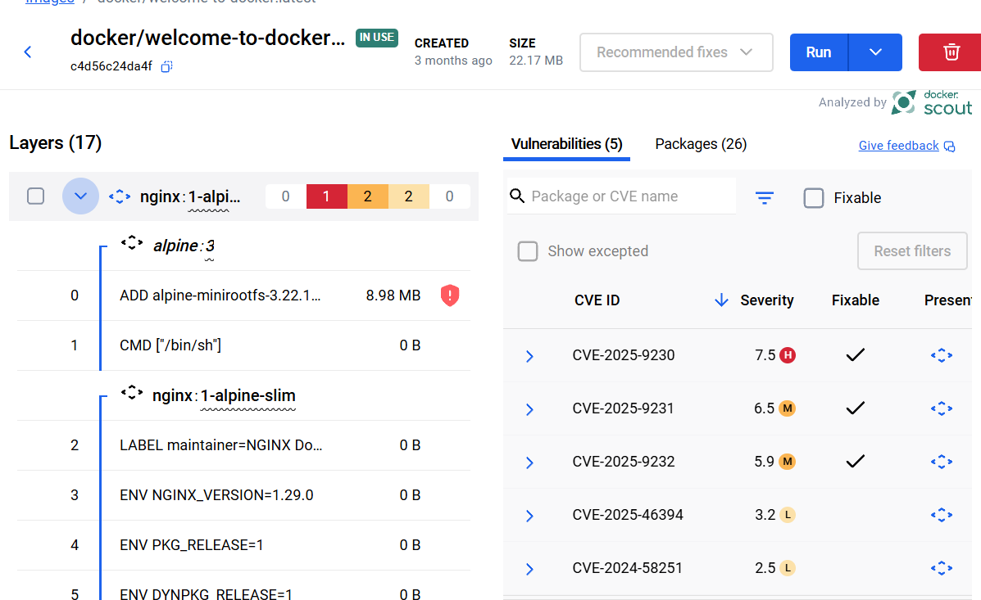

Follow the instructions to run the to-do list app on your system.

Download and install Docker Desktop.

Open a terminal and clone this sample application.

git clone https://github.com/dockersamples/todo-list-app
Navigate into the todo-list-app directory:
cd todo-list-app
Inside this directory, you'll find a file named compose.yaml. This YAML file is where all the magic happens! It defines all the services that make up your application, along with their configurations. Each service specifies its image, ports, volumes, networks, and any other settings necessary for its functionality. Take some time to explore the YAML file and familiarize yourself with its structure.

Use the docker compose up command to start the application:

docker compose up -d --build

When you run this command, you should see an output like this:
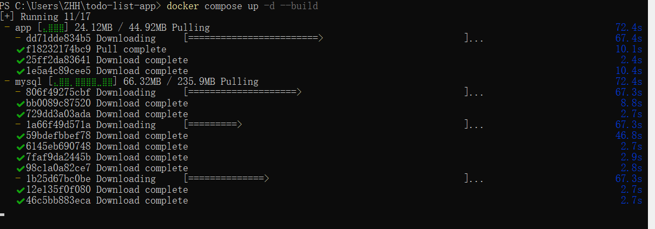

A lot happened here! A couple of things to call out:

Two container images were downloaded from Docker Hub - node and MySQL
A network was created for your application
A volume was created to persist the database files between container restarts
Two containers were started with all of their necessary config
If this feels overwhelming, don't worry! You'll get there!

With everything now up and running, you can open http://localhost:3000 in your browser to see the site. Feel free to add items to the list, check them off, and remove them.

If you look at the Docker Desktop GUI, you can see the containers and dive deeper into their configuration.

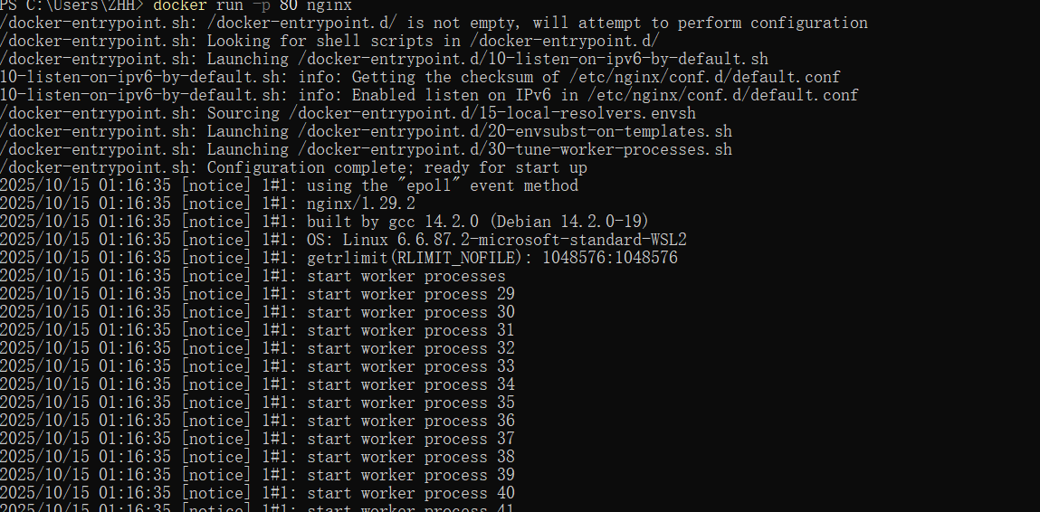
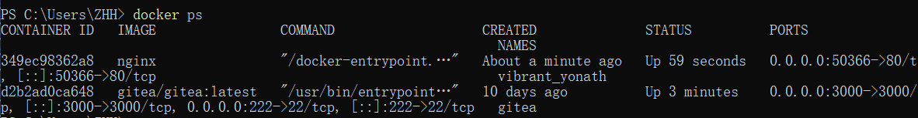
publish container ports using both the CLI and Docker Compose for deploying a web application.
Use the Docker CLI
In this step, you will run a container and publish its port using the Docker CLI.

Download and install Docker Desktop.

In a terminal, run the following command to start a new container:

docker run -d -p 8080:80 docker/welcome-to-docker

The first 8080 refers to the host port. This is the port on your local machine that will be used to access the application running inside the container. The second 80 refers to the container port. This is the port that the application inside the container listens on for incoming connections. Hence, the command binds to port 8080 of the host to port 80 on the container system.

Verify the published port by going to the Containers view of the Docker Desktop Dashboard.

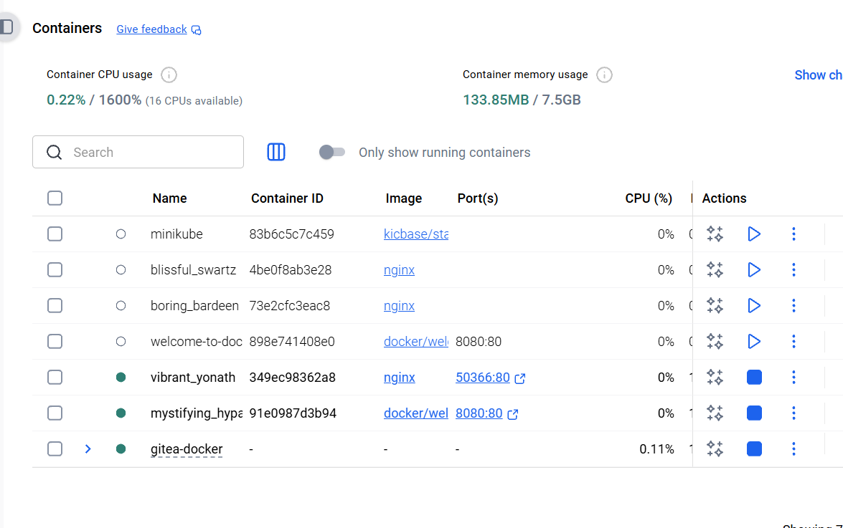
Open the website by either selecting the link in the Port(s) column of your container or visiting http://localhost:8080 in your browser.
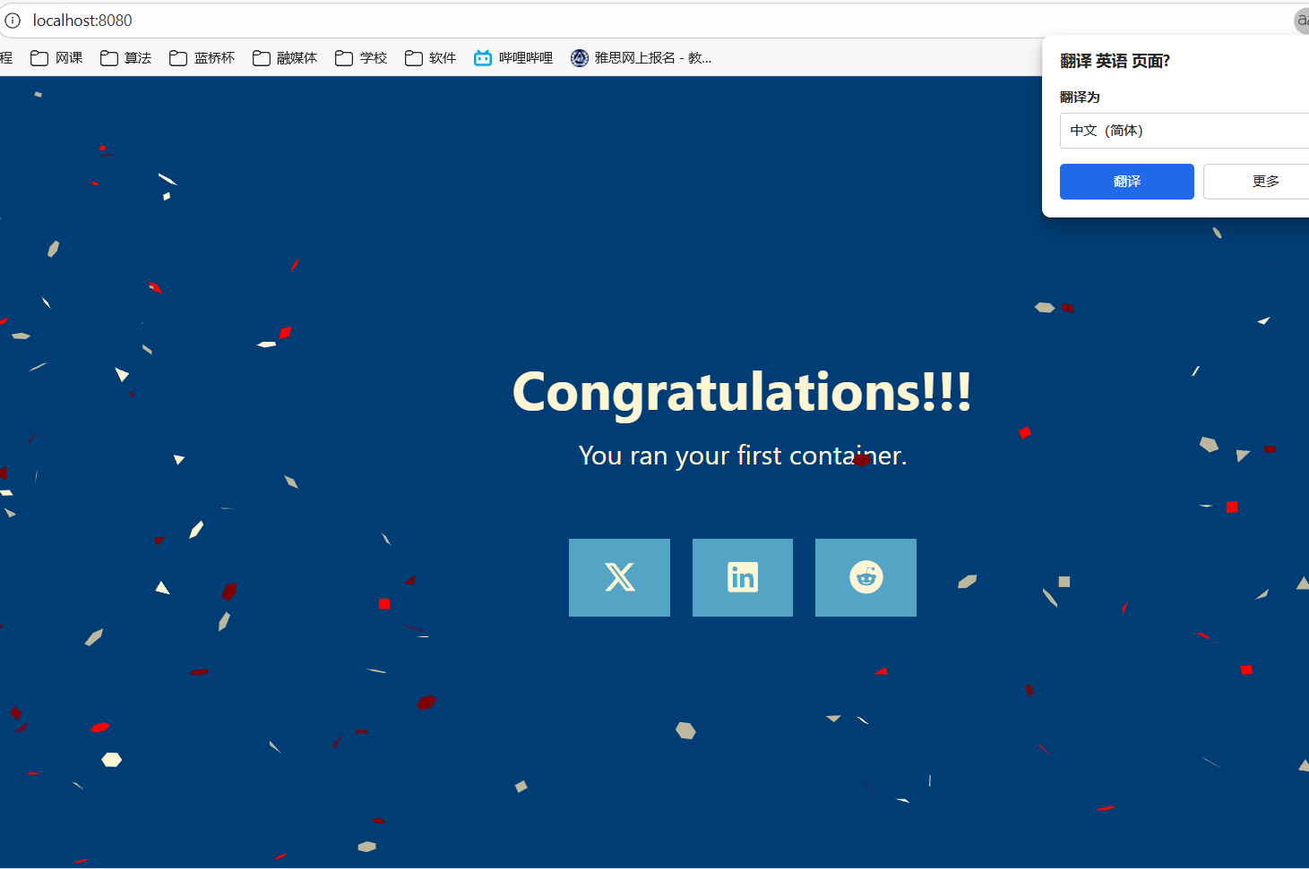
Run multiple instances of the Postgres database

Start a container using the Postgres image with the following command:

docker run -d -e POSTGRES_PASSWORD=secret -p 5432:5432 postgres

This will start the Postgres database in the background, listening on the standard container port 5432 and mapped to port 5432 on the host machine.

Start a second Postgres container mapped to a different port.

docker run -d -e POSTGRES_PASSWORD=secret -p 5433:5432 postgres

This will start another Postgres container in the background, listening on the standard postgres port 5432 in the container, but mapped to port 5433 on the host machine. You override the host port just to ensure that this new container doesn't conflict with the existing running container.

Verify that both containers are running by going to the Containers view in the Docker Desktop Dashboard.

Run Postgres container in a controlled network
By default, containers automatically connect to a special network called a bridge network when you run them. This bridge network acts like a virtual bridge, allowing containers on the same host to communicate with each other while keeping them isolated from the outside world and other hosts. It's a convenient starting point for most container interactions. However, for specific scenarios, you might want more control over the network configuration.
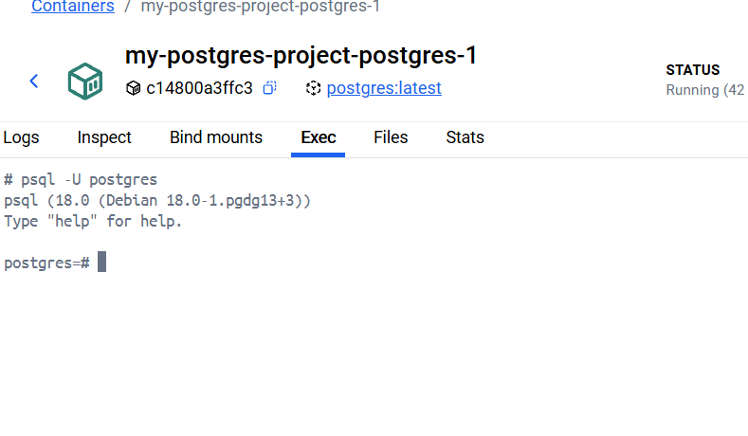

Start a container using the Postgres image with the following command:

docker run --name=db -e POSTGRES_PASSWORD=secret -d -v postgres_data:/var/lib/postgresql/data postgres

This will start the database in the background, configure it with a password, and attach a volume to the directory PostgreSQL will persist the database files.

Connect to the database by using the following command:

docker exec -ti db psql -U postgres

In the PostgreSQL command line, run the following to create a database table and insert two records:

CREATE TABLE tasks ( id SERIAL PRIMARY KEY, description VARCHAR(100));INSERT INTO tasks (description) VALUES ('Finish work'), ('Have fun');

Verify the data is in the database by running the following in the PostgreSQL command line:

SELECT * FROM tasks;

You should get output that looks like the following:

id | description----+------------- 1 | Finish work 2 | Have fun(2 rows)

Exit out of the PostgreSQL shell by running the following command:

\q

Stop and remove the database container. Remember that, even though the container has been deleted, the data is persisted in the postgres_data volume.

docker stop db docker rm db

Start a new container by running the following command, attaching the same volume with the persisted data:

docker run --name=new-db -d -v postgres_data:/var/lib/postgresql/data postgres

You might have noticed that the POSTGRES_PASSWORD environment variable has been omitted. That’s because that variable is only used when bootstrapping a new database.

Verify the database still has the records by running the following command:

docker exec -ti new-db psql -U postgres -c "SELECT * FROM tasks"

View volume contents
The Docker Desktop Dashboard provides the ability to view the contents of any volume, as well as the ability to export, import, and clone volumes.

Open the Docker Desktop Dashboard and navigate to the Volumes view. In this view, you should see the postgres_data volume.

Select the postgres_data volume’s name.
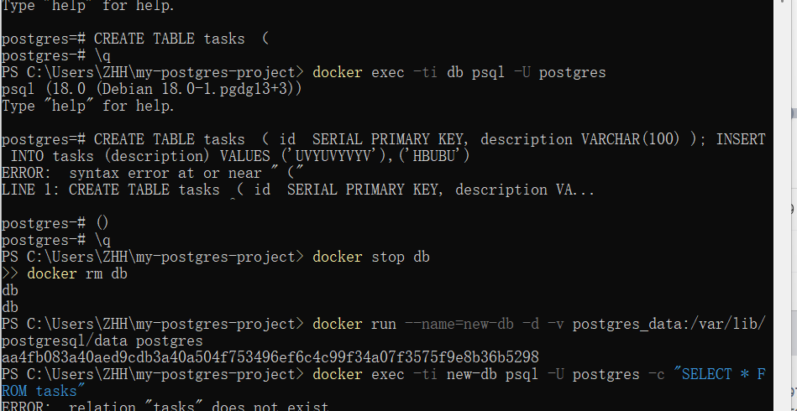

The Data tab shows the contents of the volume and provides the ability to navigate the files. Double-clicking on a file will let you see the contents and make changes.

Right-click on any file to save it or delete it.

Remove volumes
Before removing a volume, it must not be attached to any containers. If you haven’t removed the previous container, do so with the following command (the -f will stop the container first and then remove it):
docker rm -f new-db
There are a few methods to remove volumes, including the following:

Select the Delete Volume option on a volume in the Docker Desktop Dashboard.

Use the docker volume rm command:

docker volume rm postgres_data

Use the docker volume prune command to remove all unused volumes:

docker volume prune

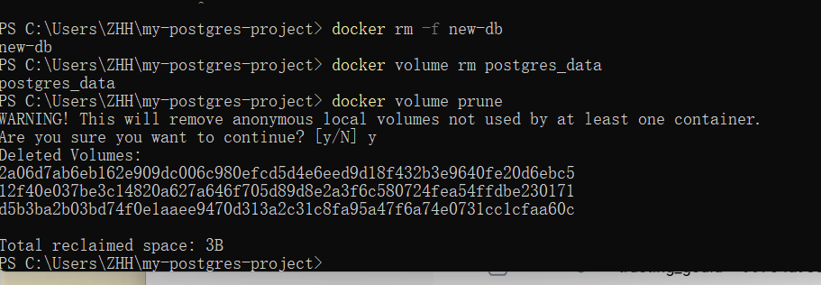

Use a bind mount
Using a bind mount, you can map the configuration file on your host computer to a specific location within the container. In this example, you’ll see how to change the look and feel of the webpage by using bind mount:

Delete the existing container by using the Docker Desktop Dashboard:

Create a new directory called public_html on your host system.

mkdir public_html

Navigate into the newly created directory public_html and create a file called index.html with the following content. This is a basic HTML document that creates a simple webpage that welcomes you with a friendly whale.

<!DOCTYPE html><html lang="en"><head><meta charset="UTF-8"><title> My Website with a Whale & Docker!</title></head><body><h1>Whalecome!!</h1><p>Look! There's a friendly whale greeting you!</p><pre id="docker-art"> ## . ## ## ## == ## ## ## ## ## === /"""""""""""""""""\___/ ==={ / ===-\______ O __/\ \ __/ \____\_______/Hello from Docker!</pre></body></html>

It's time to run the container. The --mount and -v examples produce the same result. You can't run them both unless you remove the my_site container after running the first one.

-v --mount

docker run -d --name my_site -p 8080:80 -v .:/usr/local/apache2/htdocs/ httpd:2.4

Tip

When using the -v or --mount flag in Windows PowerShell, you need to provide the absolute path to your directory instead of just ./. This is because PowerShell handles relative paths differently from bash (commonly used in Mac and Linux environments).

With everything now up and running, you should be able to access the site via http://localhost:8080 and find a new webpage that welcomes you with a friendly whale.

Access the file on the Docker Desktop Dashboard

You can view the mounted files inside a container by selecting the container's Files tab and then selecting a file inside the /usr/local/apache2/htdocs/ directory. Then, select Open file editor.

Delete the file on the host and verify the file is also deleted in the container. You will find that the files no longer exist under Files in the Docker Desktop Dashboard.

Recreate the HTML file on the host system and see that file re-appears under the Files tab under Containers on the Docker Desktop Dashboard. By now, you will be able to access the site too.

Stop your container
The container continues to run until you stop it.

Go to the Containers view in the Docker Desktop Dashboard.

Locate the container you'd like to stop.

Select the Delete action in the Actions column.
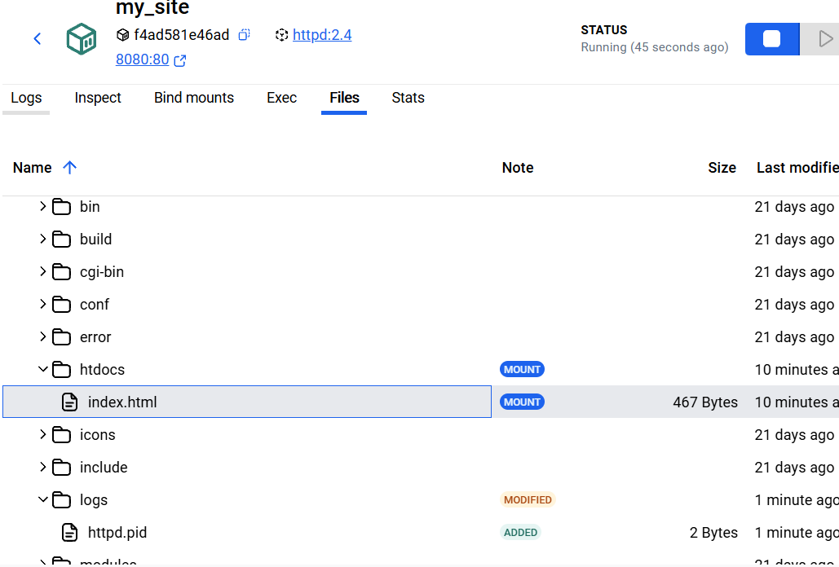

Docker Compose provides a structured and streamlined approach for managing multi-container deployments. As stated earlier, with Docker Compose, you don’t need to run multiple docker run commands. All you need to do is define your entire multi-container application in a single YAML file called compose.yml. Let’s see how it works.
Navigate to the root of the project directory. Inside this directory, you'll find a file named compose.yml. This YAML file is where all the magic happens. It defines all the services that make up your application, along with their configurations. Each service specifies its image, ports, volumes, networks, and any other settings necessary for its functionality.

Use the docker compose up command to start the application:

docker compose up -d --build

When you run this command, you should see output similar to the following:

Running 5/5✔ Network nginx-nodejs-redis_default Created 0.0s✔ Container nginx-nodejs-redis-web1-1 Started 0.1s✔ Container nginx-nodejs-redis-redis-1 Started 0.1s✔ Container nginx-nodejs-redis-web2-1 Started 0.1s✔ Container nginx-nodejs-redis-nginx-1 Started

If you look at the Docker Desktop Dashboard, you can see the containers and dive deeper into their configuration.
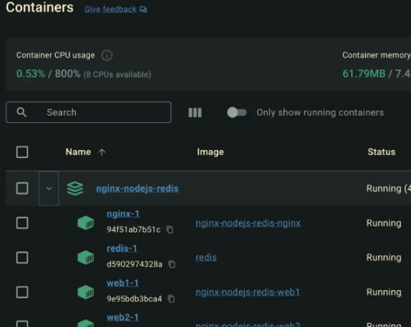

Alternatively, you can use the Docker Desktop Dashboard to remove the containers by selecting the application stack and selecting the Delete button.

