Step 1: Install Minikube
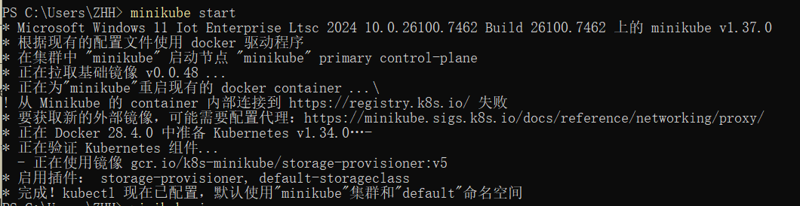
Create a Deployment
Use the kubectl create command to create a Deployment that manages a Pod. The Pod runs a Container based on the provided Docker image.View the Deployment:View the Pod
View application logs for a container in a pod
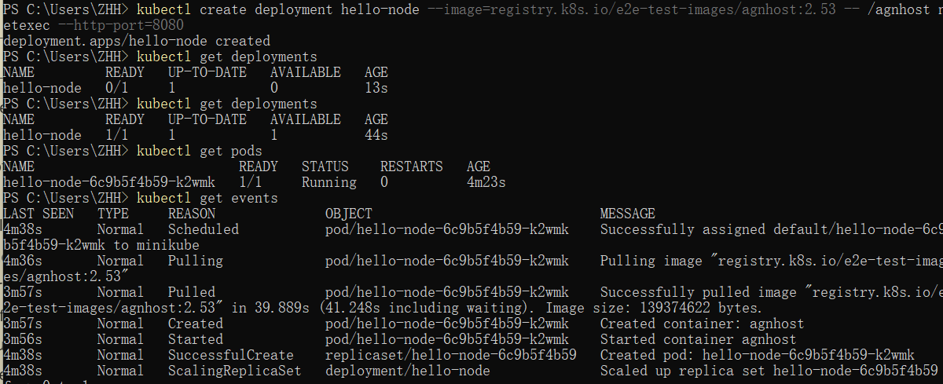

View application logs for a container in a pod (replace pod name with the one you got from kubectl get pods).
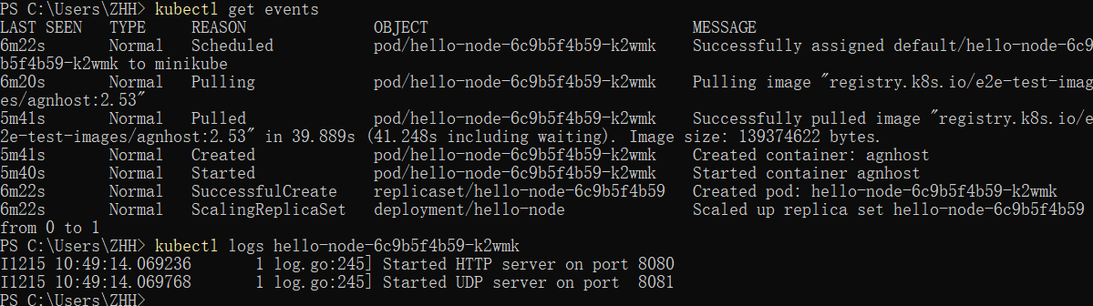
Create a Service
Expose the Pod to the public internet using the kubectl expose command:View the Service you created:
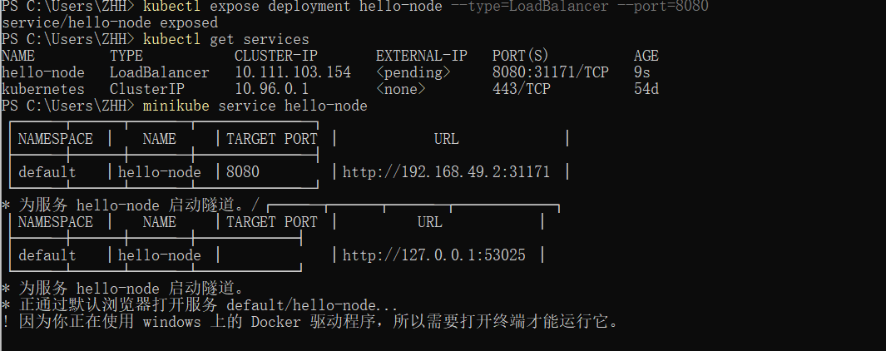
Run the following command:
minikube service hello-node
This opens up a browser window that serves your app and shows the app's response.
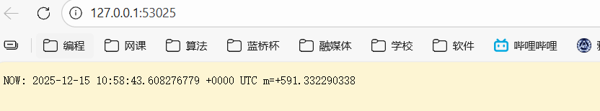

Enable addons
List the currently supported addons。
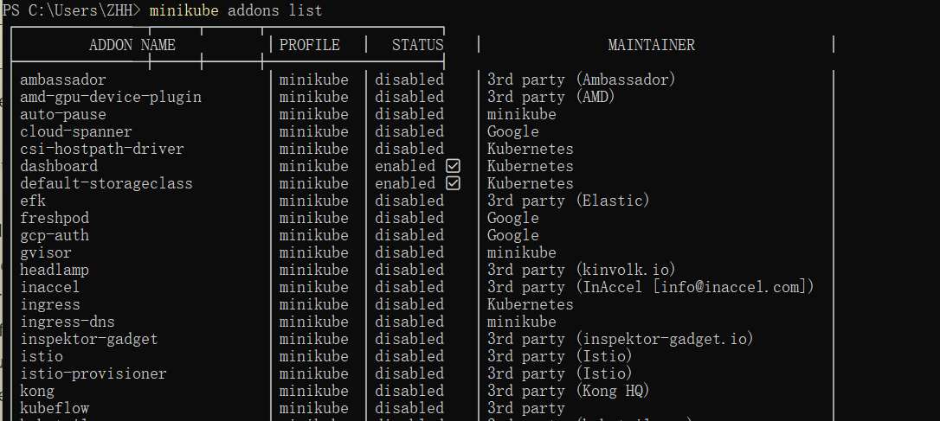
Enable an addon, for example, metrics-server
View the Pod and Service you created by installing that addon
Check the output from metrics-server
Disable metrics-server
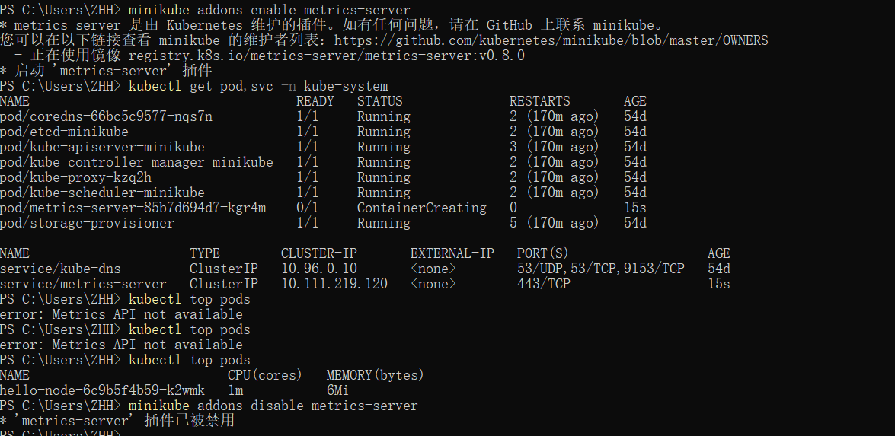

Deploying your first app on Kubernetes
Deploy an app
Let’s deploy our first app on Kubernetes with the kubectl create deployment command.
To list your deployments use the kubectl get deployments command:

View the app
The kubectl proxy command can create a proxy that will forward communications into the cluster-wide, private network. The proxy can be terminated by pressing control-C and won't show any output while it's running.You can see all those APIs hosted through the proxy endpoint. For example, we can query the version directly through the API using the curl command:

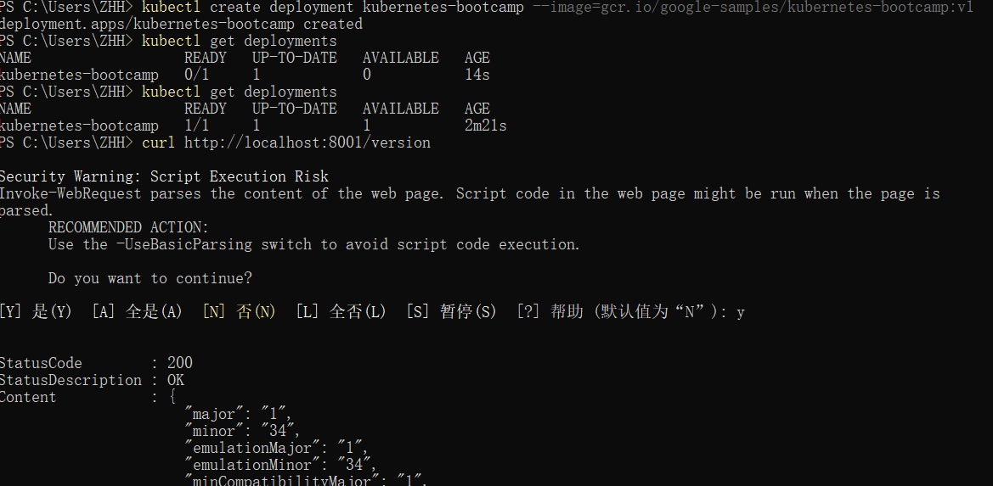

First we need to get the Pod name, and we'll store it in the environment variable POD_NAMEYou can access the Pod through the proxied API, by running

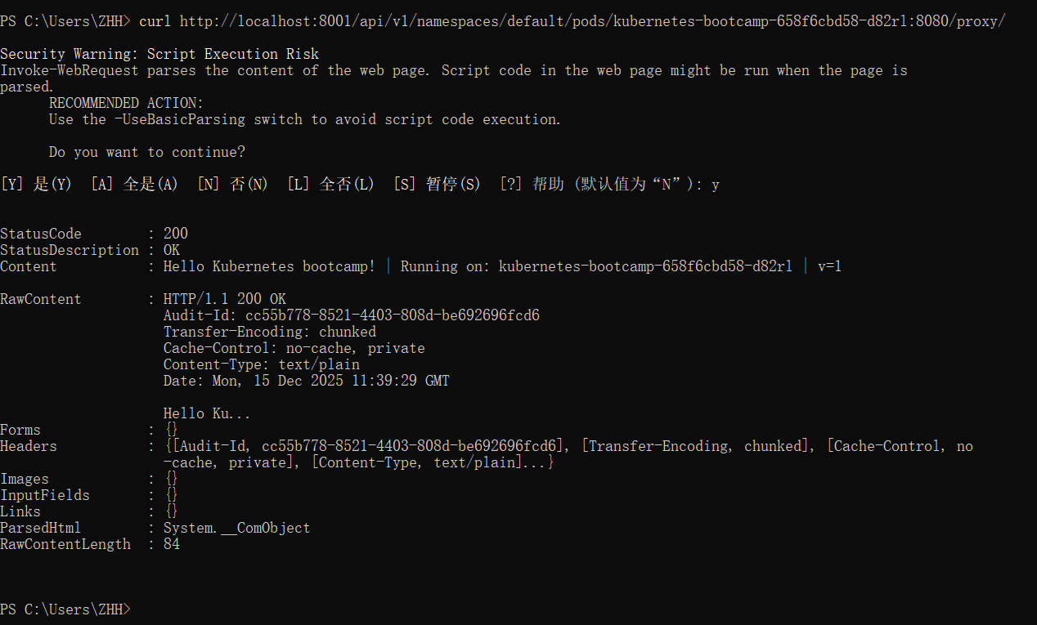

Troubleshooting with kubectl
Check application configuration
Let's verify that the application we deployed in the previous scenario is running. We'll use the kubectl get command and look for existing Pods:
Next, to view what containers are inside that Pod and what images are used to build those containers we run the kubectl describe pods command:
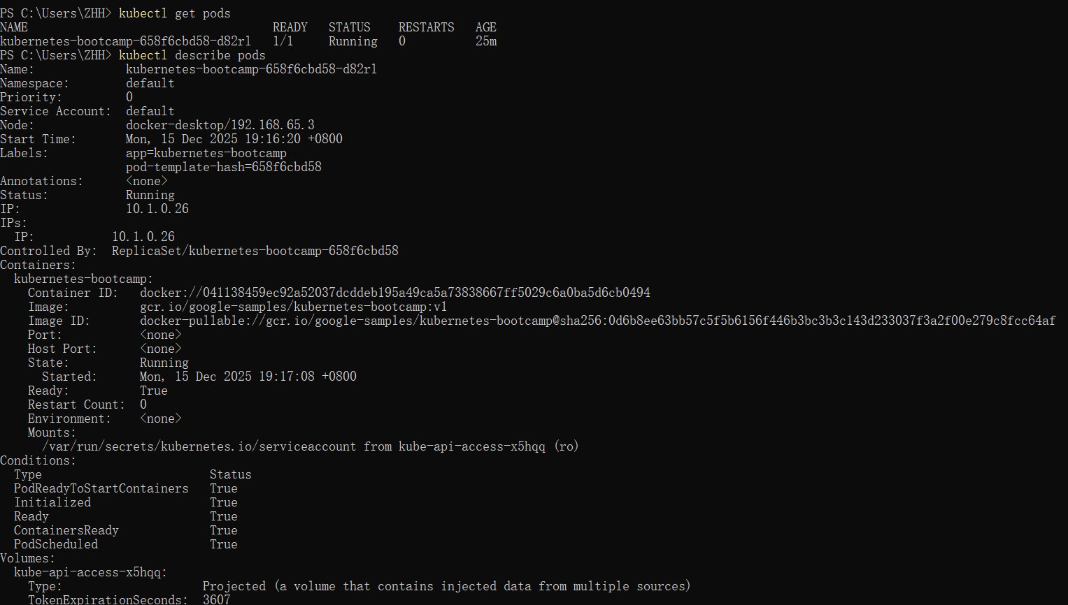
Show the app in the terminal
Now again, we'll get the Pod name and query that pod directly through the proxy. To get the Pod name and store it in the POD_NAME environment variable:To see the output of our application, run a curl request

Executing commands on the container
We can execute commands directly on the container once the Pod is up and running. For this, we use the exec subcommand and use the name of the Pod as a parameter. Let’s list the environment variables
Again, it's worth mentioning that the name of the container itself can be omitted since we only have a single container in the Pod.
Next let’s start a bash session in the Pod’s container:
We have now an open console on the container where we run our NodeJS application. The source code of the app is in the server.js file:You can check that the application is up by running a curl command:
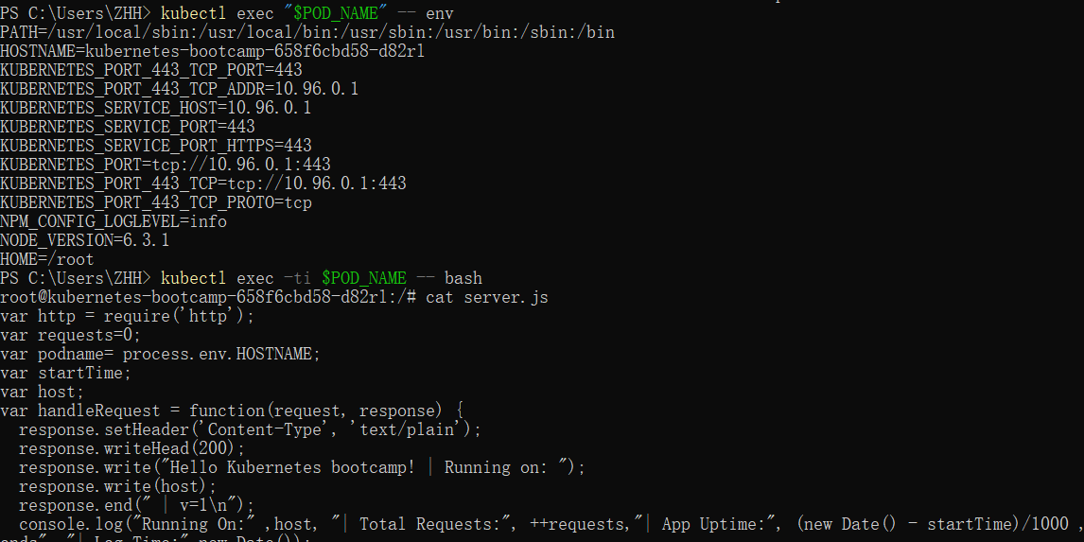

Step 1: Creating a new Service
To expose the deployment to external traffic, we'll use the kubectl expose command with the --type=NodePort option:To find out what port was opened externally (for the type: NodePort Service) we’ll run the describe service subcommand:Create an environment variable called NODE_PORT that has the value of the Node port assigned:
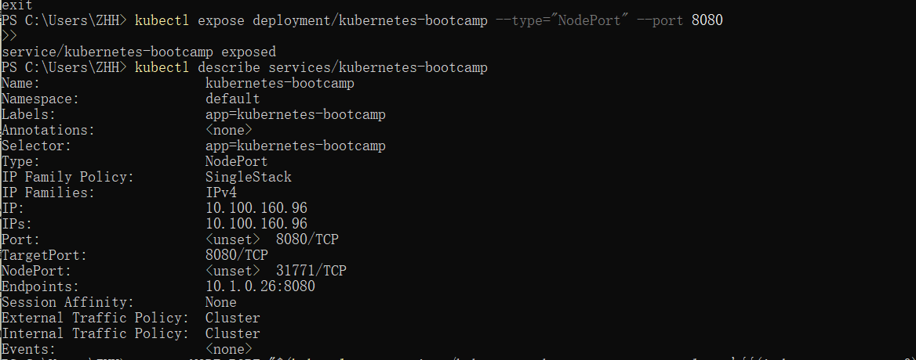

Now we can test that the app is exposed outside of the cluster using curl, the IP address of the Node and the externally exposed port
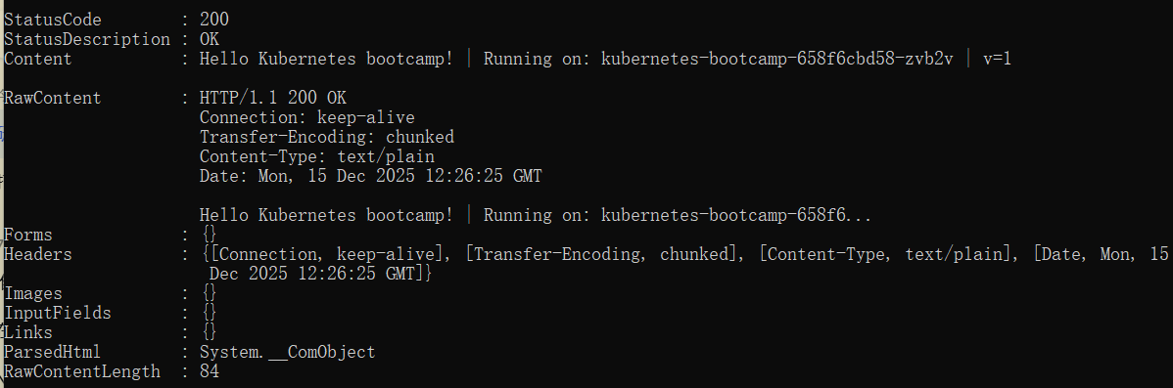

Step 2: Using labels
The Deployment created automatically a label for our Pod. With the describe deployment subcommand you can see the name (the key) of that label:
Let’s use this label to query our list of Pods. We’ll use the kubectl get pods command with -l as a parameter, followed by the label values:
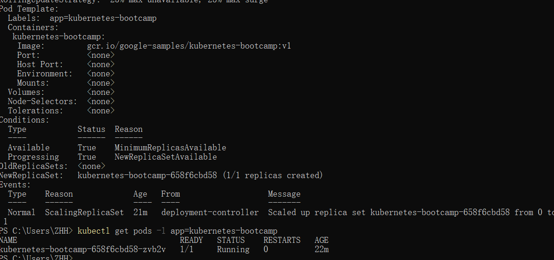

Get the name of the Pod and store it in the POD_NAME environment variable:To apply a new label we use the label subcommand followed by the object type, object name and the new label:

This will apply a new label to our Pod (we pinned the application version to the Pod), and we can check it with the describe pod command:We see here that the label is attached now to our Pod. And we can query now the list of pods using the new label:
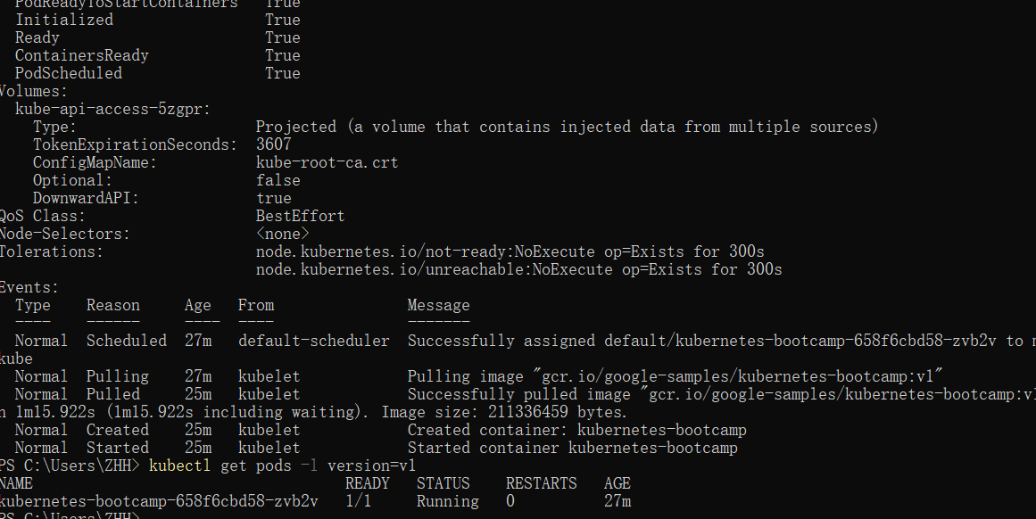
Step 3: Deleting a service
To delete Services you can use the delete service subcommand. Labels can be used also here:
Confirm that the Service is gone:This confirms that our Service was removed. To confirm that route is not exposed anymore you can curl the previously exposed IP and port:This proves that the application is not reachable anymore from outside of the cluster. You can confirm that the app is still running with a curl from inside the pod:
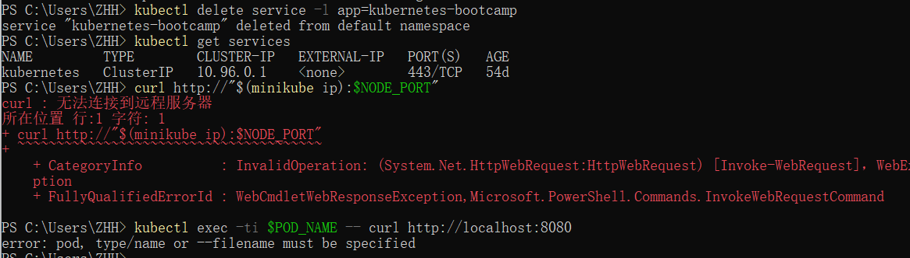

Step 1: Start Minikube Cluster
bash
minikube start --driver=docker

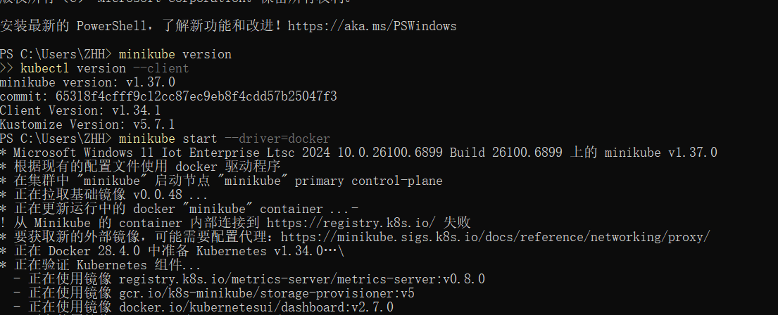
Step 2: Check Cluster Status
bash
minikube status
kubectl cluster-info
Expected Output:
text
minikube
type: Control Plane
host: Running
kubelet: Running
apiserver: Running
kubeconfig: Configured
Screenshot: Cluster status showing all components running
Step 3: View Nodes
bash
kubectl get nodes
kubectl describe nodes
Notes:

Single node cluster in minikube
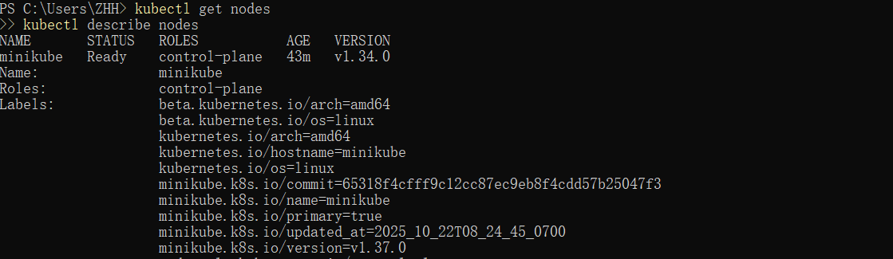

Perform a rolling update to v2
kubectl set image deployments/kubernetes-bootcamp kubernetes-bootcamp=docker.io/jocatalin/kubernetes-bootcamp:v2

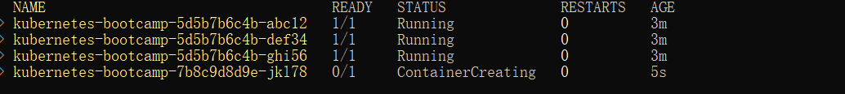
Update verified successfully

Attempt to update to a non-existent v10 image

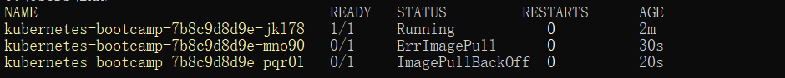
Roll back to the previous stable version

