It tells the installation and configuration of the Wutang cover on the group has been recorded

Install Istio
For this guide, we use the demo configuration profile. It is selected to have a good set of defaults for testing, but there are other profiles for production, performance testing or OpenShift.
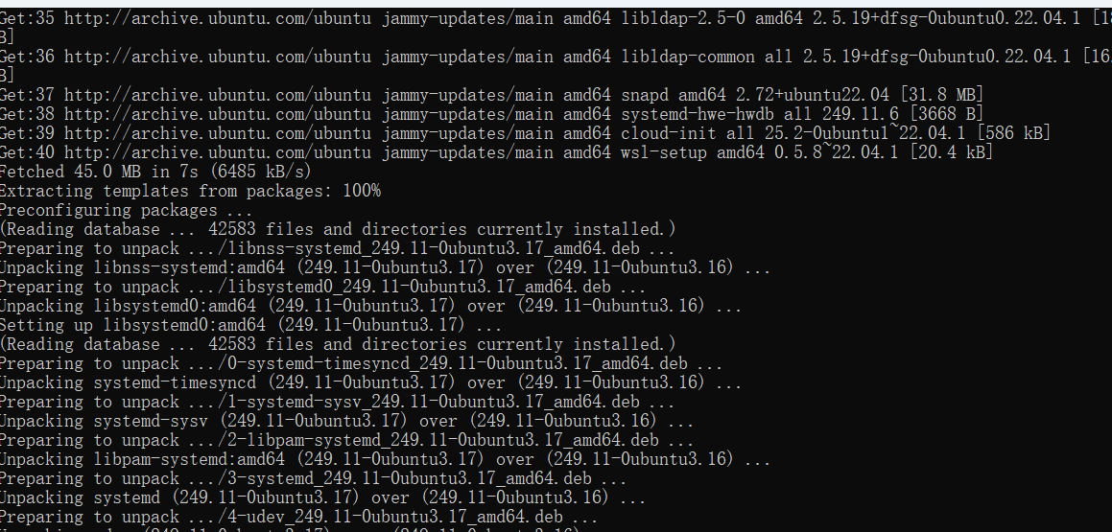
Install the Kubernetes Gateway API CRDs
The Kubernetes Gateway API CRDs do not come installed by default on most Kubernetes clusters, so make sure they are installed before using the Gateway API.
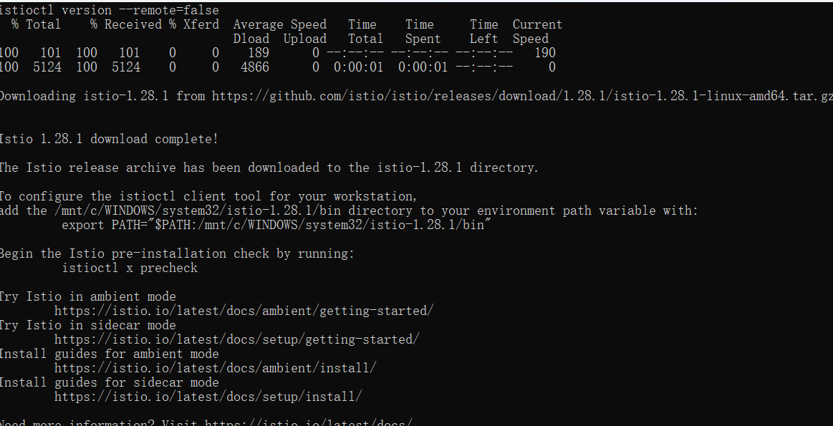

Deploy the sample application
You have configured Istio to inject sidecar containers into any application you deploy in your default namespace.
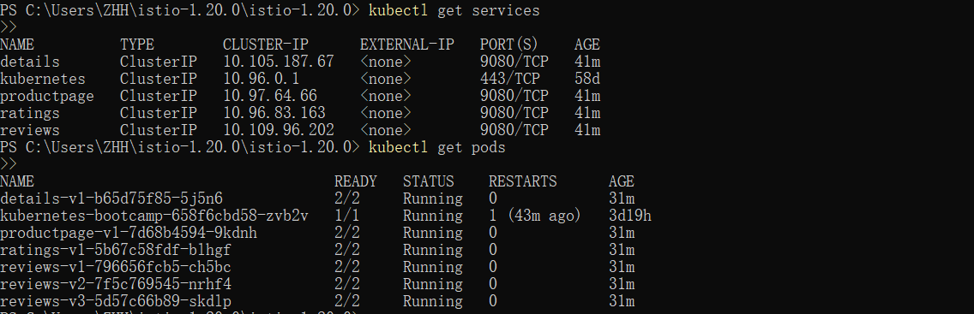
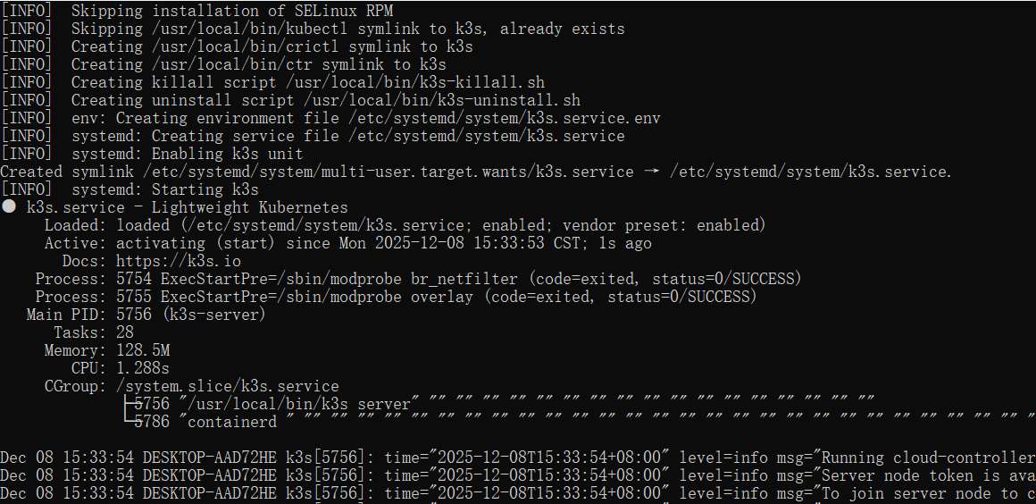
Open the application to outside traffic
The Bookinfo application is deployed, but not accessible from the outside. To make it accessible, you need to create an ingress gateway, which maps a path to a route at the edge of your mesh.

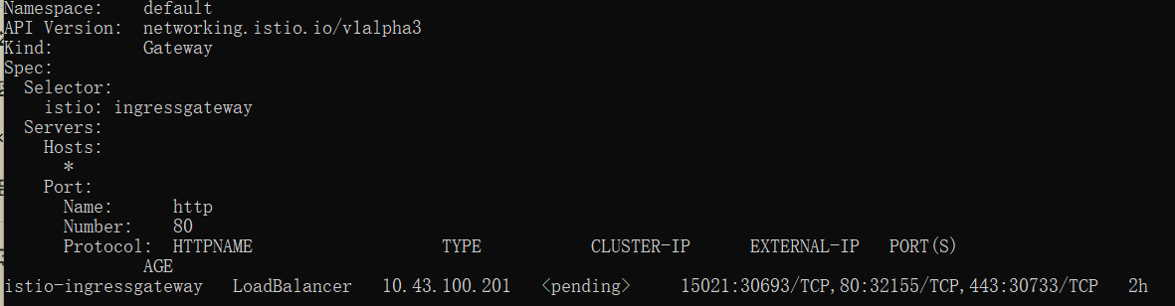
Access the application
You will connect to the Bookinfo productpage service through the gateway you just provisioned. To access the gateway, you need to use the kubectl port-forward command:
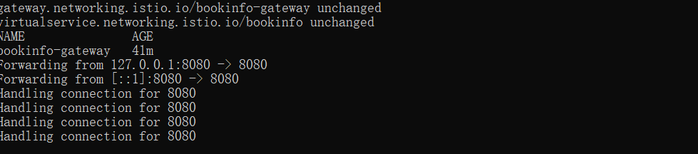
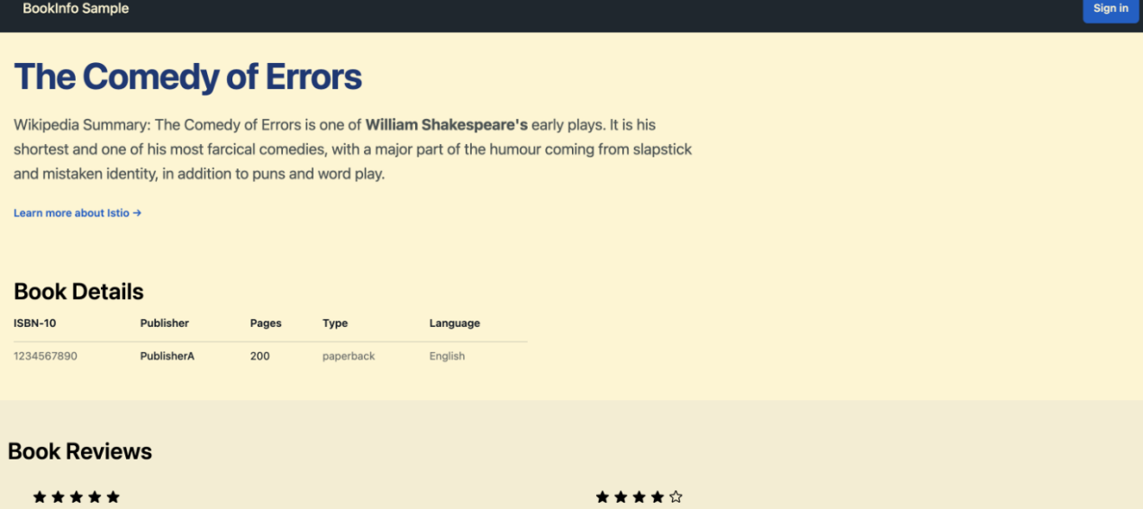

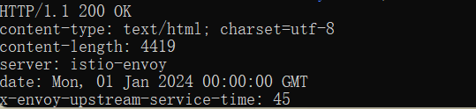
View the dashboard
Istio integrates with several different telemetry applications. These can help you gain an understanding of the structure of your service mesh, display the topology of the mesh, and analyze the health of your mesh

