1. Docker Desktop Installation
Open terminal, and run: wsl --install
Download Docker Desktop and install it.
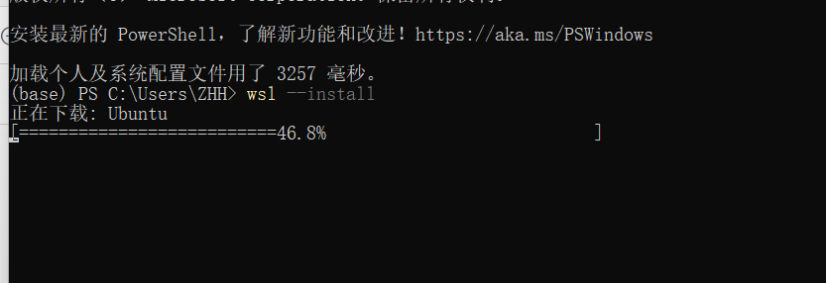
2. Gitea Installation using Docker
Docker Compose Configuration
Start Gitea Container
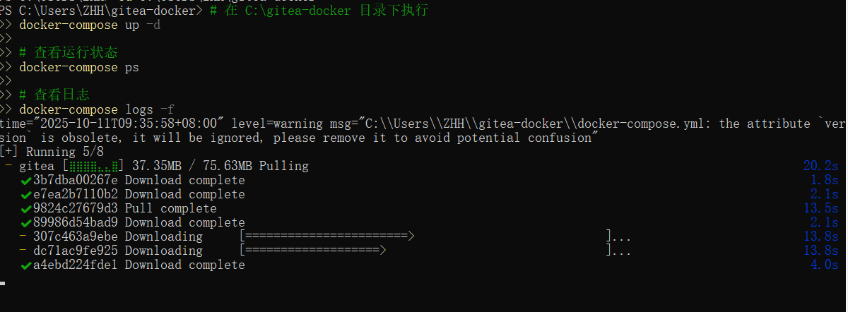
3. Gitea Initial Setup

Open browser and navigate to http://localhost:3000

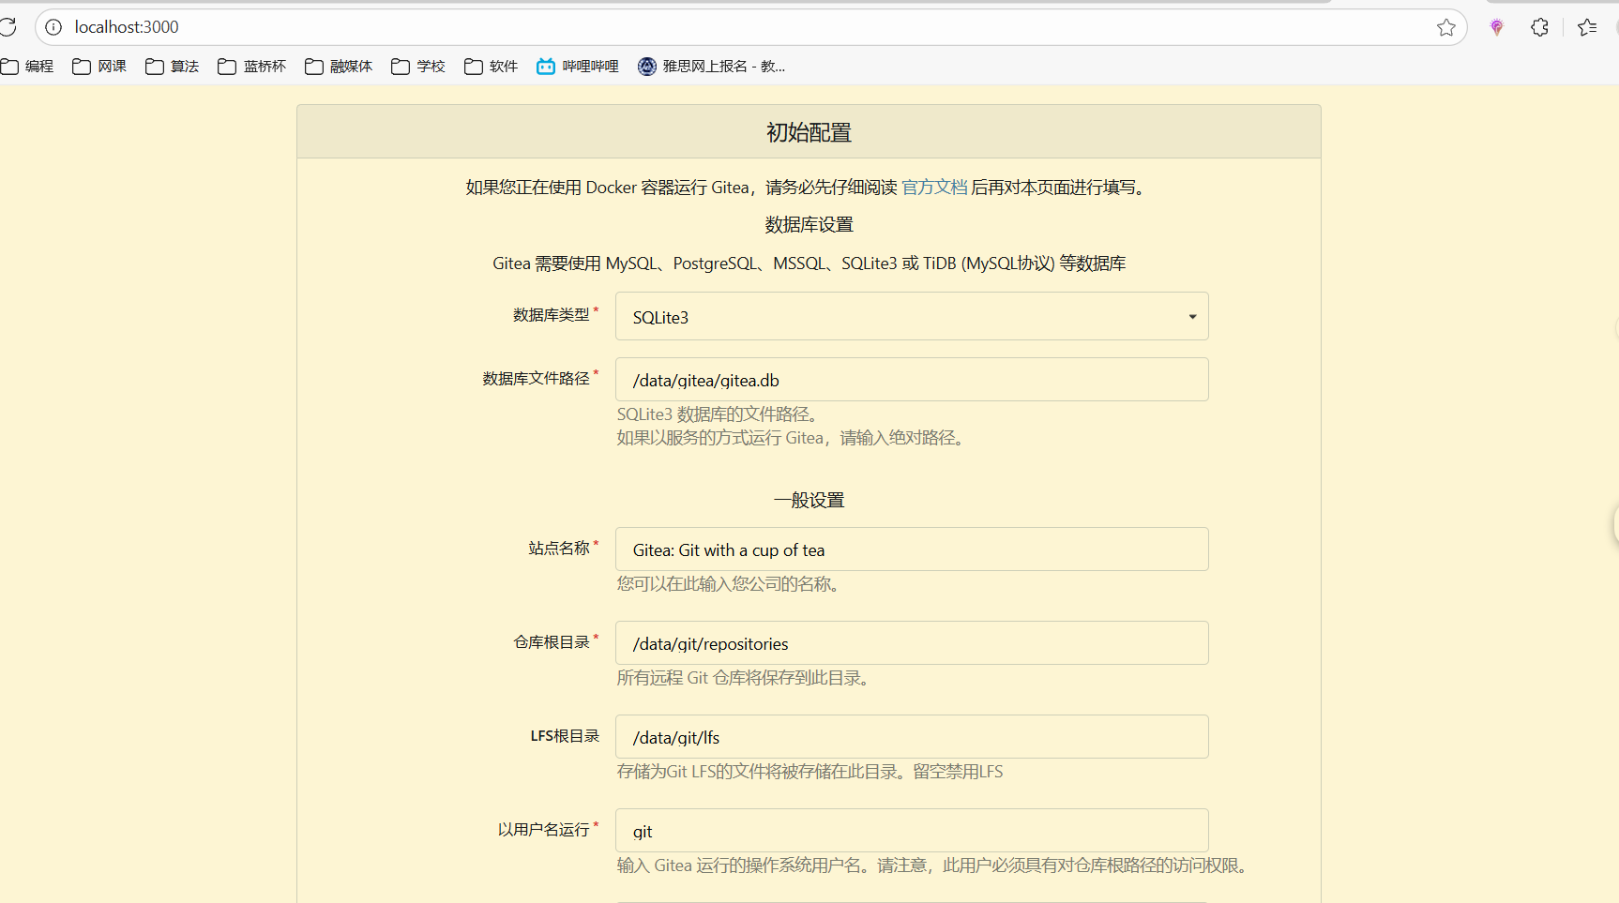

4. Task A: LFS Support Verification
Check LFS Support
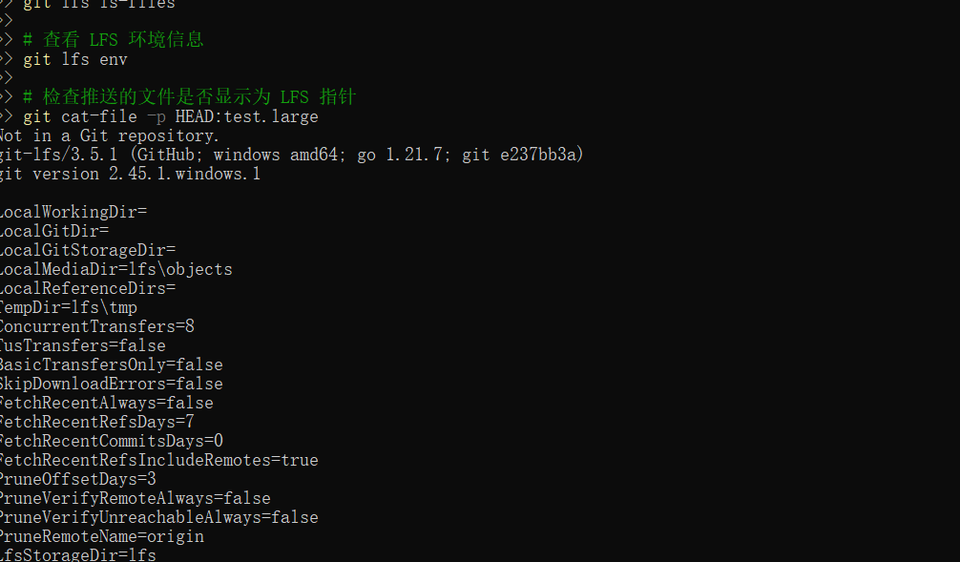5. Task B: Create Repository with Large File (1GB+)
Create Large File Repository
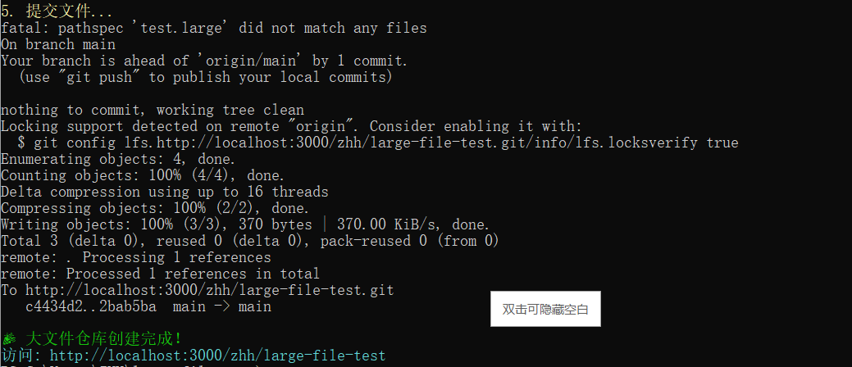
6. Task C: Create Module Repository
Create Course Module Repository

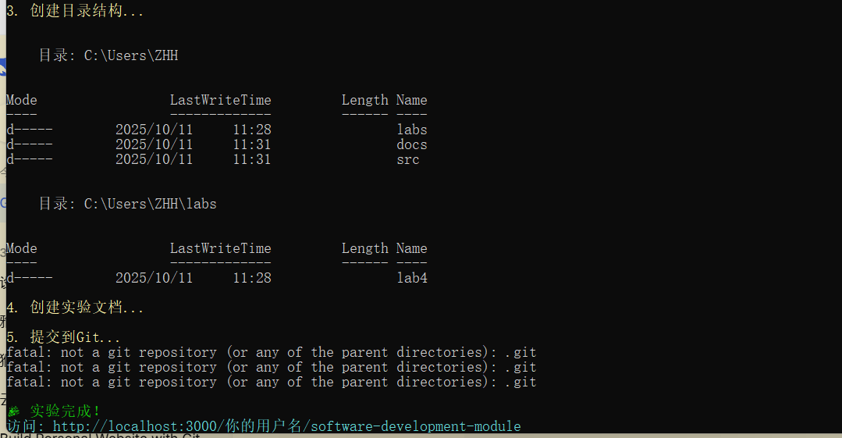

7. Task D: Backup and Restore (Optional)
Backup Procedure

