Daniel Lara - ID: 49651280

Zachary Hart – ID: 70953123

CS 132

HW 2: Wireshark Labs

# Question 2: Wireshark Labs

## HTTP:

1. Is your browser running HTTP version 1.0 or 1.1? What version of HTTP is the server running?

**Answer: Both the browser and the server are using version 1.1.**

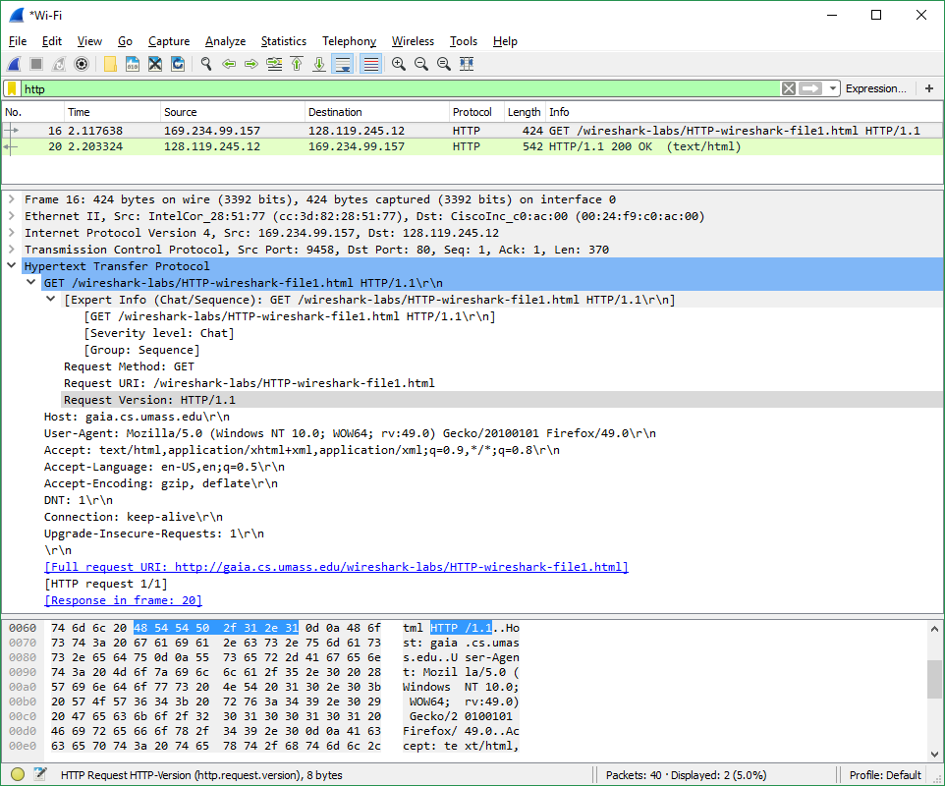



1. What languages (if any) does your browser indicate that it can accept to the  
   server?

**Answer: en-US, en**

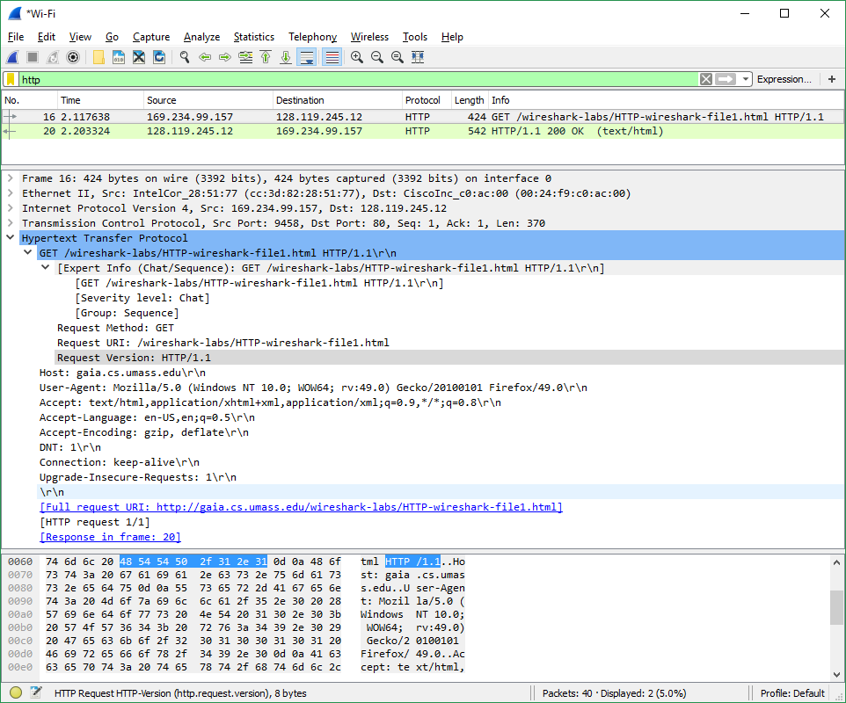



1. What is the IP address of your computer? Of the gaia.cs.umass.edu server?

**Answer: My IP = 169.234.99.157 Edu IP = 128.119.245.12**

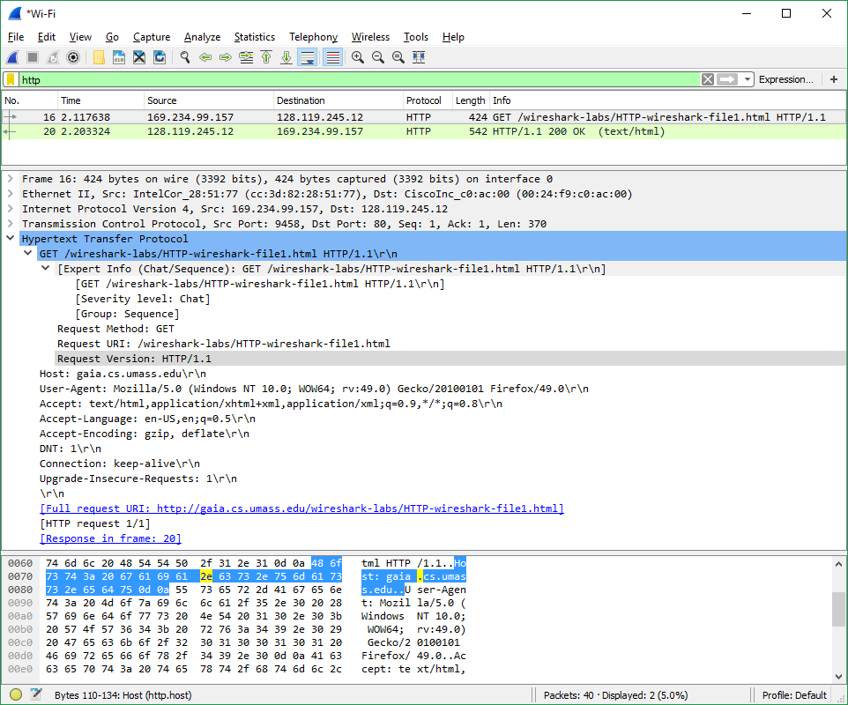



1. What is the status code returned from the server to your browser?

**Answer: HTTP/1.1 200 OK (Status Code: 200, Response Phrase: OK)**

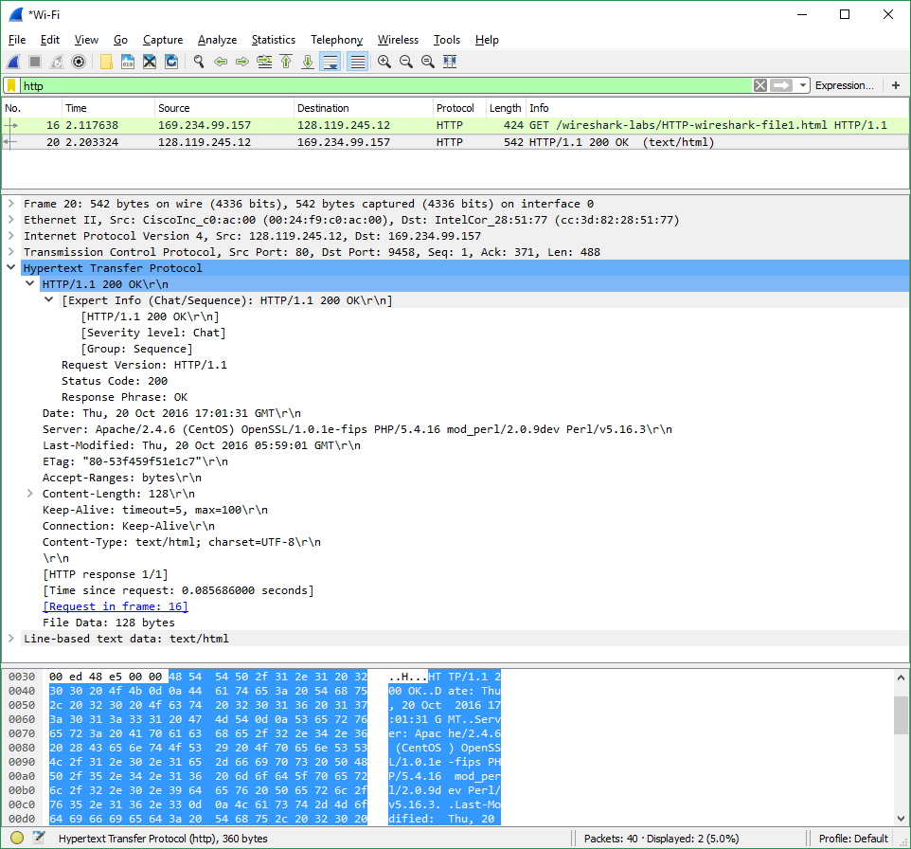



1. When was the HTML file that you are retrieving last modified at the server?

**Answer: Thu, 20 Oct 2016 05:59:01 GMT**

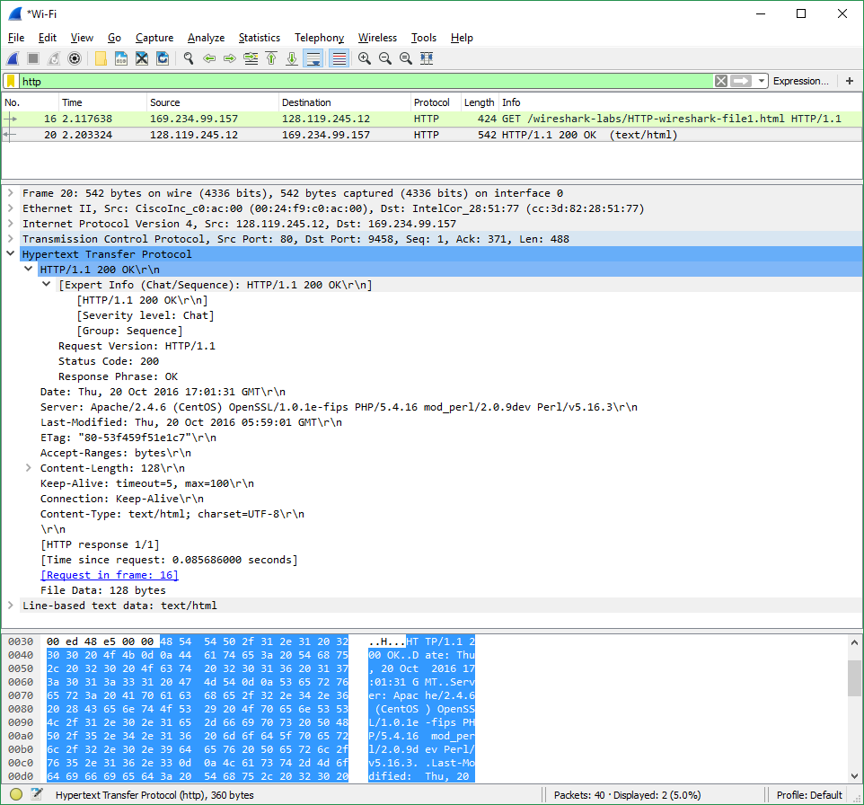



1. How many bytes of content are being returned to your browser?

**Answer: Content-Length: 128 (128 bytes)**

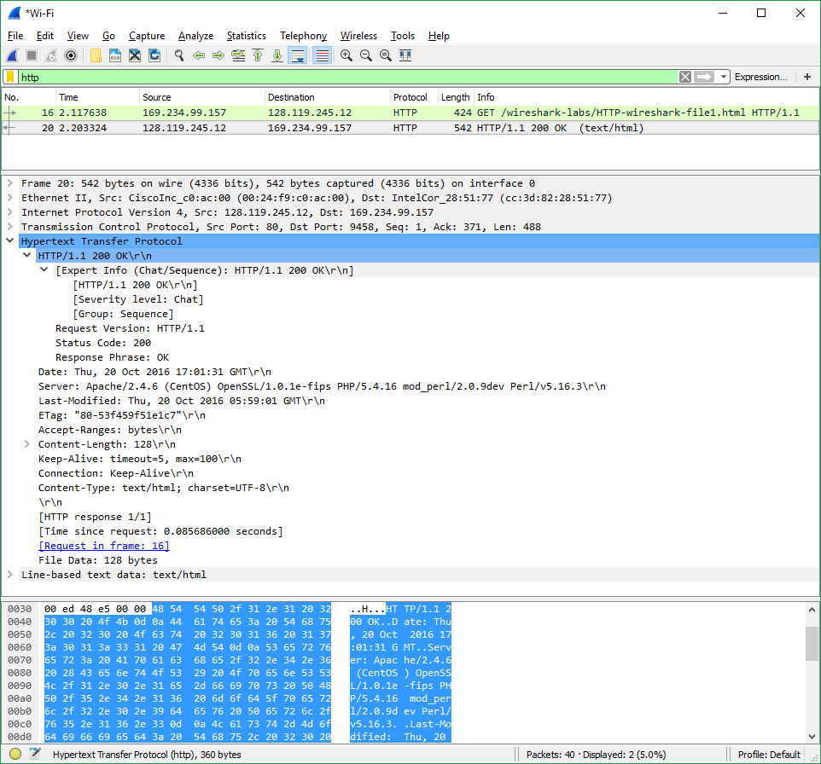



1. By inspecting the raw data in the packet content window, do you see any headers  
   within the data that are not displayed in the packet-listing window? If so, name  
   one.

**Answer: No. All the headers are accounted for in the raw data.**

# Question 2: Wireshark Labs

## DNS:

1. Locate the DNS query and response messages. Are then sent over UDP or TCP?

**Answer: Both the query and the query response use UDP**

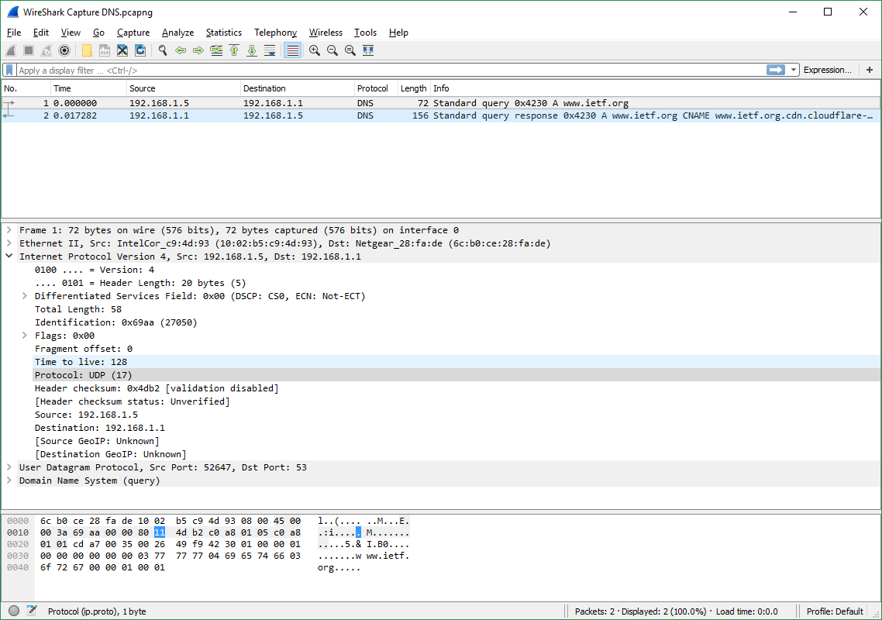



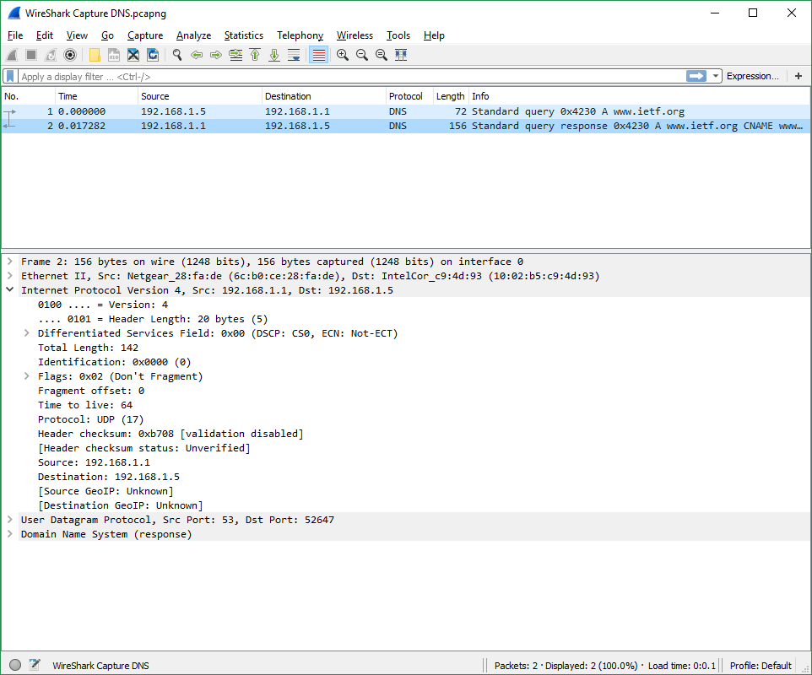



1. What is the destination port for the DNS query message? What is the source port  
   of DNS response message?

**Answer: Destination Port = 53 and Source Port = 53**

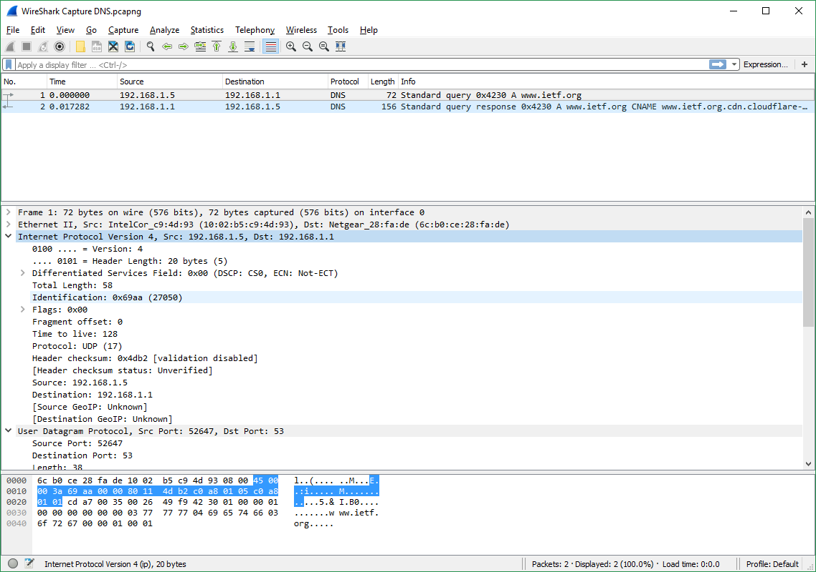



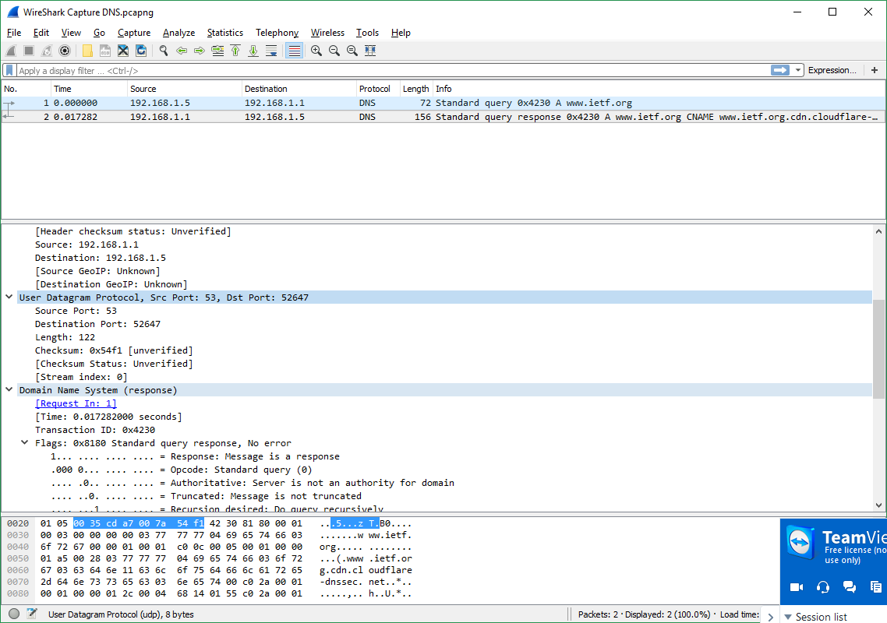



1. To what IP address is the DNS query message sent? Use ipconfig to determine the  
   IP address of your local DNS server. Are these two IP addresses the same?

**Answer: IP Address = 192.168.1.1 | Local DNS server IP Address = 192.168.1.1 (Local DNS was found using the command “ipconfig /all”**

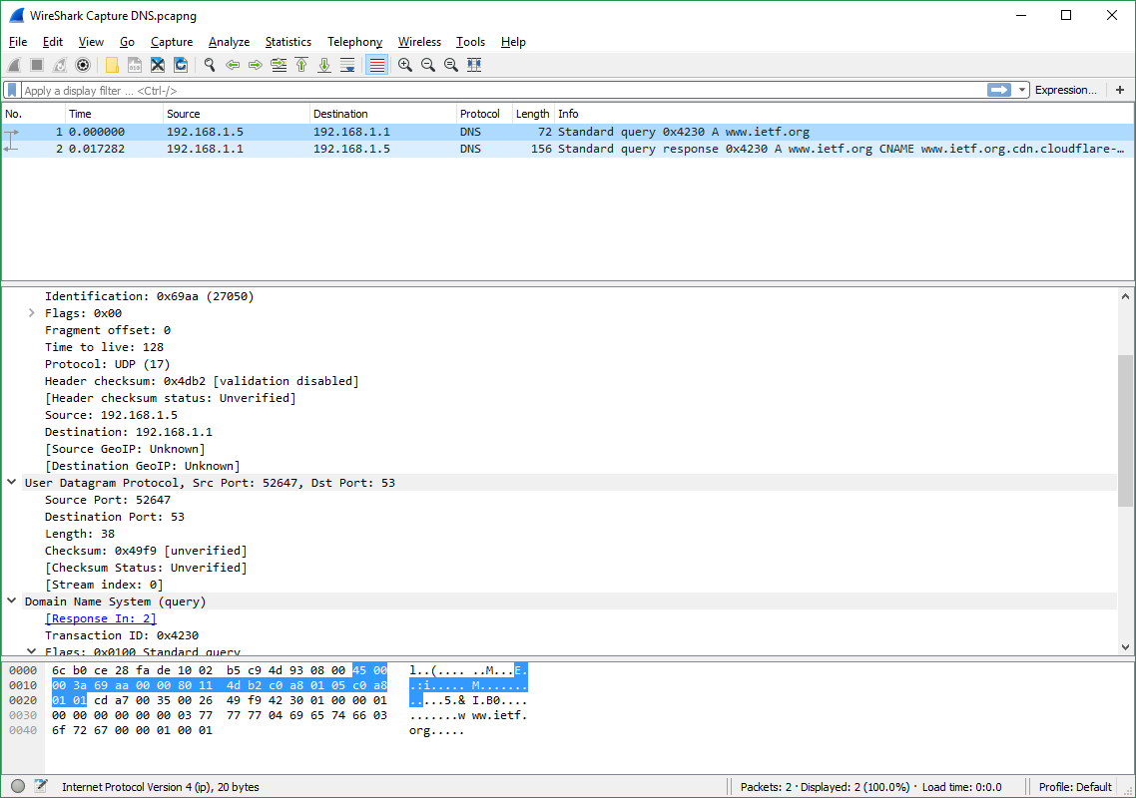



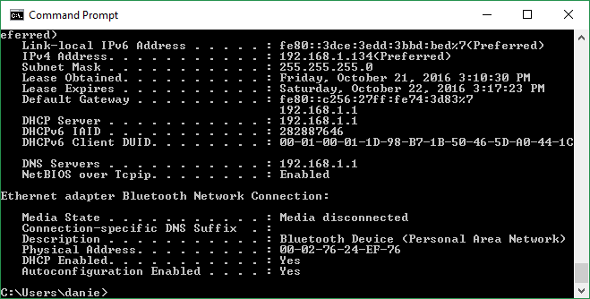



1. Examine the DNS query message. What “Type” of DNS query is it? Does the  
   query message contain any “answers”?

**Answer: Type-A, class IN. The Query message does not have any answers associated with it.**

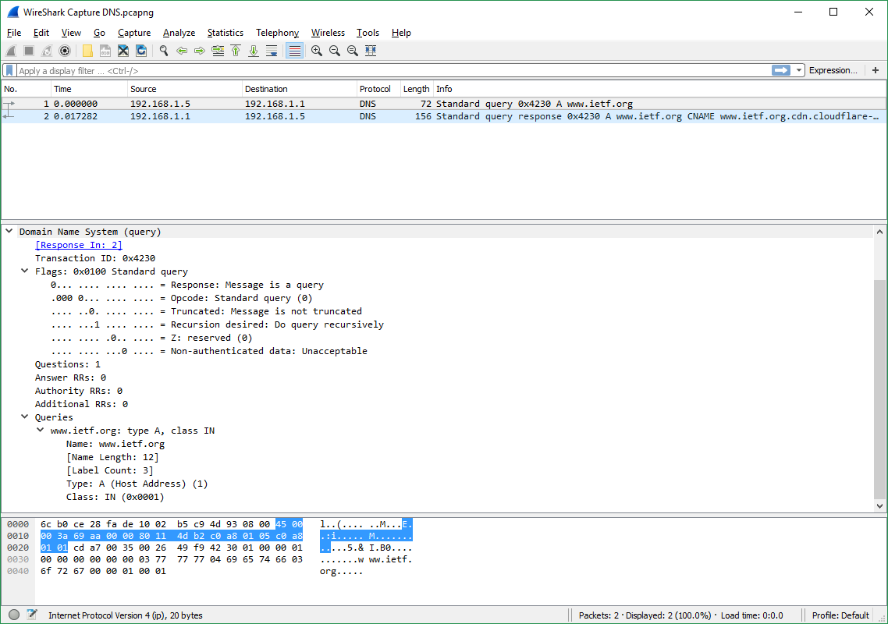



1. Examine the DNS response message. How many “answers” are provided? What  
   do each of these answers contain?

**Answer: There were 3 answers provided. All of the answers have the following: Name, Type, Class, Time to live, and Data length. The first answer is of type “CName” and its value is** [**www.ietf.org.cdn.cloudflare-dnssec.net**](http://www.ietf.org.cdn.cloudflare-dnssec.net)**. The other two responses are of type A and have addresses associated with them. (2nd: 104.20.1.85, 3rd: 104.20.0.85)**

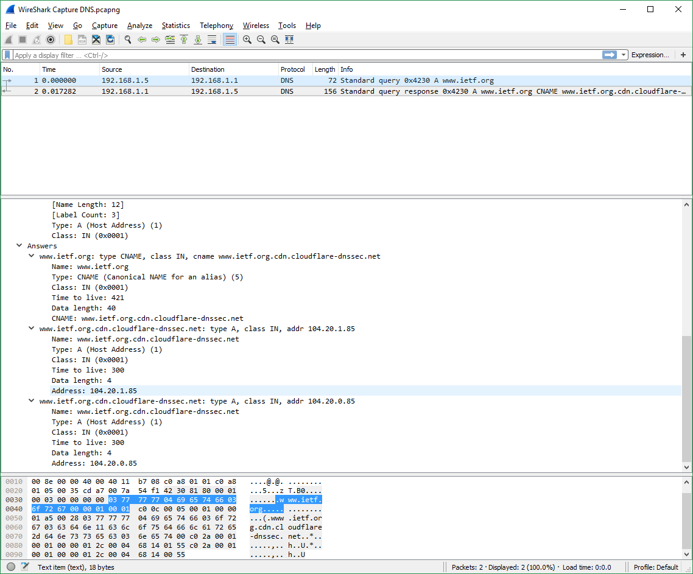



1. What is the destination port for the DNS query message? What is the source port of DNS response message?

**Answer: The destination port in the query message is 53. The source port of the response message is 53**



1. To what IP address is the DNS query message sent? Is this the IP address of your default local DNS server?

**Answer: The IP address is 192.168.1.1. This is the same address as the local DNS server (found by using ipconfig /all).**

1. Examine the DNS query message. What “Type” of DNS query is it? Does the query message contain any “answers”?

**Answer: The DNS query message is type A, it does not contain any answers.**

1. Examine the DNS response message. How many “answers” are provided? What do each of these answers contain?

**Answer: The response message contains 3 answers. Each answer contains a name, a type, a class, time to live, data length, and either an address (if type A) or a CNAME (if type CNAME).**

1. Provide a screenshot.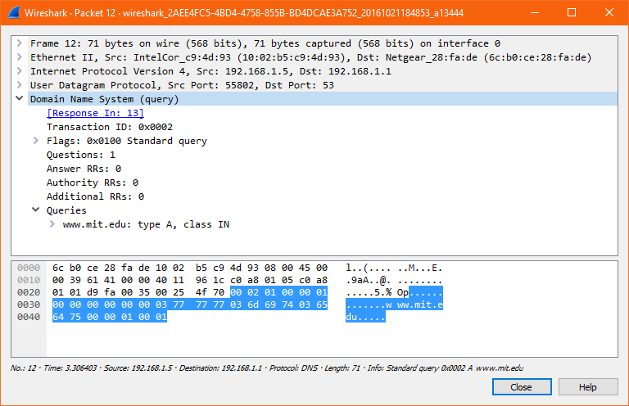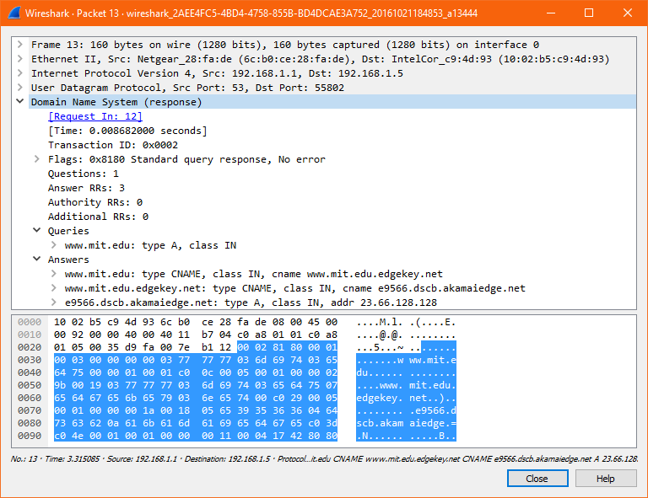
2. To what IP address is the DNS query message sent? Is this the IP address of your default local DNS server?

**Answer: The IP address is 192.168.1.1. This is the same address as the local DNS server (found by using ipconfig /all).**

1. Examine the DNS query message. What “Type” of DNS query is it? Does the query message contain any “answers”?

**Answer: The query is of NS and contains no answers.**

1. Examine the DNS response message. What MIT nameservers does the response message provide? Does this response message also provide the IP addresses of the MIT nameservers?

**Answer: The nameservers provided are as follows:**

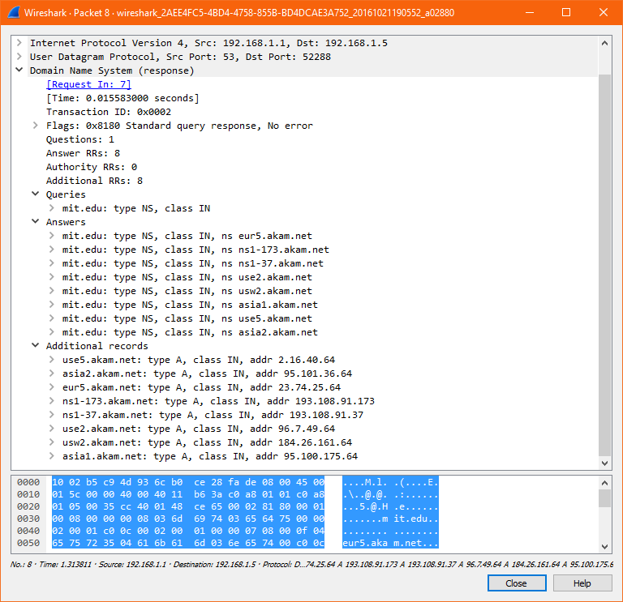

**In addition, the IP addresses of the nameservers are also provided:**



1. Provide a screenshot.