# NFRC Agreement for Submission of Frame Component Data to NFRC CMAST Databases

# March 2014

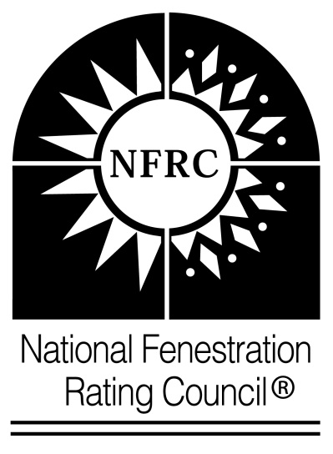

This agreement for submission of frame component data into databases is made as of the date below, by the undersigned party (participant) and National Fenestration Rating Council, Inc. (NFRC).

**BACKGROUND**

1. NFRC maintains and accesses Databases containing thermal performance data necessary to calculate whole product energy performance for use on CMA bid reports, CMA label certificates, and NFRC residential labels. NFRC maintain the *Component Modeling Approach Software Tool* (CMAST) which hosts all NFRC approved frame component data.
2. Certain of the data in the Databases are accepted for use with the NFRC fenestration rating, certification and labeling program (the *NFRC Component Modeling Approach Product Certification Program*) according to the *NFRC 705-Component Modeling Approach Product Certification Program.*
3. The frame component participant may, from time to time, wish to submit CMA frame component data into the CMAST databases. In order to submit these data, the participant must agree to comply with NFRC’s requirements relating to the submission of data into the databases.
4. Now therefore, the participant agrees as follows:
5. In connection with any submissions of data into the databases that participant makes, the participant shall adhere to and comply with the requirements of NFRC 100, NFRC 200, NFRC 705, NFRC 704: *Fee Schedule*, and NFRC 714: *NFRC Challenge and Appeals Procedures*, as each may be interpreted, amended, or supplemented by NFRC from time to time.
6. The participant shall remit to NFRC such participation fees per NFRC 704 and charges as NFRC establishes from time to time for submission of data into the Databases.
7. The participant agrees to cooperate in the resolution of challenges or disputes relating to Submitter’s data included in the Databases in accordance with the procedures established by NFRC from time to time, including under NFRC 714.
8. This Agreement does not confer on the participant any rights to use or display NFRC’s trademarks, service marks, or trade names or to represent that it is a licensee in NFRC’s CMA Product Certification Program.
9. This Agreement may be terminated by either party with or without cause upon five days prior written notice. Upon such termination, all data of the participant in the databases shall be made inaccessible for future product ratings. This agreement may be amended from time to time by NFRC as follows:
   1. NFRC shall provide written notice of the proposed amendment to participant.
   2. If Participants does not object in writing to that amendment within 30 days of receipt of notice, the amendment shall be deemed effective.
10. This Agreement shall be interpreted under Maryland law.
11. Licensee assigns to NFRC all copyrights Licensee may own in any written materials Licensee voluntarily submits to NFRC for incorporation into any NFRC program or NFRC technical documents, whether in written, electronic, or other tangible format (the “Contributions”). Licensee acknowledges that Licensee will have no future rights in any of these Contributions and that NFRC shall own the entire copyright in such Contributions. Licensee certifies that it has the legal right to assign the copyright in such Contributions to NFRC, and that to its knowledge such Contributions are not protected by any copyright or other proprietary rights owned by any other person or entity.

So Agreed:

Participant [fill in name]

By: ___________________________

(Authorized Signature)

___________________________

(Print name)

Title: _________________________

Accepted by NFRC

By:

Effective Date (Authorized Signature)

___________________________

(Print name)