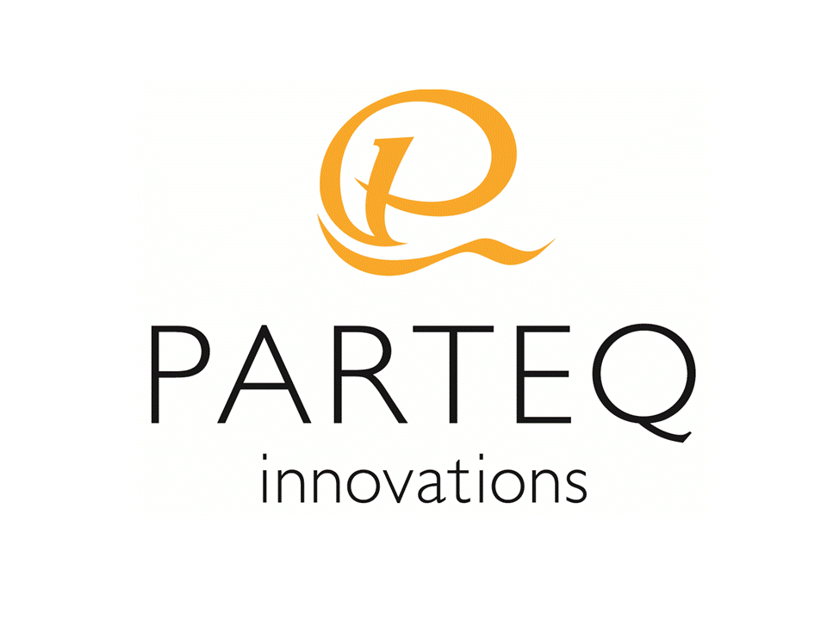TECH ID: [tech id]

# INTELLECTUAL PROPERTY AGREEMENT

Entered into this [date] day of [date].

Between PARTEQ Research and Development Innovations

a not-for-profit, non-share capital corporation

having its offices at Queen's University at Kingston (hereinafter “Queen’s”),

Kingston, Ontario K7L 3N6

(hereinafter “PARTEQ”)

and

[PI]

and

[PI]

[PI Address]

(hereinafter “Creators”)

WHEREAS PARTEQ is the technology transfer arm of Queen's University and is experienced in the protection and commercialization of intellectual property;

AND WHEREAS in the Collective Agreement between Queen’s University and its faculty as first ratified by the Queen’s Board of Trustees on January 10, 1997 and amended from time to time (the “Collective Agreement”), in certain circumstances grants ownership of intellectual property created by its faculty and staff to the Creator thereof;

AND WHEREAS the Creator has created the Intellectual Property (as defined herein) described in Schedule A and wishes to have such Intellectual Property protected and commercialized by PARTEQ;

In consideration of the mutual promises and covenants set out in the Agreement, and for other good and valuable consideration, (the receipt and sufficiency of which are hereby acknowledged);

The Parties now agree as follows:

1. Definitions: As used herein, the following terms shall have the following meanings:

“Contributor” means any person, institution, or entity which has or may have made a material contribution to the Intellectual Property.

“Intellectual Property” and “Invention” means any and all of:

(a) Inventions: any new and useful art, process, method, machine, manufacture or composition of matter or any improvements therein whether or not patentable;

(b) Copyright: any new article, dramatic, literary or musical work, including computer software;

(c) Industrial Design: any design capable of registration under the Industrial Designs Act, which is capable of reproduction in more than 50 single copies;

(d) Trade Secrets or Confidential Information, for example, test results, protocols, reagents, undisclosed inventions or source code;

(e) Rights in Data, whether or not registered;

(f) Other rights related to the Intellectual Property, for example, assignable rights arising from beta testing or clinical trials:

(g) Rights in physical objects related to the Intellectual Property, for example, any digital media, diskettes, databases or tissue samples;

(h) Any other intellectual or industrial property right;

which are disclosed in, related to and/or by necessary inference are included in the disclosure contained in Schedule A.

“Gross Revenues” means either:

Gross revenues, in cash or kind, actually received by PARTEQ in consideration of any license, or sale of any of the Intellectual Property

“Net Proceeds” means:

Gross Revenues less identifiable patenting and commercialization expenses incurred by PARTEQ relative to the Intellectual Property (“Identifiable Costs”). Identifiable Costs shall not include salaries or other remuneration paid to PARTEQ employees with the exception of PARTEQ’s salaried patent agents.

1. Creator represents and warrants that they (i) have not collaborated with any other person to create the Intellectual Property and that there have not been any other contributors to the Intellectual Property, other than those disclosed in Schedule B; (ii) have not encumbered, licensed, assigned, or granted any rights in, the Intellectual Property, including rights granted to a third-party in a research contract with industry or a funding agency; (iii) have not, except as already disclosed to PARTEQ or as itemized on Schedule C, publicly disclosed the Intellectual Property; and (iv) do not have any obligation to provide any proceeds arising from commercialization of the Intellectual Property to any other person. In the event such representations and warranties are not correct, then PARTEQ may, provided it acts fairly and reasonably, allocate a portion of Net Proceeds due to the Creator under Article 14 to any other person to remedy or rectify this misstatement. Further during the term of this Agreement, Creator will inform PARTEQ of any research collaborations that may involve the Invention prior to entering into an agreement for a research collaboration.
2. During the term of this Agreement, Creator shall not disclose or discuss the Intellectual Property with, or to, any potential licensee(s) or potential partners without the prior consent of PARTEQ, where such agreement is not to be unreasonably withheld. During the term of this Agreement, PARTEQ shall have the right to disclose the Intellectual Property to any potential licensee(s) or potential commercial partners, provided (i) no confidential information related to the Intellectual Property or such party has executed a confidentiality agreement in a form acceptable to PARTEQ; and (ii) said party is not disclosed in Schedule D. By receiving and reviewing the disclosure of Intellectual Property, PARTEQ will not be barred from receiving or reviewing other intellectual property, which may be deemed to be competitive with the Intellectual Property.
3. Prior to the transfer of ownership of any Intellectual Property rights to Queen’s and/or prior to PARTEQ or any corporation or other entity in which PARTEQ has an interest entering into an agreement with a third party in relation to the commercialization of the Intellectual Property, PARTEQ shall:
4. Investigate with due diligence the extent of involvement of any and all Contributors and co-inventors whether or not they are identified on the invention disclosure form provided to PARTEQ (the “Inventorship Investigation”); and
5. Provide the Creator with a detailed account of the Inventorship Investigation including the names of all individuals contacted, the date on which each was contacted, and their involvement in the Intellectual Property.
6. If PARTEQ elects to seek protection of the Intellectual Property and the Creator has signed an acknowledgement certifying that the Creator is satisfied as to the completeness and accuracy of the Inventorship Investigation, the Creator agrees to, forthwith, assign all right, title and interest in and to the Intellectual Property to Queen's or their primary institution on the terms set forth in this Agreement. The Creator further agrees, at the expense of PARTEQ, to execute all necessary papers, and take any additional steps as PARTEQ requires, to perfect title in and to the Intellectual Property and patent or other applications, reissues, divisions, continuations or continuations-in-part thereof arising therefrom to Queen's. Creator shall waive all moral rights in the Intellectual Property.
7. PARTEQ shall have the sole and exclusive right to commercialize the Intellectual Property and the Creator shall not negotiate any such commercialization or enter into any agreement related to commercializing the Intellectual Property without the prior written consent of PARTEQ.
8. The Creator agrees that all improvements made in the field of the Intellectual Property while they are employed by Queen’s or other institution, whether or not patentable, will be promptly reported and fully disclosed to PARTEQ and that such improvements shall be assigned to Queen’s, on the same terms as the Intellectual Property, upon the request of PARTEQ.
9. If PARTEQ elects to seek protection of the Intellectual Property, PARTEQ agrees to pay, or arrange for payment of, all costs for preparing, prosecuting and maintaining all applications for patent, copyright or industrial design (as appropriate), all patents, copyrights, registered designs issuing thereon in all such countries as it shall, in its judgement, elect. PARTEQ shall not permit any such application or registration to become irrevocably abandoned, other than by way of final rejection by the appropriate office from which there is no further appeal within that office, without affording the Creator at least thirty (30) days to assume responsibility for continued prosecution and/or maintenance at Creator’s own expense.
10. Any dispute or difference between the parties hereto concerning questions of interpretation, fact, procedures, practices or standards relevant to this agreement which cannot be resolved or settled by the parties, shall be settled and determined by arbitration. Any party may at any time give written notice to the other of its desire to submit such dispute to arbitration stating with reasonable particularity the subject matter of such dispute and indicating its desire for the parties to jointly appoint an arbitrator. Within ten (10) days after receipt of such notice, the parties shall appoint a single arbitrator with appropriate experience to determine such dispute. If the parties fail to appoint an arbitrator within such ten (10) day period, either party may apply to a Judge of the Ontario Court of Justice (General Division) to appoint an arbitrator to determine such dispute. The arbitrator so appointed shall forthwith proceed to arbitrate the dispute. The costs of the arbitration shall be divided equally between the parties. Despite anything to the contrary contained in the *Arbitrations Act (Ontario)*, the award of the arbitrator shall be final and binding upon the parties and all persons claiming through or under them. Judgement upon the award rendered by the arbitrator may be entered in any court having jurisdiction and thereupon execution or other legal process may issue thereon. The parties hereto and all persons claiming through or under them hereby attorn to the jurisdiction of the arbitrator and to the jurisdiction of any court in which the judgement may be entered.
11. PARTEQ will generate a project plan, with estimated timelines, that will outline the activities and contributions PARTEQ plans to make to the commercialization of the Intellectual Property. Such project plan will be reviewed, modified, and updated from time to time. In general, where each case may vary, PARTEQ will provide the following services (with input from the Creator):
    1. Complete a more comprehensive review of the technology
    2. Generate and implement a commercialization strategy
    3. Generate and implement an intellectual property protection plan (which may or may not entail the preparation and filing of a patent application or applications)
    4. Actively market the Intellectual Property to third-parties
    5. Negotiate relevant commercialization-related agreements (e.g., confidentiality agreements, license agreements)
    6. Provide financial accounting and reporting
    7. In certain cases, support the creation of a start-up company for the commercialization of the Intellectual Property
12. PARTEQ shall, at its own expense, exercise such effort as shall be reasonable in the circumstances to commercialize the Intellectual Property. PARTEQ and Queen’s will retain the right to use and practice the Intellectual Property for non-commercial, research and/or academic purposes only, which right it may exclusively license to other educational, hospital, or not-for-profit research organizations for non-commercial, research and/or academic purposes.
13. PARTEQ shall maintain accurate records of its Identifiable Costs
14. PARTEQ shall keep the Creator informed, in a timely manner (as outlined in Article 19), of its commercialization efforts, including any negotiations it is having with third parties who may be potential licensees, and shall endeavour to involve the Creator in such commercialization efforts should the Creator so wish.
15. PARTEQ shall provide the Creator with a report of Gross Revenue received, if any have been received, and at the same time shall pay to the Creator 50 % of the Net Proceeds received in each calendar year, not later than March 1st in the following calendar year. In the event of more than one Creator of the Intellectual Property, any such 50% of the Net Proceeds shall be divided equally between all Creators of the Intellectual Property, unless all Creators of such Intellectual Property have agreed, in writing, to a different sharing arrangement.
16. At PARTEQ's discretion, and without the approval of the Creator, PARTEQ may withhold up to 10% of the Net Proceeds to fund Identifiable Costs of subsequent years where such Identifiable Costs are anticipated by PARTEQ to be greater than Gross Revenues. Should PARTEQ request to withhold an amount great than 10% of Net Proceeds, the consent of the Creator is required, which will not be unreasonably withheld.
17. Net Proceeds is exclusive of taxes such as Goods and Services Tax, Provincial Sales Tax, Harmonized Sales Tax or any other tax exigible thereon. Creator will promptly notify PARTEQ should the share of Net Proceeds paid to Creator is subject value-added taxation. In the event a share of Net Proceeds is paid to a non-Canadian resident, PARTEQ shall withhold, and remit to Receiver General of Canada on the non-Canadian resident Creator’s behalf, the statutory minimum withholding taxes.
18. Creator hereby acknowledges that PARTEQ is a suitable vehicle for exploitation of the Intellectual Property.
19. Creator hereby agrees that the terms of this Agreement form an acceptable proposal for exploitation of the Intellectual Property as contemplated in the Collective Agreement.
20. Prior to PARTEQ, or any corporation or other entity in which PARTEQ has an interest, entering into an agreement with a third party relating to the commercialization of the Intellectual Property, the Creator may terminate this agreement upon advanced written notice if PARTEQ has failed to dedicate appropriate skills and effort towards exploitation of the Intellectual Property over time or if the Creator determines that the exploitation of the Intellectual Property is interfering with his/her ability to pursue scholarly research.
21. Creator shall have seven (7) days to terminate this Agreement following receipt of the written Inventor Investigation outlined in Article 4.

1. Prior to PARTEQ, or any corporation or other entity in which PARTEQ has an interest, entering into an agreement with a third party relating to the commercialization of the Intellectual Property, PARTEQ shall, for any business or other reason, have the right to terminate this Agreement by providing Creator thirty (30) days advanced written notice.
2. PARTEQ shall notify Creator of PARTEQ’s participation in discussions with a third-party in relation to the commercialization of the Intellectual Property at least fifteen (15) calendar days prior to entering into a commercialization agreement with such third-party.
3. PARTEQ shall have the right to terminate this Agreement by providing thirty (30) days advanced written notice to Creators.
4. This Agreement shall enure to the benefit of and be binding upon the parties hereto and their respective heirs, executors, personal legal representatives, successors and permitted assigns.

1. Neither party shall assign this Agreement or any rights deriving from this Agreement without the written consent of the other party.
2. PARTEQ’s limitation of liability for any cause of action relating to this Agreement shall be $50,000. PARTEQ shall in no event be liable for special, punitive, exemplary, indirect, incidental or consequential damages, loss of profit or reputation.
3. The Creator acknowledges that he or she has been advised that he or she should obtain independent legal and tax advice as to the terms of this Agreement and has had the opportunity to do so.
4. This Agreement shall be governed under the laws of the Province of Ontario and Federal laws applicable therein. The parties attorn to jurisdiction and venue of the Courts of Ontario in respect of any matter relating to this Agreement.
5. This Agreement (including the documents and instruments referred to herein and the schedules and exhibits hereto) supersedes all prior representations, arrangements, negotiations, understandings and agreements between the parties both written and oral, relating to the subject matter hereof and sets forth the entire complete and exclusive agreement and understanding between the parties hereto relating to the subject matter hereof; no party has relied on any representation, arrangement, understanding or agreement (whether written or oral) unless expressly set out or referred to in this Agreement.
6. All Gross Revenues, Identifiable Costs, and Net Proceeds are in Canadian dollars and in the case of Net Proceeds, to be paid in Canadian dollars. With respect to amounts in currency other than Canadian dollars, calculations required to ascertain the amounts in equivalent Canadian dollars shall be made using the official closing exchange rate quoted by the Bank of Canada on the transaction day of the event resulting in Gross Revenues or Identifiable Cost. The applicable transaction day is as determined under Canadian generally accepted accounting principles in place at the time of the transaction. Unrealized and realized foreign exchange gains and losses are not include in Gross Revenues, identifiable patent and commercialization expenses, and Net Proceeds.

[signature page follows]

**IN WITNESS WHEREOF** the parties have executed this memorandum at Kingston, Ontario this [date] day of [month], [year].

**PARTEQ Research and Development Innovations**

By: ___________________________________

President and CEO

**Witness: Creator:**

_______________________ By: ___________________________________

Print Name: [Name]

_______________________ By: ___________________________________

Print Name: [Name]

*Rejection of Offer:*

Creator hereby rejects the above-described offer. The Creator hereby agrees that any proceeds resulting from the eventual commercialization of the Intellectual Property will be distributed in accordance with Article 16 of the above-mentioned Collective Agreement.

**Creator:**

By: ___________________________________

[Name]

By: ___________________________________

[Name]

**Schedule A**

The intellectual property more fully described in the following documents:

**Schedule B**

Creators and Contributors of Intellectual Property

Creators

Contributors

None

**Schedule C**

Prior Public Disclosures

**Schedule D**

List of Excluded Entities